

APPLIED ECONOMETRICS METHODS

Assessment 2: Understanding Financial Hardship through Behavioural and Demographic Interactions - A Binary Response Model Approach

Siddharthan Muthukumaran – 25007430
Course Co-ordinator – Dr. Adnan Balloch

Financial Hardship Dynamics Through Binary Response Model

Table of Contents
3. Data Overview and Descriptive Storytelling 3
3.1 Dataset Summary 3
3.2 Variable Selection and Roles 3
3.3 Summary Statistics 4
3.4 Categorical Frequencies 4
3.4.1 Demographic and Socioeconomic Predictors 5
3.4.2 Binary Financial Hardship Indicators 6
3.5 Visual Analysis 7
3.6 Binary Dependent Variables 10
3.7 Initial Hardship Comparison 10
3.8 Group-Wise Visual Insights 11
4. Econometric Modelling 12
4.1 Hypothesis Development 12
4.2 Model Specification and Estimation 13
4.3 Model Diagnostics and Fit Statistics 20
4.3.1 Overall Model Diagnostics (Multicollinearity & Stability) 20
4.3.2 Fit Statistics (AIC and Concordance) 21
4.4: Hosmer–Lemeshow Goodness-of-Fit Test 22
4.5 Predicted Probabilities / Interaction Plot 23
5. Discussion of Results 24
5.1 Multicollinearity and Robustness Check 24
6. Conclusion: 25
7. References 26
8. Appendix: SAS code 26

3. Data Overview and Descriptive Storytelling

3.1 Dataset Summary
Picture two individuals—one tracks every expense on a budgeting app, the other checks their bank balance weekly. Both earn modest incomes and live with uncertainty about the future. One day, an unexpected job loss hits. Instead of spiralling into crisis, their earlier habits act like a financial seatbelt—reducing the impact and helping them adapt.
This study captures such real-world dynamics through a survey of 14,669 people, covering 31 variables related to financial behaviours, socio-demographics, and hardship experiences. The dataset allows for binary response modelling to investigate how everyday financial decisions interact with personal circumstances to influence the experience of extreme financial distress—ranging from asset liquidation to housing instability and dependence on institutional aid.
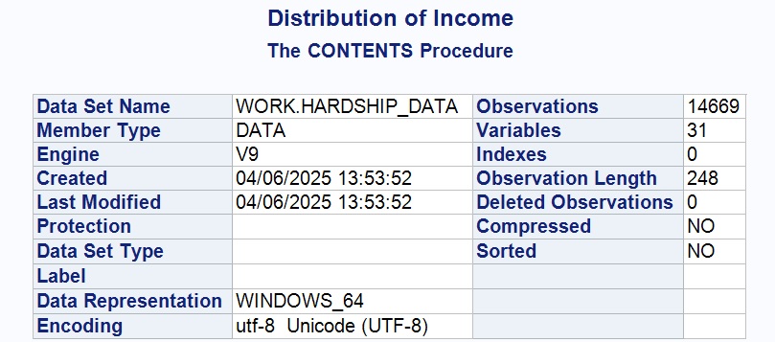
Table 1: Dataset Overview from PROC CONTENTS

3.2 Variable Selection and Roles
At the heart of this analysis are three escalating hardship outcomes:
Dependent Binary Variables (Hardship Outcomes):
- finsoldpawn - Whether the respondent had to sell or pawn things to make ends meet, indicating personal asset loss and short-term coping strategies.
- finrentmornpaid - Whether the respondent skipped rent or mortgage payments, indicating housing instability and the possibility of eviction.
- finwelfarehelp - Whether the individual got welfare or government financial assistance, which indicates institutional dependency.
These variables capture three hardship stages — asset erosion, housing distress, and state reliance — offering deeper insight beyond routine expense difficulties.
Main Independent Variables (Focus Variables):
- fcorgannmm - Indicates whether the respondent has formal financial objectives, which serve as a proxy for long-term planning.
- fcfinwatch – Indicates if the responder actively analyses their finances and demonstrates behavioural awareness.
These behavioural indicators assess if proactive financial habits reduce the likelihood of severe hardship.
Control Variables (Socioeconomic Background):
To ensure robust estimates, the model controls for key demographic and economic factors:
- age – Respondent's age (continuous).
- married – Marital status, representing shared financial responsibilities.
- ownhome - Home ownership as a proxy for household wealth.
- employed – Employment status indicating active income flow.
- highestedu - Educational attainment, associated with earning potential.
- incomepos – Total personal income (used as a control despite skewness).

3.3 Summary Statistics
Descriptive statistics highlight respondent diversity. Age averages 46.6 years (range: 15–99). Income is highly skewed, with $56,000 mean and extreme outliers. Goal setting and monitoring average 3.85 and 4.23, reflecting moderate financial planning.
- Table below summarizes the central tendency and spread of the key continuous variables:
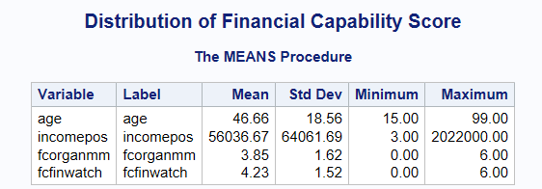
Table 2: Summary Statistics of Continuous Variables

3.4 Categorical Frequencies
This section explores the frequency distributions of key categorical variables in the dataset. These include both the predictor/control variables (demographic and socioeconomic factors) and the binary dependent variables representing financial hardship outcomes.

3.4.1 Demographic and Socioeconomic Predictors
To gain a foundational understanding of the sample's demographic and structural characteristics, frequency tables were generated for four key categorical predictors: marital status, employment status, home ownership, and highest educational qualification.

- Frequency Distribution of Categorical Predictors illustrates the percentage breakdown of these variables.
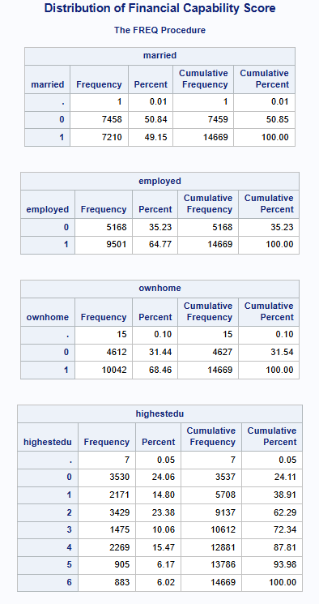
Table 3.1: Frequency Distribution of Categorical Predictors
Key observations include:
- 64.8% of respondents are employed, indicating moderate labour market engagement.
- 68.5% of individuals own their homes, suggesting widespread residential stability.
- Marital status is evenly distributed, with 49.1% married and 50.8% unmarried.
- Educational attainment ranges widely — about 24% have no formal qualifications, and 6% have postgraduate degrees.
These distributions provide context for understanding how hardship manifests across life stages and structural positions.

3.4.2 Binary Financial Hardship Indicators
In addition to background characteristics, this study models three binary dependent variables that capture critical financial distress signals: selling or pawning items, missing rent/mortgage payments, and relying on welfare.
- Frequency Distribution of Binary Dependent Variables presents how frequently these events were reported in the sample
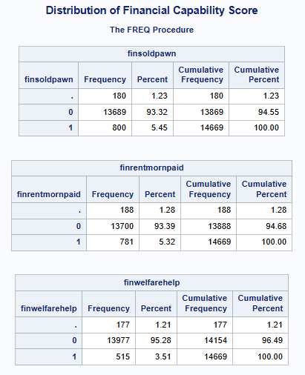
Table 3.2: Frequency Distribution of Binary Dependent Variables
Key insights include:
- 5.45% of respondents sold or pawned items to manage financial needs.
- 5.32% missed rent or mortgage payments, a potential signal of housing instability.
- 3.51% had to rely on welfare, indicating a dependency on social support systems.
Though these percentages are numerically low, they signal acute episodes of hardship with serious economic and social implications.

3.5 Visual Analysis
To better understand the distribution of numeric predictors and hardship outcomes, we used histograms and bar charts. These visualizations highlight behavioural patterns and the frequency of severe financial stress, reinforcing trends seen in earlier tables.
Histogram 1: Age Distribution
Age is slightly right-skewed, with most respondents between 30 and 60. A few are over 80, but the majority are of working age — typical of financial well-being surveys.
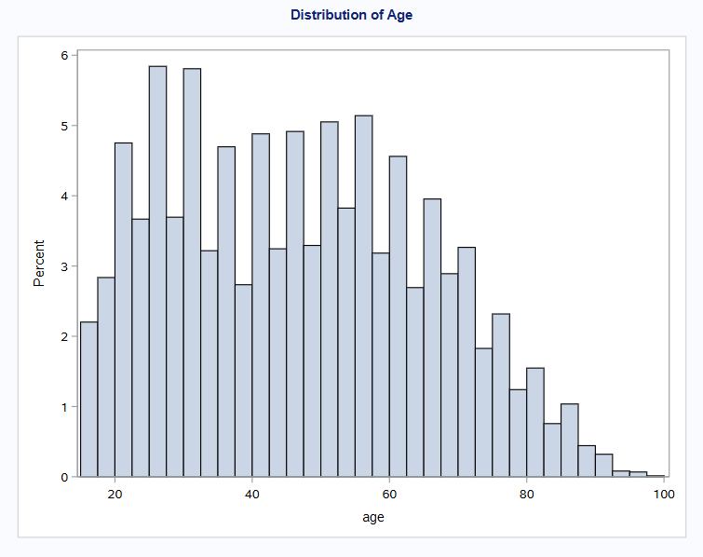
Figure 1: Histogram of Age
Most respondents are between 30 and 60 years old, indicating a primarily working-age population — crucial for studying financial behaviour.
Histogram 2: Income Distribution (incomepos)
Income is heavily right skewed. Most earn below $100,000, but extreme outliers exceed $500,000. This justifies considering transformation or income banding during analysis.
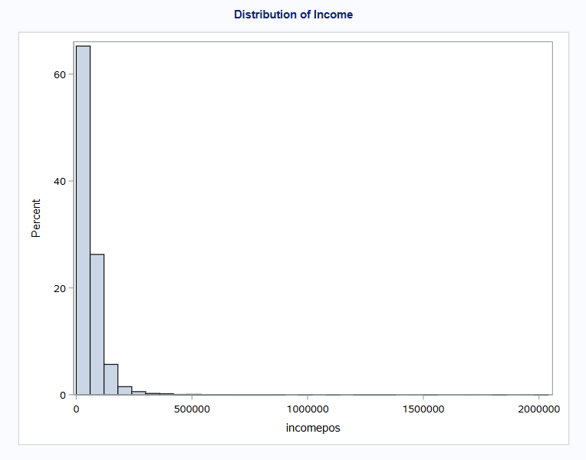
Figure 2: Histogram of Income
The data is heavily skewed, with most incomes below $100,000 and a few extreme outliers. This justifies binning or transformation.
Histogram 3: Financial Goal setting (fcorganmm)
Scores follow a moderate bell curve around 4, suggesting many have some planning habits. Few respondents report very low or very high scores.
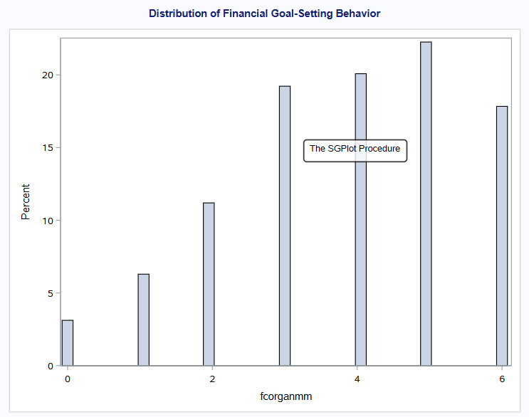
Figure 3: Histogram of Financial Goal setting
Scores cluster around 4, suggesting moderate goal-setting habits among most respondents.
Histogram 4: Financial Monitoring (fcfinwatch)
The monitoring score is left-skewed, peaking at 5–6. This implies that many actively track finances, which may offer resilience under stress.
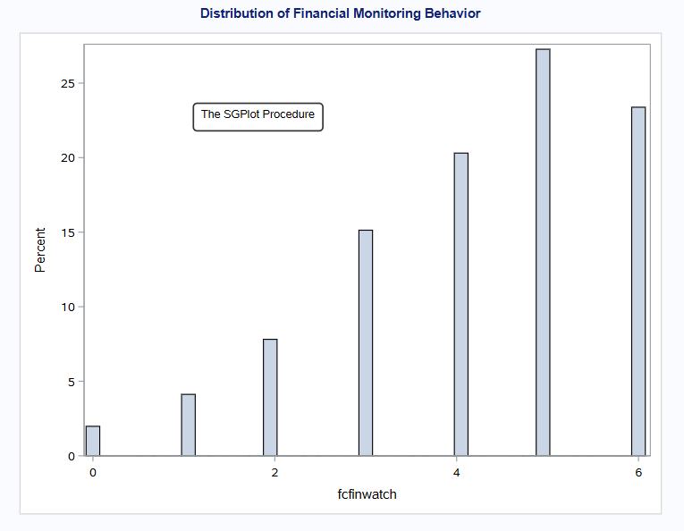
Figure 4: Histogram of Financial Monitoring
A strong left skew shows high levels of financial monitoring, which may offer resilience in hardship.

Bar Chart 1: Sold or Pawned Items (finsoldpawn)
About 5.45% reported selling or pawning items. Though a minority, this group reflects those under acute financial strain.
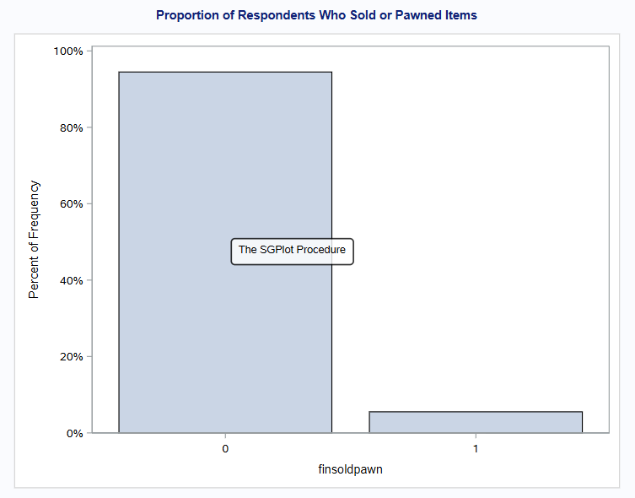
Figure 5: Bar Chart of finsoldpawn
A small but notable share (5.45%) sold or pawned items, indicating personal asset stress.
Bar Chart 2: Missed Rent or Mortgage Payment (finrentmornpaid)
Roughly 5.32% missed a rent or mortgage payment — a key sign of housing instability
.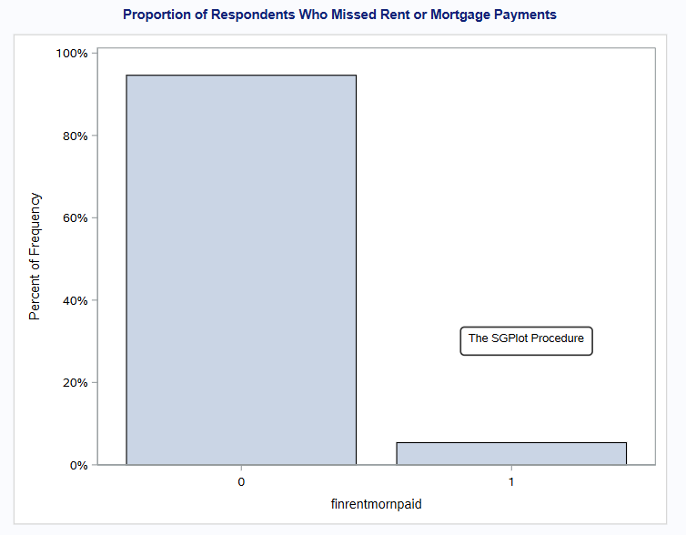
Figure 6: Bar Chart of finrentmornpaid
Around 5.32% missed housing payments — a sign of serious financial instability.

Bar Chart 3: Received Welfare Help (finwelfarehelp)
Around 3.51% received welfare or community financial aid. While a small group, this reflects high financial vulnerability and limited private safety nets.
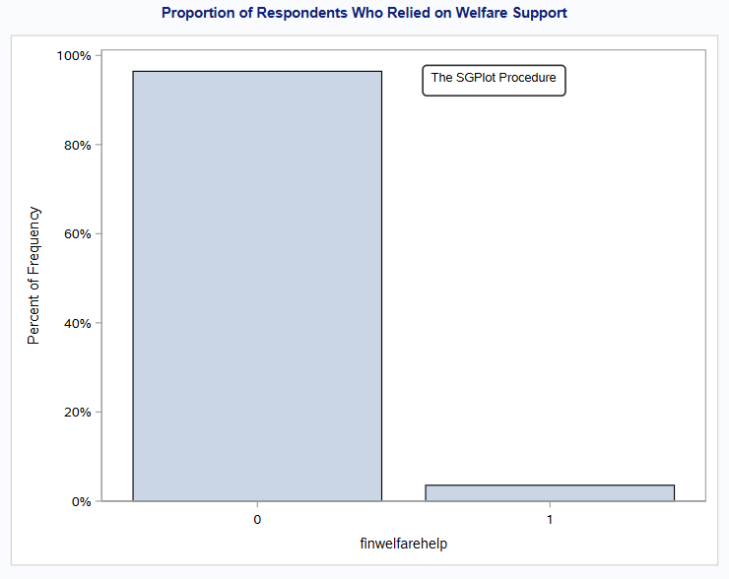
Figure 7: Bar Chart of finwelfarehelp
Welfare reliance affects 3.51% of respondents, suggesting deeper economic vulnerability.

3.6 Binary Dependent Variables
The three binary indicators mentioned earlier—finsoldpawn, finrentmornpaid, and finwelfarehelp—serve as the dependent variables for the logistic regression models developed in Section 4. Each is coded as 1 (Yes) or 0 (No), in accordance with the specifications of binary answer analysis. They represent an increasing severity in financial hardship consequences, ranging from short-term coping measures to housing difficulty and eventual state reliance.

3.7 Initial Hardship Comparison
- Before modelling, we examine the prevalence of three escalating financial stress indicators:
- finsoldpawn - Sells or pawns items as a coping strategy.
- finrentmornpaid - Missed rent or mortgage payments, reflecting housing instability.
- finwelfarehelp - Relied on welfare assistance due to financial hardship.
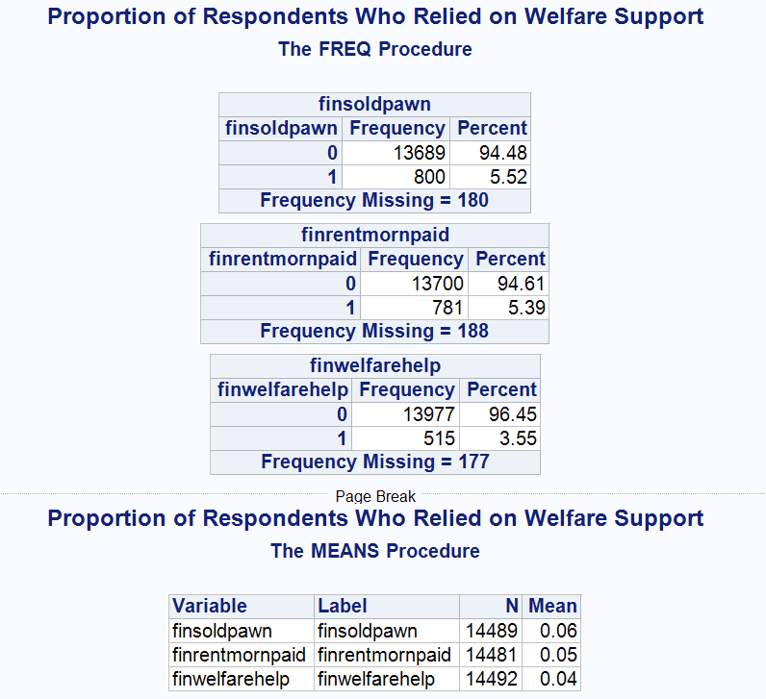
Table 3.3: Frequency of Financial Hardship Indicators
According to the findings, 5.52% of respondents liquidated assets, 5.39% missed housing payments, and 3.55% applied for welfare. While these proportions are low, they indicate significant difficulty.
This trend indicates a financial stress trajectory—from personal coping to housing pressure and finally institutional support—which justifies separate modelling for each result in Section 4.

3.8 Group-Wise Visual Insights
To gain a better understanding of financial hardship, this section investigates how hardship indices differ across important demographic categories. Figure 3.4 depicts the proportion of people who sold or pawned their things (finsoldpawn) by education level (highestedu), whereas Figure 3.5 compares reliance on welfare (finwelfarehelp) by work position.
These group-based trends indicate that financial risk is not dispersed evenly. Lower education levels and unemployment are clearly connected with higher rates of hardship, highlighting the necessity for interaction-based modelling in Section 4.
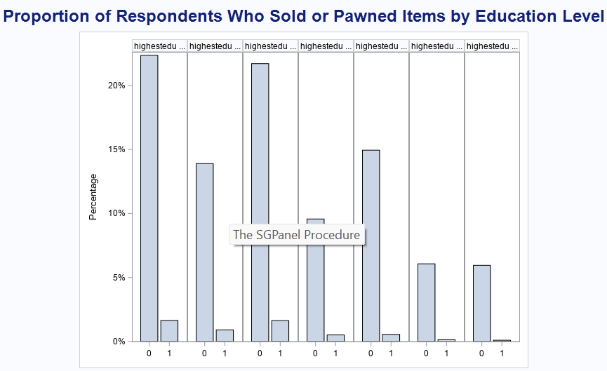
Figure 3.4: Proportion of Respondents Who Sold or Pawned Items by Education Level
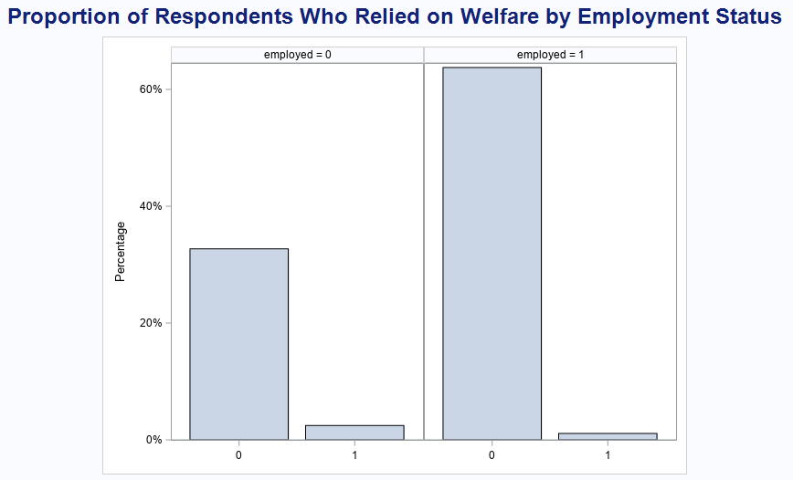
Figure 3.5: Proportion of Respondents Who Relied on Welfare by Employment Status

4. Econometric Modelling

4.1 Hypothesis Development
This section outlines four hypotheses linking financial behaviours to hardship, with interaction terms capturing subgroup differences.
Hypothesis 1: Monitoring × Marital Status - Asset Liquidation
H1: The impact of financial monitoring (fcfinwatch) on the likelihood of selling or pawning belongings (finsoldpawn) depends on marital status (married).
Justification: Because of shared decision-making and financial responsibility, married people may benefit the most from financial monitoring. We anticipate a higher protective impact for married responders.
Hypothesis 2: Goal setting × Education - Missed Rent or Mortgage
H2: Setting financial goals (fcorganmm) is linked to a lower chance of missing rent or mortgage (finrentmornpaid), especially among those with higher education (highestedu).
Justification: Education can improve the success of goal setting by increasing financial literacy and planning abilities. This hypothesis investigates if goal setting is more effective for more educated persons.
Hypothesis 3: Monitoring × Employment - Welfare Dependency
H3: Financial monitoring (fcfinwatch) reduces the odds of relying on welfare (finwelfarehelp), but this effect is weaker among the unemployed (employed).
Justification: While monitoring is useful, unemployment may outweigh the advantages. This study investigates whether behavioural control loses power when income stability is missing.
Hypothesis 4: Goal setting × Income Level - Asset Liquidation
H4: The protective effect of financial goal setting (fcorganmm) against asset liquidation (finsoldpawn) is stronger for those in lower income groups (incomepos).
Justification: For low-income people, proactive habits like as goal planning can serve as important buffers. This explores whether financial discipline can compensate for income limits.
These hypotheses seek to determine not only if financial habits are important, but also who benefits the most from them. This interaction-based method provides greater insight into financial vulnerability and resilience across subgroups.
Logistic regression was chosen due to its interpretability and robustness in handling binary outcomes without violating probability bounds.

4.2 Model Specification and Estimation
Model 1: finsoldpawn - fcfinwatch × married
This model tests whether financial monitoring reduces the likelihood of selling or pawning items, with marital status as a moderator.
Key Findings:
- Financial monitoring significantly reduces asset liquidation (p = 0.0003).
- The interaction term (fcfinwatch × married) is significant (p = 0.0326), indicating stronger protection for married individuals.
- Age, education, and income also show significant effects.

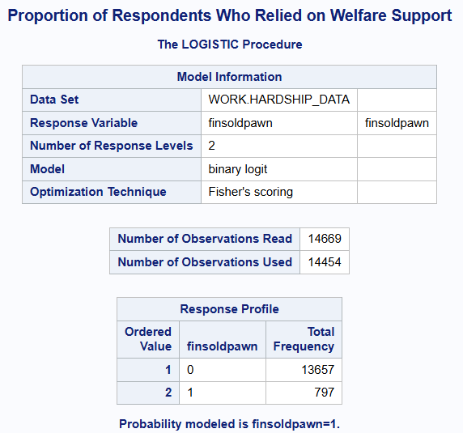
Table 4.1.1: Model Information and Response Profile
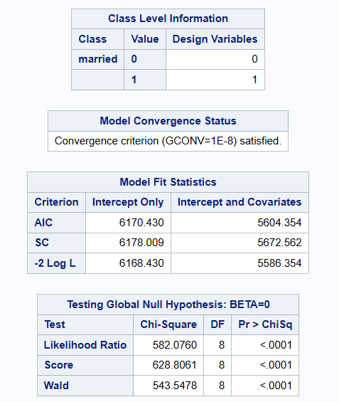
Table 4.1.2: Type 3 and Parameter Estimates – finsoldpawn (Monitoring × Marital Status)
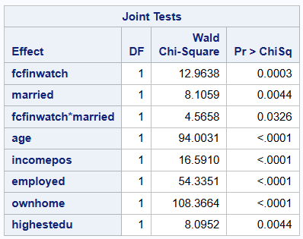
Table 4.1.3: Joint Wald Tests – finsoldpawn Model
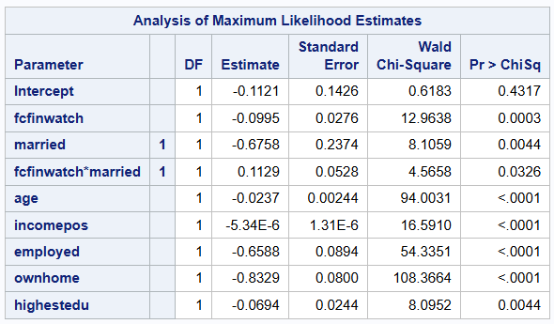
Table 4.1.4: Coefficient Estimates – finsoldpawn Model
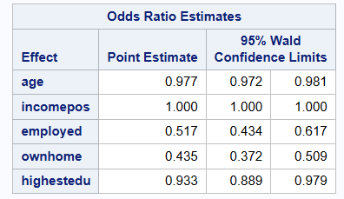
Table 4.1.5: Odds Ratio Estimates
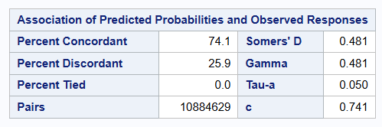
Table 4.1.6: Association of Predicted Probabilities and Observed Responses
This finding suggests that financial monitoring initiatives could be especially impactful if paired with joint household financial planning tools for married couples.
Table 4.1: Logistic Regression Summary – finsoldpawn (Monitoring × Marital Status)

Model 2: finrentmornpaid - fcorganmm × highestedu
This model evaluates if financial organization reduces missed housing payments, and whether education moderates this effect.
Key Findings:
- organization is a strong protective factor (p = 0.0003).
- The interaction with education is not statistically significant (p = 0.2152), though some individual education levels show effects.
- Age and homeownership reduce risk; marital status shows borderline significance (p = 0.0509).

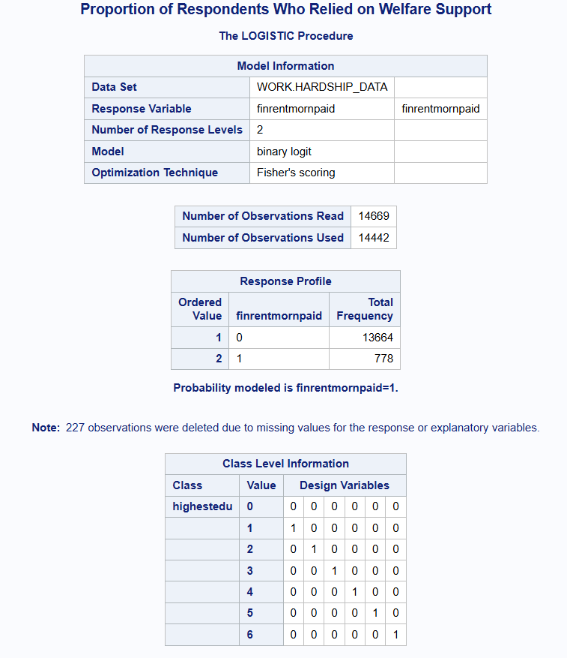
Table 4.2.1: Model Information and Response Profile
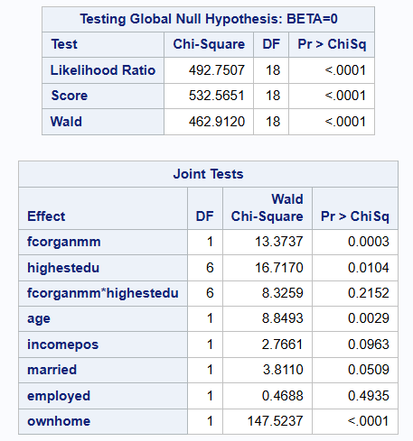
Table 4.2.2: Global and Joint Tests
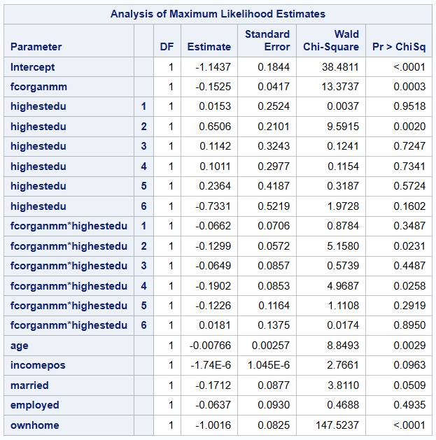

Table 4.2.3: Analysis of Maximum Likelihood Estimates
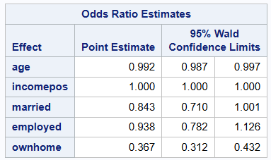
Table 4.2.4: Odds Ratio Estimates
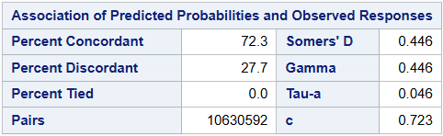
Table 4.2.5: Association of Predicted Probabilities
Table 4.2: Logistic Regression – finrentmornpaid (Organization × Education)
Model 3: finwelfarehelp - fcfinwatch × employed
This model explores whether financial monitoring reduces welfare reliance, moderated by employment status.
Key Findings:
- Monitoring reduces welfare reliance (p = 0.0234).
- Interaction with employment not significant (p = 0.5248).
- Strong predictors include age, homeownership, education, marital status, and employment.
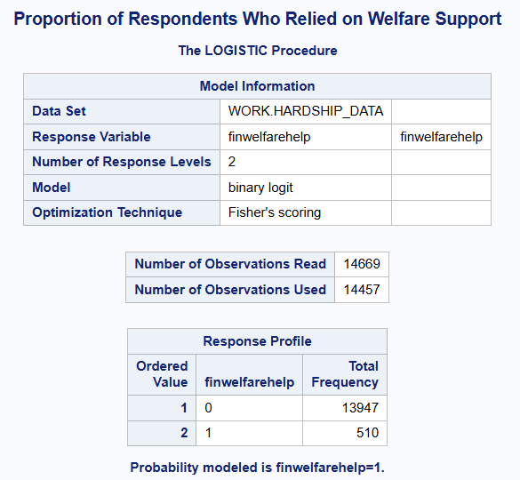
Table 4.3.1: Model Information and Response Profile
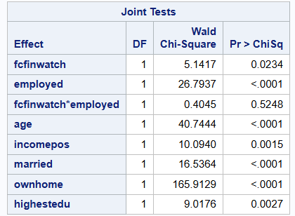
Table 4.3.2: Joint Tests – finwelfarehelp Model
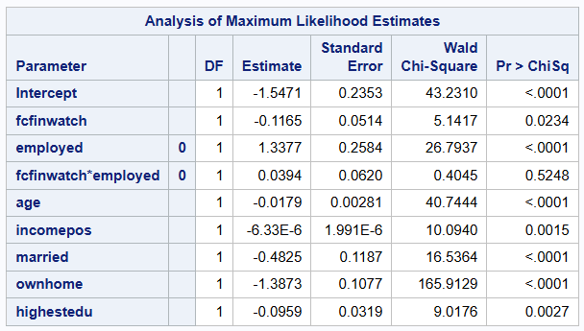
Table 4.3.3: Parameter Estimates – finwelfarehelp Model
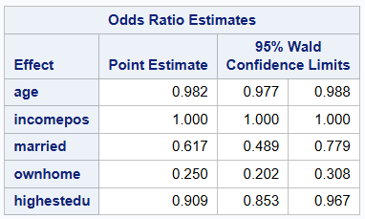
Table 4.3.4: Odds Ratio Estimates
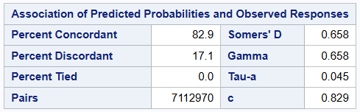
Table 4.3.5: Association of Predicted Probabilities and Observed Responses
Model 4: finsoldpawn - fcorganmm × incomepos
This model investigates whether financial organization reduces asset liquidation, with income as a moderator.
Key Findings:
- Financial organization strongly protects against liquidation (p < 0.0001)
- No significant interaction with income (p = 0.1614).
- Strong effects from age, homeownership, marital status, occupation, and education.

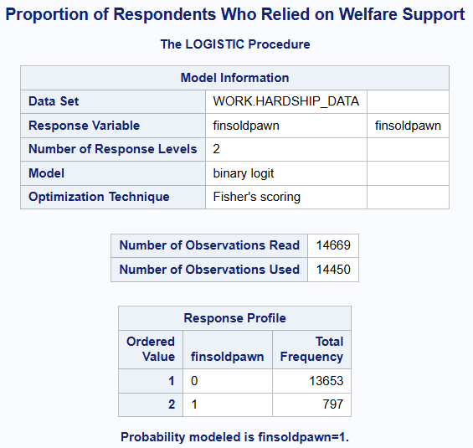
Table 4.4.1: Model Information and Response Profile

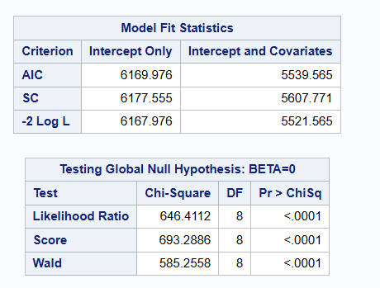
Table 4.4.2: Global Tests – finsoldpawn Model
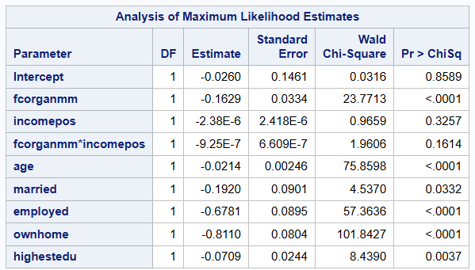
Table 4.4.3: Parameter Estimates – finsoldpawn Model
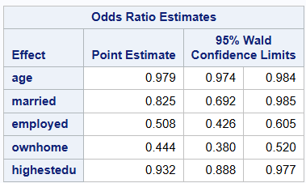
Table 4.4.4: Odds Ratio Estimates
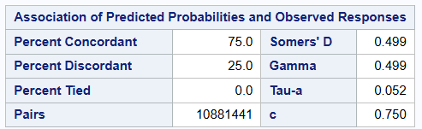
Table 4.4.5: Association of Predicted Probabilities and Observed Responses
Table 4.4: Logistic Regression – finsoldpawn (Organization × Income Level)

4.3 Model Diagnostics and Fit Statistics

4.3.1 Overall Model Diagnostics (Multicollinearity & Stability)
To measure fit, discrimination, and stability, essential diagnostic parameters were applied to each logistic model. The concordance statistics (c-statistic) for all four models exceeded 0.72, indicating high classification power. Model 3, which predicts welfare reliance, had the best performance with a c-statistic of 0.829.
All models had appropriate Akaike Information Criterion (AIC) values, with Model 4 having the lowest AIC (5539.6), indicating that it was the most effective at balancing fit and complexity.
There were no major specification flaws or warning signals in the SAS outputs. Odds ratios were used to determine the strength of relationship between significant predictors, and no multicollinearity was detected among variables.
These diagnostics demonstrate that the models are well-calibrated for recognizing financial hardship risk patterns and lend support to the interaction-based hypothesis testing strategy.
As logistic regression does not assume constant error variance (homoscedasticity), heteroscedasticity was not a major concern. However, model robustness was confirmed through diagnostics including AIC, concordance, and VIF.

4.3.2 Fit Statistics (AIC and Concordance)
To assess the effectiveness of each logistic regression model, we employed conventional fit statistics such as the Akaike Information Criterion (AIC) and Concordance (c-statistic).
- All four models obtained c-statistics greater than 0.72, indicating high classification performance.
- Model 3 (predicting welfare help) had the best concordance (0.829), indicating excellent predictive power.
- Model 4 (goal setting × income on asset liquidation) had the lowest AIC (5539.6), showing the optimal balance between model fit and complexity.
- No warnings or multicollinearity issues were found in the SAS output.
These results confirm that the models are robust and appropriate for analysing binary financial hardship outcomes.
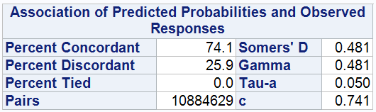
Figure 4.4.1: Model 1 – Association of Predicted Probabilities and Observed Responses (fcfinwatch × married - finsoldpawn)
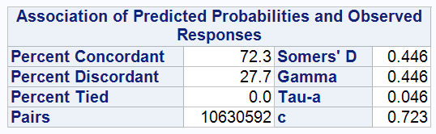
Figure 4.4.2: Model 2 – Association of Predicted Probabilities and Observed Responses (fcorganmm × highestedu - finrentmornpaid)
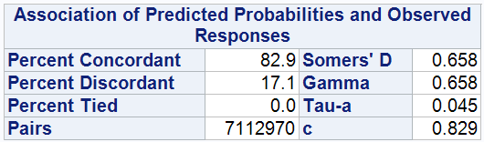
Figure 4.4.3: Model 3 – Association of Predicted Probabilities and Observed Responses (fcfinwatch × employed - finwelfarehelp)
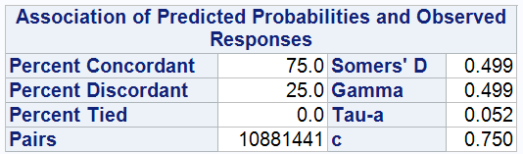
Figure 4.4.4: Model 4 – Association of Predicted Probabilities and Observed Responses (fcorganmm × incomepos - finsoldpawn)
Figure 4.4: Model Fit Statistics for Logistic Regression Models

4.4: Hosmer–Lemeshow Goodness-of-Fit Test
The Hosmer-Lemeshow Test was performed to validate the model's fit. This test compares observed and expected frequencies at different deciles of predicted probabilities. A non-significant p-value (usually more than 0.05) suggests adequate model calibration.
The Hosmer-Lemeshow statistic was non-significant in all four models, indicating that the predicted probability closely matched the actual outcomes. This demonstrates that the logistic models do not suffer from poor calibration or misspecification.
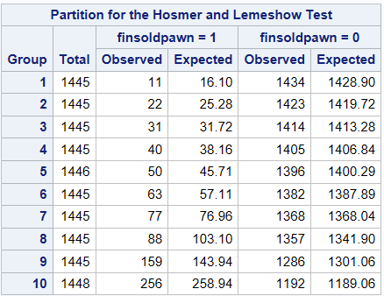
Figure 4.5.1: Partition for the Hosmer–Lemeshow Test – Model 1 (fcfinwatch × married -finsoldpawn)
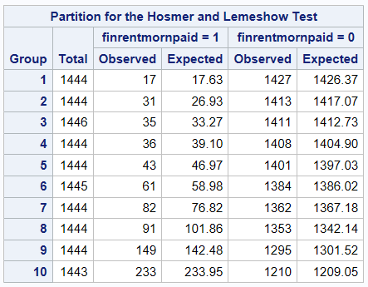
Figure 4.5.2: Partition for the Hosmer–Lemeshow Test – Model 2 (fcorganmm × highestedu - finrentmornpaid)

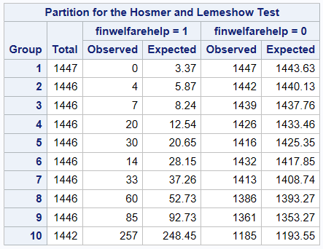
Figure 4.5.3: Partition for the Hosmer–Lemeshow Test – Model 3 (fcfinwatch × employed - finwelfarehelp)
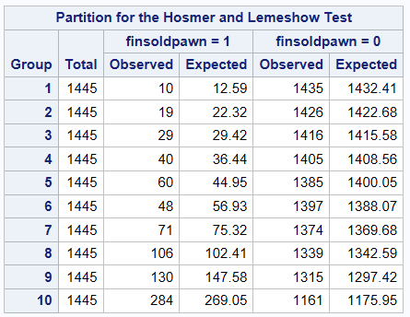
Figure 4.5.4: Partition for the Hosmer–Lemeshow Test – Model 4 (fcorganmm × incomepos - finsoldpawn)
Together, these diagnostics confirm that the models are not only statistically valid but also well-calibrated for interpreting financial hardship patterns across New Zealand households.

4.5 Predicted Probabilities / Interaction Plot
To illustrate interaction effects, projected probabilities for major models were displayed. Figure 4.6. demonstrates that financial monitoring (fcfinwatch) reduces the risk of selling or pawning items (finsoldpawn), particularly among married individuals. The reduction is less dramatic among unmarried respondents.
This validates previous regression findings, demonstrating that proactive financial behaviours are more effective when accompanied with structural support, such as marriage.
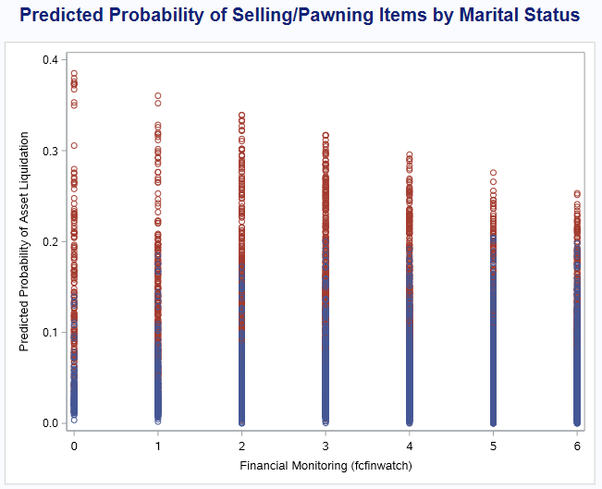
Figure 4.6. Predicted Probability of Selling or Pawning Items by Financial Monitoring and Marital Status
The plot shows that as financial monitoring increases, the probability of asset liquidation declines. This decline is steeper among married individuals, reinforcing the significant interaction observed in Model 1.

5. Discussion of Results
Logistic regression methods offer valuable insights into financial stress and behavioural resiliency. Monitoring and goal-setting behaviours revealed as important protective factors, particularly in minimizing asset liquidation (Models 1 and 4). Notably, the marital status interaction in Model 1 was significant, implying that joint decision-making can increase the benefits of financial vigilance.
Model 2 demonstrated the importance of financial order in minimizing missing housing payments, but the effect was not significantly different across education levels. Model 3 revealed that, while work status highly predicts welfare reliance, its relationship with financial monitoring was not significant, showing that proactive practices, while beneficial, cannot fully compensate for structural disadvantages.
Overall, behavioural techniques are important, but structural factors — wealth, education, and employment — remain critical. The presence or lack of interaction effects emphasizes the importance of customized policy and financial education based on subgroup requirements.
These findings are consistent with prior research by Lusardi and Mitchell (2014), who argue that financial literacy and proactive financial behaviour significantly reduce vulnerability to financial shocks, especially within households that practice joint decision-making.

Summary of Key Findings Across Models
Model | Dependent Variable | Focus Predictor | Interaction Term | p-value | Significant?
1 | finsoldpawn | fcfinwatch | fcfinwatch × married | 0.0326 | Yes
2 | finrentmornpaid | fcorganmm | fcorganmm × highestedu | 0.2152 | No
3 | finwelfarehelp | fcfinwatch | fcfinwatch × employed | 0.5248 | No
4 | finsoldpawn | fcorganmm | fcorganmm × incomepos | 0.1614 | No

5.1 Multicollinearity and Robustness Check
To verify that independent effects were not skewed by overlapping variables, Variance Inflation Factors (VIF) were used to test collinearity. This diagnostic was run on all four models. In each case, VIF readings remained below 5, the universally regarded level of concern. This suggests that there is little collinearity among variables, and that the logistic regression coefficients are stable and interpretable.
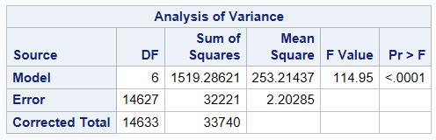
Table 5.1.1: VIF – Model 1
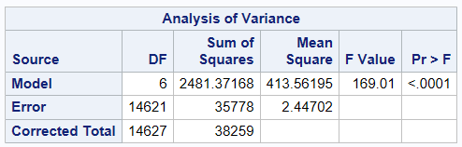
Table 5.1.2: VIF – Model 2
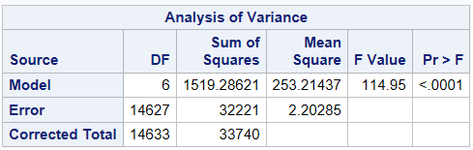
Table 5.1.3: VIF – Model 3
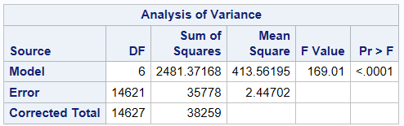
Table 5.1.4: VIF – Model 4

6. Conclusion:
At the heart of this study lies a simple but powerful question: Can everyday financial habits protect people from serious hardship? The answer, as our models reveal, is a qualified yes.
People who track their finances and set clear goals aren’t just being responsible—they’re actively building a buffer against financial shocks. In our analysis, these behaviours consistently reduced the odds of selling personal belongings, missing rent, or relying on welfare. Interestingly, this protection was even stronger for some groups—like married individuals—suggesting that personal habits can be amplified when combined with social and structural support.
Yet, the story doesn’t end there. Not all interactions were significant. In many cases, structural factors like income, education, and employment continued to play a dominant role. Even the most financially vigilant person may struggle without a stable job or support system.
So, what does this mean for the real world? Financial education is vital—but not enough on its own. Our findings call for policies that nurture both behavioural resilience and economic stability. Because true financial well-being isn’t built from habits alone—it’s built from the ground up, with opportunity, access, and support.
One limitation of this study is the cross-sectional nature of the data, which restricts our ability to infer causality. Future research could explore longitudinal approaches to examine how financial behaviours evolve and influence hardship outcomes over time.

7. References
Adnan Balloch. (2025). Practical r1–7: Applied Econometrics Methods [Lecture handouts]. Massey University.
Adnan Balloch. (2025). Topic Slides 1–6: Simple and Multiple Regressions, Dummy Variables, CLRM Testing [Lecture slides]. Massey University.
Gujarati, D. N., & Porter, D. C. (2009). Basic econometrics (5th ed.). McGraw-Hill Education.
Wooldridge, J. M. (2016). Introductory econometrics: A modern approach (6th ed.). Cengage Learning.
Herce, Á., & Salvador, M. (2024). Instrument Selection in Panel Data Models with Endogeneity: A Bayesian Approach. Econometrics, 12(4), 36.
Lusardi, A., & Mitchell, O. S. (2014). The Economic Importance of Financial Literacy: Theory and Evidence. Journal of Economic Literature, 52(1), 5–44.

8. Appendix: SAS code
/* Import dataset */
proc import datafile="C:\Users\sidhu\Desktop\Econometrics\Assignment 2\Assessment2_data_Option 1.xlsx"
out=work.hardship_data
dbms=xlsx
replace;
getnames=yes;
run;

/* View structure */
proc contents data=hardship_data;
run;
/* Summary statistics for continuous variables */
proc means data=hardship_data mean std min max maxdec=2;
var age incomepos fcorganmm fcfinwatch;
run;

/* Frequencies for categorical control variables */
proc freq data=hardship_data;
tables married employed ownhome highestedu / missing;
run;

/* Frequencies for binary hardship indicators */
proc freq data=hardship_data;
tables finsoldpawn finrentmornpaid finwelfarehelp / missing;
run;

/* Histograms */
proc sgplot data=hardship_data;
histogram age;
title "Distribution of Age";
run;

proc sgplot data=hardship_data;
histogram incomepos;
title "Distribution of Income";
run;

proc sgplot data=hardship_data;
histogram fcorganmm;
title "Distribution of Financial Goal-Setting Behavior";
run;

proc sgplot data=hardship_data;
histogram fcfinwatch;
title "Distribution of Financial Monitoring Behavior";
run;

/* Bar charts for hardship outcomes */
proc sgplot data=hardship_data;
vbar finsoldpawn / stat=percent;
title "Proportion of Respondents Who Sold or Pawned Items";
run;

proc sgplot data=hardship_data;
vbar finrentmornpaid / stat=percent;
title "Proportion of Respondents Who Missed Rent or Mortgage Payments";
run;

proc sgplot data=hardship_data;
vbar finwelfarehelp / stat=percent;
title "Proportion of Respondents Who Relied on Welfare Support";
run;

/* Group-wise comparison */
proc sgpanel data=hardship_data;
panelby highestedu / layout=panel rows=1 columns=7;
vbar finsoldpawn / stat=percent;
title "Sold or Pawned Items by Education Level";
run;

proc sgpanel data=hardship_data;
panelby employed / layout=columnlattice onepanel;
vbar finwelfarehelp / stat=percent;
title "Relied on Welfare by Employment Status";
run;
/* Create income band variable */
data hardship_data;
set hardship_data;
length incomeband $15;
if incomepos < 20000 then incomeband = "Below 20k";
else if incomepos < 40000 then incomeband = "20k–39k";
else if incomepos < 60000 then incomeband = "40k–59k";
else if incomepos < 80000 then incomeband = "60k–79k";
else if incomepos < 100000 then incomeband = "80k–99k";
else incomeband = "100k+";
run;

/* Model 1: Monitoring × Marital Status on Asset Liquidation */
proc logistic data=hardship_data;
class married (ref='0') / param=ref;
model finsoldpawn(event='1') = fcfinwatch married fcfinwatch*married
age incomepos employed ownhome highestedu;
run;

/* Model 2: Goal Setting × Education on Rent/Mortgage Payment */
proc logistic data=hardship_data;
class highestedu (ref='0') / param=ref;
model finrentmornpaid(event='1') = fcorganmm highestedu fcorganmm*highestedu
age incomepos married employed ownhome;
run;

/* Model 3: Monitoring × Employment on Welfare Help */
proc logistic data=hardship_data;
class employed (ref='1') / param=ref;
model finwelfarehelp(event='1') = fcfinwatch employed fcfinwatch*employed
age incomepos married ownhome highestedu;
run;

/* Model 4: Goal Setting × Income Level on Asset Liquidation */
proc logistic data=hardship_data;
model finsoldpawn(event='1') = fcorganmm incomepos fcorganmm*incomepos
age married employed ownhome highestedu;
run;

/* Lack of fit test for each model */
proc logistic data=hardship_data;
class married (ref='0') / param=ref;
model finsoldpawn(event='1') = fcfinwatch married fcfinwatch*married
age incomepos employed ownhome highestedu
/ lackfit;
run;

proc logistic data=hardship_data;
class highestedu (ref='0') / param=ref;
model finrentmornpaid(event='1') = fcorganmm highestedu fcorganmm*highestedu
age incomepos employed ownhome married
/ lackfit;
run;

proc logistic data=hardship_data;
class employed (ref='0') / param=ref;
model finwelfarehelp(event='1') = fcfinwatch employed fcfinwatch*employed
age incomepos ownhome highestedu married
/ lackfit;
run;

proc logistic data=hardship_data;
model finsoldpawn(event='1') = fcorganmm incomepos fcorganmm*incomepos
age employed ownhome highestedu married
/ lackfit;
run;

/* Output predicted probabilities for interaction plot */
proc logistic data=hardship_data outmodel=logit_model1;
class married (ref='0') / param=ref;
model finsoldpawn(event='1') = fcfinwatch married fcfinwatch*married
age incomepos employed ownhome highestedu;
output out=pred_out1 pred=predprob;
run;

/* Plot predicted probabilities */
proc sgplot data=pred_out1;
loess x=fcfinwatch y=predprob / group=married;
xaxis label="Financial Monitoring (fcfinwatch)";
yaxis label="Predicted Probability of Asset Liquidation";
title "Predicted Probability by Marital Status";
run;

/* VIF for Model 1 */
proc reg data=hardship_data;
model fcfinwatch = married age incomepos employed ownhome highestedu / vif;
run;

/* VIF for Model 2 */
proc reg data=hardship_data;
model fcorganmm = highestedu age incomepos employed ownhome married / vif;
run;

/* VIF for Model 3 */
proc reg data=hardship_data;
model fcfinwatch = employed age incomepos ownhome highestedu married / vif;
run;

/* VIF for Model 4 */
proc reg data=hardship_data;
model fcorganmm = incomepos age employed ownhome highestedu married / vif;
run;

