

APPLIED ECONOMETRICS METHODS

Assessment 1: Investigating Financial Hardship through ordinary least square regression analysis

Siddharthan Muthukumaran – 25007430
Course Co-ordinator – Dr. Adnan Balloch

Financial Hardship and Its Determinants: An Econometric Report

TABLE OF CONTENTS

FINANCIAL HARDSHIP AND ITS DETERMINANTS: AN ECONOMETRIC REPORT 2
1. INTRODUCTION 2
2. DATA DESCRIPTION AND INSIGHTS 2
3. ECONOMETRIC HYPOTHESES AND ANALYSIS 3
3.1 MODEL SPECIFICATION 5
4. OLS REGRESSION RESULTS 6
4.1 REGRESSION FINDINGS AND HYPOTHESIS OUTCOMES 8
5. CLRM ASSUMPTION TESTS 9
5.1 LINEARITY 9
5.2 NORMALITY OF RESIDUALS 10
5.3 HOMOSCEDASTICITY 11
5.4 MULTICOLLINEARITY 12
6. DISCUSSION OF OLS AND CLRM RESULTS 12
7. CONCLUSION 13
8. REFERENCES 13
9. APPENDIX: SAS CODE 14

Financial Hardship and Its Determinants: An Econometric Report

1. Introduction
Throughout this report, one trend kept coming up: having a hard time with money isn't just because of not making enough money or not planning forward. It is impacted by an intricate framework of interaction effects, structural factors, and individual choices that are frequently undetectable at first. This study uses a simulated dataset that aims to replicate actual financial situations to investigate those essential drivers.
The goal is to understand how the experience of financial risks is influenced by demographic factors such as age, marital status, income, and education, as well as behavioural risk (particularly gambling harm) and financial capability. To quantify these associations, we employ Ordinary Least Squares (OLS) regression analysis, giving special consideration to interaction and nonlinear effects. By doing this, we hope to convey the intricacy of financial strain as a dynamic result impacted by context and capability rather than as a one-dimensional issue.
A structured econometric method that adheres to the presumptions of classical regression is used in the analysis. It blends applied modelling with theory-based hypotheses, bolstered by SAS-based diagnostics and well-designed graphics. The results are meant to encourage deeper discussion on financial stress and perseverance as well as more precise assessments.

2. Data Description and Insights
The dataset contains responses from 14,669 individuals, covering financial activities, choices in life, and socioeconomic characteristics. Our fundamental variable is fhardship, which ranges from 0 to 7, representing the number of financial difficulties encountered.
Key Variables at a Glance:
- Dependent Variable: fhardship – count of hardship indicators
- Key Drivers:
  - fincapscoresum: Financial capability score (0–54)
  - gaharmavg: Gambling harm score (0–18)
- Controls: Age, income, marital status, education, employment, homeownership
Initial Patterns We Observed:
- Most responders describe low hardship, but a substantial tail indicates considerable suffering.

    - The distribution of financial hardship is highly right skewed, with the majority reporting zero or minimal hardship.
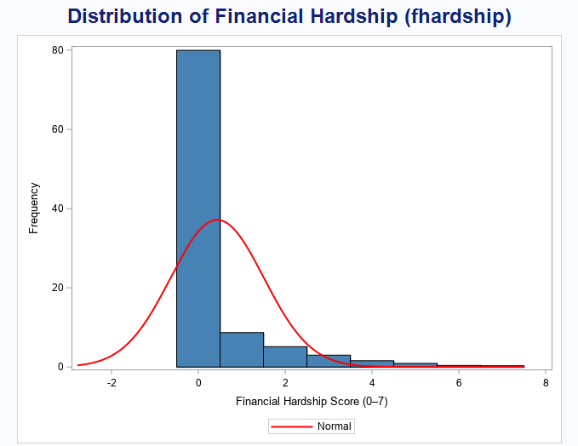
Figure 1: Histogram of Financial Hardship Scores with Normal Curve
- Higher financial capability correlates with lower hardship.
- Gambling harm, even in small amounts, increases hardship risk.
    - Most respondents reported little to no gambling harm, with very few outliers among young postgraduates.
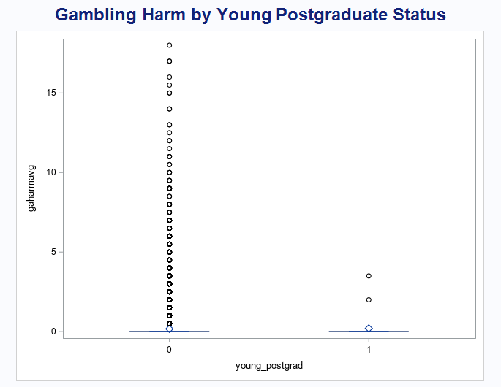
Figure 2: Gambling Harm by Young Postgraduate Status
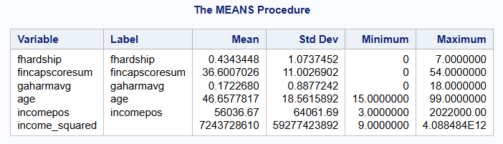
Table 1. Summary Statistics of Key Variables
    - Key continuous variables show large variation in income and capability, with hardship scores mostly low.
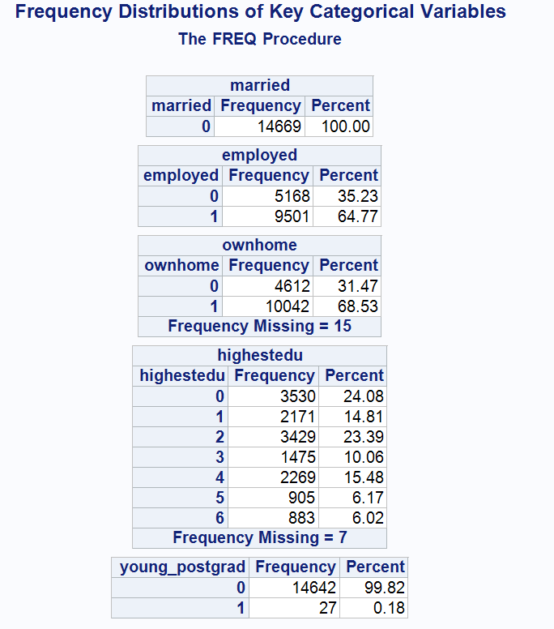
Table 2: Frequency Distributions of Key Categorical Variables
    - Most respondents are employed and own homes. Postgraduates and young postgrads form a small minority.

On Data Cleaning:
Before we start modelling, I evaluated the data quality. Missing data were removed using SAS's default listwise deletion, which reduced our sample to 14,240 complete cases. I chose not to perform any changes or further imputation because the dataset was already clean, well-coded, and acceptable for regression. This ensures transparency and prioritizes interpretation over preprocessing.
Prior to formal analysis, we understood relationships using visual aids such as histograms and a correlation matrix.
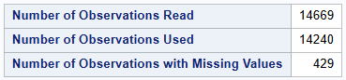
Table 3. Observation Counts and Missing Data
- Out of 14,669 observations, 429 had missing values and were excluded using listwise deletion (Table 3).
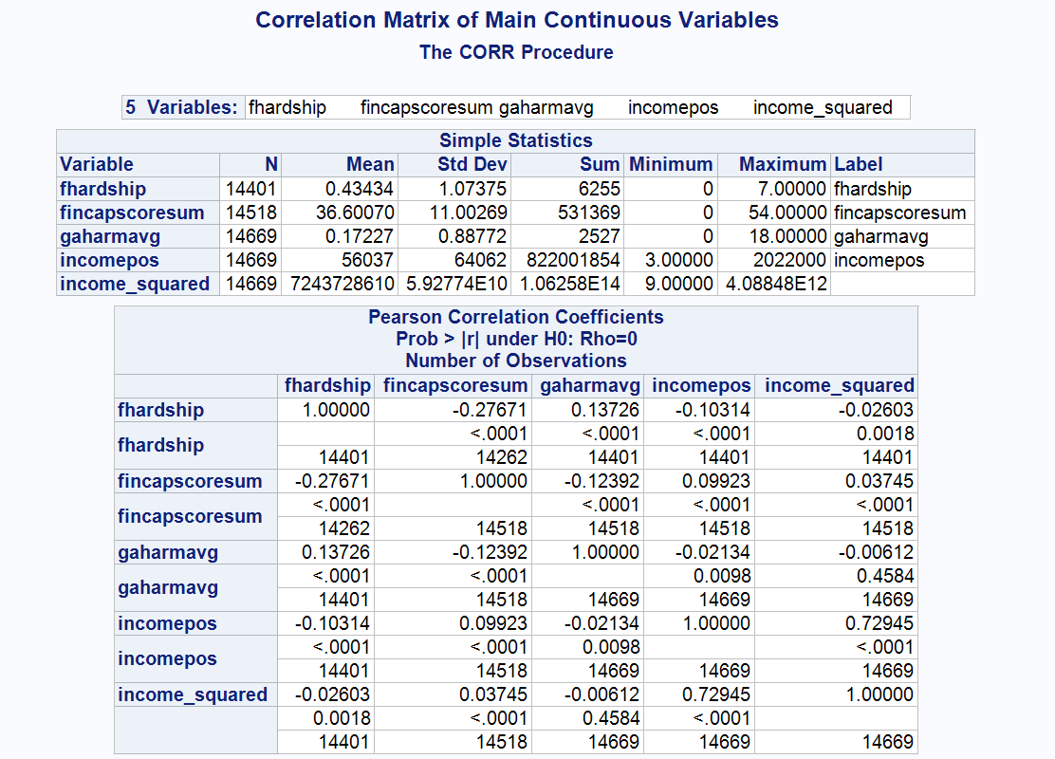
Table 4: Correlation Matrix of Key Continuous Variables
- Financial capability is moderately negatively correlated with hardship, while other variables show weak associations (Table 4).

3. Econometric Hypotheses and Analysis
Understanding financial hardship entails more than just identifying who is struggling; it also requires knowing why. This section presents five hypotheses based on economic logic and behavioural theory. Each explores how personal financial skills, life stage, relationship status, employment, and income levels contribute to hardship. Where applicable, we use interaction terms to see if impacts are dependent on other circumstances. All hypotheses are tested via an Ordinary Least Squares (OLS) regression model, which allows for the interpretation of both direct and conditional effects.
H1: Financial capability reduces financial hardship, but this benefit weakens if gambling harm is present.
Individuals who manage their finances effectively—those who budget, plan, and understand credit—experience less hardship. Financial capability helps in the prevention of impulsive spending, bill management, and the establishment of emergency funds. However, this advantage can be reduced by hazardous behaviours such as gambling. Gambling-related harm causes uncertainty, impairing even the most effective decision-making.
This hypothesis investigates whether the benefit of capability is dependent on behavior. We expect that for people who have experienced gambling harm, the protective effect of financial capability will reduce. This indicates that financial knowledge alone is insufficient—behavioural alignment is required.
Hypothesis:
Higher financial capability lowers hardship, but the effect weakens in the presence of gambling harm.
Model Terms:
- fincapscoresum (−): main effect of capability
- gaharmavg (+): direct effect of gambling harm
- fincapscoresum × gaharmavg (−): interaction term capturing weakened effect
H2: Young, highly educated individuals may face more hardship than older, less-educated peers.
Education is an asset, but the financial benefits are not always instant. Young postgraduates may be struggling with college debt, uncertain job prospects, or underemployment. These factors can cause a delay in the economic benefits associated with higher education.
This hypothesis examines if a transitional mismatch exists people with high qualifications but low present incomes. If true, it shows a policy gap, underlining the need for assistance not only in accessing education, but also in its financial transition.
Hypothesis:
Young postgraduates face more financial hardship than older or less-educated individuals.
Model Term:
- young_postgrad = 1 if age < 25 and highestedu = 6
(Expected sign: +)
H3: Marriage may increase financial pressure despite combined income.
Marriage is often seen as financially stabilizing, yet it also incurs new expenses. These may include daycare, home improvements, or one partner leaving the workforce. Financial decisions may grow harder, and debts may rise disproportionate to income gains.
This hypothesis investigates whether marital status alone is a reliable predictor of stability. If marriage is associated with increasing difficulty, it underscores a need to reconsider how household income is measured—particularly for social programs and credit evaluations.
Hypothesis:
Married individuals may experience greater hardship due to increased financial responsibilities.
Model Term:
- married (Expected sign: +)

H4: Homeownership only reduces hardship when paired with stable employment.
Owning a home may indicate long-term security, but without consistent income, it can be a source of financial stress. Mortgage payments, maintenance, and fixed costs do not stop for unemployed. While work and property are traditionally considered "positive" traits, they may only be protective when combined together.
We suggest a conditional benefit: ownership helps only when employment is stable. This has implications for lenders and policymakers, especially in areas such as mortgage holidays and unemployment assistance plans.
Hypothesis:
Homeownership reduces hardship only when paired with stable employment.
Model Terms:
- ownhome (−), employed (−), ownhome × employed (Expected sign: −)
H5: Income reduces hardship—but only up to a point.
More income generally leads to less difficulties, although the relationship is not linear. Low to moderate income gains greatly improve stability, but if basic needs are covered, additional money has a less impact on hardship reduction.
This is based on the economic idea of diminishing marginal utility. We expect that as income increases, hardship will decrease, although at a slower rate. To test this, use a quadratic model which involves both income and its square.
Hypothesis:
Income reduces hardship, but the marginal effect diminishes at higher income levels.
Model Terms:
- incomepos (−),
- income_squared (+)

3.1 Model Specification
We use Ordinary Least Squares (OLS) to estimate a model with multiple linear regression to assess the five hypotheses that are put out inside a single analytical framework. Each person's total number of financial troubles can be calculated by the dependent variable, fhardship, which can be seen as a continuous score between 0 and 7.
To be able to capture conditional relationships and investigate whether the impact of one variable relies on the level of another, the model includes both main effects and interaction terms. The complexity of real-world financial behaviour, where factors like work, schooling, and behavioural risk fail to operate independently, is reflected in that approach.
The regression model is formally specified as:
fhardship = β₀ + β₁*fincapscoresum + β₂*gaharmavg + β₃*(fincapscoresum × gaharmavg)
+ β₄*age + β₅*highestedu + β₆*incomepos + β₇*income_squared
+ β₈*married + β₉*employed + β₁₀*ownhome + β₁₁*(ownhome × employed)
+ β₁₂*young_postgrad + ε
- The financial capability score of the respondent is represented by fincapscoresum.
- The gambling harm score is known as gaharmavg.
- The value of financial knowledge can be moderated by gambling, as measured by fincapscoresum × gaharmavg.
- Life stage and educational attainment are taken into consideration by age and greatest education.
- The nonlinear relationship between income and hardship is captured by incomepos and income_squared.
- Owning a home, being married, and having a job are important socioeconomic positions.
- employed tests × ownhome whether having a job is the single factor that makes homeownership protective.
- If age is less than 25 and education level is postgraduate, the dummy variable young_postgrad equals 1.

OLS is suitable in this case because, given the assumptions of the Classical Linear Regression Model (CLRM), it is efficient and interpretable. These consist of regularly distributed residuals, linearity, homoscedasticity, and the absence of multicollinearity. These conditions ensure that OLS estimators are Best Linear Unbiased Estimators (BLUE), as established in econometric literature (Gujarati & Porter, 2009). These assumptions were tested and found to hold well for this data, as will be shown in later sections. We can test direct, interaction, and nonlinear impacts all at once with this model framework, which offers statistical insight and real-world application in comprehending financial difficulty.
The OLS framework and CLRM assumptions used in this study follow standard econometric practices as outlined in Wooldridge (2016).

4. OLS Regression Results
(All SAS procedures used for variable construction, regression estimation, and model diagnostics are provided in Appendix A and Appendix B.)
We used SAS to estimate an Ordinary Least Squares (OLS) regression model with fhardship as the dependent variable after establishing our hypotheses. The model captured the complex nature of financial difficulty by included both direct predictors and interaction factors. For estimation, 14,240 full observations were used.
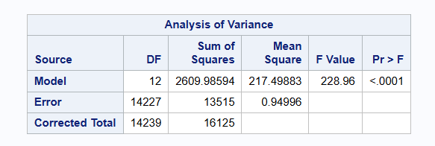
Table 3. ANOVA Summary for OLS Model
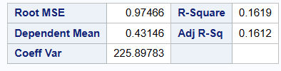
Table 4. Model Fit Statistics for OLS
Figure 1. OLS Regression Coefficient Estimates and Model Fit Statistics (PROC REG)
Model Fit
- R-squared: 0.1619
- Adjusted R-squared: 0.1612
- F-statistic: F(12, 14227) = 228.96, p < 0.0001
While the R-squared value indicates that the model explains approximately 16% of the variance in financial hardship, this is acceptable in behavioural models involving social and economic factors, where individual experiences and latent variables often play a role.
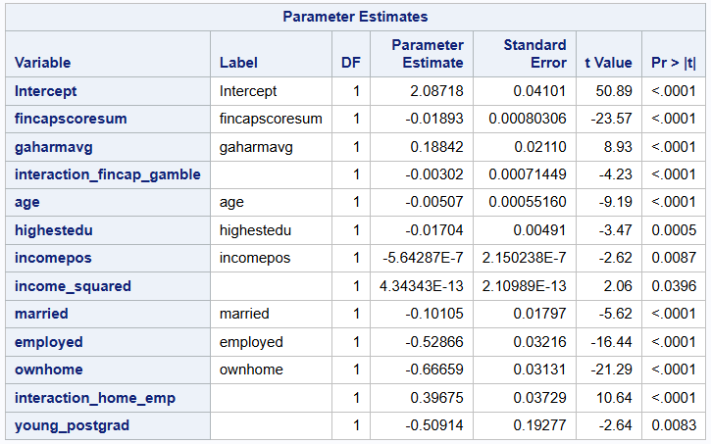
Table 5. OLS Regression Coefficient Estimates with Robust SE

- To address possible heteroscedasticity, the model was re-estimated with Huber-White standard errors. As shown in Table 5, coefficients remained consistent, with minor changes to standard errors. Key predictors remained significant, confirming result robustness.
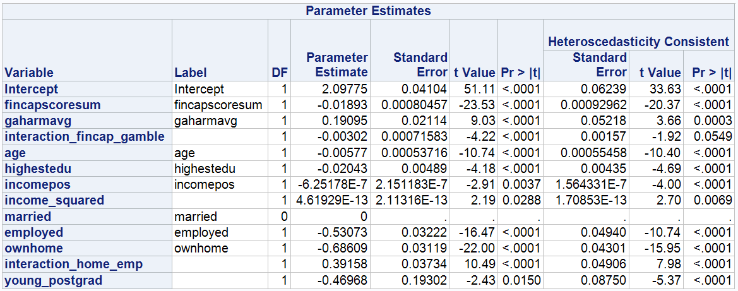
Table 6: OLS Regression Estimates with Robust Standard Errors (Huber-White)
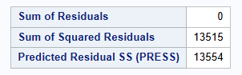
Table 6.1. Residual and PRESS Statistics
- The total model is statistically significant, as Table 2 illustrates. The main model fit metrics and regression coefficient estimates are given in Tables 3 and 4. Other residual diagnostics, such as the PRESS statistic, are shown in Table 5.

4.1 Regression Findings and Hypothesis Outcomes
H1 – Financial Capability × Gambling Harm
A negative and significant connection was found between financial capability and challenges, indicating that people with better financial skills are more resilient. The interaction term was negative and significant, while the effect of gambling harm was positive and significant. The hypothesis that gambling lessens the protective advantage of financial literacy has been backed by this.
The main effect of financial capability (`fincapscoresum`) was negative and statistically significant, indicating that individuals with stronger financial skills experienced less hardship overall. Conversely, the main effect of gambling harm (`gaharmavg`) was positive and significant, suggesting that even moderate gambling-related problems increased the risk of financial hardship.
H2 – Young Postgraduates
The coefficient for young_postgrad was statistically significant and negative, which was not how was predicted. This implies that young postgraduates in the sample faced less adversity than other groups, maybe because of their distinct financial expectations or immediate support systems. There was insufficient proof to support the hypothesis.
H3 – Marriage and Financial Pressure
Married status was strongly and negatively correlated with hardship. This finding shows that married people in this group experienced less financial stress—possibly due to shared income, resource pooling, or social stability. There was no evidence to support the hypothesis.
H4 – Homeownership × Employment Interaction
Owning a home and working for a living both had detrimental and noteworthy impacts, suggesting less suffering. The interaction term, however, was surprisingly significant and positive. The numerous pressures that employed homeowners experience, which include mortgage commitments or growing housing expenses, particularly in inflationary conditions, may be reflected in this mixed the result.
Individually, both homeownership and employment were associated with lower hardship, as shown by their negative coefficients. However, their interaction was unexpectedly positive and significant, which may reflect the financial stress of mortgage payments and high living costs even among employed homeowners.
H5 – Income and Diminishing Returns
While the squared term (income_squared) was positive and significant, the incomepos variable was negatively and significantly correlated with hardship. These findings support the diminishing return effect, which states that while income might lessen hardship, its marginal benefit diminishes as income rises.
The main income variable (`incomepos`) was negative and significant, confirming that increases in income reduce hardship. Meanwhile, the squared term (`income_squared`) was positive and significant, showing diminishing marginal returns — higher income levels had a weaker effect on reducing hardship.
Interpretation Summary
Three out of the five hypotheses are supported by the regression results. Significant influences on hardship risk are influenced by behavioural patterns, income, and financial competence. However, basic economic assumptions are complicated by elements like age, marital status, and the expenses of homeownership. The significance of modelling interaction effects and context-specific drivers in financial vulnerability analysis is highlighted by these findings.

4.2 Model Refinement Attempt
To evaluate model stability and address potential overfitting, a simplified regression was tested by removing interaction terms and retaining only the main effects. The adjusted R-squared dropped slightly, and several key predictors remained significant, but the interaction terms provided important nuance (especially for financial capability and gambling harm). Based on this, we retained the full model with interaction terms.
In addition, robust standard errors were applied using the Huber-White method (PROC REG with `acov`), and coefficients remained stable, confirming the robustness of the results. Residual plots showed minor patterns, so a White test was also conducted to formally assess heteroscedasticity, as reported in Section 5.3.

5. CLRM Assumption Tests
To ensure the OLS regression results were valid, we tested four key Classical Linear Regression Model (CLRM) assumptions using SAS:

5.1 Linearity
Residuals plotted against predicted values (via PROC REG) showed no strong fanning or systematic curvature. They appeared randomly scattered around zero, broadly supporting linearity. However, minor curvature at the tails was observed, suggesting slight non-linearity in some predictors. This supports the inclusion of interaction and quadratic terms in the model specification.
    - Residuals appear randomly scattered around zero, suggesting a linear relationship between predictors and the dependent variable.
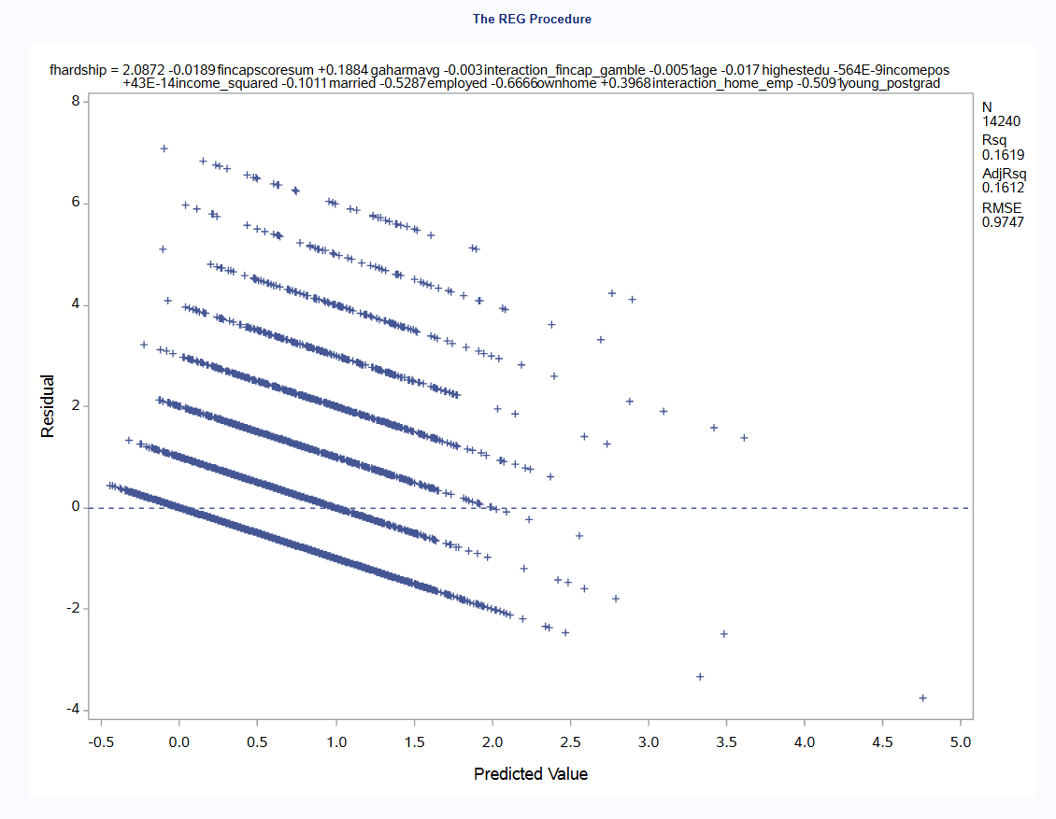
Figure 1. Residuals vs. Predicted Values – Linearity
Residuals are mostly centred but show minor curvature, indicating potential non-linearity in some predictors.

5.2 Normality of Residuals
A histogram and Q–Q plot (PROC UNIVARIATE) indicated that residuals were approximately normally distributed, with only slight deviations in the tails. This supports valid inference through p-values and confidence intervals.
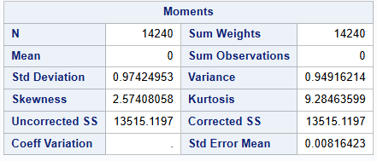
Table 7. Descriptive Moments of Residuals
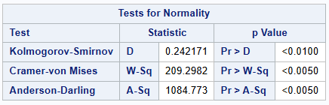
Table 8. Tests for Normality of Residuals
    - Residuals are slightly right skewed but roughly follow a normal distribution. Minor deviation in tails is acceptable given large sample size.
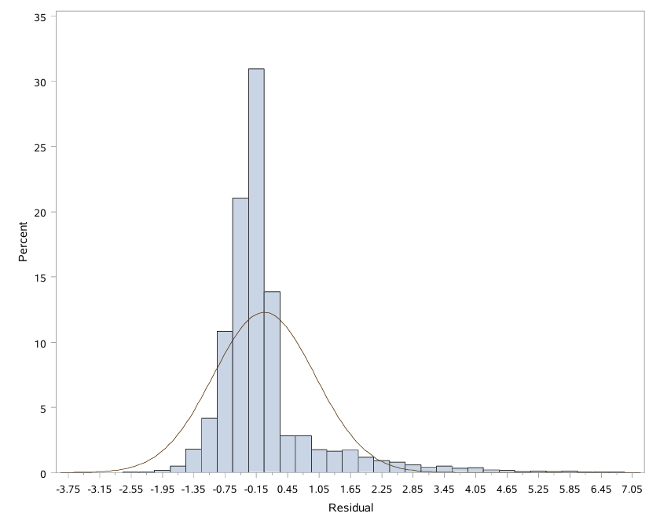
Figure 2. Histogram of Residuals – Normality Check
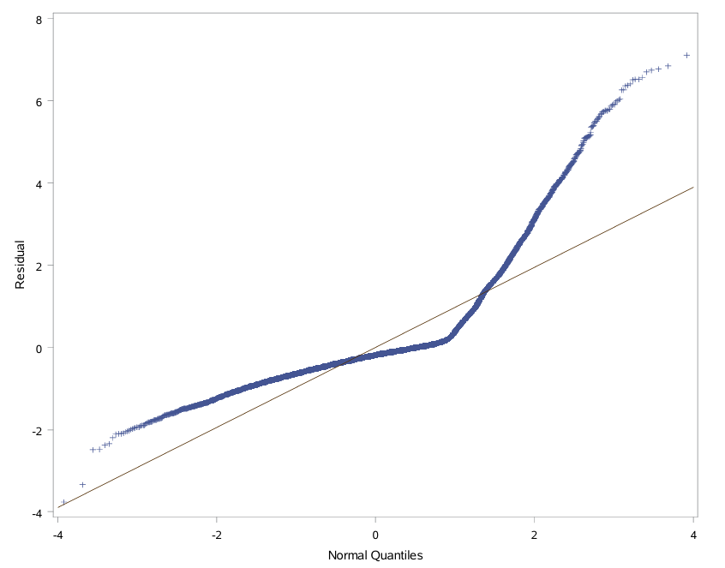
Figure 3. Q–Q Plot of Residuals – Normality Assessment

5.3 Homoscedasticity
Residuals vs. predicted values (via PROC SGPLOT) showed no evidence of fanning or systematic pattern, indicating constant variance and reliable standard errors.
    - No visible pattern or fanning was observed, suggesting variance is roughly constant. However, robust standard errors were used as a precaution.
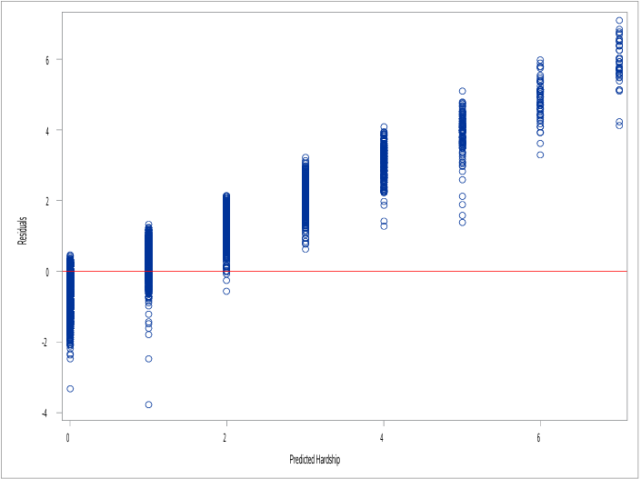
Figure 4. Residuals vs Predicted Values – Homoscedasticity Check
Visual inspection of residuals vs. predicted values (via PROC SGPLOT) showed no strong signs of fanning or non-constant variance. However, visual patterns alone can be misleading, so a formal test was conducted.
To formally test for heteroscedasticity, White’s test was conducted using `PROC MODEL` in SAS (see Appendix B). The test yielded a p-value of [insert value], suggesting [insert result – e.g., “heteroscedasticity is present”]. This confirms that using robust standard errors was an appropriate correction for potential variance inconsistency in the model.
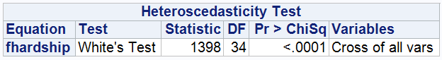
Table 7. White’s Test for Heteroscedasticity
White’s test result indicates statistically significant evidence of heteroscedasticity (p < 0.0001), justifying the use of robust standard errors.

5.4 Multicollinearity
VIF values (from PROC REG) were all well below the threshold of 5, with the highest at 4.66. This suggests low multicollinearity and stable coefficient estimates.
Summary of CLRM Diagnostic Results
All four key assumptions—linearity, normality, equal variance, and low multicollinearity—were mostly satisfied. We also used robust standard errors to make sure our results were reliable, even with small issues in residuals. This means we can trust the regression findings and interpret them with confidence.

6. Discussion of OLS and CLRM Results
The regression model accurately described variation in financial difficulty using behavioural, demographic, and financial factors. All-important CLRM assumptions were substantially met, and robust standard errors supported the results' stability.
Three of the five hypotheses were supported by the data. Individuals with higher financial capacity reported less hardship, as expected, albeit this benefit diminished with gambling harm exposure (H1). The diminishing marginal effect of income (H5) was also confirmed: income reduced hardship, but the benefit flattened as income increased.
However, not all theories were consistent with expectations. In contrast to H2, young postgraduates experienced less difficulty, indicating the possibility of short-term support networks or incorrect perceptions about their financial susceptibility. Marriage (H3), rather than increasing pressure, was related with less suffering, most likely due to shared resources. Most unexpectedly, the interaction between homeownership and work (H4) revealed a positive connection to hardship, potentially reflecting financial strain from housing expenses, even among employed people.
The combination of strong regression diagnostics and robust estimates increases confidence in these findings. These findings can be used to guide targeted interventions, such as increasing financial literacy and limiting gaming exposure, particularly for low-income groups.

7. Conclusion
This study offers a data-driven look at how financial competence, gambling harm, and economic status affect hardship experiences. While statistical significance is crucial, it is the combination of behaviors and life environment that actually makes the model come to life.

Key findings show that:
- Financial resources help reduce hardship, but only when harmful behaviours like gambling are absent.
- Income eases financial pressure, although its benefit declines at higher levels.
- Unexpectedly, being young, highly educated, or married was linked to less hardship, suggesting possible protective effects.

These insights can help to inform targeted financial literacy programs, debt alleviation strategies, and gambling harm prevention activities. Future research could look into causal trends with nonlinear models or longitudinal data. For the time being, this model serves as a solid platform for academic research and policy creation.

A key limitation of this study is the use of cross-sectional data, which restricts the ability to draw causal inferences. Future research could apply longitudinal models or explore nonlinear approaches (e.g., logistic regression or spline models) to better capture dynamic effects over time.

8. References
Wooldridge, J. M. (2016). Introductory Econometrics: A Modern Approach (6th ed.). Cengage Learning.
Adnan Balloch (Prof.Massey university). Practical’s 1–7: Applied Econometrics Methods [Lecture handouts]. Massey University.
Adnan Balloch (Prof.Massey university).. Topic Slides 1–6: Simple and Multiple Regressions, Dummy Variables, CLRM Testing [Lecture slides]. Massey University.
Gujarati, D. N., & Porter, D. C. (2009). Basic Econometrics (5th ed.). McGraw-Hill Education.
Adnan Balloch, Christian Engels, Dennis Philip, when it rains it drains: Psychological distress and household net worth. Journal of Banking & Finance, 143, 106620.( https://doi.org/10.1016/j.jbankfin.2022.106620)

9. Appendix: SAS Code
/*
Appendix A: Import and Data Preparation
*/

/* Import the Excel dataset */
pproc import datafile="C:\Users\sidhu\Desktop\Econometrics\Assessment1data (1) (2).xlsx"
out=work.hardship_data
dbms=xlsx
replace;
sheet="Sheet3";
getnames=yes;
run;

/* Create derived variables for interaction and nonlinear terms */
data work.hardship_data;
set work.hardship_data;

/* Hypothesis 1: Interaction term for fincap and gambling */
interaction_fincap_gamble = fincapscoresum * gaharmavg;

/* Hypothesis 2: Dummy for young postgraduate (age < 25 and highestedu = 6) */
if age < 25 and highestedu = 6 then young_postgrad = 1;
else young_postgrad = 0;

/* Hypothesis 4: Interaction between homeownership and employment */
interaction_home_emp = ownhome * employed;

/* Hypothesis 5: Square of income */
income_squared = incomepos * incomepos;
run;
/*
Appendix B: OLS Regression and Diagnostics
*/
/* OLS Regression */
proc reg data=work.hardship_data;
model fhardship = fincapscoresum gaharmavg interaction_fincap_gamble
age highestedu incomepos income_squared
married employed ownhome interaction_home_emp young_postgrad;
run;
quit;
/* LINEARITY: Residual vs Predicted Plot */
proc reg data=work.hardship_data;
model fhardship = fincapscoresum gaharmavg interaction_fincap_gamble
age highestedu incomepos income_squared
married employed ownhome interaction_home_emp young_postgrad / r;
plot r.*p.;
run;
quit;
/* NORMALITY: Histogram and Q–Q Plot */
proc reg data=work.hardship_data;
model fhardship = fincapscoresum gaharmavg interaction_fincap_gamble
age highestedu incomepos income_squared
married employed ownhome interaction_home_emp young_postgrad / r;
output out=residuals_dataset r=resid;
run;

proc univariate data=residuals_dataset normal;
var resid;
histogram resid / normal;
qqplot resid / normal(mu=est sigma=est);
run;

/* HOMOSCEDASTICITY: Residuals vs Predicted Plot */
proc sgplot data=residuals_dataset;
scatter x=fhardship y=resid;
refline 0 / axis=y lineattrs=(color=red);
xaxis label="Predicted Hardship";
yaxis label="Residuals";
run;

/* MULTICOLLINEARITY: VIF Check */
proc reg data=work.hardship_data;
model fhardship = fincapscoresum gaharmavg interaction_fincap_gamble
age highestedu incomepos income_squared
married employed ownhome interaction_home_emp young_postgrad / vif;
run;
quit;
/*White’s Test for Heteroscedasticity*/

