**RESULTS –**

1. Linear Regression –



1. Decision Tree

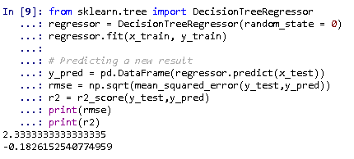

1. Random Forest

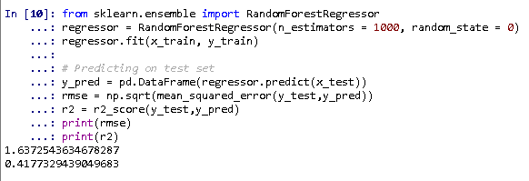

1. Polynomial Regression

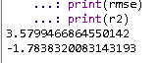

1. MLP Classifier –

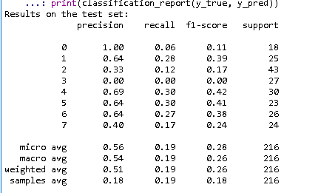

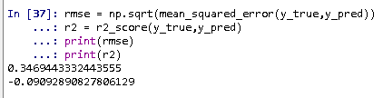

1. SVM without tuning

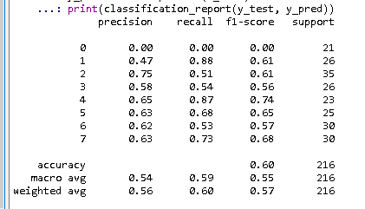

1. SVM with tuning

