EmployeeInfo Table:

EmpID | EmpFname | EmpLname | Department | Project | Address | DOB | Gender
1 | Sanjay | Mehra | HR | P1 | Hyderabad(HYD) | 01/12/1976 | M
2 | Ananya | Mishra | Admin | P2 | Delhi(DEL) | 02/05/1968 | F
3 | Rohan | Diwan | Account | P3 | Mumbai(BOM) | 01/01/1980 | M
4 | Sonia | Kulkarni | HR | P1 | Hyderabad(HYD) | 02/05/1992 | F
5 | Ankit | Kapoor | Admin | P2 | Delhi(DEL) | 03/07/1994 | M

CREATE TABLE IF NOT EXISTS public."EmployeeInfo"
(
"EmpID" integer NOT NULL,
"EmpFname" text COLLATE pg_catalog."default",
"EmpLname" text COLLATE pg_catalog."default",
"Department" text COLLATE pg_catalog."default",
"Address" character varying COLLATE pg_catalog."default",
"DOB" date,
"Gender" "char",
"Project" text COLLATE pg_catalog."default",
CONSTRAINT "EmployeeInfo_pkey" PRIMARY KEY ("EmpID")
)

TABLESPACE pg_default;

ALTER TABLE IF EXISTS public."EmployeeInfo"
OWNER to siddharth;

EmployeePosition Table:

EmpID | EmpPosition | DateOfJoining | Salary
1 | Manager | 01/05/2022 | 500000
2 | Executive | 02/05/2022 | 75000
3 | Manager | 01/05/2022 | 90000
4 | Lead | 02/05/2022 | 85000
5 | Executive | 01/05/2022 | 300000

CREATE TABLE IF NOT EXISTS public."EmployeePosition"
(
"EmpID" integer NOT NULL,
"EmpPosition" text COLLATE pg_catalog."default",
"DateOfJoining" date,
"Salary" integer,
CONSTRAINT "EmployeePosition_pkey" PRIMARY KEY ("EmpID")
)

TABLESPACE pg_default;

ALTER TABLE IF EXISTS public."EmployeePosition"
OWNER to siddharth;

INSERT INTO "EmployeePosition"(
"EmpID", "EmpPosition", "DateOfJoining", "Salary")
VALUES (5, 'Executive','01/05/2022',300000);

Please find below questions and try to write queries for same.

SET SEARCH_PATH TO public;
SHOW search_path;

-- 1. Write a query to fetch the number of employees working in the department ‘Admin’

Select count("EmpID") from "EmployeeInfo"
where "Department"= 'Admin';
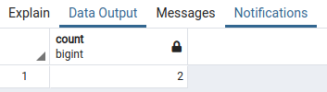

-- 2. Write a query to retrieve the first four characters of EmpLname from the EmployeeInfo table.

Select LEFT("EmpLname",4) from "EmployeeInfo";
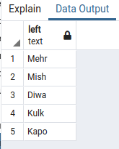

-- 3. Write q query to find all the employees whose salary is between 50000 to 100000.

select CONCAT("EmpFname",' ',"EmpLname") AS name from "EmployeeInfo"
where "EmpID" in (
select "EmpID" from "EmployeePosition"
where "Salary" between 50000 and 100000);
-- where 50000 < "Salary" and "Salary" < 100000 );
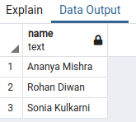

-- 4. Write a query to find the names of employees that begin with ‘S’

select CONCAT("EmpFname",' ',"EmpLname") AS name from "EmployeeInfo"
where "EmpFname" like 'S%';

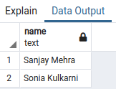

-- 5. Write a query to fetch top N records order by salary. (ex. top 5 records)

select * from "EmployeePosition"
order by "Salary"
limit 5 ;
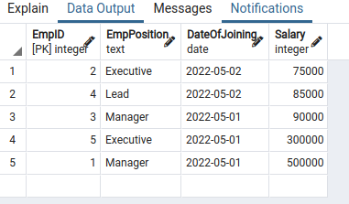

-- 6. Write a query to fetch details of all employees excluding the employees with first names, “Sanjay” and “Sonia” from the EmployeeInfo table.

Select * from "EmployeeInfo"
where "EmpFname" not in ('Sanjay','Sonia');
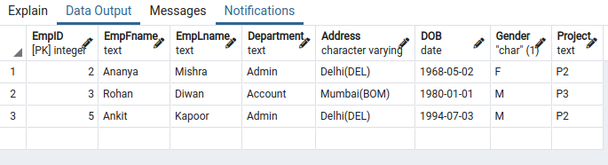

-- 7 .Write a query to fetch the department-wise count of employees sorted by department’s count in ascending order.

Select "Department",count("Department") from "EmployeeInfo"
group by "Department"
order by count("Department");

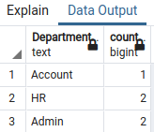

-- select * from "EmployeeInfo";

