WEB DEVELOPMENT
PROJECT REPORT
Shopping Website • FESTORA 2026 • BookNest Digital Library

Submitted by: Siddhartha venkat
Branch: CSE (AI & ML)
Technology: HTML5 and CSS3
Academic Year: 2026

A combined report for three front-end website projects.

CONTENTS
- 1. General Introduction
- 2. Common Aim and Objectives
- 3. Project 1 — Shopping Website (ShopEase)
- 4. Project 2 — FESTORA 2026 College Fest Website
- 5. Project 3 — BookNest Digital Library
- 6. Overall Conclusion
- 7. Screenshot Checklist

1. GENERAL INTRODUCTION
This report describes three front-end web development projects: a shopping website, a college fest website, and a digital library website. The projects use HTML to organize page content and CSS to style the pages. They demonstrate website navigation, structured sections, cards, tables or product displays, visual design, and responsive layouts. Screenshot spaces are included so the final browser outputs can be added before submission.

2. COMMON AIM AND OBJECTIVES

Aim
To design and develop clear, attractive, and responsive website interfaces using HTML5 and CSS3.

Objectives
- Practice structuring web pages with HTML elements.
- Apply CSS styling, layout techniques, colors, spacing, and typography.
- Create navigation links and organized website sections.
- Present information in cards, lists, tables, and banners where appropriate.
- Use responsive design techniques to support different screen sizes.
- Capture browser screenshots to demonstrate the output of each project.

Common Technologies
- HTML5 — defines the content and structure of each web page.
- CSS3 — controls visual styling, layout, colors, typography, and responsive behavior.
- Web browser — displays and tests the website output.
- Visual Studio Code or another text editor — used to create and edit the source files.

3. PROJECT 1 — SHOPPING WEBSITE (SHOPEASE)

3.1 Introduction
ShopEase is an e-commerce website interface designed to present products in an organized shopping layout. The page styling includes sections such as an announcement bar, navigation bar, hero area, benefits, product categories, product grid, newsletter area, and footer. Product details can be displayed using cards with prices, discounts, ratings, and other sample information when included in the HTML.

3.2 Aim
To create an attractive online shopping interface using HTML and CSS.

3.3 Main Features
- Announcement bar for promotional messages.
- Navigation bar for moving between shopping sections.
- Hero section to introduce the store or current offers.
- Benefits section to highlight shopping advantages.
- Category cards to organize product types.
- Product grid to present products and sample pricing details.
- Newsletter section and footer for additional information.
- Responsive CSS layout for different screen sizes, where defined in the supplied styles.

3.4 Technologies Used
HTML5 and CSS3.

3.5 Procedure
- Save the shopping page HTML as index.html (or the filename used in your project).
- Save the corresponding stylesheet in the same folder and check that the HTML links to the correct CSS filename.
- Open the HTML file in a web browser.
- Check the navigation, product cards, and page layout.
- Capture a screenshot of the main output and paste it into the space below.

3.6 Output Screenshots
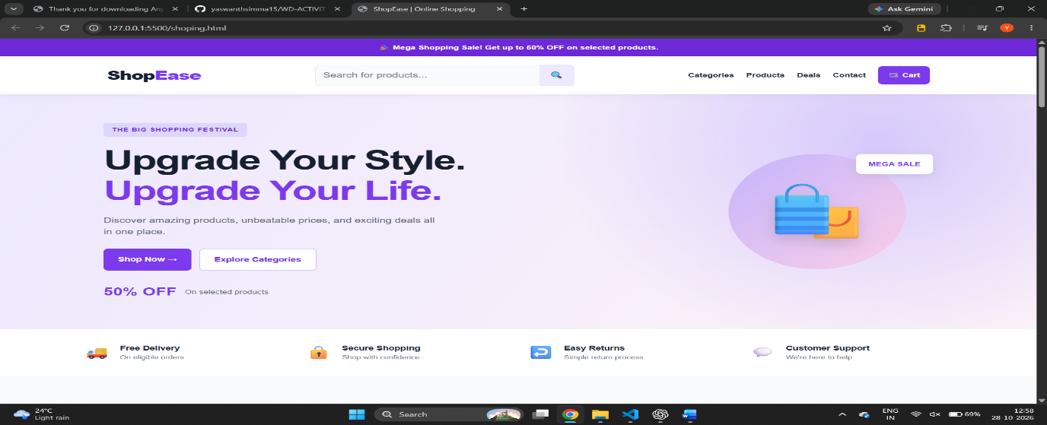.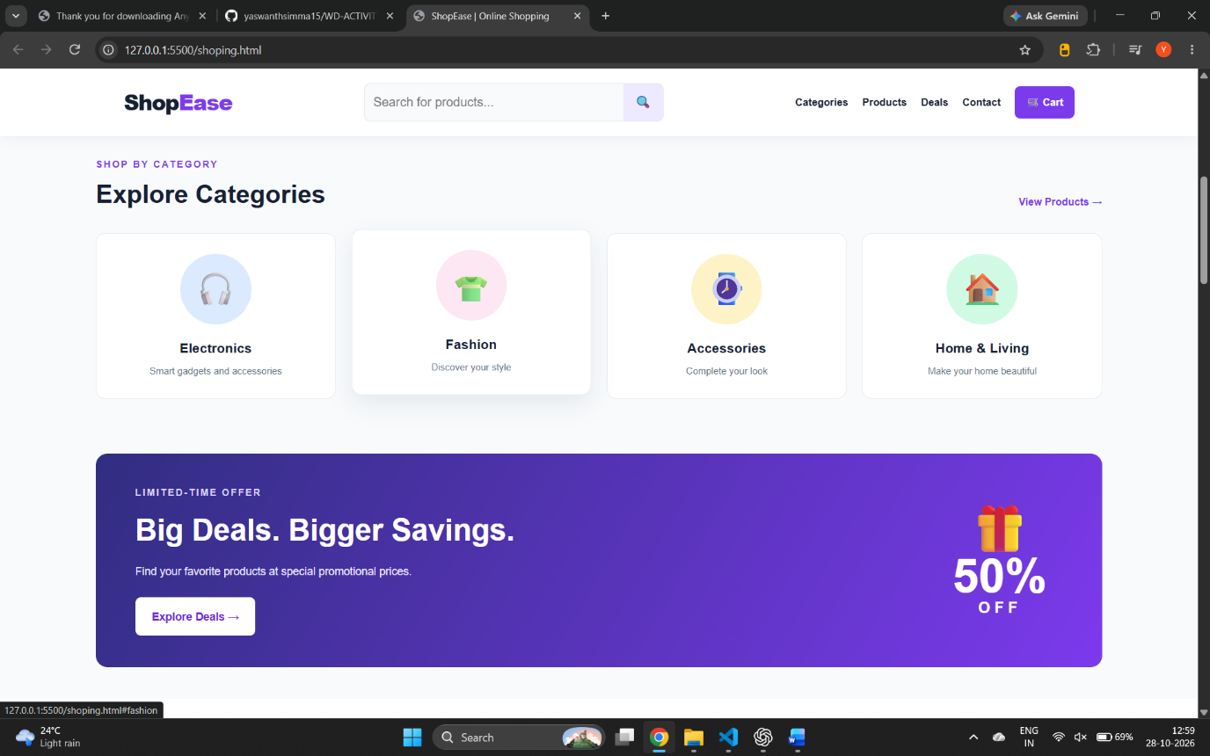

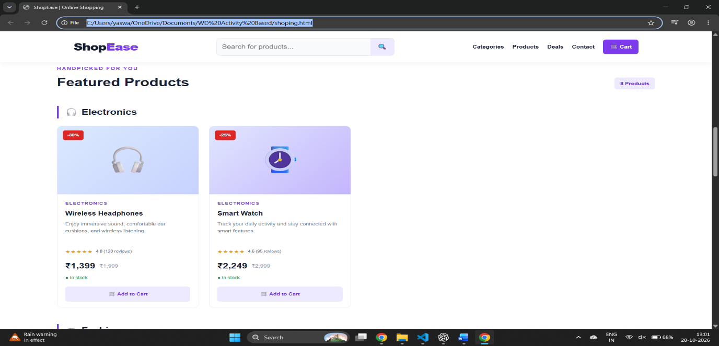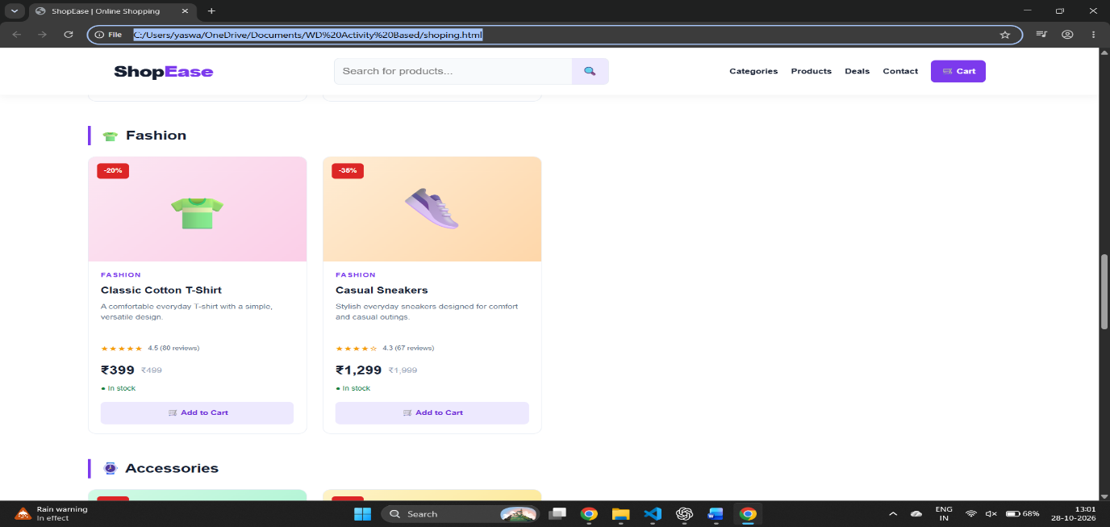

3.7 Result
The shopping website interface presents store information and products in a structured layout. Any real cart, checkout, account, or payment functionality depends on additional JavaScript and/or backend code.

4. PROJECT 2 — FESTORA 2026 COLLEGE FEST WEBSITE

4.1 Introduction
FESTORA 2026 is a college-fest website concept designed to introduce a campus event and organize its information for visitors. The page can present event branding, details, activities, schedules, registration information, and contact or footer sections according to the supplied HTML and CSS.

4.2 Aim
To build a visually engaging college fest website interface using HTML and CSS.

4.3 Main Features
- Fest name and introductory hero section.
- Navigation links to the main event sections.
- Event details and information blocks.
- Activity or event cards, where included in the source code.
- Registration or call-to-action section, where included.
- Consistent typography, colors, spacing, and visual styling.
- Responsive layout, if defined in the CSS.

4.4 Technologies Used
HTML5 and CSS3.

4.5 Procedure
- Save the FESTORA HTML file in the project folder.
- Save the associated CSS file and verify the stylesheet link.
- Open the HTML file in a browser.
- Check the hero section, event information, navigation, and other sections.
- Capture the main output and another section if needed, then paste the screenshots below.

4.6 Output Screenshots
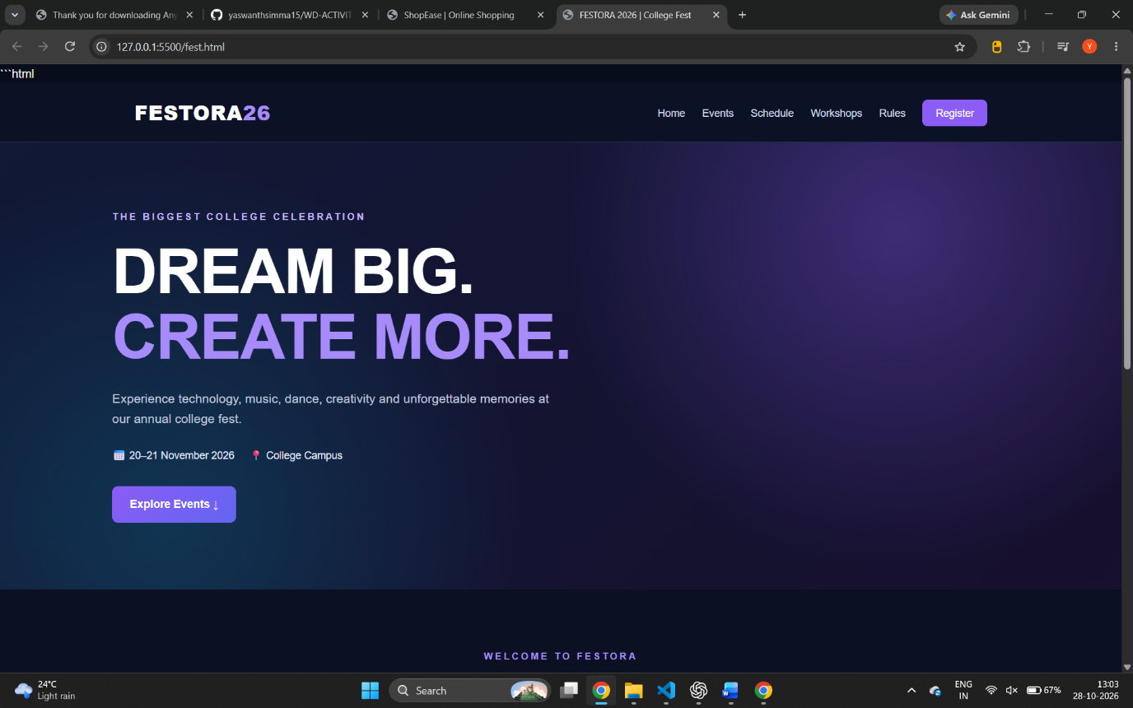
.

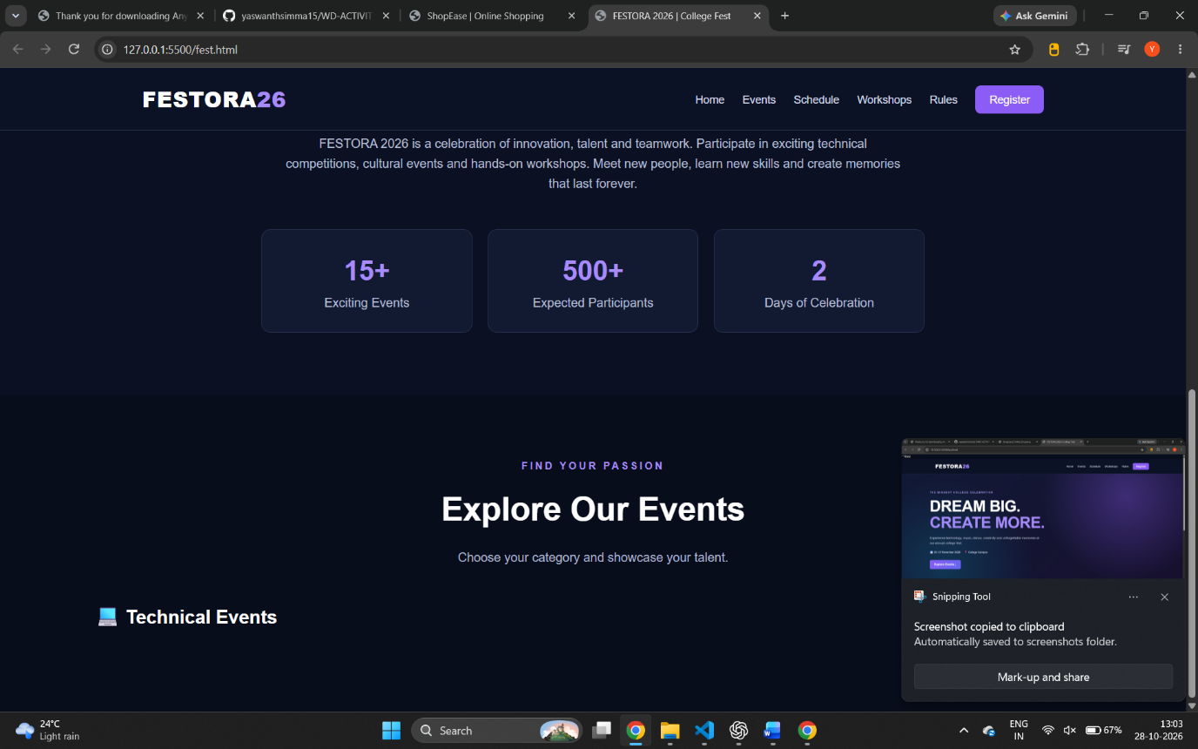

4.7 Result
The FESTORA 2026 interface provides a central web page for presenting college fest information. Any registration submission or event-management functionality requires a working form handler and/or backend.

5. PROJECT 3 — BOOKNEST DIGITAL LIBRARY

5.1 Introduction
BookNest is a digital library interface that organizes sample books into categories and featured-book cards. It also includes a search-and-filter form, a structured catalog table, library rules, a membership banner, and a footer. The page uses a teal and white color theme and CSS-based decorative book covers.

5.2 Aim
To design a user-friendly digital library website interface using HTML5 and CSS3.

5.3 Main Features
- Navigation links to Home, Categories, Books, Catalog, and Library Rules.
- Hero section with a short introduction and sample library statistics.
- Search field and dropdowns for category, availability, and sorting.
- Category cards for Programming, AI, Science, Literature, Business, and Self-Development.
- Six featured book cards with IDs, author labels, descriptions, and status labels.
- A catalog table with book ID, title, author, category, year, and status.
- Library rules cards and a membership banner.
- Responsive CSS, visible focus styles, and reduced-motion support.

5.4 Technologies Used
HTML5 and CSS3, including CSS Grid, Flexbox, transitions, and media queries.

5.5 Procedure
- Save the HTML code as index.html.
- Save the stylesheet as digital.css.
- Keep both files in the same folder and confirm that the HTML links to digital.css.
- Open index.html in a web browser.
- Check the categories, featured books, catalog table, and library rules.
- Capture the website output and paste the screenshots below.

5.6 Output Screenshots
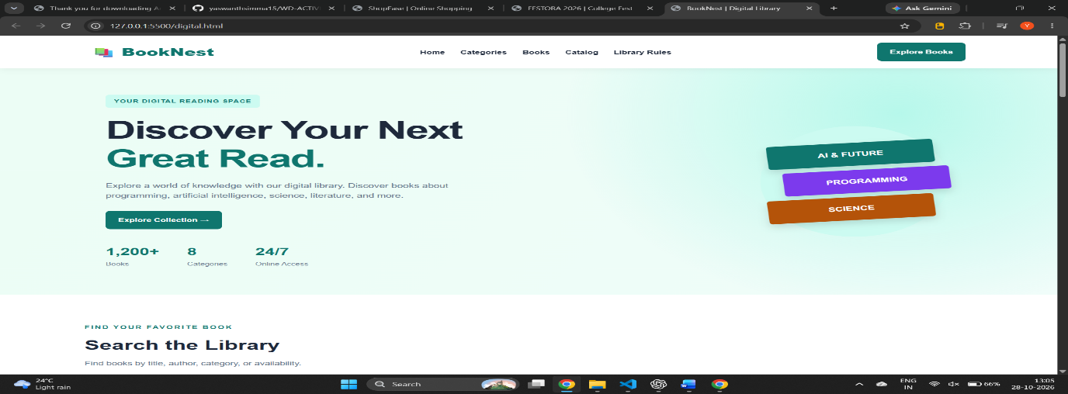.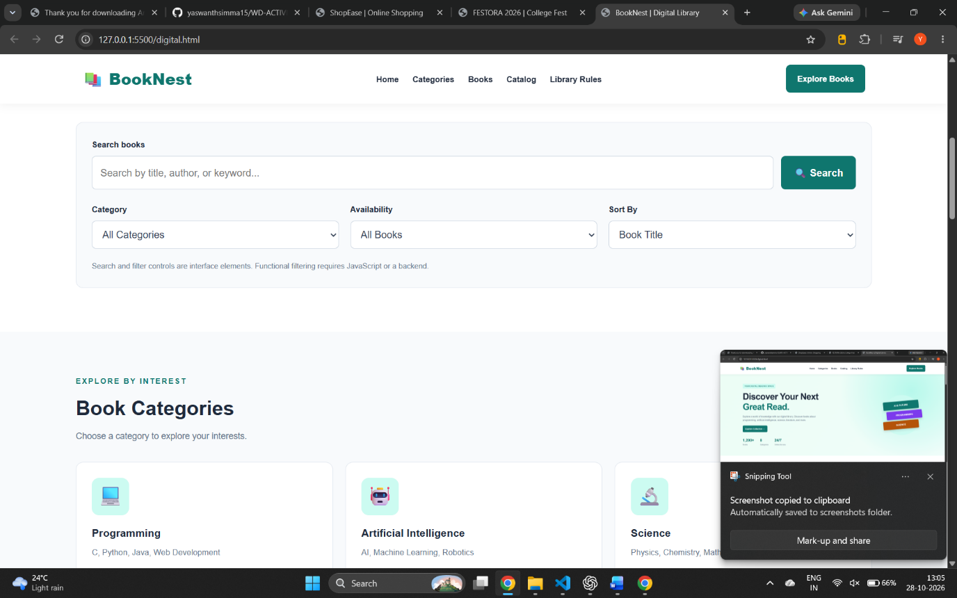

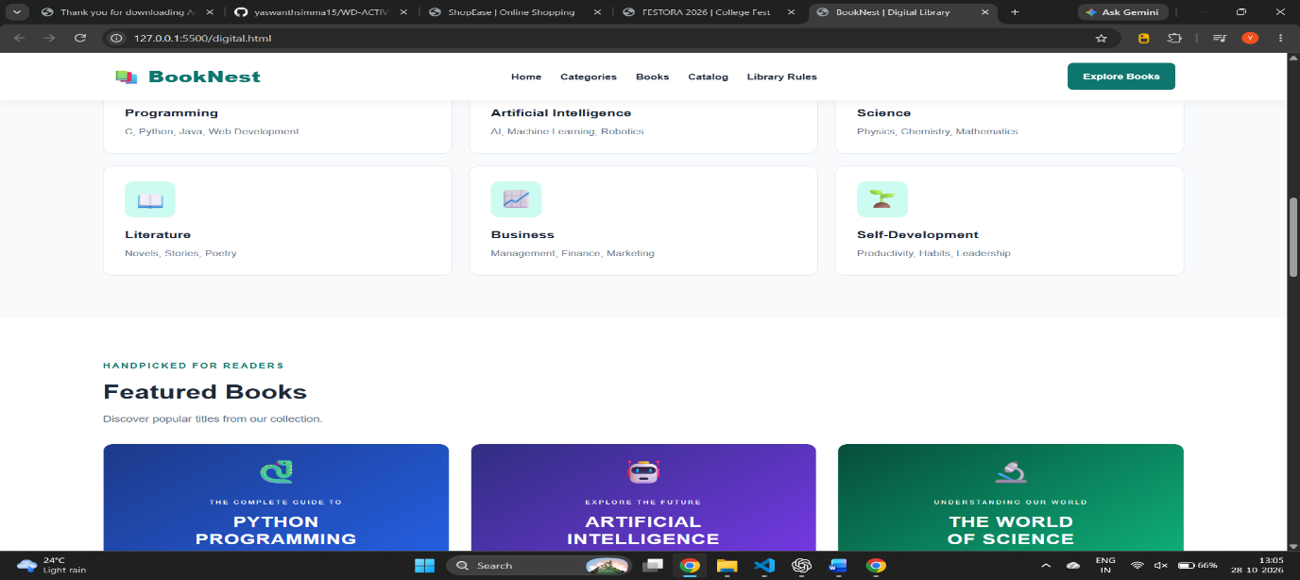

.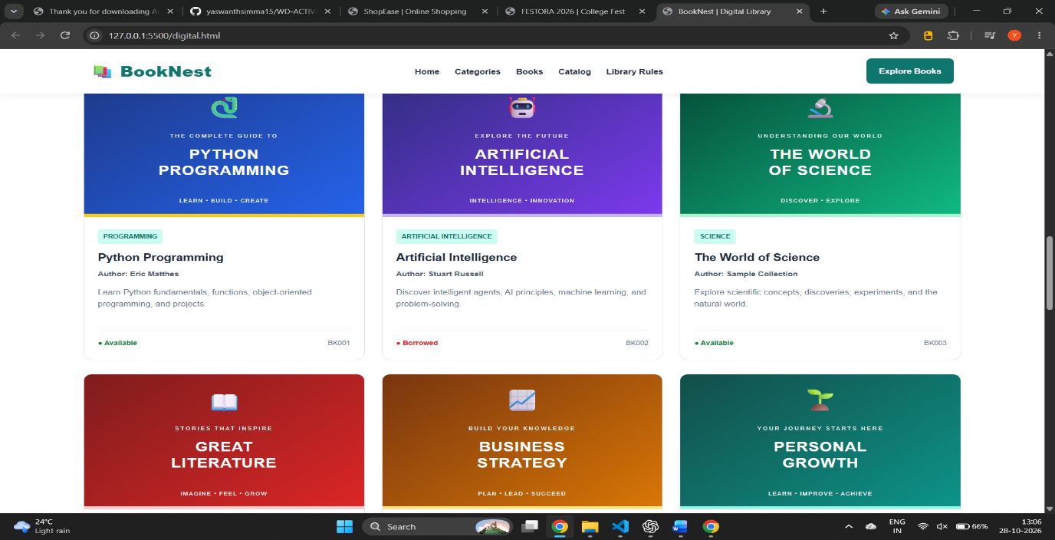

5.7 Result
The BookNest interface organizes sample library information in a readable and responsive layout. The search and filter controls are currently visual elements only; dynamic filtering, accounts, and borrowing require JavaScript and/or backend functionality.

6. OVERALL CONCLUSION
The three projects demonstrate different uses of front-end web development. ShopEase presents products in a shopping layout, FESTORA 2026 presents college event information, and BookNest organizes sample library records. Together, they provide practice with HTML structure, CSS styling, navigation, cards, tables, responsive layouts, and clear presentation of information. The screenshot spaces in this report should be filled with actual browser outputs before the document is submitted.

7. SCREENSHOT CHECKLIST
- ShopEase: capture the full home page or main visible output.
- ShopEase: capture the product grid or another important section.
- FESTORA 2026: capture the home page or hero section.
- FESTORA 2026: capture event details, activities, or registration section.
- BookNest: capture the hero section and navigation.
- BookNest: capture featured books and/or the catalog table.
- BookNest: capture the library rules or footer if required.
How to add screenshots: run each project in your browser, take a screenshot, click inside the corresponding grey placeholder area in Word, and insert the image. Resize it to fit the page. Remove the placeholder instructions after adding the screenshot.

