**Name: Kodari Siddhartha Yadav**

**Batch: 18R**

**Mobile No: 9346178913**

Task-1(Chess Board):

**Index.html:**

<!DOCTYPE html>

<html lang="en">

  <head>

    <meta charset="UTF-8" />

    <meta name="viewport" content="width=device-width, initial-scale=1.0" />

    <title>Chess Board</title>

    <link rel="stylesheet" href="./style.css" />

  </head>

  <body>

    <table>

      <tr class="a1">

        <td class="black"><img src="./images/black/elephant.png" alt=""></td>

        <td class="white"><img src="./images/black/horse.png" alt=""></td>

        <td class="black"><img src="./images/black/camel.png" alt=""></td>

        <td class="white"><img src="./images/black/queen.png" alt=""></td>

        <td class="black"><img src="./images/black/king.png" alt=""></td>

        <td class="white"><img src="./images/black/camel.png" alt=""></td>

        <td class="black"><img src="./images/black/horse.png" alt=""></td>

        <td class="white"><img src="./images/black/elephant.png" alt=""></td>

      </tr>

      <tr class="a2">

        <td class="white"><img src="./images/black/pawn.png" alt=""></td>

        <td class="black"><img src="./images/black/pawn.png" alt=""></td>

        <td class="white"><img src="./images/black/pawn.png" alt=""></td>

        <td class="black"><img src="./images/black/pawn.png" alt=""></td>

        <td class="white"><img src="./images/black/pawn.png" alt=""></td>

        <td class="black"><img src="./images/black/pawn.png" alt=""></td>

        <td class="white"><img src="./images/black/pawn.png" alt=""></td>

        <td class="black"><img src="./images/black/pawn.png" alt=""></td>

      </tr>

      <tr class="a3">

        <td class="black"></td>

        <td class="white"></td>

        <td class="black"></td>

        <td class="white"></td>

        <td class="black"></td>

        <td class="white"></td>

        <td class="black"></td>

        <td class="white"></td>

      </tr>

      <tr class="a4">

        <td class="white"></td>

        <td class="black"></td>

        <td class="white"></td>

        <td class="black"></td>

        <td class="white"></td>

        <td class="black"></td>

        <td class="white"></td>

        <td class="black"></td>

      </tr>

      <tr class="a5">

        <td class="black"></td>

        <td class="white"></td>

        <td class="black"></td>

        <td class="white"></td>

        <td class="black"></td>

        <td class="white"></td>

        <td class="black"></td>

        <td class="white"></td>

      </tr>

      <tr class="a6">

        <td class="white"></td>

        <td class="black"></td>

        <td class="white"></td>

        <td class="black"></td>

        <td class="white"></td>

        <td class="black"></td>

        <td class="white"></td>

        <td class="black"></td>

      </tr>

      <tr class="a7">

        <td class="black"><img src="./images/white/pawn.png" alt=""></td>

        <td class="white"><img src="./images/white/pawn.png" alt=""></td>

        <td class="black"><img src="./images/white/pawn.png" alt=""></td>

        <td class="white"><img src="./images/white/pawn.png" alt=""></td>

        <td class="black"><img src="./images/white/pawn.png" alt=""></td>

        <td class="white"><img src="./images/white/pawn.png" alt=""></td>

        <td class="black"><img src="./images/white/pawn.png" alt=""></td>

        <td class="white"><img src="./images/white/pawn.png" alt=""></td>

      </tr>

      <tr class="a8">

        <td class="white"><img src="./images/white/elephant.png" alt=""></td>

        <td class="black"><img src="./images/white/horse.png" alt=""></td>

        <td class="white"><img src="./images/white/camel.png" alt=""></td>

        <td class="black"><img src="./images/white/queen.png" alt=""></td>

        <td class="white"><img src="./images/white/king.png" alt=""></td>

        <td class="black"><img src="./images/white/camel.png" alt=""></td>

        <td class="white"><img src="./images/white/horse.png" alt=""></td>

        <td class="black"><img src="./images/white/elephant.png" alt=""></td>

      </tr>

    </table>

  </body>

</html>

**Style.css**

*{

    box-sizing: border-box;

}

body{

    margin: 0px 300px;

}

td{

    width:100px;

    height:100px;

    padding: 10px;

}

img{

    width:80px;

    height:80px;

}

table{

    border:30px solid yellow;

}

.a1>td:nth-child(odd){

    background-color: grey;

}

.a2>td:nth-child(even){

    background-color: grey;

}

.a3>td:nth-child(odd){

    background-color: grey;

}

.a4>td:nth-child(even){

    background-color: grey;

}

.a5>td:nth-child(odd){

    background-color: grey;

}

.a6>td:nth-child(even){

    background-color: grey;

}

.a7>td:nth-child(odd){

    background-color: grey;

}

.a8>td:nth-child(even){

    background-color: grey;

}

.a1>td:nth-child(even){

    background-color: white;

}

.a2>td:nth-child(odd){

    background-color: white;

}

.a3>td:nth-child(even){

    background-color: white;

}

.a4>td:nth-child(odd){

    background-color: white;

}

.a5>td:nth-child(even){

    background-color: white;

}

.a6>td:nth-child(odd){

    background-color: white;

}

.a7>td:nth-child(even){

    background-color: white;

}

.a8>td:nth-child(odd){

    background-color: white;

}

**Output:**

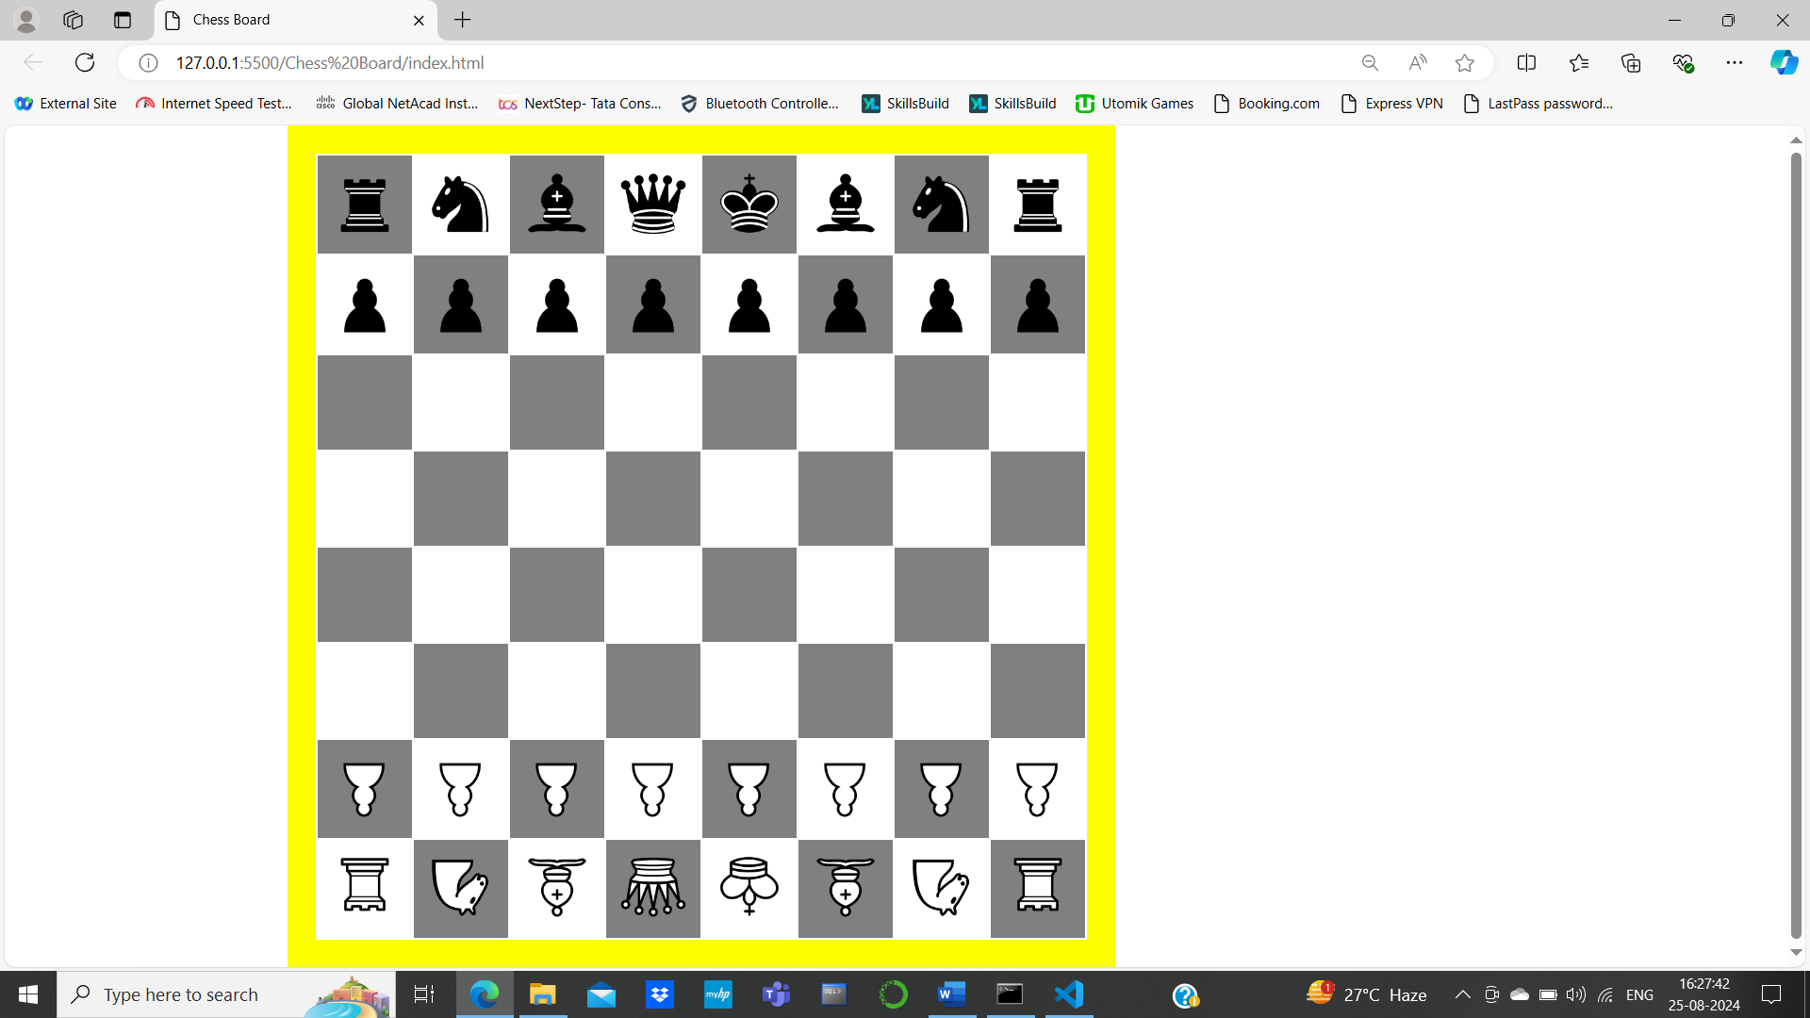

**Task-2(ham barge bar):**

**Index.html:**

<!DOCTYPE html>

<html lang="en">

  <head>

    <meta charset="UTF-8" />

    <meta name="viewport" content="width=device-width, initial-scale=1.0" />

    <title>Ham</title>

    <link rel="stylesheet" href="./style.css" />

  </head>

  <body>

    <div class="container"><img src="./images/ham.png" alt="" /></div>

    <div class="container1">

        <p>Breakfast</p>

        <p>Lunch</p>

        <p>Snacks</p>

        <p>Dinner</p>

    </div>

  </body>

</html>

**Style.css**

*{

    box-sizing: border-box;

}

body{

    margin: 0;

}

img{

    width:50px;

}

.container1{

    display: none;

}

.container:hover + .container1{

    display:block

}

**Output:** 