**Name: Kodari Siddhartha Yadav**

**Batch: 18R**

**Mobile No: 9346178913**

Task-1(Nav+position)

Index.html:

<!DOCTYPE html>

<html lang="en">

  <head>

    <meta charset="UTF-8" />

    <meta name="viewport" content="width=device-width, initial-scale=1.0" />

    <title>Ham</title>

    <link rel="stylesheet" href="./style.css" />

  </head>

  <body>

    <label for="checkbox"><img src="./images/ham.png" alt="Image"></label>

    <input type="checkbox" name="checkbox" id="checkbox">

    <div class="container">

      <a href="#">HOME</a>

      <a href="#">ABOUT</a>

      <a href="#">LOGIN</a>

      <a href="#">CONTACT</a>

      <a href="#">LOGOUT</a>

    </div>

  </body>

</html>

Style.css

*{

    box-sizing: border-box;

}

body{

    margin: 0;

}

img{

    width:50px;

}

a{

    display: block;

    border: 20px solid ;

    border-radius: 20px;

    font-size: 2.0rem;

    padding: 10px;

    width: 300px;

    text-align: center;

    border-collapse: separate;

    text-decoration-color: red;

    /* color: ; */

}

a:link{

    color: blueviolet;

}

.container{

    max-width: 0px;

    overflow: hidden;

    transition: 1.0s ease;

    position: absolute;

}

#checkbox:checked+.container{

    max-width: 300px;

}

input{

    display: none;

}

**Output**

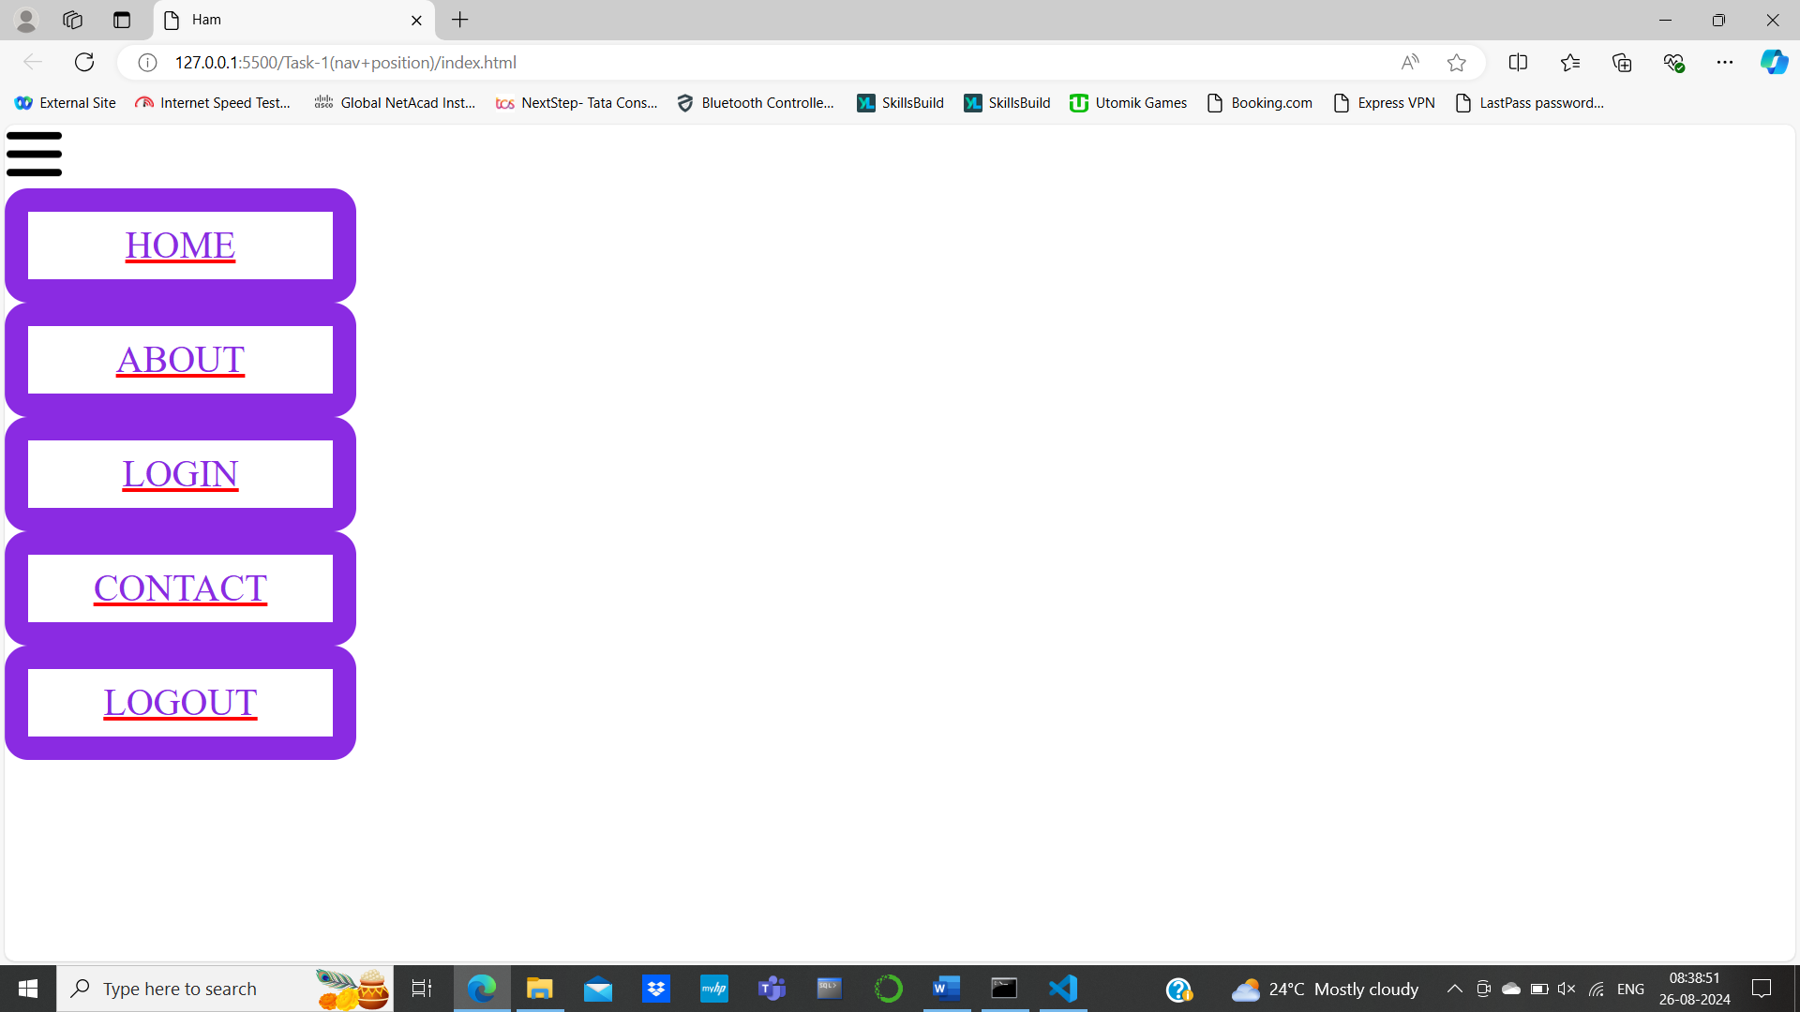

**Task-2(Trasitions)**

**Index.html**

<!DOCTYPE html>

<html lang="en">

<head>

    <meta charset="UTF-8">

    <meta name="viewport" content="width=device-width, initial-scale=1.0">

    <title>Transform</title>

    <link rel="stylesheet" href="./style.css">

</head>

<body>

    <div class="container">

        <div class="child1">

            <p class="a1">Translate</p>

            <p class="a2">Rotate</p>

            <p class="a3">Scale</p>

            <p class="a4">Skew</p>

            <div class="child2">

                <img class="img" src="./images/1.jpeg" alt="Konda">

            </div>

        </div>

    </div>

</body>

</html>

**Style.css**

*{

    box-sizing: border-box;

    font-family: sans-serif;

}

body{

    margin:0;

}

.container{

    display: flex;

    flex-direction: column;

    width:70vw;

    height: 70vh;

    transform: translate(25%,25%);

    border: 2px solid;

    justify-content: space-around;

    background-color: #eee;

}

.child1{

    display: flex;

    justify-content: space-around;

}

.child2{

    display: flex;

    justify-content: center;

}

p{

    width:150px;

    height: 70px;

    background-color: white;

    text-align: center;

    padding: 20px;

    color: black;

    outline:1px solid;

    border-radius: 30%;

    font-size: 1.3rem;

}

p:hover{

    background-color: pink;

    color: white;

    outline: 1px solid white;

    transition: 0.3s ease;

    transform: scale(1.05);

    cursor: pointer;

}

.child1 > .a1:hover ~ .child2 > .img {

    transform: translate(50px, 50px);

}

.child1 > .a2:hover ~ .child2 .img {

    transform: rotate(45deg);

}

.child1 > .a3:hover ~ .child2 .img {

    transform: scale(1.5);

}

.child1 > .a4:hover ~ .child2 .img {

    transform: skew(20deg, 10deg);

}

**Output:**

