**Name: Kodari Siddhartha Yadav**

**Batch: 18R**

**Mobile No: 9346178913**

Task-1(layout):

Index.html

<!DOCTYPE html>

<html lang="en">

<head>

    <meta charset="UTF-8">

    <meta name="viewport" content="width=device-width, initial-scale=1.0">

    <title>Grid</title>

    <link rel="stylesheet" href="./style.css">

</head>

<body>

    <div class="container">

        <div class="item1">item1</div>

        <div class="item2">item2</div>

        <div class="item3">item3</div>

        <div class="item4">item4</div>

        <div class="item5">item5</div>

        <div class="item6">item6</div>

        <div class="item7">item7</div>

        <div class="item8">item8</div>

    </div>

</body>

</html>

Style.css

*{

    box-sizing: border-box;

}

body{

    margin: 0px;

    padding: 0px;

    background-color: blueviolet;

}

.container{

    height: 100vh;

    display: grid;

    align-content: center;

    padding: 10px;

    color: white;

    gap: 10px;

    font-size: 2rem;

    font-weight: 600px;

}

.item1{

    background-color: green;

    grid-column: 1/2;

    grid-row: 1/4;

}

.item2{

    background-color: green;

    grid-column: 2/4;

}

.item3{

    background-color: red;

    grid-column: 4/5;

}

.item4{

    background-color: yellow;

    grid-column: 2/3;

    grid-row: 2/3;

}

.item5{

    background-color: red;

    grid-column: 3/4;

    grid-row: 2/3;

}

.item6{

    background-color: green;

    grid-row: 2/4;

    grid-column: 4/5;

}

.item7{

    background-color: red;

    grid-column: 2/3;

    grid-row: 3/4;

}

.item8{

    background-color: yellow;

    grid-column: 3/4;

    grid-row: 3/4;

}

Output

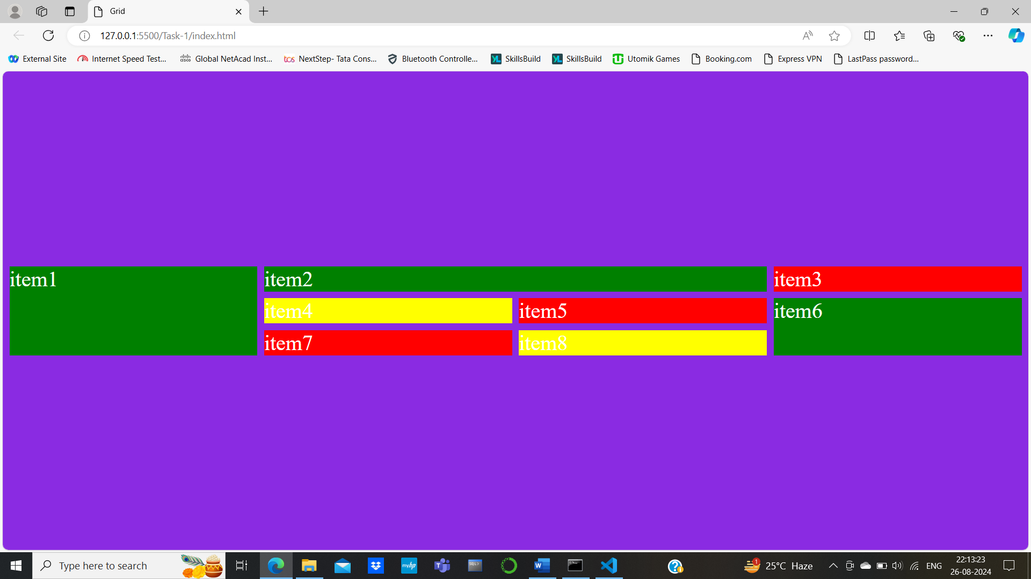

Task-2(template)

<!DOCTYPE html>

<html lang="en">

<head>

    <meta charset="UTF-8">

    <meta name="viewport" content="width=device-width, initial-scale=1.0">

    <title>Template</title>

    <link rel="stylesheet" href="./style.css">

</head>

<body>

    <header>

        <div><img src="./images/menu-svgrepo-com.png" alt="Menu" width="40px"></div>

        <div>My food</div>

        <div>Mail</div>

    </header>

    <div class="container">

        <div class="item1">

            <img src="./images/sandwich.jpg" alt="logo">

            <h2>The Perfect Sandwich, A Real NYC Classic</h2>

            <p>Lorem ipsum dolor sit amet consectetur.</p>

        </div>

        <div class="item2">

            <img src="./images/steak.jpg" alt="logo">

            <h2>Let Me Tell You About This Steak</h2>

            <p>Lorem ipsum dolor sit amet consectetur.</p>

        </div>

        <div class="item3">

            <img src="./images/cherries.jpg" alt="logo">

            <h2>Cherries, interrupted</h2>

            <p>Lorem ipsum dolor sit amet consectetur.</p>

        </div>

        <div class="item4">

            <img src="./images/wine.jpg" alt="logo">

            <h2>Once Again, Robust Wine and Vegetable Pasta</h2>

            <p>Lorem ipsum dolor sit amet consectetur.</p>

        </div>

        <div class="item5">

            <img src="./images/popsicle.jpg" alt="logo">

            <h2>All I Need Is a Popsicle</h2>

            <p>Lorem ipsum dolor sit amet consectetur.</p>

        </div>

        <div class="item6">

            <img src="./images/croissant.jpg" alt="logo">

            <h2>Salmon For Your Skin</h2>

            <p>Lorem ipsum dolor sit amet consectetur.</p>

        </div>

        <div class="item7">

            <img src="./images/7.jpg" alt="logo">

            <h2>The Perfect Sandwich, A Real Classic</h2>

            <p>Lorem ipsum dolor sit amet consectetur.</p>

        </div>

        <div class="item8">

            <img src="./images/croissant.jpg" alt="logo">

            <h2>Le French</h2>

            <p>Lorem ipsum dolor sit amet consectetur.</p>

        </div>

    </div>

</body>

</html>

Style.css

*{

    box-sizing: border-box;

}

body{

    margin: 0px;

}

header{

    height: 100px;

    display: flex;

    font-size: 1.5rem;

    color: black;

    justify-content: space-between;

}

.container{

    display: grid;

    grid-template-columns: repeat(4,1fr);

    gap: 10px;

}

h2{

    margin: 10px;

    text-align: center;

}

p{

    margin: 10px;

    text-align: center;

}

Output

