**Name: Kodari Siddhartha Yadav**

**Batch: 18R**

**Mobile No: 9346178913**

Task-1

Index.html

<!DOCTYPE html>

<html lang="en">

<head>

    <meta charset="UTF-8">

    <meta name="viewport" content="width=device-width, initial-scale=1.0">

    <title>Document</title>

    <link rel="stylesheet" href="./style.css">

</head>

<body>

<div class="container">

  <div class="image1"><img src="./images/1.avif" alt="logo"></div>

  <div class="image2"><img src="./images/2.avif" alt="logo"></div>

  <div class="image3"><img src="./images/3.avif" alt="logo"></div>

  <div class="image4"><img src="./images/4.avif" alt="logo"></div>

  <div class="image5"><img src="./images/5.avif" alt="logo"></div>

  <div class="image6"><img src="./images/6.avif" alt="logo"></div>

  <div class="image7"><img src="./images/7.avif" alt="logo"></div>

  <div class="image8"><img src="./images/8.avif" alt="logo"></div>

  <div class="image9"><img src="./images/9.avif" alt="logo"></div>

  <div class="image10"><img src="./images/10.avif" alt="logo"></div>

  <div class="image11"><img src="./images/11.avif" alt="lgog"></div>

  <div class="image12"><img src="./images/12.avif" alt="logo"></div>

  <div class="image13"><img src="./images/13.avif" alt="logo"></div>

  <div class="image14"><img src="./images/14.avif" alt="logo"></div>

  <div class="image15"><img src="./images/15.avif" alt="logo"></div>

  <div class="image16"><img src="./images/16.avif" alt="logo"></div>

  <div class="image17"><img src="./images/17.avif" alt="logo"></div>

  <div class="image18"><img src="./images/18.avif" alt="logo"></div>

  <div class="image19"><img src="./images/19.avif" alt="logo"></div>

</div>

</body>

</html>

Style.css

*{

  box-sizing: border-box;

}

html,body{

  width: 100%;

  height: 100%;

  margin: 0px;

  padding: 0px;

}

body{

  display: grid;

  place-content: center;

  text-align: center;

}

.container{

  display: grid;

  gap: 10px;

  padding: 10px;

  height: 100%;

  grid-template-columns: 17vmin 8vmin 5vmin 7vmin 10vmin 15vmin 15vmin;

  grid-template-rows: 4vmin 9vmin 15vmin 7vmin 13vmin 8vmin 5vmin;

  align-items: stretch;

  justify-items: stretch;

  background-color: black;

  margin: 20px solid;

  grid-template-areas:

  "a b b c d e e"

  "f g g g h e e"

  "f g g g i e e"

  "f j j j i k l"

  "m j j j n o l"

  "m j j j n p q"

  "r j j j n s q";

  animation: animate-columns 30s ease-in-out infinite alternate;

}

img{

  width: 100%;

  height: 100%;

}

.container> :nth-child(1){

  grid-area: a;

}

.container> :nth-child(2){

  grid-area: b;

}

.container> :nth-child(3){

  grid-area: c;

}

.container> :nth-child(4){

  grid-area: d;

}

.container> :nth-child(5){

  grid-area: e;

}

.container> :nth-child(6){

  grid-area: f;

}

.container> :nth-child(7){

  grid-area: g;

}

.container> :nth-child(8){

  grid-area: h;

}

.container> :nth-child(9){

  grid-area: i;

}

.container> :nth-child(10){

  grid-area: j;

}

.container> :nth-child(11){

  grid-area: k;

}

.container> :nth-child(12){

  grid-area: l;

}

.container> :nth-child(13){

  grid-area: m;

}

.container> :nth-child(14){

  grid-area: n;

}

.container> :nth-child(15){

  grid-area: o;

}

.container> :nth-child(16){

  grid-area: p;

}

.container> :nth-child(17){

  grid-area: q;

}

.container> :nth-child(18){

  grid-area: r;

}

.container> :nth-child(19){

  grid-area: s;

}

@keyframes animate-columns {

  0% {

    grid-template-columns: 17vmin 8vmin 5vmin 7vmin 10vmin 15vmin 15vmin;

    grid-template-rows: 4vmin 9vmin 15vmin 7vmin 13vmin 8vmin 5vmin;

  }

  25% {

    grid-template-columns: 10vmin 8vmin 15vmin 5vmin 7vmin 15vmin 17vmin;

    grid-template-rows: 15vmin 4vmin 7vmin 8vmin 5vmin 13vmin 9vmin;

  }

  50% {

    grid-template-columns: 15vmin 10vmin 17vmin 5vmin 7vmin 15vmin 8vmin;

    grid-template-rows: 4vmin 9vmin 5vmin 13vmin 7vmin 8vmin 15vmin;

  }

  75% {

    grid-template-columns: 8vmin 5vmin 7vmin 15vmin 17vmin 15vmin 10vmin;

    grid-template-rows: 13vmin 4vmin 15vmin 9vmin 5vmin 7vmin 8vmin;

  }

  100% {

    grid-template-columns: 10vmin 8vmin 5vmin 7vmin 15vmin 15vmin 17vmin;

    grid-template-rows: 4vmin 15vmin 9vmin 7vmin 8vmin 5vmin 13vmin;

  }

}

OUTPUT

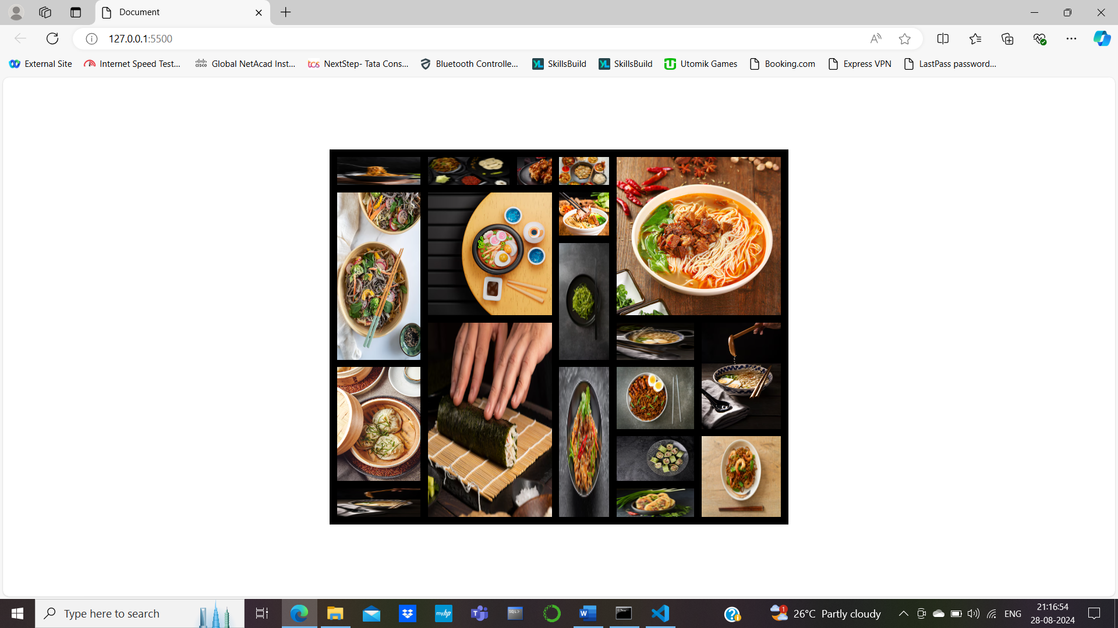

Task-2

Index.html

<!DOCTYPE html>

<html lang="en">

<head>

    <meta charset="UTF-8">

    <meta name="viewport" content="width=device-width, initial-scale=1.0">

    <title>Empty Container</title>

    <link rel="stylesheet" href="./style.css">

</head>

<body>

</body>

</html>

Style.css

body::before {

    content: "";

    display: block;

    width: 100%;

    height: 100px;

}

body::after {

    content: "";

    display: block;

    width: 100%;

    height: 50px;

}

body::before {

    background-color: blue;

}

body::after {

    background-color: red;

}

OUTPUT

