**Name: Kodari Siddhartha Yadav**

**Batch: 18R**

**Mobile No: 9346178913**

Task-1

Index.html

<!DOCTYPE html>

<html lang="en">

<head>

    <meta charset="UTF-8">

    <meta name="viewport" content="width=device-width, initial-scale=1.0">

    <title>Google loading</title>

    <link rel="stylesheet" href="./style.css">

</head>

<body>

    <div class="loader">

        <div class="blue ball"></div>

        <div class="red ball"></div>

        <div class="yellow ball"></div>

        <div class="green ball"></div>

      </div>

</body>

</html>

Style.css

body{

    display: flex;

    height: 90vh;

    width: 90vw;

    justify-content: center;

    align-items: center;

}

.loader {

    display: flex;

    justify-content: center;

    align-items: center;

    height: 200px;

    gap: 2rem;

  }

  .ball {

    width: 40px;

    height: 40px;

    border-radius: 50%;

    animation: 2s bounce ease infinite;

  }

  .blue {

    background-color: #4285F5;

  }

  .red {

    background-color: #EA4436;

    animation-delay: .25s;

  }

  .yellow {

    background-color: #FBBD06;

    animation-delay: .5s;

  }

  .green {

    background-color: #34A952;

    animation-delay: .75s;

  }

  @keyframes bounce {

      50% {

          transform: translateY(25px);

      }

  }

Output

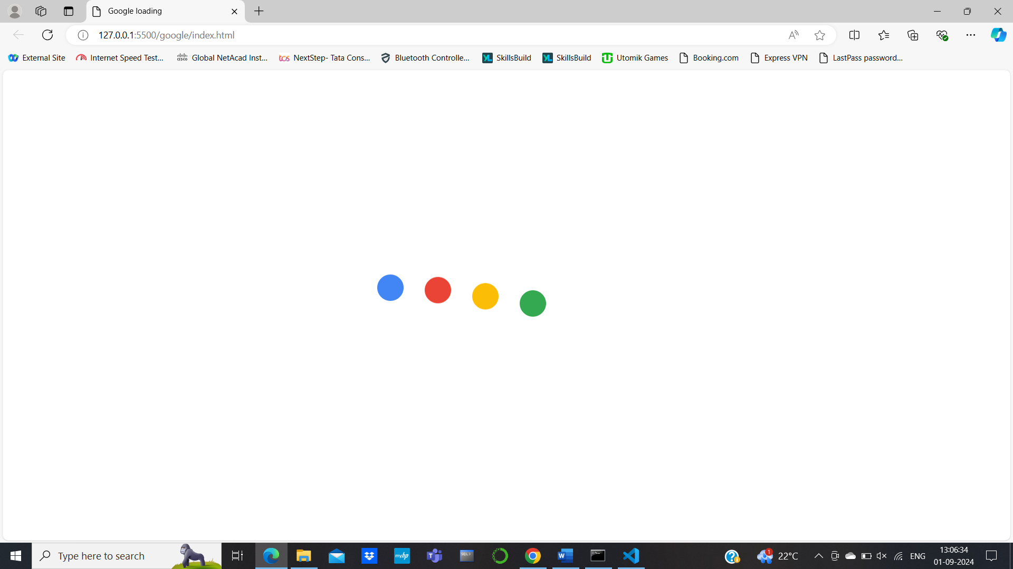Task-2

Index.html

<!DOCTYPE html>

<html lang="en">

<head>

    <meta charset="UTF-8">

    <meta name="viewport" content="width=device-width, initial-scale=1.0">

    <title>Music Bars Animation</title>

    <link rel="stylesheet" href="style.css">

</head>

<body>

    <div class="music-container">

        <div class="bar"></div>

        <div class="bar"></div>

        <div class="bar"></div>

        <div class="bar"></div>

        <div class="bar"></div>

    </div>

</body>

</html>

Style.css

body {

    display: flex;

    justify-content: center;

    align-items: center;

    height: 100vh;

    margin: 0;

}

.music-container {

    display: flex;

    justify-content: center;

    gap:10px;

    align-items: flex-end;

    width: 300px;

    height: 150px;

}

.bar {

    width: 20px;

    height: 20px;

    background-color: #00ff00;

    animation: bassReact 1s infinite ease-in-out;

    animation-fill-mode: both;

}

.bar:nth-child(1) {

    animation-delay: 0.2s;

}

.bar:nth-child(2) {

    animation-delay: 0.4s;

}

.bar:nth-child(3) {

    animation-delay: 0.25s;

}

.bar:nth-child(4) {

    animation-delay: 0.35s;

}

.bar:nth-child(5) {

    animation-delay: 0.5s;

}

@keyframes bassReact {

    0%, 100% {

        height: 20px;

        background-color: #00ff00;

    }

    50% {

        height: 120px;

        background-color: #ff0000;

    }

}

Output

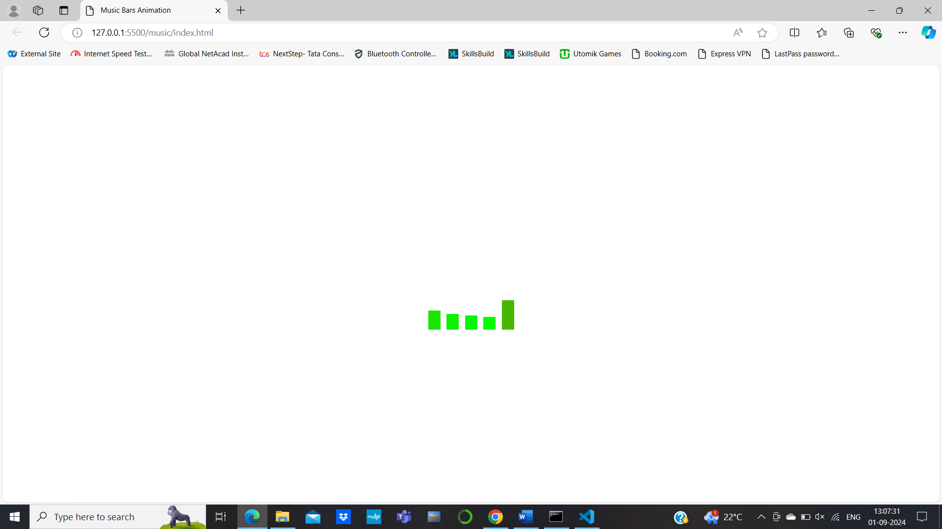

Workshop

Index.html

<!DOCTYPE html>

<html lang="en">

<head>

    <meta charset="UTF-8">

    <meta name="viewport" content="width=device-width, initial-scale=1.0">

    <title>Workshop</title>

    <link rel="stylesheet" href="https://cdnjs.cloudflare.com/ajax/libs/animate.css/4.1.1/animate.min.css" />

    <link rel="stylesheet" href="./style.css">

</head>

<body>

    <header>

        <img src="./images/logo.png" alt="lOgo" width="80px" height="80px">

    </header>

    <section>

        <h1 class="animate__animated animate__backInDown">

            Project Experience

        </h1>

        <div class="images">

            <img src="./images/1.jpeg" alt="Cat">

            <img src="./images/2.jpeg" alt="Lion">

            <img src="./images/3.jpeg" alt="Konda">

        </div>

        <p class="animate__animated animate__rotateIn">

            Lorem ipsum dolor sit amet consectetur adipisicing elit. Aperiam ipsum temporibus soluta enim itaque impedit

            non debitis sit vel sunt, ea quas dolore provident voluptatibus earum eaque suscipit error cum.

            Quia provident natus placeat debitis est incidunt aliquid vel, ex enim nam illo nulla voluptas sed,

            reiciendis beatae quibusdam distinctio fuga? Beatae, consequuntur enim nostrum quam similique provident

            praesentium dignissimos.

        </p>

    </section>

</body>

</html>

Style.css

*{

    box-sizing: border-box;

}

body{

    margin: 0px;

}

header{

    border: 2px solid black;

}

section{

    background-color: red

}

section> .images{

    width: 100px;

    display: flex;

    border-radius: 50%;

    align-items: center;

}

h1{

    text-align: center;

}

p{

    text-align: center;

}

.animate__animated.animate__rotateIn{

    --animation-fill-mode: forwards;

}

Output

