**Name: Kodari Siddhartha Yadav**

**Batch: 18R**

**Mobile No: 9346178913**

Task-1

Index.html

<!DOCTYPE html>

<html lang="en">

  <head>

    <meta charset="UTF-8" />

    <meta name="viewport" content="width=device-width, initial-scale=1.0" />

    <title>Task-1</title>

    <link rel="stylesheet" href="./style.css" />

  </head>

  <body>

    <div class="container">

      <div class="title">

        <h1>My Home</h1>

      </div>

      <input type="checkbox" id="checkbox">

      <label for="checkbox" class="ham">

        <img src="./images/ham.png" alt="">

      </label>

      <div class="text_content">

        <div>Home</div>

        <div>Pictures</div>

        <div>Location</div>

        <div>Login</div>

      </div>

    </div>

  </body>

</html>

Style.css

*{

    box-sizing: border-box;

}

body{

    margin: 0px;

    padding: 0px;

}

.container{

    background-color: black;

    height: 100px;

    display: flex;

    color: white;

    font-size: 1.5rem;

    padding: 10px;

    justify-content: space-between;

    align-items: center;

}

img{

    height: 100%;

    width: 80px;

    object-fit: cover;

    background-color: white;

}

.text_content{

    display: flex;

    gap: 20px;

}

#checkbox{

    display: none;

}

.ham{

    display: none;

}

@media screen and (max-width: 630px) {

    .text_content{

        display: none;

    }

    .ham{

        display: block;

    }

    #checkbox:checked ~ .text_content{

        display: flex;

        transition: 1.0s ease;

        position: absolute;

        width: 100%;

        margin-top: 120px;

        color: red;

        background-color: yellow;

        justify-content: space-evenly;

    }

}

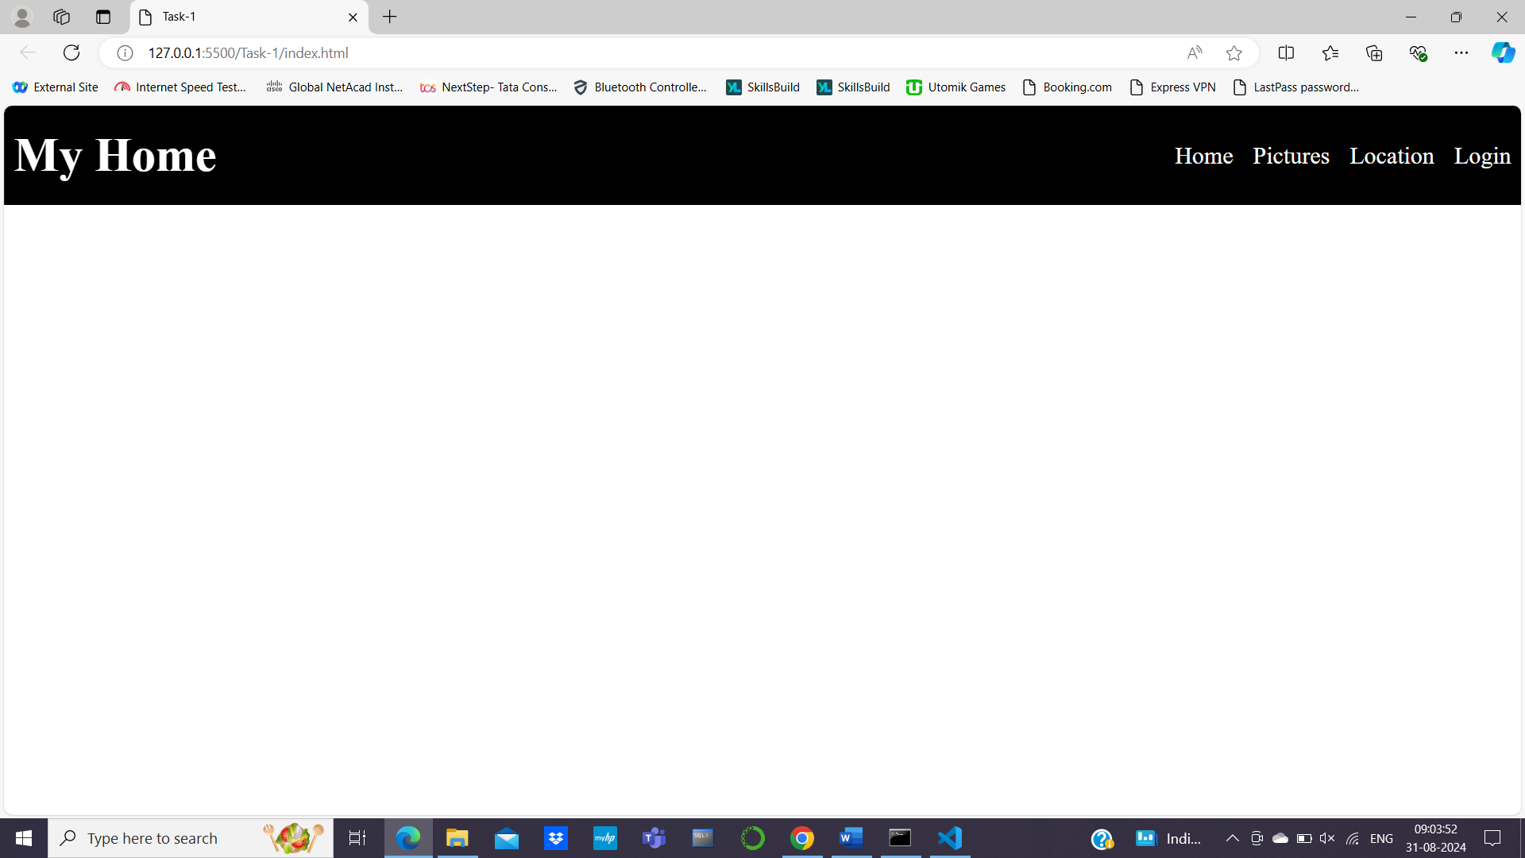

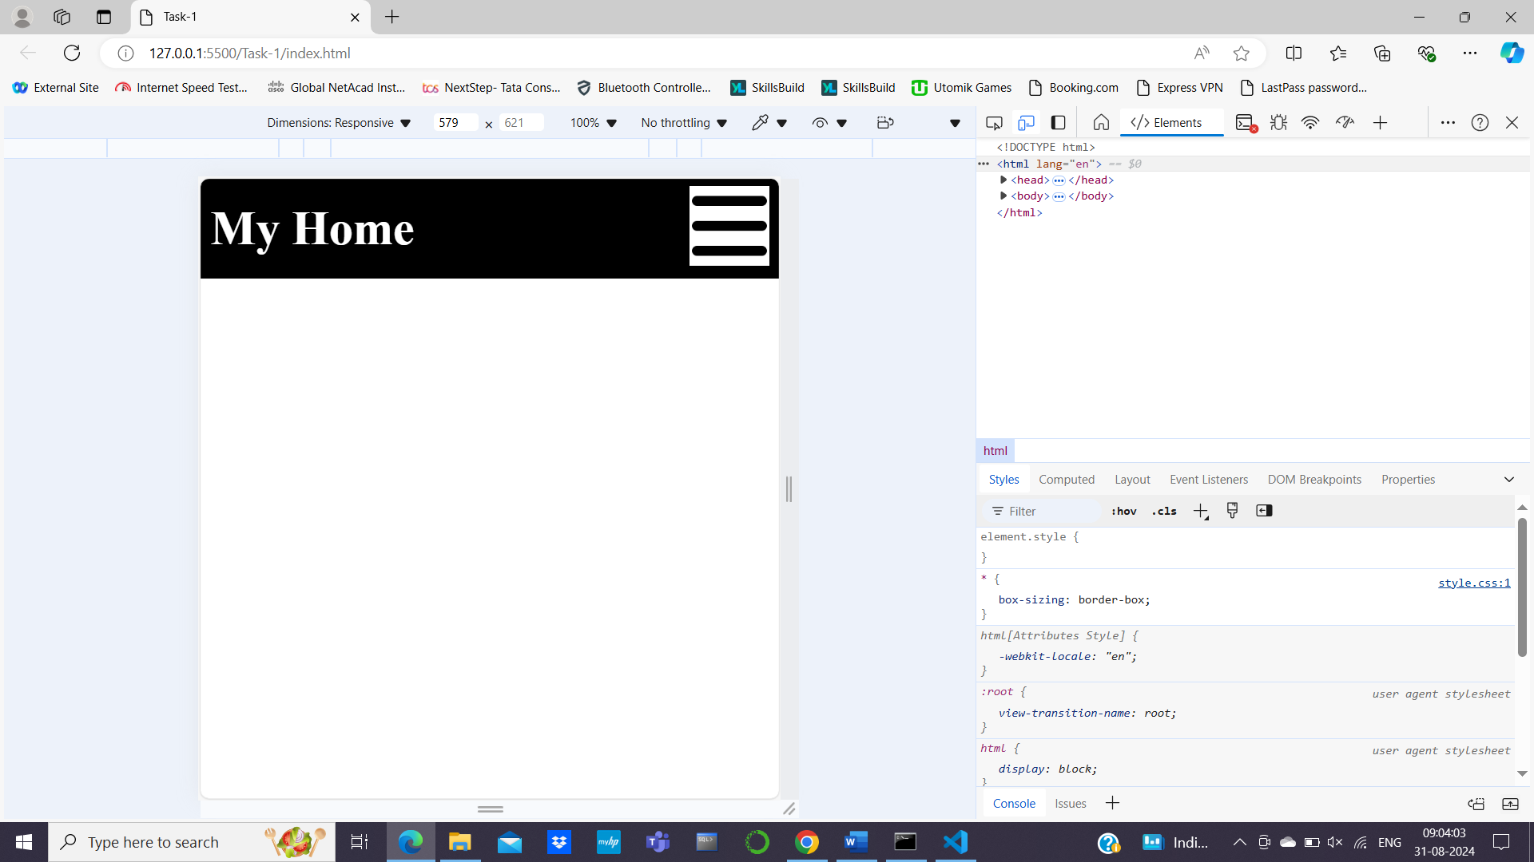

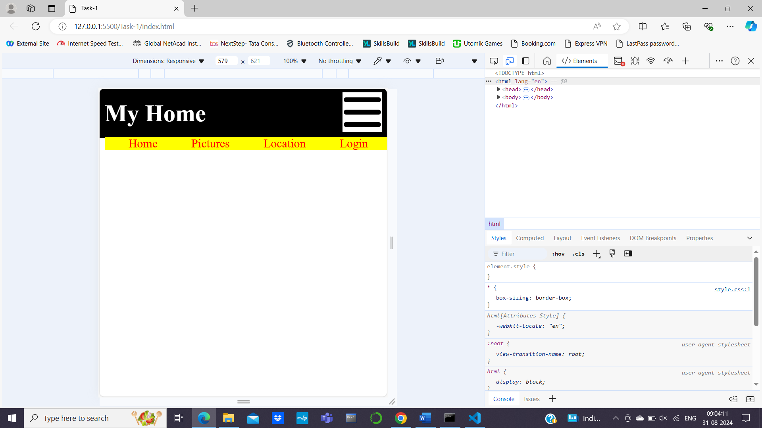

Task-2

Index.html

<!DOCTYPE html>

<html lang="en">

<head>

    <meta charset="UTF-8">

    <meta name="viewport" content="width=device-width, initial-scale=1.0">

    <title>Positions</title>

    <link rel="stylesheet" href="./style.css">

</head>

<body>

    <nav>

        <header><span>BR</span> Architects</header>

        <ul>

            <li><a href="#">Projects</a></li>

            <li><a href="#">About US</a></li>

            <li><a href="#">Contact</a></li>

        </ul>

    </nav>

    <div class="container">

        <img src="./image/architect.jpg" alt="Images">

        <h1><span>BR</span> Archirtects</h1>

    </div>

    <div class="projects">

        <h1>Projects</h1>

    </div>

    <div class="images">

        <img src="./image/1.jpg" alt="">

        <img src="./image/2.jpg" alt="">

        <img src="./image/3.jpg" alt="">

        <img src="./image/4.jpg" alt="">

        <img src="./image/2.jpg" alt="">

        <img src="./image/4.jpg" alt="">

        <img src="./image/3.jpg" alt="">

        <img src="./image/1.jpg" alt="">

    </div>

</body>

</html>

Style.css

*{

    box-sizing: border-box;

}

body{

    margin: 0px;

}

a{

    text-decoration: none;

}

ul{

    list-style: none;

    margin: 0px;

    padding: 0px;

    display: flex;

    font-size: 1.5rem;

    gap: 20px;

}

a{

    color: black;

}

header{

    font-size: 1.8rem;

}

nav {

    background-color: white;

    color: black;

    padding: 10px 14px;

    display: flex;

    justify-content: space-between;

    align-items: center;

    height: 80px;

    position: sticky;

}

.container> *{

    position: relative;

}

.container> h1{

    position: absolute;

    align-content: center;

    bottom: 200px;

    left: 500px;

    z-index: 1;

}

.projects {

    font-size: 1.5rem;

    font-style: oblique;

}

.images{

    display: grid;

    grid-template-columns: repeat(4,1fr);

    grid-template-rows: repeat(2,1fr);

    gap: 10px;

}

img{

    width: 100%;

    height: 100%;

    object-fit: cover;

}

@media  screen and (max-width: 600px) {

    .images{

        display: grid;

        grid-template-columns : repeat(1,1fr);

    }

    ul{

        display: none;

    }

}

@media screen and (max-width: 850px) {

    .container> h1{

        display: none;

    }

}

OUTPUT

