Simulators Available:

Veins:

Veins is an open source framework for running vehicular network simulations. It is based on two well-established simulators: OMNeT++, an event-based network simulator, and SUMO, a road traffic simulator. It extends these to offer a comprehensive suite of models for IVC simulation.

About Veins:

The Veins framework includes a comprehensive suite of models to make vehicular network simulations as realistic as possible, without sacrificing speed. The GUI and IDE of OMNeT++ and SUMO can be used for quickly setting up and interactively running simulations.



In the screencast above, blue cars are heading west. An accident is simulated at ①, along with a simple protocol informing drivers of jams. This makes it possible to investigate dynamic re-routing around an accident.

Working Of Veins:

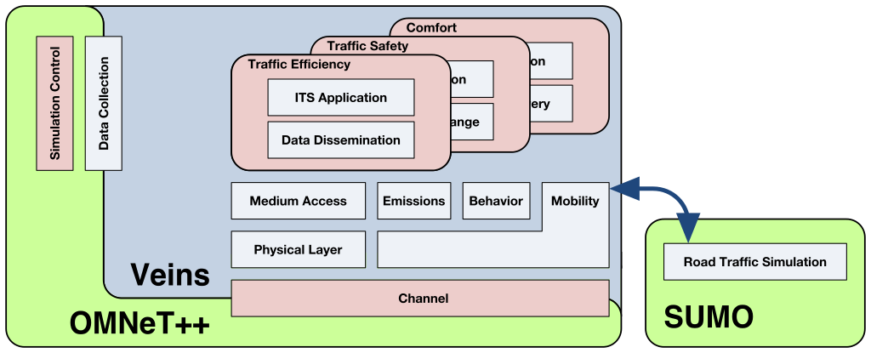

Road traffic simulation is performed by SUMO, which is well-established in the domain of traffic engineering. Network simulation is performed by OMNeT++ along with the physical layer modelling toolkit MiXiM, which makes it possible to employ accurate models for radio interference, as well as shadowing by static and moving obstacles.

Both simulators are bi-directionally coupled and simulations are performed online. This way, the influence of vehicular networks on road traffic can be modeled and complex interactions between both domains examined.

Domain specific models for vehicular networking build on this basis to provide a comprehensive framework that is still easy to learn and use.