Q-1.How are inline and block elements different from each other?
- A block element always starts on a new line and takes up the full width available that is it stretches out to the left and right as far as it can. The <div> element is a block-level element. While an inline element does not start on a new line and only takes up as much width as necessary. This <span> element is an inline-level element.
- The display property sets or returns the element's display type. ... However, if you set display:none , it hides the entire element, while visibility:hidden means that the contents of the element will be invisible, but the element stays in its original position and size.

Q-2.Explain the difference between visibility:hidden and display:none
- The display:none property hides the entire element, while visibility:hidden means that the contents of the element will be invisible, but the element stays in its original position and size.
- The display:none property keeps the property in the HTML file but removes it from the webpage , while visibility:hidden property keeps it on the webpage but doesn’t show it.

Q-3. Explain the clear and float properties.
- The CSS float property specifies how an element should float.
- The CSS clear property specifies what elements can float beside the cleared element and on which side.
Q-4 Explain difference between absolute, relative,fixed and static.
Absolute File Paths: It describes the full address(URL) to access an internet file.
<img src=”https://media.dailymotion.org/uploads” alt=”My Image”>

Relative File Path: It describes the path of the file relative to the location of the current web page file.
<img src="google.jpg" alt="Google Image" style="width:400px">

Static - This is the default value, all elements are in order as they appear in the document.

Fixed - the element is positioned related to the browser window.

Q-5 Write the HTML code to create a table in which there are 4 columns( ID , Employee Name, Designation, Department) and at least 6 rows. Also do some styling to it.
Table.HTML
<!DOCTYPE html>
<html lang="en" dir="ltr">
<head>
<title>
Tables
</title>
<meta charset="utf-8">
<link rel="stylesheet" href="style.css">
</head>
<body>
<table>
<th>ID
</th>
<th>
Employee Name
</th>
<th>
Designation
</th>
<th>
Department
</th>
<tr>
<td>1</td>
<td>Siddharth</td>
<td>Traniee</td>
<td>Java</td>
</tr>
<tr>
<td>2</td>
<td>Sapan</td>
<td>Traniee</td>
<td>Mean</td>
</tr>
<tr>
<td>3</td>
<td>Ram</td>
<td>Traniee</td>
<td>IOS</td>
</tr>
<tr>
<td>4</td>
<td>Prateek</td>
<td>Traniee</td>
<td>Android</td>
</tr
<tr>
<td>5</td>
<td>Pawan</td>
<td>Traniee</td>
<td>Cloud</td>
</tr>
<tr>
<td>6</td>
<td>Ishpreet</td>
<td>Traniee</td>
<td>AI</td>
</tr>
</table>
</body>
</html>
Style.CSS
table{
border: 1px solid black ;
background-color: red;
}
th{
border: 1px solid black ;
background-color: blue;
}
td{
border: 1px solid black ;
background-color: yellow;
}
Output
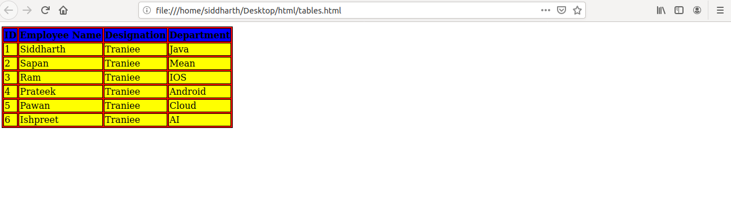

Q-6 Why do we use meta tags?
The <meta> tag provides metadata about the HTML document. Metadata will not be displayed on the page, but will be machine parsable.

The metadata can be used by browsers (how to display content or reload page), search engines (keywords), or other web services.

<meta name="keywords" content="HTML, CSS, XML, XHTML, JavaScript">

Q-7 Explain box model.
CSS box model is a container which contains multiple properties including borders, margin, padding and the content itself. It is used to create the design and layout of web pages. It can be used as a toolkit for customizing the layout of different elements. The web browser renders every element as a rectangular box according to the CSS box model.
Box-Model has multiple properties in CSS. Some of them are given below:
- borders
- margins
- padding
- Content
Border Area: It is the area between the box’s padding and margin. Its dimensions are given by the width and height of border.
Margin Area: This area consists of space between border and margin. The dimensions of Margin area are the margin-box width and the margin-box height. It is useful to separate the element from its neighbors.
Padding Area: It includes the element’s padding. This area is actually the space around the content area and within the border box. Its dimensions are given by the width of the padding-box and the height of the padding-box.
Content Area: This area consists of content like text, image, or other media content. It is bounded by the content edge and its dimensions are given by content box width and height.
Q-8. What are the different types of CSS Selectors?
CSS selectors are used to find the HTML elements you want to style.
CSS selectors can be divided into five categories:
- Simple selectors (select elements based on name, id, class)
- Combinator selectors (select elements based on a specific relationship between them)
- Pseudo class selectors (select elements based on a certain state)
- Pseudo-elements selectors(select and style a part of an element)
- Attribute selectors (select elements based on an attribute or attribute value)
Q-9 Define Doctype
The <!DOCTYPE> declaration must be the very first thing in your HTML document, before the <html> tag.
The <!DOCTYPE> declaration is not an HTML tag; it is an instruction to the web browser about what version of HTML the page is written in.
Q-10 Explain 5 HTML5 semantic tags.
- Footer -
- A <footer> is generally found at the bottom of a document, a section, or an article. Just like the <header> the content is generally metainformation, such as author details, legal information, and/or links to related information. It is also valid to include <section> elements within a footer.
- Small -
The <small> element often appears within a <footer> element which would usually contain copyright information or legal disclaimers, and other such fine print. However, this is not intended to make the text smaller. It is just describing its content, not prescribing presentation.
- Header -
The <header> element is generally found at the top of a document, a section, or an article and usually contains the main heading and some navigation and search tools.
- Nav -
The <nav> tag defines a set of navigation links.
- Section -
The <section> element defines a section in a document.A home page could normally be split into sections for introduction, content, and contact information.
Q-11. Create HTML for web-page.jpg

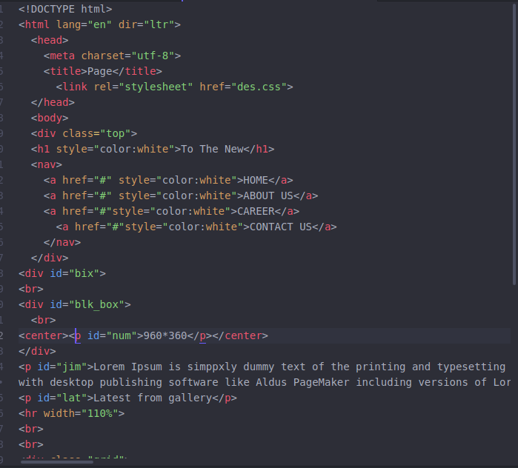

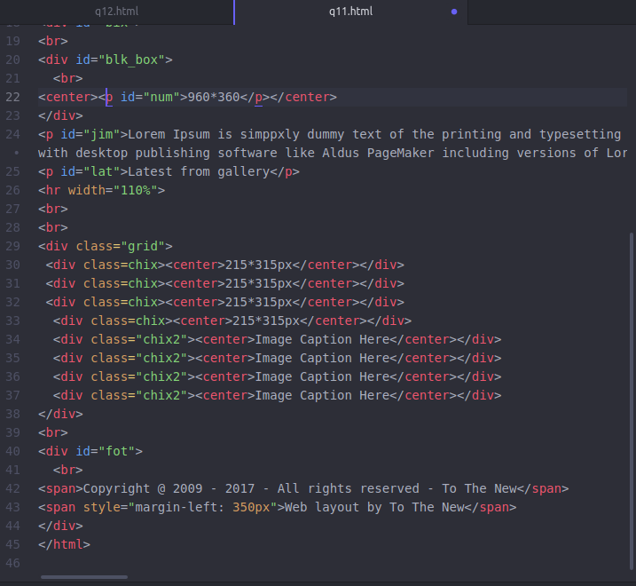
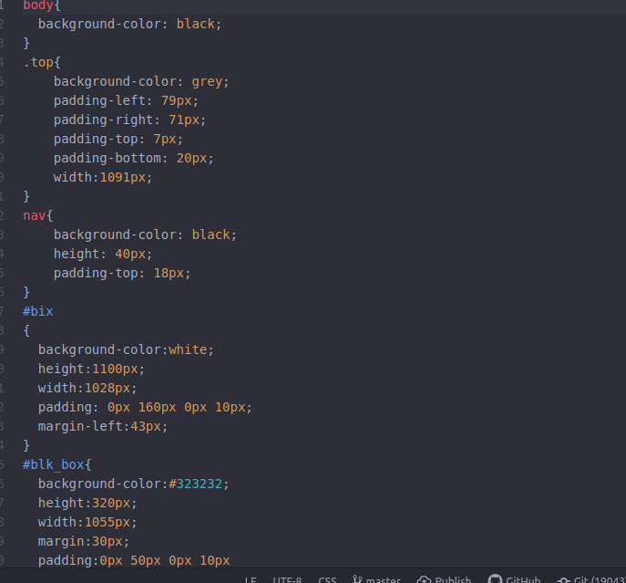
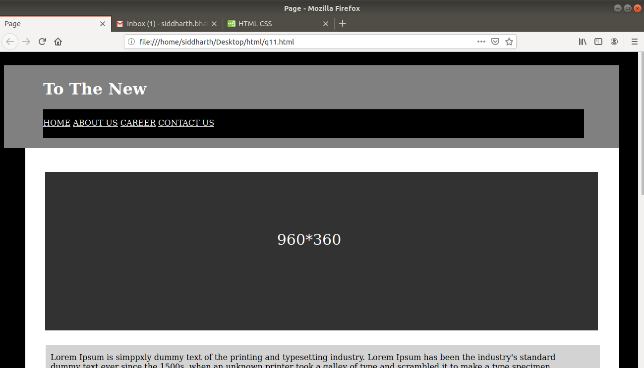

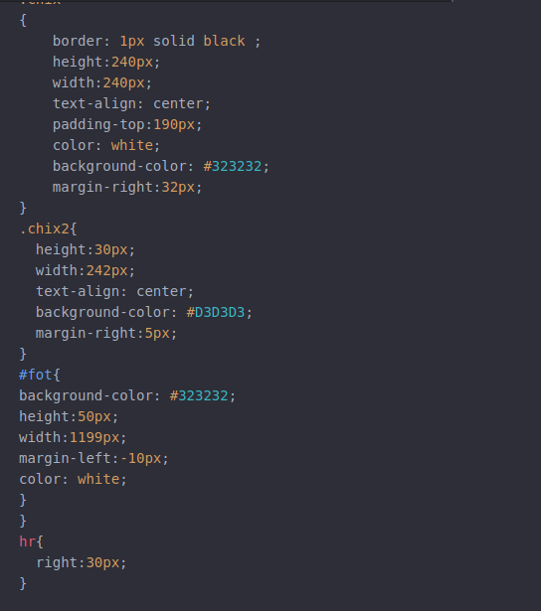

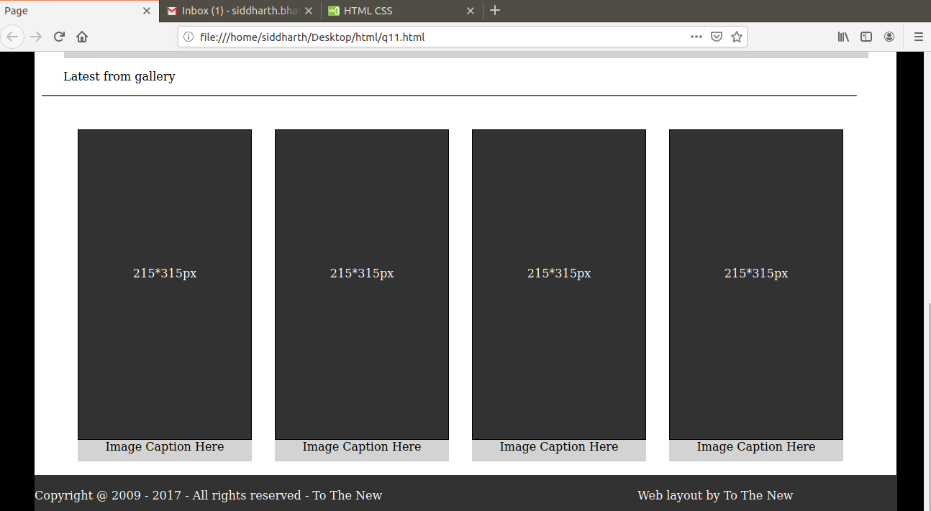

12. Create HTML for form.png (check resources, highest weightage for answers)
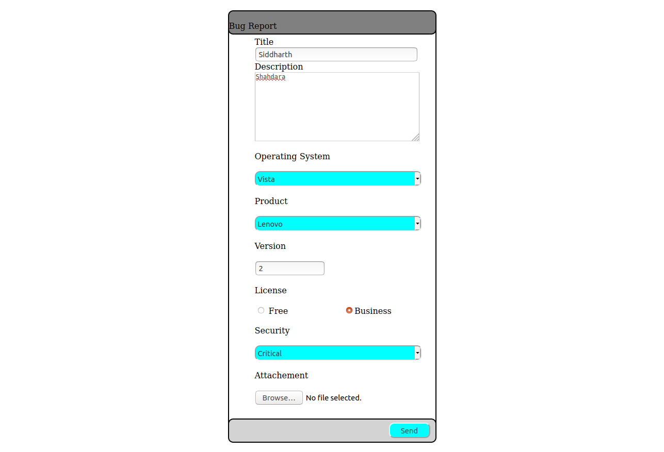
Q12.HTML
<!DOCTYPE html>
<html lang="en" dir="ltr">
<head>
<meta charset="utf-8">
<title></title>
<link rel="stylesheet" href="sst.css">
</head>
<form action="" target="_blank" method="GET">
<center>
<div id="bx">
<div id="kh"><br>Bug Report</div>
Title <br> <input type="text" id="nm" name="title">
<br>
Description<br>
<textarea name="Description" rows="8" cols="42"></textarea>
<br><br>
Operating System<br><br>
<select id="os">
<option value="xp">XP</option>
<option value="Vista">Vista</option>
<option value="7">7</option>
<option value="10">10</option>
</select>
<br><br>
Product<br><br>
<select id="os">
<option value="XP">Lenovo</option>
<option value="Vista">HP</option>
<option value="7">Apple</option>
<option value="10">Xiaomi</option>
</select>
<br><br>
Version<br><br>
<input type="text" id="jk" name="title">
<br><br>
License<br><br>
<input type="radio" name="g" value="Free"> Free &nbsp;&nbsp;&nbsp;&nbsp; &nbsp;&nbsp;&nbsp;&nbsp; &nbsp;&nbsp;&nbsp;&nbsp; &nbsp;&nbsp;&nbsp;&nbsp;
<input type="radio" name="g" value="Business">Business<br><br>
Security<br><br>
<select id="os">
<option value="XP">Critical</option>
<option value="Vista">HP</option>
</select><br><br>
Attachement<br><br>
<input type="file" name="myfile">
<br><br>
<div id="kp">
<button class="s" type="button" value="Submt">Send</button>
</div>
</div>
<center>
</form>
</html>

SST.CSS
#bx{
width: 300px;
border: 2px solid black;
padding: 50px;
margin: 20px;
border-radius: 25px;
text-align: left;
}
#kh{
width: 400px;
border: 2px solid black;
margin-left: -52px;
height:43px;
position: absolute;
top: 20px;
text-align: left;
background-color: grey;
border-radius: 10px;
}
#nm{
width:300px;
}
#os{
width:324px;
height:30px;
background-color:cyan;
border-radius: 10px;
}
#jk{
width:120px;
}
#kp
{
width: 400px;
border: 2px solid black;
margin-left: -52px;
height:43px;
position: absolute;
bottom: -220px;
text-align: left;
background-color: #d3d3d3;
border-radius: 10px;
}
.s{
position: absolute;
height:30px;width:80px;
right:10px;
top:6px;
background-color: cyan;
border-radius: 10px;
}

