Problem Statement: There can be multiple customers, who can place multiple orders on the site. Now a sales person can handle these orders will distribute into multiple sales persons (One order will be assign to one salesperson only). So a sales person can have multiple orders of multiple customers
q-1 Create Database
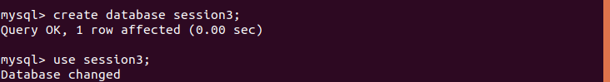
q-2 Design Schema
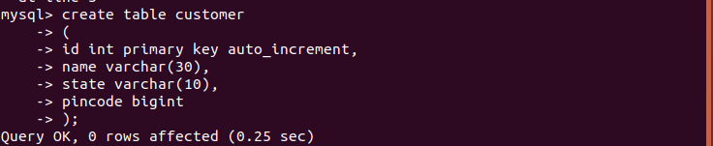

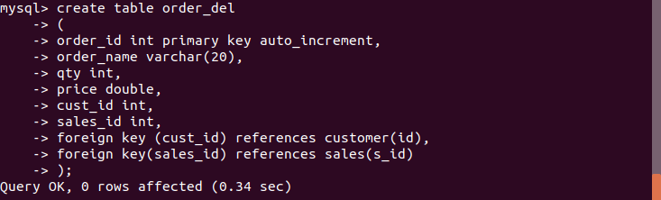

q-3 Create tables
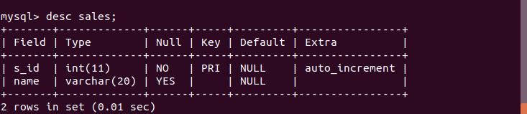
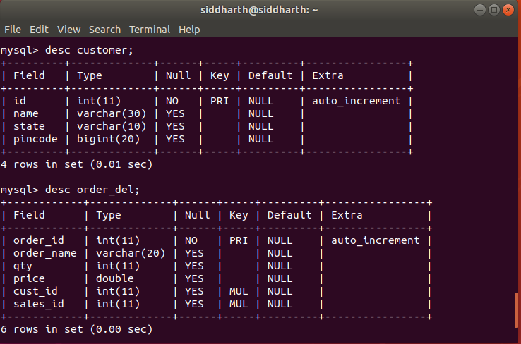

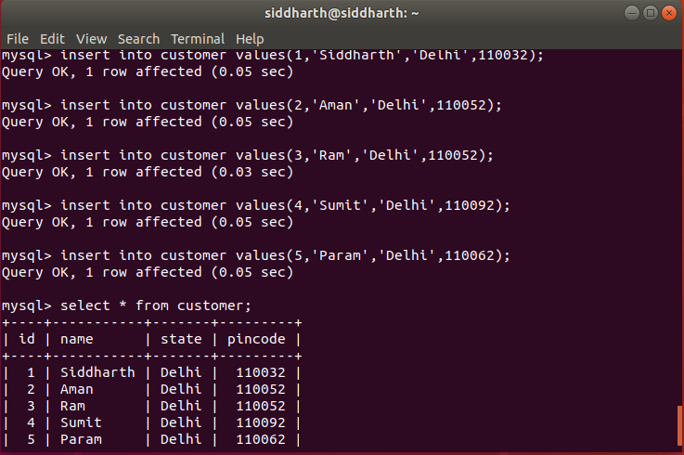
q-4 Insert sample data
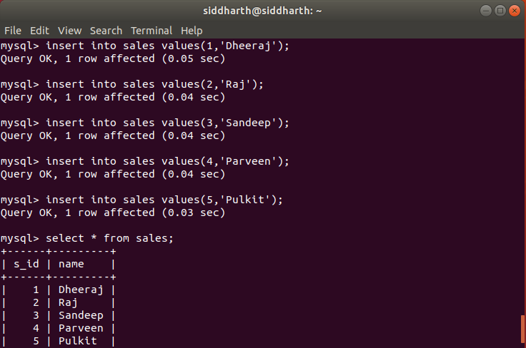
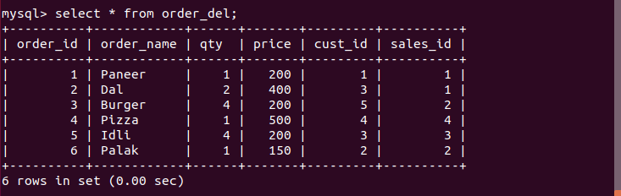
q-5 Find the sales person have multiple orders.
q-6 Find the all sales person details along with order details
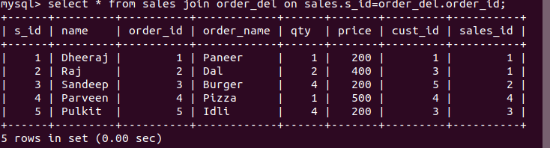
q-7 Create index
q-8 How to show index on a table
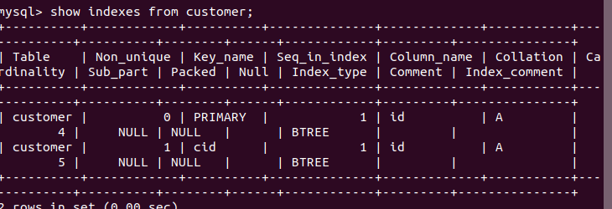
q-9 Find the order number, sale person name, along with the customer to whom that order belongs to
