q-1 Write a programe do to demonstrate the use of volatile keyword
q-2 Write a program to create a thread using Thread class and Runnable interface each.
Extending thread class
class MyThread extends Thread{
public void run() {
for (int i = 0; i < 5; i++) {
System.out.println("Child Thread");
}
}
}
public class as3q2 {
public static void main(String[] args) {
MyThread k=new MyThread();
k.start();
for(int i=0;i<5;i++)
{
System.out.println("Main THread");
}
}
}
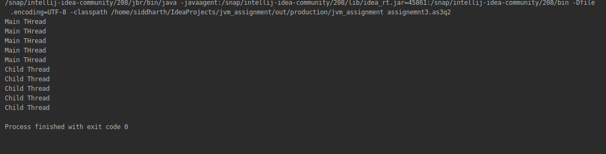
package assignemnt3;
class MyRunnable implements Runnable{
public void run() {
for (int i = 0; i < 5; i++) {
System.out.println("Child Thread");
}
}
}
public class as3q2ii {
public static void main(String[] args) {
MyRunnable r=new MyRunnable();
Thread t=new Thread(r);
t.start();
for(int i=0;i<5;i++)
{
System.out.println("Main Thread");
}
}
}
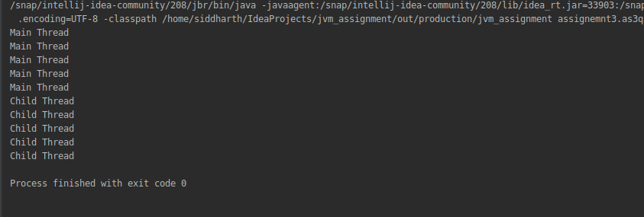

q-3 Write a program using synchronization block and synchronization method
package assignemnt3;
class display
{
public synchronized void wish(String name)
{
for(int i=0;i<10;i++)
{
System.out.print("Good Morning ");
try{
Thread.sleep(2000);
}
catch(InterruptedException e)
{
}
System.out.println(name);
}
}
}
class thmy extends Thread{
display obj;
String name;
thmy(display obj,String username)
{
this.obj=obj;
name=username;
}
public void run()
{
obj.wish(name);
}
}
public class as3q5 {
public static void main(String[] args) {
display m=new display();
thmy t=new thmy(m,"Siddharth");
thmy t2=new thmy(m,"Mohan");
t.start();
t2.start();
}
}

Synchronized block
package assignemnt3;
class Display{
public void wish(String name)
{
synchronized (this)
{
for(int i=0;i<5;i++)
{
System.out.print("Good Morning: ");
try{
Thread.sleep(2000);
}
catch (InterruptedException e)
{
}
System.out.println(name);
}
}
}
}
class mmthread extends Thread {
Display d;
String uname;
mmthread(Display d,String un)
{
this.d=d;
uname=un;
}
public void run()
{
d.wish(uname);
}
}
class SyncDemo{
public static void main(String[] args) {
Display m=new Display();
mmthread mt=new mmthread(m,"Siddharth");
mmthread mt2=new mmthread(m,"Micky");
mt.start();
mt2.start();
}
}

q-4 Write a program to create a Thread pool of 2 threads where one Thread will print even numbers and other will print odd numbers

q-5 Write a program to demonstrate wait and notify methods

package assignemnt3;
class ThreadB extends Thread{
int total;
public void run(){
synchronized(this){
for(int i=0; i<100 ; i++){
total += i;
}
notify();
}
}
}
public class as3q11 {
public static void main(String[] args){
ThreadB b = new ThreadB();
b.start();
synchronized(b) {
try {
System.out.println("Waiting for b to complete...");
b.wait();
} catch (InterruptedException e) {
e.printStackTrace();
}
System.out.println("Total is: " + b.total);
}
}
}

q-6 Write a program to demonstrate sleep and join methods.
package assignemnt3;
class Mthread extends Thread{
public void run ()
{
for(int i=0;i<5;i++)
{
System.out.println("child thread");
try {
Thread.sleep(2000);
} catch (InterruptedException ex) {
}
}
}
}
public class as3q6ii {
public static void main(String[] args) throws InterruptedException {
Mthread t=new Mthread();
t.start();
t.join();
for(int i=0;i<5;i++)
{
System.out.println("Parent thread");
}
}
}
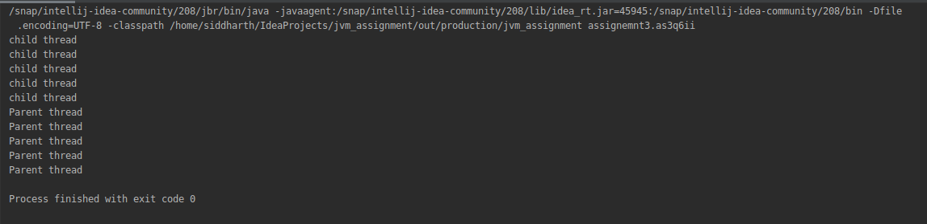
q-7 Run a task with the help of callable and store it's result in the Future.
q-8 Write a program to demonstrate the use of semaphore

q-9 Write a program to demonstrate the use of CountDownLatch

q-10 Write a program which creates deadlock between 2 threads
public class as3q10 {
public static void main(String[] args) throws InterruptedException{
Thread.currentThread().join();
System.out.println("Situation of deadlock");
}
}

