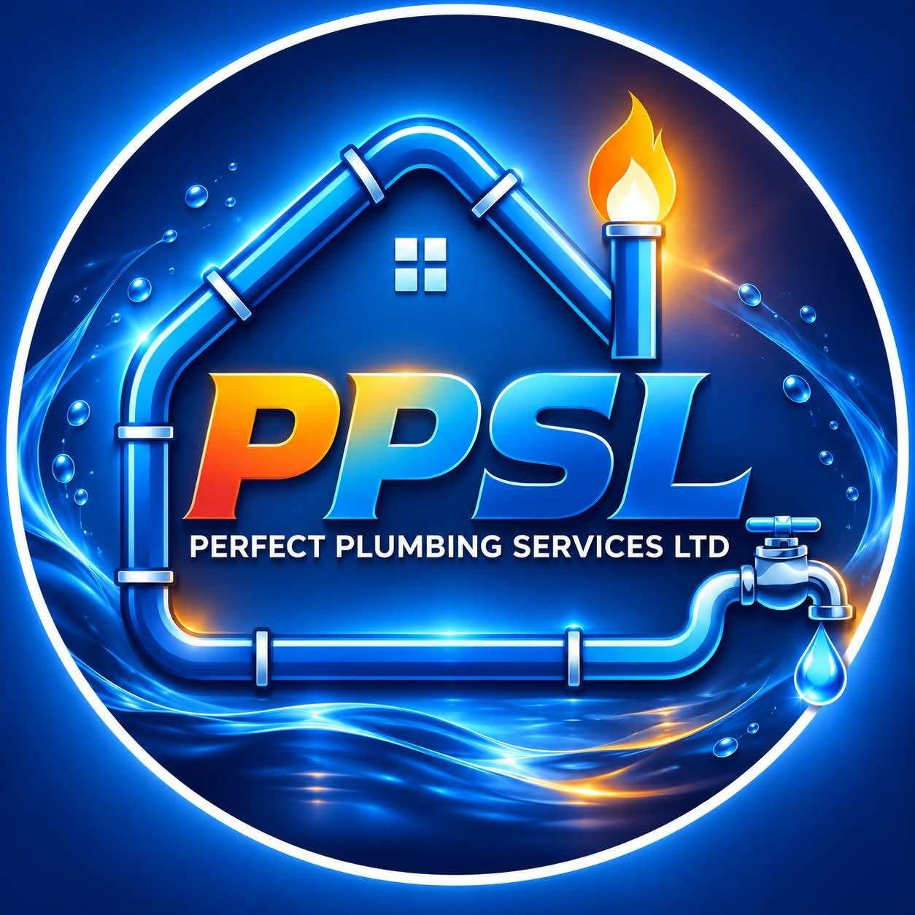

PERFECT PLUMBING SERVICES LTD (PPSL)
Official Website Blueprint, Content Architecture & Production Specification
Document Version  v1.0 (Master Spec) | Target Market  Mauritius (Domestic & Commercial) | Project Status  Architecture & Design Approval | Prepared For  Management & Stakeholders

📌 Executive Summary & Project Purpose
This master specification consolidates all commercial, creative, and technical requirements for the official PPSL website. It outlines every page section, approved copy, service portfolio, interactive gallery schema, customer inquiry flow, and pre-launch punch list. Review this document before initiating site deployment.

1. Business Identity & Global Navigation
Perfect Plumbing Services Ltd (PPSL) is a premier domestic and commercial plumbing contractor offering transparent, professional, and reliable plumbing solutions. The website navigation is engineered to provide frictionless pathways to service discovery and lead generation.
1.1 Brand Identity Essentials
- Company Legal Name: Perfect Plumbing Services Ltd (PPSL)
- Primary Brand Colorway: Deep Blue / Ocean Navy (#002B66, #013289), Sky/Cyan Accent (#0EA5E9), Slate Dark (#1E293B), Clean White (#FFFFFF)
- Visual Tone & Feel: Modern, highly dependable, clean, responsive, fast-loading, conversion-optimized.
1.2 Top Utility Bar
Positioned at the highest layer of every viewport to establish immediate confidence and rapid access:
- Value Statement: "Reliable plumbing. Quality workmanship."
- Quick Action Link: "Request a service" -> Direct deep link to the booking / quote inquiry modal.
1.3 Main Navigation Bar
Sticky header with high-contrast logo and smooth elevation on scroll:
Navigation Element | Type | Destination & Action
Home | Link | Top of page / Hero section (#home)
Services | Mega Dropdown / Link | Dedicated services matrix and detailed breakdowns (#services)
Gallery | Link | Interactive filterable project portfolio (#gallery)
Blog | Link | Articles, guides & preventive maintenance tips (#blog)
About | Link | Company story, craftsmanship standards, and credentials (#about)
Contact | Link | Direct contact info, operational area, and emergency lines (#contact)
Get a Quote | Primary CTA Button | High-visibility accent button triggering the multi-step quote builder

2. Hero Section Architecture
The primary conversion engine of the homepage. Designed to engage domestic homeowners and commercial facility managers within 3 seconds of landing.
2.1 Hero Copy & Messaging
- Headline: "Flow better. Live worry-free."
- Supporting Subtext: "From leaking pipes to new bathroom installations, PPSL helps keep homes and businesses running smoothly with practical plumbing solutions."
- Trust Badge / Eyebrow Tag: "Plumbing made simple – Solutions you can rely on"
2.2 Call-to-Action (CTA) Cluster
- Primary Button: "Request a quote" -> High-prominence button opening the instant quote request mechanism.
- Secondary Button: "Explore services" -> Smooth-scroll down to the comprehensive services breakdown.
2.3 Value Reassurance Ticks
Three trust verification icons displayed directly below the CTA buttons:
- ✓ Careful workmanship: Guaranteed precision, tidy workspace, and industry-standard materials.
- ✓ Clear communication: Transparent pricing, upfront explanations, no hidden charges.
- ✓ Home & business: Tailored plumbing solutions for single homes, apartments, retail, and corporate facilities.
3. Trust Strip & Strategic Pillars
A dedicated high-contrast metric and credibility bar anchored directly beneath the hero section to validate PPSL's market authority.
Pillar Title | Audience Scope | Customer Benefit
Domestic & Commercial | Homeowners, landlords, retail stores, offices | Complete end-to-end solutions engineered specifically for the property type.
Repair & Installation | Emergency fixes to brand-new plumbing setups | From small leaky faucets to full bathroom and commercial pipe retrofits.
Customer-First Service | All PPSL clients | Friendly, punctual, courteous, and straightforward support from first call to project sign-off.

4. Core Services Breakdown
PPSL delivers six core categories of specialized plumbing services. Each service card on the website features custom iconography, detailed scope, and an instant 'Book Service' action.
Service Category | Service Description & Scope | Target Audience
1. Plumbing Repairs | Rapid diagnosis and repair for dripping taps, faulty valves, noisy pipes, running toilets, damaged pipework, low water pressure, and everyday domestic plumbing issues. | Domestic & Commercial
2. Leak Detection & Repairs | Non-invasive inspection and acoustic/visual investigation for hidden water leaks, slab leaks, mystery damp patches, and unexplainable water meter increases, followed by planned permanent repairs. | Property Owners & Facilities
3. Bathroom Installations | Turnkey sanitaryware installation: rainfall showers, bathtub plumbing, basins, floating toilets, designer mixer taps, drainage optimization, and complete luxury bathroom renovations. | Homeowners & Renovators
4. Pipework & Fittings | Custom-tailored piping solutions: copper, PEX, PPR, and PVC pipework replacement, re-routing, pressure regulator valve fitting, and structural upgrades tailored to building architecture. | Residential & Industrial
5. Commercial Plumbing | High-capacity plumbing systems for corporate offices, retail spaces, restaurants, hotels, and industrial warehouses, including grease traps, commercial restrooms, and compliance checks. | Commercial & Corporate
6. Maintenance & Upgrades | Preventive scheduled servicing, water heater / geyser descaling and replacements, pump station checks, and modernisation to keep entire water systems functioning at peak efficiency. | Annual Contracts & Homes

5. Plumbing Projects & Interactive Gallery
The portfolio section reinforces real-world craftsmanship. It includes client-facing filter tabs to let visitors inspect work relevant to their exact requirement.
5.1 Portfolio Filtering System
- Filter 1: All Projects (Default master grid)
- Filter 2: Bathrooms (Luxury renovations, walk-in showers, sanitaryware fittings)
- Filter 3: Pipework (Copper manifolds, PPR line installations, clean utility routing)
- Filter 4: Fixtures (Designer tapware, mixers, floating vanities, architectural accessories)
5.2 Project Showcase Items
- Item 1: Modern Bathroom - Contemporary tilework and sanitary fitting with concealed cistern.
- Item 2: Careful Workmanship - Precision soldering, perfectly leveled valves, clean pipe brackets.
- Item 3: Quality Fixtures - Solid brass tapware, thermostatic mixer valves, durable shut-off taps.
- Item 4: Fresh Finishes - Clean silicone beading, watertight enclosures, seamless finishes.
- Item 5: Ready for the Job - Equipped service vehicles, specialized diagnostic tools, safety gear.
- Item 6: Finishing Details - Polished chrome trims, test pressure verification, clean site handover.
📌 Asset Migration Notice
CURRENT STATUS: Current gallery relies on high-resolution Unsplash architectural imagery. Prior to launch, these will be replaced with verified, real-world PPSL project photography taken across Mauritius job sites to maximize authenticity and trust.

6. About PPSL & Operational Philosophy
The 'About' narrative bridges technical capability with human dependability.
6.1 Core Headline & Mission Statement
- Headline: "Good service starts with doing the job right."
- Mission Statement: "PPSL aims to make plumbing projects straightforward by listening to what you need, explaining next steps and focusing on solutions that suit your property."
6.2 Strategic Pillars of Service
- 1. Clear Communication: No technical jargon; realistic timelines; transparent quotations before any spanner is turned.
- 2. Attention to Detail & Tidy Work: Clean drop-sheets, shoe covers, spotless cleanup after work, and millimeter-level alignment.
- 3. Tailored Solutions: We don't offer cookie-cutter patches. We engineer long-term fixes that fit your specific property dynamics.
- 4. Residential & Commercial Enquiries: Dedicated divisions equipped to handle domestic emergency repairs or large-scale multi-unit commercial fit-outs.
- Call to Action Button: "Talk to our team" (Links directly to phone/WhatsApp and scheduling tool).
7. Knowledge Hub & Preventive Guides (Blog)
Establishes topical authority and SEO visibility by answering everyday homeowner and property manager concerns.
Article Title | Category Tag | Read Time | Strategic Intent
5 signs that a tap or pipe may need attention | Home Maintenance | 4 min | Early detection guide to prevent disastrous water damage and costly repairs.
Planning a bathroom upgrade? Start with the plumbing | Bathroom Tips | 3 min | Educates clients on pipe sizing, water pressure, and drainage before buying tiles.
Simple habits that help prevent plumbing trouble | Prevention | 3 min | Practical maintenance guide to foster goodwill and long-term customer relationships.

8. High-Impact Call to Action (CTA)
A full-bleed navy banner with glowing accent accents designed to catch visitors before the footer:
- Headline: "Have a plumbing job in mind? Tell us what you need and let's work out the next step."
- Actions: Dual action options: 'Request a Quote Online' or 'Call for Immediate Assistance'.
9. Contact Architecture & Lead Ingestion
Comprehensive contact touchpoints providing multiple channels for domestic emergencies and corporate inquiries.
9.1 Business Contact Coordinates
- Direct Phone: +230 000 0000 (Placeholder – pending official business line and direct WhatsApp API)
- Official Email: info@yourbusiness.com (Placeholder – to be updated to contact@ppsl.mu or official domain)
- Service Area: Mauritius (Comprehensive coverage across North, Plaines Wilhems, South, East, West)
- Operating Hours: Monday – Saturday: 07:30 – 17:30 | 24/7 Emergency Dispatch (To be finalized)
9.2 Interactive Lead Intake Form Specifications
Field Name | Validation | Field Behavior & Data Options
Full Name * | Required | Plain text (First and Last name)
Phone Number * | Required | Mauritius phone format (+230 XX XX XX XX) with instant WhatsApp validation
Email Address | Optional | Standard email format validation
Service Required * | Required Dropdown | 1. Plumbing repairs  2. Leak detection & repairs  3. Bathroom installations  4. Pipework & fittings  5. Commercial plumbing  6. Maintenance & upgrades  7. Other enquiry
Project Details * | Required | Multi-line text area describing problem, property type, and urgent timing

9.3 Form Submission Pipeline Analysis
• Current Implementation: Launches the visitor's default mail client (mailto: link) pre-populated with form entries. This requires zero server infrastructure but can cause friction on mobile devices without an active mail app.
• Recommended Production Upgrade: Connect to an automated serverless endpoint (e.g., EmailJS, Formspree, or Node.js backend) with instantaneous WhatsApp click-to-chat fallback, ensuring 100% lead capture rate.
10. Global Footer & Legal Metadata
Clean, modern multi-column footer anchored on deep navy tone:
- Brand Column: PPSL · Perfect Plumbing Services Ltd with company registration and value tagline.
- Quick Links: Quick access to Home, Services, Gallery, Blog, About, Contact.
- Direct Contacts: Direct click-to-call, click-to-email, and geographical operational zones.
- Copyright Notice: © 2026 Perfect Plumbing Services Ltd. All rights reserved. Professional Plumbing Contractors.
11. Pre-Publishing Action Checklist
Crucial business inputs required to transition this specification into a fully operational production website:
Item to Finalize | Current Status | Action Required & Stakeholder Decision
Phone & WhatsApp | Placeholder (+230 000 0000) | Provide official primary voice line and WhatsApp business number.
Business Email | Placeholder (info@yourbusiness.com) | Provide custom domain email (e.g., contact@ppsl.mu or office@ppsl.mu).
Business Hours & Zones | Not filled in yet | Confirm standard opening hours (e.g., Mon–Sat 8am–5pm) & emergency coverage in Mauritius.
Authentic Photos | Stock Unsplash photos | Provide real project photos (bathrooms, pipe installations, staff/vans) or let us curate tailored photorealistic assets.

12. UI/UX Design System & Technical Strategy
To deliver a high-converting, world-class digital experience that outshines standard competitors:
- Aesthetic Language: Inter / Plus Jakarta Sans for clean typography; rich navy (#002B66) and vibrant water-accent cyan (#0EA5E9); subtle glassmorphism cards with smooth hover lifts.
- Interactive UX Elements: Instant tab switching for gallery categories; collapsible interactive FAQ; sticky contact drawer; micro-animations on service cards.
- Performance & SEO: 100% mobile-responsive, lightning-fast Core Web Vitals score (>95), clean semantic HTML5, modern vanilla CSS design system, and zero bloated dependencies.
- Lead Architecture: Dual submission route - one-click WhatsApp dispatch for instant quotes + automated email notification so no inquiry is ever lost.

