Date – 14/12/18

Experiment – 1

SOCKET PROGRAMMING

PROGRAM – 1

AIM :
To implement simple ping pong applicataion between two or more different machines.

PROGRAM :

import java.io.*;
import java.net.*;
import java.util.*;
public class Ping
{
public static void main(String[] args) throws IOException
{
Scanner sc = new Scanner(System.in);
int n = 5;

for (int i = 0; i < n; i++)
{
System.out.print("Enter IP Address : ");
String ip = sc.next();
InetAddress inet = InetAddress.getByName(ip);
System.out.println("Sending ping request to... " + inet);

if (inet.isReachable(5000))
System.out.println("Host Reachable ");
else
System.out.println("Host NOT Reachable ");
}
}
}

OUTPUT:

Enter IP Address : 192.168.0.1
Sending ping request to... /192.168.0.1
Host Reachable
Enter IP Address : 192.168.0.101
Sending ping request to... /192.168.0.101
Host NOT Reachable

RESULT :
Thus the PROGRAM is executed and output is obtained.

PROGRAM – 2

AIM :
To implement date and time display from client to server using Sockets.

PROGRAM :

Client.java:

import java.io.*;
import java.net.*;

public class DateTimeClient
{
public static void main(String args[]) throws Exception
{
Socket soc=new Socket(InetAddress.getLocalHost(),9876);

System.out.println("Connection established\n");

BufferedReader in=new BufferedReader(new InputStreamReader(soc.getInputStream() ));
System.out.println(in.readLine());
}
}

Server.java:

import java.net.*;
import java.io.*;
import java.util.*;

class DateTimeServer
{
public static void main(String args[]) throws Exception
{
ServerSocket s=new ServerSocket(9876);
System.out.println("Server running on port 9876...");
System.out.println("Waiting For Connection ...");

Socket soc=s.accept();
System.out.println("Client Connected");

DataOutputStream out=new DataOutputStream(soc.getOutputStream());
out.writeBytes("Server Date: " + (new Date()).toString() + "\n");
System.out.println("Data Sent");
System.out.println("Server Disconnecting");
out.close();
soc.close();
}
}

OUTPUT:

Server | Client
Server running on port 9876  Waiting For Connection ...  Client Connected  Data Sent  Server Disconnecting | Connection established  Server Date: Sun Feb 24 12:49:52 IST 2019

RESULT :
Thus the PROGRAM is executed and output is obtained.

PROGRAM – 3

AIM:
To write a ping pong client and server application. When a client sends a ping message to the server, the server will respond with a pong messge. Other messages sent by the client can be safely dropped by the client.
PROGRAM :

Client.java:

import java.io.*;
import java.util.*;
import java.net.*;

public class PingPongClient
{
public static void main(String args[])
{
try
{
Socket socket = new Socket("localhost", 9876);
System.out.println("Connected to server");

DataInputStream in=new DataInputStream(socket.getInputStream());
DataOutputStream out=new DataOutputStream(socket.getOutputStream());

Scanner sc = new Scanner(System.in);

while(true)
{
System.out.print("Enter message for server : ");
String msg = sc.nextLine();

out.writeUTF(msg);
if(msg.equals("Ping"))
System.out.println("Message Recieved : " + in.readUTF());

if(msg.equals("exit"))
break;
}
System.out.println("Server disconnected");
out.close();
socket.close();
}
catch(Exception e)
{
e.printStackTrace();
}
}
}

Server.java:

import java.io.*;
import java.net.*;

public class PingPongServer
{
public static void main(String args[])
{
try
{
ServerSocket server = new ServerSocket(9876);
System.out.println("Server running in port 9876...");
System.out.println("Waiting for client to connect...");

Socket socket=server.accept();
System.out.println("Client connected\n\n");

DataInputStream in=new DataInputStream(new BufferedInputStream(socket.getInputStream()));
DataOutputStream out=new DataOutputStream(socket.getOutputStream());

while(true)
{
String msg = in.readUTF();
if(msg.equals("Ping"))
{
System.out.println("Replying for Ping message");
out.writeUTF("Pong");
}
if(msg.equals("exit"))
break;
}
}
catch(Exception e)
{
e.printStackTrace();
}
}
}
OUTPUT:

Server | Client
Server running in port 9876...  Waiting for client to connect...  Client connected  Message Recieved : Hello  Replying for Ping message  Server exiting | Connected to server  Enter message for server : Hello  Enter message for server : Ping  Message Recieved : Pong  Enter message for server : exit

RESULT :
Thus the PROGRAM is executed and output is obtained.

PROGRAM – 4

AIM:
To write a socket based Java server PROGRAM that responds to client messages as follows : When it recieves a message from client, it simply converts the message into all uppercase letters and sends back the same to the client. Write both client and server PROGRAMs demonstrating this.
PROGRAM :

Client.java:

import java.io.*;
import java.util.*;
import java.net.*;

public class UpperChatClient
{
public static void main(String args[])
{
try
{
Socket socket = new Socket("localhost", 9876);
System.out.println("Connected to server");

DataInputStream in=new DataInputStream(socket.getInputStream());
DataOutputStream out=new DataOutputStream(socket.getOutputStream());

Scanner sc = new Scanner(System.in);

while(true)
{
System.out.print("Enter message for server : ");
String msg = sc.nextLine();

out.writeUTF(msg);

System.out.println("Message Recieved : " + in.readUTF());

if(msg.equals("exit"))
break;
}
System.out.println("Server disconnected");
out.close();
socket.close();
}
catch(Exception e)
{
e.printStackTrace();
}
}
}

Server.java:

import java.io.*;
import java.net.*;

public class UpperChatServer
{
public static void main(String args[])
{
try
{
ServerSocket server = new ServerSocket(9876);
System.out.println("Server running in port 9876...");
System.out.println("Waiting for client to connect...");

Socket socket=server.accept();
System.out.println("Client connected\n\n");

DataInputStream in=new DataInputStream(new BufferedInputStream(socket.getInputStream()));
DataOutputStream out=new DataOutputStream(socket.getOutputStream());

while(true)
{
String msg = in.readUTF();

System.out.println("Message recieved : "+msg);
out.writeUTF(msg.toUpperCase());

if(msg.equals("exit"))
break;
}
}
catch(Exception e)
{
e.printStackTrace();
}
}
}

OUTPUT:

Server | Cient
Server running in port 9876...  Waiting for client to connect...  Client connected  Message recieved : Hello  Message recieved : Voila  Message recieved : I'm so cool  Message recieved : exit | Connected to server  Enter message for server : Hello  Message Recieved : HELLO  Enter message for server : Voila  Message Recieved : VOILA  Enter message for server : I'm so cool  Message Recieved : I'M SO COOL  Enter message for server : exit  Message Recieved : EXIT  Server disconnected

RESULT :
Thus the PROGRAM is executed and output is obtained.

PROGRAM – 5

AIM:
To implement Broadcasting messages in your lab.
PROGRAM :

BroadcastServer.java

import java.io.*;
import java.net.*;
import java.util.*;
class broadcastServer{
public static void main(String[] args){
try{
DatagramSocket ds=new DatagramSocket();
String msg;
DatagramPacket dp;
InetAddress ip=InetAddress.getByName("255.255.255.255");
Scanner sc=new Scanner(System.in);
byte[] buf;
while(true){
System.out.println("Enter the message to be broadcasted..\n");
msg=sc.nextLine();
buf=msg.getBytes();
dp=new DatagramPacket(buf,buf.length,ip,5000);
ds.send(dp);
if(msg.equals("exit"))
break;
}
ds.close();
}
catch(Exception e){
e.printStackTrace();
}
}
}

BroadcastClient.java

import java.net.*;
import java.io.*;
import java.util.*;
class broadcastClient{
public static String toString(byte[] arr){
String s = "";
for (int i=0; i<arr.length && arr[i] != 0; s += (char)arr[i++]);
return s;
}
public static void main(String[] args){
try{
DatagramSocket ds=new DatagramSocket(5000);
String s1;byte[] buf;
DatagramPacket dp;
while(true){
buf=new byte[1024];
dp=new DatagramPacket(buf,buf.length);
ds.receive(dp);
s1=toString(buf);
//System.out.println(buf.toString());
if(s1.equals("exit"))
break;
System.out.println(s1);
}
ds.close();
}
catch(Exception e){
e.printStackTrace();
}
}
}

OUTPUT :

Server | Client
Enter the message to be broadcasted..  Hello World  Enter the message to be broadcasted..  Ping  Enter the message to be broadcasted..  exit | Hello World  Ping

RESULT :
Thus the PROGRAM is executed and output is obtained.

Date – 21/12/18

Experiment – 2

REMOTE METHOD INVOCATION
(RMI)

PROGRAM – 1

AIM :
To write a Java PROGRAM to impleent Client Server communication using RPC.

PROGRAM :

Client.java:

import java.io.*;
import java.net.*;

class client1 {
public static void main(String[] args) throws Exception {
Socket sock = new Socket("127.0.0.1", 3000);
BufferedReader keyRead = new BufferedReader(new InputStreamReader(System.in));
OutputStream ostream = sock.getOutputStream();
PrintWriter pwrite = new PrintWriter(ostream, true);
InputStream istream = sock.getInputStream();
BufferedReader receiveRead = new BufferedReader(new InputStreamReader(istream));
System.out.println("Client ready, type and press Enter key");
String receiveMessage, sendMessage, temp;
while (true) {
System.out.println("\nEnter operation to perform(add,sub,mul,div)....");
temp = keyRead.readLine();
sendMessage = temp.toLowerCase();
pwrite.println(sendMessage);
System.out.println("Enter first parameter :");
sendMessage = keyRead.readLine();
pwrite.println(sendMessage);
System.out.println("Enter second parameter : ");
sendMessage = keyRead.readLine();
pwrite.println(sendMessage);

System.out.flush();
if ((receiveMessage = receiveRead.readLine()) != null)
System.out.println(receiveMessage);
}
}
}

Server.java:
import java.io.*;
import java.net.*;

class server1 {
public static void main(String[] args) throws Exception {
ServerSocket sersock = new ServerSocket(3000);
System.out.println("Server ready");
Socket sock = sersock.accept();
BufferedReader keyRead = new BufferedReader(new InputStreamReader(System.in));
OutputStream ostream = sock.getOutputStream();
PrintWriter pwrite = new PrintWriter(ostream, true);
InputStream istream = sock.getInputStream();
BufferedReader receiveRead = new BufferedReader(new InputStreamReader(istream));
String receiveMessage, sendMessage, fun;
int a, b, c;
while (true) {
fun = receiveRead.readLine();
if (fun != null)
System.out.println("Operation : " + fun);
a = Integer.parseInt(receiveRead.readLine());
System.out.println("Parameter 1 : " + a);
b = Integer.parseInt(receiveRead.readLine());
if (fun.compareTo("add") == 0) {
c = a + b;
System.out.println("Addition = " + c);
pwrite.println("Addition = " + c);
}
if (fun.compareTo("sub") == 0) {
c = a - b;
System.out.println("Substraction = " + c);
pwrite.println("Substraction = " + c);
}
if (fun.compareTo("mul") == 0) {
c = a * b;
System.out.println("Multiplication = " + c);
pwrite.println("Multiplication = " + c);
}
if (fun.compareTo("div") == 0) {
c = a / b;
System.out.println("Division = " + c);
pwrite.println("Division = " + c);
}
}
}
}

OUTPUT

Server | Client
welcome | Client ready, type and press Enter key and EXIT to exit  welcome  EXIT

RESULT
Thus, the PROGRAM is executed and output is obtained.

PROGRAM – 2

AIM :
To implement Remote command execution using RMI.

PROGRAM :

Client.java:

import java.io.*;
import java.rmi.*;

public class client2 {
public static void main(String args[]) throws Exception {
try {
String s = "rmi://" + args[0] + "/abc";

serverint f = (serverint) Naming.lookup(s);

DataInputStream m = new DataInputStream(System.in);

int n1 = Integer.parseInt(m.readLine());
int n2 = Integer.parseInt(m.readLine());

System.out.println("the addition is : " + f.add(n1, n2));
} catch (Exception e) {
System.out.println(e);
}
}
}

Server.java:

import java.net.*;
import java.rmi.*;

public class serverf
{
public static void main(String args[])
{
try
{
serverimpl m = new serverimpl();
Naming.rebind("abc", m);
}
catch (Exception e)
{
System.out.println("Exception" + e);
}
}
}

Implementation.java:

import java.rmi.*;
import java.rmi.server.*;

public class serverimpl extends UnicastRemoteObject implements serverint
{
public serverimpl()throws Exception
{ }
public int fact(int n)
{
int i,c=1;
for(i=1;i<=n;i++)
c=i*c;
return c;
}
public int add(int a,int b)
{
return (a+b);
}
}

Interface.java:

import java.rmi.*;

public interface serverint extends Remote {
int fact(int n) throws Exception;
int add(int a, int b) throws Exception;
}

OUTPUT:

Server :
The google-chrome has been executed

Client :
google-chrome

RESULT
Thus, the PROGRAM is executed and output is obtained.
PROGRAM – 3

AIM :
To create RMI to calculate factorial of given number.

PROGRAM :

Client.java:

import java.io.*;
import java.rmi.*;

public class client2 {
public static void main(String args[]) throws Exception {
try {
String s = "rmi://" + args[0] + "/abc";
serverint f = (serverint) Naming.lookup(s);
DataInputStream m = new DataInputStream(System.in);

System.out.print("Enter the number of factorial to be found : ");
int n1 = Integer.parseInt(m.readLine());

System.out.println("the factorial of "+n1+" is" + f.fact(n1));
} catch (Exception e) {
System.out.println(e);
}
}
}

Server.java:

import java.net.*;
import java.rmi.*;

public class serverf

{
public static void main(String args[])
{
try
{
serverimpl m = new serverimpl();
Naming.rebind("abc", m);
}
catch (Exception e)
{
System.out.println("Exception" + e);
}
}
}

Implementation.java:

import java.rmi.*;
import java.rmi.server.*;

public class serverimpl extends UnicastRemoteObject implements serverint
{
public serverimpl()throws Exception
{

}

public int fact(int n)
{
int i,c=1;
for(i=1;i<=n;i++)
c=i*c;
return c;
}

public int add(int a,int b)
{
return (a+b);
}
}

Interface.java:

import java.rmi.*;

public interface serverint extends Remote {
int fact(int n) throws Exception;

int add(int a, int b) throws Exception;
}

OUTPUT
5
The factorial is 120

RESULT
Thus, the PROGRAM is executed and output is obtained.

PROGRAM – 4

AIM :
To create RMI to perform arithmetic operations using RMI.

PROGRAM :

Client.java:

import java.rmi.Naming;
import java.rmi.RemoteException;
import java.net.MalformedURLException;
import java.rmi.NotBoundException;

public class clientC {

public static void main(String[] args)
{
try {
servercmd c = (servercmd) Naming.lookup("rmi://localhost/CalculatorService");
System.out.println("Calculator");
System.out.print("SUBTRACTION 4-2="+c.sub(4, 2));
System.out.print("ADDITION 4+2 =" + c.add(4, 2));
System.out.print("MULTIPCATION 4*2="+c.mul(4,2));
System.out.println("DIVISION 4/2="+c.div(4, 2));
}
catch (MalformedURLException murle) {
System.out.println();
System.out.println("MalformedURLException");
System.out.println(murle);
}
catch (RemoteException re) {
System.out.println();
System.out.println("RemoteException");
System.out.println(re);
}
catch (NotBoundException nbe) {
System.out.println();
System.out.println("NotBoundException");
System.out.println(nbe);
}
catch (java.lang.ArithmeticException ae) {
System.out.println();
System.out.println("java.lang.ArithmeticException");
System.out.println(ae);
}
}
}
Server.java:

import java.rmi.Naming;

public class serverC {

public serverC() {
try {
servercmd c = new servercmdimpl();
Naming.rebind("rmi://localhost:1099/CalculatorService", c);
} catch (Exception e) {
System.out.println("Trouble: " + e);
}
}

public static void main(String args[]) {
new serverC();
}
}

Implementation.java:

public class servercmdimpl extends java.rmi.server.UnicastRemoteObject implements servercmd {

public servercmdimpl() throws java.rmi.RemoteException {
super();
}

public long add(long a, long b) throws java.rmi.RemoteException {
return a + b;
}

public long sub(long a, long b) throws java.rmi.RemoteException {
return a - b;
}

public long mul(long a, long b) throws java.rmi.RemoteException {
return a * b;
}

public long div(long a, long b) throws java.rmi.RemoteException {
return a / b;
}
}
Interface.java:

public interface servercmd
extends java.rmi.Remote {
public long add(long a, long b)
throws java.rmi.RemoteException;

public long sub(long a, long b)
throws java.rmi.RemoteException;

public long mul(long a, long b)
throws java.rmi.RemoteException;

public long div(long a, long b)
throws java.rmi.RemoteException;
}

OUTPUT:

Calculator
SUBTRACTION 4-2 = 2
ADDITION 4+2 = 6
MULTIPLICATION 4*2= 8
DIVISION 4/2= 2

RESULT
Thus, the PROGRAM is executed and output is obtained.

PROGRAM – 5

AIM :
Implement Domain name server : It converts IP address for given textual name.

PROGRAM :

Client.java:

import java.io.*;
import java.net.*;
import java.util.*;
class Client
{
public static void main(String args[])
{
try
{
DatagramSocket client=new DatagramSocket();
InetAddress addr=InetAddress.getByName("127.0.0.1");

byte[] sendbyte=new byte[1024];
byte[] receivebyte=new byte[1024];
BufferedReader in=new BufferedReader(new InputStreamReader(System.in));
while(true)
{
System.out.print("Enter your choice : 1. DNS\t 2. Reverse DNS\t 3. Exit\n- -\b\b");
int n = Integer.parseInt(System.console().readLine());
if(n==1)
{
sendbyte = Integer.toString(n).getBytes();
DatagramPacket sender=new DatagramPacket(sendbyte,sendbyte.length, addr,1309);
client.send(sender);
System.out.print("Enter the DOMAIN NAME:");
String str=in.readLine();
sendbyte=str.getBytes();
sender=new DatagramPacket(sendbyte,sendbyte.length,addr,1309);
client.send(sender);
DatagramPacket receiver=new DatagramPacket(receivebyte,receivebyte.length);
client.receive(receiver);
String s=new String(receiver.getData());
System.out.println("IP address : "+s.trim());
}
if(n==2)
{
sendbyte = Integer.toString(n).getBytes();
DatagramPacket sender=new DatagramPacket(sendbyte,sendbyte.length,addr,1309);
client.send(sender);

System.out.println("Enter the IP address:");
String str=in.readLine();
sendbyte=str.getBytes();
sender=new DatagramPacket(sendbyte,sendbyte.length,addr,1309);
client.send(sender);
DatagramPacket receiver=new DatagramPacket(receivebyte,receivebyte.length);
client.receive(receiver);
String s=new String(receiver.getData());
System.out.println("DOMAIN NAME : "+s.trim());
}
if(n == 3)
break;
}
client.close();
}
catch(Exception e)
{
System.out.println(e);
}
}
}

Server.java:

import java.io.*;
import java.net.*;
import java.util.*;

class Server
{
public static void main(String args[])
{
try
{
DatagramSocket server=new DatagramSocket(1309);
while(true)
{
byte[] sendbyte=new byte[1024];
byte[] receivebyte=new byte[1024];
DatagramPacket receiver=new DatagramPacket(receivebyte,receivebyte.length);
server.receive(receiver);
int n=Integer.parseInt(new String(receiver.getData()).trim());
System.out.println(n);

server.receive(receiver);
String str=new String(receiver.getData());
String s=str.trim();
System.out.println(s);
InetAddress addr=receiver.getAddress();
int port=receiver.getPort();

if(n == 1)
{
InetAddress address;
address = InetAddress.getByName(s);

sendbyte=address.getHostAddress().getBytes();
DatagramPacket sender=new DatagramPacket(sendbyte,sendbyte.length,addr,port);
server.send(sender);
}
if(n == 2)
{
InetAddress ia = InetAddress.getByName(s);
sendbyte=ia.getHostName().getBytes();
DatagramPacket sender=new DatagramPacket(sendbyte,sendbyte.length,addr,port);
server.send(sender);
}
}
}
catch(Exception e)
{
e.printStackTrace();
}
}
}
DNS.java:

import java.rmi.*;
public interface DNS extends Remote
{
public int find(String x)throws RemoteException;
}

DNSRemote.java:

import java.rmi.*;
import java.rmi.server.*;
import java.io.*;
import java.net.*;
import java.util.*;

public class DNSRemote extends UnicastRemoteObject implements DNS
{

DNSRemote()throws RemoteException
{
super();
}
public int find(String x){
try
{
InetAddress ad = java.net.InetAddress.getByName(x);
String address = ad.getHostAddress();
System.out.println(address);
}
catch(Exception e)
{
System.out.println(e);
}
return 0;
}
}

OUTPUT:

google.com
The address is 172.217.26.206

RESULT :
Thus, the PROGRAM is executed and output is obtained.

Date – 28/12/18

Experiment – 3

CLIENT SIDE SCRIPTING

PROGRAM – 1

AIM :
Create a Web page HTML CSS that holds a bulleted list of the names of your friends. Make sure that the bullets are in plain circle.

PROGRAM :

prog1.html

<!DOCTYPE html>
<html>
<head>
<title>List</title>
<link rel="stylesheet" href="prog1.css">
</head>
<body class = "body">
Friends List
<ul type = "circle">
<li>Sid</li>
<li>Manas</li>
<li>Srini</li>
<li>Safi</li>
<li>John</li>
</ul>
</body>
</html>

prog1.css
.body {
align-self: auto;
background: palegreen;
}

OUTPUT :
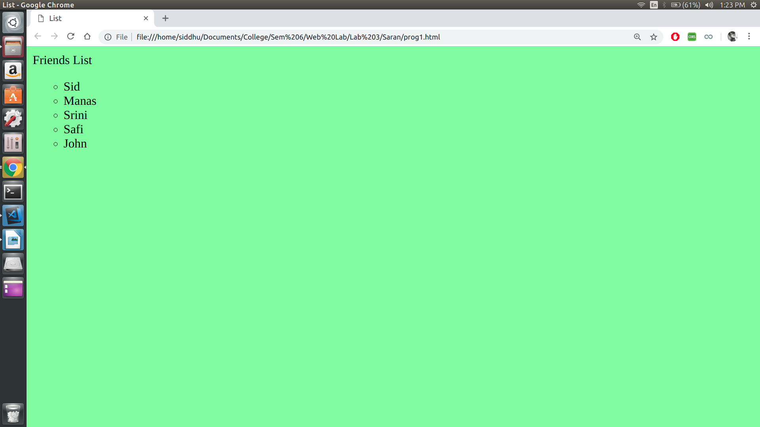
RESULT :
Thus the PROGRAM is executed and output is obtained.

PROGRAM – 2

AIM :
Create a web page in HTML CSS to display the maximum and minimum temperature of 5 cities using table.

PROGRAM :

prog2.html

<!DOCTYPE html>
<html>
<head>
<meta charset="utf-8" />
<meta http-equiv="X-UA-Compatible" content="IE=edge">
<title>Table</title>
<meta name="viewport" content="width=device-width, initial-scale=1">
<link rel="stylesheet" type="text/css" media="screen" href="prog2.css" />
</head>
<body>
<table class = "table">
<tr>
<th>City</th>
<th>Max Temperature</th>
<th>Min Temperature</th>
</tr>

<tr>
<td>Chennai</td>
<td>45</td>
<td>26</td>
</tr>
<tr>
<td>Kharagpur</td>
<td>35</td>
<td>15</td>
</tr>
<tr>
<td>Peshawar</td>
<td>10</td>
<td>-10</td>
</tr>
</table>
</body>
</html>

prog2.css

.table {
background-color: paleturquoise;
border: 1px solid green;
}

OUTPUT :

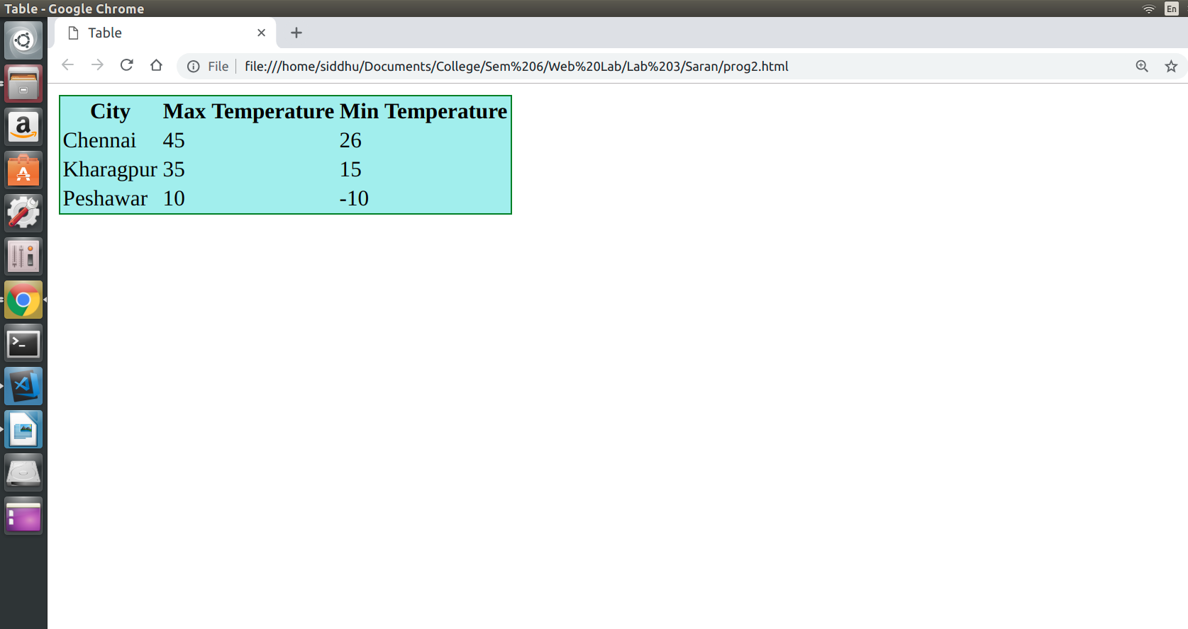

RESULT :
Thus the PROGRAM is executed and output is obtained

PROGRAM – 3

AIM :
To design a web page in HTML that accepts username and password. Opens a new window when the password corresponds to a particular value is set by the developer.

PROGRAM :

prog3.html

<!DOCTYPE html>
<html lang="en">
<head>
<meta charset="UTF-8">
<meta name="viewport" content="width=device-width, initial-scale=1.0">
<meta http-equiv="X-UA-Compatible" content="ie=edge">
<title>Document</title>
<!-- <link rel="stylesheet" href="prog3.css"> -->
</head>
<body>
Username:<input type="text", required, id="inp1">
Password:<input type="password", required, id="inp2">
<button type="button", onclick="check()">Submit</button>
</body>
<script>
function check()
{
var uname = document.getElementById("inp1");
var pass = document.getElementById("inp2");
var k = pass.value;
if( k === "password")
{
window.open("https://www.google.com/")
}
}
</script>
</html>

OUTPUT :

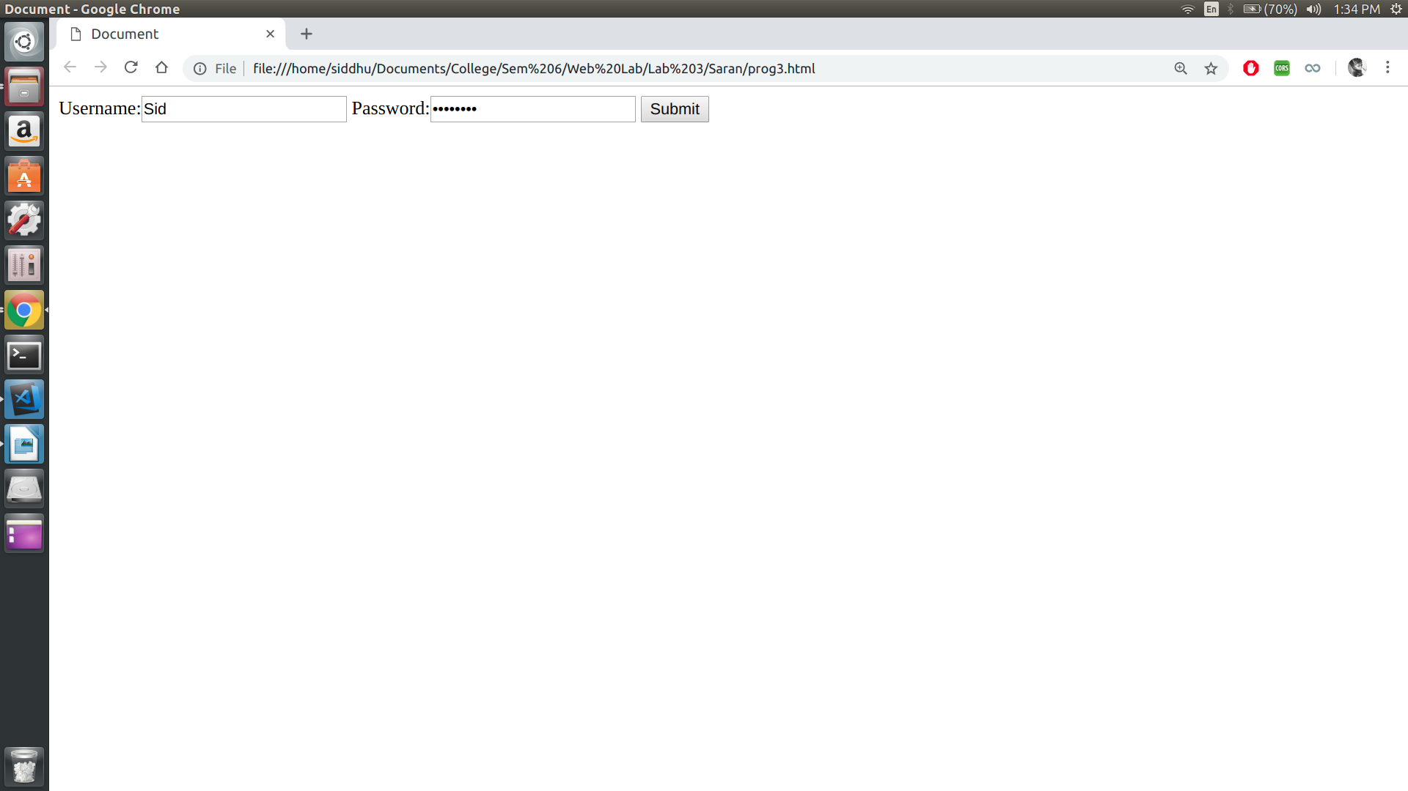

RESULT :
Thus the PROGRAM is executed and output is obtained

PROGRAM – 4

AIM :
To design a web page in HTML that consists of 2 text boxes. When the page is forst loaded set the focus to the first text box. The user should not be allowed to leave the box unless enters a value in it.

PROGRAM :

prog4.html

<!DOCTYPE html>
<html lang="en">
<head>
<meta charset="UTF-8">
<meta name="viewport" content="width=device-width, initial-scale=1.0">
<meta http-equiv="X-UA-Compatible" content="ie=edge">
<title>Document</title>
</head>

<body>
Name: <input type="text" , id="ip1" , onblur="check()" , autofocus>
Password: <input type="password" , id="ip2">
<button onclick="submitFunc()">Submit</button>
</body>
<script>
function check() {
var box = document.getElementById("ip1").value;
if (box == "")
document.getElementById("ip1").focus();
}
function submitFunc(){
alert("Password is : " + document.getElementById("ip2").value);
}
</script>
</html>

OUTPUT :

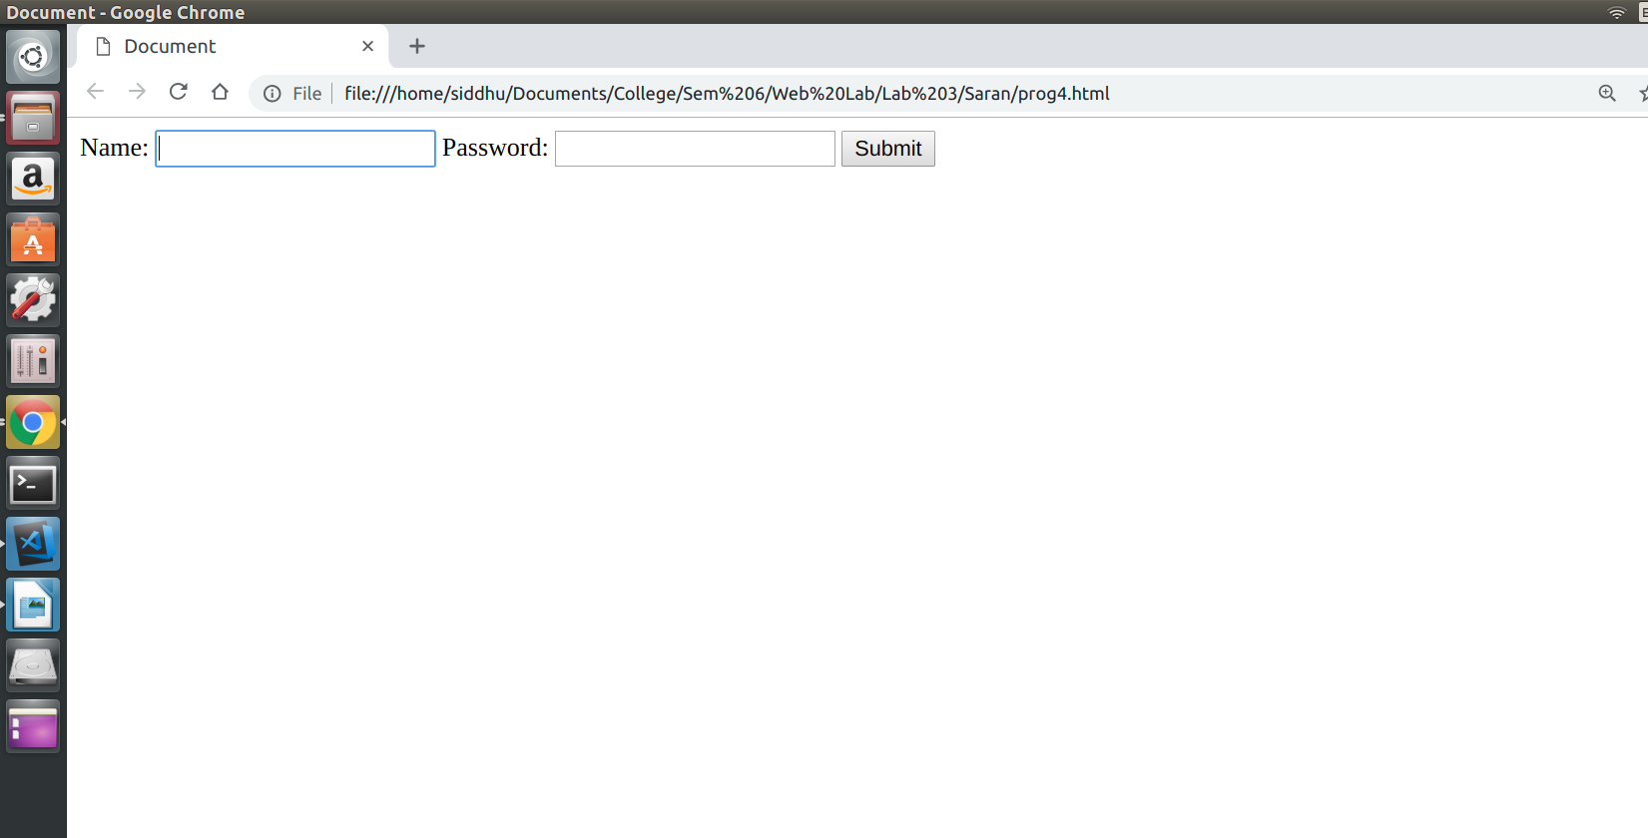
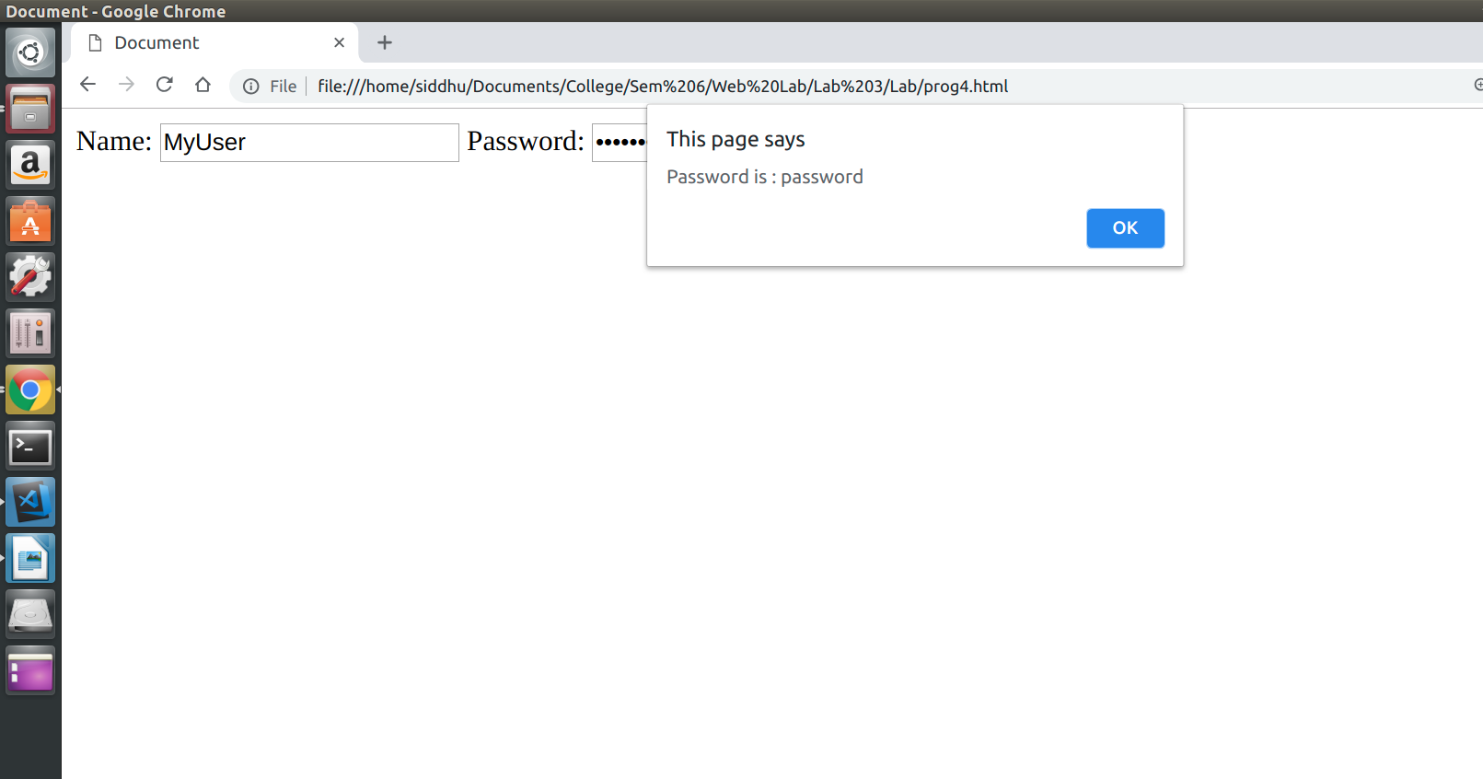

RESULT :
Thus the PROGRAM is executed and output is obtained

PROGRAM – 5

AIM :
To display an alert box to alert the x and y co-ordinates of the cursor in JavaScript.

PROGRAM :
prog5.html

<!DOCTYPE html>
<html lang="en">
<head>
<meta charset="UTF-8">
<meta name="viewport" content="width=device-width, initial-scale=1.0">
<meta http-equiv="X-UA-Compatible" content="ie=edge">
<title>Document</title>
</head>
<body onclick="fetchCoordinates()", class="body">
<p class = "para" >Click Me!!</p>
</body>
<style>
.body{
width: 100%;
min-height: 100%;
background-color: aqua;
}
</style>
<script>
function fetchCoordinates() {
console.log("heloo");
var cX = event.clientX;
var cY = event.clientY;
alert("xCoordinates: " + cX + "yCoordinates: " + cY)
}
</script>
</html>

OUTPUT :
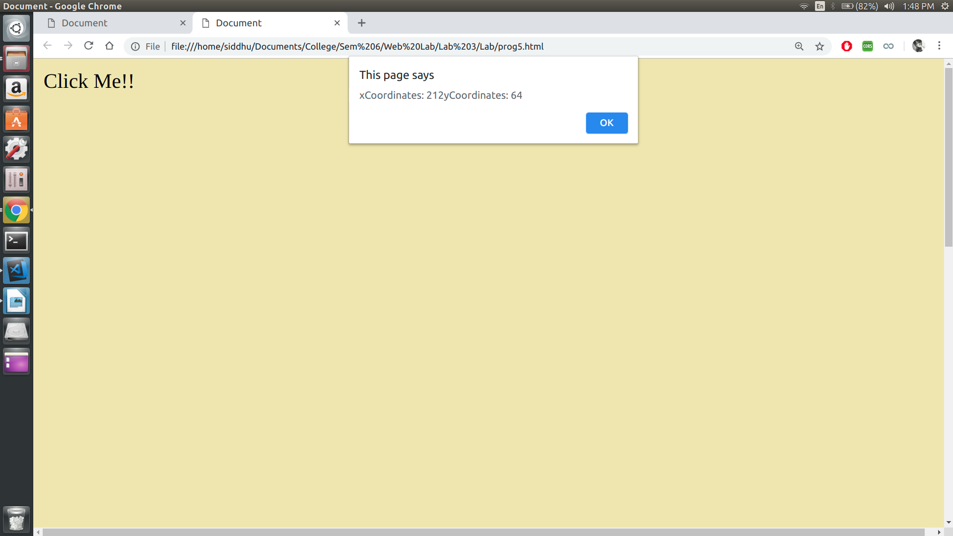
RESULT :
Thus the PROGRAM is executed and output is obtained
PROGRAM – 6

AIM :
To design a simple arithmetic calculator in JavaScript.

PROGRAM :

prog6.html

<html>
<head>
<title>Calculator</title>
</head>
<body>
<h3>Simple Calculator</h3>
<br />
<style>
#calc {
width: 300px;
height: 250px;
}
#btn {
width: 100%;
height: 40px;
font-size: 20px;
}
</style>
<form Name="calc">
<table id="calc" border="2">
<tr>
<td colspan="5">
<input
id="btn"
name="display"
onkeypress="return event.charCode >= 48 && event.charCode <= 57"
type="text"
/>
</td>
<td style="display:none"><input name="M" type="number" /></td>
</tr>
<tr>
<td>
<input
id="btn"
type="button"
value="MC"
OnClick="calc.M.value=''"
/>
</td>
<td>
<input
id="btn"
type="button"
value="0"
OnClick="calc.display.value+='0'"
/>
</td>
<td>
<input
id="btn"
type="button"
value="1"
OnClick="calc.display.value+='1'"
/>
</td>
<td>
<input
id="btn"
type="button"
value="2"
OnClick="calc.display.value+='2'"
/>
</td>
<td>
<input
id="btn"
type="button"
value="+"
OnClick="calc.display.value+='+'"
/>
</td>
</tr>
<tr>
<td>
<input
id="btn"
type="button"
value="MS"
OnClick="calc.M.value=calc.display.value"
/>
</td>
<td>
<input
id="btn"
type="button"
value="3"
OnClick="calc.display.value+='3'"
/>
</td>
<td>
<input
id="btn"
type="button"
value="4"
OnClick="calc.display.value+='4'"
/>
</td>
<td>
<input
id="btn"
type="button"
value="5"
OnClick="calc.display.value+='5'"
/>
</td>
<td>
<input
id="btn"
type="button"
value="-"
OnClick="calc.display.value+='-'"
/>
</td>
</tr>
<tr>
<td>
<input
id="btn"
type="button"
value="MR"
OnClick="calc.display.value=calc.M.value"
/>
</td>
<td>
<input
id="btn"
type="button"
value="6"
OnClick="calc.display.value+='6'"
/>
</td>
<td>
<input
id="btn"
type="button"
value="7"
OnClick="calc.display.value+='7'"
/>
</td>
<td>
<input
id="btn"
type="button"
value="8"
OnClick="calc.display.value+='8'"
/>
</td>
<td>
<input
id="btn"
type="button"
value="x"
OnClick="calc.display.value+='*'"
/>
</td>
</tr>
<tr>
<td>
<input
id="btn"
type="button"
value="M+"
OnClick="calc.M.value=(Number(calc.M.value))+ (Number(calc.display.value))"
/>
</td>
<td>
<input
id="btn"
type="button"
value="9"
OnClick="calc.display.value+='9'"
/>
</td>
<td>
<input
id="btn"
type="button"
value=""
OnClick="calc.display.value=(calc.display.value==Math.abs(calc.display.value)?-(calc.display.value):Math.abs(calc.display.value))"
/>
</td>
<td>
<input
id="btn"
type="button"
value="="
OnClick="calc.display.value=eval(calc.display.value)"
/>
</td>
<td>
<input
id="btn"
type="button"
value="/"
OnClick="calc.display.value+='/'"
/>
</td>
</tr>
<tr>
<td>
<input
id="btn"
type="button"
value="1/x"
OnClick="calc.display.value=1/calc.display.value"
/>
</td>
<td>
<input
id="btn"
type="button"
value="."
OnClick="calc.display.value+='.'"
/>
</td>
<td>
<input
id="btn"
type="button"
value="x2"
OnClick="calc.display.value=Math.pow(calc.display.value,2)"
/>
</td>
<td>
<input
id="btn"
type="button"
value="v"
OnClick="calc.display.value=Math.sqrt(calc.display.value)"
/>
</td>
<td>
<input
id="btn"
type="button"
value="C"
OnClick="calc.display.value=''"
/>
</td>
</tr>
</table>
</form>
</body>
</html>

OUTPUT :

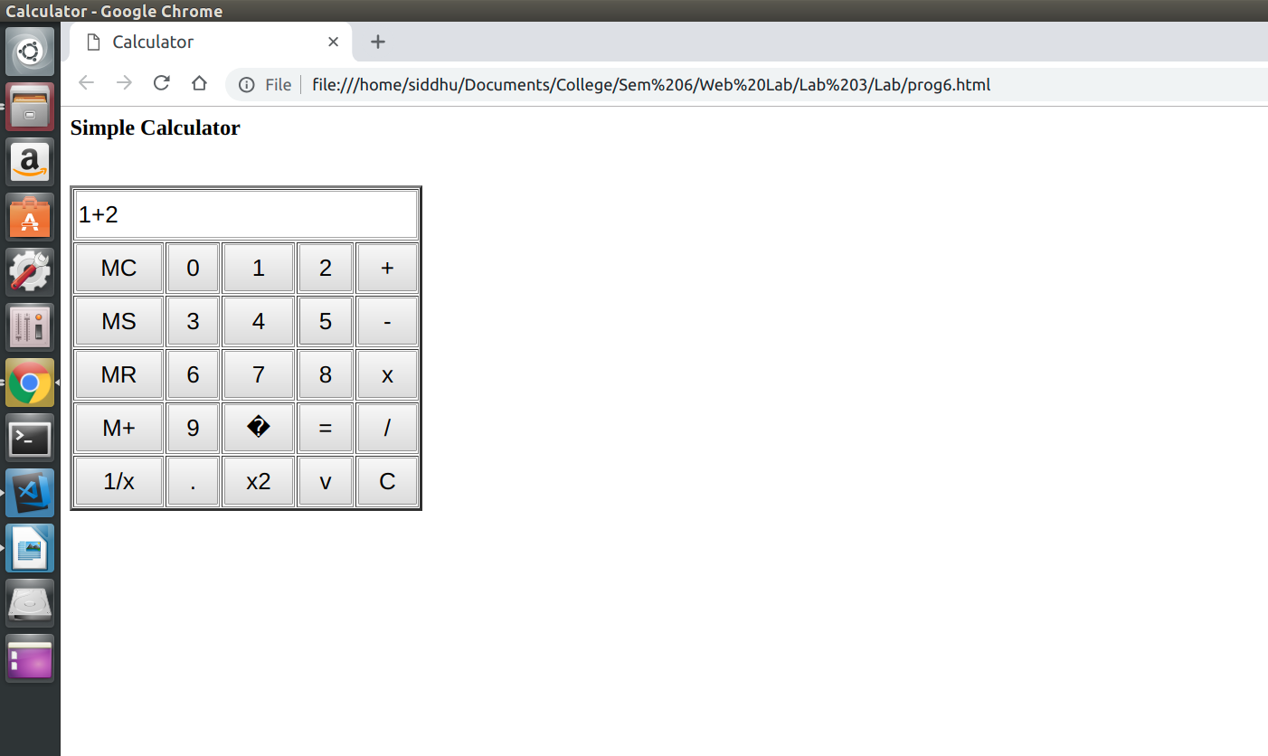
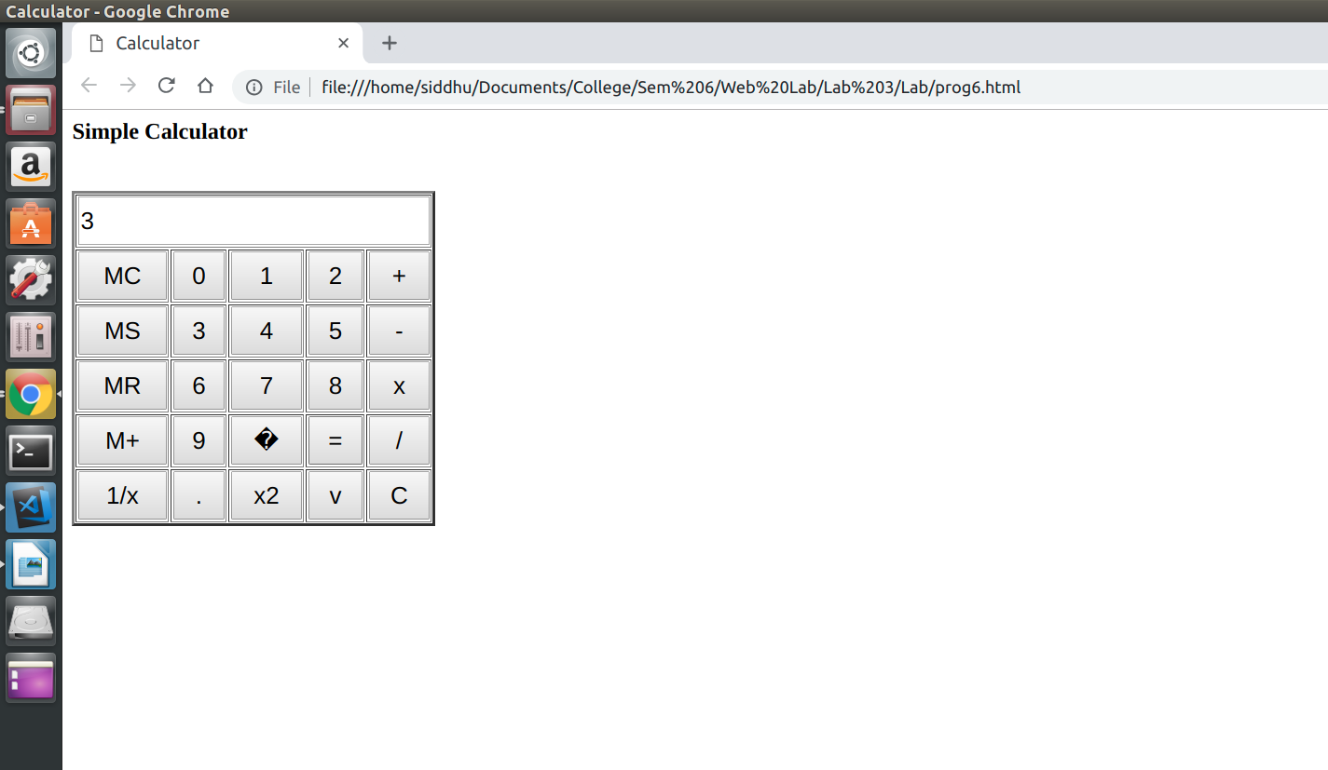

RESULT :
Thus the PROGRAM is executed and output is obtained

PROGRAM – 7

AIM :
To design a webpage to display a digital clock in JavaScript.

PROGRAM :

prog7.html

<!DOCTYPE html>
<html>
<head>
<meta charset="utf-8" />
<meta http-equiv="X-UA-Compatible" content="IE=edge">
<title>Page Title</title>
<meta name="viewport" content="width=device-width, initial-scale=1">
<link rel="stylesheet" type="text/css" media="screen" href="main.css" />
<script src="main.js"></script>
</head>
<body onload="startTime()">
<div id="txt"></div>
</body>

<script>
function startTime() {
var today = new Date();
var h = today.getHours();
var m = today.getMinutes();
var s = today.getSeconds();
m = checkTime(m);
s = checkTime(s);
document.getElementById('txt').innerHTML = h + ":" + m + ":" + s;
var t = setTimeout(startTime,500);
}
function checkTime(i) {
if(i<10)
{
i = "0" + i;
}
return i;
}
</script>
</html>

OUTPUT :

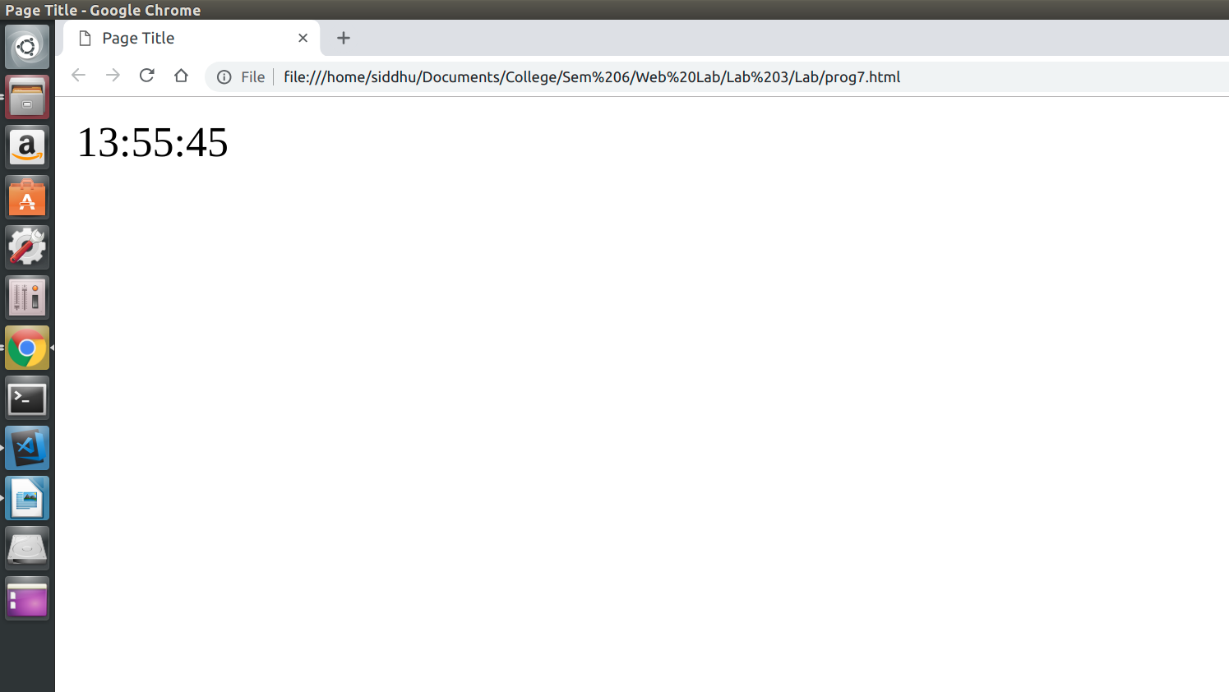

RESULT :
Thus the PROGRAM is executed and output is obtained

PROGRAM – 8

AIM :
To create, test and validate an XHTML document that describes an ordered list of 5 movies.

PROGRAM :

prog8.html

<!DOCTYPE html
PUBLIC "-//W3C//DTD XHTML 1.0 Transitional//EN" "http://www.w3.org/TR/xhtml1/DTD/xhtml1-transitional.dtd">
<html xmlns="http://www.w3.org/1999/xhtml">

<head>
<title>
Movies List
</title>
</head>

<body>
<ol>
<li>Inception</li>
<li>The dark knight</li>
<li>La la land</li>
<li>The Avengers</li>
<li>Deadpool</li>
</ol>
</body>
</html>

OUTPUT :

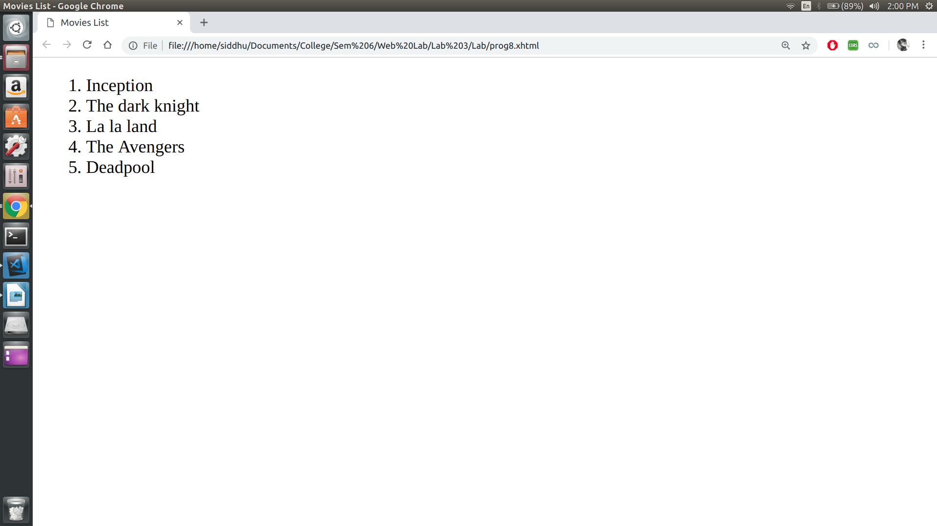

RESULT :
Thus the PROGRAM is executed and output is obtained.
PROGRAM – 9

AIM :
To create, test and validate an XHTML document that has a form with :
(i) A textbox to collect the user names.
(ii) Four check boxes.
(iii) A collection of 3 radio buttons

PROGRAM :

prog9.html

<!DOCTYPE html
PUBLIC "-//W3C//DTD XHTML 1.0 Transitional//EN" "http://www.w3.org/TR/xhtml1/DTD/xhtml1-transitional.dtd">
<html xmlns="http://www.w3.org/1999/xhtml">

<head>
<title>Document</title>
</head>

<body>
UserName: <input type="text" /> <br />
Strengths <br />
<form>
<input type="checkbox" name="gp2" id="cb1" /> Leadership<br />
<input type="checkbox" name="gp2" id="cb2" /> Technical<br />
<input type="checkbox" name="gp2" id="cb4" /> Marketing <br />
</form>
DEPARTMENT <br />
<form>
<input type="radio" name="gp1" id="rb1" checked="checked" />Computer Science Engineering<br />
<input type="radio" name="gp1" id="rb2" />Electronics and Communication Engineering<br />
<input type="radio" name="gp1" id="rb3" />Production Technology<br />
<input type="radio" name="gp1" id="rb4" />Rubber and Plastic Technology<br />
<input type="radio" name="gp1" id="rb5" />Mechanincal Engineering<br />
<input type="radio" name="gp1" id="rb6" />Automobile<br />
<input type="radio" name="gp1" id="rb7" />Aeronautical Engineering<br />
<input type="radio" name="gp1" id="rb8" />Elecronic and Instrumentation Engineering<br />
<input type="radio" name="gp1" id="rb9" />Information Technology<br />

</form>
</body>

</html>

OUTPUT :

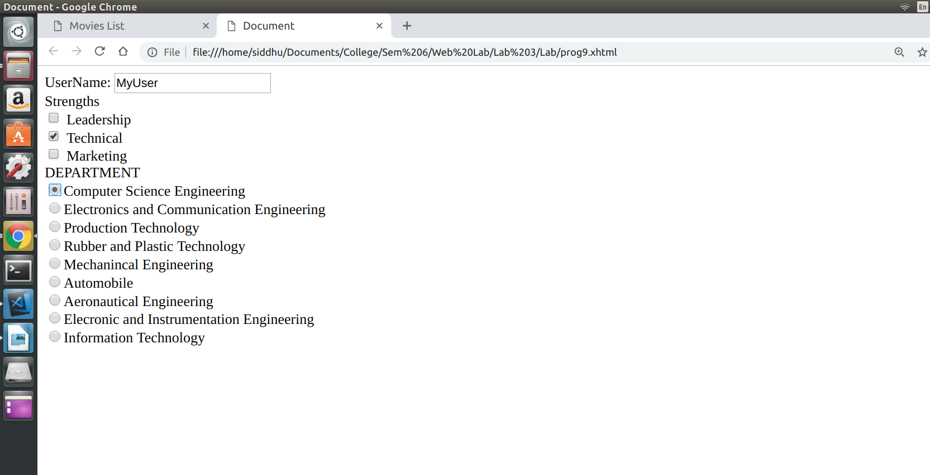

RESULT :
Thus the PROGRAM is executed and output is obtained

PROGRAM – 10

AIM :
To create a dynamic website of Department of Computer Technology in HTML / XHTML / JavaScript/

PROGRAM :

index.html

<!DOCTYPE html PUBLIC "-//W3C//DTD XHTML 1.0 Transitional//EN" "http://www.w3.org/TR/xhtml1/DTD/xhtml1-transitional.dtd">
<html xmlns="http://www.w3.org/1999/xhtml">
_{<head>}
<meta http-equiv="Content-Type" content="text/html; charset=utf-8" />
<link rel="stylesheet" type="text/css" href="style.css" />
<title>Computer Technology</title>
_{</head>}
_{<body>}
_{<div id="container">}
_{<div id="mainpic">}
<h1 style="color:blue">Department of <span class="lightblue">Computer Technology</span></h1>
_{</div>}
_{<div id="menu">}
_{<ul>}
<li class="menuitem"><a href="#">Home</a></li>
<li class="menuitem"><a href="#">About</a></li>
<li class="menuitem"><a href="http://www.mitindia.edu/en/ct-faculty">Faculty List</a></li>
<li class="menuitem"><a href="http://www.ct.mitindia.edu/studentslist.html">Student List</a></li>
<li class="menuitem"><a href="#">Services</a></li>
<li class="menuitem"><a href="#">Contact</a></li>
_{</ul>}
_{</div>}
_{<div id="content">}
_{<p>&nbsp;</p>}
_{<p>&nbsp;</p>}
_{<h1>ABOUT US</h1>}
<p> Computer technology has become an integral part of our daily life. It is the most important element in the education of students of the present and the future era. Computer Technology has revolutionized society to a great extent. Technological advancements are so rapid in this field that continual learning is essential to keep the skill set of students up to date. The department of Computer Technology was recently established in MIT campus of Anna University by bifurcating the department of Information Technology. The department offers course in computer science and engineering at undergraduate & postgraduate levels and full time/part time research PROGRAMs. The teaching and learning process emphasizes equally on theoretical and practical aspects catering to the needs of industries.</p>
_{<p>&nbsp;</p>}
_{<h2>Placement</h2>}
<p>The placement session that took place was highly successful and many students bagged great offers from various leading _{mncs</p>}
_{<p>&nbsp;</p>}
_{<h2>Contact US</h2>}
<p>Department of Computer Technology, <br />Madras Institute of Technology, <br />MIT Road, Radha Nagar, Chromepet,
<br />Chennai, Tamil Nadu 600044, India. <br />Tel:+91 44 _{2251 6231/32</p>}
_{<p>&nbsp;</p>}
_{<p>&nbsp;</p>}
_{<p>&nbsp;</p>}
_{<p>&nbsp;</p>}
_{<p>&nbsp;</p>}
_{<div id="footer">}
<h3><a href="http://www.bryantsmith.com">florida web _{design</a></h3>}
_{</div>}
_{</div>}
_{</div>}
_{</body>}
_{</html>}

style.css

body {
margin: 0;
padding: 0;
text-align: left;
font: 12px Arial, Helvetica, sans-serif;
font-size: 13px;
color: #061C37;
background: #1E4297;
background-repeat:repeat-x;
}
*
{
margin: 0 auto 0 auto;
text-align:left;}

#container
{
display: block;
height:auto;
position: relative;
width: 940px;
}
#mainpic h1
{
position:absolute;
text-align:right;
font-size:30px;
color:#FFF;
left:550px;
top:100px;
}
#mainpic h2
{
position:absolute;
text-align:right;
color:#E1E7F7;
left:550px;
top:130px;
}
#mainpic
{
background-image:url(images/main.jpg);
background-repeat:no-repeat;
width:900px;
height:402px;
}
.lightblue
{
color:black;
}
#menu
{
background-image:url(images/menu.png);
background-repeat:no-repeat;
width:940px;
height:69px;
float:left;
clear:both;
}
#content
{
width:880px;
height:auto;
background-color:#FFF;
padding-left:10px;
padding-right:10px;
padding-bottom:5px;
}
#footer h3 a,#footer h3 a:visited
{
display:inline;
text-align:center;
font-size:12px;
text-decoration:none;
color:#7198E1;
}
#menu ul {
list-style: none;
padding: 0px;
margin-left:auto;
width:900px;
}
#menu li {
list-style: none;
padding: 0px;
display: inline;
}
#menu a {
float: left;
width: 150px;
height: 40px;
display: block;
text-align: center;
text-decoration: none;
color: #ffffff;
font-weight: bold;
padding-top: 17px;
font-size: 15px;
}
html, body {
text-align: center;
}

OUTPUT :
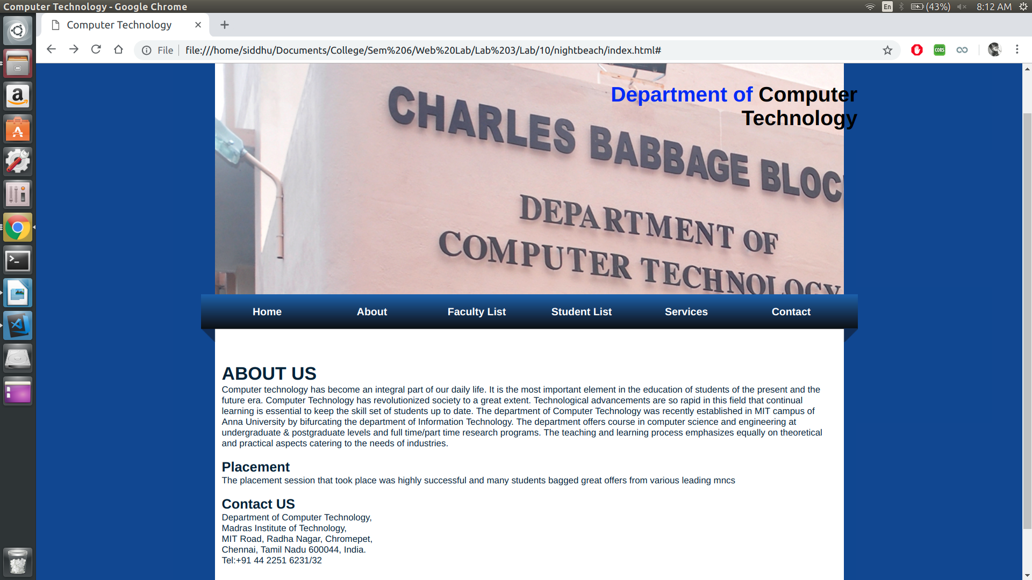
RESULT :
Thus the PROGRAM is executed and output is obtained.

Date – 04/01/19

Experiment - 4

PHP

PROGRAM 1.1:

AIM :
To write a PHP script that take in an array of strings and returns the list of unique strings in the parameter array

PROGRAM :
<?php
function compute($a1){
$a2 = array_unique($a1);
$a3 = array_values($a2);
return $a3;
}
$a1 = array("a","b","c","a","d","e");
$a2 = compute($a1);
print "The unique elements are\n";
for($x1=0;$x1<count($a2);$x1++){
print $a2[$x1]." ";
}
?>

OUTPUT:

d a b c d e
The unique elements are
a b c d e

RESULT:
Thus the PROGRAM is executed and OUTPUT is obtained

PROGRAM 1.2:

AIM :
To write a PHP script that take in an array of numbers and returns average and median of parameter array

PROGRAM:
<?php
function Average($numbers)
{
# code...
$k = array_sum($numbers);
$n = count($numbers);
$ans = $k/$n;
return $ans;
}

function Median($numbers)
{
if (count($numbers)%2 === 0) {
# code...
$mid=count($numbers)/2;
return (($numbers[$mid-1]+$numbers[$mid])/2);
}
else {
$mid=(count($numbers)-1)/2;
return $numbers[$mid];
}
}

$numbers=array(1,2,3,4,5);
echo ("AVERAGE: " .Average($numbers)."\n");
echo ("MEDIAN: ".Median($numbers)."\n");
?>

OUTPUT:

AVERAGE: 3
MEDIAN: 3

RESULT:
Thus the PROGRAM is executed and OUTPUT is obtained

PROGRAM 1.3:

AIM :
To write a PHP script that take in an array of strings and returns the list of three strings thta occur most frequently in parameter array.

PROGRAM:

<?php
function compute($a1){
$map = array_count_values($a1);
print_r($map);

arsort($map);
$a2 = array_keys($map);
for($x1=0;$x1<count($a2);$x1++)
{
print $a2[$x1];
}

return $a2;
}
$a1 = array("a","b","c","a","b","a","b","a","b","a");
$a2 = compute($a1);
print "The top 3 elements are\n";
for($x1=0;$x1<3;$x1++){
print $a2[$x1];
print " ";
}
?>

OUTPUT:

Array
(
[a] => 5
[b] => 4
[c] => 1
)
The top 3 elements are
a b c

RESULT:
Thus the PROGRAM is executed and OUTPUT is obtained

PROGRAM 1.4:

AIM :
To write a PHP script that take in an array of numbers (pass by value) and two arrays (pass by reference). The first pass by reference must have numbers less than zero and second must have numbers greater than 0

PROGRAM:

<?php
function filter($a, &$p, &$n)
{
$num = count($a);
for ($i=0; $i < $num; $i++) {
if($a[$i] > 0)
{
array_push($p,$a[$i]);
}
elseif($a[$i] < 0)
{
array_push($n,$a[$i]);
}
}
}
$numbers=array(-1,2,-3,4,-5);
$pos = array();
$neg = array();
filter($numbers,$pos,$neg);

echo "Positive array:\n";
for ($i=0; $i < count($pos); $i++) {
echo($pos[$i]." ");
}
echo "\n";
echo "Negative array:\n";
for ($i=0; $i < count($neg); $i++) {
echo($neg[$i]." ");
}
?>

OUTPUT:
Positive array:
2 4
Negative array:
-1 -3 -5

RESULT:
Thus the PROGRAM is executed and OUTPUT is obtained
PROGRAM 1.5:

AIM :
To write a PHP script that take in an string of numbers separated by spaces and returns first four digit number in the string, else return none.

PROGRAM:

<?php
function compute($a1){
$a3 = explode(' ',$a1);
$a2 = array_values($a3);
for($x1=0;$x1<count($a2);$x1++){
if(strlen($a2[$x1]) == 4){
$ans = $a2[$x1];
return $ans."\n";
}
}
return "false";
}
$a1 ="1 2 34 12 4455";
print $a1."\n" ;
$a2 = compute($a1);
print $a2 . "\n";
$a1 ="1 2 34 12 345";
print $a1."\n" ;
$a2 = compute($a1);
print $a2 . "\n";
?>

OUTPUT:

1 2 34 12 4455
4455
1 2 34 12 345
false

RESULT:
Thus the PROGRAM is executed and OUTPUT is obtained

PROGRAM 1.6:

AIM :
To write a PHP script that take in a file variable of a file of text where the words are separated by spaces or colons and returns the word that appears most often in the file

PROGRAM:

<?php
function findMax($file,$fname)
{
# code...
$filecontents = file_get_contents($fname);
echo $filecontents;
$words = preg_split('/[\s|:]+/', $filecontents, -1, PREG_SPLIT_NO_EMPTY);
$arr = array_count_values($words);
print_r($words);
$max = 0;
$word = "";
foreach ($arr as $key => $value) {
# code...
if($value > $max)
{
$max = $value;
$word = $key;
}
}
return $word;
}

$fname = "prog1_6.txt";
$file = fopen($fname,"r") or die("Unable to open file");
echo findMax($file,$fname);
?>

OUTPUT:

Input File :
harry potter lilly:potter:james:potter

OUTPUT :
potter

RESULT:
Thus the PROGRAM is executed and OUTPUT is obtained

PROGRAM 1.7:

AIM :
To write a PHP script that take in an string containing words that are delimited on the left by spaces and on the left with spaces, commas, periods or question marks and returns three most common words in the string that has 3 or more letters

PROGRAM:
<?php
function compute($a1){
$a3 = preg_split('/[\s]+|\.|\,/',$a1);
$a2 = array_values($a3);
$ff = array();
for($x=0;$x<count($a2);$x++){
if(strlen($a2[$x])>3){
array_push($ff,$a2[$x]);
}
}
$map = array_count_values($ff);
arsort($map);
$ans = array_keys($map);
return $ans;
}
$a1 =" hello, there welcome. a vdgdhfghj, welcome.";
$a2 = compute($a1);
print "The top 3 elements are\n";
for($x1=0;$x1<3;$x1++){
print $a2[$x1];
print " ";
}
?>

OUTPUT:
The top 3 elements are welcome hello there

RESULT:
Thus the PROGRAM is executed and OUTPUT is obtained

PROGRAM 2:

AIM :
To write an XHTML document that includes an anchor tag that calls a PHP document. Also write the PHP document, which returns a which returns a randomly chosen different greetings. The greetings must be stored as constant strings in the script.

PROGRAM:
<?php
function greetingCall(){
define("GREETING1","Have a nice day.");
define("GREETING2","Thank you.");
define("GREETING3","Welcome.");
define("GREETING4","Nice meeting you.");
define("GREETING5","Hope to see you again.");
$greet = array(GREETING1,GREETING2,GREETING3,GREETING4,GREETING5);
$index = rand(0,4);
echo "<div>".$greet[$index]."</div>";
}
greetingCall();
?>

XHTML:
<!DOCTYPE html PUBLIC "-//W3C//DTD XHTML 1.0 Transitional//EN" "http://www.w3.org/TR/xhtml1/DTD/xhtml1-transitional.dtd">
<html xmlns="http://www.w3.org/1999/xhtml">
<head>
<title>
PROGRAM 2
</title>
</head>
<body>
<a href="http://localhost:8000">Click to view Greeting</a>
</body>
</html>

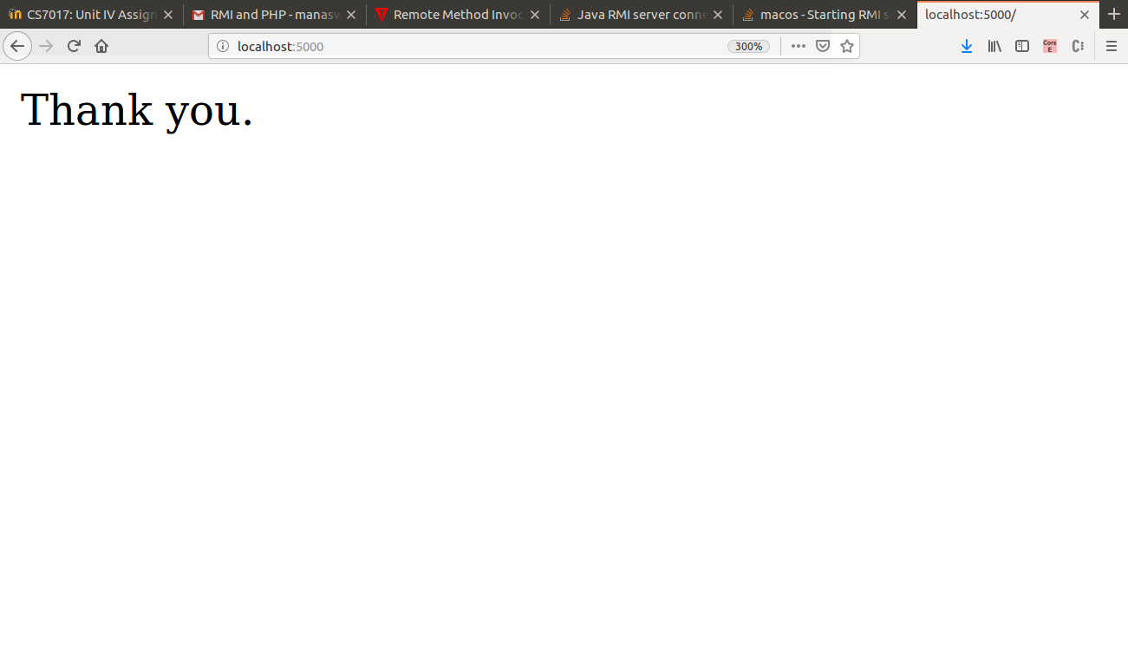
OUTPUT:
RESULT:
Thus the PROGRAM is executed and OUTPUT is obtained.

PROGRAM 3:

AIM :
To write an XHTML document to create a form that collects favorite popular songs, including the name of the song, the composer, and the performing artist or group. The document must call one PHP script where the form is submitted and another to request a current list of survey RESULTs.

PROGRAM:
<!DOCTYPE html PUBLIC "-//W3C//DTD XHTML 1.0 Transitional//EN" "http://www.w3.org/TR/xhtml1/DTD/xhtml1-transitional.dtd">
<html xmlns="http://www.w3.org/1999/xhtml">
<head>
<title>
PROGRAM 3
</title>
</head>
<body>
<?php
$display = "";
$content = $artist = $name = $song = $composer = "";
if ($_SERVER["REQUEST_METHOD"] == "POST")
{
$file = fopen("prog3.txt","r");
$content = "Name: " . $_POST["name"] . "\n" . "Favorite Song: " . $_POST["song"] . "\n" . "Composer: " . $_POST["composer"] . "\n" . "Artist/Group: " . $_POST["artist"] . "\n\n";
$myfile = file_put_contents('prog3.txt', $content.PHP_EOL , FILE_APPEND | LOCK_EX);
$display = file('prog3.txt');
}
?>

<form method="post" action="<?php htmlspecialchars($_SERVER["PHP_SELF"]);?>">
Name: <input type="text" name="name" id="name" value="<?php echo $name;?>"/><br />
Favorite Song: <input type="text" name="song" id="song" value="<?php echo $song;?>"/><br />
Composer: <input type="text" name="composer" id="composer" value="<?php echo $composer;?>"/><br />
Performing Group (or) artist <input type="text" name="artist" id="artist" value="<?php echo $artist;? >"/><br/>
<input type="submit" value="submit" /><br />
<br />
<br />
<div>
<?php
for ($i=0; $i < count($display); $i++) {
echo $display[$i] . "<br>";
}
?>
</div>
</form>
</body>
</html>

OUTPUT :

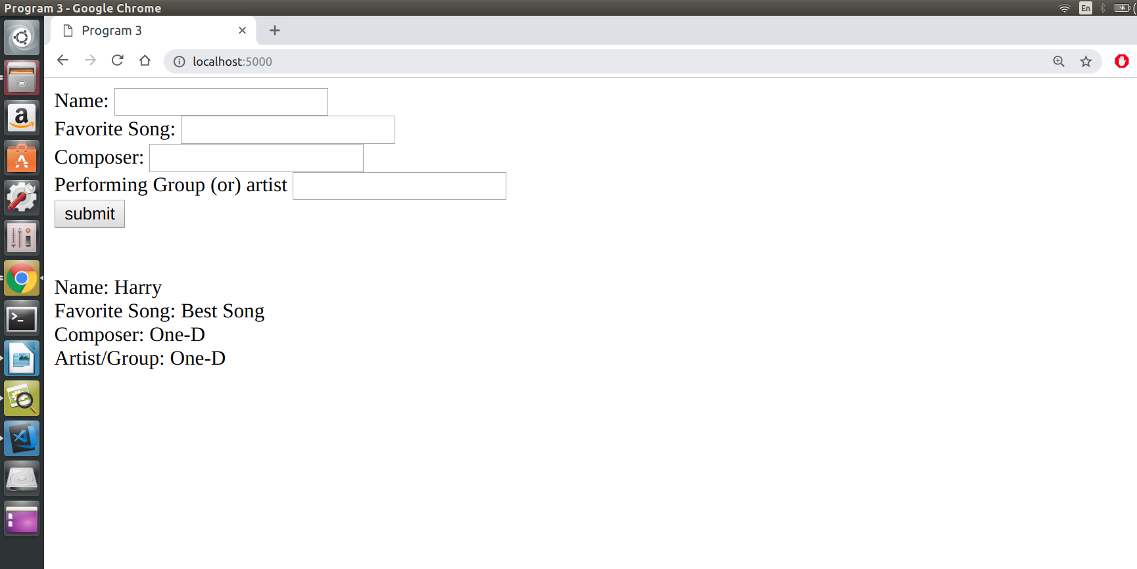

RESULT:
Thus the PROGRAM is executed and OUTPUT is obtained

PROGRAM 4:

AIM:
To write an XHTML document to provide a form that collects names and telephone numbers. The mobile numbers must be in the format +dd-dddd-dddddd. Write a PHP script that checks the submitted mobile number to be sure that it comfirms to the required format
and returns a response indicating whether the number was correct.

PROGRAM :

<!DOCTYPE html PUBLIC "-//W3C//DTD XHTML 1.0 Transitional//EN" "http://www.w3.org/TR/xhtml1/DTD/xhtml1-transitional.dtd">
<html xmlns="http://www.w3.org/1999/xhtml">
<head>
<title>
PROGRAM 4
</title>
</head>
<body>
<?php
$mobileErr = "";
$mobile = "";
$name = "";
if ($_SERVER["REQUEST_METHOD"] == "POST")
{
if(empty($_POST["mobile"])) {
$mobileErr = "Mobile number is required";
} else {
$mobile = test_input($_POST["mobile"]);
if(!preg_match("/\+\d{2}-\d{4}-\d{6}/", $mobile))
{
$mobileErr = "invalid Format";
}
}
}
function test_input($data) {
$data = trim($data);
$data = stripslashes($data);
$data = htmlspecialchars($data);
return $data;
}
?>

<h2>Form Validation</h2>
<form method="post" action="<?php htmlspecialchars($_SERVER["PHP_SELF"]);?>">
Name: <input type="text" name="name" value="<?php echo $name;?>" /><br><br>
Mobile: <input type="text" name="mobile" value="<?php echo $mobile;?>" />
<span class="error">* <?php echo $mobileErr;?></span>
<br /><br />
<input type="submit" name="submit" value="Submit" />
</form>
</body>
</html>

OUTPUT:
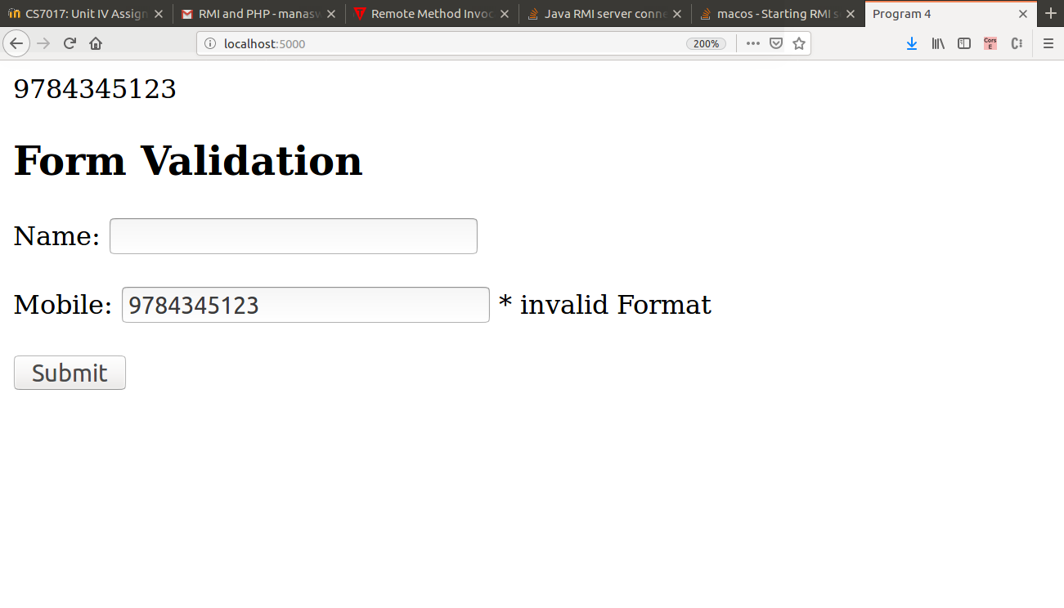

RESULT:
Thus the PROGRAM is executed and OUTPUT is obtained

PROGRAM 5:

AIM :
To modify the PHP script from Exercise 2 to count the number of visitors and display the numbers for each visitor.

PROGRAM:
<?php
function greetingCall(){
define("GREETING1","Have a nice day.");
define("GREETING2","Thank you.");
define("GREETING3","Welcome.");
define("GREETING4","Nice meeting you.");
$greet = array(GREETING1,GREETING2,GREETING3,GREETING4,GREETING5);
$index = rand(0,4);
$fp = file_get_contents("prog5.txt");
$val = (int)$fp;
$val+=1;
$fp = (string)$val;
print "<div>".$greet[$index]."</div>";
print "<div> Client Number ".$val."</div>";
} greetingCall();
?>

XHTML:
<!DOCTYPE html PUBLIC "-//W3C//DTD XHTML 1.0 Transitional//EN" "http://www.w3.org/TR/xhtml1/DTD/xhtml1-transitional.dtd">
<html xmlns="http://www.w3.org/1999/xhtml">
<head>
<title>
PROGRAM 5
</title>
</head>
<body>
<a href="http://localhost:8000">Click to view Greeting</a>
</body>
</html>

OUTPUT:
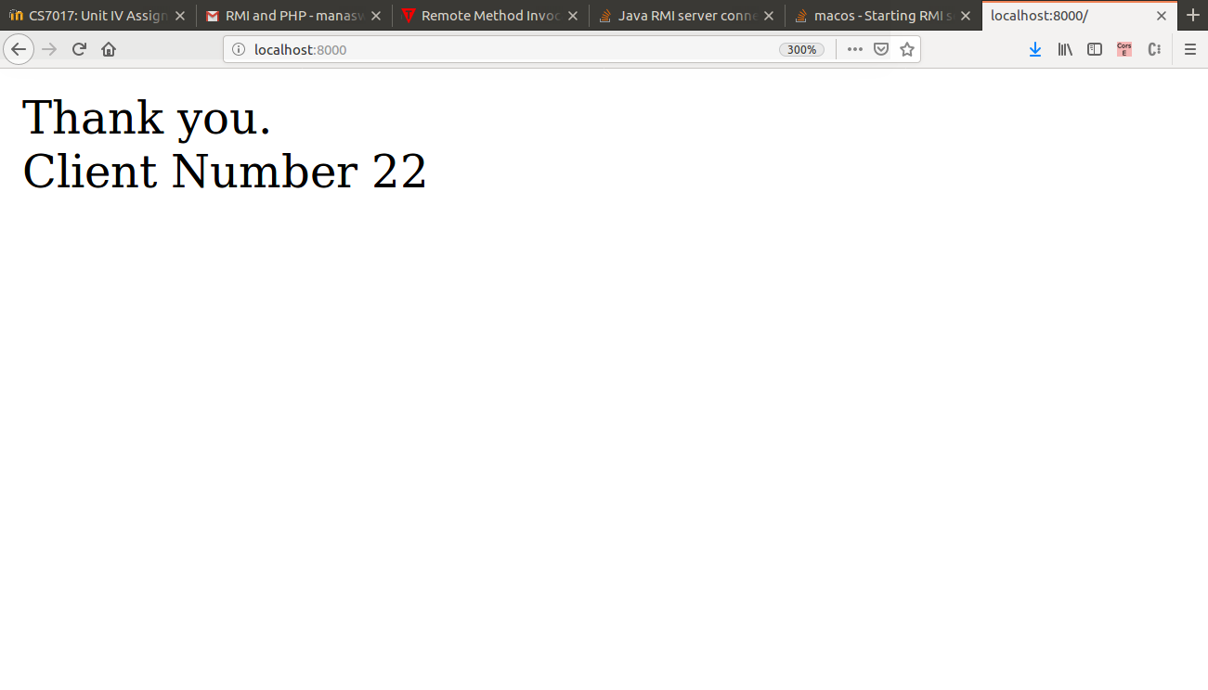
RESULT:
Thus the PROGRAM is executed and OUTPUT is obtained
PROGRAM 6:

AIM :
To implement the following modules using Server Side Scripting (PHP)
(i) Gathering form data.
(ii) Querying the database.
(iii) Response generation.
(iv) Session management.
(v) Use MySQL or JDBS or Oracle.

PROGRAM :

<html>
<head>
<style>
body{
display: inline-block;
width:100%;
height:100%;
text-align:center;
}
</style>
</head>
<body>
<?php
session_start();
?>
<?php
$regno = "";
$pwd = "";
$regErr = "";
$pwdErr = "";
$name = "";
$address = "";
$mobile = "";
$time = $_SERVER['REQUEST_TIME'];
$timeout_duration = 60;
if (isset($_SESSION['LAST_ACTIVITY']) && ($time - $_SESSION['LAST_ACTIVITY']) > $timeout_duration) {
session_unset();
session_destroy();
session_start();
}
if ($_SERVER["REQUEST_METHOD"] == "POST")
{
if(empty($_POST["regno"])) {
$regErr = "Student Registeration number is required";
}
if(empty($_POST["pwd"])) {
$pwdErr = "Password is required";
}

if(isset($_POST["reg"]) && isset($_POST["pwd"])){

$servername = "localhost";
$username = "root";
$password = "0611";
$dbname = "test";

$conn = new mysqli($servername,$username, $password,$dbname);
if($conn -> connect_error){
die("Connection failed: ".$conn- >connect_error);
}

$regno = $_POST['regno'];
$pwd = $_POST['pwd'];

$sql = "SELECT name,address,mobile,id from Tab1 where id = '$regno' and password = '$pwd';";
$result = $conn->query($sql);
if($result->num_rows > 0){
while($row = $result->fetch_assoc()){
$name = $row["name"];
$address = $row["address"];
$mobile = $row["mobile"];
$regno = $row["id"];
}
}
else{
print "Data mismatch. Please try again.";
$regno = "";
$pwd = "";
}

$conn ->close();
}
$_SESSION['LAST_ACTIVITY'] = $time;
}
?>
<div><h1>Depatment of Computer Technology</h1></div>
<br>
<br>
<form class = "form1" method="post" action="<?php htmlspecialchars($_SERVER["PHP_SELF"]);?>">
<h3>
Registeration No: <input type="text" name="regno" id ="regno" value="<?php echo $regno;?>" />
<span class="error">* <?php echo $regErr;?></span>
<br /><br />
Password: <input type="password" name="pwd" id ="pwd" value="<?php echo $pwd;?>" />
<span class="error">* <?php echo $pwdErr;?></span>
<br /><br />
<input type="submit" name="submit" value="submit" />
<br>
<br>
<div>
Student Name: <input type="text" name="name" id = "name" value="<?php echo $name;?>" />
Registeration No: <input type="text" name="reg" id = "reg" value="<?php echo $regno;?>" />
Address: <input type="text" name="address" id = "address" value="<?php echo $address;?>" />
Student Name: <input type="text" name="mobile" id = "mobile" value="<?php echo $mobile;?>" />
</div>
</h3>
</form>
</body>
</html>

OUTPUT :

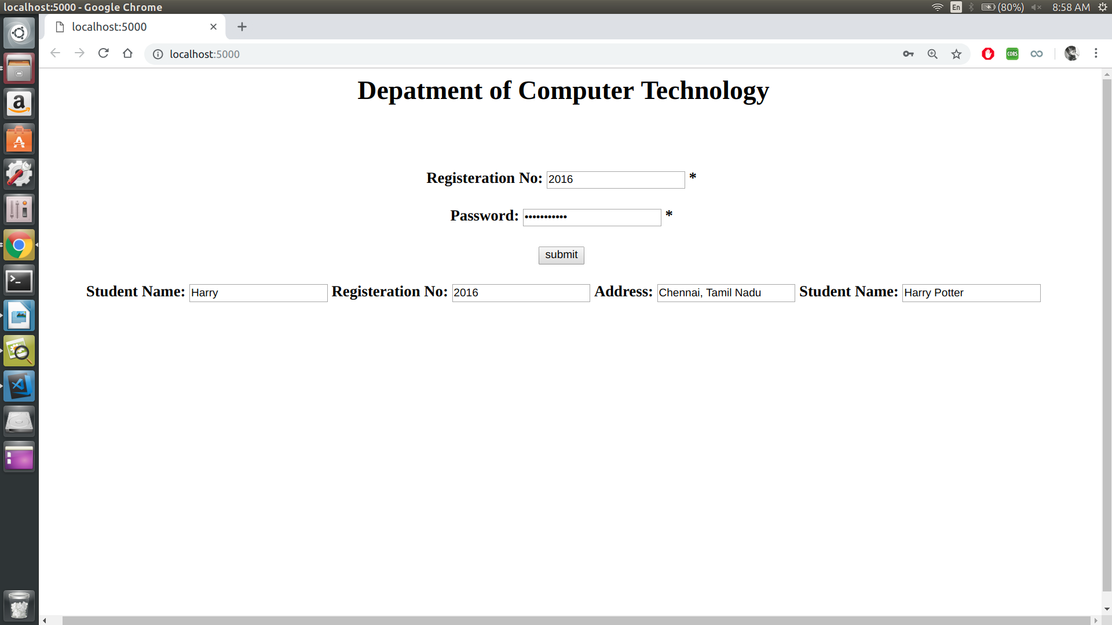
RESULT:
Thus the PROGRAM is executed and OUTPUT is obtained.

Date – 11/01/19

Experiment – 5

PYTHON PROGRAMMING

Program – 1

AIM :
To create a new program called HelloWorld.py . This file should be used to write your ”Hello World !” program.

PROGRAM :

p1.py

print('Hello World')

OUTPUT:

Hello World

RESULT :
Thus the program is executed and output is obtained.

Program – 2

AIM :
To write a function reverse to reverse a list without using the reverse function.

PROGRAM :

p2.py

li = [1, 2, 3, 4, 5]
print('Original List : ', li)
print('Reversed List : ', li[::-1])

OUTPUT:

('Original List : ', [1, 2, 3, 4, 5])
('Reversed List : ', [5, 4, 3, 2, 1])

RESULT :
Thus the program is executed and output is obtained.

Program – 3

AIM :
To write a method fact that takes a number from the user and prints the factorial.

PROGRAM :

p3.py

def fact(n):
fact = 1
for i in range(1, n+1):
fact = fact*i
return fact

n = int(input('Enter n :'))
print(str(n)+'! is : '+str(fact(n)))

OUTPUT:

Enter n :5
5! is : 120

RESULT :
Thus the program is executed and output is obtained.

Program – 4

AIM :
To write a GUI for the expression calculator using tk.

PROGRAM :

P4.py

from tkinter import *

expression = ""

def press(num):
global expression

expression = expression + str(num)

equation.set(expression)

def equalpress():
try:
global expression

total = str(eval(expression))

equation.set(total)

expression = ""

except:

equation.set(" error ")
expression = ""

def clear():
global expression
expression = ""
equation.set("")

if __name__ == "__main__":
gui = Tk()

gui.configure(background="light blue")

gui.title("Simple Calculator")

gui.geometry("300x125")

equation = StringVar()

expression_field = Entry(gui, textvariable=equation)

expression_field.grid(columnspan=4, ipadx=70)

equation.set('enter your expression')

button1 = Button(gui, text=' 1 ', fg='black', bg='pink',
command=lambda: press(1), height=1, width=7)
button1.grid(row=4, column=0)

button2 = Button(gui, text=' 2 ', fg='black', bg='pink',
command=lambda: press(2), height=1, width=7)
button2.grid(row=4, column=1)

button3 = Button(gui, text=' 3 ', fg='black', bg='pink',
command=lambda: press(3), height=1, width=7)
button3.grid(row=4, column=2)

button4 = Button(gui, text=' 4 ', fg='black', bg='pink',
command=lambda: press(4), height=1, width=7)
button4.grid(row=3, column=0)

button5 = Button(gui, text=' 5 ', fg='black', bg='pink',
command=lambda: press(5), height=1, width=7)
button5.grid(row=3, column=1)

button6 = Button(gui, text=' 6 ', fg='black', bg='pink',
command=lambda: press(6), height=1, width=7)
button6.grid(row=3, column=2)

button8 = Button(gui, text=' 8 ', fg='black', bg='pink',
command=lambda: press(8), height=1, width=7)
button8.grid(row=1, column=1)

button9 = Button(gui, text=' 9 ', fg='black', bg='pink',
command=lambda: press(9), height=1, width=7)
button9.grid(row=1, column=2)

button0 = Button(gui, text=' 0 ', fg='black', bg='pink',
command=lambda: press(0), height=1, width=7)
button0.grid(row=5, column=0)

plus = Button(gui, text=' + ', fg='black', bg='pink',
command=lambda: press("+"), height=1, width=7)
plus.grid(row=1, column=3)

multiply = Button(gui, text=' * ', fg='black', bg='pink',
command=lambda: press("*"), height=1, width=7)
multiply.grid(row=4, column=3)

divide = Button(gui, text=' / ', fg='black', bg='pink',
command=lambda: press("/"), height=1, width=7)
divide.grid(row=5, column=3)

equal = Button(gui, text=' = ', fg='black', bg='pink',
command=equalpress, height=1, width=7)
equal.grid(row=5, column=2)

clear = Button(gui, text='Clear', fg='black', bg='pink',
command=clear, height=1, width=7)
clear.grid(row=5, column='1')

gui.mainloop()
OUTPUT:
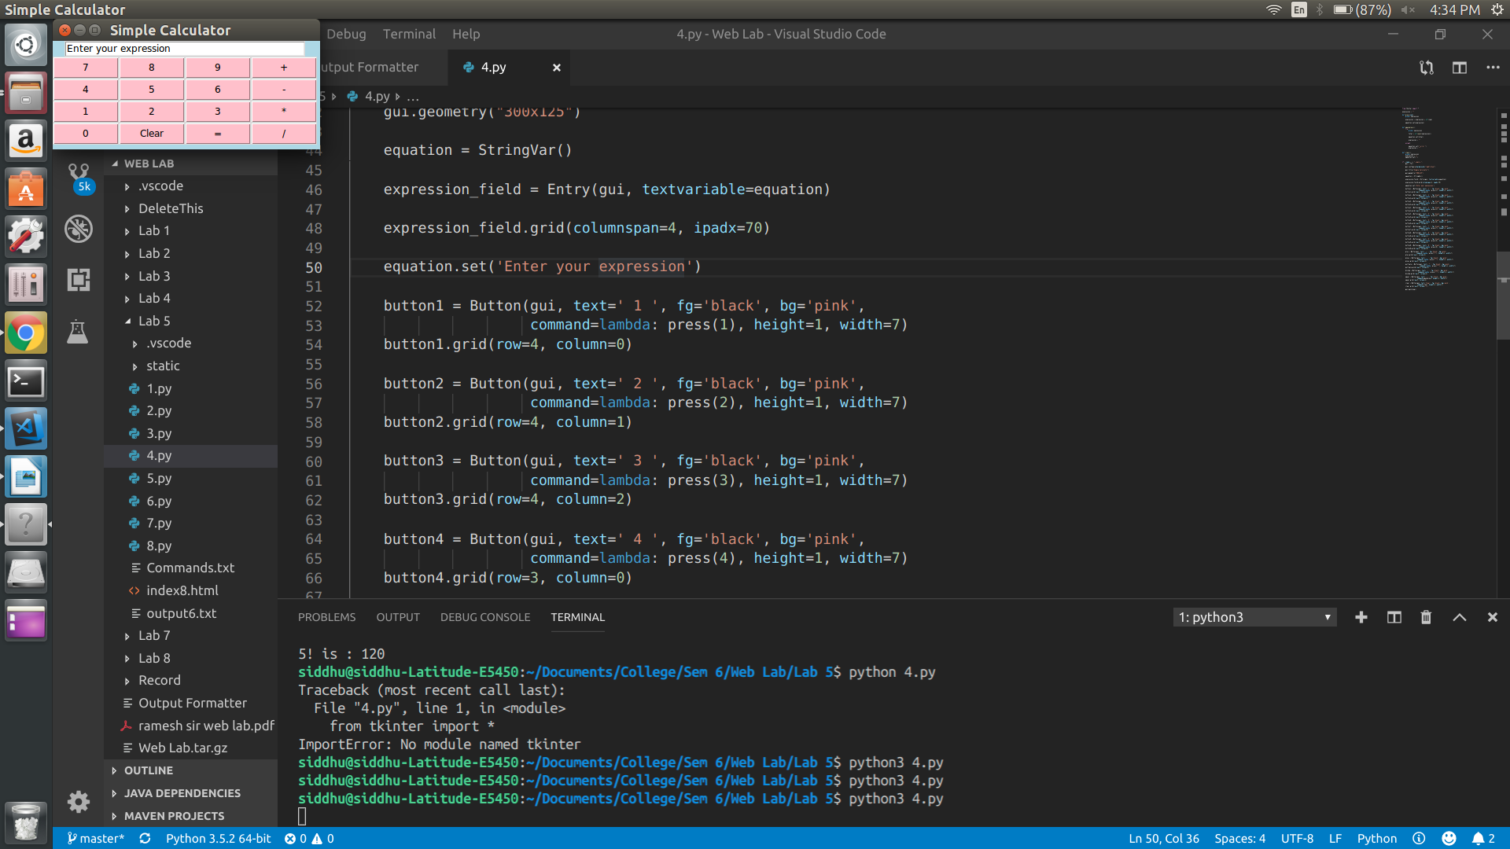
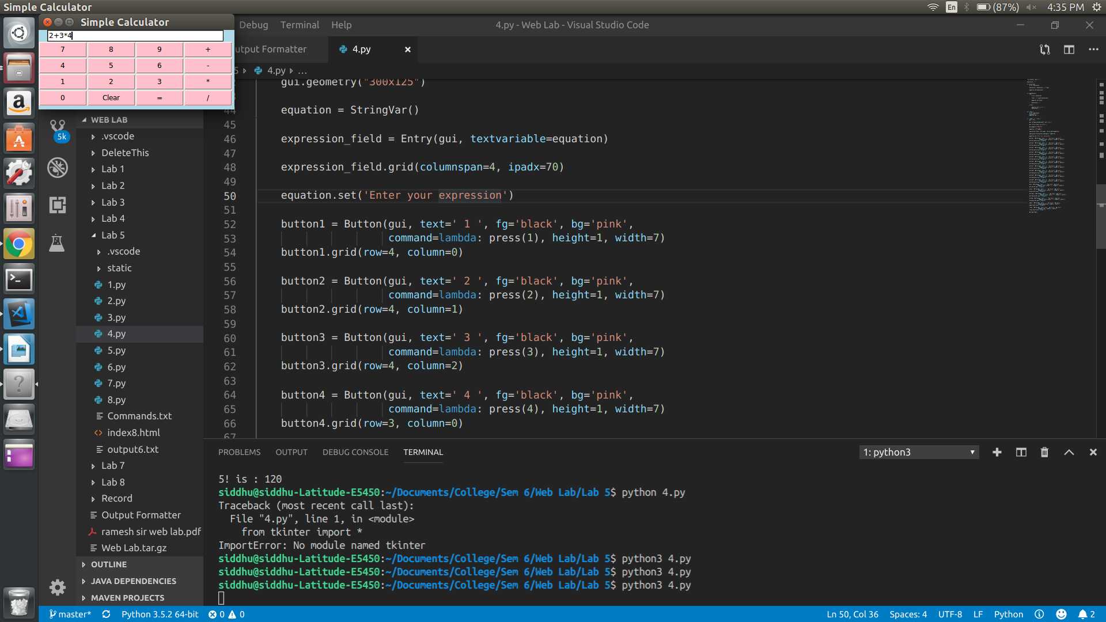
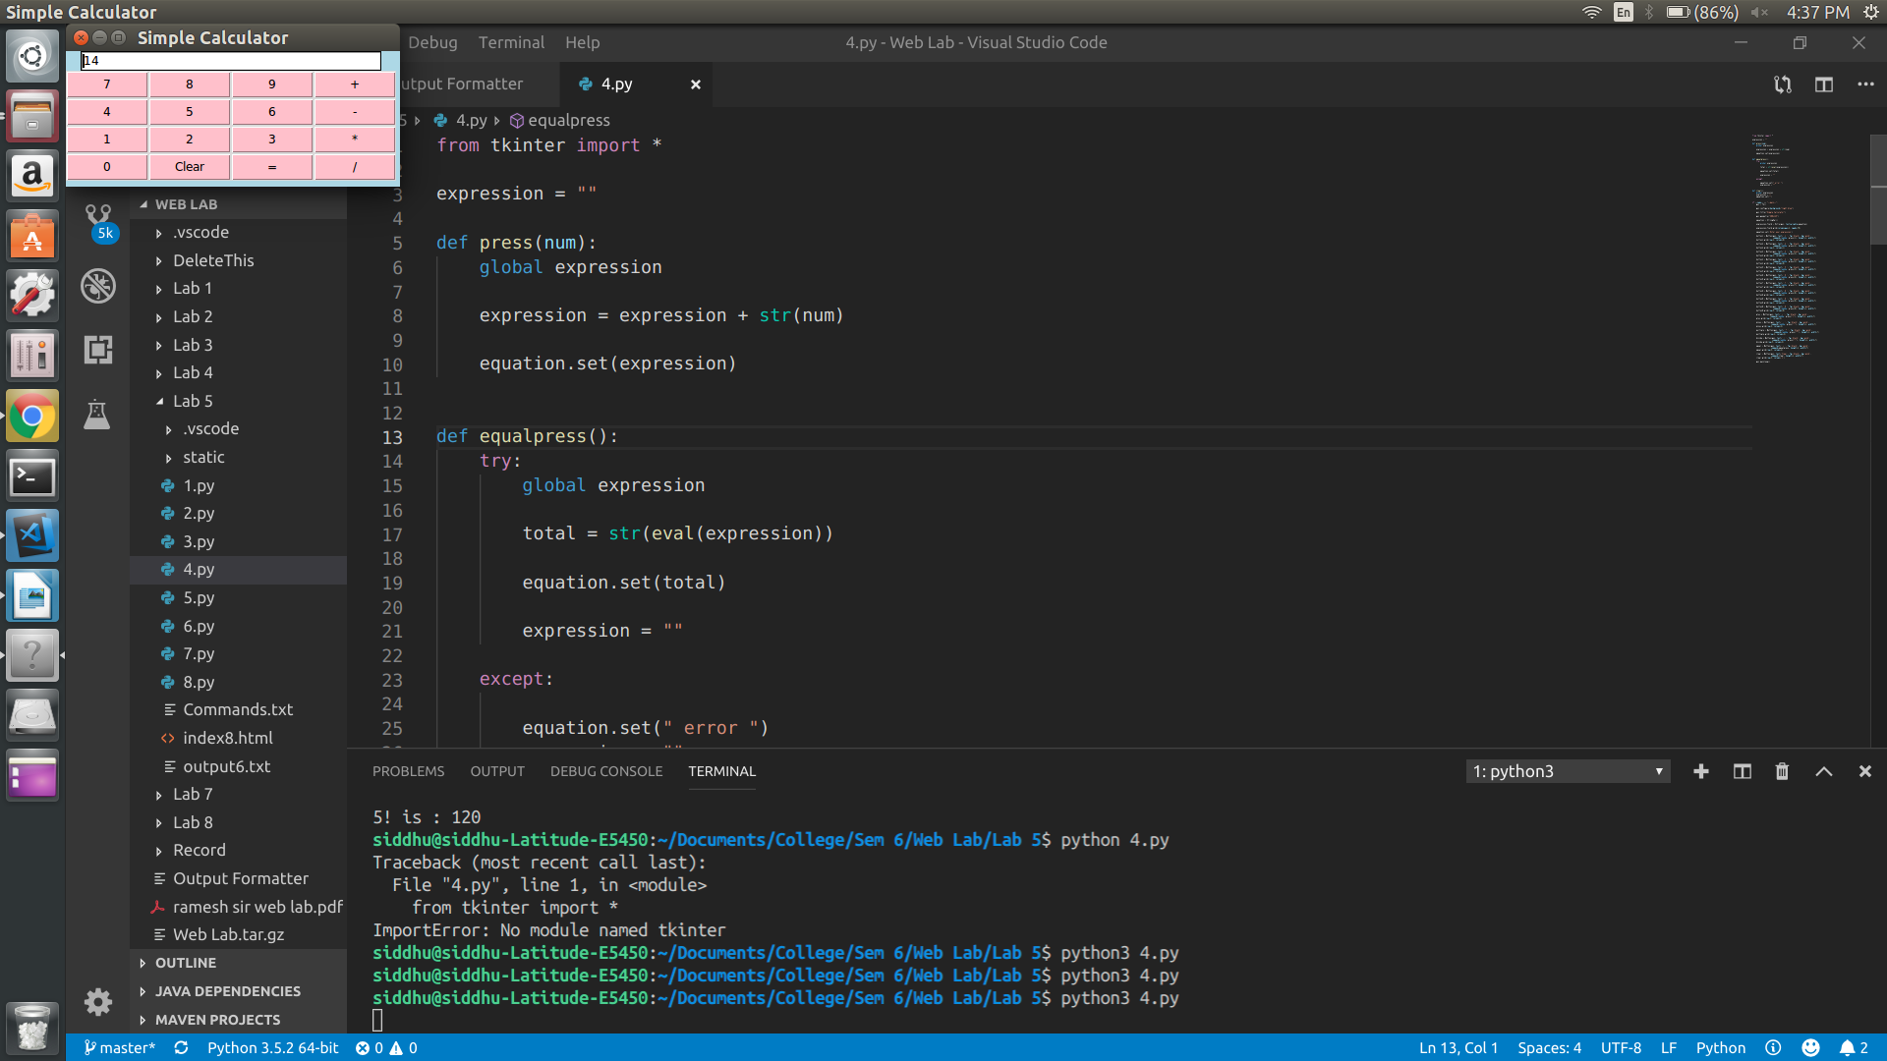

RESULT :
Thus the program is executed and output is obtained.

Program – 5

AIM :
To write a procesure to install packages requests, flask and expore them using pip.
PROGRAM :

P5.py

from flask import Flask
app = Flask(__name__)

@app.route('/')
def hello():
return "Hello World!"

if __name__ == '__main__':
app.run()

OUTPUT:

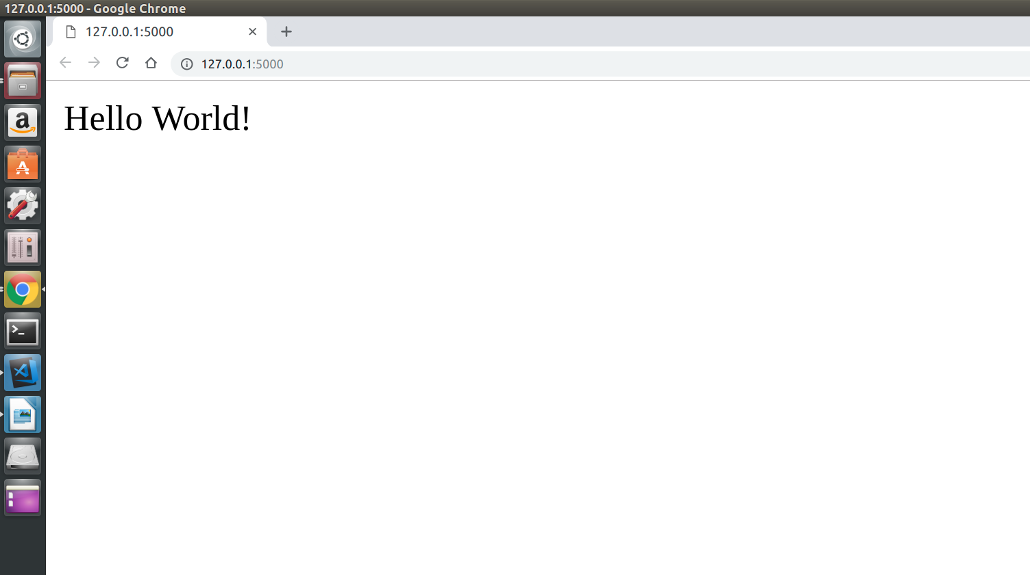

RESULT :
Thus the program is executed and output is obtained.

Program – 6

AIM :
To write a script that imports Requests and fetches the content from a page.

PROGRAM :

p6.py

import requests
from bs4 import BeautifulSoup

try:
out = open('output6.txt', 'w')
page = requests.get('https://www.nytimes.com/')
soup = BeautifulSoup(page.text, 'html.parser')

headlineItems = soup.find_all('title')
for item in headlineItems:
print(item.string)
out.write(item.string+'\n')
print()
out.write('\n')

headlineItems = soup.find_all('article')
for item in headlineItems:
print(item.h2.string)
out.write(item.h2.string + '\n')

except ValueError:
print('Value Error')
except IOError:
print('IOError')

OUTPUT:

Breaking News, World News & Multimedia - The New York Times

Listen to ‘Still Processing’
In ‘The Daily’ Newsletter
Listen to ‘The Argument’
The Enigmatic Figure at the Heart of Mueller’s Inquiry
Manafort ‘Repeatedly and Brazenly’ Broke Law, Prosecutors Say in Sentencing Memo
Some Aid From Brazil Pierces Venezuela’s Blockade
Inside the Rise and Fall of a Multimillion-Dollar Airbnb Scheme
Health Care and Insurance Industries Mobilize to Kill ‘Medicare for All’
Liberal Group Is Seeking Its Next Ocasio-Cortez
Who Will Win Best Picture, Actor and Actress? Here Are Our Predictions
Fill out your Academy Award ballot.
The Oscars are providing a stage for Participant Media’s comeback story.
11 of Our Best Weekend Reads
Did you stay up to date this week? Take our news quiz.
It’s Not That Men Don’t Know What Consent Is
Finding What’s ‘Oddly Satisfying’ on the Internet
Everything Is War and Nothing Is True
How America Learned to Stop Worrying and Love Deficits and Debt
My Daily Routine: Jasper Newman, 8 Months Old
The Green New Deal Is Better Than Our Climate Nightmare
Why Does Obama Scold Black Boys?
Waiting for the Trump-Kim Nobel Peace Prize
Why Celibacy Matters
Joe Biden’s Family Web
Why the Priesthood Needs Women
A Multimillion-Dollar Payday, at the Carwash
Two Art Collectors Who Caught Each Other’s Eye
The Week in Books

RESULT :
Thus the program is executed and output is obtained.

PROGRAM – 7

AIM :
To write a simple script that serves a simple HTTP response and a simple HTML page using Python.

PROGRAM :

p7.py

from flask import Flask

app = Flask(__name__,static_url_path = "")

@app.route('/add/<int:x>&<int:y>', methods = ['GET'])
def add(x,y):
print("result:",str(x+y))
return str(x+y)

@app.route('/sub/<int:x>&<int:y>', methods = ['GET'])
def sub(x,y):
print("result:",str(x-y))
return str(x-y)

@app.route('/mul/<int:x>&<int:y>', methods = ['GET'])
def mul(x,y):
print("result:",str(x*y))
return str(x*y)

@app.route('/div/<int:x>&<int:y>', methods = ['GET'])
def div(x,y):
if y == 0:
return 'Divide by Zero not permitted'
print("result:",str(x/y))
return str(x/y)

if __name__ == '__main__':
app.run(host='localhost',debug = True)

index.html

<html>

<head>
<title>Simple ReSTful Calculator</title>
</head>

<body>
<h2>Simple ReSTful Calculator</h2>
<form>
Variable-X: <input type="text" id="x"><br />
Variable-Y: <input type="text" id="y"><br />
Output: <input type="text" id="op" readonly><br />

<input type="button" value="ADD" name="add" onclick="rest_add()">
<input type="button" value="SUB" name="sub" onclick="rest_sub()">
<input type="button" value="MUL" name="mul" onclick="rest_mul()">
<input type="button" value="DIV" name="div" onclick="rest_div()">
</form>
<script type="text/javascript">
function rest_add() {
var a = parseInt(document.getElementById("x").value);
var b = parseInt(document.getElementById("y").value);
var url = "/add/" + a + "&" + b;
var xmlHttp = new XMLHttpRequest();
xmlHttp.open("GET", url, false);
xmlHttp.send(null);
document.getElementById("op").value = xmlHttp.responseText;
}

function rest_sub() {
var a = parseInt(document.getElementById("x").value);
var b = parseInt(document.getElementById("y").value);
var url = "/sub/" + a + "&" + b;
var xmlHttp = new XMLHttpRequest();
xmlHttp.open("GET", url, false);
xmlHttp.send(null);
document.getElementById("op").value = xmlHttp.responseText;
}

function rest_mul() {
var a = parseInt(document.getElementById("x").value);
var b = parseInt(document.getElementById("y").value);
var url = "/mul/" + a + "&" + b;
var xmlHttp = new XMLHttpRequest();
xmlHttp.open("GET", url, false);
xmlHttp.send(null);
document.getElementById("op").value = xmlHttp.responseText;
}

function rest_div() {
var a = parseInt(document.getElementById("x").value);
var b = parseInt(document.getElementById("y").value);
var url = "/div/" + a + "&" + b;
var xmlHttp = new XMLHttpRequest();
xmlHttp.open("GET", url, false);
xmlHttp.send(null);
document.getElementById("op").value = xmlHttp.responseText;
}
</script>
</body>
</html>

OUTPUT:
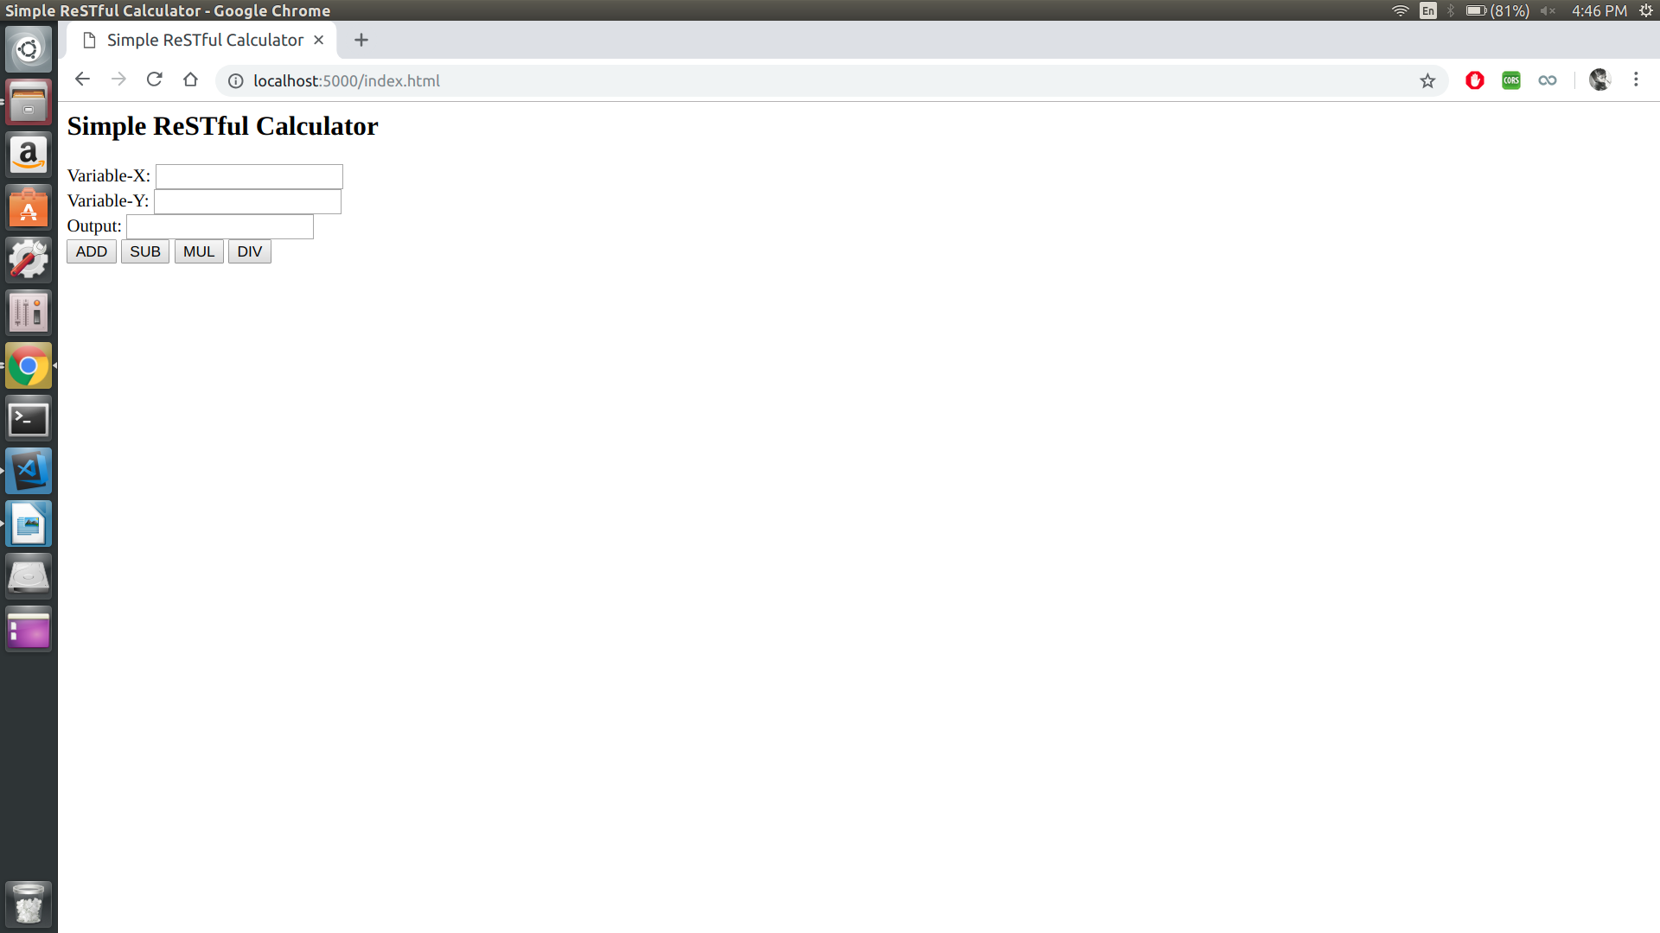
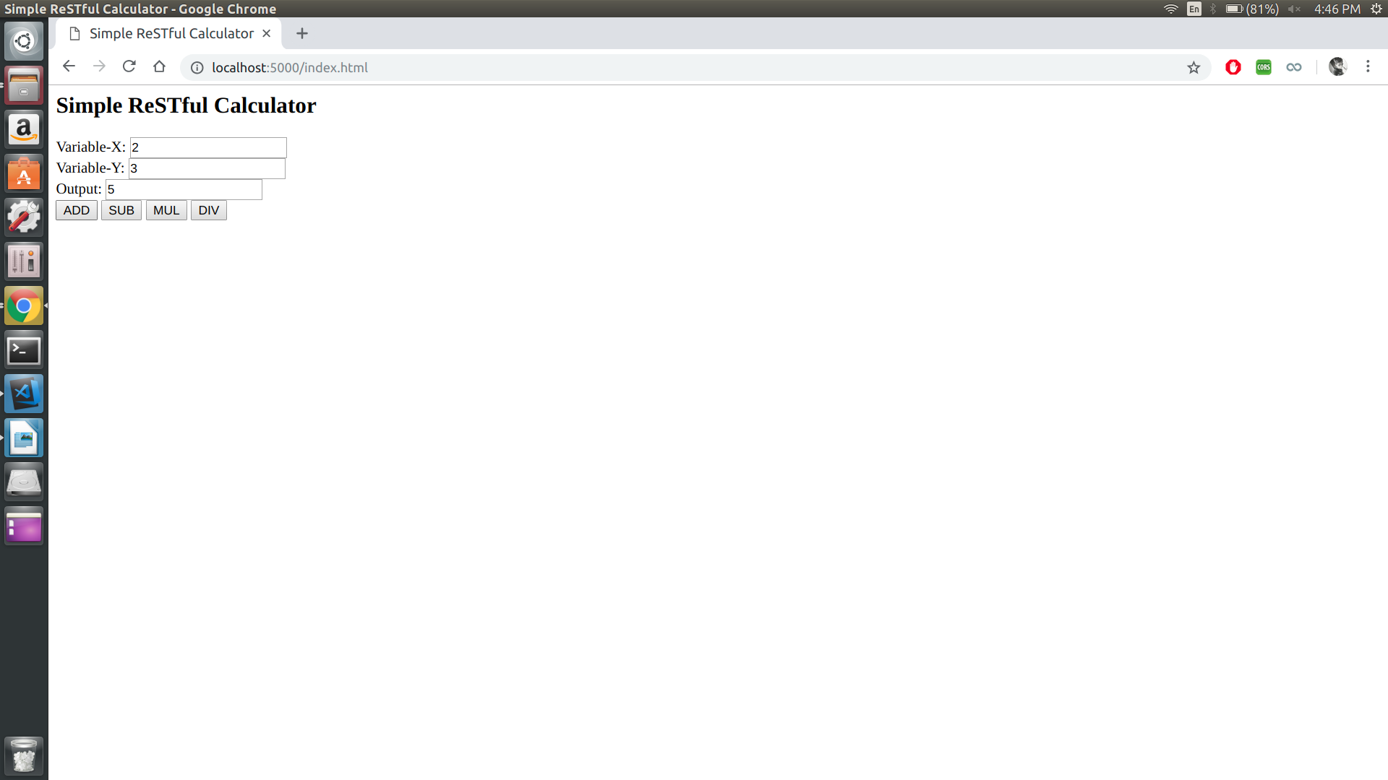
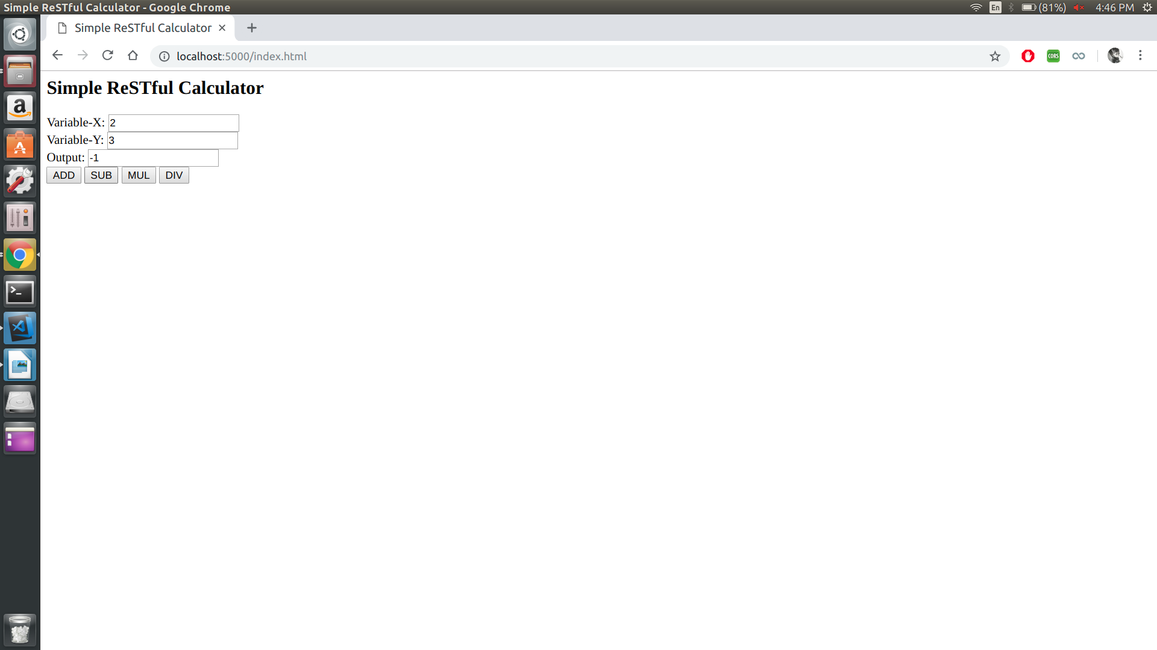

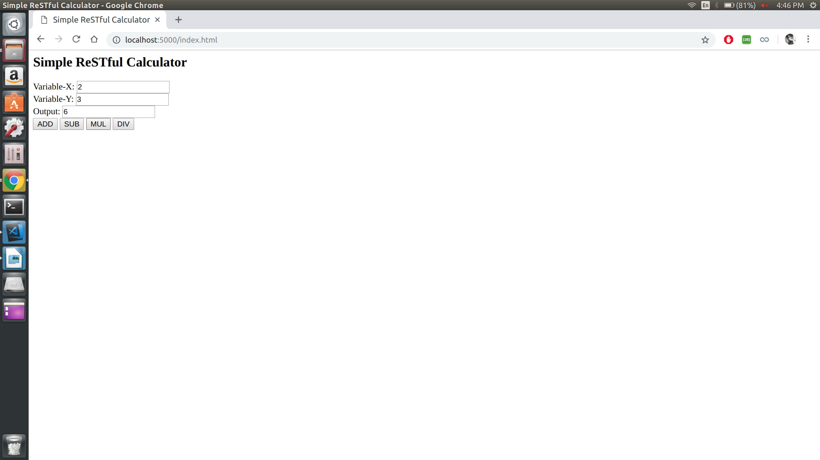

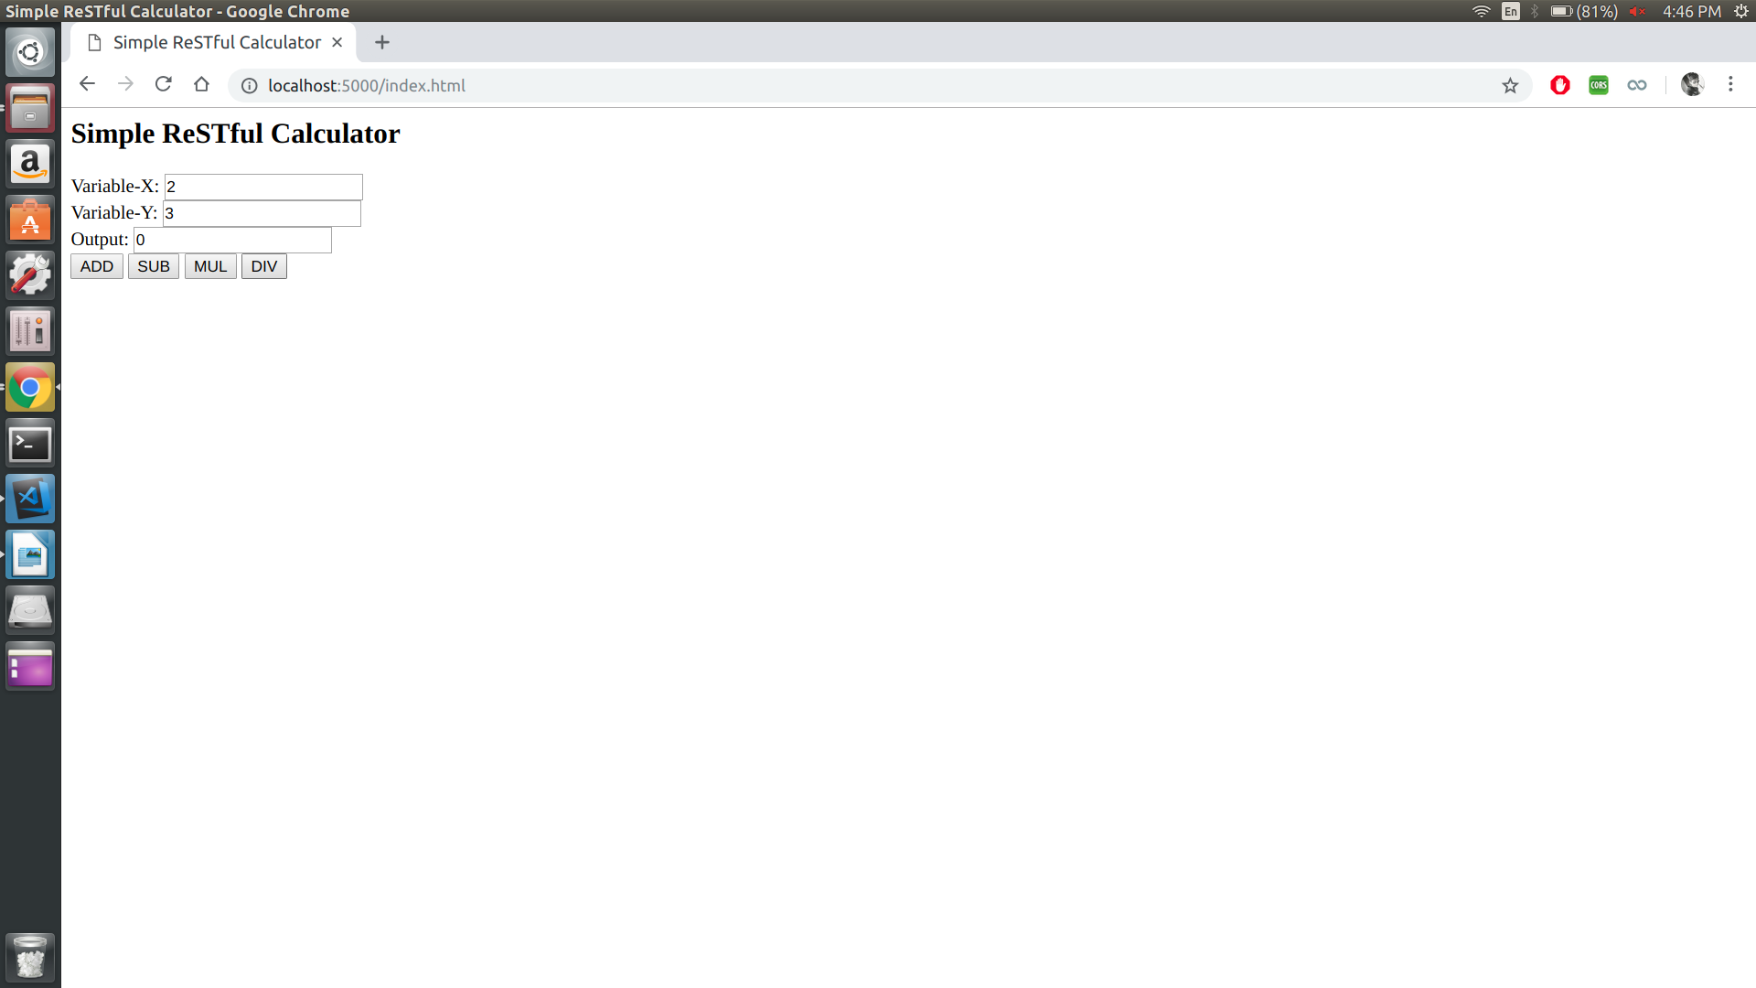

RESULT :
Thus the program is executed and output is obtained.

Program – 8

AIM :
To implement the following modules using Server Side Scripting (Python)
(i) Gathering form data.
(ii) Querying the database.
(iii) Response generation.
(iv) Session management.
(v) Use MySQL or JDBS or Oracle .

PROGRAM :

import mysql.connector
from flask import Flask, request

app = Flask(__name__,static_url_path = "")

@app.route('/result/<string:x>&<string:y>', methods = ['GET'])
def result(x,y):
try:
db = mysql.connector.connect(host="localhost",user="root",password="Sid_12345", database="test")
print(db)
cursor = db.cursor()

sql = "SELECT * from student where RegNo ='"+x+"' and Password='"+y+"';"
print(sql)

cursor.execute(sql)
result = cursor.fetchall()
print(result)
if len(result) == 0:
return "Please Verify Credentials"

ans = ""
for a in result:
for b in range(0,len(a)):
ans=ans+"#"+str(a[b])
return ans

except Exception as e:
print('Exception caught', e)

if __name__ == '__main__':
app.run(host='127.0.0.1',port=5555,debug = True)

OUTPUT :

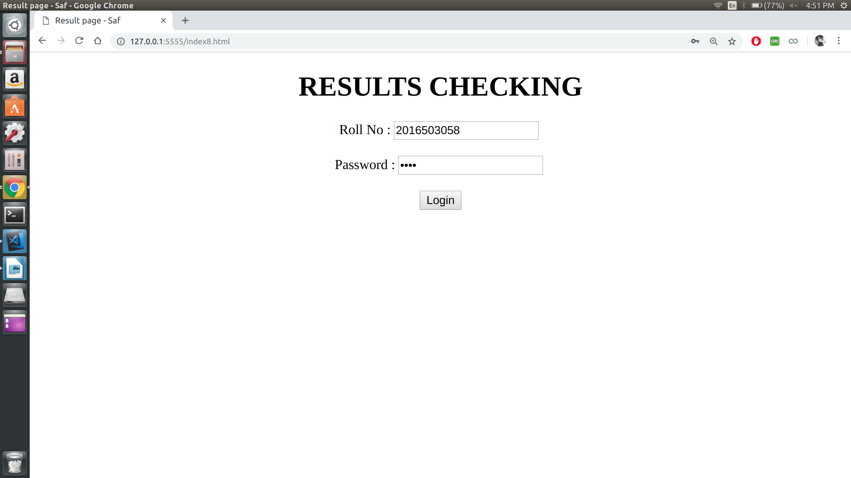
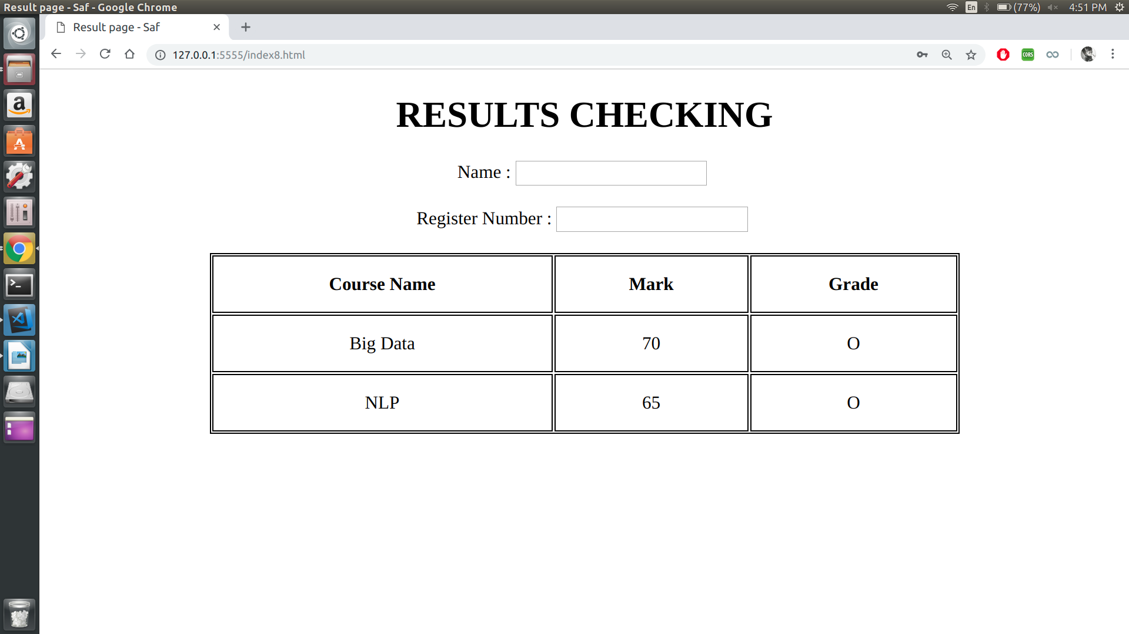

RESULT :
Thus the program is executed and output is obtained.

Date – 08/02/19

Experiment - 6

JAVA SERVLET

PROGRAM 1:

AIM:
To create a servlet program that makes Ordered list of four random numbers.

PROGRAM :

MyServlet.java
import javax.servlet.*;
import javax.servlet.http.*;
import java.io.*;

public class MyServlet extends HttpServlet
{
public void doGet(HttpServletRequest request, HttpServletResponse response)
throws ServletException, IOException
{
response.setContentType("text/html");
PrintWriter out = response.getWriter();
out.print("<ul><li>Coffee</li><li>Tea</li><li>Milk </li></ul>");
}
}
web.xml
<web-app>
<servlet>
<servlet-name>List</servlet-name>
<servlet-class>MyServlet</servlet-class>
</servlet>
<servlet-mapping>
<servlet-name>List</servlet-name>
<url-pattern>/List</url-pattern>
</servlet-mapping>
</web-app>

OUTPUT :
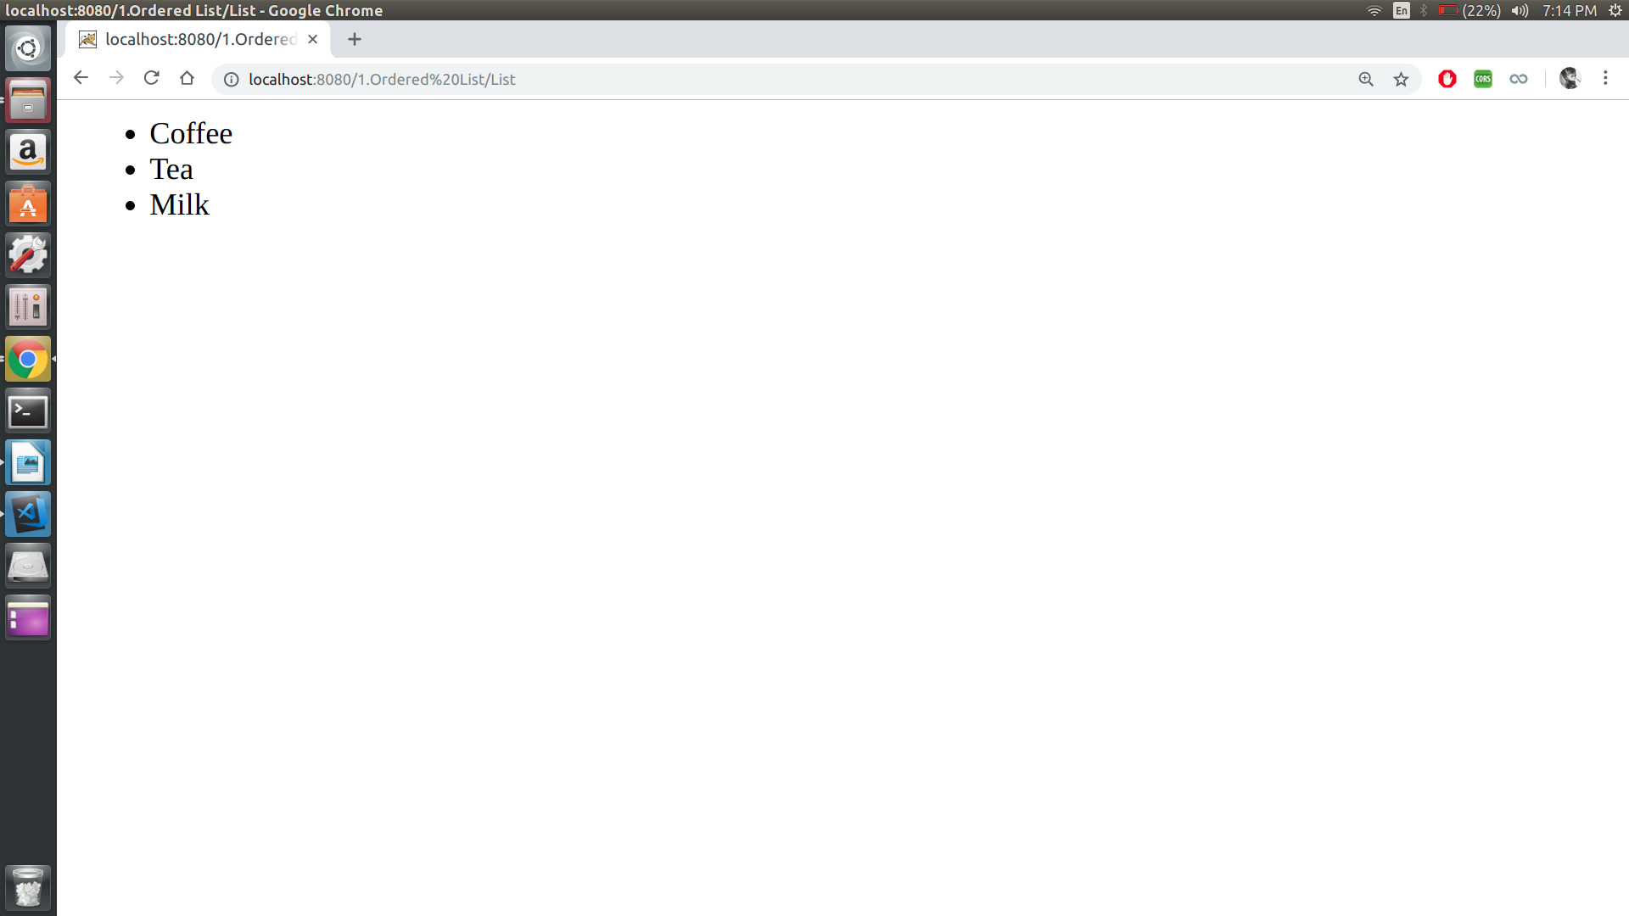
RESULT :
Thus the program is executed and output is obtained.
PROGRAM 2:

AIM :
To create a servlet program that uses a loop to output an HTML table with 20 Rows and 3 columns.

PROGRAM :

MyServlet.java

import javax.servlet.*;
import javax.servlet.http.*;
import java.io.*;

public class MyServlet extends HttpServlet
{
public void doGet(HttpServletRequest request, HttpServletResponse response) throws ServletException, IOException
{
response.setContentType("text/html");
RequestDispatcher view = request.getRequestDispatcher("html/Table.html");
view.forward(request, response);
}
}

Table.html

<html>
<head>
<title>LOL</title>
</head>
<style>
table, th, td {
border: 1px solid black;

}
</style>
<body>
<script>
var mytable = "<table cellpadding=\"0\" cellspacing=\"0\"><tbody><tr>";

for (var i=0; i<20; i++)
{
mytable += "</tr><tr>";
for(var j=0; j<3; j++)
mytable += "<td>(" + i + ", " + j + ")</td>";
}

mytable += "</tr></tbody></table>";

document.write(mytable);
</script>
</body>
</html>

web.xml

<web-app>
<servlet>
<servlet-name>HTML Table</servlet-name>
<servlet-class>MyServlet</servlet-class>
</servlet>
<servlet-mapping>
<servlet-name>HTML Table</servlet-name>
<url-pattern>/table</url-pattern>
</servlet-mapping>
</web-app>

OUTPUT :

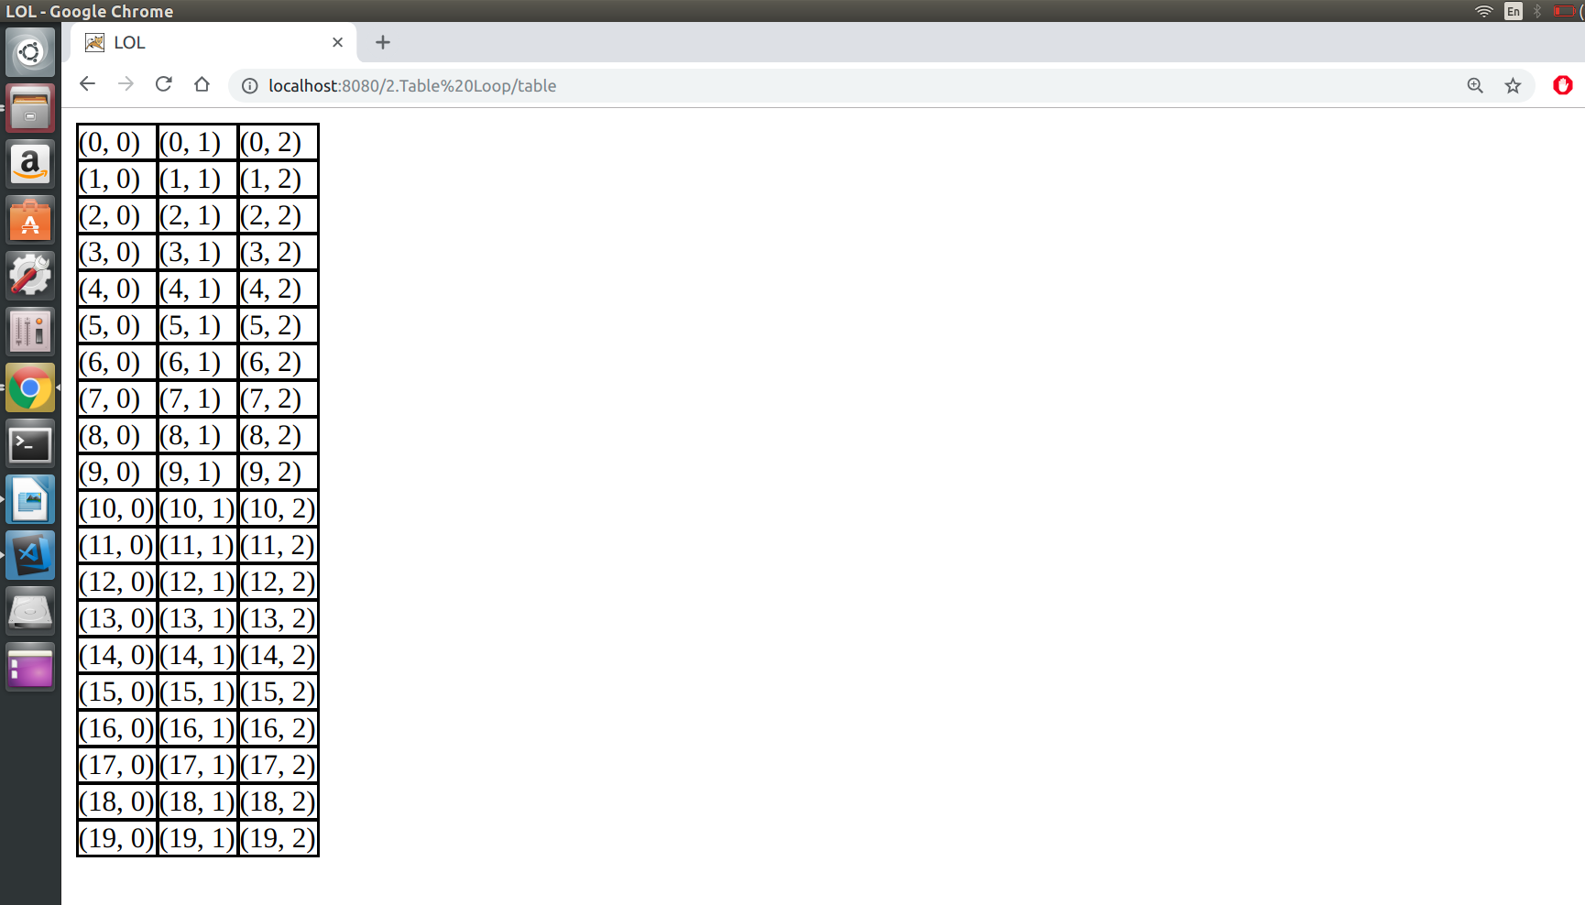

Result:
Thus the program is executed and output is obtained.

PROGRAM 3:

AIM :
To create a servlet program to ake a registration form that collects a Name, Register Number, and email address. Send the data to the servlet that displays it.

PROGRAM :

Form.html

<html>
<body>
<form action = "SimpleForm" method = "GET">
Name: <input type = "text" name = "name">
<br />
Reg. No: <input type = "text" name = "reg_no" />
<br />
Email: <input type = "text" name = "email" />
<br />
<input type = "submit" value = "Submit" />
</form>
</body>
</html>

SimpleForm.java

import java.io.*;
import javax.servlet.*;
import javax.servlet.http.*;

public class SimpleForm extends HttpServlet
{
public void doGet(HttpServletRequest request, HttpServletResponse response)
throws ServletException, IOException
{
response.setContentType("text/html");

PrintWriter out = response.getWriter();
String title = "Submitted Response";
String docType = "";
out.println(docType +
"<html>\n" +
"<head><title>" + title + "</title></head>\n" +
"<body bgcolor = \"#f0f0f0\">\n" +
"<h3 align = \"center\">" + title + "</h1>\n" +
"<ul>\n" +
" <li><b>Name</b>: " + request.getParameter("name") + "\n" +
" <li><b>Reg. No</b>: " + request.getParameter("reg_no") + "\n" +
" <li><b>Email</b>: " + request.getParameter("email") + "\n" +
"</ul>\n" +
"</body>" +
"</html>"
);
}
}

web.xml
<web-app>
<servlet>
<servlet-name>SimpleForm</servlet-name>
<servlet-class>SimpleForm</servlet-class>
</servlet>
<servlet-mapping>
<servlet-name>SimpleForm</servlet-name>
<url-pattern>/SimpleForm</url-pattern>
</servlet-mapping>
</web-app>

OUTPUT :
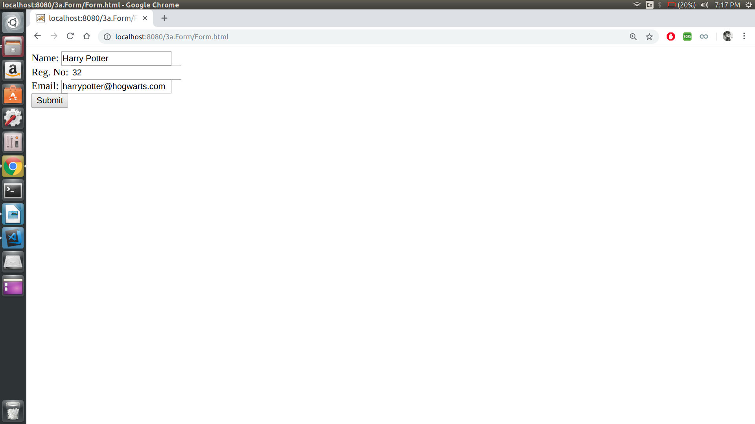
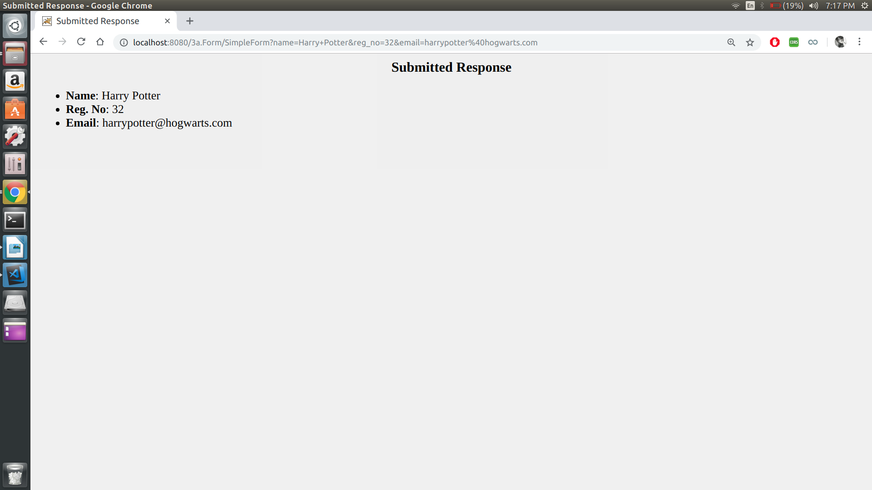
Result:
Thus the program is executed and output is obtained.
PROGRAM 4:

AIM :
To use session tracking to rdo the servlet that says “Welcome Guest” to first-time visitors (with browsing session) and “Welcome back” to repeat visitors

PROGRAM :

SessionTrack.java

import java.io.*;
import javax.servlet.*;
import javax.servlet.http.*;
import java.util.*;

public class SessionTrack extends HttpServlet
{

public void doGet(HttpServletRequest request, HttpServletResponse response)
throws ServletException, IOException
{

HttpSession session = request.getSession(true);

Date createTime = new Date(session.getCreationTime());

Date lastAccessTime = new Date(session.getLastAccessedTime());

String title = "Welcome Back";

if (session.isNew())
{
title = "Welcome to my website";
session.setAttribute("userID", "ABCD");
}
response.setContentType("text/html");
PrintWriter out = response.getWriter();

out.println("<html>\n" +
"<head><title>" + title + "</title></head>\n" +

"<body bgcolor = \"#f0f0f0\">\n" +
"<h1 align = \"center\">" + title + "</h1>\n" +
"</body>"+
"</html>"
);
}
}

web.xml

<web-app>
<servlet>
<servlet-name>SessionTrack</servlet-name>
<servlet-class>SessionTrack</servlet-class>
</servlet>

<servlet-mapping>
<servlet-name>SessionTrack</servlet-name>
<url-pattern>/SessionTrack</url-pattern>
</servlet-mapping>
</web-app>

OUTPUT :

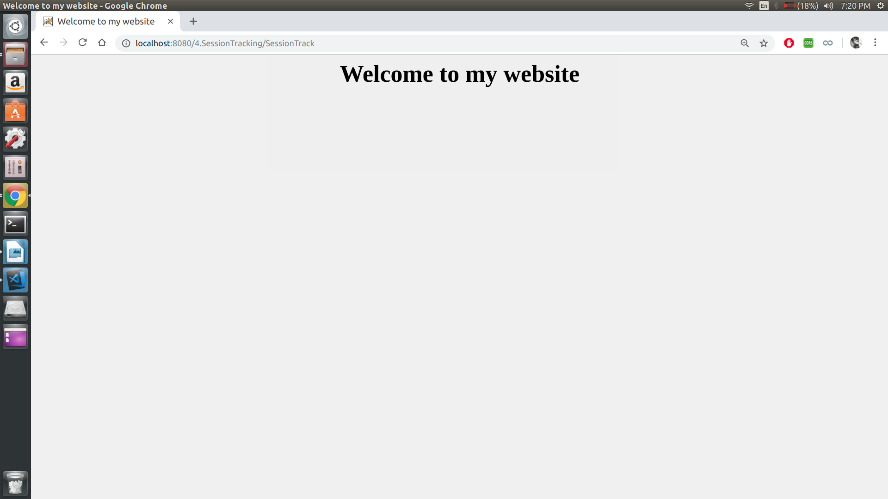
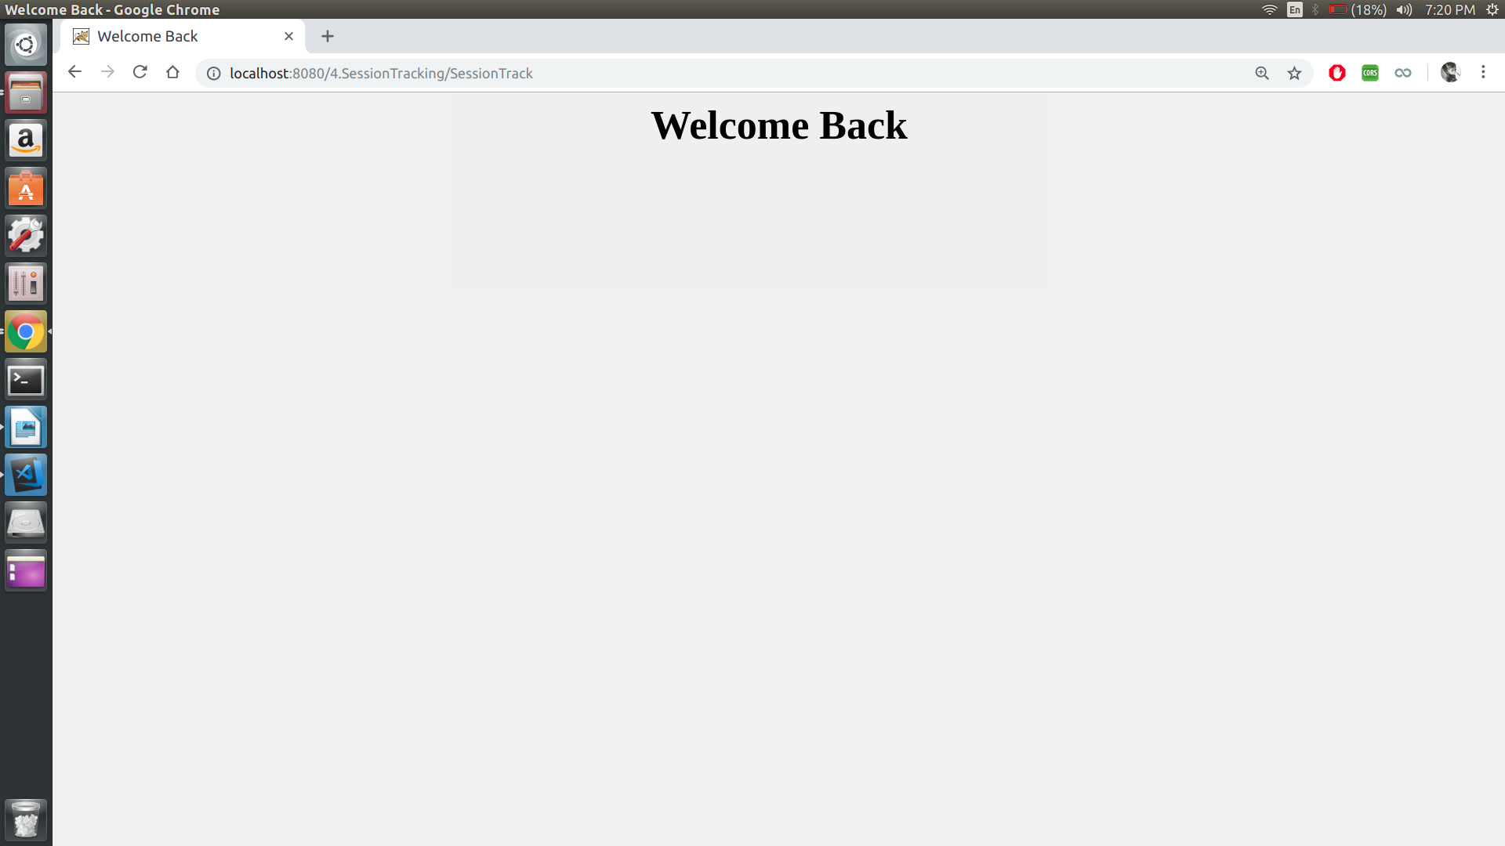

Result:
Thus the program is executed and output is obtained.

PROGRAM 5:

AIM :
To write a servlet that displays the values of Name, Register Number, and emailAddress request parameters. If a parameter is missing and the client is a irst-time visitor, have the servlet list “Unknown for the missing values. If a parameter is missing and the client is a repeat visitor, have the servlet use previously entered values for the missing values

PROGRAM :

Form.html

<html>
<body>
<form action = "Cookie" method = "GET">
Name: <input type = "text" name = "name">
<br />
Reg. No: <input type = "text" name = "reg_no" />
<br />
Email: <input type = "text" name = "email" />
<br />
<input type = "submit" value = "Submit" />
</form>
</body>
</html>

CookieClass.java

import java.io.*;
import javax.servlet.*;
import javax.servlet.http.*;

public class CookieClass extends HttpServlet
{

public void doGet(HttpServletRequest request, HttpServletResponse response)
throws ServletException, IOException
{
response.setContentType("text/html");
PrintWriter out = response.getWriter();

Cookie name = null, reg_no = null, email = null;
Cookie[] cookies = request.getCookies();
cookies = request.getCookies();

if(cookies != null)
{
for (int i = 0; i < cookies.length; i++)
{
if (cookies[i].getName().equals("Name"))
name = cookies[i];
if (cookies[i].getName().equals("Reg_No"))
reg_no = cookies[i];
if (cookies[i].getName().equals("Email"))
email = cookies[i];
}

if (request.getParameter("name").length() == 0)
out.println("Name: " + name.getValue()+"<br />");
else
{
out.println("Name: " + request.getParameter("name")+"<br />");
if (name.getValue().equals("Unknown"))
{
name.setValue(request.getParameter("name"));
response.addCookie(name);
}
}

if (request.getParameter("reg_no").length() == 0)
out.println("Registration Number: " + reg_no.getValue()+"<br />");
else
{
out.println("Registration Number: " + request.getParameter("reg_no")+"<br />");
if (reg_no.getValue().equals("Unknown"))
{
reg_no.setValue(request.getParameter("reg_no"));
response.addCookie(reg_no);
}
}
if (request.getParameter("email").length() == 0)
out.println("Email: " + email.getValue() +"<br />");
else
{
out.println("Email: " + request.getParameter("email")+"<br />");
if (email.getValue().equals("Unknown"))
{
email.setValue(request.getParameter("email"));
response.addCookie(email);
}
}
}

else if(cookies == null)
{
if (request.getParameter("name").length() == 0)
name = new Cookie("Name", "Unknown");
else
name = new Cookie("name", request.getParameter("name"));

if (request.getParameter("reg_no").length() == 0)
reg_no = new Cookie("Reg_No", "Unknown");
else
reg_no = new Cookie("Reg_No", request.getParameter("reg_no"));

if (request.getParameter("email").length() == 0)
email = new Cookie("Email", "Unknown");
else
email = new Cookie("email", request.getParameter("email"));
response.addCookie(name);
response.addCookie(reg_no);
response.addCookie(email);
}
}
}

web.xml

<web-app>
<servlet>
<servlet-name>Cookie</servlet-name>
<servlet-class>CookieClass</servlet-class>
</servlet>
<servlet-mapping>
<servlet-name>Cookie</servlet-name>
<url-pattern>/Cookie</url-pattern>
</servlet-mapping>
</web-app>

OUTPUT :
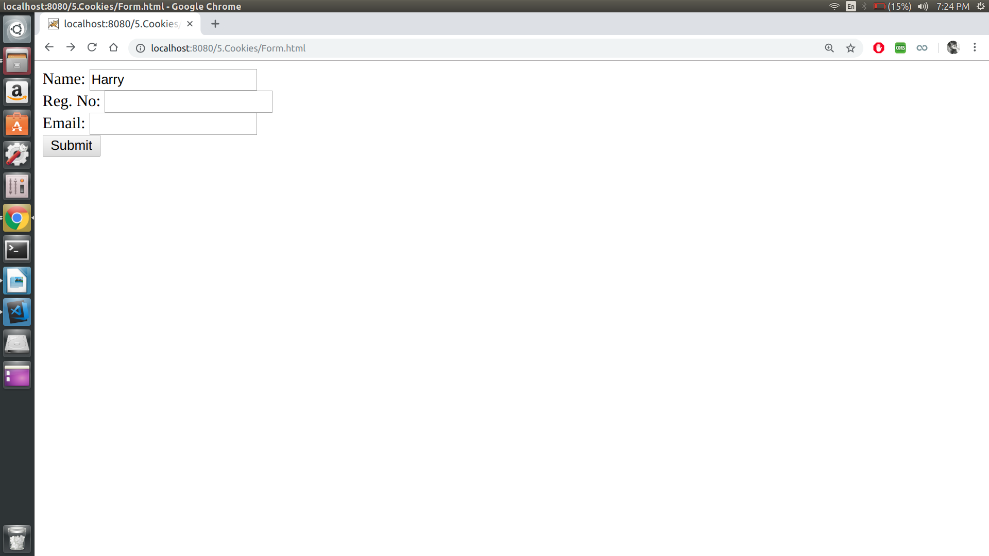

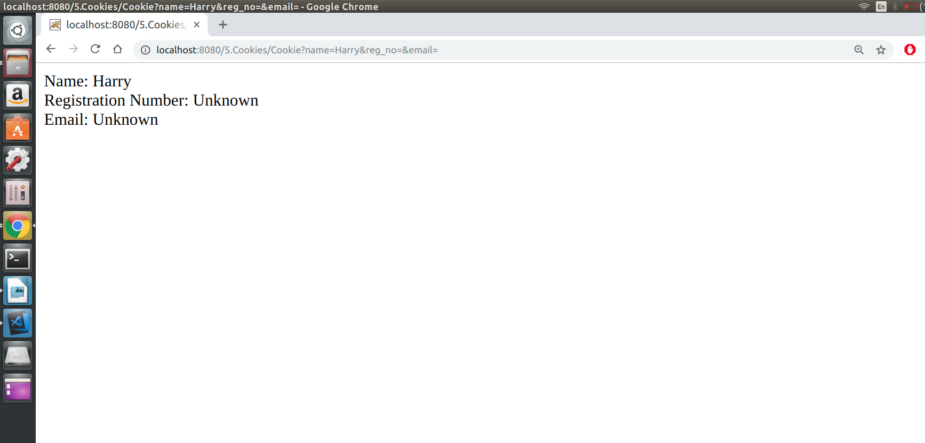
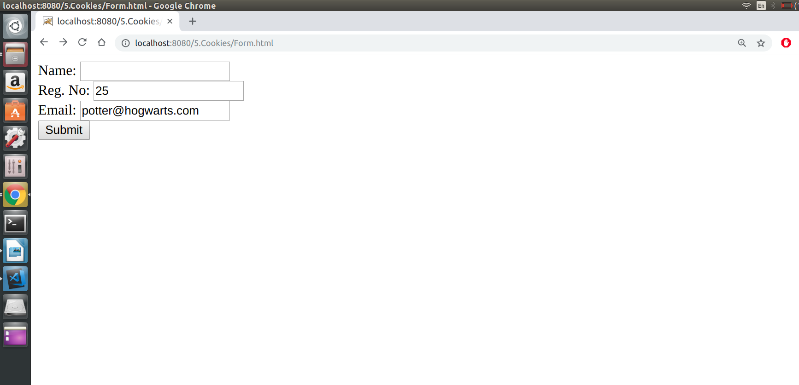
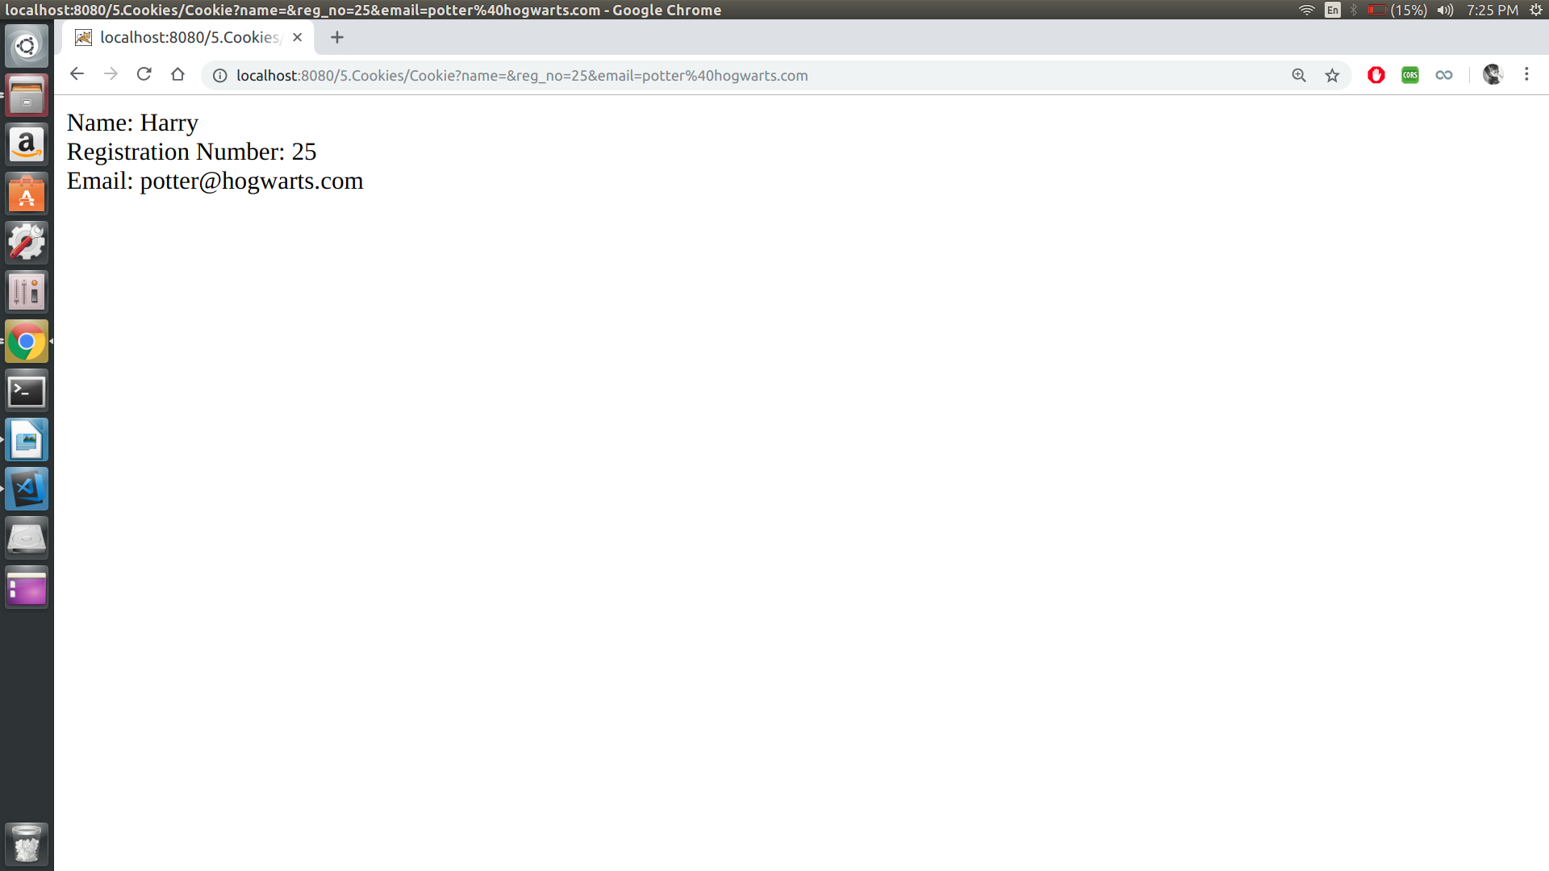

Result:
Thus the program is executed and output is obtained.
PROGRAM 6:

AIM :
To write a servlet program that shows all the request headers. Use a red background and a yellow foreground for Google Chrome users; use a yellow background and a red foreground for Firefox and other users.

PROGRAM :

RequestHeaders.java

import static java.awt.Color.yellow;
import java.io.IOException;
import java.io.PrintWriter;
import java.util.Enumeration;
import javax.servlet.ServletException;
import javax.servlet.http.HttpServlet;
import javax.servlet.http.HttpServletRequest;
import javax.servlet.http.HttpServletResponse;

public class RequestHeader extends HttpServlet {

protected void processRequest(HttpServletRequest request, HttpServletResponse response)
throws ServletException, IOException {

response.setContentType("text/html;charset=UTF-8");
try (PrintWriter out = response.getWriter()) {
out.println("<!DOCTYPE html>");
out.println("<html>");
out.println("<head>");
out.println("<title>Servlet RequestHeader</title>");
out.println("</head>");
final String clientBrowser = getClientBrowser(request);
if (clientBrowser.equals("IE"))
out.println("<body bgcolor= 'yellow' text='red'>");
else
out.println("<body bgcolor = 'red' text='yello'>");
out.println("<h1>Servlet RequestHeader at " + request.getContextPath() + "</h1>");
Enumeration<String> headerNames = request.getHeaderNames();
while (headerNames.hasMoreElements()) {
String headerName = headerNames.nextElement();
out.print("Header Name: <em>" + headerName);
String headerValue = request.getHeader(headerName);
out.print("</em>, Header Value: <em>" + headerValue);
out.println("</em><br/>");
}
out.println("<h3> The client browser is : " + clientBrowser + "</h3>");

out.println("</body>");
out.println("</html>");
}
}

public String getClientBrowser(HttpServletRequest request) {
final String browserDetails = request.getHeader("User-Agent");
final String user = browserDetails.toLowerCase();

String browser = "";

if (user.contains("msie")) {
String substring = browserDetails.substring(browserDetails.indexOf("MSIE")).split(";")[0];
browser = substring.split(" ")[0].replace("MSIE", "IE") + "-" + substring.split(" ")[1];
} else if (user.contains("safari") && user.contains("version")) {
browser = (browserDetails.substring(browserDetails.indexOf("Safari")).split(" ")[0]).split("/")[0] + "-"
+ (browserDetails.substring(browserDetails.indexOf("Version")).split(" ")[0]).split("/")[1];
} else if (user.contains("opr") || user.contains("opera")) {
if (user.contains("opera"))
browser = (browserDetails.substring(browserDetails.indexOf("Opera")).split(" ")[0]).split("/")[0] + "-"
+ (browserDetails.substring(browserDetails.indexOf("Version")).split(" ")[0]).split("/")[1];
else if (user.contains("opr"))
browser = ((browserDetails.substring(browserDetails.indexOf("OPR")).split(" ")[0]).replace("/", "-"))
.replace("OPR", "Opera");
} else if (user.contains("chrome")) {
browser = (browserDetails.substring(browserDetails.indexOf("Chrome")).split(" ")[0]).replace("/", "-");
} else if ((user.indexOf("mozilla/7.0") > -1) || (user.indexOf("netscape6") != -1)
|| (user.indexOf("mozilla/4.7") != -1) || (user.indexOf("mozilla/4.78") != -1)
|| (user.indexOf("mozilla/4.08") != -1) || (user.indexOf("mozilla/3") != -1)) {
browser = "Netscape-?";

} else if (user.contains("firefox")) {
browser = (browserDetails.substring(browserDetails.indexOf("Firefox")).split(" ")[0]).replace("/", "-");
} else if (user.contains("rv")) {
browser = "IE";
} else {
browser = "UnKnown, More-Info: " + browserDetails;
}

return browser;
}

@Override
protected void doGet(HttpServletRequest request, HttpServletResponse response)
throws ServletException, IOException {
processRequest(request, response);
}

@Override
protected void doPost(HttpServletRequest request, HttpServletResponse response)
throws ServletException, IOException {
processRequest(request, response);
}

@Override
public String getServletInfo() {
return "Short description";
}

}

web.xml

<web-app>
<servlet>
<servlet-name>myservlet</servlet-name>
<servlet-class>RequestHeader</servlet-class>
</servlet>
<servlet-mapping>
<servlet-name>myservlet</servlet-name>
<url-pattern>/head</url-pattern>
</servlet-mapping>
</web-app>

OUTPUT :

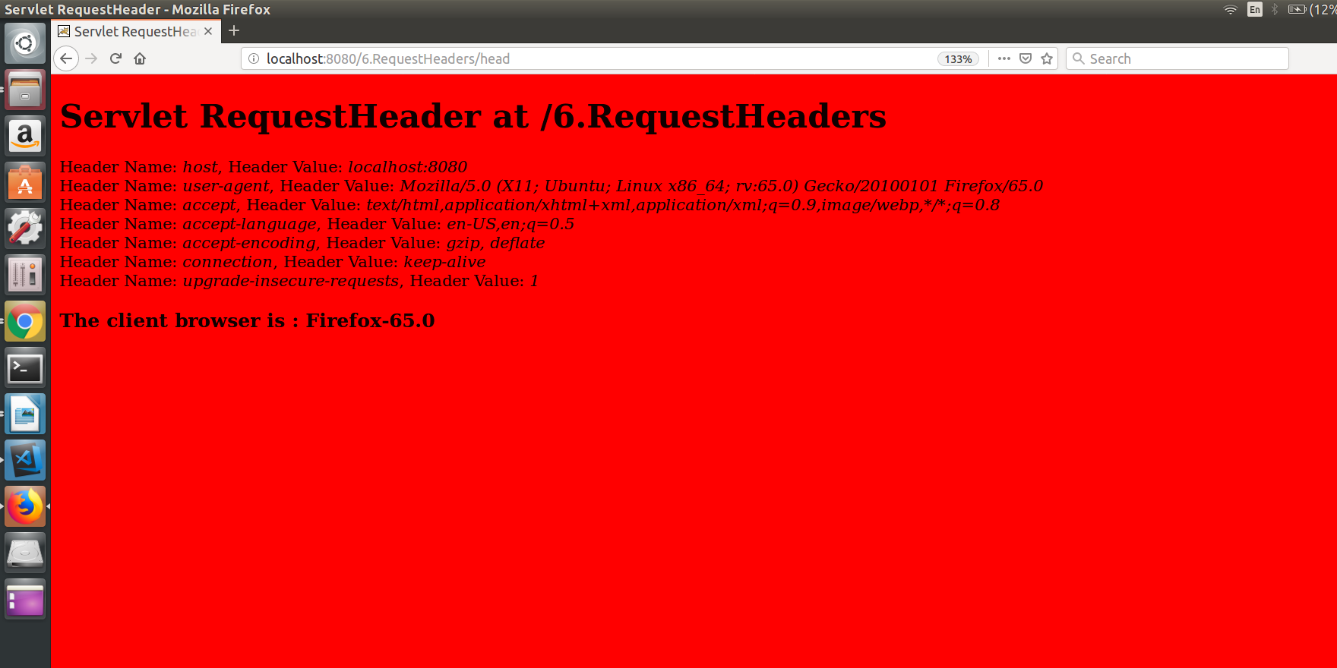

Result:
Thus the program is executed and output is obtained.

PROGRAM 7:

Aim:
To write a servlet that returns a Bad Request error page(400) unless the user supplies email-id without @ symbol in the form.

PROGRAM :

Form.html

<html>

<body>

<form action="bad" method="GET">

Username :<input type="text" name="username"><br>
Regno :<input type="text" name="regno"><br>
E-mail :<input type="text" name="email"><br>

<input type="submit" name="submit" value="SUBMIT">
</form>

</body>

</html>

MyServlet.java

import java.io.*;
import javax.servlet.*;
import javax.servlet.http.*;
import java.util.*;

public class MyServlet extends HttpServlet {

public void doGet(HttpServletRequest request, HttpServletResponse response) throws ServletException, IOException
{
response.setContentType("text/html");

PrintWriter out = response.getWriter();

String user = request.getParameter("username");
String regno = request.getParameter("regno");
String email = request.getParameter("email");

if (email.contains("@") == false)
response.sendError(400, "Bad Request");
else
{
out.println(user + "<br>");
out.println(regno + "<br>");
out.println(email + "<br>");

}
}

}

web.xml

<web-app>
<servlet>
<servlet-name>myservlet</servlet-name>
<servlet-class>MyServlet</servlet-class>
</servlet>
<servlet-mapping>
<servlet-name>myservlet</servlet-name>
<url-pattern>/bad</url-pattern>
</servlet-mapping>
</web-app>

OUTPUT :

Sample Ouput 1 :

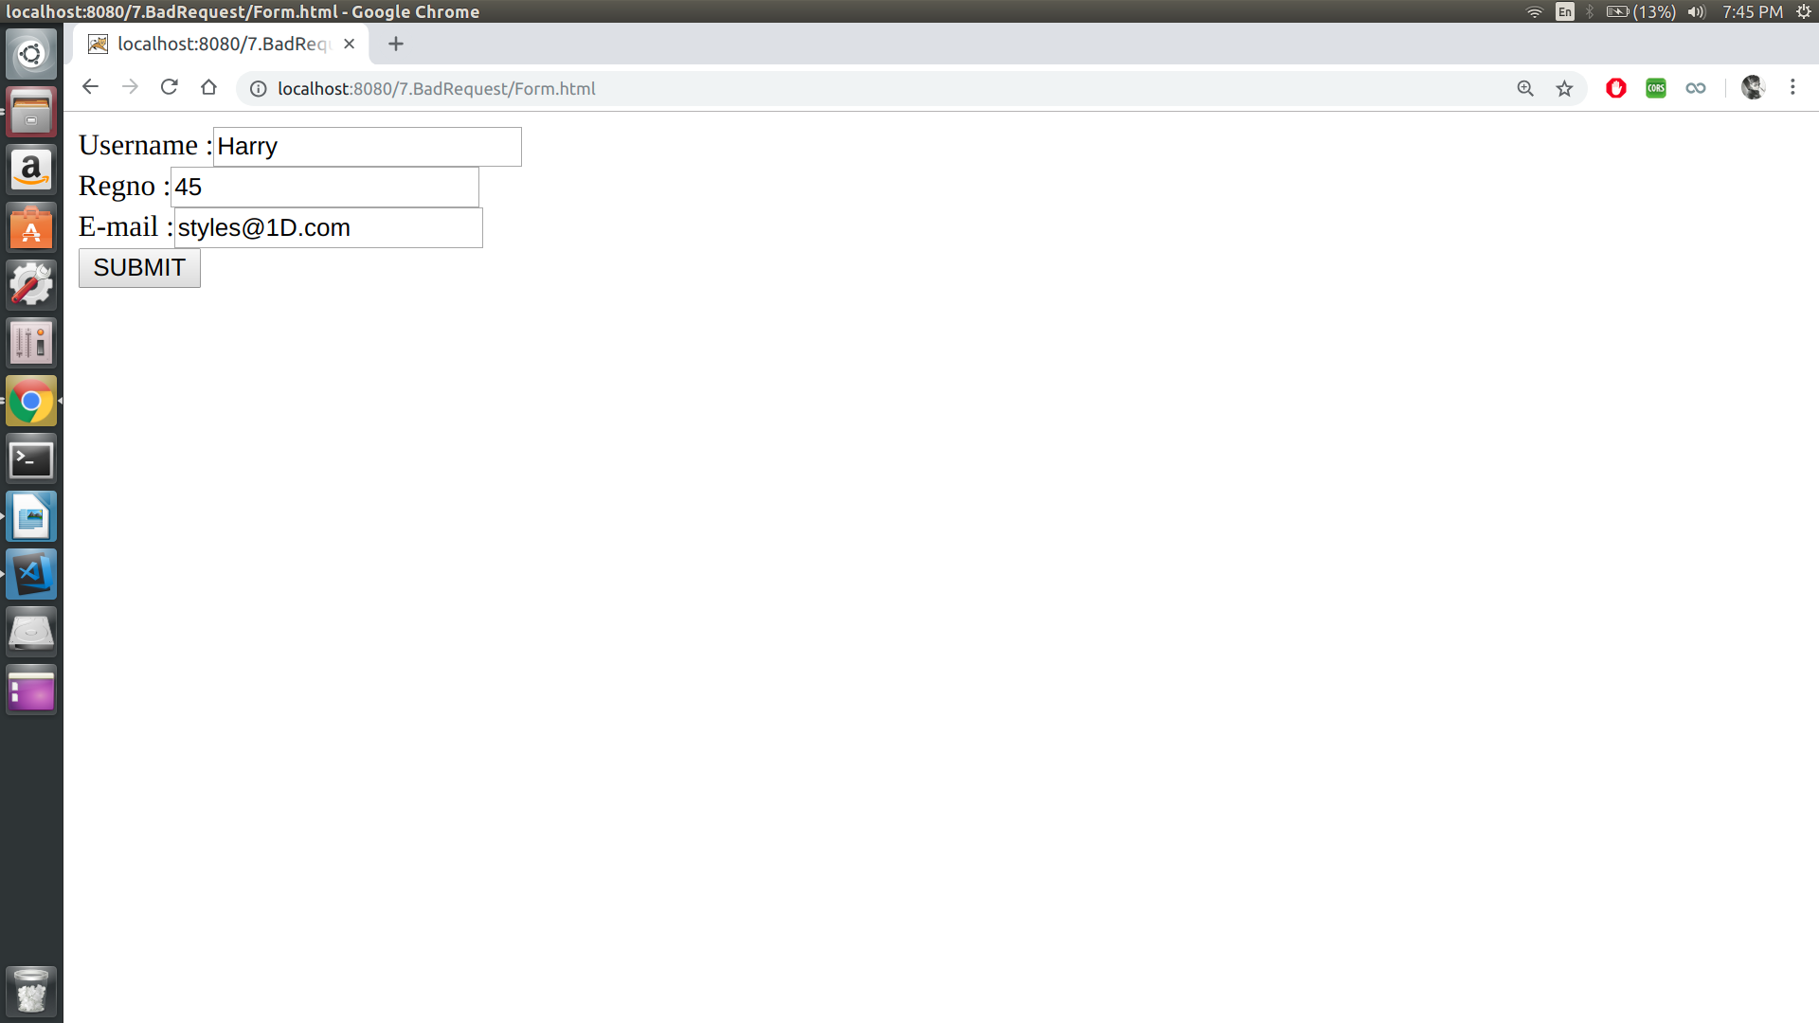
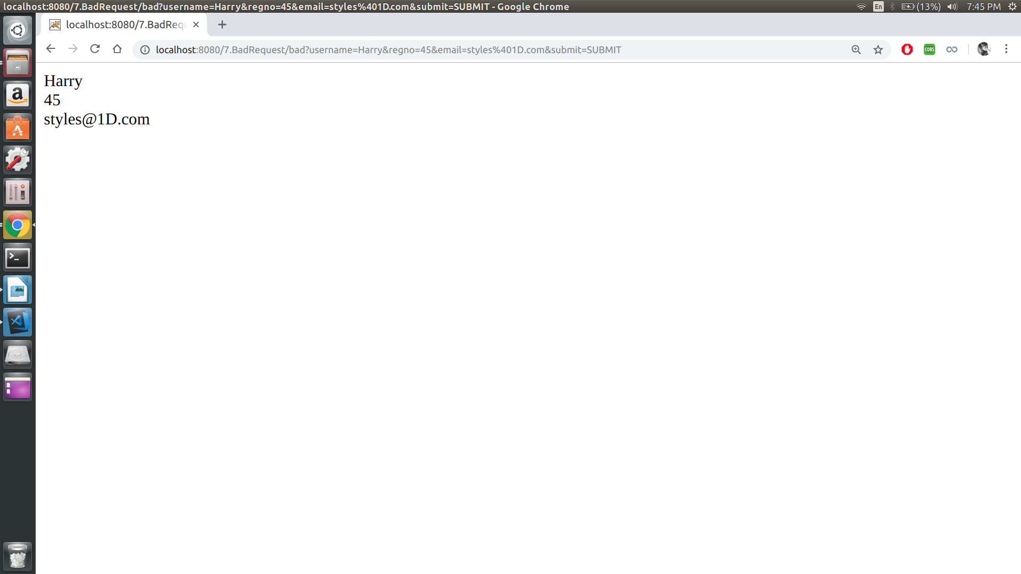

Sample Output 2 :

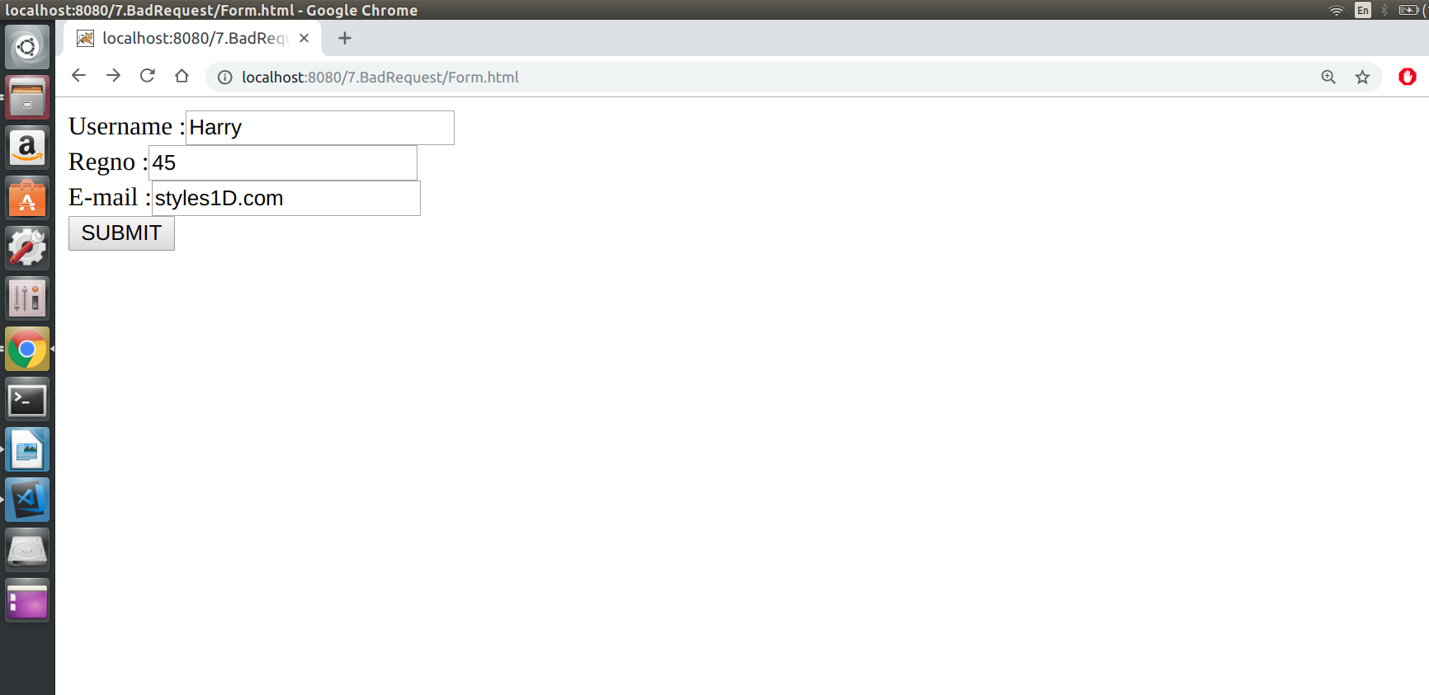

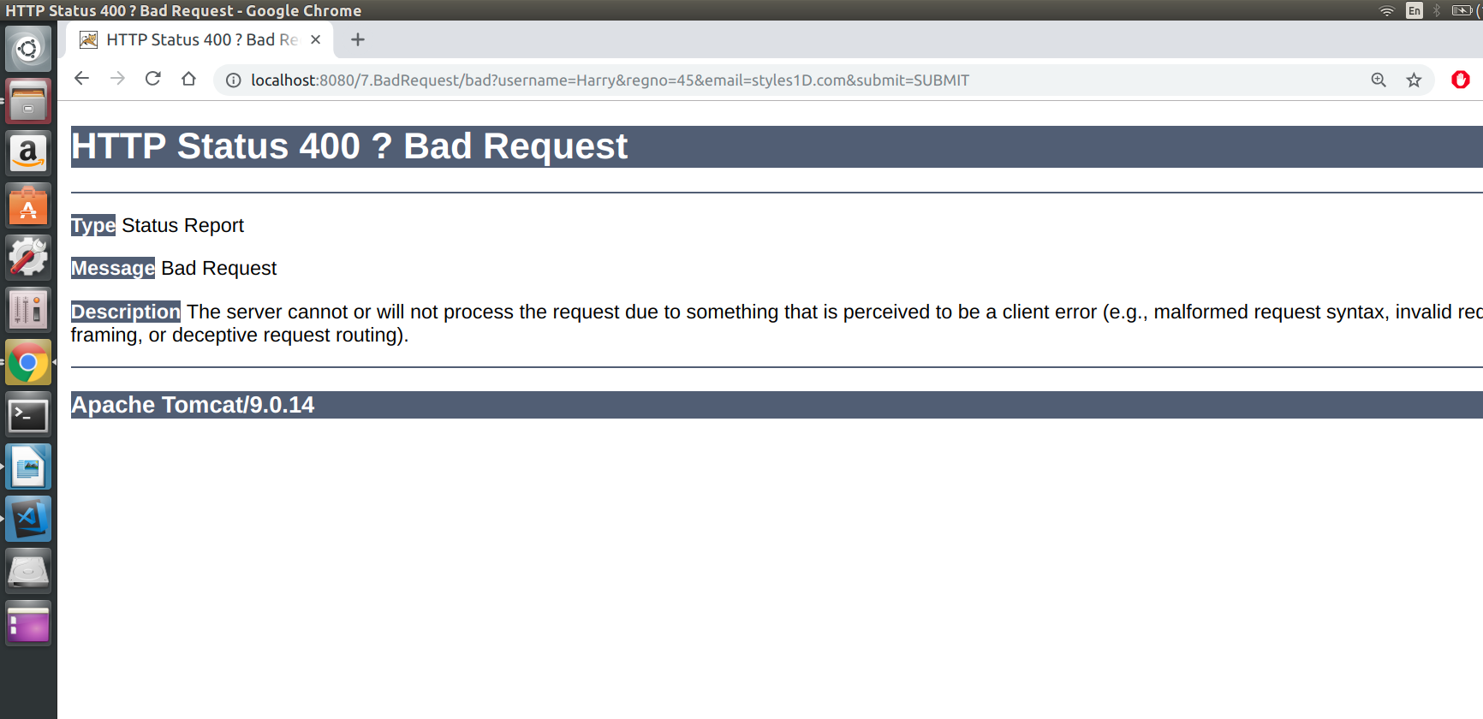

RESULT :
Thus the program is executed and output is obtained.

PROGRAM 8:

AIM :
To write a servlet that redirects a new servlet (named errorServlet) if the user supplies email-id without @ symbol in the form.

PROGRAM :

Form.html

<html>
<body>
<form action="pg1" method="GET">
Username :<input type="text" name="username"><br>
Regno :<input type="text" name="regno"><br>
E-mail :<input type="text" name="email"><br>

<input type="submit" name="submit" value="SUBMIT">
</form>
</body>
</html>

Servlet1.java

import java.io.*;
import javax.servlet.*;
import javax.servlet.http.*;
import java.util.*;

public class MyServlet extends HttpServlet {

public void doGet(HttpServletRequest request, HttpServletResponse response)
throws ServletException, IOException {
response.setContentType("text/html");

PrintWriter out = response.getWriter();

String user = request.getParameter("username");
String regno = request.getParameter("regno");
String email = request.getParameter("email");

if (email.contains("@") == false) {
RequestDispatcher rd = request.getRequestDispatcher("/pg2");
rd.forward(request, response);
} else {
out.println(user + "<br>");
out.println(regno + "<br>");
out.println(email + "<br>");

}
}
}

Servlet2.java

import javax.servlet.*;
import javax.servlet.http.*;
import java.io.*;

public class MyServlet1 extends HttpServlet {
public void doGet(HttpServletRequest request, HttpServletResponse response)throws ServletException, IOException {
response.setContentType("text/html");
PrintWriter out = response.getWriter();
out.println("@ missing");

}
}

web.xml

<web-app>
<servlet>
<servlet-name>myservlet</servlet-name>
<servlet-class>Servlet1</servlet-class>
</servlet>
<servlet-mapping>
<servlet-name>myservlet</servlet-name>
<url-pattern>/pg1</url-pattern>
</servlet-mapping>

<servlet>
<servlet-name>myservlet1</servlet-name>
<servlet-class>Servlet2</servlet-class>
</servlet>
<servlet-mapping>
<servlet-name>myservlet1</servlet-name>
<url-pattern>/pg2</url-pattern>
</servlet-mapping>
</web-app>

OUTPUT :
Sample Output 1 :

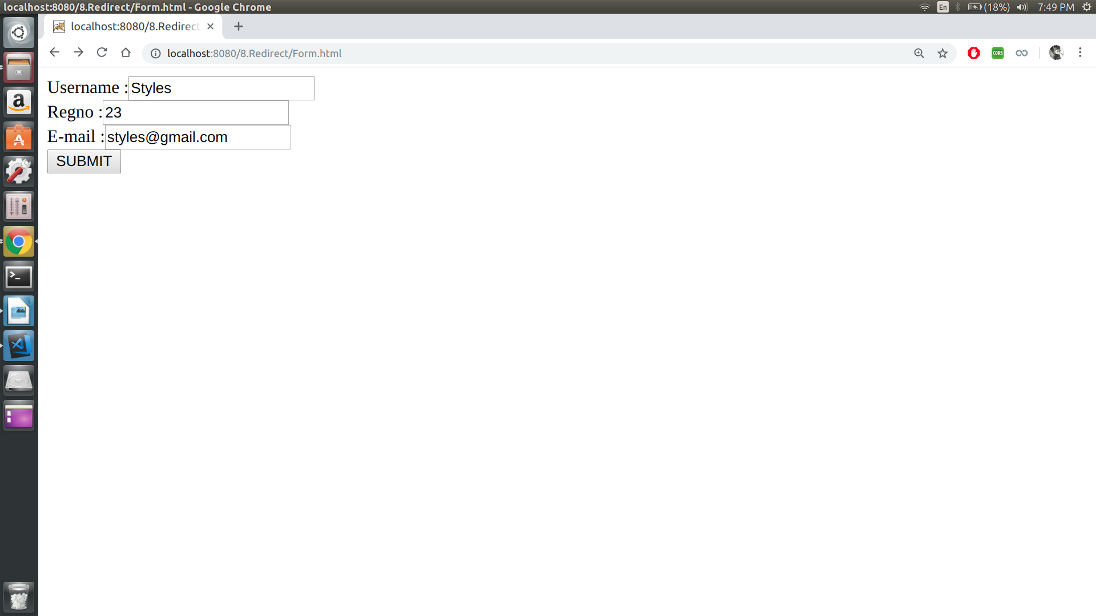
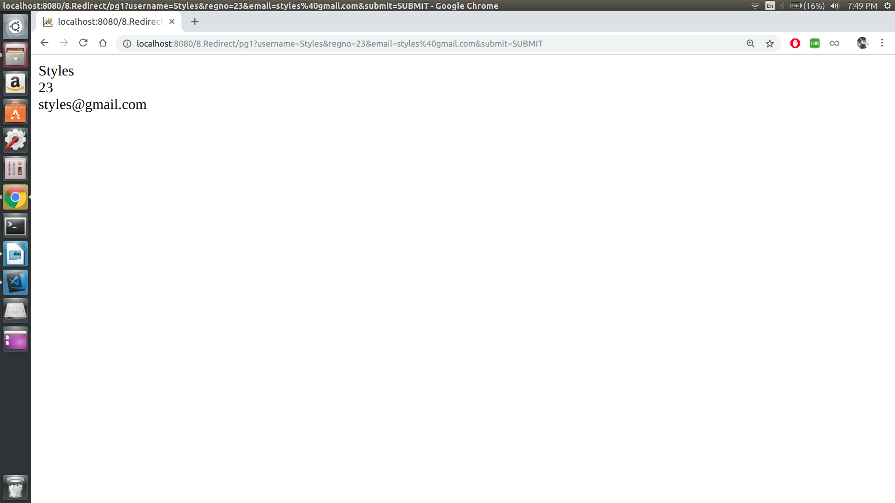
Sample Output 2 :

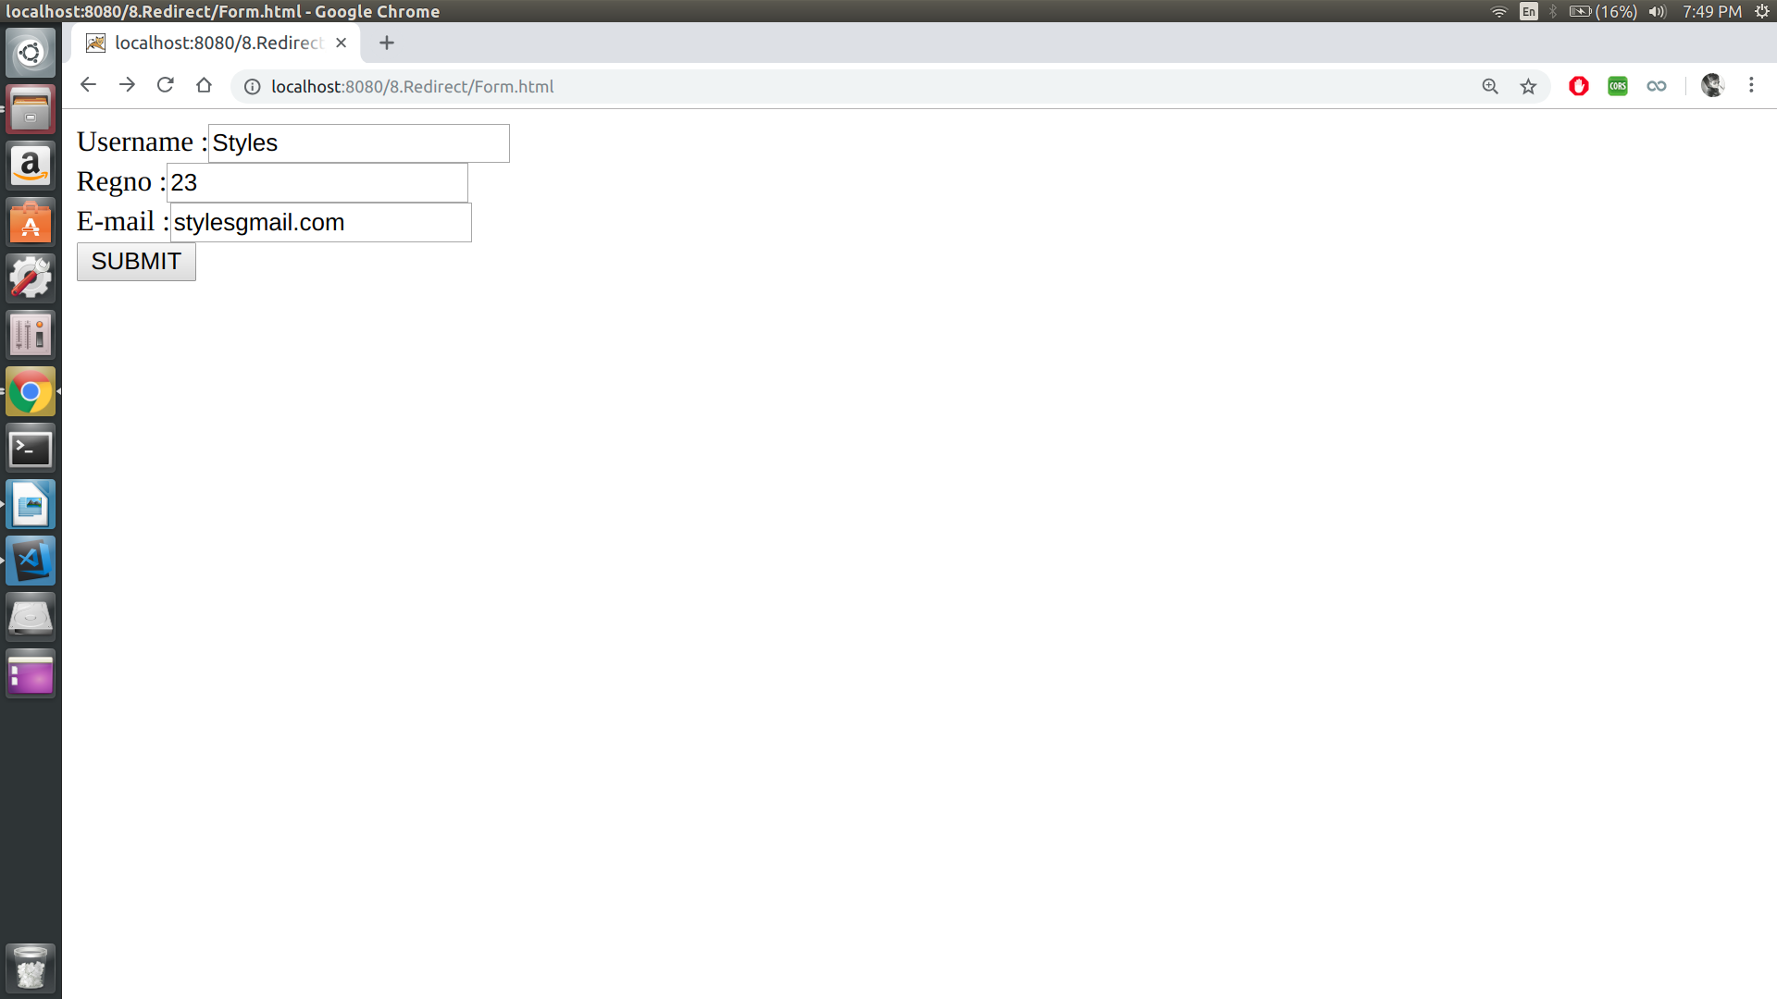
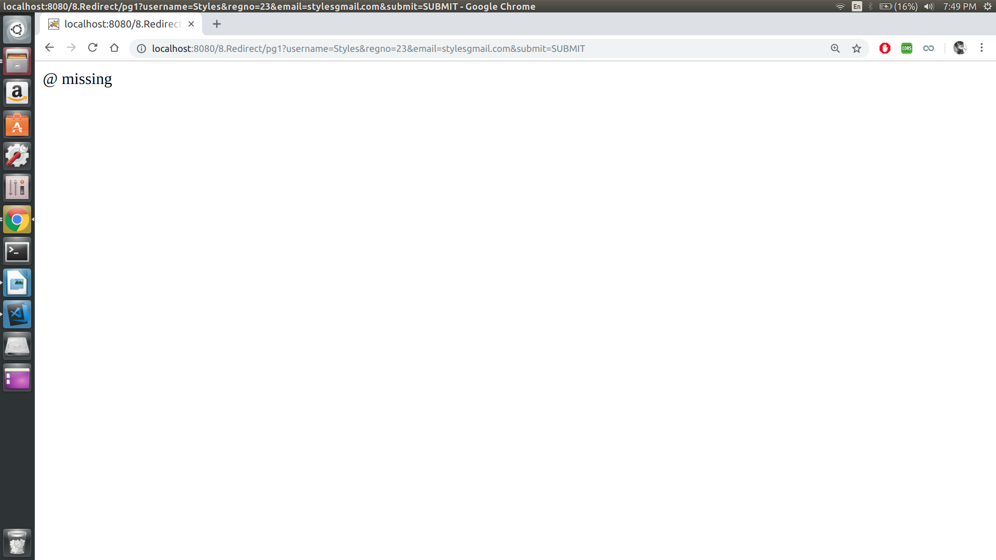

Result:
Thus the program is executed and output is obtained.
Date – 15/02/19
Experiment - 7

AJAX, JSON, JQUERY

PROGRAM 1:

AIM :
To create a DTD for a catalog of cars, heree each car has the cild elements make, model, year, color, engine, number_of_doors, transmission_type, and accessories. The engine element has the child elements number_of_cylinders and fuel_system (carburated or fuel injected). The accessories element has the attributes radio, air_conditioning, power_windows, power_steering, and power_brakes, each of which is required and has the possible values yes and no. Entities must be declared for the names of popular car models.

PROGRAM :

<?xml version="1.0" encoding="UTF-8"?>
<?xml-stylesheet type="text/xsl" href="Cars.xsl"?>
<!DOCTYPE note [
<!ELEMENT automobile (car+)>
<!ELEMENT car (make,model,year,color,engine,no_of_doors,transmission_type,accessories)>
<!ELEMENT engine (no_of_cylinders,fuel_systems)>
<!ATTLIST accessories radio CDATA #REQUIRED >
<!ATTLIST accessories air_condition CDATA #REQUIRED >
<!ATTLIST accessories power_window CDATA #REQUIRED >
<!ATTLIST accessories power_steering CDATA #REQUIRED >
<!ATTLIST accessories power_brake CDATA #REQUIRED >
]>
<catalog>
<car>
<make>Maruti</make>
<model>800</model>
<year>1999</year>
<color>Black</color>
<engine>
<number_of_cylinders>1</number_of_cylinders>
<fuel_system>fuel injected</fuel_system>
</engine>
<number_of_doors>4</number_of_doors>
<transmission_type>BB</transmission_type>
<accessories radio="Yes" air_conditioning="Yes" power_window="No" power_steering="Yes" power_brake="Yes"></accessories>
</car>
<car>
<make>Toyota</make>
<model>Camry</model>
<year>2018</year>
<color>Matte Black</color>
<engine>
<number_of_cylinders>1</number_of_cylinders>
<fuel_system>fuel injected</fuel_system>
</engine>
<number_of_doors>4</number_of_doors>
<transmission_type>BB</transmission_type>
<accessories radio="Yes" air_conditioning="Yes" power_window="No" power_steering="Yes" power_brake="Yes"></accessories>
</car>

<car>
<make>Toyota</make>
<model>Corolla</model>
<year>2016</year>
<color>Silver</color>
<engine>
<number_of_cylinders>1</number_of_cylinders>
<fuel_system>fuel injected</fuel_system>
</engine>
<number_of_doors>4</number_of_doors>
<transmission_type>BB</transmission_type>
<accessories radio="Yes" air_conditioning="Yes" power_window="No" power_steering="Yes" power_brake="Yes"></accessories>
</car>
</catalog>

OUTPUT :

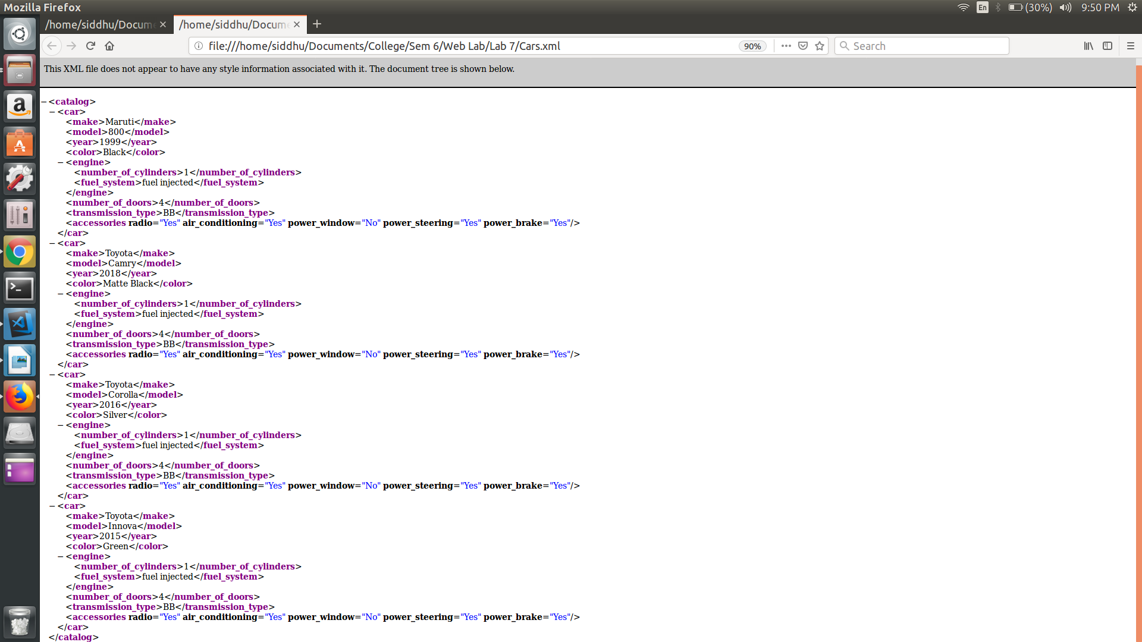
Result:
Thus the program is executed and output is obtained.
PROGRAM 2:

AIM :
To create an XML document with atleast three instances of the car element defined in the DTD of Program 1. Process the document by using the DTD of Program 1, and produce a display of raw XML document.

PROGRAM :

Cars.xml

<?xml version="1.0" encoding="UTF-8"?>
<?xml-stylesheet type="text/xsl" href="Cars.xsl"?>
<!DOCTYPE note [
<!ELEMENT automobile (car+)>
<!ELEMENT car (make,model,year,color,engine,no_of_doors,transmission_type,accessories)>
<!ELEMENT engine (no_of_cylinders,fuel_systems)>
<!ATTLIST accessories radio CDATA #REQUIRED >
<!ATTLIST accessories air_condition CDATA #REQUIRED >
<!ATTLIST accessories power_window CDATA #REQUIRED >
<!ATTLIST accessories power_steering CDATA #REQUIRED >
<!ATTLIST accessories power_brake CDATA #REQUIRED >
]>
<catalog>
<car>
<make>Maruti</make>
<model>800</model>
<year>1999</year>
<color>Black</color>
<engine>
<number_of_cylinders>1</number_of_cylinders>
<fuel_system>fuel injected</fuel_system>
</engine>
<number_of_doors>4</number_of_doors>
<transmission_type>BB</transmission_type>
<accessories radio="Yes" air_conditioning="Yes" power_window="No" power_steering="Yes" power_brake="Yes"></accessories>
</car>

<car>
<make>Toyota</make>
<model>Camry</model>
<year>2018</year>
<color>Matte Black</color>
<engine>
<number_of_cylinders>1</number_of_cylinders>
<fuel_system>fuel injected</fuel_system>
</engine>
<number_of_doors>4</number_of_doors>
<transmission_type>BB</transmission_type>
<accessories radio="Yes" air_conditioning="Yes" power_window="No" power_steering="Yes" power_brake="Yes"></accessories>
</car>

<car>
<make>Toyota</make>
<model>Corolla</model>
<year>2016</year>
<color>Silver</color>
<engine>
<number_of_cylinders>1</number_of_cylinders>
<fuel_system>fuel injected</fuel_system>
</engine>
<number_of_doors>4</number_of_doors>
<transmission_type>BB</transmission_type>
<accessories radio="Yes" air_conditioning="Yes" power_window="No" power_steering="Yes" power_brake="Yes"></accessories>
</car>

<car>
<make>Toyota</make>
<model>Innova</model>
<year>2015</year>
<color>Green</color>
<engine>
<number_of_cylinders>1</number_of_cylinders>
<fuel_system>fuel injected</fuel_system>
</engine>
<number_of_doors>4</number_of_doors>
<transmission_type>BB</transmission_type>
<accessories radio="Yes" air_conditioning="Yes" power_window="No" power_steering="Yes" power_brake="Yes"></accessories>
</car>

</catalog>

Cars.xsl

<?xml version="1.0" encoding="UTF-8"?>
<xsl:stylesheet version="1.0"
xmlns:xsl="http://www.w3.org/1999/XSL/Transform">
<xsl:template match="/">
<html>
<body>
<h2>Cars catalog</h2>
<table border="1">
<tr bgcolor="#9acd32">
<th style="text-align:left">Make</th>
<th style="text-align:left">Model</th>
<th style="text-align:left">Year</th>
<th style="text-align:left">Color</th>
<th style="text-align:left">Engine</th>
<th style="text-align:left">Doors</th>
<th style="text-align:left">Transmission Types</th>
<th style="text- align:left">Accessories</th>
<!-- <th style="text-align:left"></th> -->

</tr>
<xsl:for-each select="catalog/car">
<tr>
<td>
<xsl:value-of select="make"/>
</td>
<td>
<xsl:value-of select="model"/>
</td>
<td>
<xsl:value-of select="year"/>
</td>
<td>
<xsl:value-of select="color"/>
</td>
<td>
<xsl:value-of select="engine"/>
</td>
<td>
<xsl:value-of select="number_of_doors"/>
</td>
<td>
<xsl:value-of select="transmission_type"/>
</td>
<td>
<xsl:value-of select="accessories"/>
</td>
</tr>
</xsl:for-each>
</table>
</body>
</html>
</xsl:template>
</xsl:stylesheet>

OUTPUT :

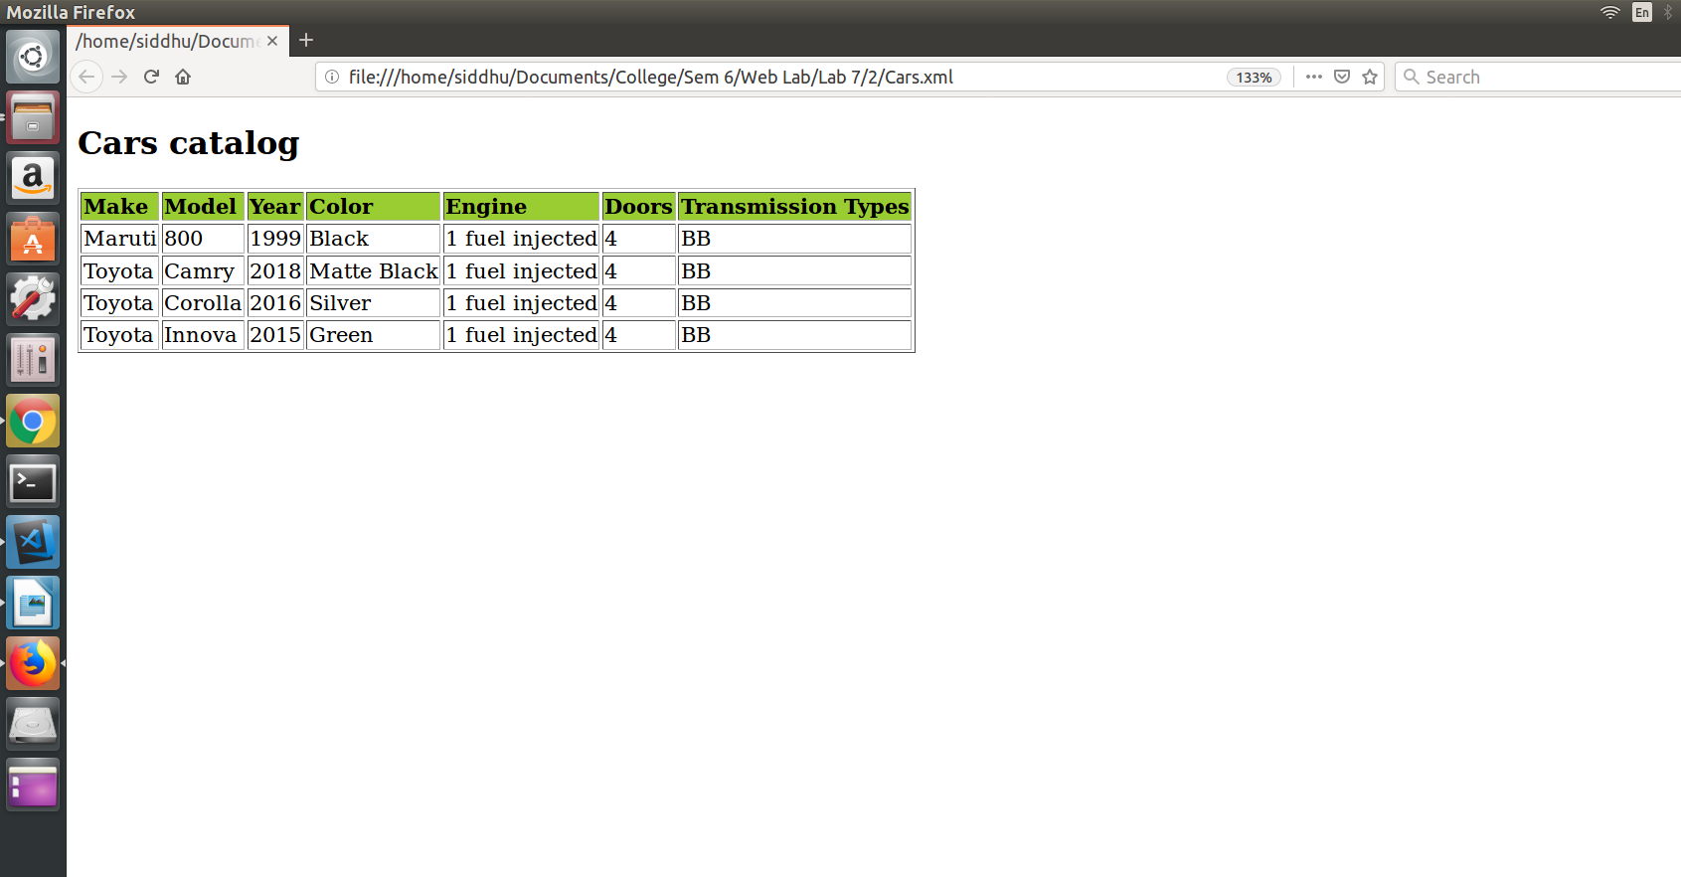

Result:
Thus the program is executed and output is obtained.

PROGRAM 3:

Aim:
To modify the example application of Program 1 to allow the user to select a make and model of used cars. The make must be in a menu. When a make is chosen, a meny of models must be displayed. This menu is produced by hardwired data in the original document. When a model is chosen, an AJAX request must be made to get a list of the years and colors of the chosen make and model that are available. Make up a server-resident script to produce the data from an example array or hash.

PROGRAM :

<html>
<head>
<title> Program 3 </title>
<style>
#display{
visibility: hidden;
}
</style>
<script>
function getData(){
var xml_load1 = new XMLHttpRequest();
xml_load1.onreadystatechange = function(){
if(this.readyState == 4 && this.status == 200){
getMakeElement(this);
}
};
xml_load1.open("GET","index.xml",true);
xml_load1.send();
}
function getMakeElement(xml){
var xmlDoc = xml.responseXML;
var content = "";
var x = xmlDoc.getElementsByTagName("make");
for(i = 0;i < x.length;i++){
var name = "button"+i.toString();
var id1 = "value"+i.toString();
content += "<br> <input type = 'text'" + "value='" + x[i].childNodes[0].nodeValue + "' id=" + id1+ " /><button id="+name+" onclick = displayUtil('" + x[i].childNodes[0].nodeValue + "')> Click to display value </button><br>";
}
document.getElementById("list").innerHTML = content;
}
function displayUtil(name){
document.getElementById("list").style.visibility = "hidden";
document.getElementById("list").style.display = "none";
console.log(name);
getContentData(name)

}
function getContentData(data){
var xml_load1 = new XMLHttpRequest();
xml_load1.onreadystatechange = function(){
if(this.readyState == 4 && this.status == 200){
loadData(this,data);
}
};
xml_load1.open("GET","index.xml",true);
xml_load1.send();
}
function loadData(xml,data){
var xmlDoc = xml.responseXML;
var content = "<table border=1><tr><th>Color</th><th>Year</th></tr>";
var x = xmlDoc.getElementsByTagName("car");
for(var i = 0;i<x.length;i++){
if(x[i].getElementsByTagName("make") [0].childNodes[0].nodeValue == data){
content+="<tr><td>"+ x[i].getElementsByTagName("color") [0].childNodes[0].nodeValue + "</td><td>"+ x[i].getElementsByTagName("year") [0].childNodes[0].nodeValue + "</td></tr>";
}
}
content+="</table>";
document.getElementById("display").innerHTML = content;
document.getElementById("display").style.visibility = "visible";
}

</script>
</head>
<body onload = "getData()">
<div id="list">
</div>
<div id = "display">
</div>
</body>
</html>

index.xml

<catalog>
<car>
<make>Indian</make>
<model>BMW</model>
<color>Blue</color>
<year>1992</year>
<engine>
<number_of_cylinders>6</number_of_cylinders>
<fuel_system>fuel injected</fuel_system>
</engine>
<number_of_doors>4</number_of_doors>
<transmission_type>automatic</transmission_type>
<accessories radio = "yes" air_conditioning = "no" power_windows = "yes" power_steering = "no" power_brakes = "yes"></accessories>
</car>

<car>
<make>English</make>
<model>Benz</model>
<color>Black</color>
<year>1985</year>
<engine>
<number_of_cylinders>8</number_of_cylinders>
<fuel_system>carburated</fuel_system>
</engine>
<number_of_doors>2</number_of_doors>
<transmission_type>manual</transmission_type>
<accessories radio = "yes" air_conditioning = "no" power_windows = "yes" power_steering = "no" power_brakes = "yes"></accessories>
</car>
<car>
<make>German</make>
<model>Volkswagon</model>
<color>Red</color>
<year>1999</year>
<engine>
<number_of_cylinders>4</number_of_cylinders>
<fuel_system>carburated</fuel_system>
</engine>
<number_of_doors>6</number_of_doors>
<transmission_type>auto</transmission_type>
<accessories radio = "yes" air_conditioning = "no" power_windows = "yes" power_steering = "no" power_brakes = "yes"></accessories>
</car>
</catalog>

OUTPUT :

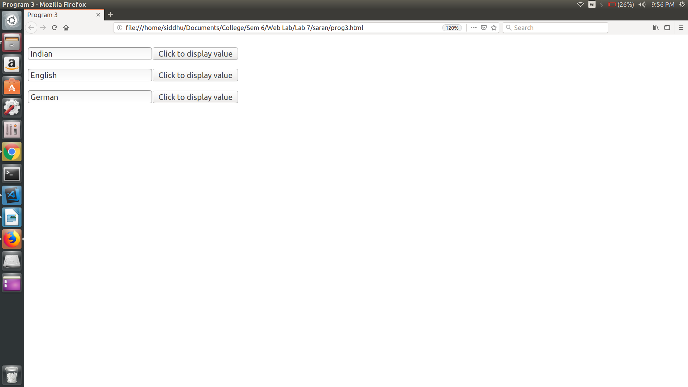
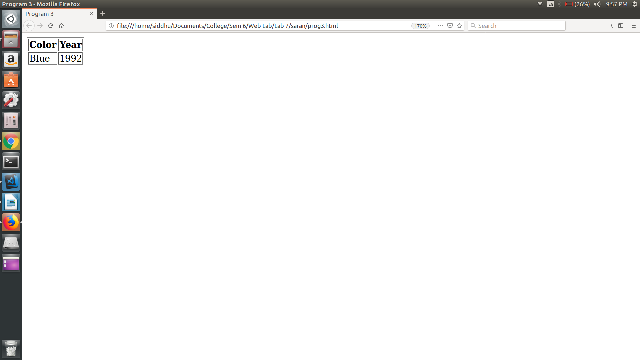
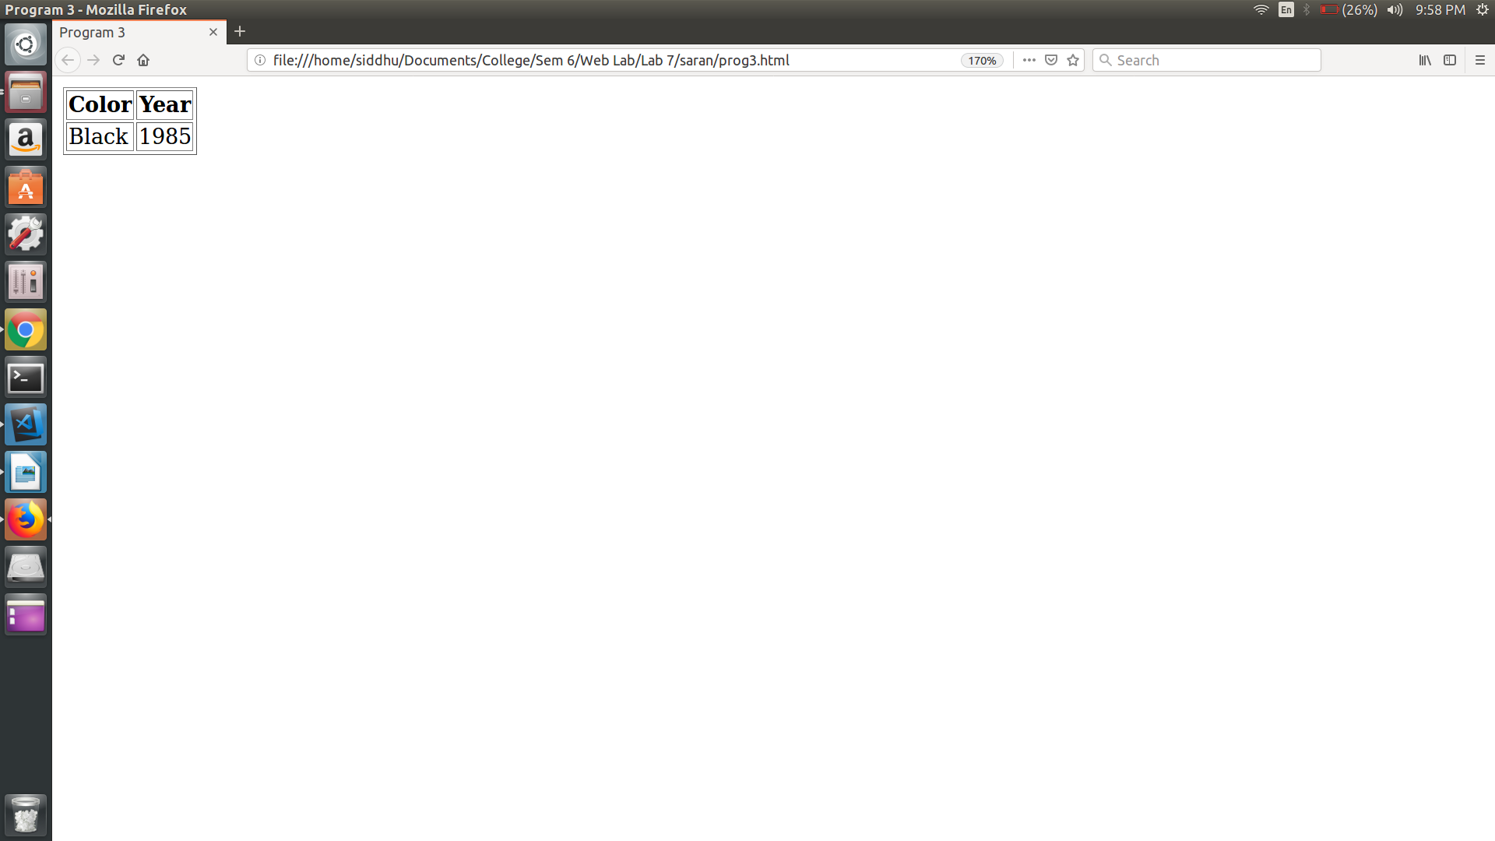

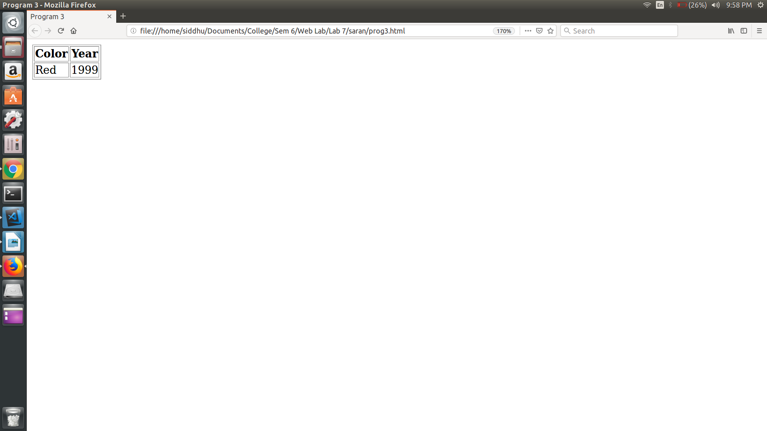

Result:
Thus the program is executed and output is obtained.

PROGRAM 4:

Aim:
To modify the example application of Program 1 to have it provide the addresses of repeat customers, using a hash of names and addresses.

PROGRAM :

Prog4.dtd :

<!ELEMENT catalog (car,customers)>
<!ELEMENT car (make, model, year, color, engine, number_of_doors, transmission_type, accessories)>
<!ELEMENT make (#PCDATA)>
<!ELEMENT model (#PCDATA)>
<!ELEMENT year (#PCDATA)>
<!ELEMENT color (#PCDATA)>
<!ELEMENT engine (number_of_cylinders,fuel_system)>
<!ELEMENT number_of_cylinders (#PCDATA)>
<!ELEMENT fuel_system (#PCDATA)>
<!ELEMENT number_of_doors (#PCDATA)>
<!ELEMENT transmission_type (#PCDATA)>
<!ELEMENT accessories (#PCDATA)>
<!ATTLIST accessories radio (yes|no)>
<!ATTLIST accessories air_conditioning (yes|no)>
<!ATTLIST accessories power_windows (yes|no)>
<!ATTLIST accessories power_steering (yes|no)>
<!ATTLIST accessories power_brakes (yes|no)>
<!ELEMENT customers (id,name,address,count)>
<!ELEMENT id (#PCDATA)>
<!ELEMENT name (#PCDATA)>
<!ELEMENT address (city,state,zipcode)>
<!ELEMENT city (#PCDATA)>
<!ELEMENT catalog (#PCDATA)>
<!ELEMENT catalog (#PCDATA)>
<!ELEMENT count (#PCDATA)>

Prog4.xml

<?xml version="1.0"?>
<!DOCTYPE catalog SYSTEM "prog4.dtd">
<catalog>
<car>
<year>1998</year>
<make>Indian</make>
<model>BMW</model>
<color>Blue</color>
<engine>
<number_of_cylinders>6</number_of_cylinders>
<fuel_system>fuel_injected</fuel_system>
</engine>
<transmission_type>auto</transmission_type>
<number_of_doors>4</number_of_doors>
<accessories radio = "yes" air_conditioning = "no" power_windows = "yes" power_steering = "no" power_brakes = "yes"></accessories>
</car>

<car>
<make>English</make>
<model>Benz</model>
<year>1912</year>
<color>Black</color>
<engine>
<number_of_cylinders>8</number_of_cylinders>
<fuel_system>carburated</fuel_system>
</engine>
<number_of_doors>2</number_of_doors>
<transmission_type>manual</transmission_type>
<accessories radio = "yes" air_conditioning = "no" power_windows = "yes" power_steering = "no" power_brakes = "yes"></accessories>
</car>

<customer>
<id>1</id>
<name>Harry</name>
<address>
<city>Albany</city>
<state>New York</state>
<zip>10001</zip>
</address>
</customer>

<customer>
<id>2</id>
<name>Lily Potter</name>
<address>
<city>Albany</city>
<state>New York</state>
<zip>10001</zip>
</address>
</customer>
</catalog>

Prog4.html

<!DOCTYPE html>
<html>
<head>
<meta charset="utf-8">
<meta http-equiv="X-UA-Compatible" content="IE=edge">
<title>Repeat Customers</title>
<meta name="viewport" content="width=device-width, initial-scale=1">
</head>
<body>
<input type="button" value="Display Frequent" onclick=dispData()>
<br>
<br>
<p id="demo"></p>

<script>
function inputData() {
var id = document.getElementById("id");
var name = document.getElementById("name");
var city = document.getElementById("city");
var state = document.getElementById("state");
var zip = document.getElementById("zip");

var xhttp = new XMLHttpRequest();
xhttp.onreadystatechange = function() {
if(this.readyState == 4 && this.status == 200) {
alert(this.responseText);
document.getElementById("demo").innerHTML = this.responseText;
}
};
xhttp.open("GET","prog4.php?id=" + id,true);
xhttp.send();
}
function dispData() {
var xhttp = new XMLHttpRequest();
xhttp.onreadystatechange = function() {
if(this.readyState == 4 && this.status == 200) {
dispXML(this);
}
};
xhttp.open("GET","prog4.xml",true);
xhttp.send();
}

function dispXML(xml) {
var xmlDoc = xml.responseXML;
var x = xmlDoc.getElementsByTagName("customer");

var content = "";

alert(x.length);
for (var i = 0; i < x.length; i++) {
console.log(i);
content += "Name: " + x[i].getElementsByTagName("name")[0] .childNodes[0].nodeValue + " <br>";
content += "Address: <br>"

var y = x[i].getElementsByTagName("address");

for (var j = 0; j < y.length; j++) {
content += "City: " + y[j].getElementsByTagName("city")[0].childNodes[0].nodeValue + " <br>";
content += "State: " + y[j].getElementsByTagName("state")[0].childNodes[0].nodeValue + " <br>";
content += "Pincode: " + y[j].getElementsByTagName("zip")[0].childNodes[0].nodeValue + " <br>";
}
content += "<br>"
}
document.getElementById("demo").innerHTML = content;

}
</script>

</body>
</html>

OUTPUT :

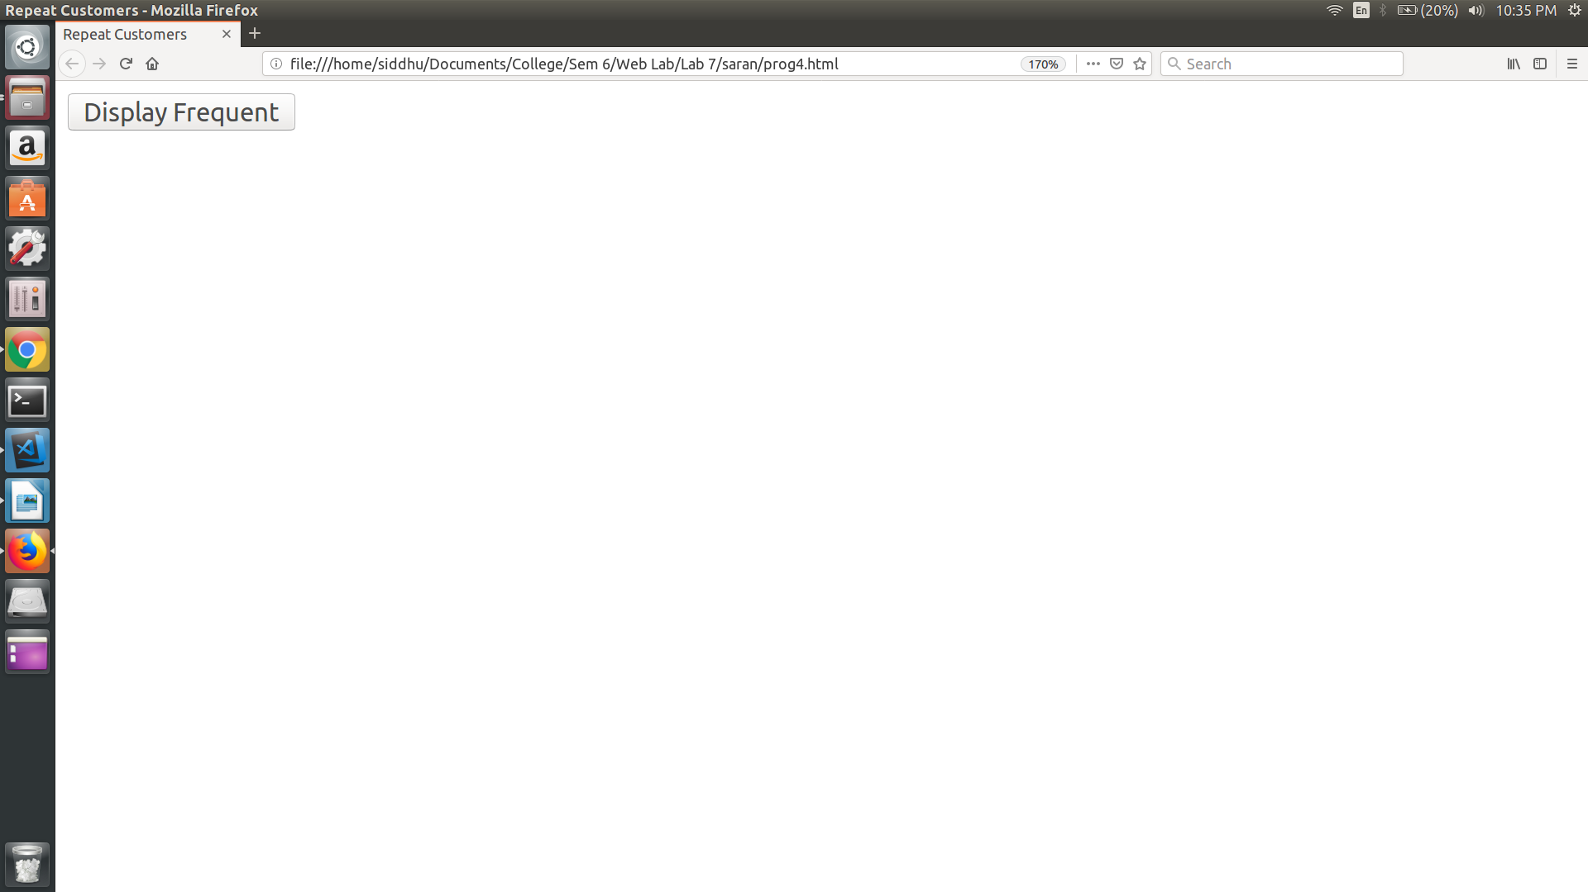
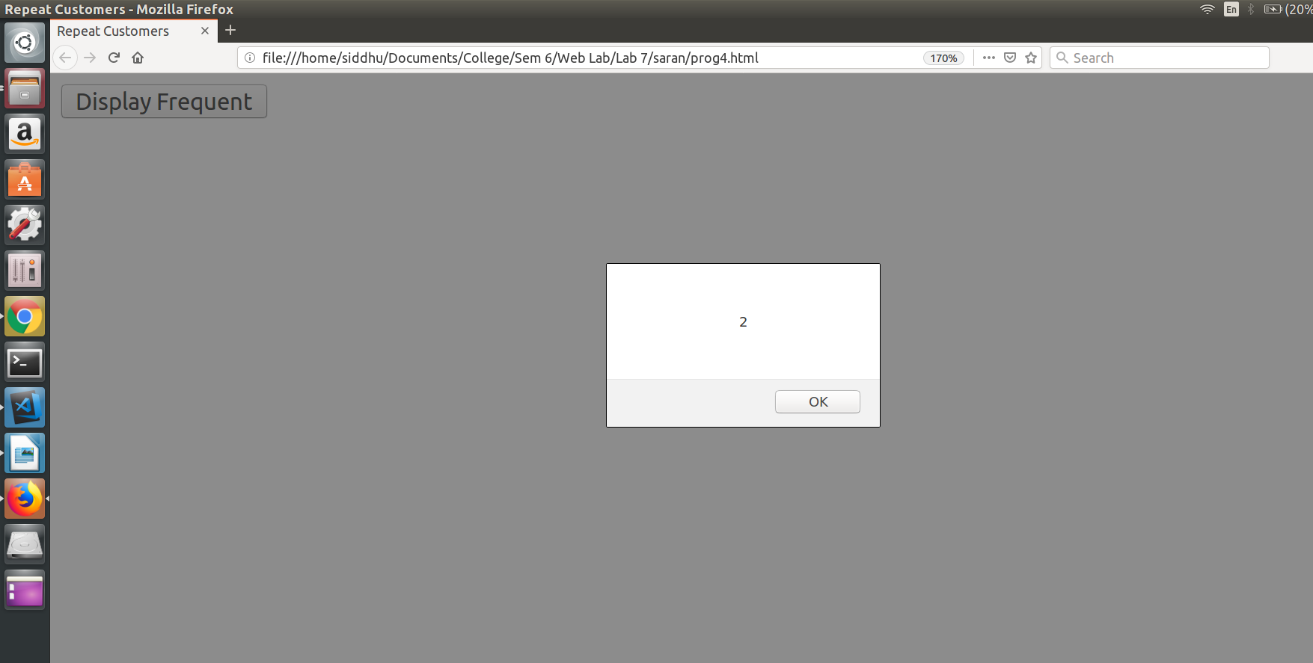
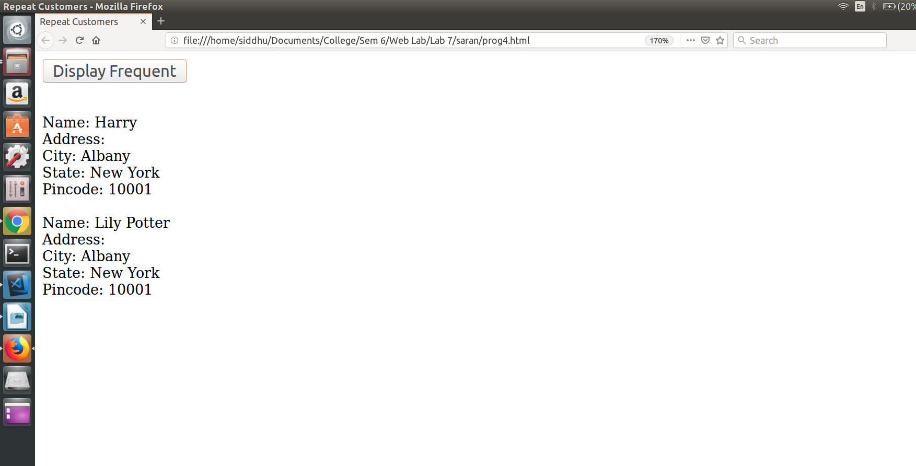

Result:
Thus the program is executed and output is obtained.

PROGRAM 5:

Aim:
To modify the example application of Program 4 with validate the zip code when it is entered, to ensure that it is a valid zip code for the given city and state. The response document can be a PHP script that looks up the zip code and the city and state in a small table of examples.

PROGRAM :

Prog5.html

<html>
<head>
<title>Program 5</title>
<meta charset="utf-8">
<script>
function myfunc(){
var x = document.getElementById("city").value;
var y = document.getElementById("state").value;
var z = document.getElementById("zipcode").value;
console.log(x);
var req = x + " " + y + " " + z;
var xml_load1 = new XMLHttpRequest();
xml_load1.onreadystatechange = function(){
if(this.readyState == 4 && this.status == 200){
}
};
xml_load1.open("GET","prog5.php? val="+req,true);
xml_load1.send();
}
</script>
</head>
<body>
<form>
City:<input id="city" type="text" value="" /><br><br>
State:<input id="state" type="text" value="" /><br><br>
ZipCode:<input id="zipcode" type="text" value="" /><br><br>
<input type="button" value="Submit" onclick=myfunc() />
</form>
</body>
</html>
Prog5.php

<?php
$address[] = "Chennai TamilNadu 600001";
$address[] = "Salem TamilNadu 600002";
$address[] = "Madurai TamilNadu 600003";

$val = $_REQUEST["val"];
$fl = 0;
for($i=0;$i<sizeof($address);$i++){
if($address[$i] == $val){
$fl = 1;
break;
}
}
if($fl==0)
echo 'inValid';
else
echo 'valid';
?>

OUTPUT :
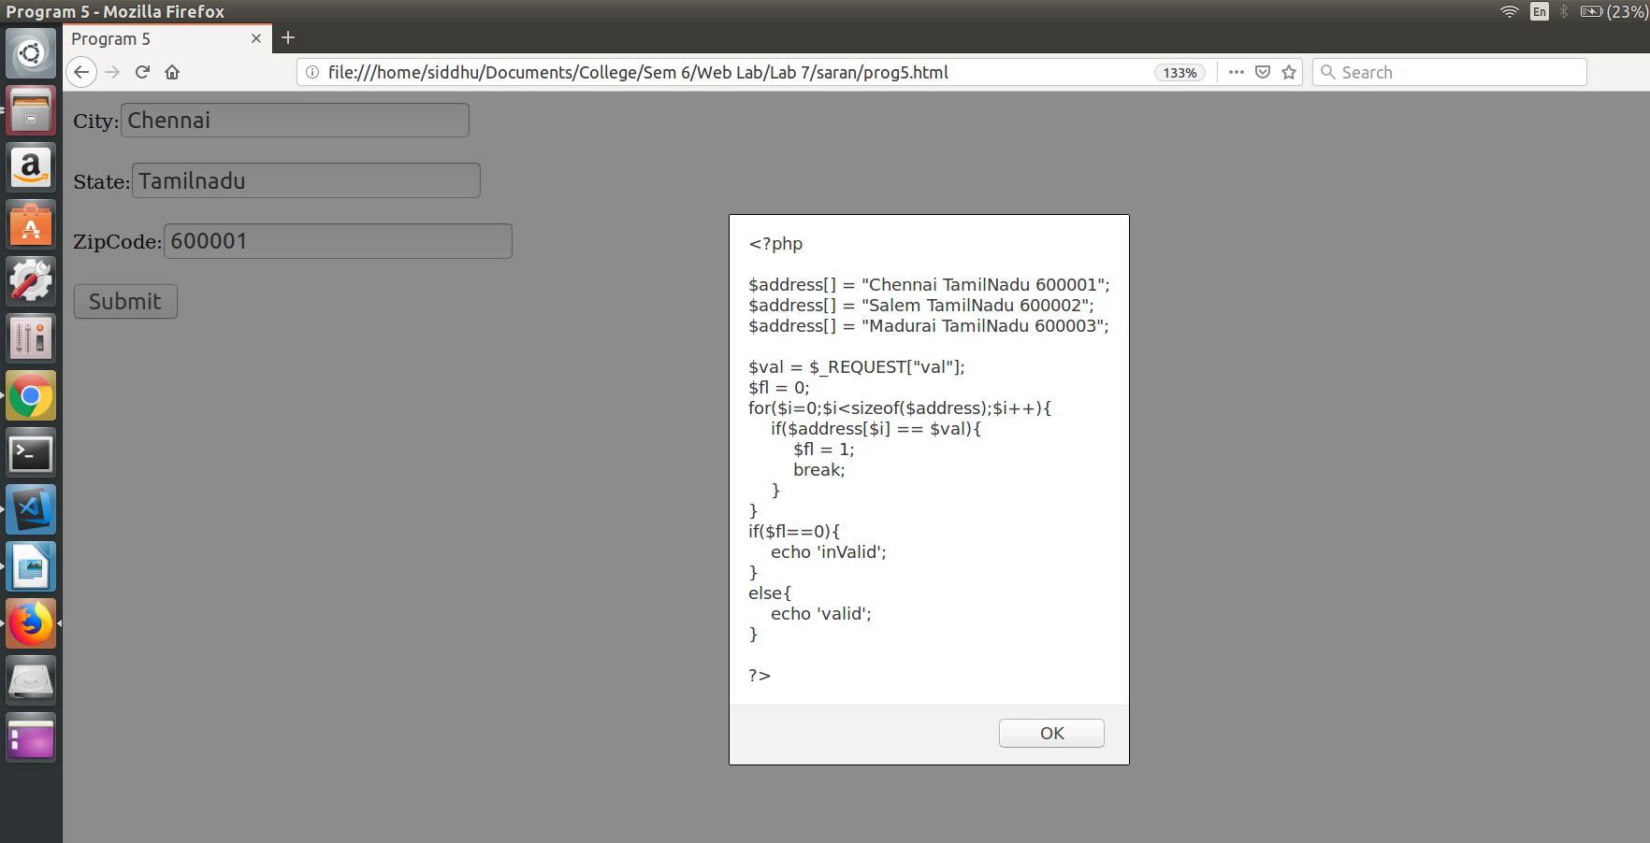
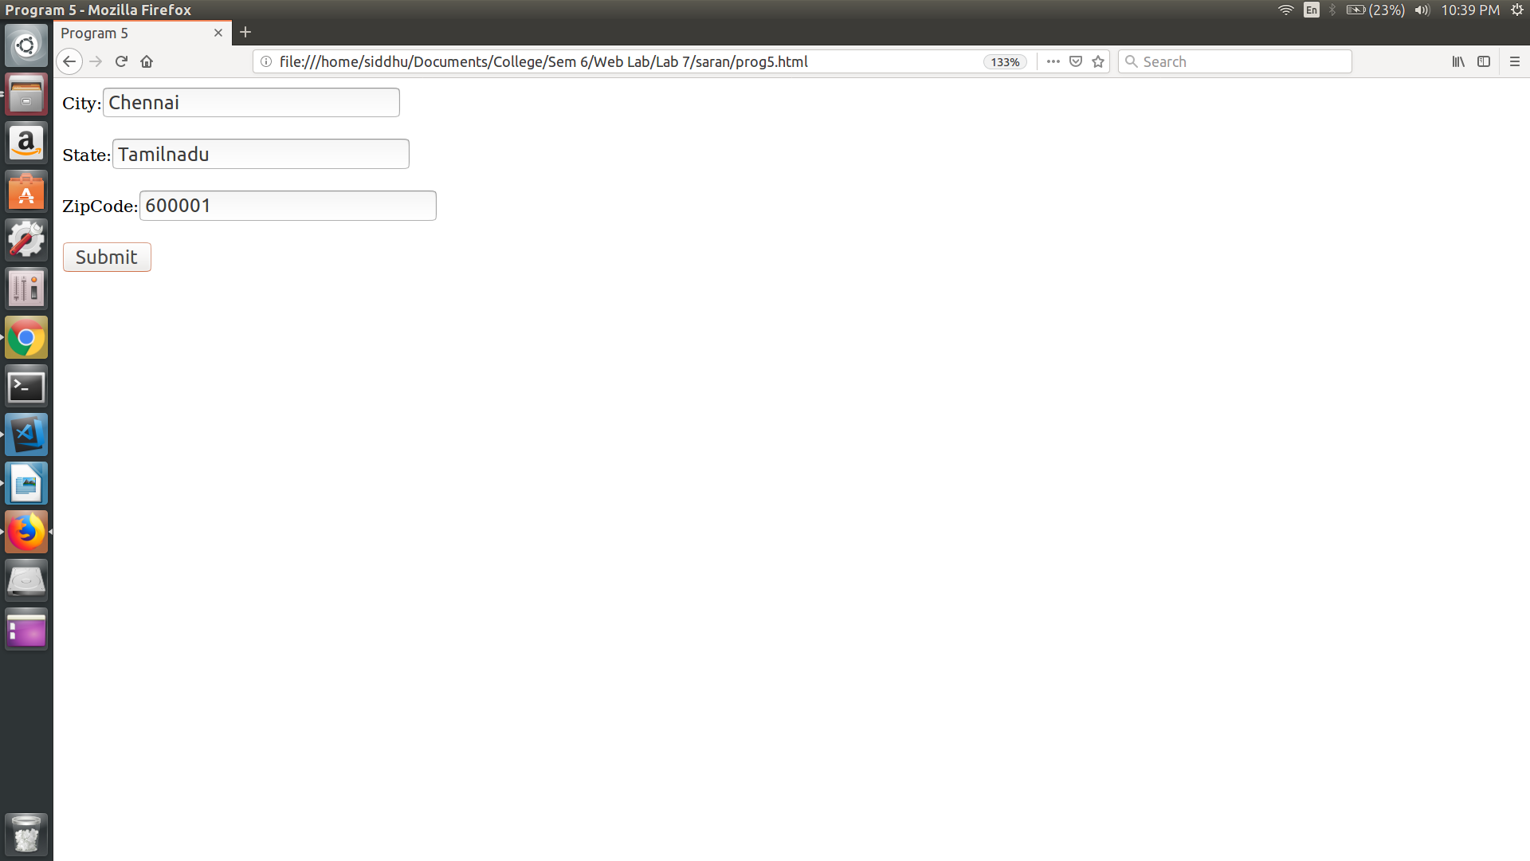
Result:
Thus the program is executed and output is obtained.
Date - 22/02/19

Experiment – 8

XML, XSLT, SAX, XPATH, DTD, PARSERS

PROGRAM 1:

AIM:
To design an XML document that stores information about patients in a hospital. Information about parents must include their name (in three parts), Social Security Number, age, room number, primary insurance company – including member identification number, group number, phone number, and address – seconary insurance company (wit same parts as the primary insurance company has), known medical problems, and known drug allergies. Both attributes and nested tags ust be included. Make up a sample data for atleast four patients.

PROGRAM :

<hospital>

<patient>
<name firstname="A" middlename="B" lastname="C" />
<sex>Male</sex>
<room-number>1</room-number>
<age>40</age>
<social-security-number>1234</social-security-number>
<primary-insurance-company>
<id>11</id>
<group-id>21</group-id>
<phone>1111111111</phone>
<address>Chennai</address>
</primary-insurance-company>
<secondary-insurance-company>
<id>21</id>
<group-id>41</group-id>
<phone>2222222222</phone>
<address>Madurai</address>
</secondary-insurance-company>
</patient>

<patient>
<name firstname="x" middlename="Y" lastname="Z" />
<sex>Male</sex>
<room-number>2</room-number>
<age>20</age>
<social-security-number>1234</social-security-number>
<primary-insurance-company>
<id>12</id>
<group-id>31</group-id>
<phone>1111111111</phone>
<address>Mumbai</address>
</primary-insurance-company>
<secondary-insurance-company>
<id>22</id>
<group-id>51</group-id>
<phone>2222222222</phone>
<address>Delhi</address>
</secondary-insurance-company>
</patient>

</hospital>

OUTPUT:

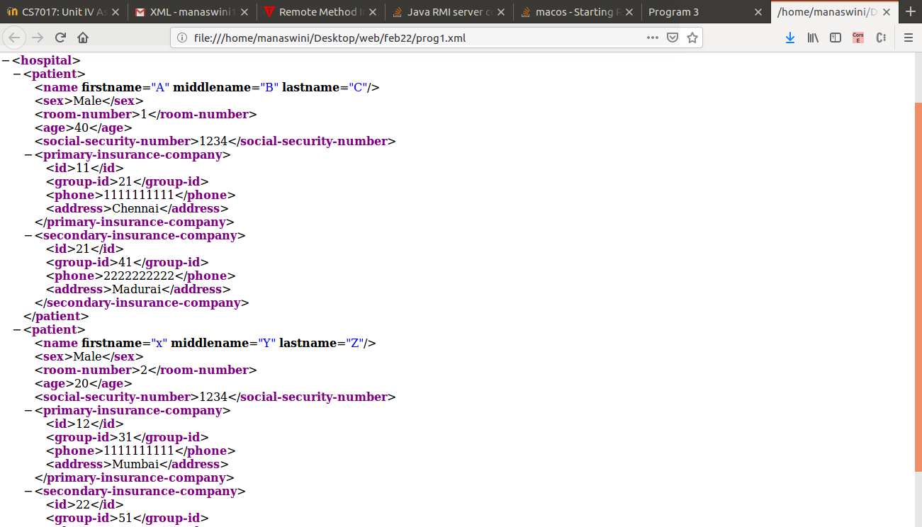

RESULT:
Thus the program is executed and output is obtained.

PROGRAM 2:

AIM :
To write a DTD for the ocument described in Program 1, but with the following restrictions: name, Social Security number, age, room number, and primary insurance company are required. All the other elements are optional, as are middle names.

PROGRAM :

<!ELEMENT hospital (patient)>
<!ELEMENT patient (name,sex,room-number,age,social-security-number,primary-insurance-company,secondary-insurance-company)>
<!ELEMENT name (#PCDATA)>
<!ATTLIST firstname #REQUIRED>
<!ATTLIST middlename >
<!ATTLIST lastname #REQUIRED>
<!ELEMENT age(#PCDATA) #REQUIRED>
<!ELEMENT sex(#PCDATA) #REQUIRED>
<!ELEMENT room-number (#PCDATA) #REQUIRED>
<!ELEMENT social-security-number(#PCDATA) #REQUIRED>
<!ELEMENT primary-insurance-company (id,group-id,phone,address) #REQUIRED>
<!ELEMENT id (#PCDATA)>
<!ELEMENT group-id (#PCDATA)>
<!ELEMENT phone (#PCDATA)>
<!ELEMENT address (#PCDATA)>
<!ELEMENT secondary-insurance-company (id,group-id,phone,address)>

RESULT:
Thus the program is executed and output is obtained.

PROGRAM 3:

AIM :
To create a CSS style sheet for the XML document of program 1 and use it to create a display of thet document.

PROGRAM :

name,sex, room-number, age, social-security-number{
color: blue;
font-family: verdana;
font-size: 200%;
display : block;
}
hospital {
border: 1px solid powderblue;
display : block;
}
sex{
color: white;
background-color : gray;
width: 200%;
}
primary-insurance-company, secondary-insurance-company{
font-size : 25px;
font-weight : bold;
}

OUTPUT:

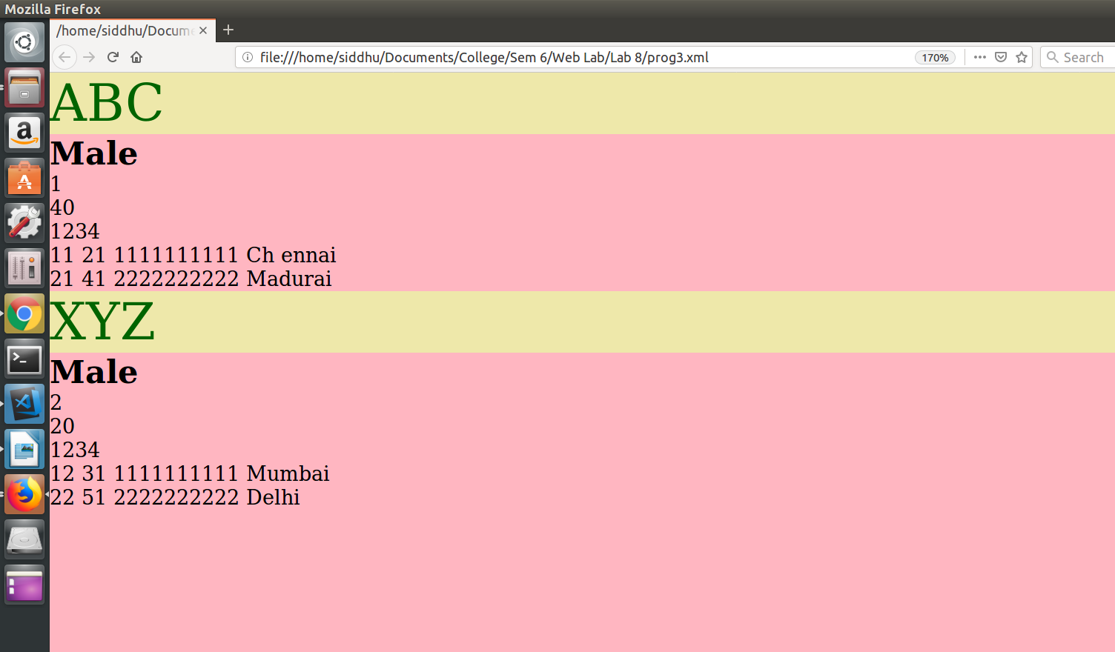

RESULT:
Thus the program is executed and output is obtained.

PROGRAM 4:

AIM:
To create an XSLT sylesheet for one patient element of the XML document of program 1 and use it to create a display of that element.

PROGRAM :

<?xml version="1.0" encoding="UTF-8"?>
<xsl:stylesheet version="1.0" xmlns:xsl="http://www.w3.org/1999/XSL/Transform">
<xsl:template match="/">
<html>
<body bgcolor="blue">
<h2 align="center" style="color:yellow font-family:helvetica">Patient History</h2>
<table border="1" align="center">
<tr bgcolor="green">
<th style="text-align:left font-size:100%">FName</th>
<th style="text-align:left font-size:100%">MName</th>
<th style="text-align:left font-size:100%">LName</th>
<th style="text-align:left font-size:100%">Sex</th>
<th style="text-align:left font-size:100%">Room-number</th>
<th style="text-align:left font-size:100%">Age</th>
<th style="text-align:left font-size:100%">Social Security Number</th>
<th style="text-align:left font-size:100%">SIC:ID</th>
<th style="text-align:left font-size:100%">SIC:GrpID</th>
<th style="text-align:left font-size:100%">SIC:Phone</th>
<th style="text-align:left font-size:100%">SIC:Address</th>
<th style="text-align:left font-size:100%">SIC:ID</th>
<th style="text-align:left font-size:100%">SIC:GrpID</th>
<th style="text-align:left font-size:100%">SIC:Phone</th>
<th style="text-align:left font-size:100%">SIC:Address</th>
</tr>
<xsl:for-each select="hospital/patient[name='XYZ']">
<tr>
<td><xsl:value-of select="name/@firstname"/></td>
<td><xsl:value-of select="name/@middlename"/></td>
<td><xsl:value-of select="name/@lastname"/></td>
<td><xsl:value-of select="sex"/></td>
<td><xsl:value-of select="room-number"/></td>
<td><xsl:value-of select="age"/></td>
<td><xsl:value-of select="social-security-number"/></td>
<td><xsl:value-of select="primary-insurance-company/id"/></td>
<td><xsl:value-of select="primary-insurance-company/group-id"/></td>
<td><xsl:value-of select="primary-insurance-company/phone"/></td>
<td><xsl:value-of select="primary-insurance-company/address"/></td>
<td><xsl:value-of select="secondary-insurance-company/id"/></td>
<td><xsl:value-of select="secondary-insurance-company/group-id"/></td>
<td><xsl:value-of select="secondary-insurance-company/phone"/></td>
<td><xsl:value-of select="secondary-insurance-company/address"/></td>
</tr>
</xsl:for-each>
</table>
</body>
</html>
</xsl:template>
</xsl:stylesheet>

OUTPUT:

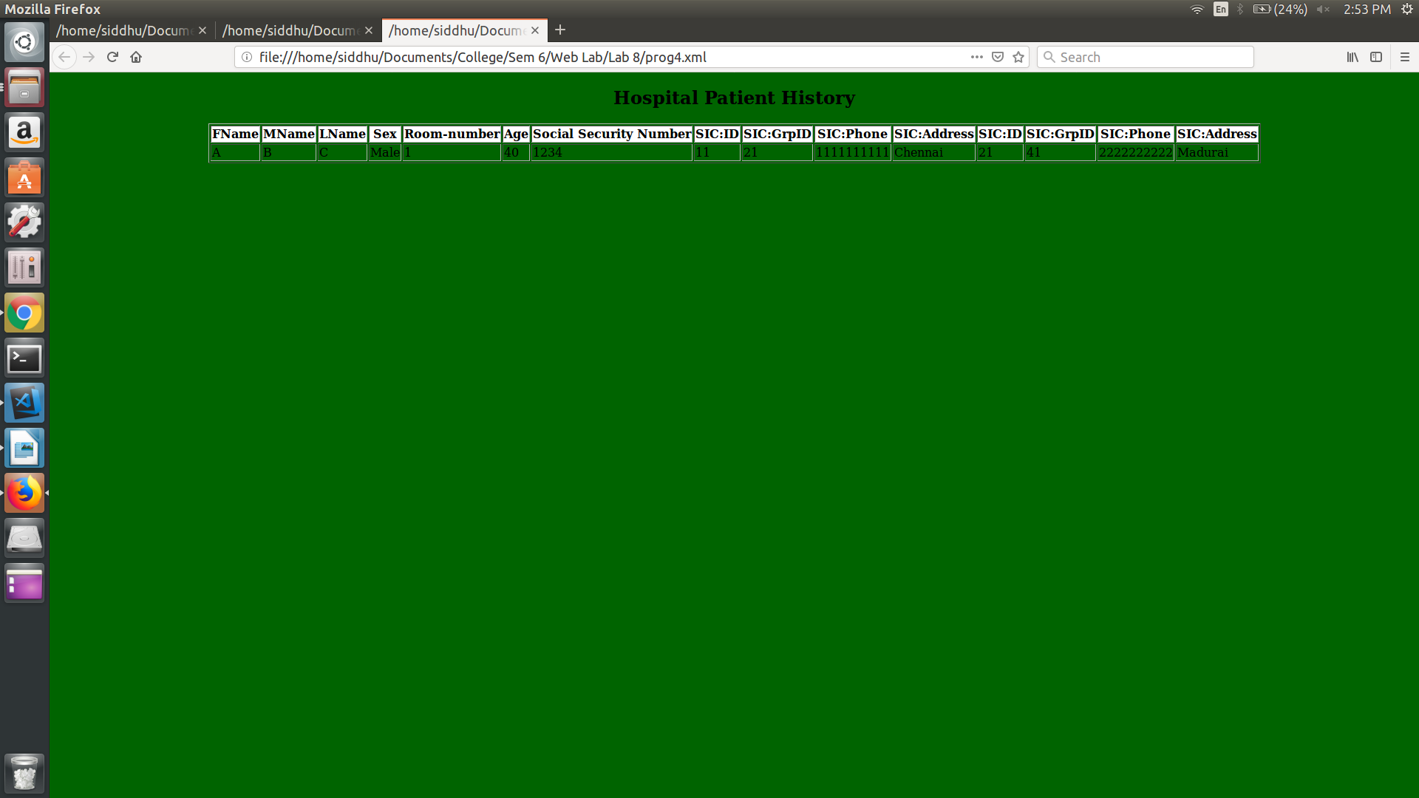

RESULT :
Thus the program is executed and output is obtained.

PROGRAM 5:

AIM :
To modify the XSLT stylesheet of Program 4 so that it formats all the patient elements in the XML document of Program 1 abd use the sylesheet to create a display of the whole document.

PROGRAM :

<?xml version="1.0" encoding="UTF-8"?>
<xsl:stylesheet version="1.0" xmlns:xsl="http://www.w3.org/1999/XSL/Transform">
<xsl:template match="/">
<html>
<body bgcolor="blue">
<h2 align="center" style="color:blue font-family:helvetica">Patient History</h2>
<table border="1" align="center">
<tr bgcolor="green">
<th style="text-align:left font-size:300%">FName</th>
<th style="text-align:left font-size:300%">MName</th>
<th style="text-align:left font-size:300%">LName</th>
<th style="text-align:left font-size:300%">Sex</th>
<th style="text-align:left font-size:300%">Room-number</th>
<th style="text-align:left font-size:300%">Age</th>
<th style="text-align:left font-size:300%">Social Security Number</th>
<th style="text-align:left font-size:300%">SIC:ID</th>
<th style="text-align:left font-size:300%">SIC:GrpID</th>
<th style="text-align:left font-size:300%">SIC:Phone</th>
<th style="text-align:left font-size:300%">SIC:Address</th>
<th style="text-align:left font-size:300%">SIC:ID</th>
<th style="text-align:left font-size:300%">SIC:GrpID</th>
<th style="text-align:left font-size:300%">SIC:Phone</th>
<th style="text-align:left font-size:300%">SIC:Address</th>
</tr>
<xsl:for-each select="hospital/patient">
<tr>
<td><xsl:value-of select="name/@firstname"/></td>
<td><xsl:value-of select="name/@middlename"/></td>
<td><xsl:value-of select="name/@lastname"/></td>
<td><xsl:value-of select="sex"/></td>
<td><xsl:value-of select="room-number"/></td>
<td><xsl:value-of select="age"/></td>
<td><xsl:value-of select="social-security-number"/></td>
<td><xsl:value-of select="primary-insurance- company/id"/></td>
<td><xsl:value-of select="primary-insurance-company/group- id"/></td>
<td><xsl:value-of select="primary-insurance- company/phone"/></td>
<td><xsl:value-of select="primary-insurance- company/address"/></td>
<td><xsl:value-of select="secondary-insurance- company/id"/></td>
<td><xsl:value-of select="secondary-insurance-company/group- id"/></td>
<td><xsl:value-of select="secondary-insurance- company/phone"/></td>
<td><xsl:value-of select="secondary-insurance- company/address"/></td>
</tr>
</xsl:for-each>
</table>
</body>
</html>
</xsl:template>
</xsl:stylesheet>

OUTPUT:

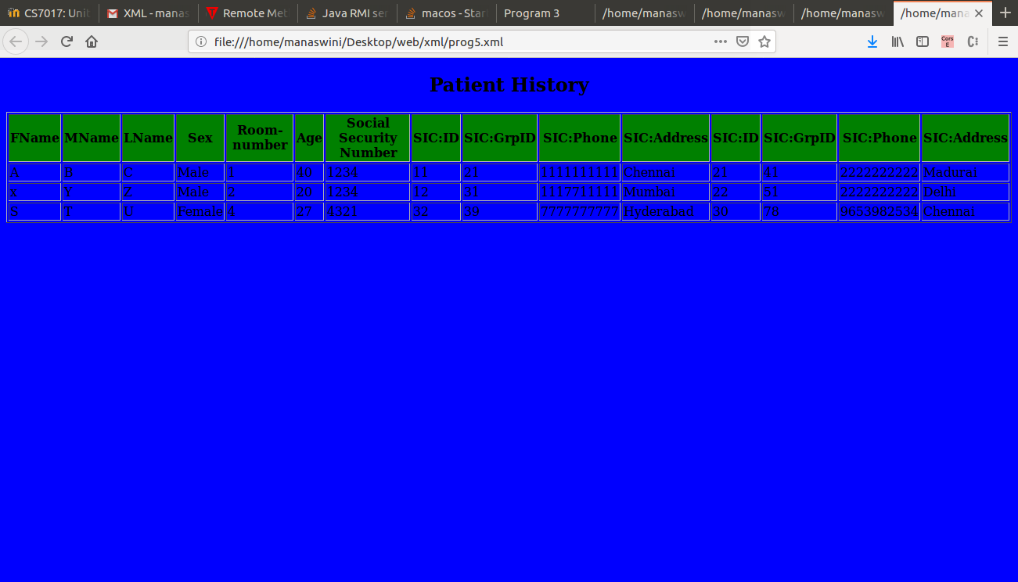

Result:
Thus the program is executed and output is obtained.

