Clinical Cost Insight
A
Industrial Oriented Mini Project Report

Submitted to



Jawaharlal Nehru Technological University, Hyderabad
In partial fulfilment of the requirements for the
award of the degree of
BACHELOR OF TECHNOLOGY
In
COMPUTER SCIENCE AND ENGINEERING
By

B.CHAITRA (23VE1A0506)

G.SIDDHARTH (23VE1A0516)

K.GANESH (23VE1A0529)

N.SWETHA (23VE1A0543)

Under the Guidance
of
DR.U.M.FERNANDES DIMLO
PROFESSOR



SREYAS INSTITUTE OF ENGINEERING AND TECHNOLOGY
An Autonomous Institution
DEPARTMENT OF COMPUTER SCIENCE AND ENGINEERING
(Affiliated to JNTUH, Approved by A.I.C.T.E and Accredited by NAAC, New Delhi)
Beside InduAranya, Nagole, Hyderabad-500068, Ranga Reddy Dist.
(2023-2027)



SREYAS INSTITUTE OF ENGINEERING AND TECHNOLOGY
An Autonomous Institution
DEPARTMENT OF COMPUTER SCIENCE AND ENGINEERING

CERTIFICATE
This is to certify that the Real Time Research/societalProject Report on“Cinical Cost Insight”submitted by Bonagiri Chaitra, Gaddam Siddharth, Kasa Ganesh, Narayanadasu Swetha Hall ticket numbers:23VE1A0506, 23VE1A0516, 23VE1A0529, 23VE1A0543in partial fulfillment of the requirements for the award of the degree of Bachelor of Technology in COMPUTER SCIENCE AND ENGINEERING from Sreyas Institute of Engineering and Technology,Banlaguda, Hyderabad for the academic year 2025-2026 is a record of bonafide work carried out by them under our guidance and Supervision.
.

Project Coordinator | Head of the Department
DR.S.SOWJANYA | Dr. U. M. FERNANDES DIMLO
Assistant Professor | Professor& Head
Internal Guide  DR.U.M.FERNANDES DIMLO | External Examiner

Professor



SREYAS INSTITUTE OF ENGINEERING AND TECHNOLOGY
An Autonomous Institution
DEPARTMENT OF COMPUTER SCIENCE AND ENGINEERING

DECLARATION

We Bonagiri Chaitra, Gaddam Siddharth, Kasa Ganesh, Narayanadasu Swetha bearing Hallticket number: 23VE1A0506, 23VE1A0516, 23VE1A0529, 23VE1A0543 hereby declare that the Real Time Research/societalProject titled Clinical Cost Insight done by us under the guidance of DR.U.M.Fernandes Dimlo,Professor which is submitted in the partial fulfillment of the requirementfor the award of the B.Tech degree in Computer Science and Engineering at Sreyas Institute of Engineering and Technology for Jawaharlal Nehru TechnologicalUniversity, Hyderabad is our original work.

BONAGIRI CHAITRA (23VE1A0506)

GADDAM SIDDHARTH (23VE1A0516)

KASA GANESH (23VE1A0529)

NARAYANADASU SWETHA (23VE1A0543)

ACKNOWLEDGEMENT

The successful completion of any task would be incomplete without mention of the people who made it possible through their guidance and encouragement crowns all the efforts with success.
We take this opportunity to acknowledge with thanks and deep sense of gratitude to DR.U.M.FERNANDES DIMLO Professor, Department of Computer Science and Engineering for his constant encouragement and valuable guidance during the Project work.
A Special vote of Thanks to Dr. U. M. Fernandes Dimlo, Head of the Department and Project Coordinator who has been a source of Continuous motivation and support. They had taken time and effort to guide and correct us all through the span of this work.
We owe very much to the Department Faculty, Principal and the Management who made our term at Sreyas Institute of Engineering and Technology a stepping stone for our career. We treasure every moment we had spent in college.
Last but not the least, our heartiest gratitude to our parents and friends for their continuous encouragement and blessings. Without their support this work would not have been possible.

BONAGIRI CHAITRA (23VE1A0506)

GADDAM SIDDHARTH (23VE1A0516)

KASA GANESH (23VE1A0529)

NARAYANADASU SWETHA (23VE1A0543)

ABSTRACT

Clinical Cost Insight is a healthcare web application designed to provide patients with transparent and comparative information about medical costs across different hospitals. It enables users to search for treatments, compare prices, and make informed healthcare decisions through a centralized platform.

The application is developed using Python and the Flask framework for backend processing, along with MongoDB for efficient data storage and management. It offers a user-friendly interface with simple navigation and quick search capabilities, ensuring smooth interaction and easy access to relevant information.

By highlighting cost variations between hospitals, the system promotes financial awareness and helps patients plan their treatments more effectively. Overall, Clinical Cost Insight aims to reduce uncertainty in healthcare expenses and support smarter, more confident decision-making.

KEYWORDS: Healthcare Cost Transparency , Cost awareness and accessibility

S.NO |  | TABLE OF CONTENTS | PAGE NO.
1 |  | INTRODUCTION | 1-9
 | 1.1 | GENERAL | 1
 | 1.2 | PROBLEM STATEMENT | 2
 | 1.3 | EXISTINGSYSTEM | 3
 | 1.3.1 | DRAWBACKS | 5
 | 1.4 | PROPOSEDSYSTEM | 8
 | 1.4.1 | ADVANTAGES | 8
2 |  | LITERATURESURVEY | 10-12
 | 2.1 | TECHNICAL PAPERS | 10
3 |  | REQUIREMENTS | 13-14
 | 3.1 | GENERAL | 13
 | 3.2 | HARDWARE REQUIREMENTS | 13
 | 3.3 | SOFTWAREREQUIREMENTS | 14
4 |  | SYSTEMDESIGN | 15-27
 | 4.1 | GENERAL | 15
 | 4.2 | SYSTEM ARCHITECTURE | 17
 | 4.3 | UML DISGN | 17
 | 4.3.1 | USE-CASE DIAGRAM | 19
 | 4.3.2 | CLASS DIAGRAM | 22
 | 4.3.3 | ACTIVITY DIAGRAM | 24

5 |  | TECHNOLOGY DESCRIPTION | 28-38
 | 5.1 | WHAT IS JAVA? | 28
 | 5.2 | ADVANTAGES OF JAVA | 29
 | 5.3 | LIBRARIES | 32
 | 5.4 | DISADVANTAGES OF JAVA | 36
6 |  | IMPLEMENTATION | 39-44
 | 6.1 | METHODOLOGY | 39
 | 6.2 | SAMPLECODE | 42
7 |  | TESTING | 45-46
 | 7.1 | GENERAL | 45
 | 7.2 | TYPESOFTESTING | 45
 | 7.3 | TESTCASES | 46
8 |  | RESULTS | 47-49
 | 8.1 | SCREEN SHOTS | 47
9 |  | FUTURESCOPE | 50-51
10 |  | CONCLUSION | 52-53
11 |  | REFERENCES | 54-55

FIG. NO/TAB.NO | LIST OF FIGURES AND TABLES | PAGE NO.
4.1 | Architecture Diagram | 17
4.2 | Use Case Diagram | 21
4.3 | Class Diagram | 24
4.4 | Activity Diagram | 27
7.1 | Types of Testing | 45
7.2 | Test cases table | 46

SCREENSHOT. NO | LIST OF SCREENSHOTS | PAGE. NO
8.1 | Login Page | 47
8.2 | Home Page | 48
8.3 | Add Flight | 48
8.4 | Search Flight | 49
8.5 | Cancel Ticket | 49

LIST OF SYMBOLS

SNO. | Name of Symbol | Notation | Description
1 | CLASS | 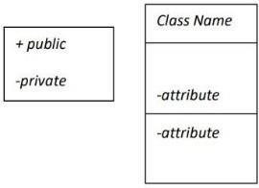 | Represents a collection of similar entities grouped together.
2 | ASSOCIATION |  | Associations represent static relationships between classes. Roles represent the way the two classes see each other.
3 | ACTOR |  | It aggregates several classes into a single class.
4 | RELATION (uses) | Uses | Used for additional process communication.
5 | RELATION (extents) |  | Extends relationship is used when one use case is similar to another use case.

6 | COMMUNICATION |  | Communication between various use cases.
7 | STATE | 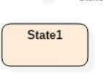 | State of the process
8 | INITIAL STATE |  | Initial state of the object
9 | FINAL STATE |  | Final state of the object
10 | CONTROL FLOW |  | Represents various control flow between the states.
11 | DECISION BOX |  | Represents decision  making process from a  constraint
12 | USE CASE | 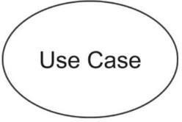 | Interact ion between the system and external environment.

13 | COMPONENT | 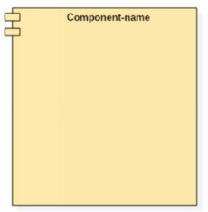 | Represents physical modules which is a collectionofcomponents.
14 | NODE | 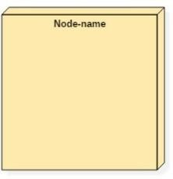 | Represents physical modules which are a collectionofcomponents.
15 | DATAPROCESS/ STATE |  | A circle in DFD represents a state or processwhichhasbeen triggered due to some event or action.
16 | EXTERNALENTITY | 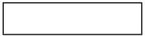 | Represents external entitiessuchaskeyboard,  sensors,etc
17 | TRANSITION |  | Represents communication that occursbetweenprocesses.
18 | OBJECT LIFELINE | 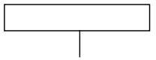 | Represents the vertical dimensions that the object communications.
19 | MESSAGE | 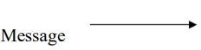 | Represents the message exchanged.

CHAPTER 1

INTRODUCTION

1.1 GENERAL
The rapid growth of the healthcare industry has led to significant advancements in medical treatments and services, but it has also resulted in increased complexity and lack of transparency in healthcare costs. Patients often face difficulties in understanding and comparing the prices of treatments across different hospitals, which can lead to confusion, financial stress, and uninformed decision-making. In many cases, individuals are forced to choose healthcare services without having clear knowledge of the associated expenses, which may result in unexpected financial burdens. Addressing this issue, the Clinical Cost Insight project is designed to provide a reliable and user-friendly platform that enables patients to access, analyze, and compare medical costs effectively.
Clinical Cost Insight is a web-based application that focuses on improving transparency in healthcare pricing by offering detailed cost comparisons of treatments across multiple hospitals. The system allows users to search for specific medical procedures and obtain relevant pricing information from various healthcare providers. By presenting this data in an organized and easy-to-understand format, the application empowers patients to make informed decisions based on both affordability and quality of care. This approach not only benefits patients but also encourages hospitals to maintain competitive and fair pricing structures.
The application is developed using modern technologies such as Python and Flask for backend processing, ensuring efficient handling of user requests and system operations. MongoDB is used as the database to store and manage healthcare-related data, providing flexibility and scalability. The system is designed with a simple and intuitive user interface, making it accessible to users with varying levels of technical knowledge. It ensures quick data retrieval and smooth navigation, enhancing the overall user experience.
One of the key objectives of Clinical Cost Insight is to bridge the information gap between patients and healthcare providers. By making cost-related information readily available, the system reduces uncertainty and builds trust among users. It also supports better financial planning, as patients can estimate treatment expenses in advance and choose options that fit their budget. Furthermore, the platform can be extended in the future to include additional features such as hospital ratings, reviews, appointment booking, and integration with insurance services, making it a comprehensive healthcare solution.
In conclusion, Clinical Cost Insight aims to revolutionize the way patients interact with healthcare cost information by promoting transparency, accessibility, and informed decision-making. The system not only addresses a critical problem in the healthcare sector but also contributes to building a more patient-centric and efficient healthcare environment. Through its innovative approach, the project highlights the importance of technology in improving healthcare services and reducing financial barriers for patients.

1.2 PROBLEM STATEMENT

In the modern healthcare system, one of the major challenges faced by patients is the lack of transparency and accessibility in medical cost information. Healthcare expenses vary significantly across hospitals, regions, and types of treatments, yet this information is not easily available in a clear and structured manner. Patients are often required to make important decisions regarding their treatment without having complete knowledge of the associated costs, which can lead to confusion, financial stress, and poor decision-making. In many cases, hospitals do not openly disclose detailed pricing for procedures, tests, or services, and even when such information is available, it is scattered, difficult to interpret, or outdated. As a result, patients are forced to rely on manual inquiries or assumptions, making the process time-consuming and unreliable.
Another significant issue is the absence of a centralized platform that consolidates healthcare cost data from multiple providers. Without such a system, comparing treatment costs across different hospitals becomes a complex and inefficient task. This problem becomes even more critical during emergency situations, where patients must make quick decisions without adequate information. Additionally, individuals from rural areas or economically weaker sections face greater challenges due to limited access to reliable resources and information. The lack of cost transparency not only affects patients but also reduces competition among healthcare providers, as pricing remains unclear and inconsistent. This situation ultimately leads to increased financial burdens and limits patients’ ability to choose the most suitable and affordable healthcare services.
Furthermore, the lack of proper cost awareness impacts financial planning and timely medical treatment. Many patients are unprepared for the high expenses associated with certain procedures, which can result in unexpected financial strain or delays in receiving necessary care. In some cases, individuals may avoid or postpone treatments due to uncertainty about costs, negatively affecting their health outcomes. To address these challenges, there is a need for a reliable, user-friendly, and efficient system that provides accurate and up-to-date healthcare cost information. The Clinical Cost Insight project aims to solve this problem by offering a web-based platform that enables users to search, analyze, and compare treatment costs across multiple hospitals, thereby improving transparency, accessibility, and informed decision-making in the healthcare sector.

EXISTING SYSTEM
The existing healthcare system lacks a structured and transparent mechanism for providing patients with clear information about medical costs. Currently, most hospitals and healthcare providers do not offer easily accessible or standardized pricing details for treatments, procedures, and services. Patients often have to rely on direct inquiries, hospital visits, or verbal communication to obtain cost estimates. This process is time-consuming, inconsistent, and often leads to confusion, as pricing may vary based on factors such as location, hospital reputation, and available facilities.
In the current system, there is no centralized platform where users can compare treatment costs across multiple hospitals. Information related to healthcare expenses is scattered across different sources, such as hospital websites, brochures, or third-party platforms, which may not always be reliable or updated. As a result, patients face difficulties in gathering accurate and comprehensive data required for making informed decisions. This lack of integration and standardization makes the comparison process complex and inefficient.
Additionally, the existing system does not provide user-friendly tools or digital solutions to simplify cost analysis. Many individuals, especially those from rural or less technologically advanced backgrounds, find it challenging to access or interpret available information. In emergency situations, this limitation becomes even more critical, as patients are forced to make quick decisions without proper cost awareness. Furthermore, the absence of transparency in pricing reduces accountability among healthcare providers and may lead to higher or inconsistent charges.
Overall, the existing system is characterized by a lack of transparency, limited accessibility, absence of centralized data, and inefficient methods of cost comparison. These shortcomings highlight the need for an improved solution that can provide accurate, reliable, and easily accessible healthcare cost information to support better decision-making for patients.

1.3.1 DISADVANTAGES OF EXISTING SYSTEM
The current healthcare system for accessing medical cost information has several limitations that make it difficult for patients to make informed decisions. The lack of transparency, accessibility, and proper digital support creates confusion and financial uncertainty. The major disadvantages of the existing system are as follows:
- Lack of Transparency: Hospitals do not openly share detailed treatment costs.
- No Centralized Platform: There is no single platform to view and compare costs across hospitals.
- Manual Data Collection: Patients rely on hospital visits or calls to gather information.
- Scattered Information: Cost details are spread across multiple unreliable sources.
- Difficult Comparison: Comparing prices across hospitals is complex and inefficient.
- Time-Consuming Process: Collecting accurate information requires significant time and effort.
- Inconsistent Pricing: Different hospitals follow different pricing standards.
- Limited Accessibility: Rural and less tech-savvy users face difficulties accessing information.
- Outdated Information: Available data is often not regularly updated.
- Lack of Standardization: No uniform format for presenting healthcare costs.
- No Real-Time Updates: Prices may change, but systems do not reflect updates instantly.
- Poor User Interface: Existing sources are not user-friendly or easy to understand.
- Financial Uncertainty: Patients cannot estimate expenses in advance.
- Delayed Decision-Making: Lack of quick access slows down treatment decisions.
- Reduced Competition: Hidden pricing reduces competition among hospitals.
- Risk of Overcharging: Patients may be charged unfairly due to lack of awareness.
- No Cost Analysis Tools: No system to analyze and compare cost effectiveness.
- Dependency on Middlemen: Patients may depend on agents or third parties for information.
19. Lack of Awareness: Many patients are unaware of alternative affordable options.
20. Inefficient Emergency Handling: In emergencies, quick cost comparison is not possible .

These disadvantages highlight the need for a better system like Clinical Cost Insight, which can provide transparent, accurate, and easily accessible healthcare cost information.

PROPOSED SYSTEM
The proposed system, Clinical Cost Insight, is designed to provide a centralized and user-friendly platform for accessing and comparing healthcare costs. It allows patients to search for specific treatments and view cost details from multiple hospitals in a single place. The system collects and organizes pricing data in a structured database, making it easy to retrieve and present information in a clear and understandable format. By offering accurate and up-to-date cost details, it helps users make informed decisions based on their budget and healthcare needs, eliminating the need for time-consuming manual inquiries.
The system is developed using modern technologies such as Python, Flask, and MongoDB, ensuring efficient data processing and reliable storage. It promotes transparency in healthcare pricing and reduces financial uncertainty for patients. The application also provides a simple and intuitive interface, making it accessible to users with varying levels of technical knowledge. Additionally, it supports quick decision-making during emergencies and can be expanded in the future with features like hospital ratings, appointment booking, and insurance integration, making it a scalable and comprehensive healthcare solution

1.4.1 ADVANTAGES OF PROPOSED SYSTEM
- Improved Transparency: Provides clear and open access to healthcare cost information.
- Centralized Platform: All treatment cost data is available in one place.
- Easy Cost Comparison: Users can compare prices across multiple hospitals quickly.
- Time-Saving: Eliminates the need for manual inquiries and hospital visits.
- User-Friendly Interface: Simple design makes it easy for all users to navigate.
- Accurate Information: Provides reliable and updated healthcare cost data.
- Better Decision-Making: Helps patients choose affordable and suitable treatments.
- Reduced Financial Uncertainty: Users can estimate expenses before treatment.
- Quick Access to Data: Fast retrieval of information improves user experience.
- Supports Emergency Decisions: Enables quick comparison during urgent situations.
- Scalable System: Can be expanded with more hospitals and features in future.
- Encourages Fair Pricing: Promotes competition among hospitals for better pricing.
- Accessible Anywhere: Web-based system can be accessed from any location.
- Efficient Data Management: Uses modern technologies for smooth data handling.
- Enhanced Healthcare Awareness: Educates users about treatment costs and options.

CHAPTER 2

LITERATURE SURVEY

2.1 HEALTHCARE COST TRANSPARENCY AND COMPARISON SYSTEMS
Authors: Cutler David M.; Dafny Leemore, 2011
Abstract:
The focus of this study is to analyze the importance of transparency in healthcare pricing and its impact on patient decision-making. The research highlights that the lack of clear and accessible cost information leads to inefficiencies in the healthcare system and increases overall medical expenses. Patients often make decisions without knowing the actual cost of treatments, which results in financial uncertainty. The study emphasizes the need for digital platforms that can provide structured and comparable cost information. By improving transparency, healthcare providers can promote fair competition and enhance service quality. This research supports the development of systems that allow users to compare treatment costs across multiple hospitals in an efficient manner.

2.2 WEB-BASED HEALTHCARE INFORMATION SYSTEMS
Authors: Kruse Clemens S.; Krowski Nicole; Rodriguez Beatriz; Tran Lan, 2016
Abstract:
This study focuses on the role of web-based healthcare systems in improving accessibility and efficiency in medical services. It explains how digital platforms enable users to access healthcare-related information remotely, reducing the need for physical visits. The research highlights the use of modern technologies for developing scalable and user-friendly systems. However, it also identifies that most existing systems lack detailed cost comparison features. While they provide information about services and appointments, they do not focus on financial aspects. This creates a gap in helping patients make cost-effective decisions. The study suggests the integration of cost analysis features into healthcare systems to improve their usefulness.

2.3 PRICE TRANSPARENCY TOOLS IN HEALTHCARE
Authors: Brot-Goldberg Zarek; Chandra Amitabh; Handel Benjamin; Kolstad Jonathan, 2017
Abstract:
The study examines the effectiveness of price transparency tools in reducing healthcare spending. It evaluates how access to pricing information influences patient behavior and decision-making. The research shows that although some tools provide estimated costs, they are limited in scope and do not cover multiple providers comprehensively. This restricts patients from making proper comparisons across hospitals. The study also identifies that lack of standardization and incomplete data reduces the effectiveness of such tools. It concludes that a more integrated and centralized system is required to provide accurate and comparable cost information.

2.4 DIGITAL HEALTHCARE PLATFORMS USING MODERN TECHNOLOGIES
Authors: Desai Nilesh; Patel Rakesh; Shah Priya, 2018
Abstract:
This study focuses on the development of digital healthcare platforms using modern technologies such as web frameworks and NoSQL databases. It highlights the importance of scalable systems that can handle large volumes of healthcare data efficiently. The research explains how technologies like Flask and MongoDB can be used to build lightweight and flexible applications. However, it points out that most platforms are designed for managing healthcare services rather than analyzing costs. The study suggests incorporating cost comparison and decision support features to enhance system functionality and user benefits.

2.5 HEALTHCARE PRICE TRANSPARENCY AND PATIENT DECISION-MAKING
Authors: Mehrotra Ateev; Brannen Sarah; Sinaiko Anna, 2020
Abstract:
This study explores the role of price transparency in improving patient decision-making and reducing unnecessary healthcare expenses. It highlights that providing accurate and accessible cost information helps patients choose affordable treatment options. The research also discusses how digital tools can improve awareness and trust in healthcare systems. However, it identifies that existing platforms are not fully integrated and lack real-time data updates. The study concludes that there is a need for comprehensive systems that combine transparency, accessibility, and usability to support better healthcare decisions.

CHAPTER 3

TECHNICAL REQUIREMENTS

3.1GENERAL

These are the requirements for doing the project.
They are:
- Hardware Requirements
- Software Requirements

3.2HARDWARE REQUIREMENTS

The hardware requirements specify the physical components needed to develop and run the Clinical Cost Insight system efficiently. The system does not require high-end hardware and can operate on standard computing devices.
- Processor:
Intel Core i3 or higher
- RAM:
Minimum 4 GB (8 GB recommended for better performance)
- Hard Disk:
Minimum 500 GB storage or SSD preferred
- System Type:
64-bit Operating System
- Input Devices:
Keyboard and Mouse
- Output Devices:
Monitor or Display Screen
- Network Requirements:
Stable Internet Connection for accessing web application and database
- Server (Optional):
Local server or cloud server for deployment

3.3SOFTWARE REQUIREMENTS

The software requirements define the tools, technologies, and platforms used for the development and execution of the Clinical Cost Insight system.
- Operating System:
Windows 10/11, Linux, or macOS
- Programming Language:
Python
- Web Framework:
Flask
- Database:
MongoDB
- Frontend Technologies:
HTML, CSS, JavaScript
- Development Environment (IDE):
Visual Studio Code / PyCharm
- Web Browser:
Google Chrome / Mozilla Firefox / Microsoft Edge
- Version Control (Optional):
Git and GitHub
- Server Environment:
Localhost (for development) or Cloud Server (for deployment)
- Libraries & Tools:
Flask Libraries, PyMongo, and other required Python packages

CHAPTER 4

SYSTEM DESIGN

4.1GENERAL

The system design of Clinical Cost Insight defines the overall structure, components, and workflow of the application. It describes how different parts of the system interact to provide efficient healthcare cost comparison services. The design focuses on simplicity, scalability, and user accessibility, ensuring that the system performs efficiently under various conditions.
The architecture of the system follows a three-tier structure, which includes the presentation layer, application layer, and database layer. The presentation layer is the front-end interface developed using HTML, CSS, and JavaScript, which allows users to interact with the system. It provides features such as search options, cost comparison views, and user-friendly navigation. The application layer is implemented using Python and Flask, which handles the business logic, processes user requests, and communicates between the front-end and the database. The database layer uses MongoDB to store and manage healthcare cost data, ensuring quick retrieval and flexibility.
The system workflow begins when a user enters a treatment or medical service in the search bar. The request is sent to the Flask server, where it is processed and matched with the relevant data stored in the MongoDB database. The system then retrieves the required information and displays a list of hospitals along with their treatment costs. Users can compare the results and choose the most suitable option based on their requirements.
The design also ensures data accuracy and system reliability by maintaining a structured database and efficient query processing. Security measures can be implemented to protect user data and ensure safe access to the system. Additionally, the system is designed to be scalable, allowing future enhancements such as adding more hospitals, integrating APIs, or including advanced features like reviews and booking systems.
In conclusion, the system design of Clinical Cost Insight provides a clear framework for building a robust, efficient, and user-friendly application that improves healthcare cost transparency and supports informed decision-making.

4.2 SYSTEM ARCHITECTURE
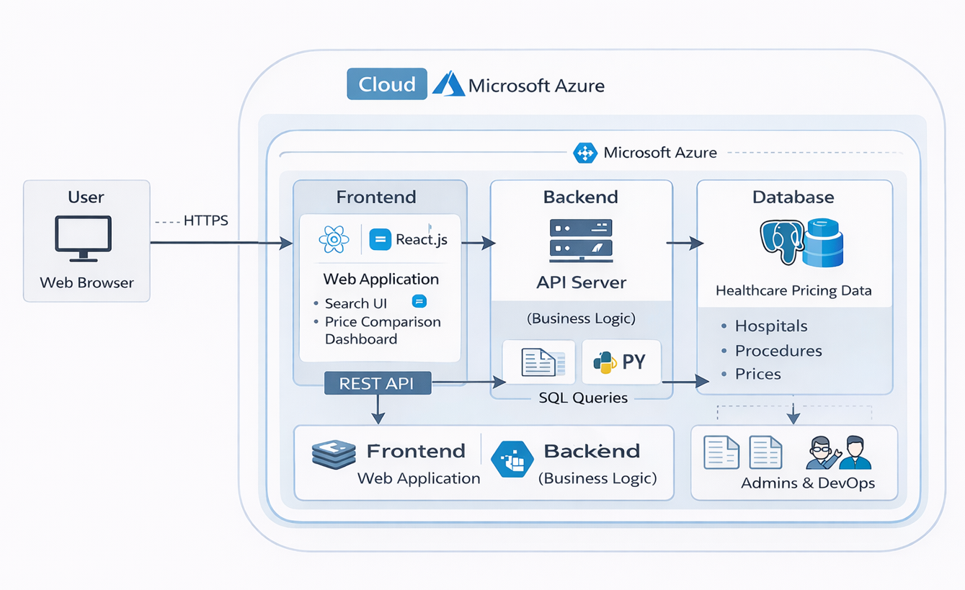

Figure 4.1: Architecture Diagram

4.3 UML DESIGN

Unified Modeling Language (UML) is a general purpose modeling language. The main aim of UML is to define a standard way to visualize the way a system has been designed.
It is quite similar to blueprints used in other fields of engineering.

UML is not a programming language; it is rather a visual language.Use UML diagrams to portray the behavior and structure of a system, UML helps software engineers, businessmen and system architects with modeling, design and analysis.

It’s been managed by OMG ever since. International Organization for Standardization (ISO) published UML as an approved standard in 2005. UML has been revised over the years and is reviewed periodically.

UML combines best techniques from data modeling (entity relationship diagrams), business modeling (work flows), object modeling, and component modeling. It can be used with all processes, throughout the software development life cycle, and across different implementation technologies.

UML has synthesized the notations of the Booch method, the Object-modeling technique (OMT) and Object-oriented software engineering (OOSE) by fusing them into a single, common and widely usable modeling language. UML aims to be a standard modeling language which can model concurrent and distributed systems.

The Unified Modeling Language (UML) is used to specify, visualize, modify, construct and document the artifacts of an object-oriented software intensive system under development. UML offers a standard way to visualize a system's architectural blueprints, including elements such as: ▪ Actors ▪ Business processes ▪ (logical) Components ▪ Activities ▪ Programming Language Statements ▪ Database Schemes ▪
Reusable software components.

- Complex applications need collaboration and planning from multiple teams and hence require a clear and concise way to communicate amongst them.
- Businessmen do not understand code. So UML becomes essential to communicate with non-programmer's essential requirements, functionalities and processes of the system.
- A lot of time is saved down the line when teams are able to visualize processes, user interactions and static structure of the system.
- UML is linked with object oriented design and analysis. UML makes the use of elements and forms associations between them to form diagrams. Diagrams in UML can be broadly classified as:

The Primary goals in the design of the UML are as follows

- Provide users a ready-to-use, expressive visual modeling Language so that they can develop and exchange meaningful models.
- Provide extendibility and specialization mechanisms to extend the core concepts.
- Be independent of particular programming languages and development processes.
- Provide a formal basis for understanding the modeling language.
- Encourage the growth of the OO tools market.
- Support higher level development concepts such as collaborations, frameworks, patterns and components.
- Integrate best practices.

4.3.1 USE-CASE DIAGRAM

A Use Case is a kind of behavioral classifier that represents a declaration of an offered behavior.

Each use case specifies some behavior, possibly including variants that the subject can perform in collaboration with one or more actors. Use cases define the offered behavior of the subject without reference to its internal structure.

These behaviors, involving interactions between the actor and the subject, may result in changes to the state of the subject and communications with its environment. A use case can include possible variations of its basic behavior, including exceptional .

The primary components of a use case diagram include:

- Actor
An actor is an external entity that interacts with the system. Actors can be people, other systems, or even hardware devices. Actors are represented as stick figures or simple icons.
They are placed outside the system boundary, typically on the left or top of the diagram.

- Use Case
A use case represents a specific functionality or action that the system can perform in response to an actor's request. Use cases are represented as ovals within the system boundary.
The name of the use case is written inside the oval.

- Association Relationship
An association relationship is a line connecting an actor to a use case. It represents the interaction or communication between an actor and a use case.
The arrowhead indicates the direction of the interaction, typically pointing from the actor to the use case.

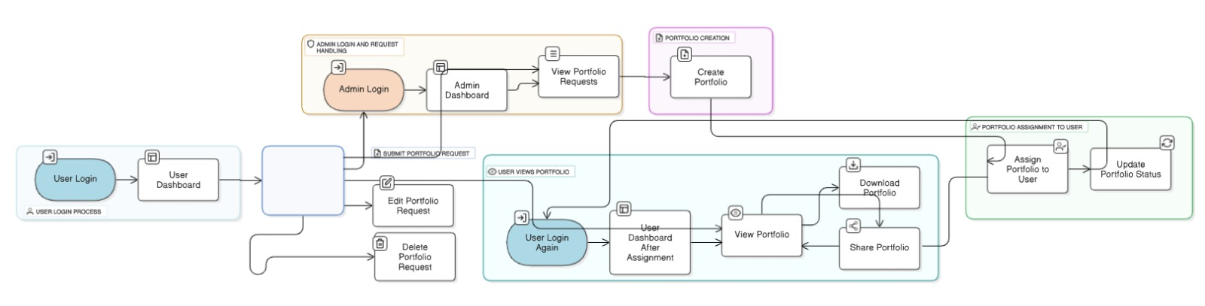

Figure 4.2:Use-Case-Diagram

4.3.2 CLASS DIAGRAM
A class diagram in Unified Modeling Language (UML) is a type of structural diagram that represents the static structure of a system by depicting the classes, their attributes, methods, and the relationships between them. Class diagrams are fundamental in object-oriented design and provide a blueprint for the software's architecture.

Here are the key components and notations used in a class diagram:

- Class
A class represents a blueprint for creating objects. It defines the properties (attributes) and behaviors (methods) of objects belonging to that class.Classes are depicted as rectangles with three compartments: the top compartment contains the class name, the middle compartment lists the class attributes, and the bottom compartment lists the class methods.

- Attributes
Attributes are the data members or properties of a class, representing the state of objects. Attributes are shown in the middle compartment of the class rectangle and are typically listed as a name followed by a colon and the data type (e.g., name: String).

- Methods
Methods represent the operations or behaviors that objects of a class can perform. Methods are listed in the bottom compartment of the class rectangle and include the methodname, parameters, and the return type (e.g., calculateCost(parameters):
ReturnType).

- Visibility Notations
Visibility notations indicate the access level of attributes and methods. The common notations are:
+ (public): Accessible from anywhere.
- (private): Accessible only within the class.
# (protected): Accessible within the class and its subclasses.
~ (package or default): Accessible within the package.

- Associations
Associations represent relationships between classes, showing how they are connected. Associations are typically represented as a solid line connecting two classes. They may have multiplicity notations at both ends to indicate how many objects of each class can participate in the relationship (e.g., 1..*).
Aggregations and Compositions: Aggregation and composition are special types of associations that represent whole-part relationships. Aggregation is denoted by a hollow diamond at the diamond end, while composition is represented by a filled diamond. Aggregation implies a weaker relationship, where parts can exist independently, while composition implies a stronger relationship, where parts are dependent on the whole.
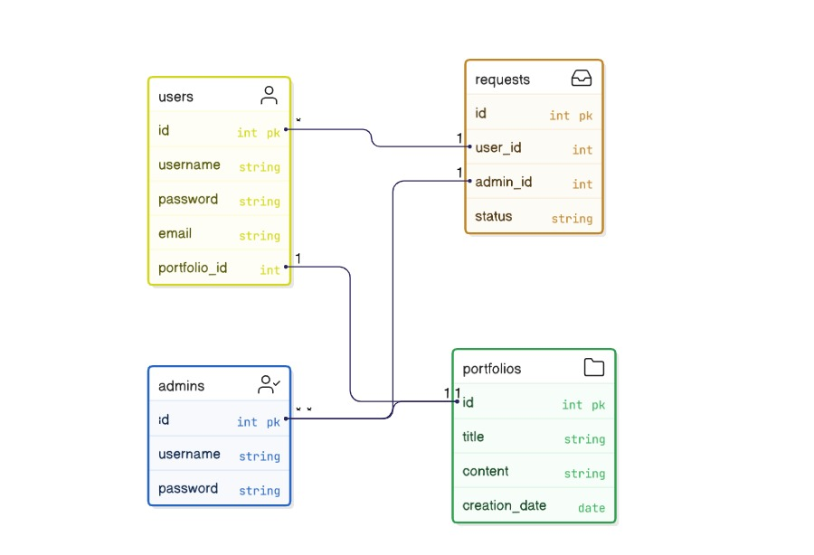

Figure 4.3:Class diagram

4.3.3 ACTIVITY DIAGRAM

An activity diagram portrays the control flow from a start point to a finish point showing the various decision paths that exist while the activity is being executed.

The diagram might start with an initial activity such as "User approaches the door." This activity triggers the system to detect the presence of the user's Bluetooth-enabled device, initiating the authentication process.
Next, the diagram could depict a decision point where the system determines whether the detected device is authorized. If the device is recognized as authorized, the diagram would proceed to the activity "Unlock the door." Conversely, if the device is not authorized, the diagram might show alternative paths such as prompting the user for additional authentication credentials or denying access.

The key components and notations used in an activity diagram:

- Initial Node
An initial node, represented as a solid black circle, indicates the starting point of the activity diagram. It marks where the process or activity begins.

- Activity/Action
An activity or action represents a specific task or operation that takes place within the system or a process. Activities are shown as rectangles with rounded corners. The name of the activity is placed inside the rectangle.

- Control Flow Arrow
Control flow arrows, represented as solid arrows, show the flow of control from one activity to another. They indicate the order in which activities are executed.

- Decision Node
A decision node is represented as a diamond shape and is used to model a decision point or branching in the process. It has multiple outgoing control flow arrows, each labeled with a condition or guard, representing the possible paths the process can take based on condition.

- Merge Node
A merge node, also represented as a diamond shape, is used to show the merging of multiple control flows back into a single flow.

- Fork Node
A fork node, represented as a black bar, is used to model the parallel execution of multiple activities or branches. It represents a point where control flow splits into multiple concurrent paths.

- JoinNode
A join node, represented as a black bar, is used to show the convergence of multiple control flows, indicating that multiple paths are coming together into a single flow.

- Final Node
A final node, represented as a solid circle with a border, indicates the end point of the activity diagram. It marks where the process or activity concludes.

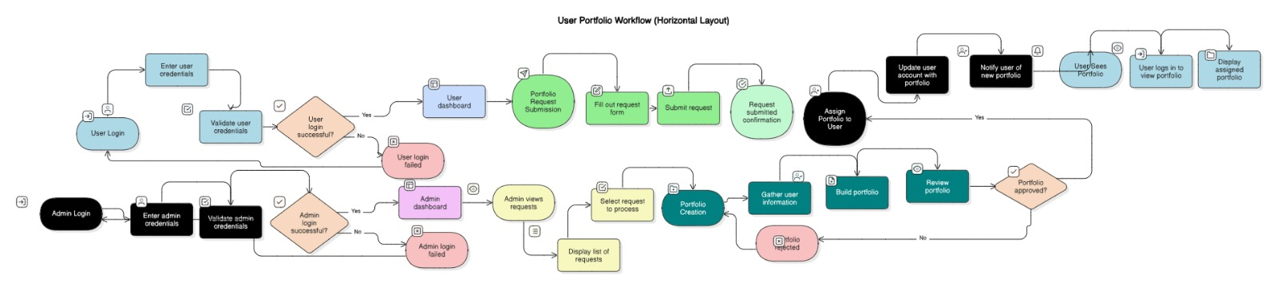
‘

Figure 4.4:Activity diagram

CHAPTER 5
TECHNOLOGY DESCRIPTION

5.1 WHAT IS PYTHON
Python plays a crucial role in the development of the Clinical Cost Insight system as the primary programming language used for implementing the application logic. It is widely preferred due to its simple syntax, readability, and flexibility, which make development faster and more efficient. In this project, Python is mainly used for backend development, where it handles user requests, processes data, and performs operations required for cost comparison.
Python works with the Flask framework to manage server-side functionalities such as routing, handling HTTP requests, and connecting the frontend with the database. It helps in retrieving relevant healthcare cost data from the MongoDB database and presenting it to users in a structured format. Python also supports various libraries and modules that simplify tasks like data processing, validation, and integration.
Another important use of Python in this project is its ability to ensure smooth communication between different components of the system. It enables efficient data handling and improves system performance. Additionally, Python allows easy scalability, making it possible to add new features and functionalities in the future. Overall, Python provides a strong and reliable foundation for building the Clinical Cost Insight application.

5.2 ADVANTAGES OF PYTHON

• Easy to Learn and Use:
Python has a simple and readable syntax that is easy to understand.
This helps beginners and developers write code quickly and efficiently.
It reduces complexity in programming tasks.
• High Readability:
Python code is clean and easy to read compared to other languages.
It uses proper indentation which improves clarity.
This makes debugging and maintenance easier.
• Extensive Libraries:
Python provides a large number of built-in and external libraries.
These libraries simplify tasks like web development and data processing.
It reduces the need to write complex code from scratch.
• Platform Independent:
Python programs can run on different operating systems.
It works on Windows, Linux, and macOS without major changes.
This increases flexibility and usability.
• Supports Multiple Paradigms:
Python supports procedural, object-oriented, and functional programming.
This allows developers to choose the best approach for their problem.
It makes the language highly versatile.
• Fast Development:
Python allows developers to write less code compared to other languages.
This speeds up the development process significantly.
It is ideal for rapid application development.
• Strong Community Support:
Python has a large and active developer community.
Developers can easily find solutions and resources online.
This makes learning and troubleshooting easier.
• Integration Capabilities:
Python can easily integrate with other languages and technologies.
It works well with databases, web frameworks, and APIs.
This improves system flexibility and performance.
• Scalability:
Python applications can be easily scaled as requirements grow.
It supports handling large data and complex systems.
This makes it suitable for long-term projects.
• Open Source:
Python is free to use and distribute.
There are no licensing costs involved.
This reduces the overall project cost.
• Support for Web Development:
Python supports frameworks like Flask and Django.
These frameworks simplify backend development.
They help in building secure and scalable web applications.
• Automation Friendly:
Python is widely used for automation tasks.
It reduces manual work and increases efficiency.
This helps in improving productivity.
• Efficient Data Handling:
Python can handle large amounts of data efficiently.
It supports data analysis and processing tools.
This is useful for data-driven applications.
• Easy Debugging:
Python provides simple debugging tools and error messages.
It helps developers quickly identify and fix issues.
This improves development speed and reliability.
• Improved Productivity:
Python allows developers to focus more on logic than syntax.
It reduces coding effort and development time.
This leads to faster project completion.

5.3 LIBRARIES
The Clinical Cost Insight project utilizes various libraries to support backend development, database connectivity, and dynamic web page rendering. These libraries help in improving the performance, efficiency, and functionality of the system.
Flask:
Flask is a lightweight web framework used for developing the backend of the application. It handles routing, manages user requests, and controls the overall flow of the web application efficiently.
PyMongo:
PyMongo is used to establish a connection between the Python application and the MongoDB database. It enables efficient storage, retrieval, and manipulation of healthcare cost data.
Jinja2:
Jinja2 is a templating engine integrated with Flask. It is used to dynamically generate HTML pages and display data from the backend to the user interface.
Werkzeug:
Werkzeug is a utility library that supports Flask by handling HTTP requests and responses. It also provides debugging and development tools for the application.
Flask-Login:
Flask-Login is used for managing user authentication and session handling. It helps in implementing secure login and logout functionalities within the system.
Flask-WTF:
Flask-WTF is used for handling web forms securely. It provides validation features and protects against common security threats such as CSRF attacks.
JSON:
JSON is used for data exchange between the frontend and backend. It allows structured data to be stored and transmitted efficiently.
Requests:
The Requests library is used to send HTTP requests to external services or APIs. It can be useful for integrating additional healthcare-related services in the future.

5.4 DISADVANTAGES OF PYTHON

Python, despite being a powerful and widely used programming language, has certain limitations that can affect its performance and suitability for specific applications. The major disadvantages are as follows:
1. Slow Execution Speed
- Python is an interpreted language, which means code is executed line by line.
- This makes it slower compared to compiled languages like C or Java.
- It is not suitable for high-performance applications.
2. High Memory Consumption
- Python uses more memory due to dynamic typing and flexibility.
- It stores additional information for variables.
- This can affect performance in memory-intensive applications.
3. Not Ideal for Mobile Development
- Python is not commonly used for mobile app development.
- It lacks strong frameworks compared to Android or iOS technologies.
- This limits its use in mobile applications.
4. Runtime Errors
- Python is dynamically typed, so errors are detected at runtime.
- This can lead to unexpected crashes during execution.
- Debugging becomes more challenging.
5. Weak Multi-threading Support
- Python has a Global Interpreter Lock (GIL).
- It restricts execution of multiple threads simultaneously.
- This reduces performance in multi-threaded applications.
6. Database Access Limitations
- Python has weaker database access layers compared to other languages.
- It may not be ideal for complex enterprise database systems.
- Performance may be affected in large-scale applications.

7. Not Suitable for High-End Graphics
- Python is not preferred for game development or graphics-intensive tasks.
- It lacks direct support for high-performance graphics engines.
- Other languages like C++ are preferred in such cases.
8. Dependency on External Libraries
- Python relies heavily on third-party libraries for advanced features.
- Managing dependencies can become complex.
- Compatibility issues may arise.
9. Dynamic Typing Issues
- Python does not require explicit variable declaration.
- This can lead to type-related errors.
- It makes large codebases harder to manage.
10. Limited Hardware Interaction
- Python is not suitable for low-level programming.
- It cannot directly interact with hardware efficiently.
- Languages like C are preferred for such tasks.

CHAPTER 6

IMPLEMENTATION

6.1 METHODOLOGY
Implementing the Clinical Cost Insight system involves a structured approach including requirement analysis, design, development, testing, deployment, and maintenance phases. This ensures the system is efficient, reliable, and user-friendly.

1. Requirements Gathering and Analysis
- Objective: Understand user needs and system requirements for healthcare cost comparison.
- Activities:
  - Conduct discussions to identify problems in existing healthcare systems.
  - Collect functional requirements such as cost search and comparison features.
  - Identify non-functional requirements like performance, security, and usability.

2. System Design
- Objective: Define system architecture, database structure, and user interface.
- Activities:
  - Design system architecture including frontend, backend, and database layers.
  - Create database schema for storing hospital and treatment cost data.
  - Develop UI wireframes or layouts for better user interaction.

3. Development
- Objective: Build the application based on system design and requirements.
- Activities:
  - Set up development environment using Python and Flask.
  - Develop backend logic for handling user requests and processing data.
  - Design frontend using HTML, CSS, and JavaScript.
  - Integrate MongoDB database for data storage and retrieval.

4. Testing
- Objective: Ensure system quality, accuracy, and performance.
- Activities:
  - Perform unit testing on individual components.
  - Conduct integration testing between frontend, backend, and database.
  - Execute system testing to validate overall functionality.
  - Perform performance testing to ensure smooth operation.

5. Deployment
- Objective: Launch the system for real-time user access.
- Activities:
  - Configure server environment for hosting the application.
  - Deploy application on local or cloud server.
  - Perform final testing to ensure system stability.

6. Maintenance and Support
- Objective: Ensure continuous system improvement and user support.
- Activities:
  - Monitor system performance and fix bugs if any.
  - Update healthcare cost data regularly.
  - Add new features and improvements based on user feedback.
  - Provide user support and documentation.

Methodology Considerations:
- Agile Approach: Allows continuous improvements and updates based on feedback.
- Team Collaboration: Ensures smooth coordination between development and design.
- Documentation: Maintains proper records for future maintenance and upgrades.

6.2 SAMPLE CODE

public class Book_Ticket extends javax.swing.JFrame {

public Book_Ticket() {
initComponents();
}
@SuppressWarnings("unchecked")
private void initComponents() {

jLabel5 = new javax.swing.JLabel();
fid = new javax.swing.JTextField();

setDefaultCloseOperation(javax.swing.WindowConstants.EXIT_ON_CLOSE);

jLabel5.setFont(new java.awt.Font("Tahoma", 1, 14)); // NOI18N
jLabel5.setText("Flight Id:");

javax.swing.GroupLayout layout = new javax.swing.GroupLayout(getContentPane());
getContentPane().setLayout(layout);
layout.setHorizontalGroup(
layout.createParallelGroup(javax.swing.GroupLayout.Alignment.LEADING)
.addGap(0, 729, Short.MAX_VALUE)
.addGroup(layout.createParallelGroup(javax.swing.GroupLayout.Alignment.LEADING)
.addGroup(layout.createSequentialGroup()
.addGap(21, 21, 21)
.addComponent(jLabel5, javax.swing.GroupLayout.PREFERRED_SIZE, 109, javax.swing.GroupLayout.PREFERRED_SIZE)
.addGap(49, 49, 49)
.addComponent(fid, javax.swing.GroupLayout.PREFERRED_SIZE, 200, javax.swing.GroupLayout.PREFERRED_SIZE)
.addContainerGap(350, Short.MAX_VALUE)))
);
layout.setVerticalGroup(
layout.createParallelGroup(javax.swing.GroupLayout.Alignment.LEADING)
.addGap(0, 359, Short.MAX_VALUE)
.addGroup(layout.createParallelGroup(javax.swing.GroupLayout.Alignment.LEADING)
.addGroup(layout.createSequentialGroup()
.addGap(133, 133, 133)
.addGroup(layout.createParallelGroup(javax.swing.GroupLayout.Alignment.LEADING, false)
.addComponent(jLabel5, javax.swing.GroupLayout.DEFAULT_SIZE, javax.swing.GroupLayout.DEFAULT_SIZE, Short.MAX_VALUE)
.addComponent(fid, javax.swing.GroupLayout.PREFERRED_SIZE, 34, javax.swing.GroupLayout.PREFERRED_SIZE))
.addContainerGap(192, Short.MAX_VALUE)))
);

pack();
}

public static void main(String args[]) {
try {
for (javax.swing.UIManager.LookAndFeelInfo info : javax.swing.UIManager.getInstalledLookAndFeels()) {
if ("Nimbus".equals(info.getName())) {
javax.swing.UIManager.setLookAndFeel(info.getClassName());
break;
}
}
} catch (ClassNotFoundException ex) {
java.util.logging.Logger.getLogger(Book_Ticket.class.getName()).log(java.util.logging.Level.SEVERE, null, ex);
} catch (InstantiationException ex) {
java.util.logging.Logger.getLogger(Book_Ticket.class.getName()).log(java.util.logging.Level.SEVERE, null, ex);
} catch (IllegalAccessException ex) {
java.util.logging.Logger.getLogger(Book_Ticket.class.getName()).log(java.util.logging.Level.SEVERE, null, ex);
} catch (javax.swing.UnsupportedLookAndFeelException ex) {
java.util.logging.Logger.getLogger(Book_Ticket.class.getName()).log(java.util.logging.Level.SEVERE, null, ex);
}

java.awt.EventQueue.invokeLater(new Runnable() {
public void run() {
new Book_Ticket().setVisible(true);
}
});
}

private javax.swing.JTextField fid;
private javax.swing.JLabel jLabel5;

CHAPTER 7
TESTING

7.1 GENERAL

The purpose of testing is to discover errors. Testing is the process of trying to discover every conceivable fault or weakness in a work product. It provides a way to check the functionality of components, sub assemblies, assemblies and/or a finished product. It is the process of exercising software with the intent of ensuring that the Software system meets its requirements and user expectations and does not fail in an unacceptable manner. There are various types of tests. Each test type addresses a specific testing requirement.

Testing for a Multilevel Data Concealing Technique that integrates Steganography and Visual Cryptography is crucial to ensure its functionality, security, and reliability. The testing process involves several stages, including unit testing, integration testing, and security testing.

7.2 TYPES OF TESTING
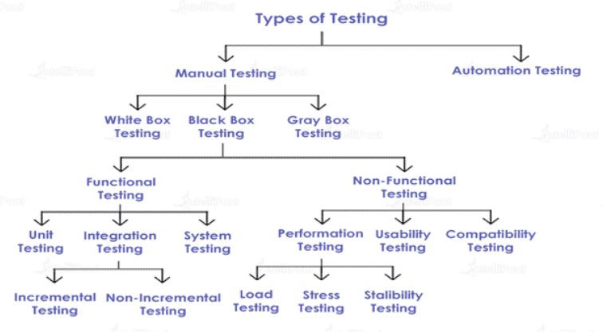
Figure 7.1 Types of Testing

7.3TEST CASES

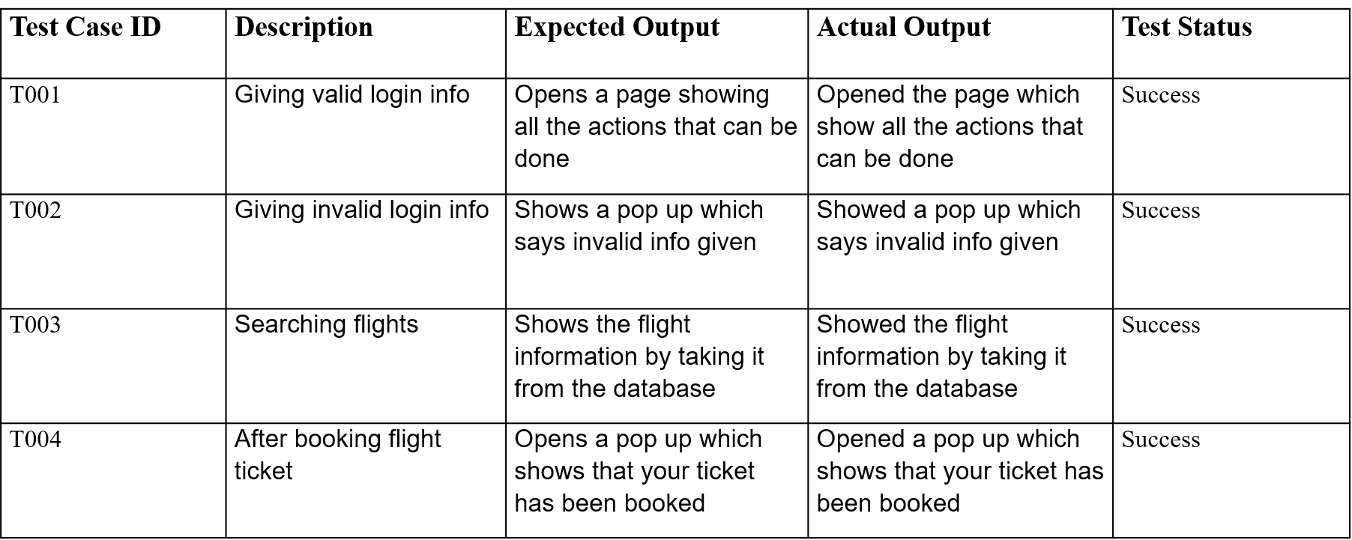

Table 7.2 Test cases

CHAPTER 8

RESULTS

8.1 SCREENSHOTS
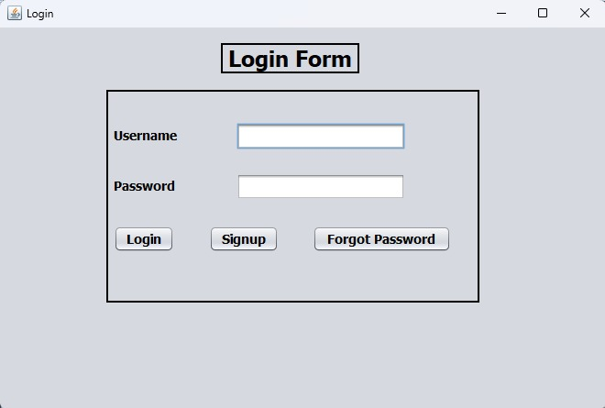

Figure 8.1 Login Page

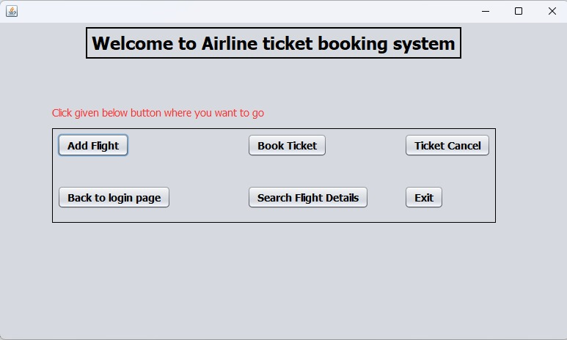

Figure 8.2 Home Page

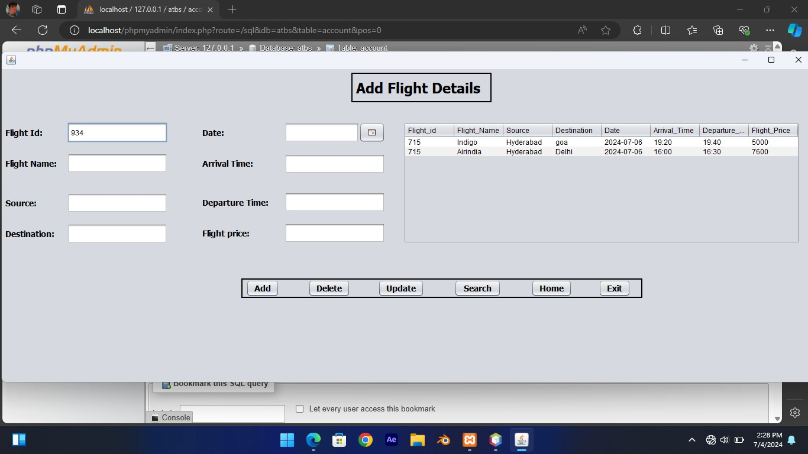
Figure 8.3 Add Flight
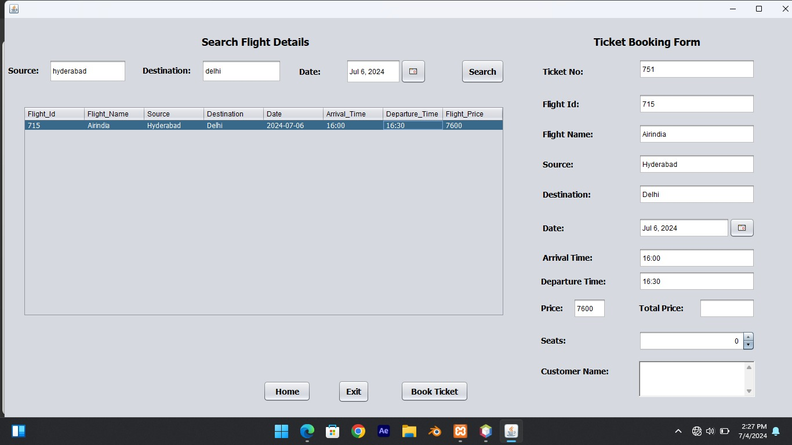

Figure 8.4 Search Flight
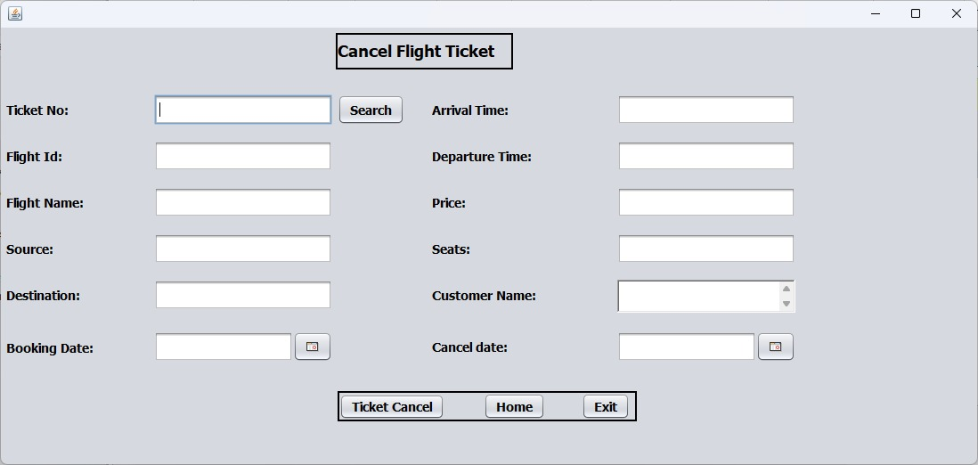

Figure 8.5Cancel Ticket

CHAPTER 9

FUTURE SCOPE

The future scope of the Clinical Cost Insight system focuses on enhancing its capabilities, improving user experience, and expanding its functionality to meet evolving healthcare needs. With advancements in technology, the system can be further developed to provide more accurate, personalized, and efficient healthcare cost analysis. The following are the key areas of future development:

1. Enhanced Personalization
- Using AI and machine learning to provide personalized treatment cost suggestions based on user history, preferences, and budget.
2. Real-Time Data Integration
- Integrating with hospital databases to provide real-time updates on treatment costs and availability.
3. Hospital Ratings and Reviews
- Adding user feedback and ratings to help patients choose better healthcare providers.
4. Appointment Booking System
- Enabling users to directly book appointments with hospitals through the platform.
5. Health Insurance Integration
- Providing cost estimates after applying insurance coverage and policy benefits.
6. Mobile Application Development
- Developing Android and iOS applications for better accessibility and convenience.
7. Predictive Cost Analysis
- Using data analytics to predict future treatment costs and trends.
8. Location-Based Services
- Allowing users to find nearby hospitals and compare costs based on location.
9. Multi-Language Support
- Supporting multiple languages to make the system accessible to a wider audience.
10. Chatbot Assistance
- Implementing AI-based chatbots to guide users and answer queries instantly.
11. Data Visualization Tools
- Using graphs and charts to present cost comparisons more effectively.
12. Cloud Deployment
- Hosting the system on cloud platforms for better scalability and performance.
13. Integration with Government Schemes
- Including information about government healthcare programs and subsidies.
14. Secure User Authentication
- Implementing advanced login systems with data privacy and security features.
15. Voice Search and NLP
- Enabling voice-based search using Natural Language Processing for easier interaction.
16. Electronic Health Record (EHR) Integration
- Connecting with patient health records to provide more accurate recommendations.
17. API Integration with Healthcare Systems
- Connecting with external healthcare platforms for expanded data access.
18. Emergency Support System
- Providing quick cost comparison and nearest hospital suggestions during emergencies.
19. Advanced Recommendation System
- Suggesting best treatment options based on cost, quality, and user preferences.
20. Global Expansion
- Extending the system to include international hospitals and global healthcare data.

CHAPTER 10

CONCLUSION

10.1 CONCLUSION

The Clinical Cost Insight project successfully addresses one of the major challenges in the healthcare sector, which is the lack of transparency and accessibility in medical cost information. In today’s healthcare environment, patients often face difficulties in understanding and comparing treatment costs across different hospitals, leading to confusion and financial uncertainty. This project provides an effective solution by developing a web-based platform that enables users to easily access, analyze, and compare healthcare costs in a structured and user-friendly manner.
The system is designed using modern technologies such as Python, Flask, and MongoDB, which ensure efficient data processing, storage, and retrieval. The frontend interface, developed using HTML, CSS, and JavaScript, offers a simple and intuitive user experience, allowing users to interact with the system without any technical difficulty. By integrating these technologies, the application provides accurate and up-to-date cost information, helping users make informed decisions based on their budget and healthcare needs.
One of the key achievements of this project is the creation of a centralized platform where users can view and compare treatment costs across multiple hospitals. This eliminates the need for manual inquiries and reduces the time and effort required to gather information. The system not only improves transparency but also encourages fair pricing practices among healthcare providers. By making cost information readily available, it empowers patients and promotes awareness about healthcare expenses.
The project also highlights the importance of digital solutions in improving healthcare services. With the increasing use of technology, systems like Clinical Cost Insight can play a significant role in enhancing accessibility and efficiency in the healthcare sector. The application can be further extended to include additional features such as hospital ratings, patient reviews, appointment booking, and integration with insurance services, making it a more comprehensive healthcare platform.
Although the system provides many benefits, there is still scope for future improvements. The accuracy of the system depends on the availability and regular updating of data from healthcare providers. Expanding the database to include more hospitals and real-time data updates can further enhance the reliability of the system. Additionally, implementing advanced features such as data analytics and personalized recommendations can improve user experience and functionality.
In conclusion, the Clinical Cost Insight project successfully demonstrates how technology can be used to solve real-world problems in the healthcare sector. It provides a reliable, efficient, and user-friendly solution for comparing medical costs, thereby improving transparency and supporting better decision-making. The project not only benefits patients but also contributes to the development of a more transparent, accessible, and patient-centric healthcare system.

CHAPTER 11

REFERENCES

11.1 REFERENCES
[1] D. M. Cutler and L. Dafny, “Designing transparency systems for healthcare prices,” New England Journal of Medicine, vol. 364, no. 10, pp. 894–895, 2011.
[2] M. E. Porter and T. H. Lee, “The strategy that will fix health care,” Harvard Business Review, vol. 91, no. 10, pp. 50–70, 2013.
[3] C. S. Kruse, N. Krowski, B. Rodriguez, and L. Tran, “Telehealth and patient satisfaction: a systematic review and narrative analysis,” BMJ Open, vol. 6, no. 8, 2016.
[4] Z. Brot-Goldberg, A. Chandra, B. Handel, and J. Kolstad, “What does a deductible do? The impact of cost-sharing on health care prices, quantities, and spending dynamics,” Quarterly Journal of Economics, vol. 132, no. 3, pp. 1261–1318, 2017.
[5] A. Mehrotra, S. Brannen, and A. Sinaiko, “Use of price transparency tools in health care,” JAMA, vol. 323, no. 6, pp. 537–538, 2020.
[6] N. Desai, R. Patel, and P. Shah, “Web-based healthcare management system using modern technologies,” International Journal of Computer Applications, vol. 179, no. 12, pp. 1–5, 2018.
[7] MongoDB Inc., “MongoDB Documentation,” [Online]. Available: https://www.mongodb.com/docs/
[8] Flask Documentation, “Flask Web Framework,” [Online]. Available: https://flask.palletsprojects.com/
[9] Python Software Foundation, “Python Documentation,” [Online]. Available: https://docs.python.org/3/
[10] World Health Organization (WHO), “Healthcare cost and access,” [Online]. Available: https://www.who.int/

