Project Name

Retail Manager

Installation

Clone the application from git hub

Git URL :https://github.com/siddharthgelda/RetailManager.git

Configuration
We need google Api key for map Api.
1 Create google account
2 Create google Api key for map api
How to get Google API Key ?
Step1: Go to Google API Console: https://code.google.com/apis/console
Step 2: Create API Project
Step 3: Register Project ID ( Go to Project => Overview Tab)
Step 4: Select Services you want to use ( Go to Project => Services Tab )
3 Please verfiy you google project Api from below link
https://console.developers.google.com/iam-admin/projects
4 Import Project(maven project) in IDE
5 Open the file path -> src\main\java\app\location\Geolocation.java
6. write your Api in in place in starts
private static String API_KEY="**********";

Run

1 run the Application,java file.
Now Application up and runing

Test
We have done testing using postman
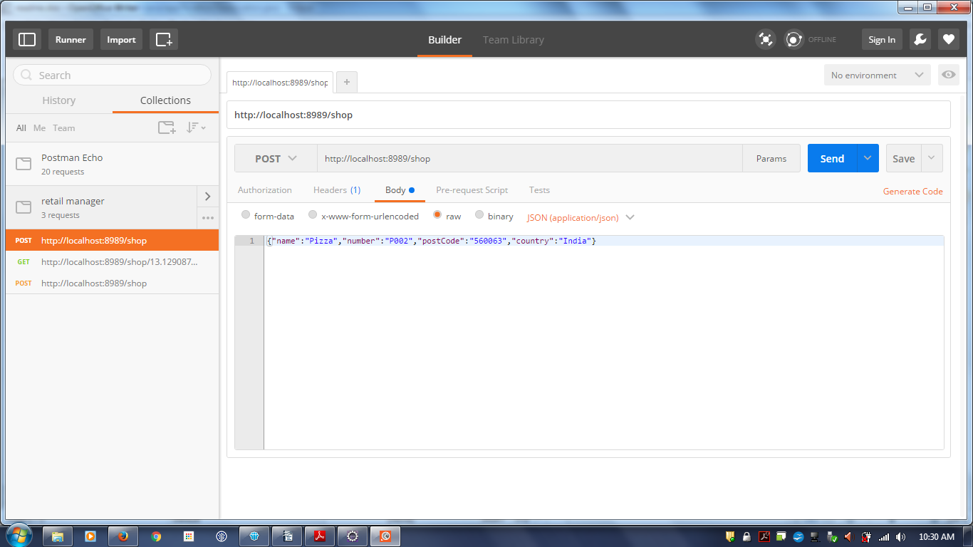
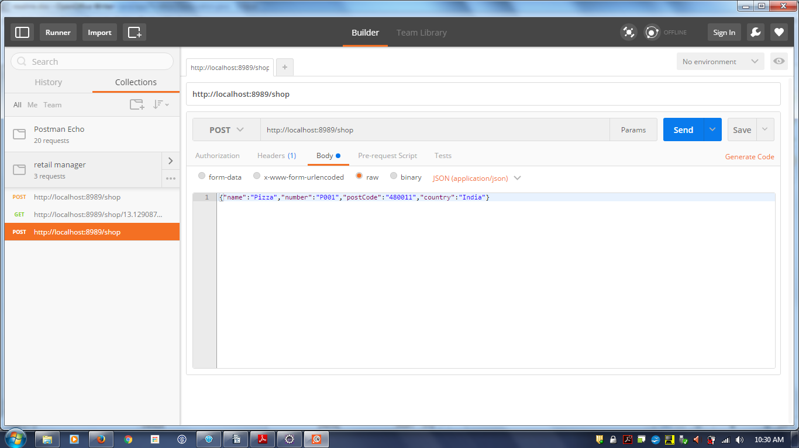

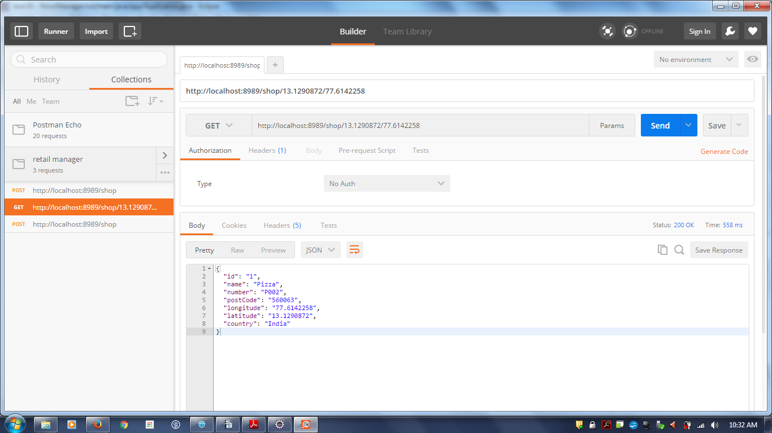

Sample Request
We have uploaded post man request collection for your test.you can import in your postman collection

