BEHAVIORAL FINANCE (MBA680)
Personal Investment Advisor
and Robo-Advisory Project
Steps 1 to 6, on the fielded peer-group responses
Every figure in this report is computed from the submitted survey responses. Where a respondent's data could not be used, that is stated and the cell is left empty. Where the class instrument cannot identify a parameter at all, that is reported as a property of the instrument. No participant results are fabricated.
Peer group | 4 respondents, roll numbers 251250039, 251250047, 251250002, 251250030
Instrument | The class form: R1-R8, T1-T6, the 30-item BFI-2 subset, U1-U6, V1-V6
Market inputs | The 60-stock maximum-Sharpe portfolio from Problem Statement 1
Methods | Expected utility theory, prospect theory, behavioral portfolio theory

1. Summary
Four classmates completed the Steps 1 to 4 survey. This report estimates everything those answers identify, builds the Step 5 portfolios on the actual Problem Statement 1 outputs rather than on illustrative market assumptions, and gives the Step 6 personality commentary. It also sets out, precisely, what the instrument cannot measure and what four extra questions would fix.

The four findings
The risk ladder cannot measure risk aversion, and two respondents proved it. Every row of R1 to R8 offers a certain amount exactly equal to the gamble's expected value. Under expected utility a risk-averse person must therefore choose the certain amount at all eight rows, and a risk-seeking person the gamble at all eight. No utility function over final wealth can produce a switch part way down. Roll 251250039 switches at R4 and roll 251250002 switches at R3. Those are not noise, they are direct violations of expected utility, and they are exactly what prospect theory predicts. Risk aversion is therefore taken from the utility curve, where it is genuinely identified.
Loss aversion is not identified by this instrument at all. Each of V1 to V6 offers a certain amount against a gamble paying double or nothing, so the certain amount cancels and the row reveals only a curvature. The gain rows fix the gain curvature and the loss rows fix the loss curvature, but nothing anywhere in the form compares their heights. Lambda needs a gamble with a gain on one side and a loss on the other. Without it, the single most important parameter in prospect theory is missing.
V1, V2 and V3 are the same question asked three times. Because the certain amount cancels, all three rows imply the identical curvature, so a steady respondent gives the same answer to each. Roll 251250039 answered 0.40, 0.45 and 0.70, implying curvatures of 1.32, 1.15, 0.51, a spread of 0.81. Averaging to 1.00 hides that. The spread is the measurement error on a single answer and belongs in the report.
The recommendation depends more on the return assumption than on the client. Both respondents with usable utility data want more than 100% in equities under every one of the three input sets, so the no-borrowing cap binds and both receive the same advice. What separates them is not their preferences but whether the Problem Statement 1 expected return of 24.9% is believed.

Data quality
Recorded rather than silently corrected.
Roll | Issue
251250047 | The four utility amounts (Rs 50,000 to Rs 85,000) fall below the stated lower endpoint A of Rs 100,000, so they lie outside the valid range. No utility curve, and therefore no Step 5 portfolio. Needs re-eliciting between A and B.
251250030 | U1 to U4 left blank, so no utility curve. The V1 to V6 indifference fields contain rupee amounts rather than probabilities, so the value function is also unusable. Both need re-collecting.
251250002 | Did not state a reference amount W0, so the value curve is drawn in relative terms.
251250047 | Did not state a reference amount W0, same treatment.
251250039 | Time answers are mildly non-monotonic. Reported as a midpoint rather than a hard bracket.

2. Participants
Roll | Age | Investable wealth | Experience | Horizon | Primary goal | Usable for Step 5
251250039 | 25 | Rs 90,000 | Moderate | 5 yrs | Wealth creation | Yes
251250047 | 24 | Rs 2 lakh | None | 10 yrs | Wealth creation | No
251250002 | 25 | Rs 10 lakh | Limited | 6 yrs | Wealth creation | Yes
251250030 | 29 | Rs 1 lakh | Limited | 15 yrs | Specified goal | No

3. Method

3.1 The risk ladder, and why it is classified rather than fitted
Every row of R1 to R8 pairs a certain amount X with a gamble paying 2X or nothing on a coin flip. The expected values are identical by construction, so the choice is a pure test of curvature. For any utility function u over final wealth, the respondent prefers the certain amount whenever
u(w0 + X) > 0.5 u(w0 + 2X) + 0.5 u(w0)
which is Jensen's inequality and holds at every X if u is concave, and fails at every X if u is convex. There is no concave or convex u for which it holds at small X and fails at large X. A switch part way down the ladder is therefore not a measurement of risk aversion, it is evidence against the model that would do the measuring. We classify the pattern, flag the violation, and take the risk aversion coefficient from Section 4 instead.

3.2 The utility curve
Probability equivalence, exactly as the Week 2 to 3 lecture sets it out. With U(A) = 0 and U(B) = 1, the probability that leaves a certain X indifferent to the gamble is the utility of X:
U(X) = (1 - p) U(A) + p U(B) = p
Two curves are fitted to the same points. The log form the lecture suggests, and a one-parameter constant relative risk aversion form:
log U(W) = [ ln W - ln A ] / [ ln B - ln A ]
CRRA U(W) = [ W^(1-A) - A_lo^(1-A) ] / [ B^(1-A) - A_lo^(1-A) ]
The CRRA coefficient is what Step 5 needs, because it is exactly the A in U = E(r) - 0.5 A sigma squared that the lecture uses for portfolio choice. The log curve is the special case A = 1 and is reported beside it.
One numerical point. Wealth is normalised by A before fitting. The probability equivalence is a ratio of utility differences and CRRA scales those by a common factor, so normalising changes no answer. At rupee scale W^(1-A) underflows to zero once A passes about six, which silently collapses the denominator and returns a meaningless fit. This bit us during development and is worth stating.

3.3 The value function, and what it cannot reach
Each of V1 to V6 offers a certain amount against a gamble paying double or nothing. At indifference v(X) = p v(2X), and with v(x) = x raised to alpha the certain amount cancels:
X^alpha = p (2X)^alpha => p = (1/2)^alpha => alpha = -log2(p)
Two consequences follow, and both matter.
First, V1, V2 and V3 are the same question at three sizes rather than three independent measurements, because the answer does not depend on X. A power value function predicts an identical response to all three. The spread across them is response noise, and it is reported in Section 5 rather than averaged away.
Second, loss aversion is not identified. Each row is internally scaled, so the gain rows pin down the gain curvature and the loss rows pin down the loss curvature, but the two limbs are never placed on a common scale. Lambda requires a prospect with a gain on one side and a loss on the other, which the form does not contain. This is why the Steps 5 to 6 analysis circulated earlier had to record lambda as unidentified; it is a property of the instrument, not of the respondents.

3.4 Step 5, the portfolio
Maximising the lecture's utility score along the capital allocation line gives the textbook solution, with A read off the fitted utility curve:
U = E(r) - 0.5 A sigma^2
y* = [ E(rP) - rf ] / ( A sigmaP^2 )
Borrowing is capped at zero as a policy choice for retail clients rather than a theoretical one. The unconstrained y* is reported alongside, because for this group it is the cap and not the preference that determines the answer.

4. Steps 2 and 3: risk, time and personality

4.1 Revealed risk preference
Roll | Pattern | Consistent with EU | Note
251250039 | Risk averse at low stakes and risk seeking at high stakes | No | Switches at R4
251250047 | Consistently risk averse | Yes | Interpretable as a curvature
251250002 | Risk seeking at low stakes and risk averse at high stakes | No | Switches at R3
251250030 | Consistently risk seeking | Yes | Interpretable as a curvature
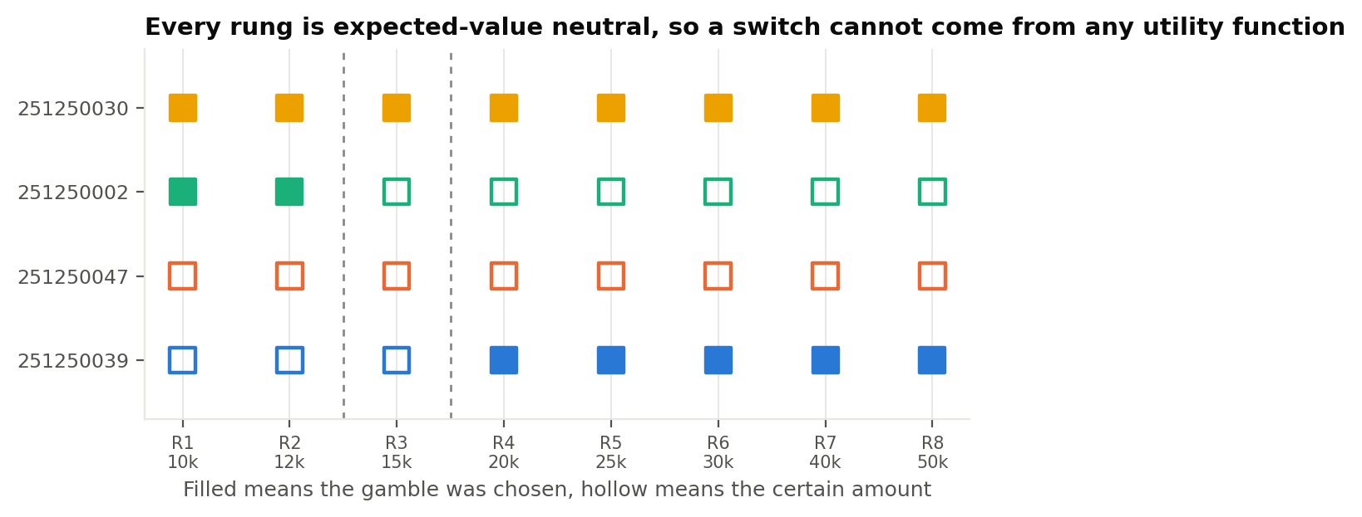
Figure 1. The eight rows for each respondent. Because every rung is expected-value neutral, a row of all-filled or all-hollow squares is the only pattern expected utility can produce.

4.2 Time preference
Roll | Implied rate | Bracket | Note
251250039 | 21.2% | 22.5% to 20.0% | Answers overlap, midpoint reported
251250047 | 21.2% | 20.0% to 22.5% | Consistent
251250002 | 15.0% | 10.0% to 20.0% | Consistent
251250030 | 34.2% | above 34.2% | Consistent
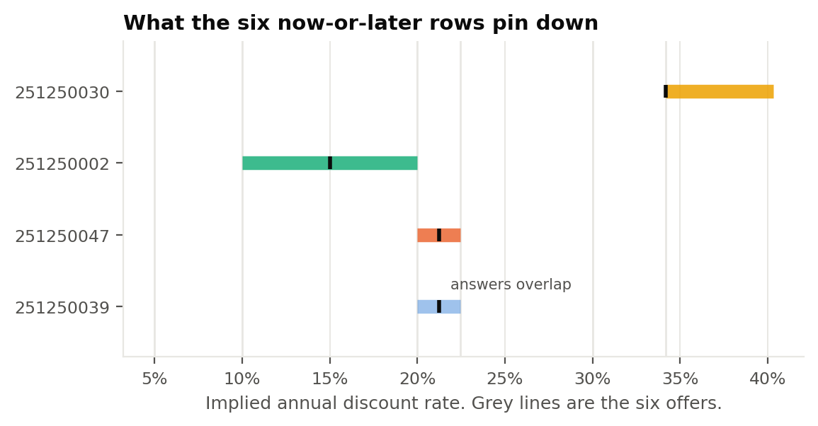
Figure 2. What the six now-or-later rows pin down. Grey lines are the six offers.
Every respondent discounts the future at a rate far above any available return, and one rejects even 34% a year. Rates this high in a survey usually mean one of three things: a real short-term need for cash, a shorter true horizon than the one stated, or the questions not being taken literally. All three are worth a conversation before acting on a stated horizon of ten or fifteen years.

4.3 Personality
Roll | Extraversion | Agreeableness | Conscientious | Neg. Emotionality | Open-Minded
251250039 | 3.33 | 3.83 | 2.33 | 2.67 | 3.50
251250047 | 3.50 | 3.00 | 3.83 | 1.67 | 3.50
251250002 | 3.50 | 3.67 | 3.33 | 3.00 | 3.50
251250030 | 3.50 | 3.50 | 3.33 | 3.33 | 3.50
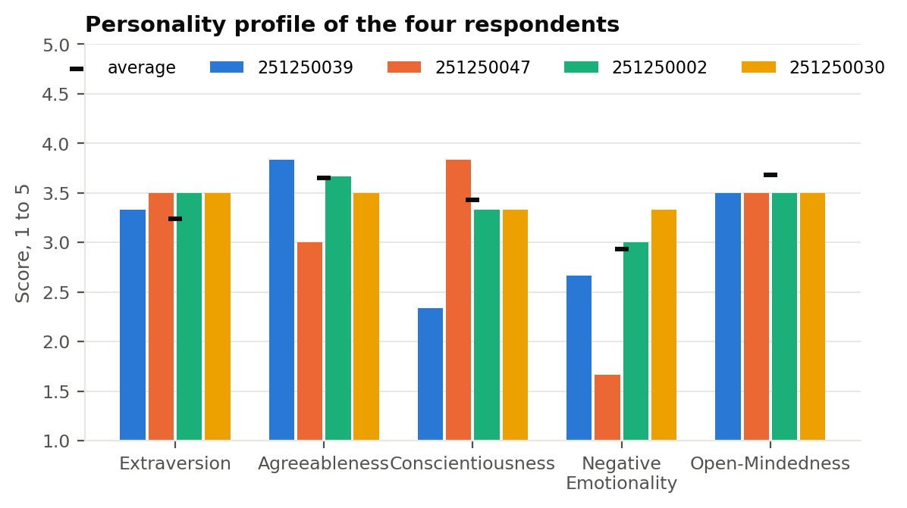
Figure 3. Domain scores against the BFI-2 norming-sample average.

5. Step 4: utility and value functions

5.1 Utility
Roll | Range A to B | Risk aversion A | Fit R2 | Log fit error | Status
251250039 | Rs 10,000 to Rs 50,000 | 0.66 | 0.202 | 0.086 | Concave, risk averse
251250047 | n/a | n/a | n/a | n/a | Not usable
251250002 | Rs 10,000 to Rs 50,000 | 1.18 | 0.948 | 0.039 | Concave, risk averse
251250030 | n/a | n/a | n/a | n/a | Not usable
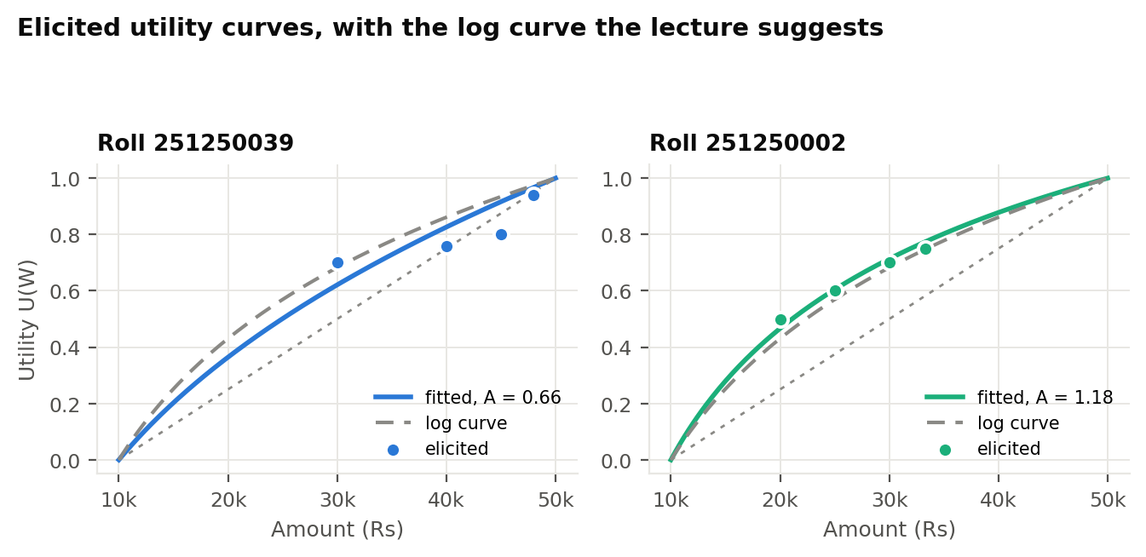
Figure 4. The two usable utility curves. Dots are the elicited points, the solid line is the fitted CRRA curve and the dashed line is the log curve from the lecture.

5.2 Value function
Roll | Gain alpha | Loss beta | Spread on gains | Spread on losses | Loss aversion
251250039 | 1.00 | 2.30 | 0.81 | 1.10 | Not identified
251250047 | 1.28 | 1.93 | 0.51 | 0.32 | Not identified
251250002 | 0.68 | 1.66 | 0.49 | 1.64 | Not identified
251250030 | n/a | n/a | n/a | n/a | Not identified
The two spread columns are the range of the curvature implied by the three rows that should all give the same number. A spread near zero would mean a steady respondent. These are not near zero.
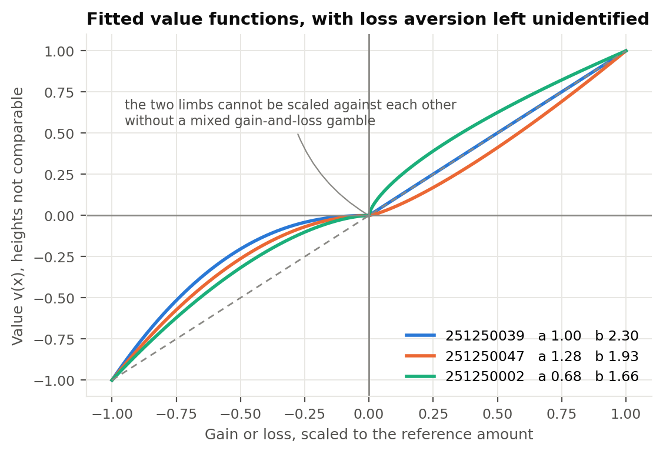
Figure 5. Fitted value functions. The two limbs are drawn on their own scales because nothing in the instrument ties their heights together.
Every estimated loss curvature is above one, which means the loss limb gets steeper as losses grow. Prospect theory predicts the opposite, diminishing sensitivity with a curvature below one. Two readings are possible. Either this group genuinely shows increasing sensitivity to larger losses, which would be an unusual and interesting result, or the loss rows are being answered with less care than the gain rows, which the spread column supports. A larger sample and a second pass on the loss questions would separate the two.

6. Step 5: portfolio recommendations
The risky asset is the 60-stock maximum-Sharpe portfolio built in Problem Statement 1, returning 24.9% against 18.0% volatility in sample, with a risk-free rate of 6.5%. This report does not re-optimise it. The personal plan only decides how much of it each respondent should hold.
That in-sample Sharpe ratio is 1.03, and it should not be planned around. Those expected returns are three-year averages taken over a strong run in Indian equities, where the error on a mean estimated that way is roughly 17% a year. Volatility estimates from the same data are far more reliable, so the volatility is carried across untouched and only the expected return is cut back toward a long-run figure. Advice is given on the base case, with the other two shown beside it.
Input set | Return | Sharpe | What it assumes
PS1 as reported | 24.9% | 1.03 | The PS1 averages repeat out of sample
Base case | 15.2% | 0.49 | A quarter of the screening premium survives
Stress case | 12.0% | 0.31 | None of it survives

6.1 Recommended allocations
Roll | Risk aversion A | Unconstrained y* | Advised equity | Expected return | Volatility
251250039 | 0.66 | 4.11x | 100% | 15.2% | 18.0%
251250047 | n/a | n/a | Not computed | n/a | n/a
251250002 | 1.18 | 2.29x | 100% | 15.2% | 18.0%
251250030 | n/a | n/a | Not computed | n/a | n/a
For the two respondents with usable data the unconstrained solution calls for borrowing, so the no-borrowing cap is what actually sets the allocation. Both are advised to hold 100% of their corpus in the Problem Statement 1 portfolio, which for roll 251250039 is Rs 90,000 and for roll 251250002 is Rs 10 lakh.
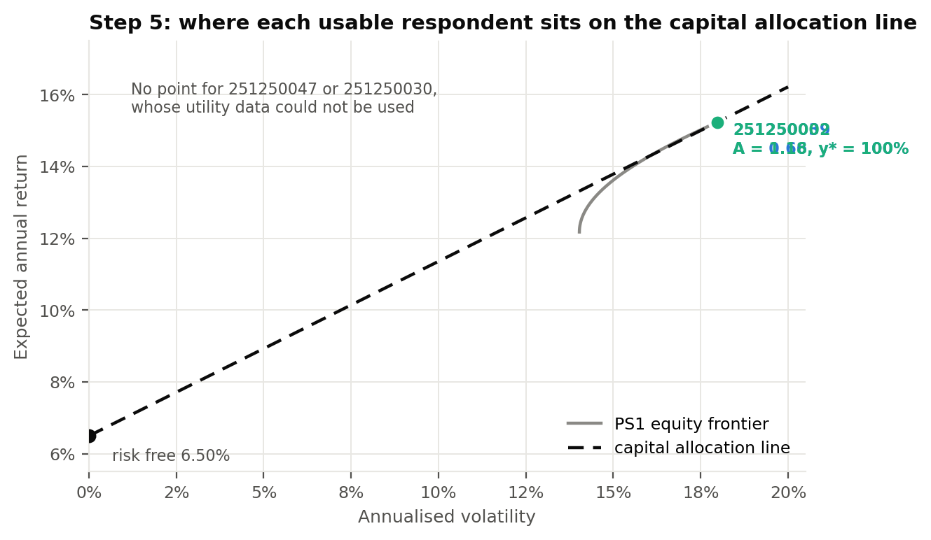
Figure 6. Where each usable respondent sits, on base-case inputs.
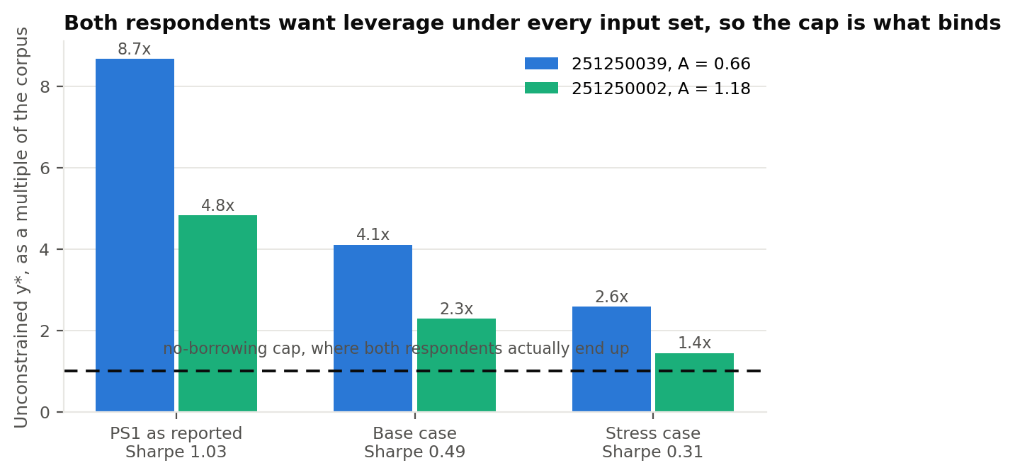
Figure 7. The unconstrained solution under all three input sets. The cap binds everywhere, so the advice is the same in all nine cells.
Two respondents receive no portfolio. Roll 251250047 and roll 251250030 have no usable utility curve, so relative risk aversion is not identified and y* cannot be computed. The risk ladder cannot substitute for it, for the reason given in Section 3.1. Assigning them a number by judgement would be inventing the input that does all the work, so the cells are left empty and the re-elicitation is specified instead.

6.2 Why the behavioral portfolio cannot be sized
Behavioral portfolio theory builds a layered portfolio: a safety layer sized to protect a floor, an income layer, and an aspiration layer holding the shot at a target. Sizing those layers needs four things, and the class instrument asks for none of them.
What is needed | Why it cannot be inferred
The floor, in rupees | The amount that must survive is a stated preference. Nothing in Sections 1 to 4 asks for it.
The acceptable chance of breaching it | Roy's safety-first criterion needs a tolerance. There is no question that reveals one.
The aspiration level | The target that defines success. Not asked.
Loss aversion, lambda | Drives the fear parameter in the SP/A objective, and is unidentified for the reason in Section 3.3.
A safety and potential split could be asserted from the personality scores and the curvature estimates, and that is what the earlier Steps 5 to 6 analysis did. It is a reasonable way to produce a number, but it should not be mistaken for a measurement: the split would be the adviser's judgement wearing the respondent's data as a costume. We prefer to state the gap and close it.

6.3 The four questions that would close it
Each is one line, and together they take about a minute. They are already live in the project's survey portal, marked as extensions to the class form.
 | Question | What it identifies
E1 | A coin flip: tails you lose Rs 10,000, heads you win G. How big must G be before you would take it? | Loss aversion lambda, by placing the two limbs of the value function on a common scale
E2 | A 10% chance of Rs 10,000, otherwise nothing. What certain amount feels as good? And the same at 90%. | The probability weighting function, and with it the hope parameter in SP/A
E3 | What is the smallest amount you must still have at the end, and how often could you live with falling below it? | The safety layer and the shortfall constraint
E4 | What amount at the end would you call a success, and how much expected wealth would you give up for a 10 point better chance of reaching it? | The aspiration layer and the weight on aspiration

7. Step 6: personality commentary
Personality does not enter the optimisation and should not. Risk aversion is already measured directly in Section 5, so adding a personality adjustment to the equity weight would be counting the same thing twice. What personality predicts is not what a client should hold but whether they will hold it: how they will read a statement, what will make them abandon the plan, and what the adviser has to do to prevent that. Those are process questions.

Roll 251250039
 | Extraversion | Agreeableness | Conscientious | Neg. Emot. | Open-Minded
Score | 3.33 | 3.83 | 2.33 | 2.67 | 3.50
Low conscientiousness is the binding constraint. Conscientiousness of 2.33 sits well below average, and it is paired with a switch to risk seeking at higher stakes and a near-linear gain curve (alpha 1.00). This profile sets a plan up and then stops watching it, and may chase larger bets after an early win. The plan should therefore contain as few decisions as possible: a standing instruction on the contribution date, automatic rebalancing at a fixed threshold, and review dates fixed in advance rather than triggered by news. A slightly worse portfolio that is actually followed beats the optimal one that is not.

Roll 251250047
 | Extraversion | Agreeableness | Conscientious | Neg. Emot. | Open-Minded
Score | 3.50 | 3.00 | 3.83 | 1.67 | 3.50
Methodical, calm, and genuinely conservative. Conscientiousness of 3.83 is high and negative emotionality of 1.67 is the lowest in the group. It would be a mistake to read that calm as hidden risk tolerance: this respondent took the certain amount at every one of the eight rows, including the ones that were actuarially fair. With a ten-year horizon and a wealth-creation goal, the right response is a glide path that steps equity up over time rather than a single large allocation at the start, so that the exposure grows with familiarity instead of being imposed on day one.

Roll 251250002
 | Extraversion | Agreeableness | Conscientious | Neg. Emot. | Open-Minded
Score | 3.50 | 3.67 | 3.33 | 3.00 | 3.50
A balanced profile that reasons in rupees, not percentages. Every domain sits between 3.0 and 3.67, and the risk pattern matches: risk seeking at small stakes, cautious once the amounts approach real money. With Rs 10 lakh invested, the switch at R3 suggests risk is being judged in nominal amounts rather than proportionally. The advisory conversation should therefore be framed in rupees throughout, including the downside case. A 20% fall means little; losing Rs 2,00,000 means something.

Roll 251250030
 | Extraversion | Agreeableness | Conscientious | Neg. Emot. | Open-Minded
Score | 3.50 | 3.50 | 3.33 | 3.33 | 3.50
Re-interview before acting on anything here. Negative emotionality of 3.33 is moderate, but the rest of this response needs a conversation rather than a model. The gamble was chosen at all eight rows, every delay was refused even at 34% a year, the utility table was left blank and the value-function fields contain rupee amounts where probabilities were asked for. Taken at face value the choices would imply a very large risky allocation. Taken as a whole they more likely indicate a genuine short-term need for cash, a horizon much shorter than the fifteen years stated, or a questionnaire filled in quickly. Re-administer Sections 4 and 4.9 first.

8. What this does not establish
Four respondents cannot support a claim about a population. What they support is a claim about the instrument, which is what Sections 3 and 6.2 make. Two of the four also failed to produce usable data, so the effective sample for Step 5 is two.
The expected return is the weakest input by a wide margin. Three scenarios are reported, but shrinkage is a patch on a genuinely hard problem. Nothing here should be read as a claim that the portfolio will return what any of the three says.
Both models are single period, applied over multi-year horizons. The projection assumes a constant mix, no contributions, no taxes and no transaction costs. Real plans have all four.
Normality is assumed throughout the probability statements. Equity returns are fat-tailed and negatively skewed, so any shortfall probability quoted here understates the true tail.
Survivorship bias is inherited from Problem Statement 1. The 60-name universe is today's index membership, so failed companies are absent and the historical statistics flatter the result.

9. References
Das, S., Markowitz, H., Scheid, J. and Statman, M. (2010). Portfolio optimization with mental accounts. Journal of Financial and Quantitative Analysis, 45(2), 311-334.
Kahneman, D. and Tversky, A. (1979). Prospect theory: an analysis of decision under risk. Econometrica, 47(2), 263-291.
Lopes, L. (1987). Between hope and fear: the psychology of risk. Advances in Experimental Social Psychology, 20, 255-295.
Roy, A. D. (1952). Safety first and the holding of assets. Econometrica, 20(3), 431-449.
Saurabh, S. Behavioral Finance (MBA680), Week 2 to 3 lecture, IIT Kanpur, 2026-27-I.
Shefrin, H. and Statman, M. (2000). Behavioral portfolio theory. Journal of Financial and Quantitative Analysis, 35(2), 127-151.
Soto, C. J. and John, O. P. (2017). The next Big Five Inventory (BFI-2). Journal of Personality and Social Psychology, 113, 117-143.

Appendix. Reproducing every number
Three commands, in order. Each reads only the output of the one before it.
responses_real.json The fielded responses, transcribed from the submitted surveys. Fields the class form does not ask are null, and invalid submissions are null with the reason attached.
classform_engine.py Estimates everything the instrument identifies, builds the Step 5 portfolios, and writes outputs/classform.json and the figures.
make_classform_report.js Builds this document, reading every quoted figure from that JSON.
The survey portal at docs/index.html fields the same instrument and uses the same estimators, so a respondent can fill it in and see their own plan immediately.

