Pimpri-Chinchwad Education Trust’s
Pimpri-Chinchwad College of Engineering
(An Autonomous Institute)
Affiliated to Savitribai Phule Pune University (SPPU)
ISO 21001:2018 Certified by TUV
VSEC MINI PROJECT
DEPARTMENT OF INFORMATION TECHNOLOGY
PROJECT REPORT
SUBJECT: VSEC – DATA SCIENCE LABORATORY
SUBJECT CODE: BIT23VS01
PROJECT TITLE:
“SINGAPORE MRT ACCESSIBILITY MAPPER”
Discovering Connectivity Patterns in Singapore’s Rail Network
SUBMITTED BY:
Name | PRN
Siddharth Kabade | 125B1F134
Mahesh Shirame | 125B1F168
Shukhraj Girme | 125B1F147

UNDER THE GUIDANCE OF:
Mrs. JYOTI MANOORKAR
________________________
Course Coordinator
DATE: 14/10/2026 SIGN: ____________
YEAR: SECOND YEAR SEMESTER: III DIVISION: B BATCH:B1 _
ACADEMIC YEAR: 2025–2026

TABLE OF CONTENTS
SR NO | CONTENT | PAGE NO
1 | Project Definition and Objectives | 3
2 | Data Collection and Preparation | 4
3 | Methodology | 6
4 | Analysis Implementation and Code Explanation | 7
5 | Tools & Technology | 9
6 | Exploratory Data Analysis (EDA) | 9
7 | Statistical Analysis & Hypothesis Testing | 11
8 | Machine Learning Models for Spatial Pattern Analysis | 14
9 | Model Evaluation and Validation | 19
10 | Conclusion and Future Scope | 21
11 | References | 21

Note: Page numbering and section arrangement are intentionally aligned to the supplied reference report. All figures and reported values in this document are taken from the supplied project archive and its saved outputs.

PROJECT DEFINITION & OBJECTIVES

1.1 PROJECT DEFINITION
The Singapore MRT Accessibility Mapper is a geospatial data-science project designed to examine the spatial distribution of Mass Rapid Transit (MRT) and Light Rail Transit (LRT) stations in Singapore. It uses station names and geographic coordinates (latitude and longitude) to calculate proximity indicators, compare the two station categories, and identify broad geographic groupings.
The project converts raw coordinate data into interpretable evidence through data cleaning, nearest-station distance calculations, exploratory visualizations, a statistical comparison, K-Means clustering, and baseline regression experiments. The objective is not to reproduce actual pedestrian routes; it is to create a transparent coordinate-based proxy that can support preliminary exploration of rail-network coverage.
Problem Statement:
Understanding the distribution of transit stations is important when studying how conveniently different parts of a city are served by rail. Station datasets from multiple sources may contain different naming conventions, duplicated records, and varying schemas. Without consistent preparation, comparisons can be misleading. This project addresses the need for a reproducible workflow that organizes station coordinates and summarizes proximity patterns.
- Station proximity: estimate straight-line distance to a nearby station using geographic coordinates.
- Network category comparison: compare MRT and LRT records using summary statistics and a Welch two-sample test.
- Spatial grouping: use K-Means to identify broad coordinate-based clusters.
- Reproducible analysis: export cleaned data, audit results, metrics, and plots for review.

1.2 PROJECT OBJECTIVES
The project was developed around the following practical objectives:
- Data acquisition and cleaning: load station-coordinate datasets, standardize field names, validate coordinates, and retain a clean primary station table.
- Exploratory data analysis: describe station counts and geographic distribution, then visualize nearest-distance patterns.
- Proximity analysis: calculate a nearest-station distance proxy and count nearby records within selected distance thresholds.
- Statistical analysis: test whether the mean nearest-distance proxy differs between MRT and LRT records.
- Unsupervised learning: use K-Means and model-selection diagnostics to explore broad spatial groupings.
- Baseline prediction: compare Linear Regression and Decision Tree regression using MAE and RMSE.
- Result communication: save plots and CSV summaries so findings can be reproduced and checked.

DATA COLLECTION AND PREPARATION

2.1 DATA COLLECTION
SOURCE 1: Singapore Train Station Coordinates (Kaggle)
Link: https://www.kaggle.com/datasets/yxlee245/singapore-train-station-coordinates
This dataset provides the primary station-level records used in the analysis. The notebook reports a primary table with 157 rows and four columns: station_name, type, lat, and lng. The type field distinguishes MRT from LRT records.
SOURCE 2: Singapore MRT/LRT Stations with Coordinates (Kaggle)
Link: https://www.kaggle.com/datasets/shengjunlim/singapore-mrt-lrt-stations-with-coordinates
A supplementary dataset with 171 rows and seven columns is included in the project for cross-reference and station-name matching. It supports the audit process rather than silently replacing the primary analytical dataset.
Dataset / artifact | Role in project
Primary station-coordinate CSV | Main input for station-level distance and spatial analysis
Supplementary MRT/LRT CSV | Cross-source reference and station-name matching audit
station_accessibility_analysis.csv | Station-level engineered output and proximity indicators
proximity_summary_by_type.csv | Grouped MRT/LRT summary statistics
station_name_match_audit.csv | Audit of name matching between sources
regression_model_metrics.csv | Regression MAE and RMSE output
kmeans_cluster_summary.csv | Station counts and coordinate summaries by cluster

2.2 DATASET DESCRIPTION
a. Primary Station Dataset
Purpose: provide the common table for station-level analysis and plotting.
Key attributes:
- station_name: text label for the station record.
- type: rail category, represented as MRT or LRT.
- lat: geographic latitude in decimal degrees.
- lng: geographic longitude in decimal degrees.
- Each row represents a station record in the primary source. The prepared table contains 157 records and 157 unique station names according to the saved notebook output.

b. Supplementary Station Dataset
Purpose: provide a second coordinate dataset against which names and available fields can be reviewed.
The supplementary source has 171 rows and seven columns. Because independently compiled station lists may use different naming conventions or scope, the project includes a name-match audit. The audit is useful for transparency: a matching name is evidence of a potential correspondence, not proof that every coordinate or station definition is identical.

2.3 DATA PREPARATION
Data preparation focuses on schema consistency, valid geographic values, and explicit handling of the station category. The primary data are retained as the main analytical source so that the analysis is internally consistent.
- Read source CSV files into Pandas data frames.
- Normalize and inspect the required columns: station_name, type, lat, and lng.
- Check for missing values and invalid latitude/longitude records.
- Review duplicate station names and category labels.
- Retain the station-name audit as a separate output for cross-source quality review.

Data quality and assumptions
The saved primary dataset contains 157 valid station records after the notebook’s cleaning workflow. The category distribution is 119 MRT records and 38 LRT records. The output archive also contains invalid-record and station-name audit files, allowing the data preparation decisions to be inspected.
The project uses coordinate values in decimal degrees. Coordinates are not street addresses and do not encode entrances, pedestrian links, interchange corridors, accessibility facilities, service frequency, or operating hours. These omissions matter when interpreting the word “accessibility.”
Data preparation summary
Check | Result / treatment
Primary table shape | 157 rows × 4 columns
Unique station names | 157
MRT records | 119
LRT records | 38
Supplementary table shape | 171 rows × 7 columns
Coordinate validity | Invalid records are exported for audit
Cross-source matching | Separate station-name match audit CSV

METHODOLOGY

The analysis follows a structured data-science workflow, from source loading to reporting. The order is important because distance metrics and models are meaningful only when station records and coordinates have been checked.

a. Data Acquisition
The two coordinate datasets are loaded from the project’s data folder. The primary dataset supplies the main analytical rows, while the supplementary dataset supports cross-source inspection.
b. Data Cleaning and Transformation
Required columns are checked, station types are normalized, and invalid coordinate records are identified. Clean station records are then passed into the feature-engineering stage.
c. Spatial Feature Engineering
For each station, geographic coordinates are used to calculate a distance-based proximity feature and counts of nearby records within selected thresholds.
d. Exploratory Visualization
Bar charts, histograms, geographic scatter plots, and grouped summaries are used to make the dataset’s structure and spatial distribution visible.
e. Statistical Testing
A Welch independent two-sample t-test compares the mean nearest-distance proxy for MRT and LRT records. Welch’s version does not require the two groups to have equal variances.
f. Unsupervised Clustering
K-Means is applied to station coordinates. Candidate cluster counts are compared using a model-selection plot, and the selected run uses k = 9.
g. Regression and Evaluation
Linear Regression and Decision Tree regression are evaluated using Mean Absolute Error (MAE) and Root Mean Squared Error (RMSE). These are baseline experiments on the project’s engineered target and features; their scores should not be interpreted as proof of real-world route prediction.

DATA SCIENCE WORKFLOW
The overall sequence is summarized below.
- DATA ACQUISITION — load primary and supplementary station-coordinate CSV files.
- DATA CLEANING — inspect schema, station names, category labels, missing values, and coordinate validity.
- FEATURE ENGINEERING — calculate coordinate-based nearest-distance and nearby-station indicators.
- EDA — produce category counts, distance distributions, and geographic plots.
- STATISTICAL ANALYSIS — compare MRT and LRT proximity summaries with a Welch test.
- MODELING — run K-Means clustering and baseline regression experiments.
- EVALUATION AND EXPORT — save plots, cluster summaries, regression metrics, and station-level output tables.

ANALYSIS IMPLEMENTATION AND CODE EXPLANATION

4.1 PROJECT IMPLEMENTATION
The supplied project is implemented as a Jupyter Notebook rather than a separate interactive dashboard. The notebook organizes imports, data loading, cleaning, feature engineering, exploratory analysis, hypothesis testing, clustering, regression, and output export into a repeatable sequence.
A. Library Imports and Data Loading
Pandas and NumPy support tabular and numerical processing. Matplotlib and Seaborn are used for visual analysis, while scikit-learn supplies the clustering and regression estimators and evaluation metrics.
import pandas as pd
import numpy as np
import matplotlib.pyplot as plt
import seaborn as sns
from sklearn.cluster import KMeans
from sklearn.linear_model import LinearRegression
from sklearn.tree import DecisionTreeRegressor
from sklearn.metrics import mean_absolute_error, mean_squared_error

B. Data Validation and Cleaning
The analysis uses the required station columns as its consistent interface. The goal is to avoid downstream errors caused by unexpected column names or malformed coordinate values.
required = ['station_name', 'type', 'lat', 'lng']
# Confirm the primary data contain the expected fields
missing = [c for c in required if c not in stations.columns]
if missing:
raise ValueError(f'Missing required columns: {missing}')

# Convert coordinate fields to numeric values
for col in ['lat', 'lng']:
stations[col] = pd.to_numeric(stations[col], errors='coerce')

# Inspect invalid coordinates before analysis
invalid = stations[stations[['lat', 'lng']].isna().any(axis=1)]

C. Distance Feature Engineering
Geographic coordinates require a spherical-distance formula rather than a simple Euclidean distance in degrees. The Haversine formula estimates great-circle distance between two latitude/longitude points. The result is a straight-line geographic distance, not a navigable walking route.
The project’s nearest-distance feature is used as a proxy for spatial proximity. Nearby-record counts at 500 metres and 1 kilometre provide additional summaries of local station concentration.
R = 6371.0 # approximate Earth radius in kilometres

def haversine_km(lat1, lon1, lat2, lon2):
# Convert coordinates to radians, then apply the Haversine formula
phi1, phi2 = np.radians(lat1), np.radians(lat2)
dphi = np.radians(lat2 - lat1)
dlambda = np.radians(lon2 - lon1)
a = (np.sin(dphi / 2) ** 2 +
np.cos(phi1) * np.cos(phi2) * np.sin(dlambda / 2) ** 2)
return 2 * R * np.arcsin(np.sqrt(a))

D. Clustering and Regression
K-Means groups coordinate points according to their distance in the feature space after the project’s chosen preprocessing. The notebook’s model-selection plot supports the selection of nine clusters. Regression models are evaluated on the prepared dataset using held-out predictions as implemented in the notebook.
The following snippets show the main estimator pattern. They are representative excerpts of the workflow; the complete implementation remains in the supplied notebook.
kmeans = KMeans(n_clusters=9, random_state=42, n_init=10)
cluster_labels = kmeans.fit_predict(coordinates)

linear_model = LinearRegression()
linear_model.fit(X_train, y_train)
linear_pred = linear_model.predict(X_test)

mae = mean_absolute_error(y_test, linear_pred)
rmse = np.sqrt(mean_squared_error(y_test, linear_pred))

E. Output Generation and Reproducibility
The notebook saves analysis artifacts under outputs/figures and outputs/results. This keeps figures separate from numerical tables and makes the work easier to inspect without rerunning every notebook cell.
- station_counts_by_type.png — category count plot.
- nearest_distance_histogram.png and nearest_distance_by_type.png — distribution and category comparison.
- station_geographical_scatter.png — geographic distribution of station records.
- kmeans_model_selection.png and kmeans_station_clusters.png — clustering diagnostics and assignments.
- regression_actual_vs_predicted.png — visual regression evaluation.
- CSV outputs — station-level features, summary statistics, matching audit, cluster summary, and model metrics.

TOOLS & TECHNOLOGY
The project uses a compact Python data-science toolchain. Each tool contributes a distinct part of the workflow.
1. Python
Used as the main programming language for data preparation, mathematical calculations, model training, and automation.
2. Pandas
Used to load CSV files, inspect columns, filter invalid records, aggregate station statistics, and export results.
3. NumPy
Used for numerical arrays, coordinate conversions, mathematical operations, and square-root calculations in evaluation metrics.
4. Matplotlib and Seaborn
Used to create category plots, histograms, spatial scatter plots, and model evaluation figures.

5. Scikit-learn
Provides K-Means, Linear Regression, Decision Tree regression, and the MAE/RMSE evaluation functions used in the notebook.
6. Jupyter Notebook
Provides a cell-based environment where code, outputs, visualizations, and interpretation are kept together. The notebook is the main executable project artifact.
7. CSV files and exported figures
CSV is used for transparent data interchange and results storage. PNG images allow charts to be included in the report and viewed independently.
Reproducibility note
The archive includes a local virtual environment. For distribution, a compact requirements file and a clean environment are preferable to relying on a bundled environment folder, because local environments can be platform-specific.

EXPLORATORY DATA ANALYSIS (EDA)
6.1 STATION CATEGORY DISTRIBUTION
The primary dataset contains 157 records: 119 MRT and 38 LRT. MRT records therefore form the larger share of the dataset, while LRT records account for the smaller category.
- The count plot confirms that the categories are imbalanced in size.
- Group comparisons should report sample sizes alongside average distances.
- The category counts describe records in the provided dataset and do not by themselves measure service quality or ridership.
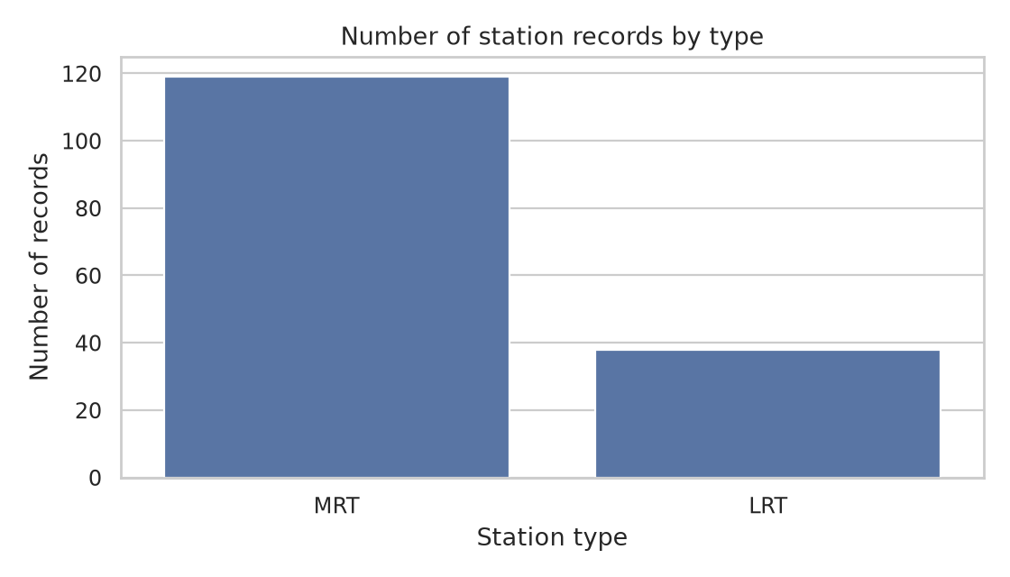
Figure 6.1: Number of station records by rail category.

6.2 NEAREST-DISTANCE DISTRIBUTION
The histogram summarizes the distribution of nearest-distance values computed by the project. The shape helps show whether most records fall in a narrow range or whether the distribution includes a longer tail of more isolated records.
- A histogram is useful for inspecting skew and spread.
- A mean alone cannot describe the full distance distribution.
- Very small or zero values should be interpreted in the context of the source coordinates and station definitions.
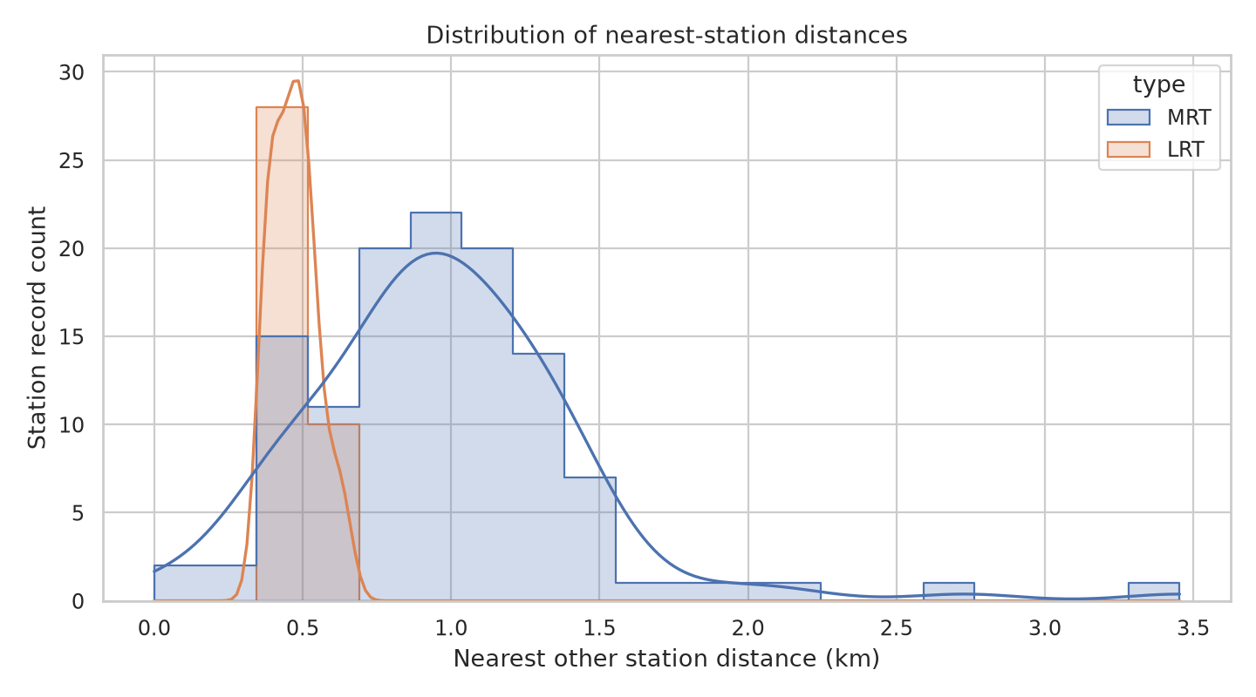
Figure 6.2: Distribution of coordinate-based nearest-station distances.

6.3 GEOGRAPHICAL DISTRIBUTION AND CATEGORY COMPARISON
The geographic scatter plot places station records by longitude and latitude, while the category comparison shows the difference in nearest-distance distributions for MRT and LRT records.
- The scatter plot reveals broad spatial structure and dense groups of coordinates.
- It is a coordinate map-like plot, not a network graph: rail lines, transfers, and walking paths are not represented.
- The separate category distance plot is used in the next section to compare proximity proxies.
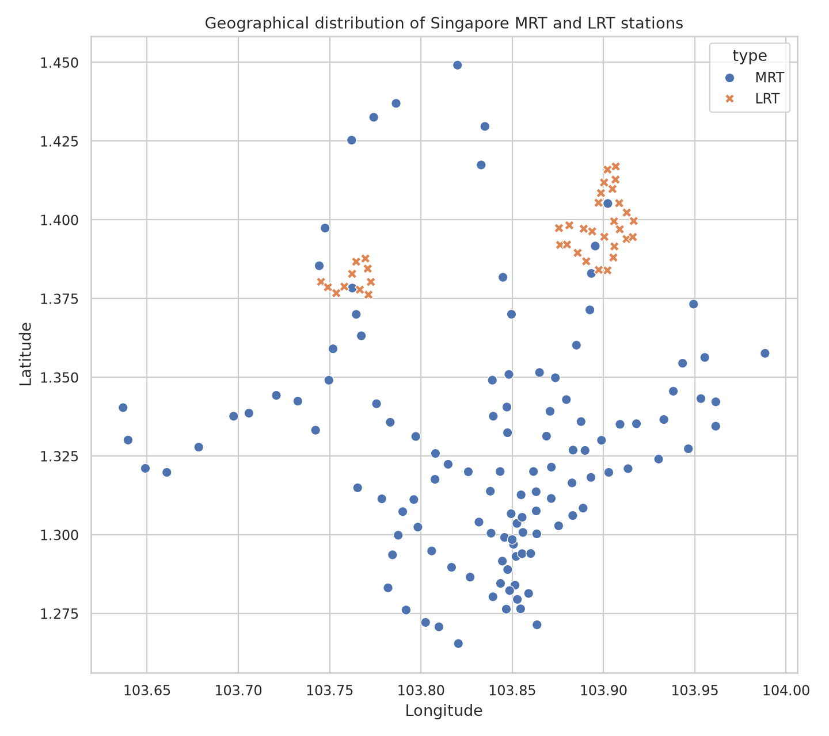
Figure 6.3: Geographic distribution of station coordinates.

STATISTICAL ANALYSIS & HYPOTHESIS TESTING

The project compares nearest-distance proxy values for MRT and LRT station records. Because the groups can have different variances and sample sizes, Welch’s independent two-sample t-test is used.
7.1 HYPOTHESES
Null hypothesis (H₀): the population mean nearest-distance proxy is equal for MRT and LRT records.
Alternative hypothesis (H₁): the population mean nearest-distance proxy differs between MRT and LRT records.
Significance level: α = 0.05.
The test is interpreted as a comparison of group means under the assumptions of the test. Since stations are geographically related, spatial dependence may limit a simple independent-observation interpretation.
H₀: μ_MRT = μ_LRT
H₁: μ_MRT ≠ μ_LRT
α = 0.05

7.2 DESCRIPTIVE STATISTICS
The grouped output reports that the LRT group has a mean nearest-distance proxy of 0.472 km, while the MRT group has a mean of 0.974 km. Median values and dispersion are also included to show how typical distances vary within each group.
Category | Records | Mean (km) | Median (km) | Std. dev. (km)
LRT | 38 | 0.472 | 0.464 | 0.076
MRT | 119 | 0.974 | 0.935 | 0.474

7.3 VISUAL COMPARISON
The box/summary visualization compares the spread and central tendency of the coordinate-based nearest-distance proxy across the two rail categories. The descriptive pattern suggests that LRT records have lower nearest-distance values in this dataset; the hypothesis test evaluates whether the difference in sample means is statistically distinguishable under its assumptions.
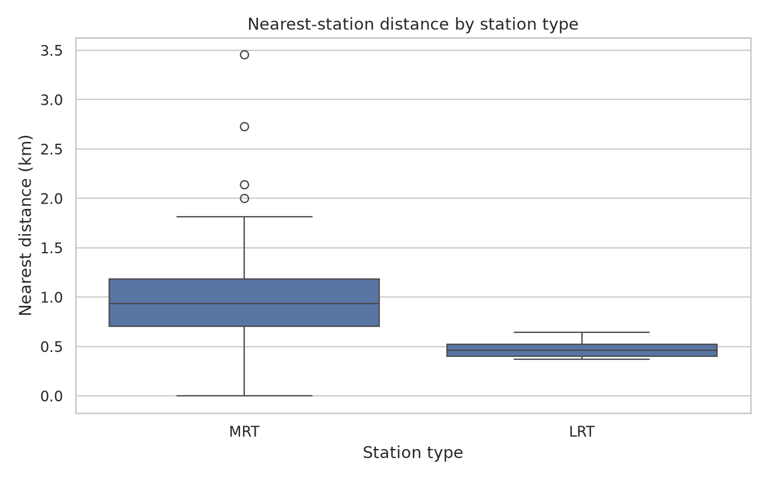
Figure 7.1: Nearest-distance proxy by MRT/LRT category.

7.4 WELCH TWO-SAMPLE T-TEST
The saved notebook output reports a Welch t-statistic of approximately 11.1105 and a p-value displayed as 0.000000 at six decimal places. This rounded display should be read as a very small p-value, not as a mathematically exact zero.
Decision rule:
If p < 0.05, reject H₀. The saved result therefore supports rejecting the equal-means null hypothesis at the 5% significance level.
Statistic | Reported value
Welch t-statistic | 11.1105
p-value | 0.000000 (rounded display)
Significance level | 0.05
Decision | Reject H₀ under the stated test

7.5 INTERPRETATION AND LIMITATIONS
The result indicates a difference in average nearest-distance proxy between the two groups as represented in the prepared dataset. It does not establish that every LRT station is more accessible than every MRT station, nor does it estimate passenger travel time.
- The dataset’s group sizes differ (38 LRT records versus 119 MRT records).
- The distance proxy depends on which stations are included in the reference set and how self-matches or coincident coordinates are treated.
- Stations within a connected rail system are spatially dependent, so the standard t-test assumptions may not fully capture geographic structure.
- The finding is descriptive and exploratory; it should not be interpreted as a causal result.
Figure 7.2: Visual context for the group comparison.

7.6 SUMMARY OF STATISTICAL FINDINGS
The statistical workflow combines descriptive summaries, visual comparison, and a formal hypothesis test. Using these three views together is preferable to relying on a single number because the group means, variability, and distribution shapes provide different kinds of information.
Analysis element | What it contributes
Group summaries | Sample size, mean, median, and standard deviation
Distance plot | Visual comparison of category distributions
Welch test | Formal test of equality of group means
Interpretation | Difference is statistically significant at α = 0.05, subject to assumptions
Caution | Coordinate distance is not a complete accessibility measure

MACHINE LEARNING MODELS FOR SPATIAL PATTERN ANALYSIS
8.1 K-MEANS CLUSTERING
K-Means is an unsupervised learning algorithm that partitions coordinate records into k groups. It assigns each point to the cluster with the nearest centroid and updates centroids until the assignments stabilize or the iteration limit is reached.
The project evaluates candidate cluster counts and selects k = 9 for the saved cluster visualization. These clusters are broad coordinate groupings; they are not official planning regions or rail service zones.
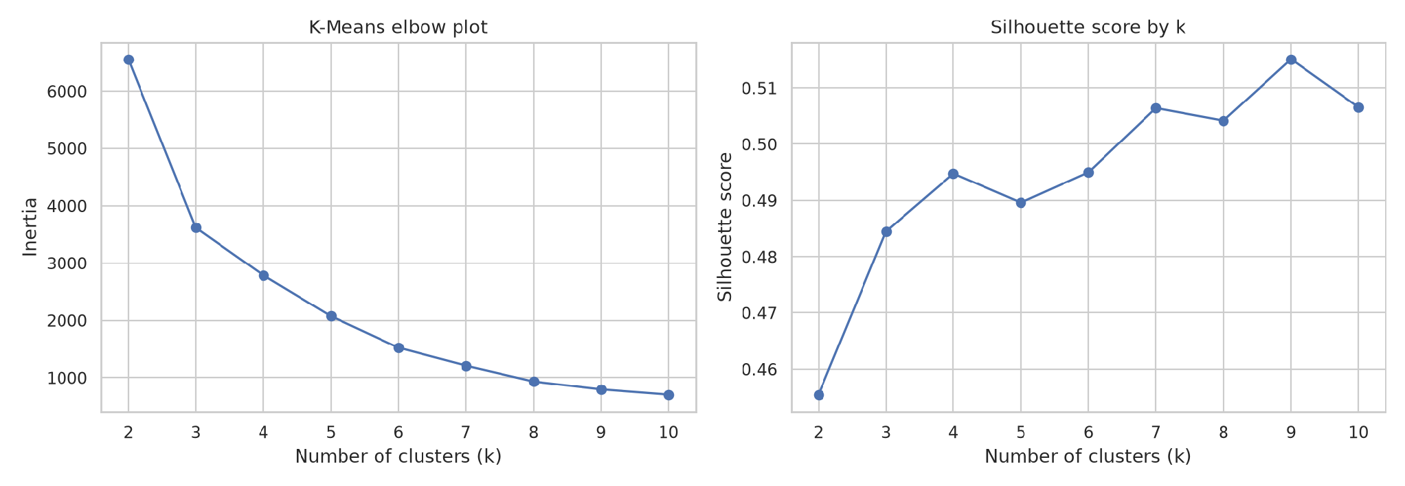
Figure 8.1: Model-selection plot used to review candidate cluster counts.

K-Means: mathematical concept
For a chosen k, K-Means minimizes the within-cluster sum of squared distances between each point and its assigned centroid.
Each station is represented by its coordinate feature vector. The algorithm iteratively assigns observations to the closest centroid and recomputes each centroid as the mean of the points assigned to that cluster.
Minimize: Σ(i=1 to n) ||xᵢ − μcᵢ||²
where:
xᵢ = coordinate feature vector for station i
μcᵢ = centroid of the cluster assigned to station i
k = selected number of clusters (k = 9 in the saved result)

K-Means implementation
The clustering step is applied to coordinate data using the selected cluster count. The saved output summarizes the number of station records and average coordinates in each cluster, with MRT and LRT counts reported separately.
kmeans = KMeans(n_clusters=9, random_state=42, n_init=10)
labels = kmeans.fit_predict(coordinate_features)

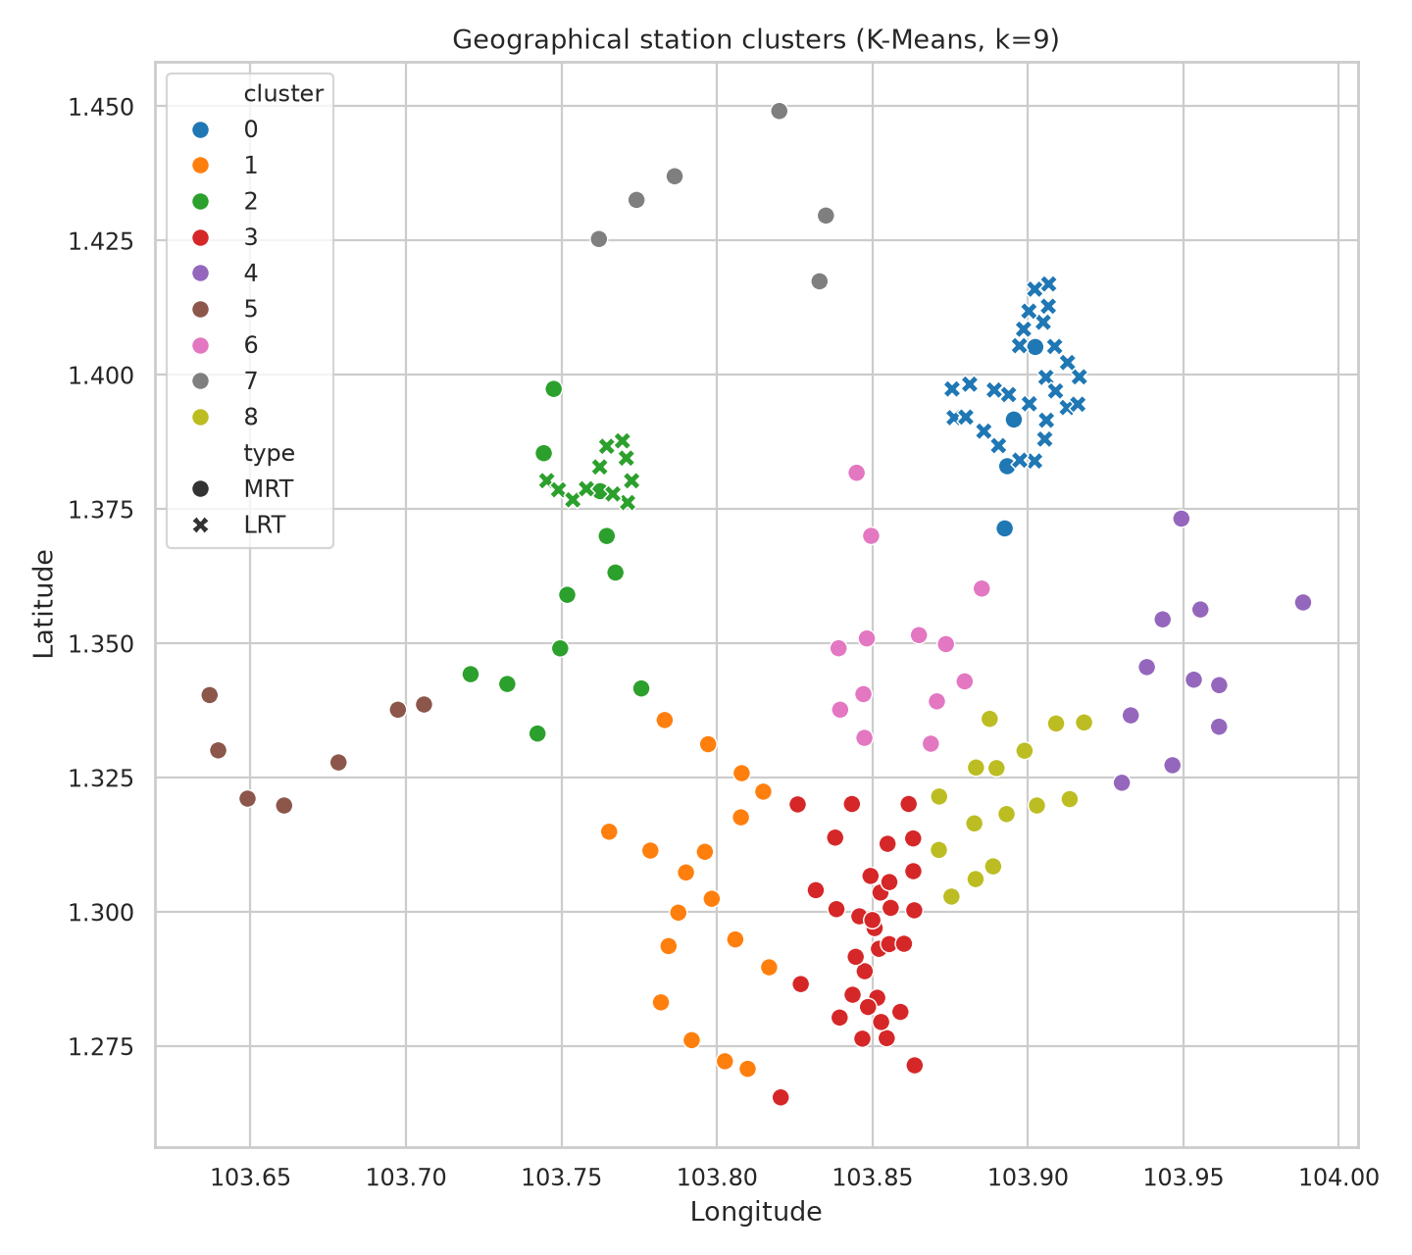
Figure 8.2: Station coordinate records colored by assigned K-Means cluster.

Cluster summary
The cluster output shows that cluster sizes are not uniform. Some clusters are dominated by MRT records, while cluster 0 includes a larger share of LRT records. This is consistent with the fact that the coordinate distribution and rail category are not evenly distributed throughout the study area.
Cluster | Records | MRT | LRT | Mean latitude | Mean longitude
0 | 31 | 4 | 27 | 1.3973 | 103.8989
1 | 18 | 18 | 0 | 1.3033 | 103.7956
2 | 22 | 11 | 11 | 1.3707 | 103.7565
3 | 33 | 33 | 0 | 1.2956 | 103.8488
4 | 11 | 11 | 0 | 1.3450 | 103.9510
5 | 7 | 7 | 0 | 1.3308 | 103.6669
6 | 13 | 13 | 0 | 1.3490 | 103.8584
7 | 7 | 7 | 0 | 1.4326 | 103.7996
8 | 15 | 15 | 0 | 1.3211 | 103.8913

8.2 LINEAR REGRESSION
Linear Regression provides a simple baseline for predicting a continuous target from selected input features. It models the target as a linear combination of predictors and is useful as a reference point even when the relationship is not fully linear.
The saved evaluation table reports MAE of approximately 0.377 km and RMSE of approximately 0.531 km for Linear Regression.
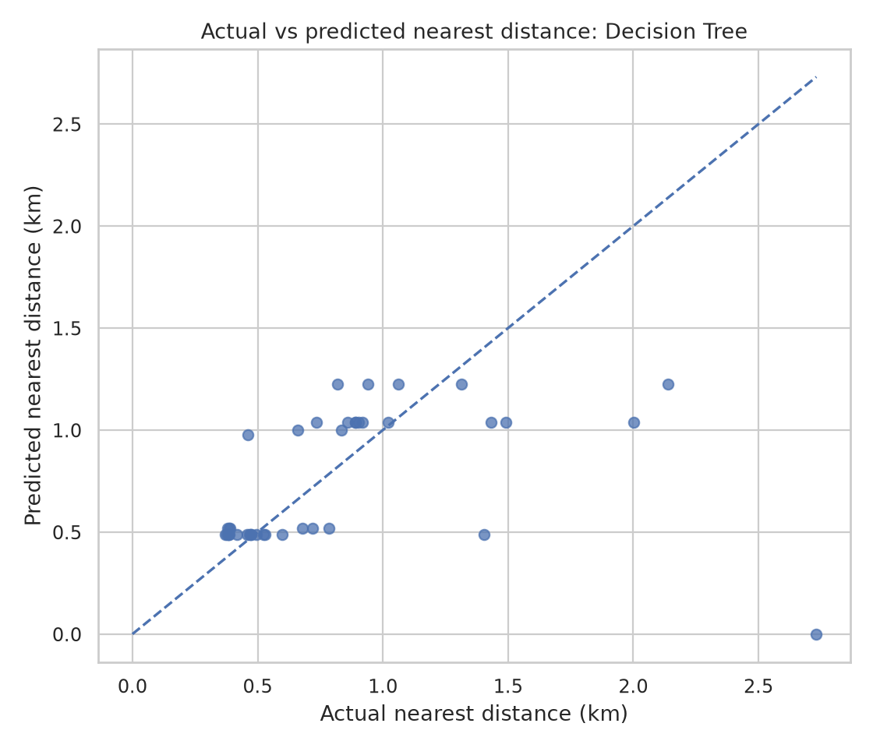
Figure 8.3: Actual-versus-predicted values for the regression experiment.

Linear Regression: mathematical concept
The fitted model estimates coefficients that minimize the sum of squared residuals on the training data. A prediction is generated by applying the learned coefficients to the input features.
ŷ = β₀ + β₁x₁ + β₂x₂ + … + βpxp

where:
ŷ = predicted target value
β₀ = intercept
βj = learned coefficient for feature j
xj = value of feature j

8.3 DECISION TREE REGRESSION
A Decision Tree regressor predicts a numerical target by splitting the feature space into regions. Each terminal leaf returns a value derived from training examples in that region. Trees can model non-linear relationships, but they may overfit when they are not appropriately constrained.
The saved result reports MAE of approximately 0.282 km and RMSE of approximately 0.538 km for the Decision Tree model.
Figure 8.4: Regression fit visual used to inspect prediction behaviour.

Decision Tree: conceptual workflow
The model repeatedly selects feature thresholds that reduce the prediction error within child nodes. Prediction for a new row follows the learned decision rules from the root node to a leaf.
tree_model = DecisionTreeRegressor(random_state=42)
tree_model.fit(X_train, y_train)
tree_pred = tree_model.predict(X_test)

mae = mean_absolute_error(y_test, tree_pred)
rmse = np.sqrt(mean_squared_error(y_test, tree_pred))

8.4 COMPARING THE BASELINE MODELS
The Decision Tree has the lower MAE, while Linear Regression has a slightly lower RMSE. The metrics therefore do not identify one model as uniformly better under both criteria. MAE measures average absolute error, whereas RMSE penalizes larger errors more strongly.
Model | MAE (km) | RMSE (km)
Decision Tree | 0.2820 | 0.5382
Linear Regression | 0.3774 | 0.5305

Model interpretation and scope
These regressors should be treated as baseline experiments within the supplied notebook. Their errors describe agreement with the held-out target values constructed for the project; they do not validate real walking distances or travel-time estimates.
- A spatially random train/test split can place nearby stations in both partitions and may overstate generalization to new geographic areas.
- Model scores depend on the engineered features, target definition, and split procedure.
- A more rigorous evaluation could use spatially separated validation, feature scaling where appropriate, and comparisons with a simple baseline.
- The notebook’s output metrics are preserved as reported; this report does not claim an unrecorded improvement or additional model result.

Summary of modeling outputs
The modeling component contains two different tasks: clustering is used to explore coordinate groupings, while regression estimates a continuous target from selected features. The outputs answer different questions and should not be compared as if they were the same type of model.
- K-Means: selected k = 9.
- Linear Regression: MAE ≈ 0.3774 km; RMSE ≈ 0.5305 km.
- Decision Tree: MAE ≈ 0.2820 km; RMSE ≈ 0.5382 km.
- The project’s central contribution remains the reproducible coordinate-based proximity analysis.
Figure 8.5: Spatial cluster output for the selected K-Means run.

MODEL EVALUATION AND VALIDATION
9.1 PERFORMANCE COMPARISON OF MODELS
The saved metrics provide an objective comparison of the two regression baselines. MAE is easier to interpret as an average absolute error in the target’s units. RMSE is more sensitive to larger residuals and can reveal a model that occasionally makes larger errors.
Model | MAE (km) | RMSE (km)
Decision Tree | 0.281967 | 0.538160
Linear Regression | 0.377376 | 0.530515

9.2 VISUAL VALIDATION
The actual-versus-predicted plot is used to inspect how closely predictions follow observed target values. Points closer to the ideal diagonal represent more accurate predictions; systematic deviations can indicate bias or a mismatch between the model form and the data.
- Use numerical metrics and plots together.
- Compare both MAE and RMSE rather than choosing a model from one metric alone.
- Confirm the train/test split and target construction before using the scores in an operational setting.
Figure 9.1: Actual-versus-predicted regression evaluation plot.

9.3 VALIDATION LIMITATIONS
Model evaluation is only as meaningful as the target definition and validation strategy. In this project, the target is derived from the same coordinate dataset that supports the spatial analysis, so the task is best viewed as a methodological baseline rather than a deployed prediction service.
- Geographic proximity is not the same as pedestrian accessibility.
- A coordinate-based dataset may include nearby or coincident coordinates for stations or related station records.
- Spatially correlated observations can leak geographic similarity across train and test partitions.
- Future evaluation should use a clearly defined target, spatial holdout regions, and comparisons against simple baselines.

CONCLUSION AND FUTURE SCOPE
10.1 CONCLUSION
The Singapore MRT Accessibility Mapper demonstrates an end-to-end data-science workflow for studying the spatial distribution of MRT and LRT station coordinates. It combines data preparation, proximity feature engineering, exploratory visualization, a Welch statistical comparison, K-Means clustering, and regression baselines into a reproducible notebook-based analysis.
The prepared primary table contains 157 records, including 119 MRT and 38 LRT records. The saved group summaries show a mean nearest-distance proxy of 0.974 km for MRT records and 0.472 km for LRT records. The Welch test reports a t-statistic of 11.1105 with a p-value displayed as 0.000000 to six decimal places, supporting rejection of equal group means at α = 0.05 under the test assumptions.
The clustering output uses nine groups, and regression evaluation shows a trade-off between MAE and RMSE for the two baseline models. These findings are useful for exploration, but they should not be overinterpreted as direct measures of real-world accessibility.

10.2 FUTURE SCOPE
The project can be extended from coordinate proximity toward more realistic and decision-ready accessibility analysis.
- Pedestrian network distances: calculate walking routes using street and footpath networks instead of straight-line distances.
- Station entrance detail: include entrances, exits, interchange passages, lifts, ramps, and barrier-free access attributes.
- Time-aware accessibility: incorporate service frequency, opening hours, and transfer penalties where reliable data are available.
- Spatial validation: test models on held-out geographic regions to assess generalization.
- More robust inference: account for spatial autocorrelation and conduct sensitivity analysis for duplicate or coincident coordinates.
- Interactive presentation: optionally build a map interface with station search, category filters, distance thresholds, and export functions.
- Data updates: document source versions, refresh dates, and matching rules to support repeatable updates.

REFERENCES
11.1 DATA AND SOURCE FILES
1. Singapore Train Station Coordinates. Kaggle dataset used as the primary station-coordinate source. https://www.kaggle.com/datasets/yxlee245/singapore-train-station-coordinates
2. Singapore MRT/LRT Stations with Coordinates. Kaggle dataset used as a supplementary source for cross-reference and name-matching audit. https://www.kaggle.com/datasets/shengjunlim/singapore-mrt-lrt-stations-with-coordinates
11.2 SOFTWARE LIBRARIES AND DOCUMENTATION
3. Pandas documentation — https://pandas.pydata.org/docs/
4. NumPy documentation — https://numpy.org/doc/
5. Matplotlib documentation — https://matplotlib.org/stable/
6. Seaborn documentation — https://seaborn.pydata.org/
7. Scikit-learn documentation — https://scikit-learn.org/stable/
8. Jupyter documentation — https://docs.jupyter.org/

11.3 METHODS AND TECHNICAL REFERENCES
9. Haversine distance: standard great-circle distance calculation from latitude and longitude on a spherical Earth. The project uses the distance as a geographic proxy and not as a pedestrian route.
10. Welch’s two-sample t-test: unequal-variance independent-samples test used to compare group means.
11. K-Means clustering: unsupervised centroid-based clustering implemented using scikit-learn.
12. Linear Regression and Decision Tree Regression: scikit-learn estimators used for baseline regression evaluation.

PROJECT ARTIFACTS
The analysis notebook and the exported figures/CSV files included in the supplied ZIP archive are the primary implementation references for this report. Numeric values shown in the report are taken from the saved project outputs. Where the archive reports a rounded p-value, the displayed precision is preserved and interpreted as rounding.
FINAL NOTE
This report follows the section order, formal academic presentation, numbered headings, tables, figures, code extracts, evaluation discussion, and reference-page arrangement of the provided sample report. It adapts the content to the actual MRT/LRT coordinate-analysis project and does not claim that the notebook implements a dashboard or real walking-route engine.

