GAJJAR HUB

Gajjar Hub
Everything hostel, in one place.
Product Requirements Document for a mobile-first, dark-themed hostel app built with Next.js and Supabase.

v2.0 | 25 October 2026 | Short version
Note to the AI coding agent (Cursor / Antigravity)
- This PRD plus the attached reference image Home Mobile_2x.png are the source of truth. Match the Home page to the image closely, and reuse the same look for every other page (Appendix A shows the image).
- Mobile-first (390 px wide), dark theme only. Do not add features that are not listed here.
- Supabase handles login and all data. No custom backend. Enforce permissions with Row Level Security, never only in the UI. Never expose the service-role key to the browser.
- Build in the order in Section 7 and check each step on a 390 px viewport before moving on.

Overview

Gajjar Hub is a mobile web app for hostel residents. It puts complaints, official notices, the mess menu, mess polls and hostel contacts in one place, so students stop chasing people on WhatsApp. Login and data run on Supabase.

Page | What it has
Home | Hero with title and shortcuts, feature cards, today's menu for Mess 1 and Mess 2, latest notices.
Notices | Two tabs: official Notices (posted by the captain) and Complaints (posted by students, with like and dislike and a status).
Mess | Weekly menu for each mess, and polls where residents vote on next week's menu.
HS (Hostel Management) | Hostel leaders with name, post and contact info.

Role | Can do
Student | Read everything. Post complaints about their own wing. Like or dislike complaints. Vote in polls of their own mess.
Captain | Everything a student can, plus: post notices, edit the mess menu, create polls, manage the HS list, change complaint status, delete any complaint. Used by the hostel captain or warden; assigned in the Supabase dashboard.

Tech Stack(or you can choose by yourself)

- Frontend: Next.js (latest stable, App Router, TypeScript), Tailwind CSS, lucide-react icons. Fonts: Manrope and JetBrains Mono (next/font).
- Backend: Supabase (Postgres, Auth, Row Level Security) using supabase-js and @supabase/ssr. No Storage needed (no image uploads in v1).

- Other: react-hook-form with zod for forms, date-fns-tz for dates (time zone Asia/Kolkata, week starts Monday), hosting on Vercel.
- Env vars: NEXT_PUBLIC_SUPABASE_URL and NEXT_PUBLIC_SUPABASE_ANON_KEY. Include a
.env.example.

Design System (taken from the reference image)

Dark charcoal surfaces, one blue for primary actions, one amber for accents and monospace labels. Calm, high contrast, lots of spacing.

 | Token | Value | Usage
 | bg | #222223 to #131314 | Page background: vertical gradient, lightest at the top.
 | surface | rgba(255,255,255,0.04) | Cards (about #242425). Secondary buttons and icon buttons use 0.06.
 | border | rgba(255,255,255,0.10) | 1 px borders on cards and buttons (about #353536).
 | text | #E5E7EB | Headings and main text.
 | text-muted | #9CA3AF | Descriptions and subtext.
 | text-dim | #6B7280 | Meta text (dates, categories) and placeholders.
 | primary | #6B95FF | Primary button, icons, eyebrow badge. Text on primary: #0D1224.
 | amber | #E6A835 | Headline accent, mono labels and links, 'See all'.
 | success / danger | #4ADE80 / #F87171 | Only for Resolved status, active like and dislike, delete actions.

Typography

Element | Style
Eyebrow badge | JetBrains Mono 12 px, uppercase, wide letter-spacing (0.2em), primary text on #0D1224 with a #1F2A4D border, fully rounded, 30 px tall.
Hero heading | Manrope 700, 44 px / 46 px, letter-spacing -0.02em. Second line in amber.
Hero subtext | Manrope 18 px / 27 px, text-muted.
Card and section titles | Manrope 600, 22 px. Body text in cards: Manrope 16 px / 24 px, text-muted.
Mono labels and links | JetBrains Mono 13 to 14 px. Labels uppercase in amber (BREAKFAST). Links in amber with a trailing arrow (New complaint). Meta in text-dim, uppercase.

Shape, spacing and components
- Page side padding 24 px. Cards: radius 20 px, padding 24 px, surface background, 1 px border, 16 px gap between cards.
- Hero buttons: full width, 52 px tall, radius 14 px, 14 px gap. Primary has a soft blue glow (box-shadow 0 0 32px rgba(107,149,255,0.35)). Secondary uses surface and border with light text.
- Header icon buttons: 44 px squares, radius 12 px, surface and border. Icons are outline style (lucide), 1.5 to 2 px stroke.
- Lists inside cards (menu, notices) are rows separated by a 1 px divider (white at 8 percent) with 20 px vertical padding.
- Hero decoration: a cluster of large rotated squares (45 degrees) in #282930 at the top right, partly cut off by the screen edge, with one small diamond outline in primary and a faint blue glow. Decorative only (aria-hidden, behind the text).

- Shared pieces: BottomSheet (all forms), SegmentedControl (mono labels, active segment filled with primary), Badge, Toast, skeleton loaders, empty states.
- Touch targets at least 44 px. Text contrast meets WCAG AA. Respect safe-area insets.

Navigation and Routes

- Sticky header on every page (as in the reference): logo button and 'Gajjar Hub' on the left, hamburger button on the right. It is transparent over the hero and gets a blurred background (bg at 80 percent) and a bottom border once the page scrolls.
- Hamburger menu: a panel sliding in from the right with links Home, Notices, Mess, HS, then Profile and Sign out. The current page is highlighted in primary. It closes on link tap or when the overlay is tapped.
Route | Screen | Access
/login | Sign in and sign up | Public
/onboarding | Name, wing, room number, mess (1 or 2). Required before anything else. | Signed in, profile incomplete
/ | Home | Signed in
/notices | Tabs: Notices | Complaints (?tab=notices or complaints) | Signed in
/mess | Tabs: Weekly menu | Polls (?tab=menu or polls) | Signed in
/hs | Hostel Management | Signed in
/profile | Edit profile, sign out | Signed in
Forms open as bottom sheets over their page, not as separate routes.

Page Specs

Home ( / )
Build this to match the reference image. Top to bottom:
- Header as described in Section 4.
- Hero: eyebrow badge 'GAJJAR HUB'; heading 'Everything hostel,' in text color then 'in one place.' in amber; subtext 'Raise a complaint, read the latest notices and check today's mess menu without chasing anyone.'
- Three stacked buttons: 'Submit a complaint' (primary, opens the New complaint sheet), 'View notices' (secondary, /notices), 'View mess menu' (secondary, /mess).
- Three feature cards (icon, title, text, amber mono link), content below.
- Today's menu card. Title 'Today's menu' on the left and today's date on the right in mono, uppercase, text-dim (for example SUN, 25 OCT). Under the title, a small Mess 1 | Mess 2 segmented control (the only addition to the reference; defaults to the user's mess and remembers the last choice). Then four rows in order: BREAKFAST, LUNCH, SNACKS, DINNER: amber mono label, then the items (comma separated, 17 px). Empty meal: 'Not updated yet' in text-dim.
- Latest notices card. Title 'Latest notices' and an amber 'See all' link (/notices). Three newest notices; each row has the title (Manrope 500, 18 px) and mono meta in text-dim: date and category (for example 24 OCT / MESS). Tapping a row opens /notices. Empty: 'No notices yet'.
Card | Icon | Text | Link
Complaints | message-circle-alert | Report an issue with your room, water, power or Wi-Fi and track its status. | New complaint (opens the sheet)
Notices | bell | Official announcements from the warden and hostel office, newest first. | Read notices (/notices)
Mess Menu | utensils | See what's served for breakfast, lunch, snacks and dinner, every day of the week. | Weekly menu (/mess)

Notices ( /notices )
    - Page starts with a small eyebrow badge, the title and a segmented control: Notices | Complaints.
    - Notices tab: cards with title, mono meta (date and category), body clamped to 3 lines with 'Read more'. Categories: General, Mess, Maintenance, Event, Urgent. Captain only: '+ New notice' (sheet with title, body, category) and edit or delete from a menu on each card.
    - Complaints tab: primary button 'Submit a complaint' at the top. Filter chips: My wing (default), All wings, then each wing. Card: title, description (4 lines), mono meta WING / CATEGORY / STATUS, author name and time, then thumbs-up and thumbs-down buttons with counts.
    - Voting: one vote per user per complaint; like and dislike are exclusive; tapping the active one removes it. Update the UI immediately and roll back on error.
    - New complaint sheet: category (Room, Water, Power, Wi-Fi, Other), title (3 to 100 characters), description (up to 500). Wing comes from the user's profile and is read-only, so students can only post about their own wing.
    - Status is Open (amber), In progress (primary) or Resolved (green). Captain changes it. Authors can delete their own complaints; the captain can delete any. Newest first, 20 per page with infinite scroll.

Mess ( /mess )
    - Mess 1 | Mess 2 segmented control (defaults to the user's mess) above two tabs: Weekly menu | Polls.
    - Weekly menu: seven day cards, Monday to Sunday, today expanded. Each uses the same four-row layout as Today's menu. The menu repeats every week. Captain: a pencil on each meal opens a sheet to add or remove items as chips.
    - Polls ('vote for next week's menu'): active polls first (closing soonest), then closed. Card: title (for example 'Sunday dinner, next week'), 'Closes in 2d 4h' in mono, and 2 to 6 options as tappable rows. After voting, show a bar, percentage and count per option with the user's choice marked. The vote can be changed until the poll closes. Closed polls show the winner. Votes are anonymous.
    - Only residents of that mess can vote; the other mess's polls are view-only. Captain: '+ New poll' (mess, title, options, closing date and time), close early, delete. The captain updates the weekly menu by hand using the result.

HS ( /hs )
    - Title 'Hostel Management'. One card per leader, ordered by sort_order: name (Manrope 600, 20 px), post as an amber mono label (for example HOSTEL CAPTAIN), phone and email.
    - Action buttons: Call (tel:), WhatsApp (wa.me link) and Email (mailto:). Hide any that are missing. Store phone numbers with country code (+91...).
    - Captain: add, edit, delete and reorder leaders.

Login and onboarding
    - /login: email and password sign up and sign in, plus forgot password. Optional: limit sign-ups to the college email domain with an ALLOWED_EMAIL_DOMAIN env var.
    - /onboarding runs on first login and blocks other pages until done: full name, wing, room number, mess (1 or 2). The same fields can be edited on /profile. Role is never editable by the user.

Data Model and Access Rules

Create these tables in Supabase (uuid primary keys with gen_random_uuid(), created_at timestamptz default now(), unless noted).

Table | Columns
wings | id, name (seed: Wing A to Wing D as placeholders)
profiles | id (= auth user id), full_name, room_no, wing_id, mess (1 or 2), role ('student' or 'captain', default 'student')
notices | id, title, body, category, created_by, created_at
complaints | id, user_id, wing_id, category, title, description, status ('open', 'in_progress', 'resolved'), created_at

Table | Columns
complaint_votes | complaint_id, user_id, value (1 like or -1 dislike). Primary key (complaint_id, user_id)
mess_menu | mess (1 or 2), day_of_week (1 = Monday to 7 = Sunday), meal ('breakfast', 'lunch', 'snacks', 'dinner'), items text[]. Unique on the first three
polls | id, mess (1 or 2), title, closes_at, is_closed, created_by, created_at
poll_options | id, poll_id, label, sort_order
poll_votes | poll_id, option_id, user_id. Primary key (poll_id, user_id). Option must belong to the poll
hostel_leaders | id, name, post, phone, email, sort_order
- Views: create complaint_feed (complaint, author name, like count, dislike count, the current user's vote) and poll_results (vote count per option) so that other people's individual votes are never readable. Both return rows only to signed-in users.
- Auto profile: a trigger on auth.users creates a profiles row on sign-up.
- Row Level Security on every table. Only signed-in users can read content tables. Votes tables: users see only their own rows.
- Students: insert a complaint only with their own user_id and their own wing; delete own complaints; manage own complaint votes; vote in a poll only if it is open (not closed and before closes_at) and belongs to their own mess; update own profile except role.
- Captain (profiles.role = 'captain', checked through a helper function is_captain()): full write access to notices, mess_menu, polls, poll_options and hostel_leaders; update complaint status; delete any complaint.
- Roles are changed only in the Supabase dashboard (for example update profiles set role = 'captain' where id = ...). Block clients from updating the role column.

Build Order

- Setup: Next.js, Tailwind, fonts, design tokens, Supabase clients, .env.example.
- Database: tables, views, trigger, helper function, RLS policies, seed wings and sample data.
- Auth and shell: login, onboarding, profile, sticky header, hamburger menu, four empty pages.
- Mess and Home: weekly menu (read and captain edit), then the Home page matching the reference.
- Notices and Complaints: notices with captain tools, then the complaint feed, voting and status.
- Polls and HS, then polish: polls, HS list, loading, empty and error states, deploy to Vercel.

Defaults and Out of Scope

- App name is Gajjar Hub; wing names are placeholders. Wings, leaders and menus are edited in the app or the Supabase dashboard, not hard-coded.
- The mess menu is a weekly menu that repeats; polls are advisory and the captain applies the result by editing the menu.
- English only. Time zone Asia/Kolkata.
- Not in v1: image uploads, comments, anonymous posting, push notifications, admin dashboard, offline mode.

Appendix A. Design Reference: Home (mobile, 390 px)

Reference for the Home page. Also attach the original file Home Mobile_2x.png when prompting Cursor or Antigravity. Bracketed text such as [Menu items] and [Notice title] marks live data from Supabase.
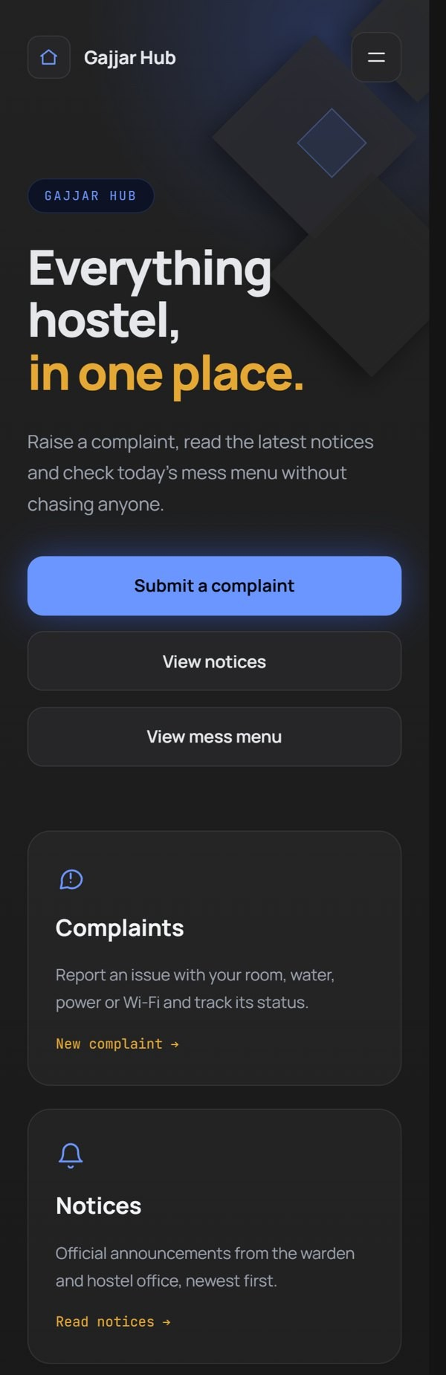
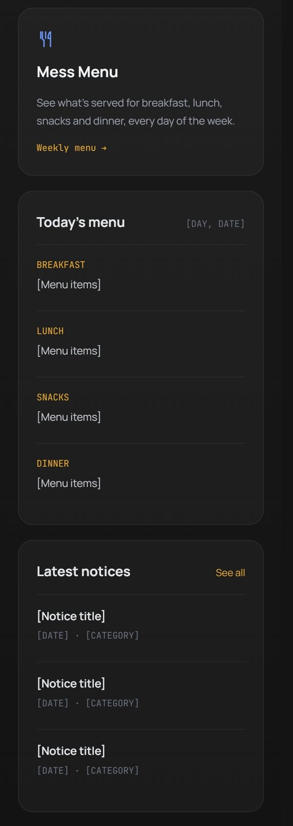
Top half: header, hero, buttons, feature cards Bottom half: today's menu, latest notices

