AI Physiological State Monitor
A Project Report
Submitted By
2514111117-Shambhuraje Jagtap
2514111125-Sahil Tagunde
2514111109-Bhavesh Bhole
2514111118-Atharv Retawade
In partial fulfilment of the requirement
For the course of
BACHELOR OF TECHNOLOGY
In
INFORMATION TECHNOLOGY
Under the guidance of
Prof. Prashant Chavan

DEPARTMENT OF INFORMATION TECHNOLOGY
BHARATI VIDYAPEETH (DEEMED TO BE UNIVERSITY)
COLLEGE OF ENGINEERING, PUNE – 43
2026–27
BHARATI VIDYAPEETH (DEEMED TO BE UNIVERSITY)
COLLEGE OF ENGINEERING, PUNE – 43

CERTIFICATE
This is to certify that the Project Based Learning report titled “AI Physiological State Monitor” submitted by Shambhuraje Jagtap,Sahil Tagunde,Bhavesh Bhole And Atharv Retawade to the Bharati Vidyapeeth (Deemed to be University), College of Engineering, Pune – 43 for the award of the degree of BACHELOR OF TECHNOLOGY in INFORMATION TECHNOLOGY is a bonafide record of the PBL work done by them under my supervision.
Prof. Prashant Chavan
Guide, Department of Information Technology
Date: ___________________
INDEX
Sr. No. | Topic | Page No.
1 | Abstract | 4
2 | Introduction | 5
3 | Problem Statement and Objectives | 6
4 | Existing and Proposed System | 7
5 | System Requirements and Technology Stack | 8–9
6 | System Design and Architecture | 10
7 | Dataset and Data Preprocessing | 11–12
8 | Personal Baseline and Feature Engineering | 13
9 | Calculation And Formula | 14
10 | IMPLEMENTATION AND RESULTS | 15–17
11 | Testing and Results | 18
12 | Unique Features, Limitations and Future Scope | 19
13 | Conclusion and References | 20
ABSTRACT
Physiological monitoring generates repeated measurements such as heart rate, heart-rate variability (HRV), and activity. These signals vary throughout the day and between individuals, so a single universal threshold may not describe every person well. This project, the AI Physiological State Monitor, builds a simple personal baseline from an initial set of observations and measures how later observations differ from that reference. The system is an educational prototype and is not a medical device.
The project is implemented in Python and tested on a bundled synthetic dataset containing 1,500 five-minute observations. The pipeline validates the required columns, converts timestamps and numeric values, removes invalid or duplicate records, derives time and rolling-window features, and calculates standardized deviations (z-scores) from the baseline. An Isolation Forest model then assigns anomaly flags and anomaly scores to observations.
A rule-based classification layer labels patterns such as Normal, High Activity, Elevated Physiological Activity, or Deviation Detected. A Streamlit dashboard displays summary metrics, trends, state classifications, and anomaly visualizations. In the demonstration run, the model flagged 75 of 1,500 observations.
The demo data is synthetic and includes deliberately unusual combinations to demonstrate anomaly detection. The report therefore focuses on software design, pipeline behaviour, and sample outputs rather than medical conclusions.
Keywords: Artificial intelligence, time-series data, physiological signals, heart rate, HRV, personal baseline, Isolation Forest, anomaly detection, Python, Streamlit.
1. INTRODUCTION
1.1 Background
Wearable devices and monitoring systems can produce repeated measurements such as heart rate, HRV, and activity. Looking at every measurement individually may make it difficult to understand changing patterns. Time-series analytics helps organize measurements by time and highlight observations that are unusual relative to a reference pattern.
1.2 Project Overview
This project, AI Physiological State Monitor, combines basic data preparation, statistical baseline calculations, machine-learning anomaly detection, and a visual dashboard. It accepts a bundled sample dataset, a CSV uploaded by a user, or a supported PhysioNet data source when the dataset is available locally in the expected structure. PBL Code: B19 — FAIR-AI-19.
The major functions of the project include:
- Loading physiological time-series data from a CSV dataset.
- Validating required fields and cleaning invalid or duplicate records.
- Engineering rolling-window and time-related features.
- Establishing a personal baseline from an initial warm-up window.
- Calculating standardized baseline deviations (z-scores).
- Training an Isolation Forest model to generate anomaly flags and scores.
- Assigning rule-based descriptive state labels.
- Presenting results through an interactive Streamlit dashboard.
1.3 Motivation
The motivation behind this project is to demonstrate an end-to-end applied AI workflow using Python. It explores how personal reference values can contextualize time-series observations, provides understandable graphs and flagged observations through a browser-based dashboard, and creates a foundation for later dataset evaluation and comparison of algorithms.
1.4 Scope of the Project
The current implementation is a learning prototype. It analyzes numeric time-series features and visualizes deviations. It does not connect to a live wearable sensor, provide emergency alerts, validate clinical thresholds, or establish medical diagnoses. The system is intended for educational analytics and demonstration only and must not be used to diagnose, treat, or make clinical decisions.
1.5 Group Members
Roll No. | Name
 | Shambhuraje Jagtap
 | Sahil Tagunde
 | Bhavesh Bhole
 | Atharv Retawade
2. PROBLEM STATEMENT AND OBJECTIVES
2.1 Problem Statement
A dataset containing many physiological observations can include natural daily variation, measurement noise, and occasional unusual combinations. A basic fixed-threshold system may not represent differences between individuals. The problem addressed by this project is the need to investigate a simple personalized-baseline approach, combined with unsupervised anomaly detection, to flag potentially unusual observations for review.
Key Problems Identified
- Physiological signals vary naturally across the day and between individuals.
- Fixed universal thresholds do not account for personal differences.
- Raw data may contain missing columns, invalid timestamps, non-numeric values, and duplicate records that distort rolling statistics and model results.
- Reviewing every measurement individually makes changing patterns difficult to understand.
- No labelled ground truth is available, so unusual observations must be found with an unsupervised method.

2.2 Objectives
- To load physiological observations from a CSV dataset.
- To validate the required fields: timestamp, heart_rate, hrv, and activity.
- To clean invalid rows and sort observations chronologically.
- To create rolling statistics and time-related features.
- To estimate a personal baseline from an initial warm-up segment.
- To calculate standardized baseline deviations.
- To train an Isolation Forest model and generate anomaly flags and scores.
- To classify patterns using transparent rules and visualize the output.
- To document the software setup, testing approach, limitations, and future improvements.

2.3 Project Goals
- Produce a reproducible Python pipeline for physiological time-series analysis.
- Provide an interactive dashboard showing physiological trends, counts of flagged observations, state classifications, and summary baseline values.
- Produce descriptive, interpretable state labels for each observation.
- Deliver a complete project report demonstrating the full pipeline. Outputs support demonstration and analysis, not medical decisions.
3. EXISTING AND PROPOSED SYSTEM
3.1 Existing System
Existing approaches to interpreting physiological measurements commonly rely on viewing individual readings or applying fixed universal thresholds. These methods are simple, but they treat all individuals alike and do not give recent context to each measurement.
3.2 Limitations of the Existing System
- Fixed thresholds do not represent differences between individuals.
- Looking at every measurement individually makes changing patterns hard to understand.
- Raw readings are not related to a personal reference pattern.
- Invalid, duplicate, or non-numeric values are not systematically handled.
- Simple threshold rules do not learn unusual combinations of heart rate, HRV, and activity.

3.3 Proposed System
The proposed system is a Python-based pipeline that validates and cleans physiological time-series data, derives rolling and time-related features, establishes a personal baseline from the first 50 observations, and calculates standardized deviations. An Isolation Forest model flags unusual observations, a rule-based layer assigns readable state labels, and a Streamlit dashboard presents the results.
3.4 Advantages of the Proposed System
- Personalized — observations are compared with a baseline rather than a single universal threshold.
- Unsupervised — anomaly detection does not require labelled examples.
- Interpretable — state labels follow transparent, rule-based logic.
- Reproducible — a fixed random seed (random_state=42) gives a reproducible model configuration.
- Accessible — the browser-based dashboard supports the sample dataset, CSV upload, and supported local PhysioNet data.

3.5 Comparison of Existing and Proposed System
Feature | Existing System | Proposed System
Reference values | Fixed universal thresholds | Personal baseline from first 50 observations
Context | Individual readings viewed in isolation | Rolling window of 20 observations
Deviation measure | Raw value comparison | Standardized z-scores from baseline
Anomaly detection | Rule or threshold based | Isolation Forest (unsupervised)
State labelling | Manual interpretation | Rule-based descriptive labels
Data validation | Not systematic | Column checks, cleaning, de-duplication
Presentation | Raw tables or manual charts | Interactive Streamlit dashboard

4. SYSTEM REQUIREMENTS AND TECHNOLOGY STACK
4.1 Hardware Requirements
Component | Requirement
Processor | Modern dual-core CPU or better
RAM | 4 GB minimum; 8 GB recommended
Storage | Approximately 200 MB or more for environment and project files
Display | Laptop or desktop browser

4.2 Software Requirements
Software / Tool | Purpose
Python 3.10+ (recommended) | Runtime for the application
pandas | Tabular data handling and cleaning
NumPy | Numerical operations
scikit-learn | Isolation Forest anomaly detection
Matplotlib | Charts and plots
Streamlit | Interactive browser dashboard
Joblib | Model utility dependency listed in requirements

4.3 Functional Requirements
- FR-01: Load physiological observations from the sample CSV, an uploaded CSV, or supported local PhysioNet data.
- FR-02: Validate the required columns: timestamp, heart_rate, hrv, and activity.
- FR-03: Convert timestamps and numeric values; drop invalid rows, sort by timestamp, and remove duplicate timestamps.
- FR-04: Clip negative activity values to zero.
- FR-05: Compute rolling features using a window of 20 observations, plus hour, day of week, and minute of day.
- FR-06: Compute a personal baseline (mean and standard deviation) from the first 50 observations.
- FR-07: Compute baseline z-scores for heart rate, HRV, and activity.
- FR-08: Train an Isolation Forest model and output an anomaly score and anomaly flag per observation.
- FR-09: Assign a rule-based state label to each observation.
- FR-10: Display metrics, trend charts, state counts, and flagged observations in the Streamlit dashboard.

4.4 Non-Functional Requirements
- Reproducibility: The Isolation Forest uses a fixed random seed so the model configuration is reproducible.
- Data Integrity: Required columns, timestamps, and numeric values must be validated before modelling.
- Interpretability: State labels must follow transparent, documented rules.
- Usability: Results must be presented in a browser-based dashboard with understandable graphs.
- Safety: Outputs are for education and demonstration only and must not be used for clinical decisions.

4.5 Technology Stack
4.5.1 Python, pandas and NumPy. Python is the primary language for all processing. pandas is used for loading, validating, cleaning, and transforming the time-series data, while NumPy supports numerical operations.
4.5.2 scikit-learn. scikit-learn provides the IsolationForest class used for unsupervised anomaly detection, producing anomaly scores and flags.
4.5.3 Matplotlib. Matplotlib is used to generate the trend, anomaly, and state-classification charts.
4.5.4 Streamlit. Streamlit provides the interactive browser dashboard, including the sidebar for choosing the data source and the display of metrics and charts.
4.5.5 Joblib. Joblib is listed in the project requirements as a model utility dependency.
5. SYSTEM DESIGN AND ARCHITECTURE
5.1 System Architecture
The application follows a layered pipeline architecture. Each layer produces a well-defined output that feeds the next layer.
Layer | Description | Output
Data Input | Sample CSV, uploaded CSV, or supported local PhysioNet data | Raw observations
Validation & Preprocessing | Timestamp parsing, numeric conversion, sorting, duplicate removal | Clean, ordered dataset
Feature Engineering | Time features, rolling statistics, baseline deviations | Feature matrix
Anomaly Model | Isolation Forest scoring | Anomaly score and anomaly flag
State Classification | Rule-based descriptive labels | State label per observation
Streamlit Dashboard | Metrics, trend charts, state counts, flagged observations | Interactive visual output

5.2 End-to-End Pipeline Flow
- Choose a dataset source in the dashboard sidebar.
- Load the data and validate the required columns.
- Clean and order observations by timestamp.
- Calculate rolling features and baseline deviations.
- Fit the Isolation Forest on the prepared feature matrix.
- Attach anomaly scores and flags to the observations.
- Apply the rule-based state classifier.
- Display the results in the dashboard.

5.3 Main Modules and Project Structure
AI_Physiological_State_Monitor/
├── main.py (runs pipeline, prints summary)
├── requirements.txt (dependencies)
├── data/
│ └── generate_data.py (synthetic sample data)
├── src/
│ ├── preprocessing.py (validation, cleaning, rolling features)
│ ├── baseline.py (baseline and z-score features)
│ ├── anomaly_detection.py (Isolation Forest, scores, flags)
│ └── state_classification.py (rule-based state labels)
├── app/
│ └── dashboard.py (Streamlit interface)
└── real_data/
└── physionet_loader.py (loads compatible local PhysioNet data)
6. DATASET AND DATA PREPROCESSING
6.1 Dataset Description
The project uses a bundled synthetic sample dataset generated for demonstration. It is not real patient data. Observations are spaced five minutes apart.
Property | Value
Rows | 1,500
Distinct timestamps | 1,500
Observation interval | 5 minutes
First timestamp | 2026-01-01 08:00:00
Required columns | 4 (timestamp, heart_rate, hrv, activity)
Data nature | Synthetic, with deliberately injected unusual values
Supported sources | Bundled sample CSV, uploaded CSV, supported local PhysioNet data

6.2 Dataset Fields
Column | Description | Example
timestamp | Date and time of observation | 2026-01-01 08:00:00
heart_rate | Heart rate in beats per minute | 73.08
hrv | Heart-rate variability value in dataset units | 55.54
activity | Normalized activity value in the demo data | 0.145

6.3 Sample Data
Timestamp | Heart rate | HRV | Activity
2026-01-01 08:00:00 | 73.08 | 55.54 | 0.145
2026-01-01 08:05:00 | 71.38 | 54.35 | 0.04
2026-01-01 08:10:00 | 78.12 | 58.0 | 0.187
2026-01-01 08:15:00 | 76.33 | 43.76 | 0.205
2026-01-01 08:20:00 | 71.97 | 50.94 | 0.0

6.4 Data Quality Checks and Treatment
Issue | Treatment
Missing required column | Validation error is raised
Invalid timestamp string | Converted to missing value; row dropped
Non-numeric physiological value | Converted to missing value; row dropped
Rows missing required values | Dropped from the dataset
Out-of-order observations | Sorted by timestamp
Duplicate timestamps | Removed after sorting
Negative activity values | Clipped to zero

Good preprocessing is essential because invalid timestamps, duplicated observations, and non-numeric measurements can distort rolling statistics and model results.
6.5 Data Cleaning Logic (Illustrative)
required = ["timestamp", "heart_rate", "hrv", "activity"]
df["timestamp"] = pd.to_datetime(df["timestamp"], errors="coerce")
df[["heart_rate", "hrv", "activity"]] = df[["heart_rate", "hrv",
"activity"]].apply(pd.to_numeric, errors="coerce")
df = df.dropna(subset=required).sort_values("timestamp")
df = df.drop_duplicates(subset="timestamp")
df["activity"] = df["activity"].clip(lower=0)
6.6 CSV Input Format
timestamp,heart_rate,hrv,activity
2026-01-01 08:00:00,72,48,0.20
7. PERSONAL BASELINE AND FEATURE ENGINEERING
7.1 Rolling and Time Features
The preprocessing module calculates rolling means and selected deviations using a window of 20 observations. A rolling window gives recent context to each measurement. Time features include hour, day of week, and minute of day.
7.2 Personal Baseline
The baseline module uses the first 50 observations as the warm-up window in the main pipeline. For heart rate, HRV, and activity, it calculates the mean and population standard deviation. Each measurement is then converted into a standardized deviation (z-score):
z = (observation − baseline mean) / baseline standard deviation
A positive z-score indicates a value above the reference mean; a negative score indicates a value below it. A larger absolute value indicates a larger difference relative to the baseline variation. This simple baseline can be sensitive to the selected warm-up period and is not a clinically validated personal reference.
7.3 Example Baseline Output
Baseline measure | Computed value
Heart-rate mean | 77.58
Heart-rate standard deviation | 3.63
HRV mean | 50.18
HRV standard deviation | 3.79
Activity mean | 0.213
Activity standard deviation | 0.086

7.4 Model Feature Handoff
The Isolation Forest receives three groups of features: the raw measurements (heart rate, HRV, activity), the rolling deviations, and the baseline z-scores. The timestamp is used for ordering and display and is not a model input.
8. ANOMALY DETECTION AND STATE CLASSIFICATION
8.1 Isolation Forest
Isolation Forest is an unsupervised machine-learning method that identifies observations that are easier to isolate from the rest of the data. Such observations receive more extreme anomaly scores and are flagged as outliers.
8.2 Final Model Configuration
Parameter | Value
Algorithm | Isolation Forest (scikit-learn)
Number of trees | 200
Contamination | 0.05
random_state | 42
Features used | Raw measurements, rolling deviations, baseline z-scores

8.3 Model Outputs
- Anomaly score — a continuous model-derived score used to compare relative unusualness in the dataset.
- Anomaly flag — True when the model labels an observation as an outlier; otherwise False.
- State label — a rule-based descriptive category based on deviations, activity, and the anomaly flag.

8.4 Rule-Based State Categories
Label | Simplified rule interpretation
Significant Deviation | Anomaly flag and large absolute heart-rate or HRV baseline deviation
High Activity | Activity and heart-rate deviations are both elevated
Elevated Physiological Activity | Heart-rate deviation is high, with a supporting HRV pattern in one rule
Recovery / Relaxed | HRV is higher while heart rate and activity remain comparatively modest
Deviation Detected | Anomaly flag without a more specific rule
Normal | No earlier rule is satisfied

These are software labels, not health assessments. Their meanings depend on the implemented rules and on the synthetic or uploaded data.
9.Calculation And Formula:-
Mathematical Formulas Used in AI Physiological State Monitor

9.1. Heart Rate (HR)
Heart rate represents the number of heartbeats per minute. In our project, the heart rate value is obtained directly from the recorded HR dataset.
Formula:
HR = Number of heartbeats per minute (BPM)

9.2. Heart Rate Variability (HRV)
Heart Rate Variability measures the variation in time intervals between consecutive heartbeats. In our project, HRV is calculated using the Root Mean Square of Successive Differences (RMSSD) from Inter-Beat Interval (IBI) data.
Formula:
RMSSD = √[ Σ (IBIᵢ₊₁ − IBIᵢ)² / (N − 1) ]
Where:
- IBIᵢ = Current inter-beat interval
- IBIᵢ₊₁ = Next inter-beat interval
- N = Number of IBI measurements in the calculation window

9.3. Physical Activity Magnitude
Physical activity magnitude is calculated using acceleration values along the three axes (X, Y, and Z) of the accelerometer.
Formula:
A = √(aₓ² + aᵧ² + a_z²)
Where:
- aₓ = Acceleration along the X-axis
- aᵧ = Acceleration along the Y-axis
- a_z = Acceleration along the Z-axis
- A = Activity magnitude

9.4. Personal Baseline and Z-Score
The personal baseline represents the reference average of physiological measurements. The Z-score indicates how far a measurement deviates from the baseline mean.
Formula:
Z = (x − μ) / σ
Where:
- x = Current measurement
- μ = Baseline mean
- σ = Baseline standard deviation
- Z = Standardized deviation from the baseline

9.5. Isolation Forest Anomaly Detection
Isolation Forest is an unsupervised machine-learning algorithm used to identify unusual observations in physiological data. It isolates observations through random feature selection and random splitting.
Anomaly score formula:
s(x, n) = 2⁻ᴱ⁽ʰ⁽ˣ⁾⁾/ᶜ⁽ⁿ⁾
Where:
- E(h(x)) = Average path length required to isolate observation x
- c(n) = Expected average path length for a binary search tree with n observations
- n = Number of observations used to construct the tree
The normalization term is:
c(n) = 2H(n − 1) − 2(n − 1)/n
Where H(n − 1) is the harmonic number.
A higher anomaly score indicates that an observation is easier to isolate and is more likely to be anomalous. The final prediction also depends on the model's decision threshold.

9.6. Physiological State and Anomaly Severity
The system uses rule-based logic to classify physiological state and assign anomaly severity based on the calculated measurements, baseline deviations, and anomaly prediction.
This classification is rule-based and is not a separate trained machine-learning model.

10. IMPLEMENTATION AND RESULTS
10.1 Setup Steps
- Extract AI_Physiological_State_Monitor.zip to a project folder.
- Open the extracted folder in VS Code or a terminal.
- Create and activate a virtual environment if desired.
- Install dependencies using: pip install -r requirements.txt
- Run the command-line pipeline: python main.py
- Start the interactive dashboard: streamlit run app/dashboard.py
- Open the local URL printed by Streamlit in the browser.

10.2 Example Terminal Output
AI Physiological State Monitor
====================================
Rows: 1500
Detected anomalies: 75
Personal baseline: {'heart_rate_mean': 77.583, 'heart_rate_std': 3.633,
'hrv_mean': 50.1796, 'hrv_std': 3.792, 'activity_mean': 0.2128,
'activity_std': 0.0861}

Run the dashboard with:
streamlit run app/dashboard.py
10.3 Dashboard Operation
The dashboard sidebar allows the user to choose Real PhysioNet Dataset, Sample Dataset, or Upload CSV. The sample option loads the included CSV. The upload option expects the four required columns. For the PhysioNet option, the corresponding data must already be available in a compatible local layout; this report does not claim that external data was downloaded.
10.4 Output Screens
All figures below were generated by running the analysis logic on the bundled synthetic sample dataset. The model flagged 75 of 1,500 observations in this run. This result is a demonstration of the configured model, not a performance or clinical validation claim.
Heart-rate trend
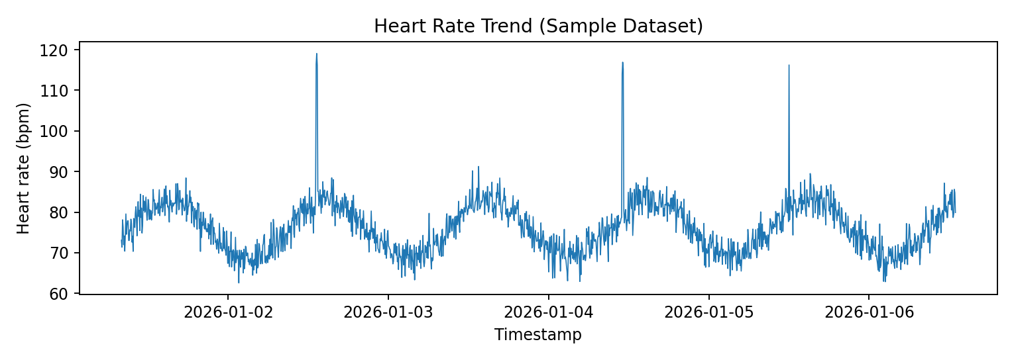
Figure 9.1: Heart rate plotted against time. The plot helps reveal the overall pattern and visibly unusual spikes in the synthetic observations.
Anomaly detection output
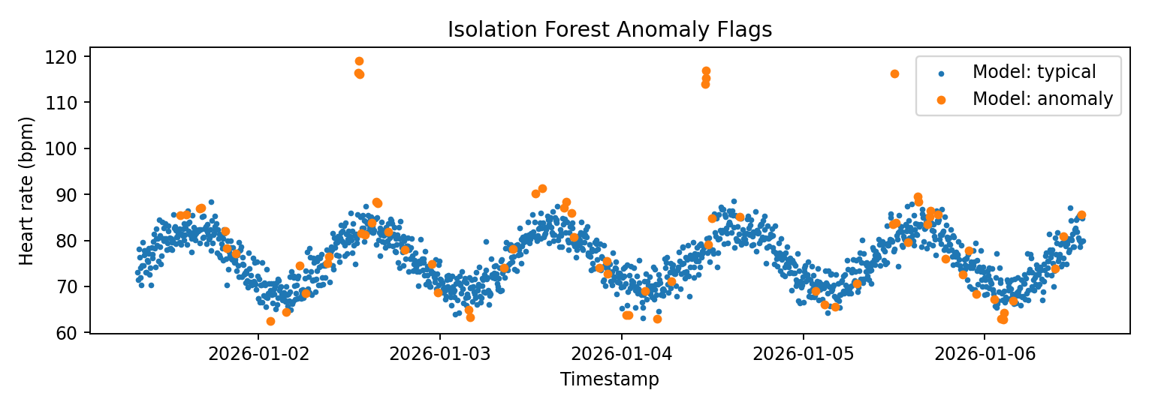
Figure 9.2: Model-flagged observations are shown separately from observations the model treats as typical.
HRV and activity output
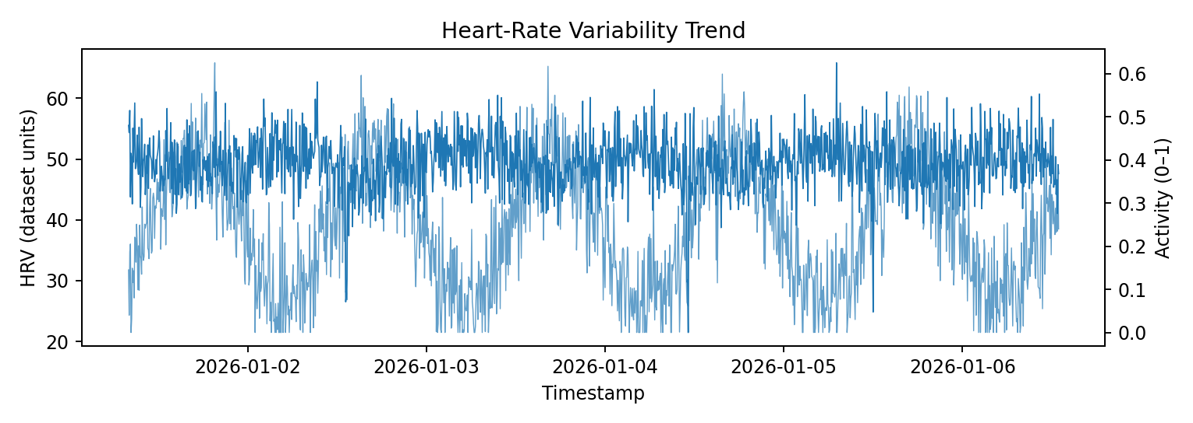
Figure 9.3: HRV and activity trends are displayed over the same timeline using separate vertical axes.
State classification output
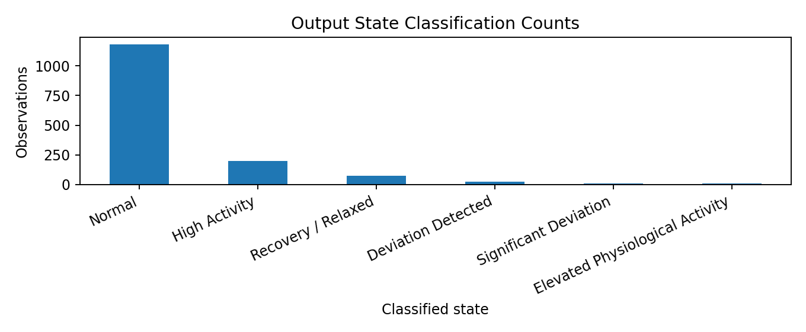
Figure 9.4: Count of observations assigned to each descriptive state label.
10.5 Result Interpretation
The charts show how the application turns a time-ordered dataset into trend plots and model-generated flags. Injected unusual values in the synthetic dataset help demonstrate the output. The model can also flag ordinary variation or miss meaningful events; labels should therefore be reviewed as analytical signals rather than ground truth.
11. TESTING AND RESULTS
11.1 Testing
Test | Expected Result | Actual Result | Status
Valid sample CSV | Pipeline processes rows and generates outputs | Demonstrated using bundled CSV (1,500 rows) | PASS
Missing required column | Validation raises a clear error | Implemented in preprocessing module | PASS
Invalid timestamp / value | Invalid required rows removed | Implemented | PASS
Duplicate timestamps | Duplicates removed after sorting | Implemented | PASS
CSV upload | Dashboard accepts CSV with required columns | Feature present; verify interactively in local environment | VERIFY
PhysioNet source unavailable | Loading or data-location error shown | Handled with error message | PASS
Repeatability | Fixed seed gives reproducible model configuration | Configured with random_state=42 | PASS

11.2 Results
- The pipeline from data loading to dashboard visualization was completed on the bundled synthetic dataset.
- All 1,500 observations were processed and scored by the Isolation Forest model.
- The model flagged 75 of 1,500 observations (5.0%), consistent with the configured contamination value of 0.05.
- A personal baseline was computed from the first 50 observations: heart-rate mean 77.58, HRV mean 50.18, and activity mean 0.213.
- Each observation was assigned a rule-based state label, and the results were displayed as trend charts and state counts.
- No accuracy, precision, recall, or F1 values are reported because the dataset has no labelled ground truth.
12. UNIQUE FEATURES, LIMITATIONS AND FUTURE SCOPE
12.1 Unique Features
- Personal Baseline Approach: Observations are compared with a baseline derived from the same data stream instead of a single universal threshold.
- Hybrid Analysis: Machine-learning anomaly detection is combined with transparent rule-based state labels.
- Rolling and Baseline Features: Rolling deviations, time features, and z-scores give each observation context.
- Interactive Dashboard: A Streamlit interface supports the sample dataset, CSV upload, and supported local PhysioNet data.
- Reproducible Configuration: A fixed random seed and documented parameters support repeatable runs.

12.2 Limitations
- The included dataset is synthetic, not a clinical dataset.
- The initial 50-row baseline may not represent a person’s long-term normal pattern.
- The model is fitted on the same dataset it scores; this is useful for demonstration but is not a rigorous held-out evaluation.
- The contamination value is a configuration choice, not a measured real-world anomaly rate.
- No labelled ground truth is included, so accuracy, precision, recall, and F1 cannot be meaningfully reported.
- Sensor noise, missing intervals, different devices, and population differences may change behaviour.
- The dashboard is not a medical device and must not be used for diagnosis or treatment decisions.

12.3 Future Scope
- Evaluate on an appropriately licensed public physiological dataset and document its source.
- Split data by time or participant to reduce evaluation leakage.
- Compare Isolation Forest with statistical and alternative anomaly-detection methods.
- Add precision/recall metrics when reliable anomaly labels are available.
- Improve baseline adaptation, missing-data handling, and model monitoring.
- Add automated tests, clearer model explanations, accessibility, and privacy controls.
13. CONCLUSION AND REFERENCES
13.1 Conclusion
This project demonstrates a complete introductory analytics workflow: data ingestion, cleaning, rolling feature generation, personal-baseline calculation, unsupervised anomaly detection, rule-based state labelling, and dashboard visualization. The sample outputs confirm that the included data can be processed and displayed as trends and anomaly flags.
Further evaluation with suitable real-world datasets and carefully designed tests is required before drawing stronger conclusions about model performance. The system is an educational prototype and must not be used for diagnosis, treatment, or other clinical decisions.
13.2 References
[1] Project source files supplied with AI_Physiological_State_Monitor.zip: README.md, PROJECT_ROADMAP.md, main.py, app/dashboard.py, and modules under src/ and data/.
[2] Liu, F. T., Ting, K. M., and Zhou, Z.-H. “Isolation Forest.” IEEE International Conference on Data Mining, 2008.
[3] pandas Documentation. https://pandas.pydata.org/docs/
[4] scikit-learn Documentation. https://scikit-learn.org/stable/
[5] Streamlit Documentation. https://docs.streamlit.io/

