AWS ASEAN – 2026 EXECUTION PLANS: SINGAPORE
Purpose & Objective: The purpose of this document is to outline key initiatives that will turbocharge the SG CS business to deliver accelerated growth of 22% Y/Y with further aspiration to reach an escape velocity of 25% Y/Y through organic growth, in-flight deals and key initiative execution for FY26. The key initiatives are focused on defending our revenue base and accelerating business growth, critical to ensure SG (CS+SUP) is on track to become a $1B ARR business by 2027. Our mission is to establish AWS as the AI-first public cloud provider of choice for Singapore customers by reinventing their business on the most secure, innovative, compliant and reliable AI-first global cloud infrastructure to achieve industry-leading outcomes.
FY25 Overview: SG CS is forecast to attain $635M QSR (105.5% vs plan, 20.7% Y/Y, 17% excl GRAB, Supabase, Wish) with GenAI QSR at $8.9M (100% vs plan, 181.6% vs OP2). Sales motion view; Deep was at $187.9M (105.1% vs plan, 19.4% Y/Y, 14.6% ex-GRAB ) led by top accts such as Grab ($107.1M, 23.4% Y/Y) and ASM ($5.1M, 244% Y/Y), Focus at $292.9M (106.6% vs plan, 32.7% Y/Y, 17.3% ex-Supabase) with ENT-F at $107.1M (98% of plan, 20.2% Y/Y), ISV-F at $145.6M (119% of plan, 37.5% Y/Y) and SMB-F at $87.3M (95% of plan, 22.8% Y/Y) and Scale at $51M (124.1% vs plan, 21.3% Y/Y). ProServe: Revenue Forecast at $4.7M (114% vs plan, 12% Y/Y), bookings $7.6M (106% vs plan, 70% Y/Y). T&C: Forecast at $880K (88% vs plan, -11% Y/Y). YTD Net Usage Growth (22.7% Y/Y), CMGR (ex-Supabase): 6M 1.9%, 12M 1.7%; Incremental Revenue: $130M, 18% Y/Y driven by Large Scale Migrations (e.g., Grab, Kiteworks, ASM) and solid ISV momentum (e.g. Supabase, Affle). [Industry Performance] 5 priority industries for SG are FSI, S&I, Manufacturing, TMEGS and Retail & CPG. Forecast: FSI at $113M (21.9% Y/Y) driven by growth in capital markets (27.1% Y/Y), insurance (16.1% Y/Y) and banking (21.9% Y/Y) due to strong performance in key accounts such as UOB (256% Y/Y), Bolttech (62% Y/Y) and Presto (31% Y/Y), S&I at $141M (37.1% Y/Y, 20.1% Y/Y ex-Supabase); TMEGS at $60.1M (16.6% Y/Y) driven by Starhub ($6.1M, 27% Y/Y) and Anuttacon ($2.5M, 1752% Y/Y); Manufacturing at $23.2M (45.8% Y/Y) driven by growth in key accounts such as ASM ($4.6M, 221% Y/Y) Wilmar ($2.7M, 41% Y/Y). Retail & CPG at $42M (-2% Y/Y) impacted by Dyson ($10M, -9% Y/Y), Shopback ($1.6M, -55% Y/Y) and GFG ($4.5M, -12% Y/Y) - growth ex-Dyson, Shopback and GFG at 12% Y/Y. [IPMM] YTD $create at $528.7M (124.8% vs plan, 44.6% Y/Y), $launch at $205.2M (94.9% vs plan, 19.9% Y/Y). [LSM] Forecast at $72.4M ARR (116% vs plan, -3.8% Y/Y) from 46 wins incl Keppel ($4.7M), GRAB ($4M). [RMR] Forecast at $103M (135% vs plan) VMware: 7/57 VMware in-flight mig. ($6.8M ARR), 86.3% attn ($1.6M/$1.9M). SAP: 2/57 SAP in-flight migration ($1.1M ARR), 108.6% attn ($0.4M/$0.4M). Analytics: 14/57 in-flight mig. ($24.1M ARR), 191.4% attn ($11.3M/$5.9M). [Partner] PCR at 67.0% (vs goal of 70.1%, +281 bps Y/Y), PAR at 68.6% (+310 bps Y/Y).
Country Business Landscape: Outside-in view: Singapore’s GDP is estimated to be $569B (+4% YoY) for 2025, reflecting resilient global economic conditions and strong demand for technology products. Growth was primarily driven by two sectors, namely (i) Manufacturing - driven by global demand for AI-related semiconductors and other products in the electronics and biomedical manufacturing clusters, (ii) Financial Services - driven by growth in banking and financial activities, driven by improved business and investor sentiment and increased payment transaction volumes and (iii) InfoComm sector – driven by enterprise demand for digital solutions and services. According to the Ministry of Trade and Industry (MTI), growth is projected to be between 1-3% reflecting a pronounced impact from US tariffs on global trade, potential easing of the AI-driven electronics up-cycle and an overall caution on valuations in the financial services trading industry. From a customer demand standpoint, we observe a continued disproportionate interest in all forms of AI (GenAI, AgenticAI etc), early views into emerging technologies such as advanced manufacturing, next-gen cybersecurity and quantum computing while driving strong corporate interest in executing a business-impactful sustainability agenda. Nurturing talent, creating a strong technology ecosystem, partnering with regulatory bodies/industry associations, and working with Government agencies are essential to progress and success in these areas. FY26 SG CS GTM coverage model: FY26 SG CS TAS (DFS) is represented by 1817 accts with $4.1B TAS. Across Deep and Focus, FSI TAS is at $760M [5 Deep $450M, 53 Focus $310M], ISV at TAS $358M [1 Deep $65M, 66 Focus $317M], Cross-Industry TAS at $1.2B [12 Deep $774M, 107 Focus $480M], TMEGS TAS at $428M [1 Deep $66M, 15 Focus $362M], Scale at TAS $1.3B (1557 accts).
FY26 Financial Summary: In FY26, Singapore will continue to be the bedrock of AWS ASEAN and to that effect we project to deliver $731.6M (17% Y/Y) by executing on our fundamentals of strategic account engagements and must-win deal closures while maintaining a high operational bar in running the business. Despite intense competition and a significant investment of time and resources to defend our large base, our bold stretch is estimated to deliver $763.7M (22.1% Y/Y, incremental revenue +$32M) powered by 5 strategic initiatives as detailed in the below sections, namely: (i)Accelerating VMWare Migrations ($15.8M IYR); (ii)AI Platforms ($5.1M IYR); (iii)AI Tools Accelerator ($2.3M IYR); (iv)Service Penetration and Expansion ($5.5M IYR) and (v)China to ASEAN (C2A) ($3.4M). Finally, reaching our escape velocity aspiration of $781.8M (25% Y/Y, incremental revenue $18M) would be contingent upon (i) Service availability and fulfilment of capacity needs, (ii) Strong uptick and adoption of our new offerings such ProServe curated assets for GenAI, Unified Operations, new modernisation programs such as MODNET (iii) Non-linear acceleration in our C2A initiative and (iv) Strong execution across by key partners (SI and ISV) in our Focus business. While the growth engines have been explained above, there are material risks we need to navigate such as (i) Attrition risks (70% of AMs are >4 yr tenure, compensation adjustments for SAs), (ii) Intense competition in our lighthouse accounts (E.g. DBS) and (iii) Sustaining and improving our growth rates in Top 50 accounts contributed $397M (26% Y/Y) - which represent 66% of our FY25 Revenue .
- Strategic Initiative: Accelerating VMware Migration | IYR – $15.8M | Stretch - $2.6M | Total - $18.4M
Initiatives to defend existing revenue base: Singapore performance: [YTD: Created $83.09M (252% Attn), Launched $14.16M (137% Attn) - Key Wins: Keppel $4.7M, ASM $3M, MaxSoft $1.8M] FY25 exit forecast at $16.29M (134% attainment). The VMware TAS is $237.7M (Deep $87.4M, Focus $150.3M), of which we have captured $20.4M (FY24 - $5.8M, FY25 - $14.6M, 151% YoY) or 8.6% of total opportunity. Large opportunities in flight: FY26 H1: RGE $7M – 2K VMs, UOB $4M – 2K VMs, Panasonic $4M- 700VMs, StarHub $5M – 2K VMs, NETS $2.8M - 800 VMs. Compete situation: [Broadcom/VMware] We had learnt that select Deep customers (UOB, OCBC, Singtel, StarHub, SIA) had renewed their contracts with Broadcom as a temporary measure to buy time for strategic evaluation, presenting an opportunity for AWS to demonstrate support and thought leadership in infrastructure modernization. [Chinese Hypervisors] Huawei (50% lower TCO) and SangFor (70% lower TCO) is leveraging this transition period by offering free migration and hypervisor licenses with hardware, designed for seamless VMware transition. [Action and Our Approach] 1/Proactive reach out to top 30 VMWare TAS >$3M ARR (QUIP - Appendix below) 2/Leverage dragon win room and compete funding (AMA, MAP, RTL) to build business case 3/Drive velocity with VMware PDS and in-country PDM/ PSM on VMware Distributor Play (e.g. Asiapac, Ingram Micro, VSTECS) for account mapping and joint GTM.
FY26 execution plans, top priorities, and key activities and initiatives: To attain a $24.1M ARR launch goal, we will: 1/Accelerate Large VMware Takeout - RGE ($7M), StarHub ($8.3M), Panasonic ($4M), Keppel ($4.7M) learnings applied to Top 30 VMware customers, Account Teams to secure RVTool reports and conduct rapid TCO assessments through in-country tiger team and present VMCCO/AMA Programs to CXO. 2/Capture VMware workloads in Focus by (a)Achieving 100% Coverage in Focus Accounts: To-date, we have coverage of 76.1% (gap of 50+ accounts) through continued sponsorship from SGLT, (b)Customer-led Assessment (New initiative with $1K AWS credits for migration assessments) targeting 75 assessments (250K ARR each) to drive 18.75M ARR (Target list), 3/Execute VMware sprint in Q1 to drive $5M ARR $create, 4/Accelerate through Partner SCA/Distributor strategy by (a) Joint account mapping with top VMware disty (Asiapac, Ingram Micro, VSTECS) to drive sales motion, (b)4x P-led CxO roundtables (16M ARR) - with top SI partners targeting decision makers delivering a goal of $4M ARR and (c)Drive AMA through top 3 Partners - capture long tail customers bundled under 1 large AMA (>$5M ARR) with each partner.
Key Customers | FY 2025 | Q1 2026 | Q2 2026 | Q3 2026 | Q4 2026 | FY 2026
ASM PT | $909,511 | $155,176 | $258,626 | $258,626 | $362,077 | $1,034,505
Keppel Management Limited | $120,000 | $24,000 | $40,000 | $40,000 | $56,000 | $160,000
United Overseas Bank Limited | $324,022 | $64,804 | $108,007 | $108,007 | $151,210 | $432,029
Great Eastern Holdings Ltd | $109,325 | $32,798 | $54,663 | $54,663 | $76,528 | $218,651
Others - Maxsoft, Netmarks, IPOS + 2025 Launched Opps (Est – 50%) | $350,505 | $770,830 | $1,284,717 | $1,284,717 | $1,798,604 | $5,140,869
Total Deals in Commit: | $1,814,661 | $1,047,868 | $1,746,446 | $1,746,446 | $2,445,024 | $6,985,784
RGE |  |  | $375,000 | $375,000 | $525,000 | $1,500,000
StarHub |  |  | $375,000 | $375,000 | $525,000 | $1,500,000
Panasonic |  |  | $200,000 | $200,000 | $280,000 | $800,000
NETS BCS |  |  | $125,000 | $125,000 | $175,000 | $500,000
OCBC |  |  | $125,000 | $125,000 | $175,000 | $500,000
Others – SIA, Diners Club, Tuas Power, KGI, Aramco, PSPL, Metronix |  | $30,298 | $439,497 | $639,497 | $934,695 | $801,986
FY 2026 Launched Target $24M (Est - 20%, Stretch – 30%) |  | $723,571 | $1,205,952 | $1,705,952 | $2,188,333 | $5,823,810
Total Deals in Commit + Must win + 2026 Launched Opps: | $1,814,661 | $1,801,737 | $4,591,895 | $5,291,895 | $7,248,053 | $18,411,581
Dependencies and Help Needed: 1/Delivery governance: Capacity constraints with ProServe for large scale migrations (RGE, Panasonic, StarHub [Approach] (a)Weekly ProServe-Country team interlocks with standardized migration tracking and escalation framework (b)Leverage top 3 VMware migration partners (e.g. SoftwareOne, CloudKinetics, ECV) with strong Vmware competency, supported by technical account managers 2/SGLT sponsorship and focus for top 30 Strategic VMware deals – Weekly cadence to track progress, 3/Partner team to drive partner strategy through Disty and SCA partners – (a)Account mapping and joint GTM strategy, (b)Sales cadence on large deals and (c)Drive assessments through partners.

- Strategic Initiative: AI Platform | IYR - $5.1M | Stretch - $5.9M | Total - $11M
Initiatives to defend existing revenue base with a Refuse to Lose mindset: YTD-Nov revenue at $5.1M ARR for AI (113% YoY, 141% of Plan) and $17.3M for ANA (13.1% YoY, 104% of Plan) driven by 11 major Data & AI platform wins including UOB (AI Refinery), Mediacorp (Metadata Platform), CIMB SG (Unified Data to AI platform), NETS, Grab OVO (GCP to AWS Data Warehouse Migration), Great Eastern (AI-Powered Insurance Bot), Seatrium (RigOps AI Agent Platform), Popular Holdings (Data & AI Platform), Infowiz (Streaming Analytics with Managed Kafka), Singapore Airlines (Generative BI). Key competitors: 1/Hyperscalers, 2/ Data & AI ISVs (e.g. SNOW, DBX, SAP, SFDC) and 3/ Foundation Model Providers. In FY26, our goal is to defend existing footprint for top 20 accounts (App E7) and expand our wallet share in next 20 accounts (App E8) with across 1/ Software & Internet & 2/ FSI (App E9). We will drive through 1/Defending & Growing our top accounts with Agentic AI leveraging Amazon Quick Suite, Agentic Q assistant (Amazon SageMaker Unified Studio) and ProServe Delivery Agents, 2/ Acquiring net new workloads in top 20 pursuit accounts (App E7), by establishing AI-ready Data Foundation leveraging SageMaker Lakehouse enabling interoperability and workload portability to fulfil regulatory, data residency and sovereign needs.
FY26 execution plans, top priorities, and key activities and initiatives:
SG customers’ AI adoption is hindered by fragmented data environments, poor data quality, limited data literacy, accumulated “data debt,” and the lack of a unified approach to data management, security, and governance (CIMB SG, NETS, Mediacorp, Wilmar). For FY26, we have identified 4 key initiatives to drive the Data and AI business 1/ AI Agents to Automate Data & ML Lifecycle (KI1): Agentic Q assistant within Amazon SageMaker Unified Studio to streamline and automate the end-to-end data and ML lifecycle tasks (eg. Data prep workflows like ETL processes, creation and mgmt of semantic models etc), 2/Agentic Insights (KI2): AI agents with Amazon Quick Suite to analyse, find info and act by automating tasks, 3/AI-ready Data Foundation (KI3): Unify unstructured, structured and event streams on open Amazon SageMaker Lakehouse with support for open table formats (Apache Iceberg, Hudi & Delta Lake, and 4/AI Factories (KI4): Combining AWS Trainium and Nvidia GPUs integrated with AWS AI services (Bedrock, SageMaker) highly regulated customers can accelerate deployment timelines whilst meeting their strict data residency and sovereign AI needs. Specifically for our Deep cohort of customers (majority build approach), we will lead with Unified AI Platform adoption driving all 4 initiatives (KI1 to KI4) by working with them to move from AI testing phase to use case specific (eg. chatbot, developer tools) and build enterprise-wide AI foundation. Across our Focus cohort we will (i) Identify key opportunities by deal size of > 100K ARR and drive high touch engagements via Executive Visioning (EVs) and D2E workshops, (ii) Enable: BRIDGE Technical Field Enablement and AI Pathfinder series to series to continue and (iii) Drive ASEAN Spring of AI (March-May): AI acceleration initiative to accelerate pipeline progression to launch, increase partner attach and increase AI penetration.
 | Est. FY 2025 | Q1 2026 (NN) | Q2 2026 (NN) | Q3 2026 (NN) | Q4 2026 (NN) | FY 2026 (Total)
Data + AI Revenue
Grab | $3.24M | $200K | $200K | $200K | $200k | $4.04M
Supabase | $101K | $250K | $250K | $250K | $250K | $1.1M
OCBC | $2.4K | $50K | $80K | $100K | $170k | $800K
CIMB SG | $73K | $54K | $68K | $84K | $166K | $445K
International SOS | $77K | $56K | $112K | $168K | $225K | $638K
ASM | $16.7K | $30K | $60K | $80K | $100K | $397K
StarHub | $580K | $75K | $75K | $75K | $75K | $880K
Singapore Airlines | $1.04M | $50k | $75K | $75K | $100K | $1.3M
Great Eastern | $647.5K | $75K | $75K | $75K | $75K | $947.5K
Income Insurance | $752K | $75K | $75K | $75K | $75K | $1.05M
Others | $16.4M | $675K | $675K | $675K | $675K | $23M
In-year revenue from the initiative | $22.4M | $1.59M | $1.75M | $1.85M | $2.11M | Total: $33.4M  Net New: $11M
Dependencies and Help Needed: 1/Service availability of new AI Services in SIN, 2/ GPU Capacity and SOTA Model Availability in SIN.

- Strategic Initiative: AI Tools Accelerator (Kiro, Quick Suite) | IYR - $2.3M | Pull-through- $5.3M | Total - $7.6M
Initiatives to defend existing revenue base with a Refuse to Lose mindset:
We aim to have 100% coverage for top 20 revenue generating accounts through Kiro/Q-Dev thereby protecting our base from using compete tools. [Approach] 1/ 90-day path to production assistance + PoC funding, 2/ Measure impact to their business, 3/ Amplify through case studies, customer champions in 1:many events. We will also target Devs and non-tech personas, for new workloads ($5.33M ARR - based on data from 20 AI-DLC engagements in FY25 with avg $123K ARR and $600K for migration engagements – see App E5).
FY26 execution plans, top priorities, and key activities and initiatives:
[Market Opportunity] Based on Evans Data, SG is forecasted to have 263K devs [2025 performance] Q-dev at 839 subscribers, $201K ARR (11x growth vs Jan 25). [2026 Goal] 10X growth to 8.4K subscribers of AI tools (Kiro, Quick Suite) at $2.3 M ARR. [Approach] Target 2 distinct audiences: (i) Corporates (Employer-Driven Adoption): 35-40% of the addressable market with tool selection decision driven by procurement, security compliance, and enterprise integration needs. We will focus on exec engagement, pilot programs (Eg. Kiro/Kiro CLI Adoption & Acceleration Program) and deployment at scale. Time to revenue: 3-9 months from initial contact. Mechanisms: 1/: Kiro/Kiro CLI Adoption & Acceleration Program for customers with existing AWS footprint. 2/ AI-DLC Workshops for top 30 customers undergoing transformation with 200+ developers (delivered via DevTx+champions, select partners (Thoughtworks, Searce, Slalom) to create “software transformation” practice. 3/ Quick Suite targeting non-IT personas within non-regulated traditional enterprises. 4/ AM level goal (e.g. 100 active Kiro or Quick Suite subscriptions), gamified with SPIFF, each consolidation partner has a subscription goal, PDM+PSA to ensure partner use our AI tools in every SOW, 5/Create MS Copilot/GCP Gemini Agent compete playbook, 6/Position cost optimisation savings towards reinvestment into AI tooling. (TAMs) (ii) Grassroots / Community Developers (Individual-Driven Adoption): 60-65% of the market incl. students, freelancers etc. Focus on education, community building, free-tier adoption, and skills development with orgs (App E6). Investing in grassroots education builds pipeline of AWS-proficient developers who will drive tomorrow’s enterprise adoption. Competitor activity: Google sponsoring/hosting the 2nd (Datascience SG) and 4th (ML Singapore) biggest dev groups in SG. Mechanisms: 1/Partner with 3rd party dev bootcamp company (eg. General Assembly), universities (e.g. SMU, NTU) to train spec-driven coding, scholarship to 30K trainees. 2/ Kiro user presentation to AWS UG, PUGS, CNCF, GoSG, SG Ruby, KSUG, PyData, 3/ 1 year platform credit for Community Builders and Heroes and 4/ Bi-monthly “Kiro fiestas” events, starting from the re:Invent recap events beginning January 2026.
 | Est. FY 2025 | Q1 2026 | Q2 2026 | Q3 2026 | Q4 2026 | FY 2026
INPUT Metrics: 1:many AI Builder (Fiesta, Summit/Cloud Day, etc) | 1 | 2 | 2 | 2 | 2 | 8
INPUT Metrics: AI DLC Workshop | - | 2 | 8 | 15 | 17 | 17
INPUT Metrics: GameDay/Hackathon (in-country) | - | - | 1 | - | - | 1
INPUT Metrics: 3rd party Developers bootcamp scholarship (# of trainees) | - | - | 10K | 20K | 30K | 30K
INPUT Metrics: Capability FCD+Demo of Kiro&Quick (AM+SA+CSM) | - | 100% | - | - | - | 100%
OUTPUT Metrics: # of AI Tools paid subscribers (Kiro, Quick) | 839 | 1,492 | 2,653 | 4,718 | 8,390 | 8,390
OUTPUT Metrics: # of Kiro users (including free) | N/A | 3.2K | 5.7K | 11.5K | 21K | 21K
OUTPUT Metrics: Customer Case Study |  | - | 1 | - | 1 | 2
OUTPUT Metrics: # of AI tools ARR usage (ongoing)  Pull through revenue from AI-DLC and Migrations (Details App E4) | $201K | $315K | $552K | $1.1M | $2.3M  $5.3M | $2.3M  $5.3M
Dependencies and Help Needed:
To achieve the goal, we ask for: 1/ investment approach, including the $201K marketing investment for Singapore (for evangelism & dev marketing, case study, 3rd party bootcamp developer scholarship), pilot funding, partner co-investment, field incentives, within program parameters. Please refer to consolidated ASK from ASEAN SA OneTech AI-Tooling Paper regarding these initiatives; 2/ CM&FLM support to set individual AM target for AI tools active subscribers for DEEP+FOCUS. Provide with SPIFF for account team, and PoC funding; 3/ PSM support to have AI tools target per consolidated partners for SCALE customers and Pilot funding; 4/ PDM+PSA support to create AI-DLC practice within certain selected partners (current proposal Searce, Thoughtworks, Cloudmile, eCV), 5/ AI Tools enablement Sales motion and Delivery, AI Tools bootcamp for Sales and Tech alike, ‘you can't sell a Ferrari if you haven’t driven one’ mindset.

- Strategic Initiative: Strategic Services Penetration (StratS) | IYR $5.5M | Stretch $2M | Total - $7.5M
Initiatives to defend existing revenue base with a Refuse to Lose mindset: Focused on increasing the adoption of Strategic Services (StratS)^{[StratS A]} in the DEEP & FOCUS business. We’ve chosen StratS using these criteria: i/ reduce undifferentiated heavy lifting vs. self-managed on EC2, ii/ increase customer stickiness through AWS unique features and iii/ existing revenue: Analytics [3.63%], Containers [7.6%], Databases [14.45%] and Efficient Compute [10.39%]. Systematic focus on increasing StratS will lead to increased customer stickiness (as a defense mechanism) and uplift revenue. In alignment with AGS/GTM, we have identified key solution plays to be executed through internal enablement, partner enablement, customer propensity models, GTM playbooks, 1:many/1:1 engagements and consistent revenue-based metrics for progress (Includes AWS Support offerings to deeply entrench within customer).
FY26 execution plans, top priorities, and key activities and initiatives: [1] FlexAI is a solution developed by specialists (Containers, XC, Graviton) that enables enterprises to implement open-source hybrid AI platforms on EKS to support diverse AI/ML use cases. This addresses the growing cohort of customers (UOB $2.79M YTD, Anuttacon $2.07M YTD, Nova Prospect $3.9M YTD, Razer $128K ramping, DBS $127K POC) that seek deeper customization, data residency, on-prem GPU fleet extension, cost optimization, model choice and optionality to use open source as well as proprietary AI services. By enabling customers to build AI platforms using EKS alongside AWS compute, storage and networking primitives, FlexAI defends against competitive threats as well as addresses challenges due to lack of model choice in Bedrock in SIN. We plan to leverage the SG ECI funding program and the Self-Managed ML POC Credits program to support this initiative. [2] MODNET is a strategic AWS Growth Initiative (AGI) to free customers from legacy Microsoft technologies (.NET Framework, SQL Server, Windows Server). The program is designed to defend existing revenue and win new workloads by helping customers modernize Microsoft workloads to Linux to eliminate licensing costs, aided by AWS Transform for .NET, AWS credits covering up to 100% of modernization costs through Q1 2026, ProServe’s AWS Transformation Factory as well as partners incentives (1CloudHub, Accenture, SoftwareOne etc). [3] Efficient App Mod with Graviton targets EKS/ECS/Fargate customers running on x86 architecture, as well as customers running on-premise containers. These customers find it easier to adopt Graviton due to modern architecture and native tools integration like Karpenter, and benefit from up to 20% cost reduction and up to 40% price-performance improvement. Graviton specialists together with account teams will focus on these customers with 1:1 prescriptive guidance as well as through qualified partners such as 1CloudHub, SoftwareOne and ECV. [4] SAP-Data+: Modernize SAP analytics by implementing the AWS Unified Data Platform (UDP) for SAP solution, offering customers 40-60% lower TCO with 2 in-flight opps (SK-TES $200K ARR, Hindo $40K ARR) and targeting 22 customers that launched SAP on AWS in the 2024-25 timeframe; leveraging ECI funding and partners for delivery. [5] DB MigMod^{[StratS B]}: VMware migrations present significant database modernization opportunities (20-30% of the workloads). Key strategies: Move-to-Managed on RDS/Aurora; Database Freedom for heterogeneous commercial-to-OSS migrations reducing licensing costs; winning with ODB@AWS (Singapore GA Q2'26) for RAC/Exadata needs; and capturing SQL Server workloads on RDS using the new Developer edition & Optimize CPU feature (up to 55% cost savings). [6] Unified Ops (UO) and Countdown Premium (CDP): with the launch of new support offerings at RIV25, we aim to drive UO uptake across 5 out of the 19 DEEP accounts by positioning new capabilities such as Domain Engineers and 5-minute context-aware response time. Simultaneously, we aim to drive CDP uptake for 25% of the production cutovers of large-scale migrations and GenAI opportunities.
 | YTD Oct 2025 | Current YoY % | 2026 Est. | YoY % Target | 2026 Target | Incremental
[Grow][Analytics] SAP-Data+ | $2.14M | 34.1% | $2.87M | 40% | $3M | $0.12M
[Grow][Containers] FlexAI, MODNET | $2.11M | 53.5% | $3.24M | 60% | $3.37M | $0.13M
[Grow][Databases] Lead with Native DB, MODNET | $4.6M | 15.6% | $5.35M | 20% | $5.55M | $0.20M
[Grow][Efficient Compute] Efficient App Mod with Graviton | $22.3M | 141.1% | $53.98M | 150% | $55.47M | $1.48M
[Protect & Expand][Analytics] SAP-Data+ | $13.8M | 16.1% | $16.04M | 19% | $16.44M | $0.40M
[Protect & Expand][Containers] FlexAI, MODNET | $6.5M | 14.3% | $7.47M | 17% | $7.64M | $0.17M
[Protect & Expand][Databases] Lead with Native DB, MODNET | $58.8M | 10.2% | $64.83M | 14% | $66.33M | $1.75M
[Protect & Expand][Efficient Compute] Efficient App Mod with Gv | $23.3M | 58.3% | $36.97M | 65% | $38.53M | $1.55M
In-year revenue from the initiative (QSR) | $133.8M |  | $190.78M |  | $197.53M | $5.5M
Stretch Goal | $133.8M |  | $190.78M |  | $199.53M | $7.5M
Dependencies and Help Needed: i/ For SAP-Data+, the challenge is the lack of partners with proven cross-domain capability (SAP + AWS Data). Existing partners Celebal Tech (SAP + Databricks), Mark9 (SAP BTP), SoftwareOne & 1CloudHub (both have AWS Data & AI skills) will require nurturing by AWS SAP & Analytics teams to develop their cross-domain capability. ii/ To drive the next wave of Graviton adoption at Enterprises, we need 1 SPOC each from ProServe & Partner SA teams to position Graviton proactively and provide Graviton expertise during execution, escalating to the Graviton team when needed. iii/ Investment of $100K to run 4x 1:many events (2 FlexAI, 2 AWS Transform for .NET) in Q1 & Q2.

- Strategic Initiative: China-to-ASEAN | IYR $3.4M | Stretch $1M | Total $4.4M
C2A is a newly formed territory within the broader C2G (China-to-Global), specifically designed to intentionally reach out and capture large Chinese ENT that are expanding into ASEAN markets, leveraging SG as their launch pad. We have ringfenced 150 high-po accts, including prominent names like Chery, Anta, and Horizon Robotics, which collectively represent significant spend currently on Chinese CSP’s such as Huawei and Alicloud. In 2026, success will be measured by our ability to capture accounts with the potential to bill $10M ARR within the next three years. The framework for 2026 will therefore focus not just on immediate revenue generation, but on the quantity, quality of account acquisition, relationship building with Chinese enterprise decision-makers, and the establishment of a robust pipeline that positions these accounts for significant growth trajectory toward the $10M ARR milestone.
The FY26 execution plan for China-to-ASEAN (C2A) targets 15 strategic greenfield accounts with $10M+ ARR potential and 135 named accounts with $1.5M ARR. The execution strategy is built on three themetic priorities: 1/ market intelligence and ecosystem to systematically expand our current base and build new pipeline through partner-led outreach, government and multiplier channel alignment including IMDA/EDB programs, and PE firm introductions via Hillhouse portfolio companies. 2/ Value proposition assets to demonstrate AWS differentiation for ASEAN expansion through comprehensive migration playbooks, competitive positioning assets, customer success showcases, and the ASEAN Expansion Sandbox program providing hands-on evaluation opportunities. 3/ Deal acceleration, conversion, and customer success to convert pipeline to revenue while driving adoption through architecture design sessions, cross-functional deal teams with native Chinese-speaking support, Dragon win room activation for competitive migrations, and CSM immersion sessions ensuring long-term customer success and expansion.
Strategic accounts represent 15 strategic greenfield accounts with the potential to bill $10M ARR within 2-3 years. These accounts will be account manager led with tight alignment across cross-functional teams to ensure coordinated execution spanning technical, business development, and customer success functions. The execution plan follows these approachs: 1/ a 2-prong strategy emphasizing cross-collaboration with AWS GCR to systematically cover both China and international business executives, ensuring comprehensive information sharing and coordinated engagement with different executive stakeholders across geographies and organizational hierarchies. 2/ Active prospecting across different lines of business within each target account, recognizing that C2A expansion opportunities often span multiple business units, use cases, and buying centers requiring parallel engagement tracks. 3/ Conducting architecture design sessions for China-to-ASEAN multi-region deployments to address technical requirements and build technical champions. 4/ Maintaining monthly executive connects to sustain momentum and executive-level alignment on business outcomes. 5/ Activating Dragon win room support for competitive migrations to deploy competitive intelligence when competing against Alibaba, Huawei, and Tencent Cloud in strategic deals.
Named accounts will be primarily partner-led to enable efficient coverage across a broader account base of 135 accounts. The execution plan leverages strategic partnerships to drive growth through: 1/ Activating partner-led engagement models with key C2A partners including Scash, Metronics, Ingram, Combo, and China Telecoms to systematically prospect and manage named accounts, ensuring partners are equipped with the right enablement materials, competitive positioning, and AWS resources to drive customer conversations independently. 2/ Implementing a partner enablement framework that includes developing C2A Migration Playbooks covering compliance, data residency, connectivity, and Global Landing Zones, and creating competitive assets against Alibaba, Huawei, and Tencent Cloud specific to industries such as automotive and retail. 3/ Publishing case studies from successful implementations like China Taiping, OneConnect, and AdvanceAI to provide partners with proven reference architectures and customer success stories that accelerate sales cycles. 4/ Establishing scalable customer programs including the ASEAN Expansion Sandbox offering a 90-day program with $10,000-$50,000 credits for hands-on evaluation and hosting executive roundtables to address expansion challenges including GDPR, compliance, and data sovereignty, supplemented by monthly C2A office hours providing overlay support across ASEAN to assist C2A activities. 5/ Conducting quarterly partner business reviews to track pipeline health, identify expansion opportunities, and ensure partners maintain momentum across their account portfolios. 6/ Hosting quarterly China-to-ASEAN networking and knowledge-sharing events with 3 in Singapore and 1 in Malaysia to build community, share best practices, and strengthen the partner ecosystem supporting named account growth.

The C2A initiative targets growth from $7.5M (FY25) to $100M ARR by FY28 (133% CAGR) across three segments: Strategic accounts (15→30 accounts, $2M→$47M), Named accounts (135 partner-led, $11M→$32M), and Influenced accounts ($5M→$21M). (refer appendix E2)

 | Est. FY 2025 | Q1 2026 | Q2 2026 | Q3 2026 | Q4 2026 | FY 2026
[Success Metric 1] 2 Strategic account conversion X GCR |  |  | 1 | 1 |  | 2
[Success Metric 2] Sandbox activation – 80 new customers |  | 20 | 30 | 20 | 10 | 80
[Success Metric 3] Pipeline generation |  | 5M | 25M | 50M | 50M | 130M
Scash |  | $100,000 | $200,000 | $200,000 | $250,000 | $750,000
Chery (GF) |  | $15,000 | $25,000 | $160,000 | $350,000 | $550,000
Gotion (GF) |  | $50,000 | $50,000 | $70,000 | $80,000 | $250,000
Horizon Auto (GF) |  |  | $200,000 | $300,000 | $800,000 | $1,300,000
Anta (GF) |  |  | $5000 | $15,000 | $50,000 | $70,000
Blacklake(GF) |  |  |  | $10,000 | $20,000 | $30,000
Advance AI (startup) – influence revenue |  | $15,000 | $20,000 | $20,000 | $25,000 | $80,000
Others: (GCR split) |  | $100,000 | $300,000 | $300,000 | $570,000 | $1,370,000
Total:
In-year revenue from the initiative (QSR) |  | 0.3M | 0.8M | 1.1M | 2.2M | $4.4M
Dependencies and Help Needed: 1. 3rd party marketing info, 2. DGR / Intern support on reaching out to GF prospects, 3. Marketing support for events with Partners/Multipliers, 4. Sandbox funding approval, 5. ES/CSM native Chinese support for strategic customers 6. HC incremental for 2027

APPENDICES:
- Appendix A: Organization Chart as applicable (Planned for FY26)

- Appendix B: Waterfall Chart

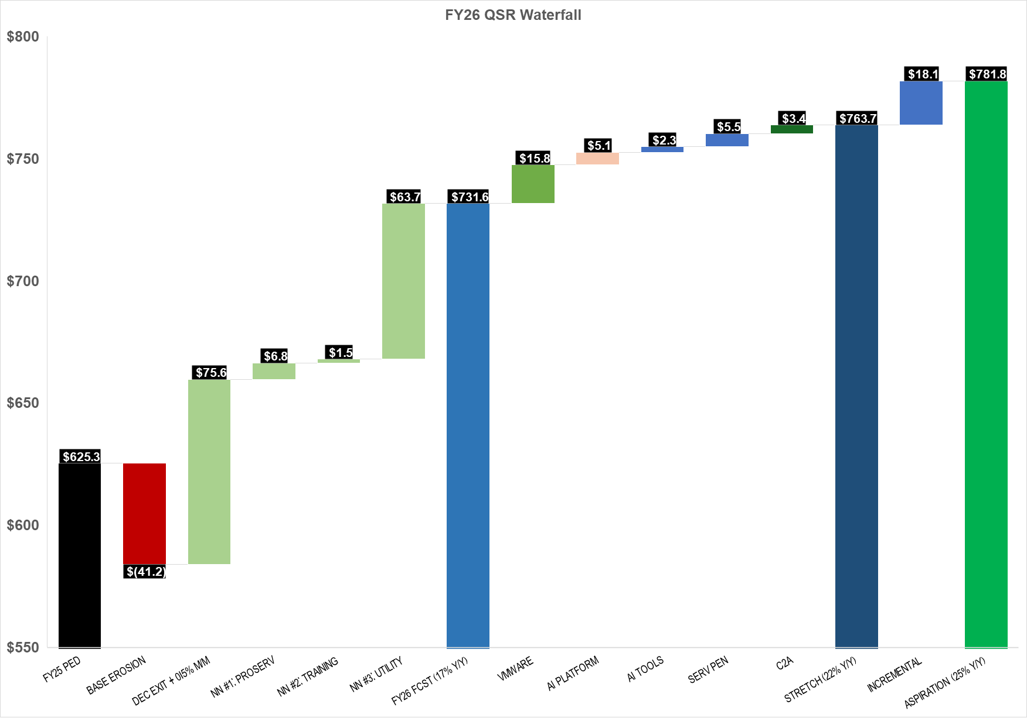

Appendix C: Growth Templates

Appendix D: Program Spend

<< LINK >>

Appendix 1: Strategic Initiative: Accelerate Partner contribution and double down on Focus)
Initiatives to defend existing revenue base with a Refuse to Lose mindset (2025 Performance and Learnings):
YTD-Nov, Partners contributed 66.7% (70.5% incl AO non-compliant) of Singapore CS launched ARR excl SUP vs 70.1% target, with Focus at 56.2% and Deep at 72.9%. Total launched ARR excl GenAI was $152.7M (101.43% of plan, 32.4% YoY), driven by large enterprise wins in Deep (+54.1% YoY) and GF MAP execution in Scale (+116.7% YoY); Focus partner business underperformed with +6.8% YoY launch growth vs. +11.9% Focus GSR growth. Goals: Partner GenAI launches (Full Stack) at $25.2M ARR(234% vs plan, 865% YoY, PAR at 57%, #1 in ASEAN); Partners contributed to 64% of the VMware country Launch ARR (CS ex. SUP) at $27.1M(331.6% YoY); Large Migration wins at $77M (140.7% vs plan, 15% YoY). Marketplace TCV below plan at $51M(61.9% vs plan). 2025 Learnings: 1) Partners with consistent commitment and resources drive sustained results (Eg. SoftwareOne in Focus due to ability to stay invested with consistent account coverage and customer engagement model. 2) Exec alignment on large Transformation deals with GSIs (Eg. ACN at UOB) and BCAP paves way for long-term success; 3) Opportunistic engagement by consolidation/SI partners in Focus sales motion leading to sub-par performance including within incumbent accounts, 4) Partners with GenAI and AI led use-case specific GTM gaining better mindshare vs pure-play infrastructure led GTM (Eg. 1CloudHub vs Cloud Kinetics); 5) ISV momentum impacted by change in SCB incentivization, lack of structured GISV engagement, low traction in our ISV accounts and absence of focused industry ISV GTM.
FY26 execution plans, top priorities, and key activities and initiatives: 1/Lead partner GTM through Data/AI thematics ($XM ARR launch): We will (i) Partner with GSIs (Accenture, Deloitte), BCAPs and boutique (Eg. Thoughtworks, OnebyZero) partners in our Deep cohort to drive AI-platform led initiatives and workloads as these customers build deep AI capabilities while (ii) doubling down on Industry led use cases in the Focus cohort across FSI, Mfg, Retail&CPG along with proven horizontal use cases leveraging our consolidation(Eg. XX,XX) and emerging AI (Eg. XX,XX) partners. (iii) Execute Partner-Led AI-DLC workshops across 20 ISV/Digital Native Focus accounts by proactively mapping account coverage with Searce, Thoughtworks, and Cloudmile to drive organisation-wide developer-led AI transformation, (iv) Leverage PACE program to drive partner-Led prototyping working with eCV, OnebyZero) beginning with seven funded prototypes in H1 and (v) Accelerate ECI/DLP program supported customer adoption to 3x vs FY25 (XX) across all 13 partners onboarded onto the program. 2/Drive enterprise-wide migration and modernisation doubling down on next workloads across the focus cohort (+$xxM ARR launch). Along with the account team, we will map our Focus accounts primarily with our consolidation partners based on incumbency, coverage and capability to drive strong upsell across min. of 3 workloads in each account contributing to 60% of partner launches for SG. Workload purview will be across migrations (VMWare based, DC exits), SAP++ (next workload at accounts with SAP on AWS leveraging SWOne and 1CH SAP GenAI solutions), application modernisation and database/infrastructure modernisation to unlock data for AI workloads. This will be supported by our established partner programs (Eg. MAP 2.0, MAP Lite) and extending new program constructs such as MODNET (AWS Growth Initiative) to the partner community. We will leverage the NFO sprint mechanism to cadence and drive progress with partners and account teams on this initiative. 3. Accelerate ISV co-sell through deep, proactive engagements across named accounts: (+$xxM Marketplace TCV): 1/ Drive proactive deep account engagement with top 5 G-ISVs with a goal of XX deal wins across XX accounts ($XXM ARR) per G-ISV supported by ISV PDM (hiring in progress) and PSM through marketplace (FY25 top 5 GISVs: Splunk, Snowflake, GitLab, Palo Alto and Okta); 2/ Intentional acceleration of Industry ISVs across top 3 traditional focus industries industry with three top Industry ISVs with Deep and Focus PSMs on FSI, Manufacturing and Retail/CPG [Nominated industry ISVs for proactive engagement: FSI – Thoughtmachine, Nice, Synpulse; Retail/CPG - XX, XX and XX; Manufacturing – Siemens, XX, XX], 3/ Drive SG country ISV interlock with traditional industry/ies customer base by identifying top 4 local ISVs with GTM focus in SG to drive account interlock and deal momentum across XX accounts.
Dependencies and Help Needed: (1) Singapore-specific Partner Investment Fund (PIF) for partners without SCA coverage to ensure sustained investment for key top and emerging partners to stay invested for 3 years in the market – Axrail, CloudMile and Searce; (2) An account upsell/ next workload oriented modernization funding construct to incentivize partners to drive incremental revenue/upsell in incumbent accounts through deep engagement with clear constructs to incorporate MAP and AI incentives across varied deal scenarios (New Managed Services Incentive has limited partner access); (3) AGS sponsorship for Partner Showcasing Events essential for recruiting and validating our targeted 10 AI Native/First partners for customer engagement; (4) SG SA team collaboration to launch ISV Ambassador Program driving co-sell revenue through Marketplace motion for tech-savvy ISV/DNB customers; and (5) Approve $xxK marketing budget for Industry Flywheel events across FSI, Manufacturing, and Retail.

Appendix 2: Strategic Initiative: ProServe IYR $5.5M
FY25 Performance- Singapore: FY25: Direct Revenue at $4.66M (114% att., +12% Y/Y), Billable Bookings: $7.61M (106% att., +70%Y/Y) including Nets VMCCO. Our FY26 Start of Year Backlog stands at $3M. With an expected base revenue growth rate of 20% at $5.5M Direct Revenue, our backlog represents 53% of forecasted revenue, with 47% anticipated from in-year opportunity launches including a concentration of launches in Q1. This backlog provides confidence in meeting our base revenue and bookings goals.
Initiatives to defend existing revenue base with a Refuse to Lose mindset: FY26 Key Initiatives - a) VMCCO (VM Migration & Cloud Optimization): Agentic-driven modernizations across six accounts aim to drive $23M+ in pipeline. RGE plans to lead at $4.8M, migrating 30 data centers across 7 countries, followed by Starhub's $7.4M infrastructure transformation and NETS' $4.2M migration of 1,600 VMs. DBS intends to pursue systematic migration of 1,000+ VMs through BCG assessment, while Dyson targets $966K for data center exit. SIA completed an assessment showing 70% of its estate already cloud-resident, b) Excellence and Outcomes in AI We will move from PoC execution to deeper AI transformation engagements in partnership with the GenAIIC team . We will do so by, i)Continuing to build Industry-First GenAI assets that include End-to-end reference architectures on Bedrock, Domain-specific prompt libraries, RAG patterns optimized for sector datasets, Embedding evaluation modules, Cost governance and model-switching logic, Security + compliance guardrails, and Deployment scripts (IaC) and monitoring. These assets will reduce delivery time 50–60%, increase win rate, and position Proserve as a thought leader, ii) Leverage packaged services : Scale our use of services such as AI Hub, GenAI Discovery, and our Data & Foundation Pack, the Agentic Workflow Accelerator (A thin AWS-native orchestration layer), and our Data Readiness-as-a-Serviceoffering that prepares customer data for AI consumption with an expected pipeline of $11.3M, c) Contact Center Modernization: $6.4M pipeline across Amazon Connect opportunities. SIA leads with a $2.9M opportunity in BAFO stage, while OCBC plans to transform operations, reducing costs while improving CX ($2.4M). These initiatives aim to deliver operational efficiency and enhanced customer experience through intelligent automation. d) Migration & Infrastructure including the AC/DC growth initiative: $10M+ in pipeline spanning deep accounts: DBS ($6.13M) including HCL PySpark Migration ($3-10M) and Avaloq EKS deployment, Chubb's post-acquisition partnership ($2.5M) with Vietnam and Asia estate migrations, and Dyson's HPC opportunity for computational efficiency ($1.1M).
FY26 execution plans, top priorities, and key activities and initiatives:
FSI - DBS represents a multi-horizon partnership spanning immediate cloud adoption through strategic AI transformation. Near-term initiatives include ProServe advisory for HCL's PySpark Migration ($3-10M program), Avaloq Container Platform deployment on EKS to modernize wealth management operations, and resiliency enhancements aimed at strengthening digital banking continuity. Medium-term focus centers on BCG's assessment of 250+ applications for systematic cloud migration of 1,000+ VMs using VMCCO constructs to optimize costs. Strategic investments aim to position ProServe as a trusted advisor for AI-driven transformation, including digital twin capabilities for workforce optimization and operational management frameworks addressing organizational restructuring required for enterprise AI adoption. Bookings Target: $6M with $2M+ in transformation programs (Q2) . Revenue Target: $750M
OCBC engagement focuses on hybrid cloud architecture and data modernization imperatives for competitive advantage. The Hybrid GenAI platform initiative positions AWS against hyperscaler alternatives as the foundation for enterprise AI capabilities driving customer experience innovation and operational efficiency. Amazon Connect deployment aims to transform contact center operations, reducing costs while improving satisfaction metrics. The cornerstone $20-30M data platform modernization over three years—migrating from legacy Teradata and Cloudera to cloud-native architectures—will enable real-time analytics, reduce operational overhead, and accelerate time-to-insight for business-critical decisions. Bookings Target: $2.4M (Q2) in immediate bookings with $20-30M in multi-year transformation- Revenue Target: $1M
UOB initiatives address critical operational imperatives in risk management and compliance while enabling AI-driven customer engagement. Migrating high-performance computing for capital stress testing aims to deliver 20-30% cost reduction and faster calculation times, directly impacting regulatory reporting and capital efficiency. Compliance automation addresses escalating AML/CTF and fraud prevention requirements, reducing operational risk. The AI/ML personalization program with HCL and Adobe aims to transform customer engagement through intelligent targeting and omnichannel experiences, improving NPS/CSAT while driving revenue through enhanced cross-selling effectiveness. Bookings Target: $700K (Q3) - Revenue Target: $200k
NETS Group engagement encompasses comprehensive infrastructure transformation. VMCCO migration of 1,600 VMs with Cloud Kinetics aims to eliminate data center dependencies while improving agility and reducing costs. Central Bank of Bahrain migration demonstrates regional expansion and regulatory compliance expertise. Modernization from legacy Oracle to PostgreSQL and OS updates aim to reduce licensing costs, improve security, and enhance performance. Transformation initiatives including AI chatbot and Project Nexus payment rail position NETS for next-generation payment processing and improved service efficiency. Bookings Target: $4.2M (Q1) - Revenue Target: $1M
Singlife engagement focuses on AI-driven operational transformation across core insurance processes. OBZ GenAI Factory implementation with four Agentic AI use cases aims to automate complex workflows, reducing processing time and costs while improving underwriting and claims accuracy. Expansion to additional use cases aims to accelerate customer onboarding, reduce loss ratios through improved risk assessment, and enhance satisfaction through faster claims resolution. Amazon Connect deployment aims to modernize customer interactions, reducing contact center costs while enabling AI-powered self-service capabilities. Bookings Target: $1.55M across AI and customer experience transformation. Revenue Target: $750M
Chubb represents a growing post-acquisition partnership built on successful Thailand estate migration (Q2) and data warehouse migration (Q3), establishing a new greenfield relationship driving substantial bookings and revenue year-to-date. Forward-looking initiatives focus on unlocking Vietnam estate migration, migrating the entire Asia estate to AWS leveraging programs like AMA, and potential mainframe modernization in FY26. Strategic expansion includes forging strong regional relationships to drive adoption of Data and AI services, with GenAI initiatives targeting insurance productivity improvements across operations. Current support delivery model faces scaling limitations for multi-country estates due to integration complexities and regulatory variances across ASEAN, particularly regarding taxes and travel restrictions. Bookings Target: $2.5M (Q2) - Revenue Target: 500k
Industrial and T&T - OLAM (OFI) engagement encompasses multiple migration and AI initiatives building on successful global C-Suite engagement demonstrating business outcomes. Recent achievements include on-premises migration advisory closed at $352K in Q4 FY25, establishing a foundation for broader cloud adoption. Advancing initiatives include ECI OT AI qualified at $116K, Salesforce with Amazon Q qualified at $228K, and supply chain use cases prospected at $116K. GenAI implementation and IoT-based preventative maintenance solutions totaling $700K across Q4-Q1 FY26 aim to address operational efficiency and predictive capabilities. Strategic proposal centers on a centralized data platform covering foundational and operating models supporting agency foundational build and integration with OFI through project Argus, extending beyond technical build to enable comprehensive data-driven transformation. Target: $1.8M (Q2) - Revenue Target: $500k
Dyson engagement focuses on high-performance computing and data center exit initiatives following a paused Data Lakehouse RFP. HPC initiative qualified at $1.06M (Q1 FY26) aims to address computational efficiency and innovation velocity for tech appliance development. Data center exit prospected at $966K (Q2 FY26) leverages VMCCO for VMware transitions, eliminating infrastructure dependencies. Strategic initiatives include integrating GenAI capabilities for tech appliance innovations through project Orbit, accelerating product development cycles. Current engagement faces challenges including teaming agreement complexities across regions, UK-shared account structure precluding APJ pursuits, partner oversight increasing costs, and production environment restrictions creating client friction. Target: $2.0M ( Q2) - Revenue Target: $500k
Royal Eagle Group (RGE) represents a substantial data center exit opportunity via VMCCO, with dual VM Migration entries in business validation at $4.8M each (Q3 FY26), scoping 30 data centers across 7 countries. Leveraging AGI VMCCO to migrate VMware estate to AWS, initially sized at approximately $4M, aims to address infrastructure consolidation and operational efficiency across geographically distributed operations. Strategic expansion opportunities include unified data platforms and GenAI integrations for pulp, paper, and palm oil operations, extending beyond foundational migrations to enable data-driven operational optimization and sustainability initiatives. Bookings Target: $4.8M (Q1) Revenue Target: $1M
Singapore Airlines (SIA) key engagement centers on contact center modernization RFP, with SIA-Connect-ProServe opportunity at $2.9M (Q3 FY26), currently working on BAFO and clarifications following RFP processes. Building on AGI VMCCO assessment noting 70% of estate already in cloud with no immediate migration opportunity, focus shifts to Amazon Connect integrations for customer experience transformation. Early discussions aim to assess remaining on-premises estate for potential migration. SIA remains highly cost-focused with systems integrators such as TCS heavily embedded in the account, requiring competitive positioning and demonstrated value delivery. Bookings Target: $2.9M (Q2) - Revenue Target: $500k
DNB - Grab engagement focuses on LLM cost optimization and agentic AI initiatives building on established trust and previous GenAIIC engagements. Agent Platform Cost Optimization engagement in business validation at $692K (closing Q4 FY25) aims to address efficiency and scalability, with scope revisions supported by the Proserve Expert Services team and co-innovation validation underway. Strategic expansion includes engaging GenAIIC team for strategy and advisory discussions to expand collaboration and innovation on agentic use cases throughout the organization, leveraging co-innovation fund to accelerate adoption. Initiatives target organization-wide transformation through intelligent automation and AI-powered decision-making capabilities. Bookings Target: $2M (Q3) , Revenue Target: $750K
NTUC - We will continue collaborating with NTUC to define opportunities for AI to deliver value across the broader organization. Through our Q4FY25 activities we have established a strong executive commitment and identified 10 initial use-cases via a recent working backwards workshop, to develop over the next FY. Key in-flight opportunities include NTUC Union × NCS agentic GenAI Virtual Assistant on Amazon Connect ($1.1M ProServe + $100k ARR), NTUC First Campus GenAI Use Cases ($290k qualified Q1 FY26), and potentially Gift Fulfilment agentic workflow on Strands Agents. Bookings Target: $1.5M, Revenue Target: $200k
Telco - Starhub engagement represents concentrated infrastructure transformation addressing technical debt and operational efficiency. VMCCO migration aims to modernize infrastructure, improve disaster recovery, and reduce operational overhead. Comprehensive OS and database modernization across 600 VMs aims to eliminate end-of-life risks, improve security, reduce licensing costs, and establish the foundation for future application modernization driving business agility and competitive advantage. Bookings Target: $7.4M ( Q1), Revenue Target: $1M – Q2 Kickoff
Partners – Partners remain critical for scaling delivery and accelerating growth. We maintain regular engagements with select partners including OBZ, Cloud Kinetics, Software One, Slalom, and Celebal to identify opportunities, augment delivery capacity, and align on business goals. Key collaboration areas include joint sales and delivery motions (e.g., capturing VMware migration market share in 2026), ISV solutions (Databricks, Snowflake), innovative AI platforms (OBZ), and Global System Integrators through MSAs (Accenture in Industrials). We target partner capabilities in application development, AI, and third-party product expertise to complement ProServe's strengths. Expected Outcomes: Partner Co-sell 50% of ProServe Bookings, Partner Co-sell Pipeline 3X of Goal, Partner Sub-con Revenue 25% of ProServe Revenue.
 | Est. FY 2025 | Q1 2026 | Q2 2026 | Q3 2026 | Q4 2026 | FY 2026
DBS | $376k | $100k | $200k | $2500k | $200k | $750k
OCBC/ GE | $154k | $100k | $300k | $400k | $400 | $1M
UOB | $111k | $50k | $200k |  |  | $250k
NETS.BCS | $1.2M | $200k | $300k | $300k | $250k | $1M
Singlife | $297k | $300k | $300k | $150k |  | $750k
Chubb | $927k | $170k | $200k | $300k | $100k | $770k
OLAM | $50k | $200k | $100k | $100k | $100k | $500k
Dyson | 0 | 0 | $200k | $200k | $100k | $500k
REG | 0 |  | $200k | $500k | $300k | $1M
SIA | 0 |  | $100k | $200k | $200k | $500k
Grab | 0 | $300k | $200k | $150k | $100k | $750k
Starhub | $2.5k |  | $300k | $400k | $300k | $1M
Keppel | $577k | 0 | 0 | $200k | $200k | $400k
 |  | $970k | $1.6M | $2.2M | $1.4M | $6.2M
Dependencies and Help Needed: 1) Given the pipeline we have for Q1 in VM Ware migrations, we request help in simplifying the VMMCO approval process to allow for a faster execution and a shorter contracting cycle, this requires alignment between SCE, AGI and AMA on a streamlined approach to business case development and funding where feasible , 2) Work with the partner organization to identify and operationalize ( pre-project identification) a set of select partners and establish a long term multi project collaborations for the fiscal year. This approach will introduce pricing efficiencies, consistency in methodology, and a higher delivery quality as we move into Fixed price proposals.

Appendix 3: Strategic Initiative: Training & Certification |IYR $1.5M
Enterprise-wide AI/Data fluency and workforce skills transformation
Initiatives to defend existing revenue base with a Refuse to Lose mindset:
AWS Data and AI workforce skills enablement with T&C represents a significant opportunity across Singapore's top 25 customers. With a 2025 T&C penetration of 38% ($270K) across SG deep accounts, T&C represents an incremental opportunity of $1.5M+ in 2026 with concentrated efforts in this patch to accelerate large scale structured AWS AI awareness training to non-technical/ business audiences and advanced AI/data training for tech audience in building AI expertise for production capabilities.
Q3/Q4 has shown scaled up executive engagement opportunities stemming from CXO interest in ways to enable and support workforce in AI awareness and upskilling (ex, UOB,OCBC/GEL, NETS, Seatrium, Certis). T&C plan is to leverage these tail winds to position a comprehensive Enterprise AI skills transformation agenda for future ready AI workforce across the non-tech and tech teams with packaged/tailored AI skills roadmaps. A successful execution of the strategy in FY26 offers a rev attainment of $1.5M (+70% YoY). T&C approach of "refuse to lose" mindset in the Deep/T2K/AGS priority accounts is to support large scale workforce AI transformation that will leverage strategic use of funding mechanisms including —Training Investment funds, T2K funding, VM AMA, Learn 2Earn, and PE Ignite offering customer decision-makers compelling value case for training investment decisions.
FY26 Goal: Drive enterprise-wide Data/AI upskill initiative with target to train 2,500+ business/general non-tech and 500+ tech professionals in data/AI with intentional focus of Deep, T2K and high-propensity AGS strategic accounts with aim to deliver stretched goal of $1.5M in T&C revenue.
FY26 execution plans, top priorities, and key activities and initiatives:
K1: Proactive CXO Engagement to capitalize a sense of urgency for change management and enterprise-wide AI upskilling to accelerate transformational opportunities in top 25
accounts. targeted, intentional engagement supported SG/segment leadership to evangelize and position Data/AI/Modernization skills enablement proposition at the CXO level
engagements in Deep acounts accounts. [Input metrics] 100% activated CXO upskilling engagements and presentations in target Deep/T2K/AGS strategic accounts with monthly
engagement pipeline goals. [Output metrics]: 1/ 100% T&C CXO engagement in 19 deep accounts 2/ Achieve 75% active T&C penetration in deep patch (min $50K and >100 people trained per account). Projected revenue opportunity: $750K.

K2: AI Guild Workforce Skills Transformation Program Deploy comprehensive end-to-end AI Guild programs (16 weeks to 6 months of tailored structured enablement) in 5 accounts. [Input metrics]: Position value and outcome-led strategic enablement proposals in 4 prioritized deep accounts- UOB, OCBC, Wilmar, NTUC/ Income. [Output metrics]: Achieve 3 wins in FY26. Projected revenue opportunity: $400K.
K3: AWS Skill Builder Pilot Program Support free 4-week AWS Skill Builder pilots with choreographed value demonstrations to key decision-makers to accelerate digital skills platform adoption across all top 25 accounts. [Input metrics]: Secure customer support to run minimum 10 pilots in H1'26 and 10 in H2'26. [Output metrics]: Achieve Skill Builder adoption of >30 licenses in minimum 10 new logos, totaling 500+ licenses and $ 225K billed revenue.
K4: T&C Attachment to Strategic Deals Ensure T&C attachment to all sizeable MAP deals (>$2M), multi-year PPAs (>$6M/year), and large-scale AGS strategic initiatives including AMA- qualified VMware, >$1M SAP, and large modernization workload-specific skills enablement engagements with billed revenue totaling $125-150K.
Cross-Functional Collaboration: T&C will drive focused and intentional collaboration with account teams, ProServe, Enterprise Support TAMs, SA organization, and specialist teams (VMware, SAP, and migration) to achieve these objectives.
 | Est.  FY 2025 | Q1 2026 | Q2 2026 | Q3 2026 | Q4 2026 | FY 2026
[Success Metric 1] DEEP/T2K attach success and T&C billed rev/customer + people trained
[Success Metric 2] Skill builder attach + AI certs in top 25 accts
[Success Metric 3] total T&C attach into key large volume MAP, PPA, T2K win room and AGS initiative customer pool
UOB |  |  |  | $ 90K | $60K |  | $ 50K | $200K
OCBC + GEL |  |  |  |  | $ 90K |  | $100K | $190K
Seatrium |  |  |  | $100 K | $65K |  | $35K | $200K
ASMI |  |  |  |  | $75K |  | $75K | $150K
Keppel+M1 |  |  |  | $ 100K |  |  |  | $100K
Income +NTUC |  |  |  | $50K |  |  |  | $50K
Olam |  |  |  | $50K |  |  |  | $50K
NETS |  |  | $ 25K |  | $75K |  |  | $100K
DBS |  |  |  |  |  |  | $75K | $75K
Wilmar |  |  |  | $30K |  |  |  | $30K
Boltech |  |  |  | $30K |  |  |  | $30K
Starhub |  |  | $15K |  |  |  |  | $15K
Dyson |  |  | $25K |  |  |  | $25K | $25K
Certis |  |  |  | $25K | $25K |  |  | $50K
Singlife |  |  | $25K | $ 55K |  |  |  | $80K
In-year revenue from the initiative (QSR) |  |  | $90K | $530K | $390K |  | $360K | Total (Baseline + Incremental): $1500K  Incremental: $500K
Dependencies and Help Needed: Critical dependencies to the above goals being met are 1/ UOB workload/migration win. 2/ OCBC AI and Data RFP win . 3/ Seatrium CXO budget commit for AI guild. 4/ T&C funding availability into FY26. 5/ DBS accelerated account growth led by oppys in AI and key migration workloads .

Appendix 4: Strategic Initiative: Scale IYR $2M
Initiatives to defend existing revenue base with a Refuse to Lose mindset - Scale SG (excluding gaming) manages 1,604 customer accounts with a PED QSR of $56.6M, with a critical strategic imperative to defend $24.1M ARR (35% of total revenue) from 267 accounts exceeding 70% TAS penetration – our “Defend the Base” cohort. (More territory information can be found in Appendix H). Five-Pillar Base Protection Execution Strategy: 1/ISV and Digital-first Segment Silent Churn Detection & Reversal - Heightened usage anomaly detection for all 60 ISV accounts with weekly early call-outs for >10% consumption decline. Mandate 1:1 engagement with top 50 Protect the Base accounts, prioritizing ISV/SI customers with monthly check-ins for top 10 at-risk accounts. For ISV customers who are also AWS partners (e.g., AXXIS Consulting, tothenew), activate Partner Development Team for joint business planning sessions. 2/ Technical & Cost Optimization Value Demonstration - High TAS penetration customers face diminishing marginal value perception and cost scrutiny, creating competitive vulnerability. Deploy 50 WARs across top at-risk accounts in H1 FY26, focusing on cost optimization and performance efficiency pillars. Negotiate targeted PPAs and EDPs with 3-year terms, where appropriate, for top 25 accounts, embedding Reserved Instances and Savings Plans to create switching costs. Establish 2-3 Cost Optimization Workshops in FY26 for CFO/Finance stakeholders, demonstrating 15-25% cost reduction opportunities through rightsizing and commitment programs. Secure $5M in multi-year commitments; achieve 90% retention rate for accounts with active cost optimization programs. 3/ Partner-led value expansion and co-selling - Increase partner engagement from current 60% to 85% of Protect the Base cohort by Q3 FY26. APJ Consulting Partner FastTrack Academy: Nominate 10 SI customers for partner growth programs, focusing on SAP (AXXIS Consulting), data analytics, and application modernization capabilities. For ISV customers, activate AWS Marketplace Private Offers and co-sell motions to deepen commercial relationships. Achieve 85% partner attachment and drive $3M incremental ARR through partner-led expansion. 4/ GenAI as Retention & Expansion Catalyst - Customers with high TAS penetration risk viewing AWS as commodity infrastructure provider. GenAI workloads create new value narrative and technical lock-in. Conduct C-level GenAI strategy sessions for top 25 at-risk accounts and GenAI Workshop on Bedrock and Quicksuite to position AWS against Microsoft Co-pilot. Secure 30 GenAI POCs in Protect the Base cohort; convert 50% to production workloads. 5/ Competitive Defence Protocol – Competitive pressures from Azure in Enterprise and FSI segments, and Chinese CSPs in other segments. Establish cross-functional SWAT team (CSR, SA, Partner SA, Specialist) with mandate to respond to competitive threats within one week with technical differentiation, pricing flexibility, and executive engagement.
FY26 execution plans – 1/ Migration Revenue Acceleration focuses on shifting to 100% proactive MAP positioning at first customer contact, emphasizing industry-specific migration approaches rather than generic cloud migration discussions. 2/ GenAI as Retention & Expansion Driver represents a fundamental shift in sales approach, moving from a sequential strategy to implementing Migration and GenAI in parallel. This includes Quicksuite-first positioning and quarterly GenAI Builder workshops, aiming for $3M ARR from GenAI workloads. 3/ Industry-first Customer Engagement shifts from AWS-centric to industry-focused conversations, particularly in Retail + CPG, Manufacturing and Semiconductor, and FSI sectors. The approach includes flagship events and specialist engagement, targeting $4M ARR pipeline from industry events. 4/ Partner-Led Delivery & Ecosystem Expansion acknowledges that partner-attached accounts show 2.6x higher growth rates, focusing on expanding the partner ecosystem through active incubation and systematic partner matching, particularly with enterprises like Thoughtworks, Accenture, and GoPomelo.
Resource Realignment for Productivity and Growth - 1/ HC-constrained environment assumptions - No net new CSR headcount in FY26 (8 CSRs managing 1,550 accounts), continued access to cross-functional specialists (Focus, Deep, Industry team), partner capacity remain available for Scale SG .2/ CSR Portfolio Rebalancing: ISV segment consolidation under a new CSR with ISV experience (Azfar) for specialized engagement, Greenfield Enterprise acceleration under existing CSRs ensuring continuity (Vivian, Mark) and an additional 0.5 HC (Ariff) to double down on success shown in FY25 Greenfield Enterprise (100+% YoY) with primary focus on Azure compete, multi-year migrations, and industrial industries focus, Protect the Base redistribution across 8 reps to ensure sufficient attention to customer cohort. 3/ Cross-Functional Leverage Model: Industry specialist embedding for top deals (>$250K ARR), Focus/Deep team coordination for aligned GTM motion (e.g. GenAI, Industry days), APJ, Partner and SG Marketing(e.g. AWS Summit), Agency engagement (A*STAR, EDB, SBF, SMF, DISG, SGTech, IMDA), Compete team, and Programs (MAP, PPA).
 | Est. FY 2025 | Q1 2026 | Q2 2026 | Q3 2026 | Q4 2026 | FY 2026
Protect the Base Cohort | $18.1M | $18.3M | $18.6M | $19.0M | $19.5M | $19.5M (7% Y/Y)
Gen AI (No. Of POC/ No. Of Conversions) | - | 5 POC/2 Conv. | 8 POC/4 Conv. | 8 POC/4 Conv. | 9 POC/5 Conv. | 30 POC/15 Conv.
MAP/MAP Lite Targets | 55 (?) | 15 | 20 | 20 | 25 | 80
In-year revenue from the initiative (QSR) - Migration Revenue Acceleration and GET100 | N/A | Total: $1M  Incremental: $0.1M | Total: $1.5M  Incremental: $0.25M | Total: $1.5M  Incremental: $0.25M | Total: $2M  Incremental: $0.4M | Total: $6M  Incremental: $1M
In-year revenue from the initiative (QSR) - Gen AI as Retention & Expansion Driver | N/A | Total: $0.5M  Incremental: $0.1M | Total: $0.5M  Incremental: $0.1M | Total: $0.5M  Incremental: $0.1M | Total: $0.5M  Incremental: $0.2M | Total: $2M  Incremental: $0.5M
In-year revenue from the initiative (QSR) - Industry First Customer Engagement | N/A | Total: $0.5M Incremental: $0.1M | Total: $0.7M  Incremental: $0.1M | Total: $0.8M  Incremental: $0.1M | Total: $1M  Incremental: $0.2M | Total: $3M  Incremental: $0.5M
Dependencies and Help Needed: Support from WWSO, Industry Teams, SA, Partner and APJ Investments

- Appendix E: Other appendices as required

APPENDICES:

Appendix E1 (C2A segmentation)

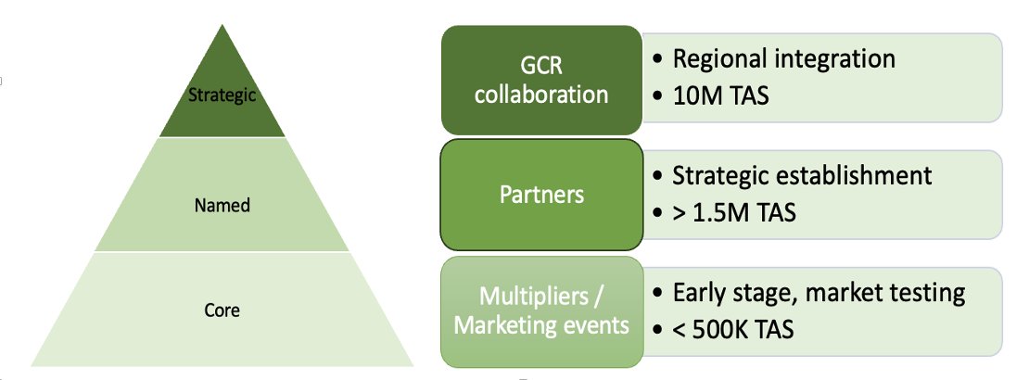

Appendix E2: C2A growth trajectory

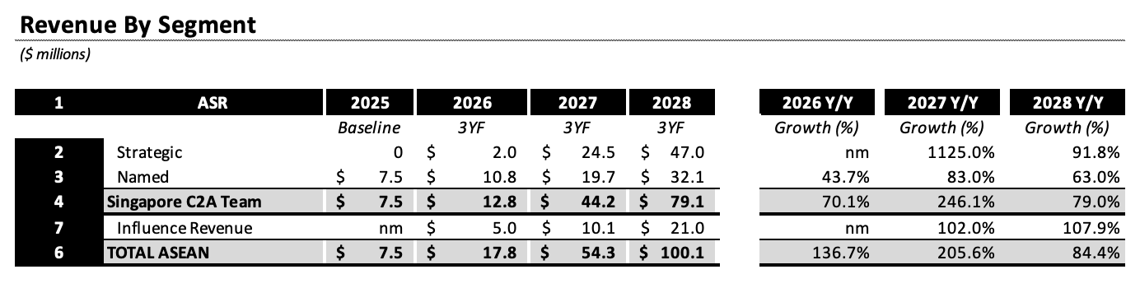

Appendix E3: C2A segmentation and score card

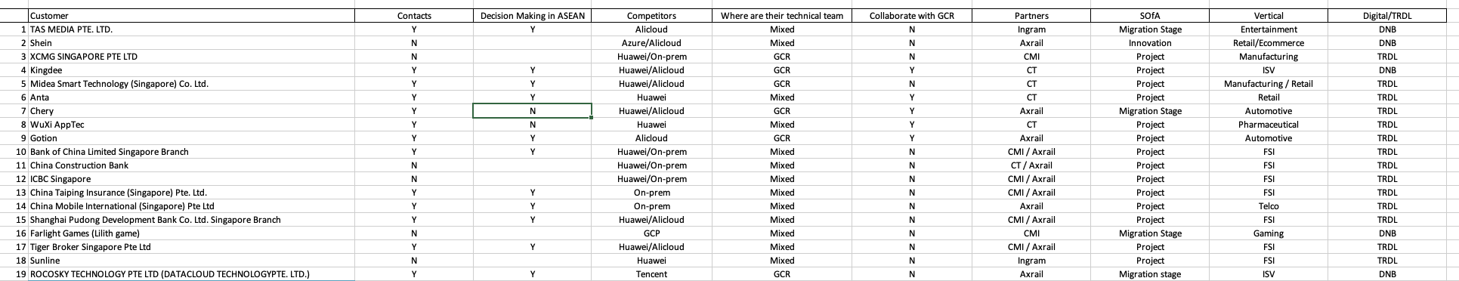

Appendix E4: Method for calculating pull-through revenue
Pull-through oppty value is based on partial 2025 data about AI-DLC engagements from DevTx team.
The average oppty size that an AI-DLC engagement originates is $319k ARR, the median $123k ARR.
We do not have comprehensive data about the stuck opportunities that those engagements unblock, but it’s anecdotally higher, e.g. Bandlab, and SG DNB, where AI-DLC on brownfield monolith strangling unblocked a $2M ARR migration, Joyride PH Firebase to AWS $1.4M ARR migration, OCB VN $600k ARR Backbase migration, Mono TH $1.7M ARR streaming migration.
For our calculations, we assume 70% of the pull-through revenue is net-new workloads (oppty size $123k ARR), and 30% is migrations (oppty size $600k ARR, considering that the threshold for MAP Lite to become MAP 2.0/ MAP-PPA is $500k ARR).

Appendix E5: Developer population (APAC)
Source from Evans Data 2024
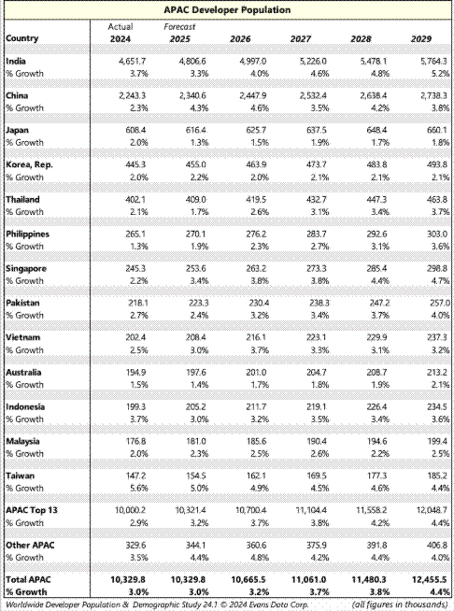

Appendix E6: Developer communities in Singapore

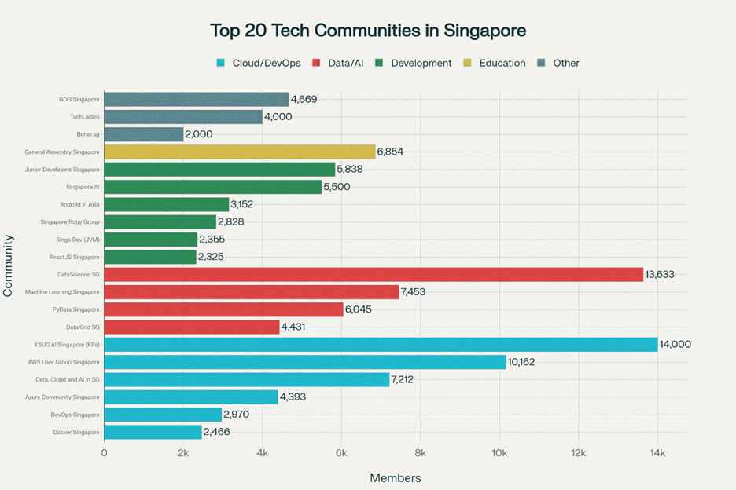
Source: https://www.perplexity.ai/search/find-me-the-biggest-tech-commu-xg58wBiXSL.Wd7vXSiiewg#0

Tier 1: Largest Communities (5,000+ Members)
These communities offer the broadest reach and would be ideal anchor partners for any large-scale developer initiative.
Community | Members | Focus | Why Partner | Target for collaboration
KSUG.AI Singapore | 14,000+ | Kubernetes, Cloud Native, AI | Most active K8s community in Singapore; monthly meetups with strong corporate sponsorship | Yes
DataScience SG | 13,633 | Data Science, ML, Analytics | Largest data community with active Slack and Facebook groups; regular events at Google DevSpace | No
AWS User Group Singapore | 10,162 | AWS, Cloud | Part of global AWS network; monthly meetups with strong industry engagement | Yes
Machine Learning Singapore | 7,453 | TensorFlow, PyTorch, Deep Learning | Very active with monthly talks; venue sponsored by Google | No
PyData Singapore | 6,045 | Python, Data Tools | Supported by NumFOCUS; strong connection to international PyData network | Yes
SingaporeJS | 5,500 | JavaScript, Node.js, Web | Established community hosting monthly talk.js sessions; CityJS Singapore organizer | Yes

Tier 2: Substantial Communities (2,000–5,000 Members)
These are highly engaged niche communities that would be excellent co-partners for targeted developer segments.
Community | Members | Focus | Special Events | Target for collaboration
GDG Singapore | 4,669 | Google Technologies | DevFest Singapore organizer; monthly meetups at Google DevSpace | No
Azure Community Singapore | 4,393 | Microsoft Azure | Microsoft-backed; hybrid events | No
TechLadies | 4,000+ | Women in Tech | Regional community across Asia; education and mentorship programs | TBD
DevOps Singapore | 2,970 | DevOps Practices | Organizes DevOpsDays Singapore | TBD
Singapore Ruby Group | 2,828 | Ruby on Rails | RedDotRubyConf organizer; one of the longest-running communities | Yes
Docker Singapore | 2,466 | Containers, Docker | Docker ecosystem events | TBD
Singa Dev | 2,355 | JVM, Polyglot Dev | Evolved from Java User Group to polyglot focus | TBD
ReactJS Singapore | 2,325 | React, React Native | Front-end focused community | TBD
Better.sg | 2,000+ | Tech for Good | Singapore's largest tech charity; 1,500+ active volunteers | TBD

Tier 3: Specialized & Influential Communities
These communities may have smaller membership counts but high engagement and influence within their domains.
Community | Focus | Why They Matter | Target for collaboration
Lorong AI | AI, Government-backed | Singapore's government AI co-working hub; hosts "AI Wednesdays" with ministers and tech leaders like OpenAI, AWS, Groq | Yes
Python User Group Singapore (PUGS) | Python | PyCon SG organizer; registered society with official invoicing capabilities | Yes
Singapore Gophers (GoSG) | Go/Golang | GopherCon Singapore organizer; strong corporate backing from Google | Yes
Cloud Native Singapore (CNCF) | Kubernetes, Cloud Native | Official CNCF chapter; credibility in enterprise K8s space | TBD

Appendix E7: Top 20 Accounts to Defend for Data & AI
Top 10 Billers for AIML in Singapore CS
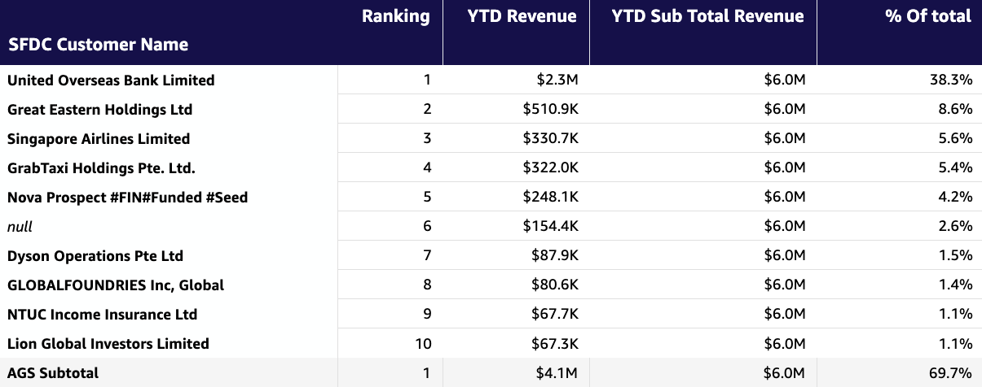

Top 10 Billers for Analytics in Singapore CS
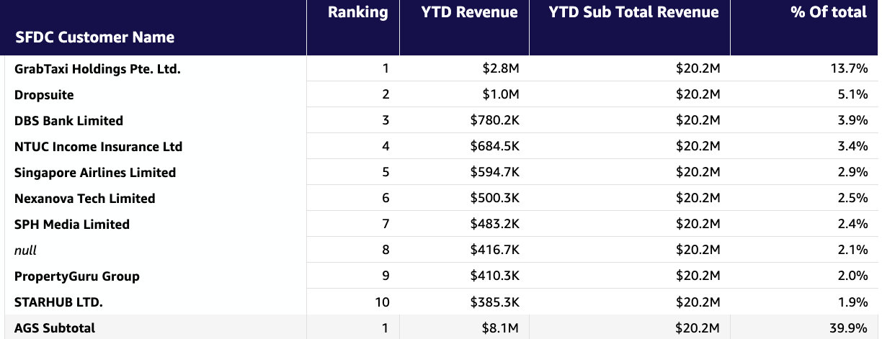

Appendix E8: Next 20 Accounts to Acquire for Data & AI
Coverage Segment | Account Name
Deep | ASM Pacific Technology
Deep | Certis CISCO Security Pte Ltd
Deep | GrabTaxi Holdings Pte. Ltd.
Deep | International SOS
Deep | NETS Singapore
Deep | NTUC Enterprise Nexus Co-operative Limited
Deep | Oversea-Chinese Banking Corporation Limited
Deep | Supabase
Deep | Wilmar International Limited
Focus | Affle International Pte. Ltd.
Focus | Anuttacon
Focus | CIMB BANK SINGAPORE
Focus | Circles.Life
Focus | Great Eastern Holdings Ltd
Focus | Infowiz Pte. Ltd.
Focus | Mediacorp Pte Ltd
Focus | PropertyGuru Group
Focus | Tokio Marine Asia Pte Ltd
Focus | Trinusa Travelindo, PT (Traveloka)
Focus | Singlife

Appendix E9: Total Addressable Market for AI spend in Singapore for FY26 by Vertical

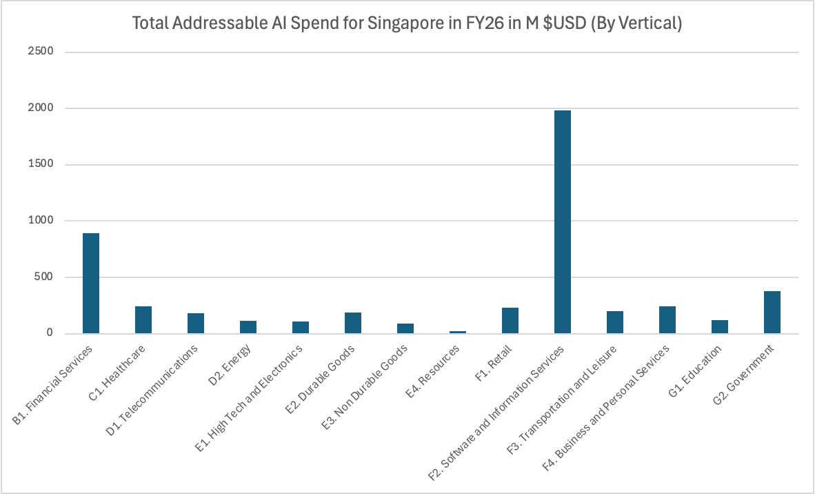

Appendix H: Scale Singapore Additional Information
Initiatives to defend existing revenue base with a Refuse to Lose mindset
Scale SG (excluding gaming) manages 1,550 customer accounts generating $51.2 TTM GAR and PED QSR of $46.3M, with a critical strategic imperative to defend $18.1M ARR (35% of total revenue) from 267 accounts exceeding 70% TAS penetration – our “Protect the Base” cohort. (More territory information can be found in Appendix). This cohort represents our most mature relationships and faces elevated competitive displacement risks. High-Risk Account Portfolio – Our top-10 highest-value vulnerable accounts include AXXIS Consulting ($1.54M TTM GAR), X Star Technology ($485K), Telin Singapore ($477K), The Bank of Nova Scotia ($421K), tothenew ($402K), Glico Asia Pacific ($320K), Memberson ($308K), Webcada ($297K), Essilor Amera ($294K), and Haafor Singapore ($285K). Collectively, these 10 accounts represent $4.9M ARR (27% of at-risk revenue) and require immediate executive-level engagement protocols. Six of these top 10 accounts are SI/ISV partners, indicating a dual vulnerability—both as customers and as channel partners. Loss of these accounts would create cascading revenue impact through reduced partner-led opportunities. General “Protect the Base” Customer Cohort Characteristics & Market Dynamics: 1/ Digital-first customer concentration: 159 accounts (60% of cohort) from Digital industries (Software & Internet, Financial Services, Professional Services) generate $11.9M ARR (65% of Protect the Base revenue). These digitally native customers exhibit lower engagement friction but higher competitive switching propensity due to cloud-native architectures and multi-cloud strategies. 108 accounts (40% of cohort) across 20 traditional industries (Retail, CPG, Hi-Tech, Semiconductor) contribute $6.2M ARR (35% of revenue). Traditional industry accounts show lower switching costs and deeper technical dependencies, making them more defensible with proper engagement 2/ Engagement Maturity & Revenue Concentration - 94% of Protect the Base revenue ($17.0M ARR) generated by Engaged customers (64% of cohort) who have exceeded GTE thresholds. High revenue concentration in engaged accounts means any churn event has outsized P&L impact. 3/ Segment Performance Divergence in “Protect the Base” Cohort – ENT (80% YoY), SMB (30% YoY), ISV (-1% YoY). Overall cohort growth: 29.4% YoY PED QSR FY24-25 with ISV segment (60 accts, $2.1M ARR in critical alert). 4/ Partner attachment as growth multiplier – Partner attached accounts: 50% QSR growth rate, non-partner accounts: 19% QSR growth rate. Partner engagement is not just a growth driver but a retention mechanism—partner-attached accounts show 2.6x higher growth rates, suggesting deeper technical integration and stickiness.
FY26 execution plans, top priorities, and key activities and initiatives:
Scale Singapore manages 1,550 customer accounts generating $51.2TTM GAR in FY26 Engaged Cohort: 581 accounts (37% of portfolio) generating $45.0M GAR (88% of revenue) at $77,458 average account value, demonstrating 29.4% YoY growth. Greenfield Cohort: 969 accounts (63% of portfolio) generating $6.2M GAR (12% of revenue) at $6,390 average account value, showing significantly higher growth velocity. Protect the Base Cohort: 267 accounts with >70% TAS penetration (overlap with some Engaged and Greenfield cohort) representing $18.1M ARR (35% of total revenue) – our most vulnerable and strategically critical segment. The concentration of 88% of revenue in just 37% of accounts creates both opportunity and risk. Our territory is transitioning from a predominantly Greenfield acquisition engine to a balance portfolio requiring simultaneous defense of high-penetration accounts and aggressive new logo acquisition. FY26 execution plans, top priorities, and key activities and initiatives: 1/ Migration Revenue Acceleration – Migration workloads remain our fastest path to revenue realization, particularly in traditional industries (Mfg, Retail, FSI) where cloud adoption is accelerating but requires structured framework and price/value selling. In FY26, we are shifting to 100% proactive MAP positioning at first touch, reducing sales cycle time. We are also implementing industry-specific migration discussions rather than generic cloud migration narratives, increasing relevance and conversion rates. Activities & Execution: MAP and MAP Lite programmatic positioning in first customer conversations to establish cloud journey structure and AWS commitment. Cross-Functional Migration SWAT teams (CSR + Migration SA + MAP BD + Partner SA) for accounts with >$250K migration opportunity. Partner with AWS Compete team to position AWS programs against Azure/GCP/Chinese CSP is competitive displacement scenarios. Input Metrics: 150 MAP/MAP Lite proposals presented (~15% of Greenfield), 50 competitive displacement opportunities identified and engaged. Output metrics: $15M incremental ARR from migration workloads, 30 MAP commitments secured, 50% win rates in competitive migration scenario, 20 new enterprise logos acquired through migration-led GTM. 2/ GenAI as Retention & Expansion Driver – Our FY25 learning is definitive – infrastructure leadership does not guarantee GenAI workload capture Customer with high TAS penetration are evaluating Microsoft Co-Pilot, Google Vertex AI, and other platforms for GenAI, creating existential risk to our core compute/storage/database revenue. We are fundamentally resequencing our sales motion from “Migration à Modernization à AI/ML à GenAI” to “Migration + GenAI in parallel”. This recognizes that GenAI is not the final stage of cloud maturity. Activities: Migration + GenAI Dual-Track approach in all conversations, Quicksuite-first positioning to drive enterprise adoption, 4 quarterly GenAI Builder workshops across Protect-the-base and high-potential greenfield account, GenAI CXO Roundtable for top-down C-Suite mandate. Output metrics: $3M ARR launch from GenAI workloads, 50% PoC-to-Production conversion rate, 3 new GenAI partners onboarded on AWS and 50 ECI applications by March 2026. 3/ Industry-first Customer Engagement - We are shifting from AWS-centric discussions across all segments (SMB, ISV, ENT) to industry-central outcome conversations, where possible. Aligning with SG’s vertical focus, Scale SG will create focus sales plays and engagements around Retail + CPG, Manufacturing and Semiconductor, FSI and Others. We will continue our FY25 momentum with flagship events – AWS Innovation Day (Manufacturing, Industrial and Supply Chain Edition), AWS in Engineering, Construction and Real Estate (with Singapore Contractors Association Limited), AWS Retail Day and AWS Capital Markets Day. AWS Specialist Engagement with AWSI team (e.g. Pascal Pergougnou from AWS Manufacturing team, Homin Kim from AWS Retail team) for 1:1 customer deals (>$250K ARR or strategic logo) and peer-to-peer executive engagement (nominated in Q1 FY26). Input metrics: 4 major industry events per year, 30 industry-specific executive briefings, and 50 accounts with active industry specialist engagement. Output metrics: $4M ARR pipeline from industry events, 20 new enterprise logos from traditional industries and 3 industry-influence customer references. 4/ Partner-Led Deliver & Ecosystem Expansion - Partner-attached accounts show 2.6x higher growth rates (50% vs 19%). Traditional industries require partner-led implementation support, while digital-native ISVs need to co-sell and marketplace activation. Learnings from FY25 indicate a strong need to addressing our limited partner ecosystem through active partner incubation rather than accepting the status quo. Activities: Partner attachment acceleration with focus in Protect the Base and Greenfield cohort through systematic partner matching, New partner incubation such as Thoughtworks, Accenture and GoPomelo/Digital China to address enterprise consulting gap beyond existing set of partners (SoftwareOne, 1CH, Axrail) and obtaining. 5/ Disciplined Program and Incentive Utilization – FY25 revealed that use of one-time programs (e.g. Activate, CEI Funding, AWS Lift) may create short-term spikes but insufficient long-term customer commitment. We are implementing a “sustainable revenue first” philosophy, measuring CSRs more heavily on ARR closed, 12-month revenue ramp and retention rates rather than MBOs (MBAs, GFCs) to create accountability for program utilization quality, not just quantity. Activities: MAP/MAP Lite as default framework, creating 2-3 year commitment structure. Quarterly review of top-partner cash funding raised, PoC and other Credit disbursements across CSRs and revenue ramp. Input metrics: 80 MAP & MAP Lite commitments, 20 ECI-funded strategic initiatives, 50% reduction in one-time credit usage (<$10K PoC requests). Resource Realignment for Productivity and Growth - 1/ HC-constrained environment assumptions - No net new CSR headcount in FY26 (8 CSRs managing 1,550 accounts), continued access to cross-functional specialists (Focus, Deep, Industry team), partner capacity remain available for Scale SG . 2/ CSR Portfolio Rebalancing: ISV segment consolidation under a new CSR with ISV experience (Azfar) for specialized engagement, Greenfield Enterprise acceleration under existing CSRs ensuring continuity (Vivian, Mark) and an additional 0.5 HC (Ariff) to double down on success shown in FY25 Greenfield Enterprise (100+% YoY) with primary focus on Azure compete, multi-year migrations, and industrial industries focus, Protect the Base redistribution across 8 reps to ensure sufficient attention to customer cohort. 3/ Cross-Functional Leverage Model: Industry specialist embedding for top deals (>$250K ARR), Focus/Deep team coordination for aligned GTM motion (e.g. GenAI, Industry days), APJ, Partner and SG Marketing(e.g. AWS Summit), Agency engagement (A*STAR, EDB, SBF, SMF, DISG, SGTech, IMDA), Compete team, and Program Teams (MAP, PPA).

Appendix StratS A: Strategic Services (StratS)
Databases | Containers | Analytics | Efficient Compute
RDS | ECS | Athena | All Graviton Instance Types
Aurora | EKS | Glue
DocumentDB | Batch | Redshift
DynamoDB | Fargate | MSK
ElastiCache |  | Kinesis
MemoryDB |  | OpenSearch
Neptune |  | EMR
Keyspaces |  | Apache Flink
Timestream |  | Clean Rooms
 |  | Data Exchange
 |  | Lake Formation

Appendix StratS B: Database Motions [excerpt; full doc here]
Gartner is estimating that 70% of new apps will use Open-Source (OSS) databases by 2027 and 50% of commercial databases (Oracle, MSSQL) migrating to OSS. PostgreSQL’s rapid, community-driven adoption is well reflected in RDS/Aurora PostgreSQL adoption in SG CS at $16.7M (+35.3% Y/Y, 850+ billers) YTD-Oct. In FY26, we will prioritize three motions to acquire strategic Database workloads: [1] Large-scale migration and modernization: In VMware migrations for app-DB workloads, databases typically make up 20-30% of the inventory. This presents a strong opportunity to drive database modernization and move-to-managed sales plays across both OSS and commercial engines, in collaboration with Migrations and Database Specialist teams - a) Move-to-Managed on RDS/Aurora for homogenous database migrations to elevate cloud value proposition, without compromising migration speed. b) Database Freedom to Aurora for heterogenous database migrations from commercial to OSS engines, helping customers free from licensing cost. c) Win Oracle Workloads on RDS/Aurora and new ODB@AWS (GA in Singapore Q2’26), for workloads requiring RAC and Exadata capacity. d) Win SQL Server Workloads on RDS leveraging new capabilities - Developer edition, and CPU optimization options with new generation instances (M7i, R7i) for up to 55% lower price and separately billed licensing fees. [2] Core Industry Application Modernization: core applications are gradually shifting to cloud-native architectures, creating a huge opportunity, as 95% of banks still run legacy core systems on-premises, including upstream and downstream applications. We will prioritize FSI & Telco accounts in SG with a must-win mindset across core and digital systems in banking and Insurance and OSS/BSS in Telco to win their databases on Aurora, through strategic ISV partnerships (like Temenos, Thought Machine, Amdocs). [3] Databases for AI: experimental initiative for 2026, targeting key AI-driven use cases to enhance situational (RAG solutions) and semantic (Vector support) context to LLMs leveraging our cloud-native databases: Aurora, DynamoDB, DocDB, EC, MemoryDB. Database Programs & Incentives: Database OLA, Directional Business case (DBC), Database Migration Accelerator (DMA), Must Win Fund, and License Freedom, Proserve AML. Execution: a) Database Sales (Hailey, Raj) will lead 1:1 customer engagement driving above initiatives supported via database programs and incentives; and b) Database GTM (KP) will execute 1:M events: GenAI-powered modernization workshop (Q2’26), FSI Industry forum (Q3’26), 3x Technical workshop (H1’26) to influence pipeline creation and acceleration.

Appendix x - Accelerate Partner contribution and double down on Focus $78.75M IYR
Initiatives to defend existing revenue base with a Refuse to Lose mindset (2025 Performance and Learnings): YTD-Nov, Partners contributed 66.7% (70.5% incl AO non-compliant) of Singapore CS launched ARR excl SUP vs 70.1% target, with Focus at 56.2% and Deep at 72.9%. Total launched ARR excl GenAI was $152.7M (101.43% of plan, 32.4% YoY), driven by large enterprise wins in Deep (+54.1% YoY) and GF MAP execution in Scale (+116.7% YoY); Focus partner business underperformed with +6.8% YoY launch growth vs. +11.9% Focus GSR growth. Goals: Partner GenAI launches (Full Stack) at $25.2M ARR(234% vs p lan, 865% YoY, PAR at 57%, #1 in ASEAN); Partners contributed to 64% of the VMware country Launch ARR (CS ex. SUP) at $27.1M(331.6% YoY); Large Migration wins at $77M (140.7% vs plan, 15% YoY). Marketplace TCV below plan at $51M (61.9% vs plan). 2025 Learnings: 1) Partners with consistent commitment and resources drive sustained results (Eg. SoftwareOne in Focus due to ability to stay invested with consistent account coverage and customer engagement model. 2) Exec alignment on large Transformation deals with GSIs (Eg. ACN at UOB) and BCAP paves way for long-term success; 3) Opportunistic engagement by consolidation/SI partners in Focus sales motion leading to sub-par performance including within incumbent accounts, 4) Partners with GenAI and AI led use -case specific GTM gaining better mindshare vs pure-play infrastructure led GTM (Eg. 1CloudHub vs Cloud Kinetics); 5) ISV momentum impacted by change in SCB incentivization, lacck of structured GISV engagement, low traction in our ISV accounts and absence of focused industry ISV GTM.
- FY26 execution plans, top priorities, and key activities and initiatives:
1/Lead partner GTM through Data/AI thematics (+$18.27M IYR GenAI OP2 FY26, 35% YoY): We will (i) Partner with GSIs (Accenture, Deloitte), BCAPs and boutique (Eg. Thoughtworks, OnebyZero) partners in our Deep cohort to drive AI-platform led initiatives and workloads as these customers build deep AI capabilities while (ii) doubling down on Industry led use cases in the Focus cohort across FSI, Mfg, Retail&CPG along with proven horizontal use cases leveraging our consolidation(Eg. Axrail : Retail&CPG, 1CH: Logistic, SW1:FSI) and emerging AI (Eg. Searce, OnebyZero, Thoughtworks) partners. (iii) Execute Partner-Led AI-DLC workshops across 20 ISV/Digital Native Focus accounts by proactively mapping account coverage with Searce, Thoughtworks, and Cloudmile to drive organisation-wide developer-led AI transformation, (iv) Leverage PACE program to drive partner-Led prototyping working with eCV, OnebyZero) beginning with seven funded prototypes in H1 and (v) Accelerate ECI/DLP program supported customer adoption to 3x across all 13 partners onboarded onto the program. 2/Drive enterprise-wide migration and modernisation doubling down on next workloads across the focus cohort (+$45.17M IYR Migration Realized Revenue with 55% Modernization Rate, 30% YoY). Along with the account team, we will map our Focus accounts primarily with our consolidation partners based on incumbency, coverage and capability to drive strong upsell across min. of 3 workloads in each account contributing to 60% of partner launches for SG. Workload purview will be across migrations (VMWare based, DC exits), SAP++ (next workload at accounts with SAP on AWS leveraging SWOne and 1CH SAP GenAI solutions), application modernisation and database/infrastructure modernisation to unlock data for AI workloads. This will be supported by our established partner programs (Eg. MAP 2.0, MAP Lite) and extending new program constructs such as MODNET (AWS Growth Initiative) to the partner community. We will leverage the NFO sprint mechanism to cadence and drive progress with partners and account teams on this initiative. 3. Accelerate ISV co-sell through deep, proactive engagements across named accounts: (+$15.32M Marketplace TCV Platform consumption, 100% YoY): 1/ Drive proactive deep account engagement with top 5 G-ISVs with a goal of 70 deal wins across XX accounts ($2.8M total TCV) per G-ISV supported by ISV PDM (hiring in progress) and PSM through marketplace (FY25 top 5 GISVs: Splunk, Snowflake, GitLab, Palo Alto and Okta); 2/ Intentional acceleration of Industry ISVs across top 3 traditional focus industries industry with three top Industry ISVs with Deep and Focus PSMs on FSI, Manufacturing and Retail/CPG [Nominated industry ISVs for proactive engagement: FSI – Thoughtmachine, Nice, Synpulse; Retail/CPG - XX, XX and XX; Manufacturing – Siemens, etc], 3/ Drive SG country ISV interlock with traditional industry/ies customer base by identifying top 4 local ISVs with GTM focus in SG to drive account interlock and deal momentum across XX Focus accounts.
 |  | YTD'25 ($M) | Q1'26 ($M) | Q2'26 ($M) | Q3'26 ($M) | Q4'26 ($M) | FY26 ($M)
#1 | Revenue from GenAI OP2 (66.5% PRR) | NA | 2.74 | 6.03 | 4.93 | 4.57 | 18.27
#2 | Revenue from Migration Win (66.5% PRR) | 20.24 | 9.30 | 12.38 | 12.20 | 11.29 | 45.17
#3 | Revenue from Marketplace TCV (17%) | 7.66 | 3.29 | 4.06 | 4.14 | 3.83 | 15.32
 | Total IYR Estimated: |  | 15.33 | 22.47 | 21.26 | 19.69 | 78.75
