CSCI222 Assignment 1 Report

Team Number : <C4>

 | Student Number | Name | Email Address
1 | 5922690 | Siddharth Singh  (Team Leader) | Tel : +65 8435 3954  Email : siddharthmdps@gmail.com
2 | 5920723 | Darren Toh | Tel : +65 8188 6388  Email : darreazyl@hotmail.com
3 | 5920139 | Evan Emmanuel Ong Zong Jian | Tel : +65 9764 0333  Email : dimension@hotmail.com
4 | 6097765 | Yeo Shun Yuan Justine | Tel : +65 9657 8882  Email : justineyeo96@gmail.com
5 | 5922550 | Pavinder Singh S/O Gurmit Singh | Tel : +65 9181 2355  Email : pavindermahinder@hotmail.com
6 | 5920127 | Chong Chuan Bin, Dominic | Tel : +65 91816888  Email : domccb94@gmail.com

Contents
Project Overview 4
Introduction 4
Vision 4
Initial Use-Case Model 4
Project Plan – Gantt Chart 5
Roles and Responsibility 6
Risk Analysis and Counter Measures 7
Use Case – Iteration 1 8
Use Case - Iteration 2 9
Detailed Use Case Diagram – Iteration 1 10
Add Stock 10
Edit Stock 11
Search Report 12
Remove Stocks 13
Summary Report 14
Detailed Use Case Diagram – Iteration 2 15
Login 15
Add Stock 16
Edit Stocks 17
Remove Stocks 18
Search Stocks 19
Stock Summary 20
Register 21
Sequence Diagram – Iteration 1 22
Add Stock 22
Edit Stock 23
Search Report 24
Remove Stocks 25
Summary Report 26
Sequence Diagram – Iteration 2 27
Login 27
Add Stocks 28
Edit Stocks 29
Remove Stocks 30
Search Stocks 31
Stock Summary 32
Register 33
Activity Workflow – Iteration 1 34
Activity Workflow – Iteration 2 35
Component Diagram – Iteration 1 36
Component Diagram – Iteration 2 37
Class Diagram – Iteration 1 38
Class Diagram – Iteration 2 39
Appendix A - Formal Meeting Records 40
Inception Phase - Iteration 1 40
Elaboration Phase - Iteration 1 41
Inception Phase - Iteration 2 42
Elaboration Phase - Iteration 2 43
Appendix B - Individual Work Diaries 44
Team Member 1 : Siddharth Singh 44
Team Member '2' : Darren Toh 45
Team Member '3' : Evan Emmanuel Ong Zong Jian 46
Team Member ‘4’ : Yeo Shun Yuan Justine 47
Team Member ‘5’ : Pavinder Singh S/O Gurmit 48
Team Member ‘6’ : Chong Chuan Bin, Dominic 49

Project Overview

Introduction
Running a warehouse can be a complex and tedious task for the user. With stocks incoming and outgoing constantly, it would be an issue for the user to manage it and keep a close track of it. So, to counter this issue, the user faces every day while handling the task of running the warehouse, a system can be created such that it would help out in the task of keeping track of all the stocks.
A Warehouse Management (WM) Tool idea is brought up as a solution. It’s an easy and reliable way for the user to manage his Warehouse.

Vision
The Warehouse Management (WM) Tool is created such that it would help the user with the ability to manage the stock in his warehouse inventory. It would also be able to provide him with all the necessary stock details, such as stock report. This WM tool should make the stock taking more efficient, allowing the user to keep track of the stock closely with minimal effort and be updated on the stock quantity, stock flow, and stock reports. This would also help the user in making critical decisions for his warehouse.

Initial Use-Case Model
The initial use case diagram is shown below. The user would have to login to the system first before using the program. The user would go through an authentication, where the user id and password would be cross checked with the userFile. After successful login, the user would reach an option, where the user can choose to add the stock, view the stock, remove the stock and edit the stock. The user would be able to use all the functions mentioned above, as well as the user can view the summary report – daily summary report, weekly summary report and monthly summary report.
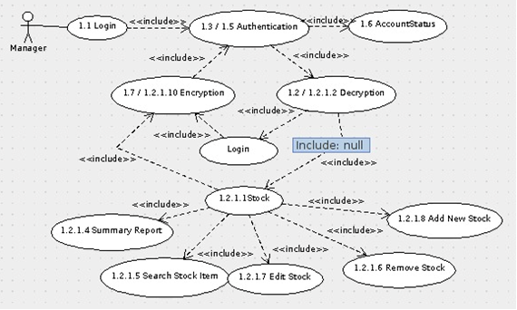

Project Plan – Gantt Chart
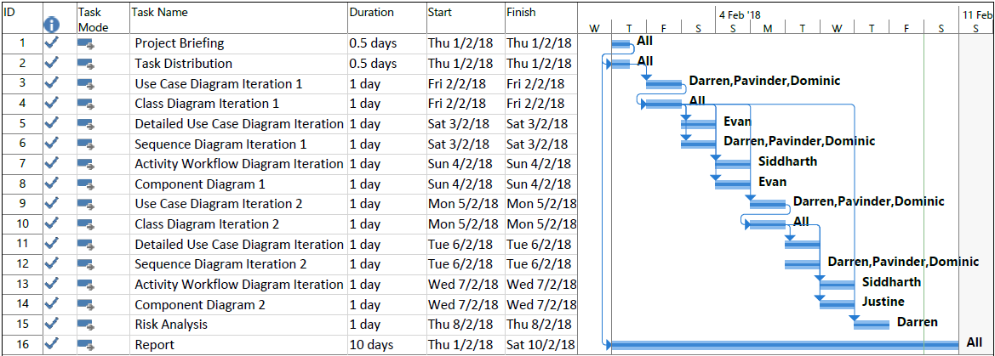

Roles and Responsibility

Team Number : <C4>

 | Student Name | Role | Artefacts
1 | Siddharth Singh  (Team Leader) | Manager | Class Diagram, Activity Workflow Diagram, SRS and Project Overview
2 | Darren Toh | Designer and Implementor | Use Case Diagram, Class Diagram, Sequence Diagram, SRS and Risk Analysis
3 | Evan Emmanuel Ong Zong Jian | Lead Designer and Implementor | Detailed Use Case Diagram, Class Diagram, SRS and SRS Compiling
4 | Yeo Shun Yuan Justine | Implementor and Documentation | Class Diagram, Component Diagram, Gantt Chart, SRS and Report Compiling
5 | Pavinder Singh S/O Gurmit Singh | Systems Integration and Testing | Use Case Diagram, Class Diagram, Sequence Diagram, SRS and PPT
6 | Chong Chuan Bin, Dominic | Designer and Implementor | Use Case Diagram, Class Diagram, SRS and Sequence Diagram

Risk Analysis and Counter Measures

 | Impact Type | Risk Seriousness (%) | Likelihood of Occurrence (%) | WBS  (affected work / task ) | Risk Description
1 | Budget | 80% | 5% | 1 | Client requires extra functionality of the program
2 | Deadline | 90% | 10% | 1 - 16 | Team member does not do work
3 | Deadline/  Budget | 90% | 10% | 3 - 16 | Client changes deadline
4 | Data Loss | 100% | 2% | 1 - 16 | Data corruption or failure to back up
5 | Deadline | 60% | 5% | 1 - 16 | Poor understanding of project requirements
6 | Deadline | 60% | 10% | 3 - 16 | Too many concurrent projects ongoing at the same time

 | Risk Description | Proposed Mgmt Plan | (Possible) Reduction in Risk Seriousness (%)
1 | Client requires extra functionality of the program | Plan 1: Hold some funds in reserve | -50%
1 | Client requires extra functionality of the program | Plan 2: Request extra funds from client | -80%
2 | Team member does not do work | Plan 1: Get a new team member | -50%
2 | Team member does not do work | Plan 2: Split the work among the remaining members | -70%
3 | Client changes deadline | Work with client to come up with a reasonable deadline for submission | -50%
4 | Data corruption or failure to back up | Plan 1: Do multiple backups of data on different devices; e.g. each member keep a copy of the data | -100%
4 | Data corruption or failure to back up | Plan 2: Save regularly | -90%
5 | Poor understanding of project requirements | Ensure that all the team members know what is going on and understands the requirements of the project | -80%
6 | Too many concurrent projects ongoing at the same time | Plan 1: Prioritize the more important ones to finish first | -30%
6 | Too many concurrent projects ongoing at the same time | Plan 2: Request for an extend of deadline | -50%

Use Case – Iteration 1

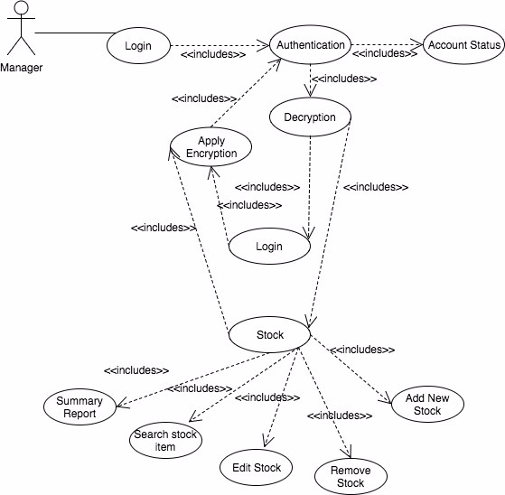

Use Case - Iteration 2

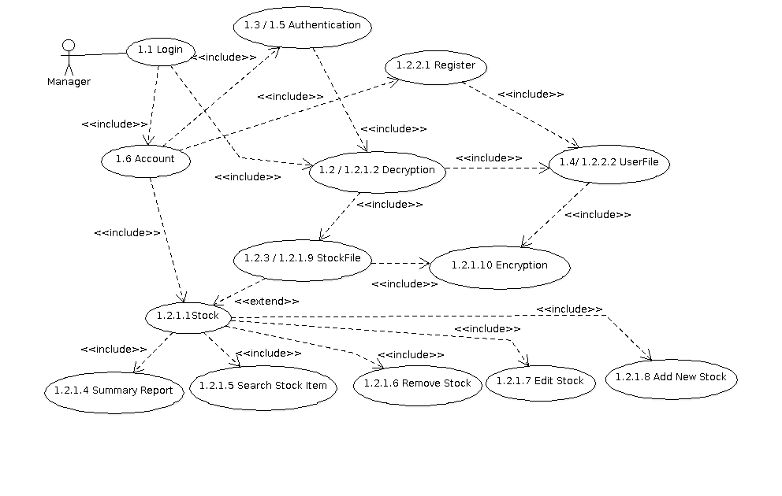

Detailed Use Case Diagram – Iteration 1

Add Stock
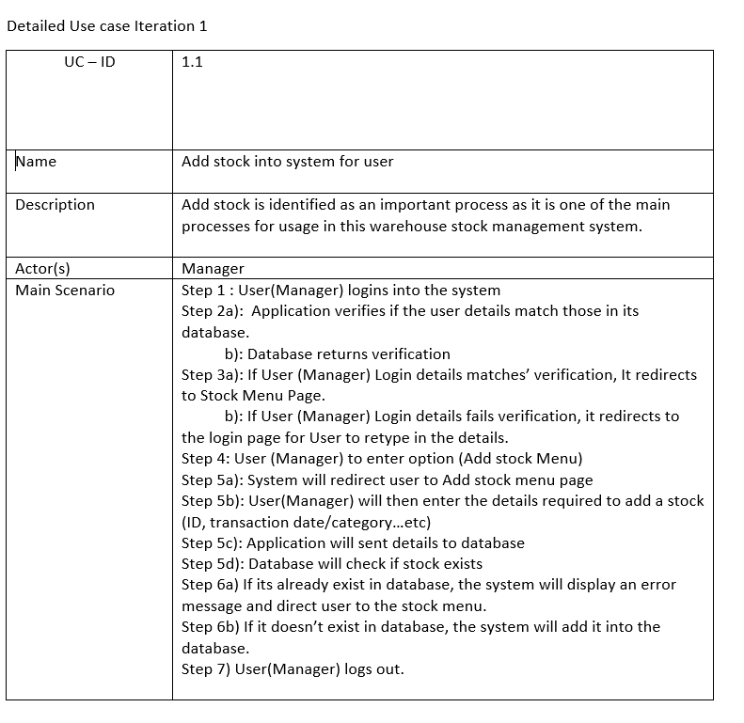

Edit Stock
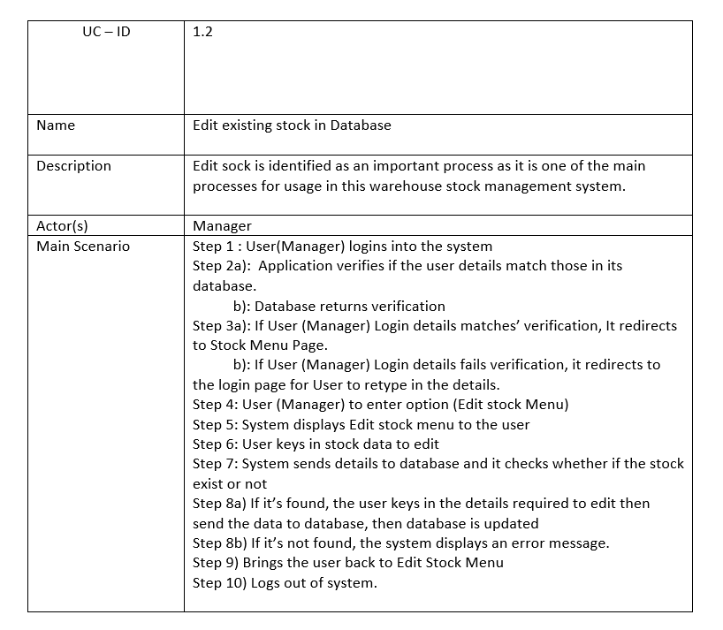

Search Report
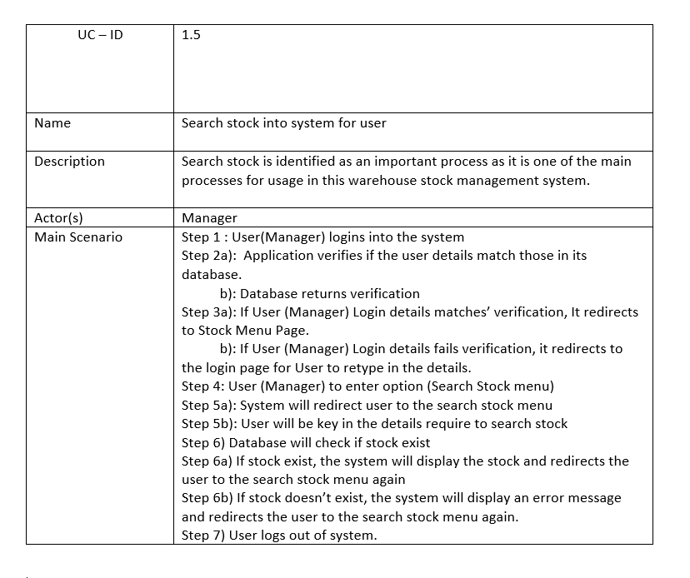

Remove Stocks
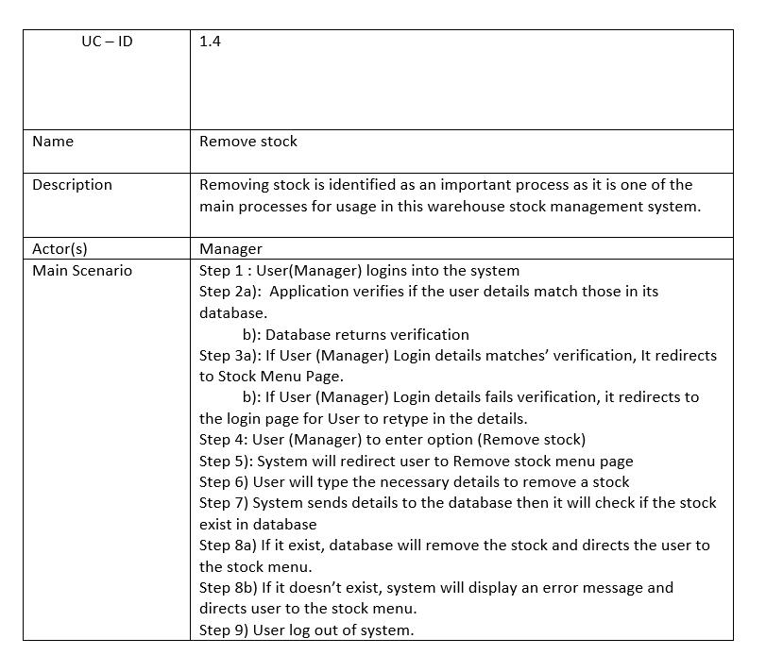

Summary Report
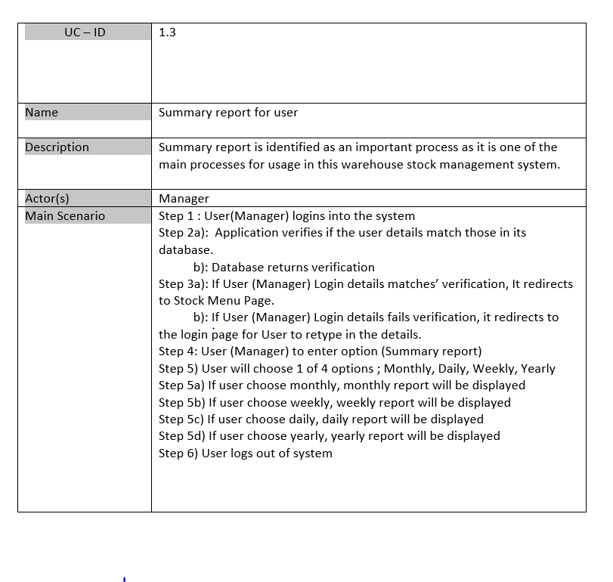

Detailed Use Case Diagram – Iteration 2

Login
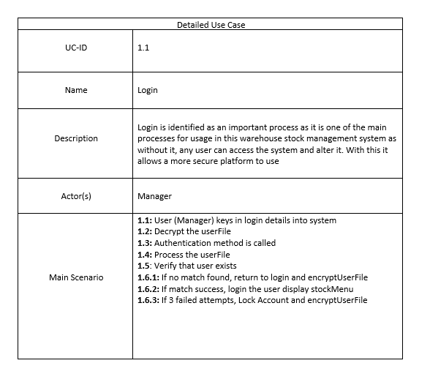

Add Stock
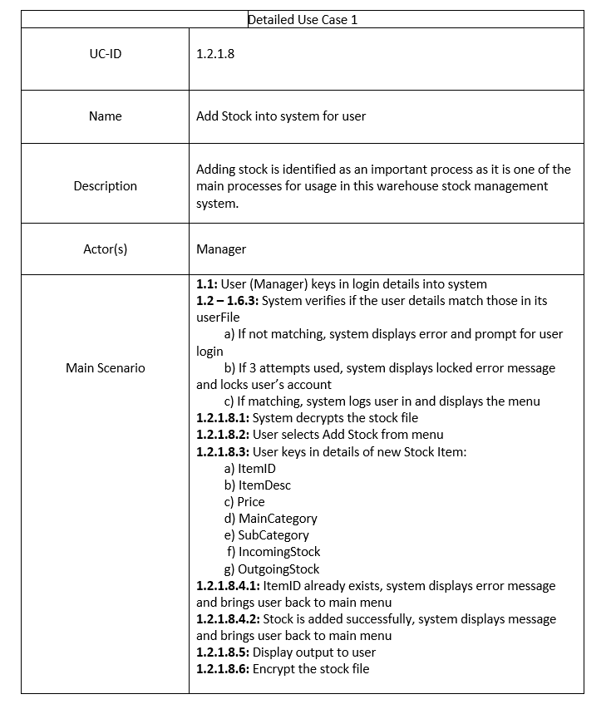
Edit Stocks 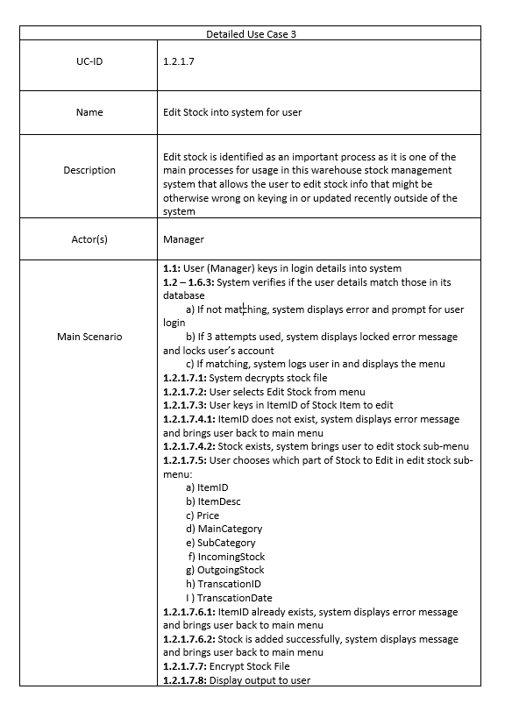

Remove Stocks 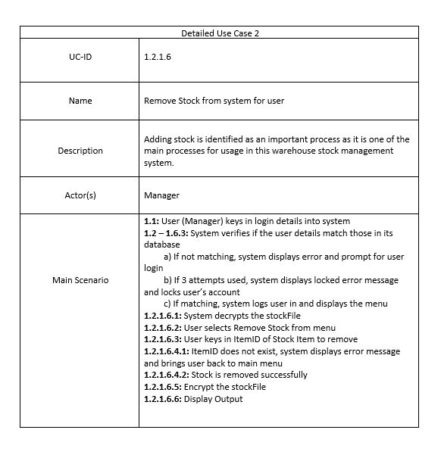

Search Stocks 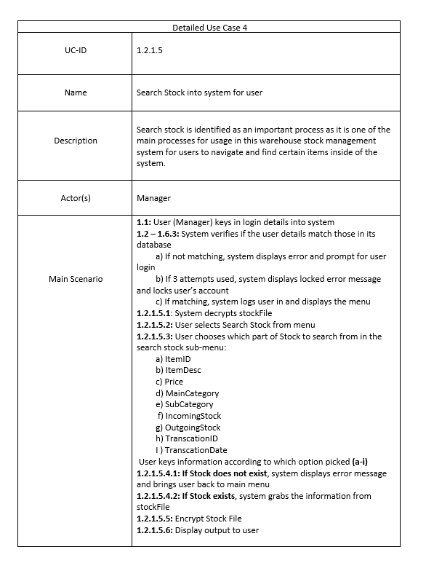

Stock Summary 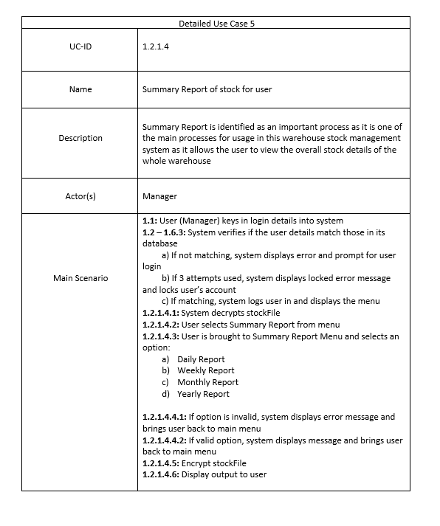

Register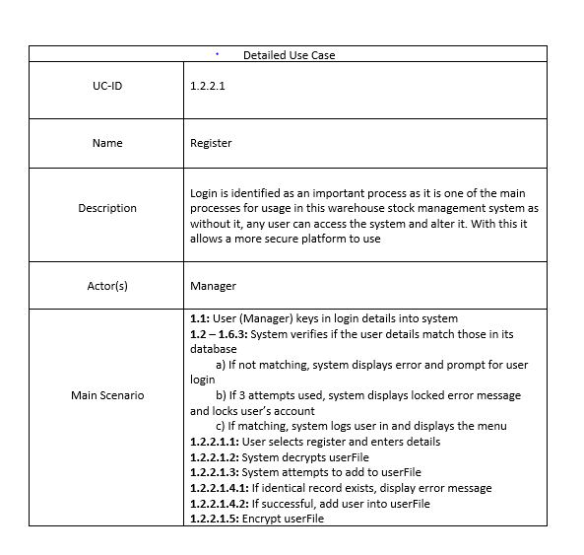

Sequence Diagram – Iteration 1

Add Stock
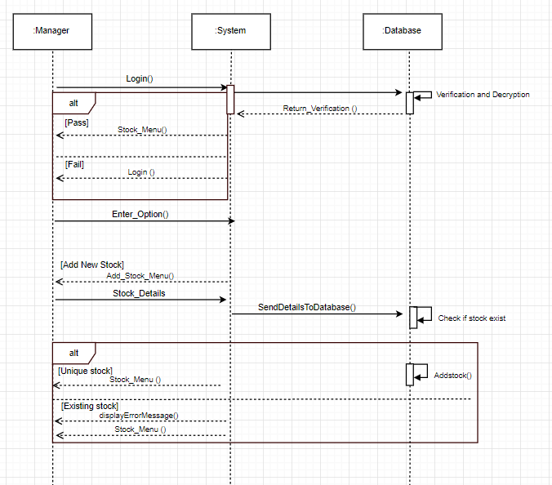

Edit Stock
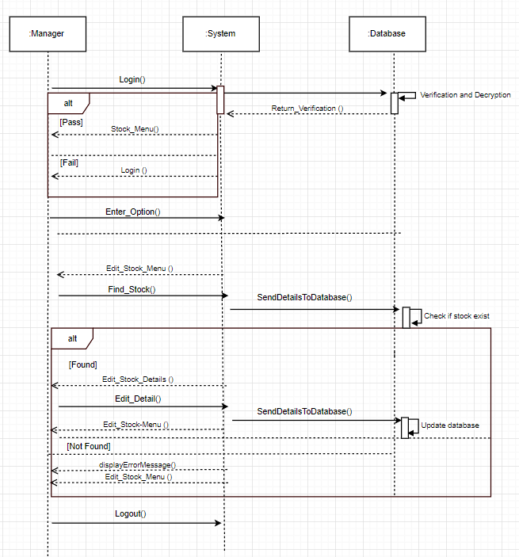

Search Report
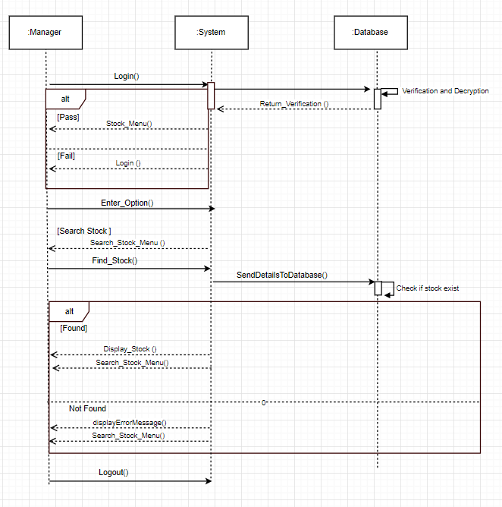

Remove Stocks
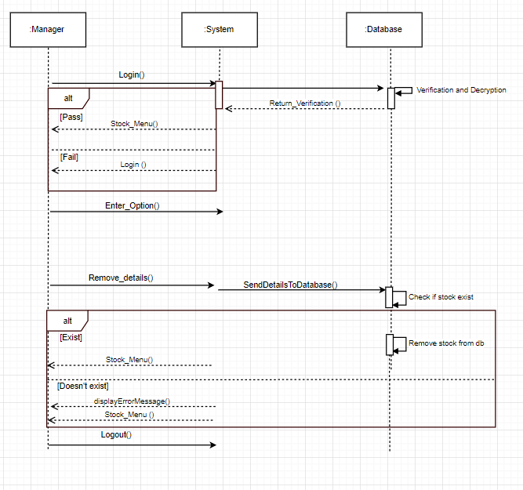

Summary Report
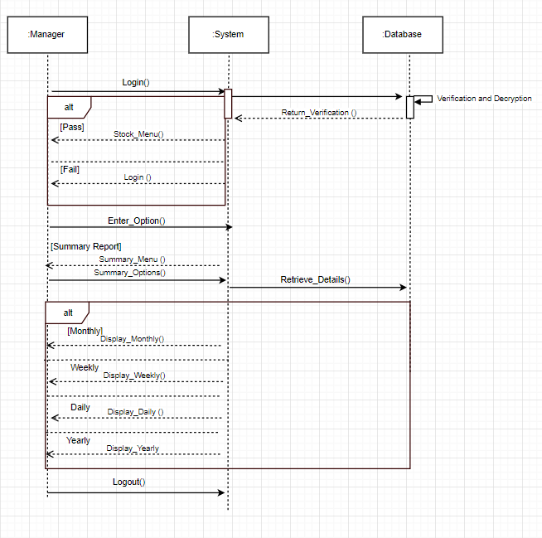

Sequence Diagram – Iteration 2

Login
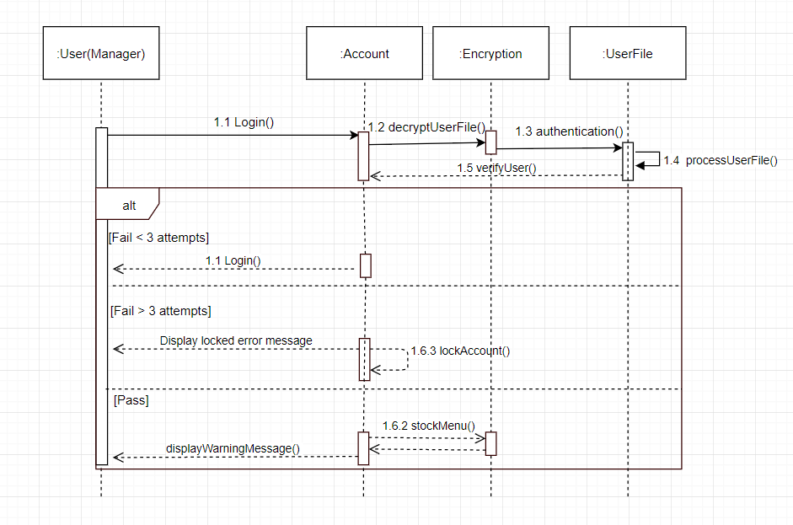

Add Stocks
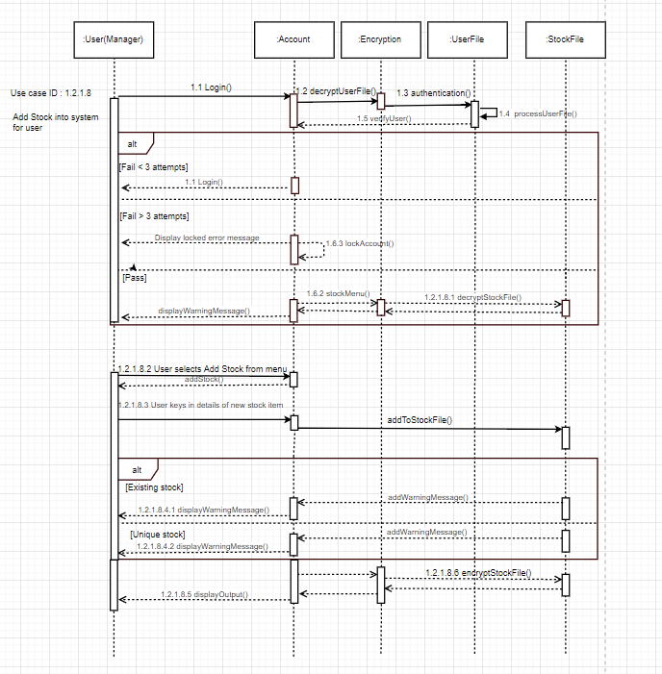

Edit Stocks
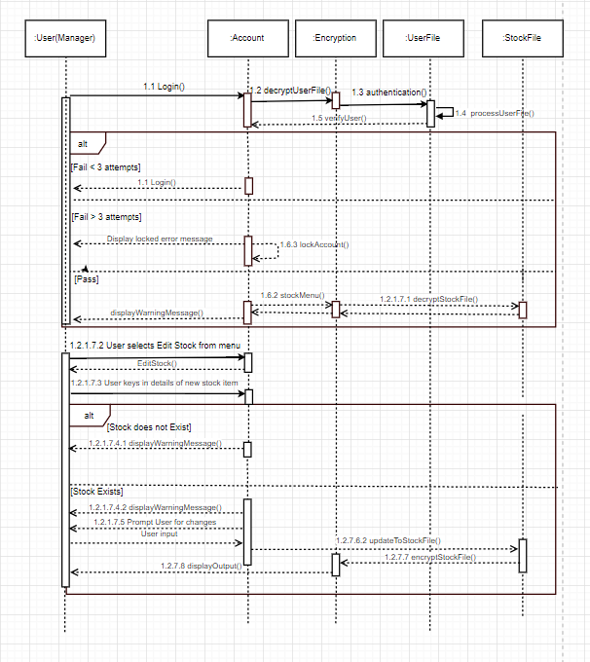

Remove Stocks
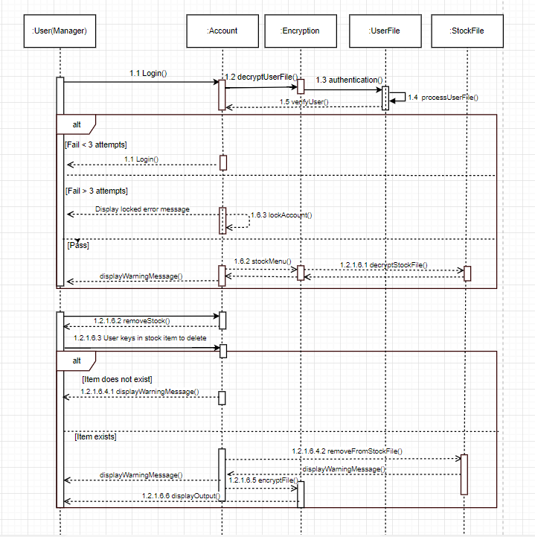

Search Stocks
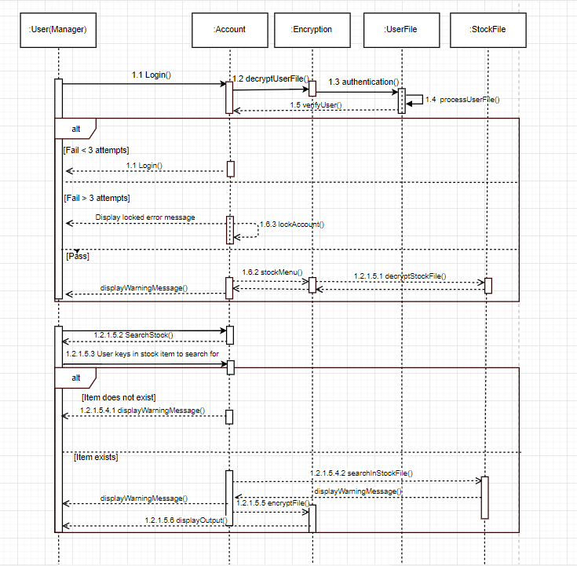

Stock Summary
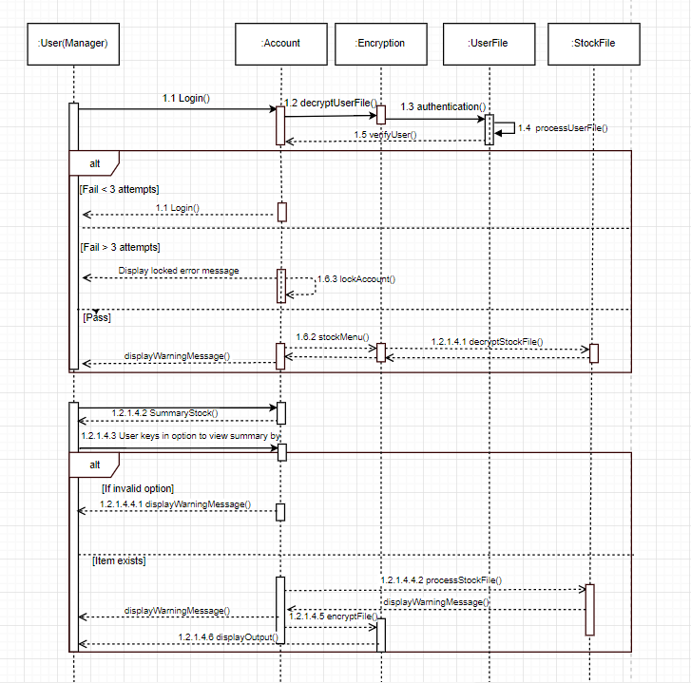

Register
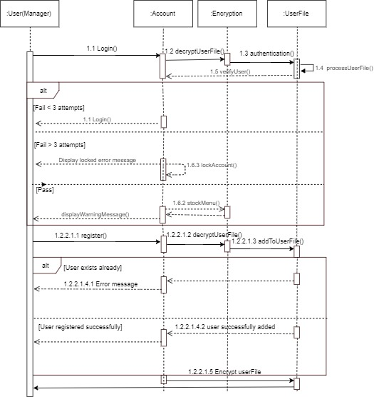

Activity Workflow – Iteration 1

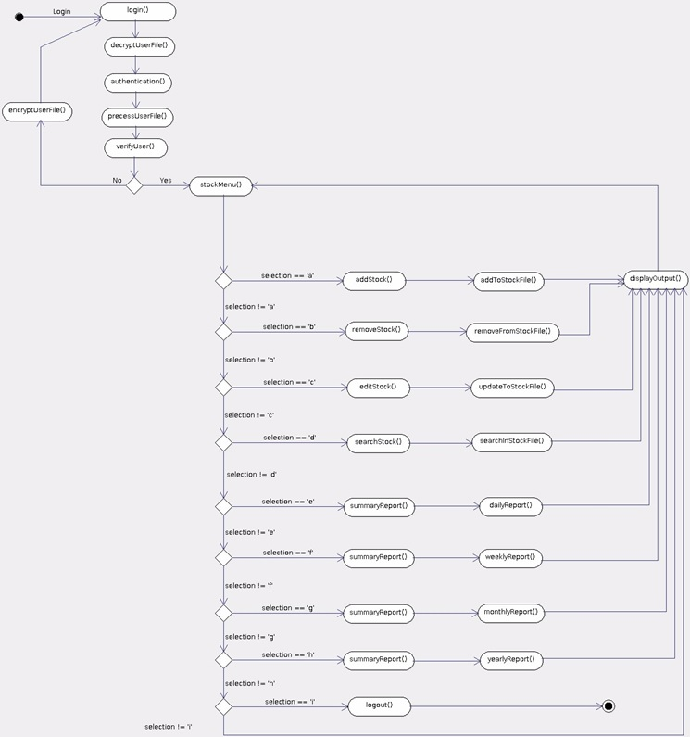

Activity Workflow – Iteration 2

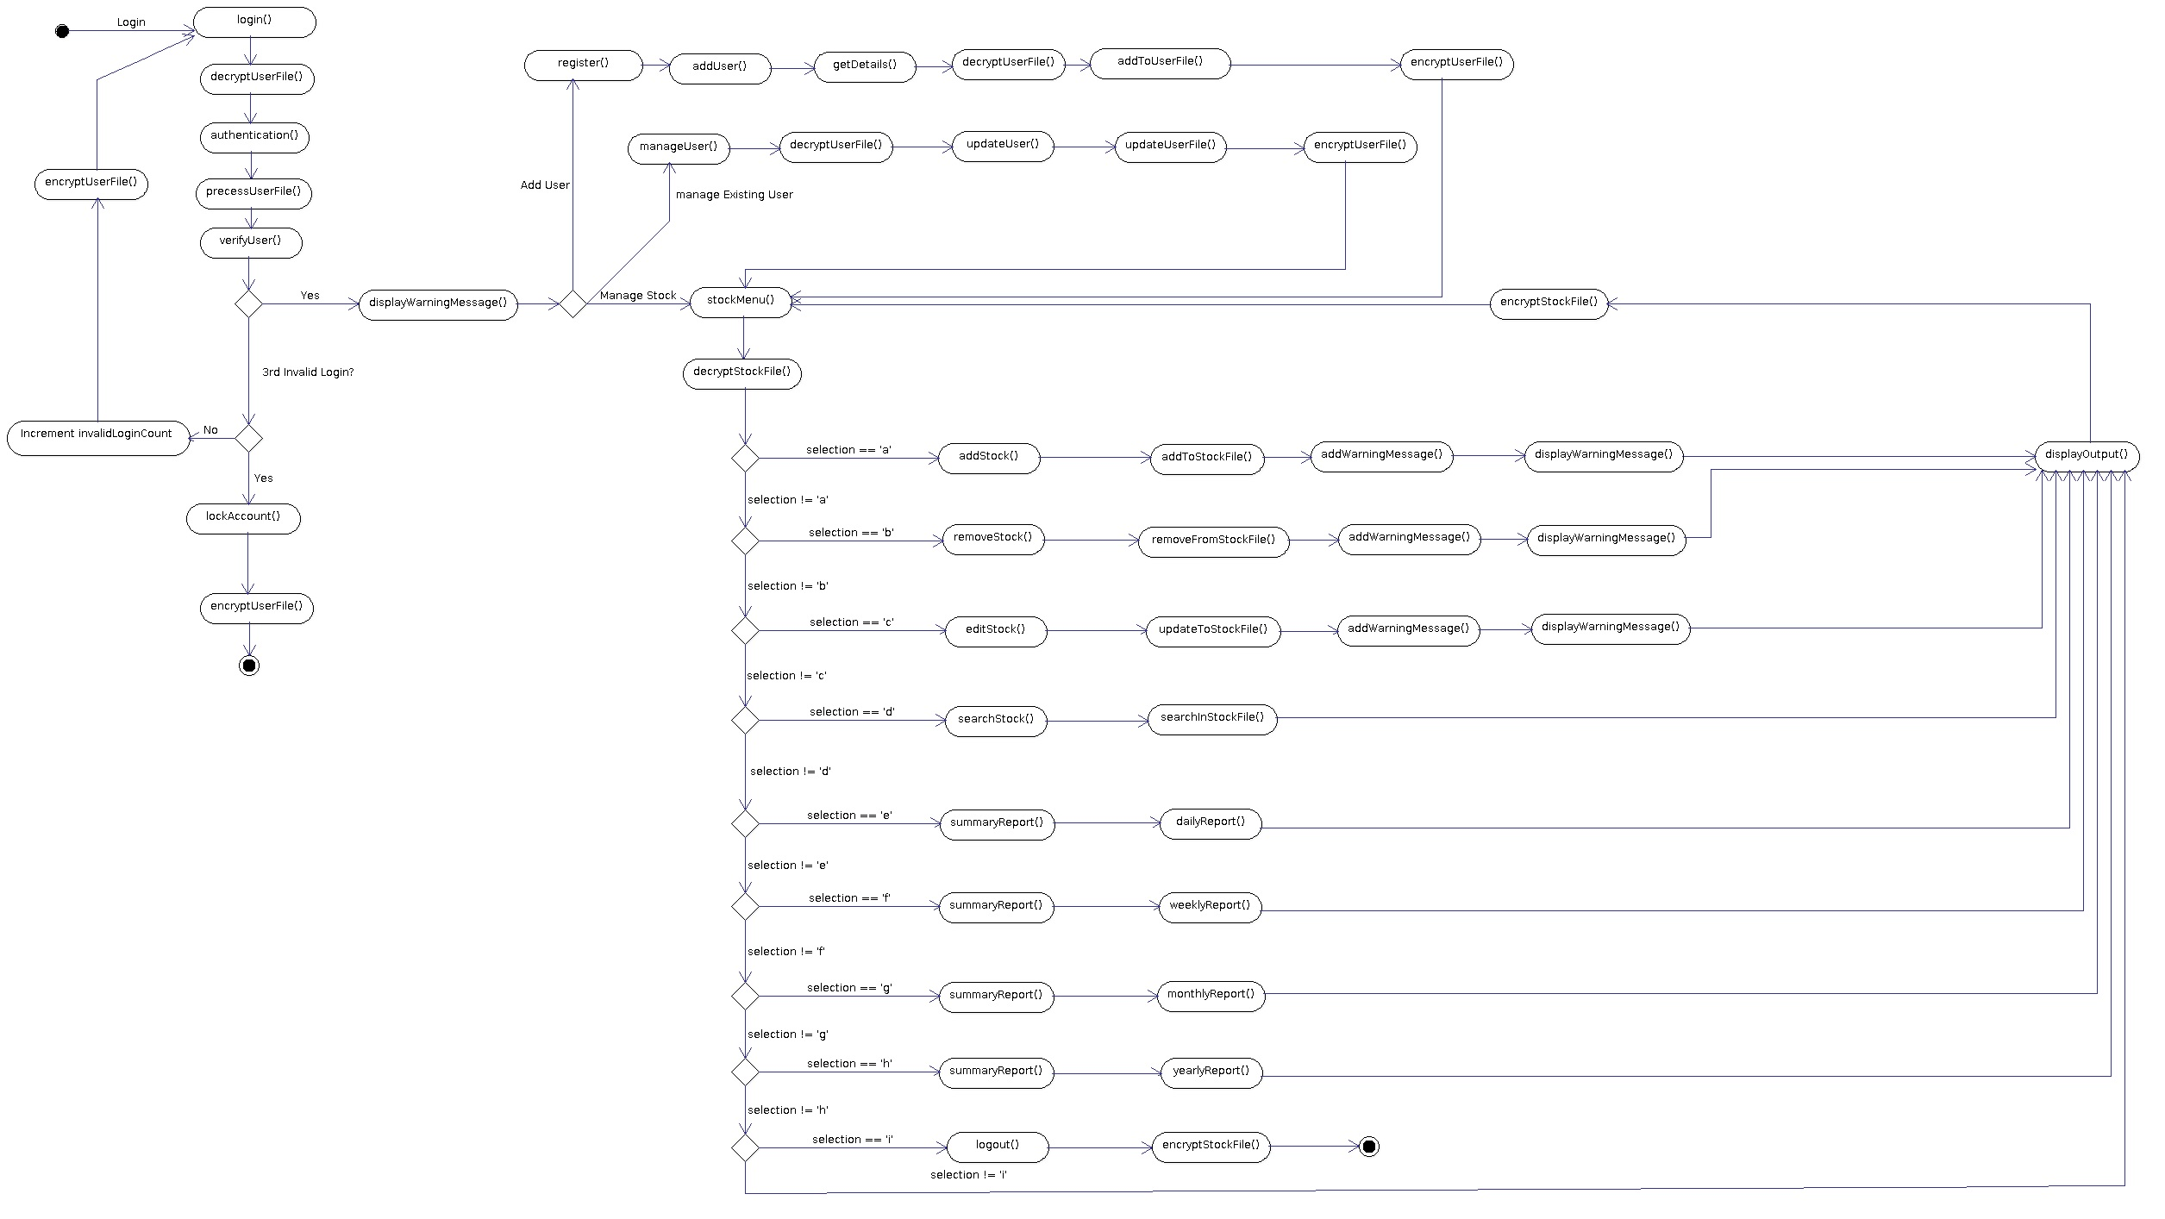

Component Diagram – Iteration 1

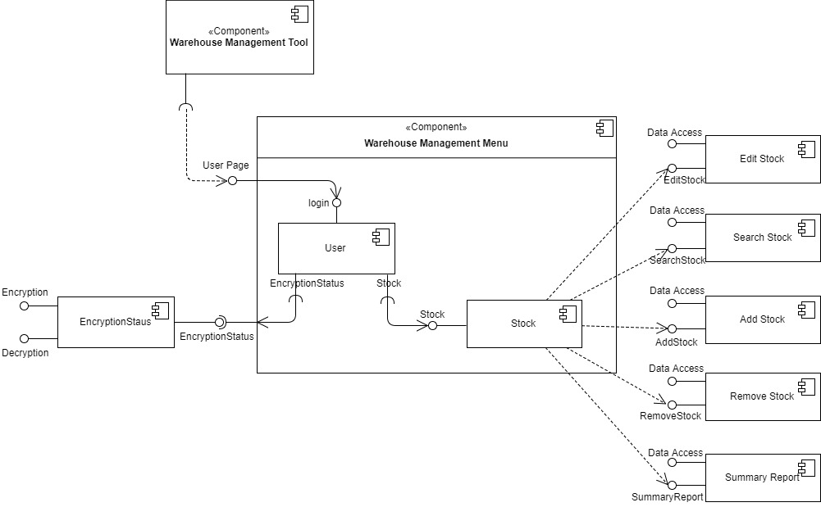

Component Diagram – Iteration 2

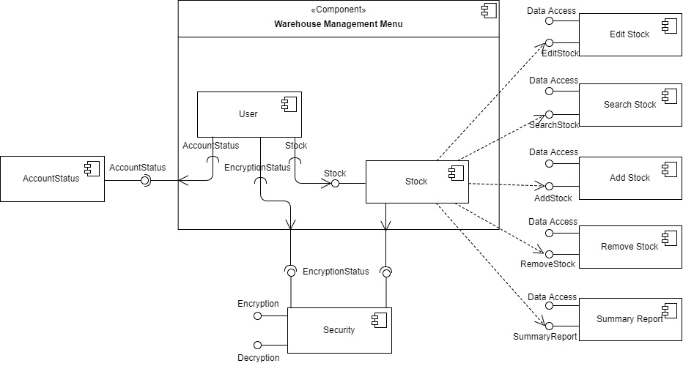

Class Diagram – Iteration 1

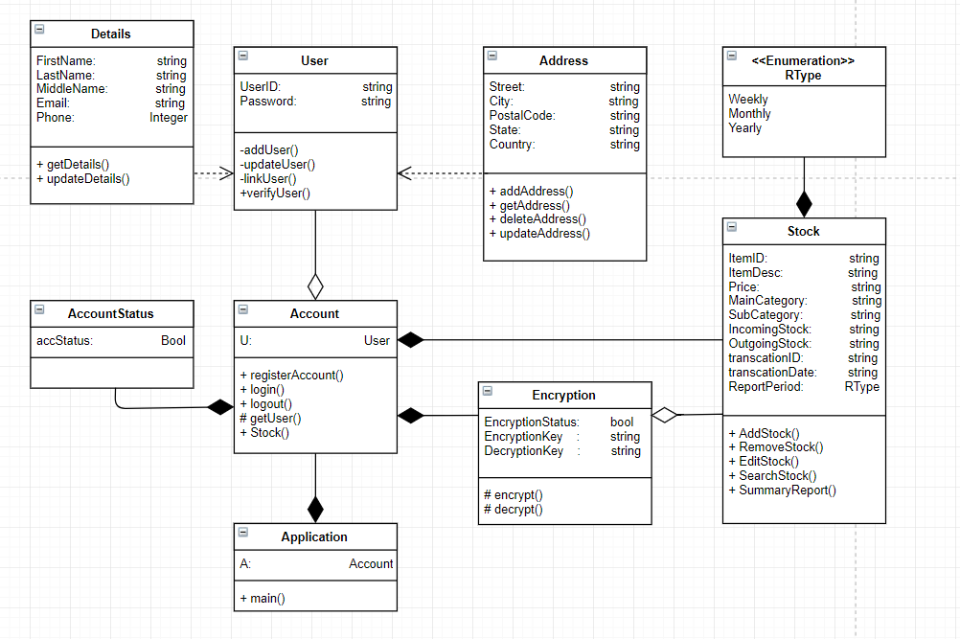

Class Diagram – Iteration 2

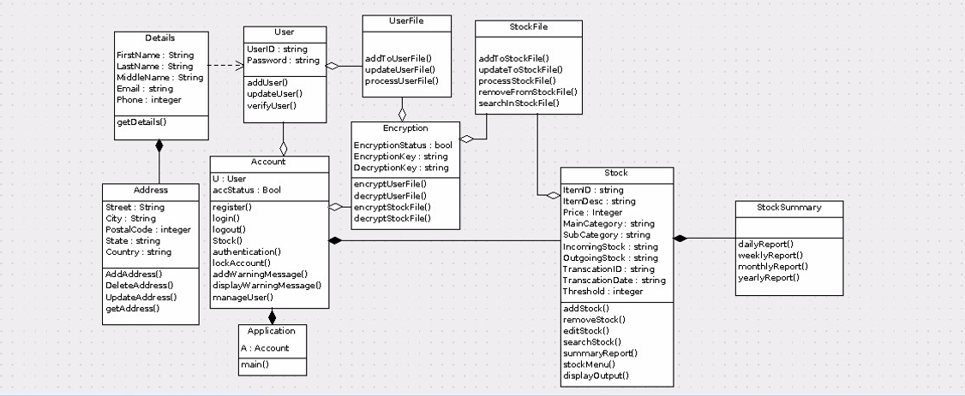

Appendix A - Formal Meeting Records

Inception Phase - Iteration 1
Location

The first team meeting was held at SIM HQ Block A on 01/02/2018 at 1530hrs which then ended at 1730hrs with a total duration of 2 hours.

Project Status

The design for a new warehouse management tool was assigned to the group.

Discussion

During the meeting, the team has discussed together as a group on how the initial use case model should be and the class diagram was drawn out on a piece of paper. We also discussed on the different tasks each member is supposed to complete and set the dateline for each task.

Task Allocation

After the discussion was done, the team decided to have Siddharth to draft up the Project Overview, Evan to construct the first Use Case Iteration and Darren to construct the first Class Diagram.
As shown in the table below.

Task | Assigned To
Project Overview | Siddharth
Project Plan Gantt Chart | Justine
Use Case Diagram | Evan
Class Diagram | Darren

By the next meeting, the Use Case Diagram and Class Diagram should be ready as discussed by the group.

Elaboration Phase - Iteration 1
Location

The second team meeting was held at SIM HQ Block A on 02/02/2018 at 1300hrs which then ended at 1600hrs with a total duration of 3 hours.

Progress Status

The project overview is partially completed with the introduction and vision. The Use Case Diagram and the Class Diagram for the first iteration were also done.

Project Status

Use Case Diagram and Class Diagram for the first iteration is completed. This completes the inception phase for the first iteration and now we moved on to the elaboration phase for the first iteration.

Discussion

During the discussion, the team came up with different diagrams which were needed to help in elaboration on how the system would work. Also, different diagrams were distributed for each individual member to complete before deadline i.e. next meeting.

Task Allocation

After going through the class diagram and use case diagram together as a team again, Evan was tasked to construct the Detailed Use Case Diagram, Siddharth for the Activity Workflow Diagram, Pavinder and Dominic for the Sequence Diagram and Justine for the component Diagram.

Task | Assigned To
Detailed Use Case Diagram | Evan
Activity Workflow Diagram | Siddharth
Sequence Diagram | Pavinder and Dominic
Component Diagram | Justine

By the next meeting, all the diagrams should be done and ready for vetting by the group.

Inception Phase - Iteration 2
Location

The third team meeting was held at SIM HQ Block A on 05/02/2018, commencing at 1200hrs and ended at 1600hrs. A total of 4 hours.

Progress Status

The Detailed Use Case Diagram, Activity Workflow Diagram, Sequence Diagram and Component Diagram for the first iterations are all done. Also, Siddharth has completed the Project Overview. The SRS has also been partially completed.

Discussion

After going through all the diagrams done before the third meeting, the team has decided to make more improvements to the diagrams so that the system can serve better with more enhanced functionalities. Hence, we started to go more in depth on the Use Case Diagram and Class Diagram. Nearing the end of the meeting, the team has come up with a finalized version of both the diagrams.

Task Allocation

After the discussion was done, Evan was allotted the task to finalize Use Case Iteration and Darren to finalize the Class Diagram.
As shown in the table below.

Task | Assigned To
Finalized Use Case Diagram | Evan
Finalized Class Diagram | Darren

By the next meeting, the finalized Use Case Diagram and Class Diagram should be ready as discussed by the group.

Elaboration Phase - Iteration 2
Location

The final team meeting was held at SIM HQ Block A on 06/02/2018, commencing at 1530hrs and ended at 1830hrs. A total of 3 hours.

Progress Status

The Use Case Diagram and Class Diagram have been finalized. Project Plan Gantt Chart has also been completed. SRS is nearing the final stage.

Project Status

The finalized Use Case Diagram and Class Diagram are completed. This completes the second iteration of the inception phase and now we move on to the elaboration phase for the final iteration.

Discussion

During the discussion, the team discussed on ways to improve on the different diagrams and how the diagrams would help the client better understand the Warehouse Management tool. Finally, we decided on having the individual members to work on the different diagrams to reconstruct the specific diagrams from the previous iteration. This concludes the last meeting that the team had and also each member’s task to complete their part of the report and send it to Justine who would then compile the report. Also, the tasks for individual member to complete their distributed parts of the SRS were assigned and Evan was allocated for compiling the SRS document.

Task Allocation

After going through the finalized class diagram and use case diagram together as a team again, Evan was tasked to finalized the Detailed Use Case Diagram, Siddharth for the Activity Workflow Diagram, Pavinder and Dominic for the Sequence Diagram and Justine for the component Diagram.

Task | Assigned To
Finalized Detailed Use Case Diagram | Evan
Finalized Activity Workflow Diagram | Siddharth
Finalized Sequence Diagram | Pavinder, Darren and Dominic
Finalized Component Diagram | Justine
Compiling of SRS | Evan
Compiling of Report | Justine

Appendix B - Individual Work Diaries

Team Member 1 : Siddharth Singh

Inception Phase - Iteration 1

As the manager for the group, I called all the team members for a formal meeting on 01/02/2018. The meeting started at 3:30 PM and lasted till 5:30 PM. In these 2 hours all the team members discussed the project. The goal for this meeting was to come up with an initial design for the system. After a lot of arguments, comments, and advancements, we settled with a design to go for this iteration. Everyone was asked to pick a task for the iteration. I chose to do the Project Overview as my part and the rest was divided equally in other members. We decided a deadline for the allocated task as 02/02/2018, the day for our next group meeting where all the allocated task was to be reviewed and the project to be progressed.

Elaboration Phase - Iteration 1

The second meeting was scheduled on 02/02/2018. All the team members came to discuss the Elaboration Phase for the iteration. This team meeting happened for 4 hours from 12:00 PM to 4:00 PM. We all brainstormed together on how the system should work. After the discussion, we split the task. I chose Activity Workflow diagram as my task and we decided to meet again on 05/02/2018. After this meeting, every day I spent 1 hour for the next 3 days to come up with a good Activity Work-Flow diagram.

Inception Phase - Iteration 2 (Optional)

The third meeting for the group was scheduled on 05/02/2018. This meeting’s goal was to review Iteration 1 and come up with a better design for the system and to minimize flaws in the Iteration 1’s system design. We debated a lot on the last design and finally we settled for a design for this Iteration. This meeting lasted for 4 hours from 12:00 PM to 4:00 PM and we decided our next meeting to be on 06/02/2018 for discussing the next phase.

Elaboration Phase - Iteration 2

The fourth meeting happened on 06/02/2018. This meeting lasted for 3 hours from 3:30 PM to 6:30 PM. In this meeting we discussed different diagrams for the iteration. After all the discussion, we split the task and I chose Activity Work-Flow Diagram for my part. I spent 2 hours each day for the next 2 days to develop Activity Work-Flow Diagram.
We all put our best efforts to make our system as good as possible.

Team Member '2' : Darren Toh

Inception Phase - Iteration 1

During the initial inception phase 1, the team had the first meeting at SIM on 1st Feb 2018 at 1530 hours. The team then sat down to brainstormed and eventually we came up with many different ideas. After some team discussion and thoughts to it, we came to the conclusion of that there would be a user who will access the stock in the program. The use case and class diagram was designed for a single user as for now. I was then tasked to do the class diagram and project overview by the team leader. The team meeting then ended at 1730 hours with a total duration of 2 hours dedicated to do the planning.

Inception Phase - Iteration 2

During the third meeting, the team met up in SIM again on 5th Feb 2018 at 1200 hours. The team then discovered that our use case is lacking encryption and decryption of the stocks This is so as such that stock details could be viewed by potential hackers if leaked, and the encryption would be there to prevent it. Also, we then realised that we missed a crucial information – the system should lock the user out if the user fails his/her login attempts more than 3 times. Adjustments were then added to make sure that our diagram are all in order. As most of the changes would affect the class diagram, I was tasked to finalize the class diagram by the next meeting and send to the team. The team meeting then ended at 1600 hours with a total duration of 4 hours.

Elaboration Phase - Iteration 1

The second meeting was on 2nd Feb 2018 at 1300 hours which the team met up to do the stuffs that we lack for iteration 1 – sequence diagram, activity diagram and component diagram. The project overview is partially done and then I was then tasked to complete it before the next meeting. This meeting concludes the end of iteration 1 as we have decided that all the current work is finalized and the team would then proceed to iteration 2 for the next meeting. The team also came up with different diagrams which are needed to help elaborate how our system would work. The team meeting then ended at 1600 hours with a total duration of 3 hours.

Elaboration Phase - Iteration 2

The fourth team meeting was at SIM again on 6th Feb 2018 at 1530 hours. Most of the diagrams and tasks that were assigned to the team members were completed. SRS was left at its final stage of completion. The SRS report was split up among the members such that everyone had an equal amount of work to do. Also, some minor and final changes were added to certain diagrams and all of the diagrams were sent to Justine for compilation – for the team report. During this meeting, I was tasked to complete and finalize the minor changes for the sequence diagram. The team meeting ended at 1830 hours with a total duration of 3 hours. It was then the last meeting that the team had.

Team Member '3' : Evan Emmanuel Ong Zong Jian

Inception Phase - Iteration 1

On the 1st of February 2018, we commenced Inception phase , we discussed the first version of our use case and class diagrams. During discussion we mapped out the rough classes and main use cases we could think of. We then proceeded to implement it into our diagrams, I mainly focused on construction of the use case diagram. While Darren mainly constructed the class diagrams. After that we discussed on some things in the future that might be done in future meetings. We discussed on potential things to add or not and what to be expected to do for the project.

Inception Phase - Iteration 2

On the 5th of February 2018, after reviewing our diagrams, we realized that our overall system lacked certain features that we wanted to include. We lacked certain key features like encryption and decryption as well as locking the user out when too many attempts were used. After much discussion, many new classes and methods were added to the relevant diagrams by us. We also got rid of redundant classes like, AccountStatus which was merged into the overall account class.

Difficulties we faced were the tedious task of converting iteration 1 with the new and improved features to iteration 2 and making sure it was all synced properly.

Elaboration Phase - Iteration 1

On the 2nd of February 2018, after completing the first inception phase, referencing the completed use case diagram and class diagram. We started to discuss about the relevant diagrams/documentation to create to support our inception of our system. It was decided that we would create four different diagrams to elaborate more on how the system flows so that there would be better understanding in our creation of it. These diagrams/documents included, detailed use case, sequence diagram, component diagram and activity diagram. During this time, work was split between the group and I was tasked with creating the detailed use case diagrams. Difficulties faced were to have a constant sync with all the diagrams so that the overall representation of the system in the diagrams were accurate.

Elaboration Phase - Iteration 2

On the 6th of February 2018, we commenced the second inception, we had a clear idea of our final product and the additional features we were going to add into the system after discussion looking back at our improved class and use case diagrams. We then proceeded to creating our iteration 2 of the respective diagrams. I continued to work on the new iteration detailed use case diagrams. Once again, the only difficulty was in syncing our diagrams together. Once done, I went to work on the SRS for the report side work of the project.

Team Member ‘4’ : Yeo Shun Yuan Justine
Inception Phase - Iteration 1

On 01/02/2018, I was called in for a team meeting by the manager for a discussion regarding the design of the new project on a Warehouse Management tool. During the meeting, we sat down and discussed about the project overview and how the initial use case model and class diagram should be like. I was then tasked to create the Project Plan Gantt Chart. After the meeting I went back and thought about what type of diagrams would be able to help get a better understanding of our thoughts.

Inception Phase - Iteration 2

On 05/02/2018, I was called in for a third meeting. During this meeting, we went through all the diagrams done together as a team. From there, we found out that there are some missing factors that the team did not think of during the first inception phase. After which, we discussed on how we could improve on the Use Case and Class Diagram again. By the end of the meeting, we were able to draft up the finalized Use Case and Class Diagram which were left to be reconstructed by Evan and Darren.

Elaboration Phase - Iteration 1

On 02/02/2018, I went for the team’s second meeting. In this meeting, we went through the completed Use Case and Class Diagram that Evan and Darren were tasked to construct respectively after the first meeting. After which, we went on to discuss about the different diagrams. After which, I was tasked to construct a Component diagram following the initial Use Case and Class Diagram before the next meeting. I then had to go back and research on how a Component Diagram is done before starting to construct the diagram. Luckily, I was able to complete the Diagram on time.

Elaboration Phase - Iteration 2

At our final meeting on 06/02/208, we went through the finalized Use Case and Class Diagram again to ensure that there is no mistake during the construction. After which, we moved on to discuss on how improvements can be made to the other existing diagrams and finalizing it. At the end of the meeting, I was tasked to reconstruct the Component Diagram and to take charge of compiling the report.

Team Member ‘5’ : Pavinder Singh S/O Gurmit
Inception Phase - Iteration 1

a) 1st and 2nd Feb 2018
b) Project briefing, Task Distribution, Use case 1, Class Diagram 1
In the Inception phase, our team brainstormed and came up with the use case 1 and class diagram 1 stated above in our report in accordance to the functionality of what the Owner of the warehouse Management (WM) wanted. The use case and class diagram was designed for single user only.
Use case and class diagram are according to what we feel when first view the Assignment 1.

Inception Phase - Iteration 2 (Optional)

a) 3rd and 5th Feb 2018

b) Use case diagram iteration 2

In the Iteration 2, we discovered that our use case, lacked the, decryption and encryption of the stock items which also reflected in our class diagram. In addition, it also lacked the login part where if owner fails to login 3 times, he would be locked from the system. Adjustment were made to iteration 2 for multiple users to access the system. Thus, relevant adjustments were made to the use case and the class diagram.

Elaboration Phase - Iteration 1

a) 6th Feb 2018
b) Sequence Diagram 1
In Elaboration phase, using our use case 1 and class diagram for iteration 1. We came out with the sequence diagram 1, Activity diagram 2 and the component diagram 2.
Doing all of them at once was a problem as we had to make sure every class, attributes, functions were in sync.
Elaboration Phase - Iteration 2

a) 10th Feb 2018

b) Report, Synchronization of diagrams, Sequence Diagram 2

In Elaboration phase, seeing that we adjusted the use case and class diagram for iteration 2, we changed our sequence diagram 2, Activity diagram 2 and the component diagram 2.

After changing, we had to make one last check whether they are in order and correct, then, compile them into the ppt for presentation.

Team Member ‘6’ : Chong Chuan Bin, Dominic
Inception Phase - Iteration 1

a) 1st Feb 2018
b) Project briefing, Task allocation, Use case 1, Class Diagram 1
The Project briefing is for us to identify the actors, classes and attributes for our diagrams which took us roughly 2 hours, we had problems deciding on whether some actors or classes should be included or not. We split the tasks based on diagrams that we were more confident in. A rough use case and class diagram during this period based on first impression of the Assn 1.

Inception Phase - Iteration 2

a) 5th Feb 2018

b) Sequence diagram 1 and Use case diagram iteration 2.

In iteration 2, decryption and encryption were left out in iteration 1 which was required which we added in. Related to the decryption and encryption, we also have to cater to the locking of the account (Where the user fails to key In the correct user and password more than three times). Due to this change, we’ll have to change every diagram.

Elaboration Phase - Iteration 1

a) 2nd Feb 2018
b) Sequence Diagram 2
In Elaboration phase, using our use case 1 and class diagram for iteration 1. We came out with the sequence diagram, Activity diagram and the component diagram, Synchronization is a difficult part for this way as while we were synchronizing, we realized that a class diagram/use case were lacking of some information.

Elaboration Phase - Iteration 2

a) 6th Feb 2018

b) Report, Synchronization of diagrams

In Elaboration phase, whatever changes we made to the use case and class diagram, we‘ll have to sync with the other diagrams. We will have to cross check with other diagrams whether every information is correct

