*Bank Application*

Wireframe Documentation

*1*.MainBankApplication: This is the main page of Banking Application. Execution will start from here. It is just like Homepage.

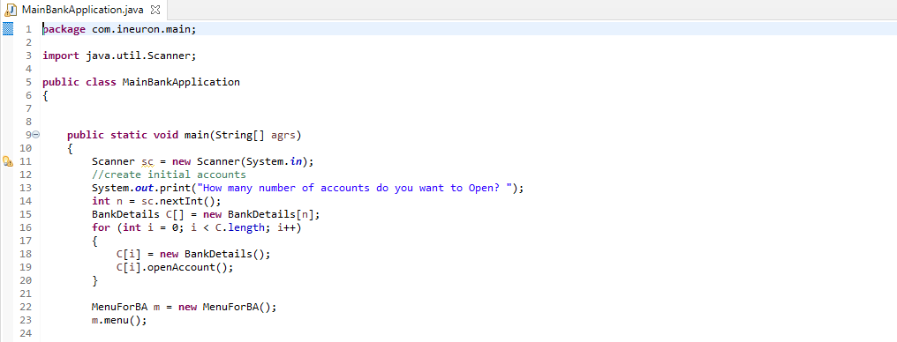

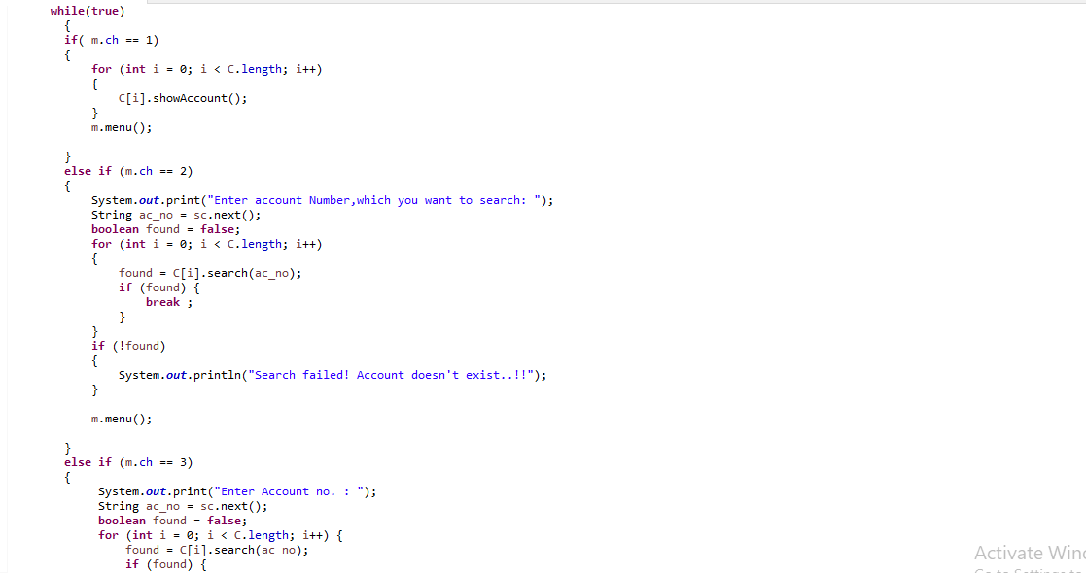

2.MenuForBA: Bank Operation related menu present here.

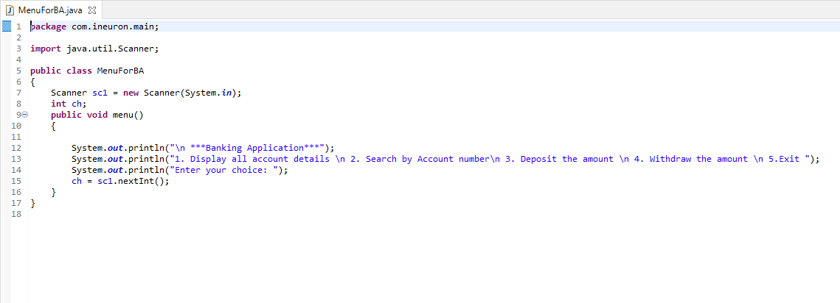

3.BankDetails: This class is sole of the Banking Application. All the operation related task written here.

