Healthcare Data Pipeline
End-to-End Azure Data Engineering Project
Project Documentation
Repository  Customer_Account_Analysis_Pipeline_TeamName | Tech Stack  Azure Data Factory | Databricks | PySpark  ADLS Gen2 | Azure SQL | Power BI

README.md
Project Overview
This project implements a full end-to-end Azure Data Engineering pipeline for a healthcare dataset. Raw patient data is ingested from an HTTP source into the Bronze layer, cleaned and standardised in the Silver layer, and aggregated into 12 Power BI-ready tables stored in both the Gold layer (ADLS Parquet) and Azure SQL Database.
The pipeline follows the Medallion Architecture (Bronze → Silver → Gold) and is orchestrated entirely by Azure Data Factory.

Architecture

Diagram

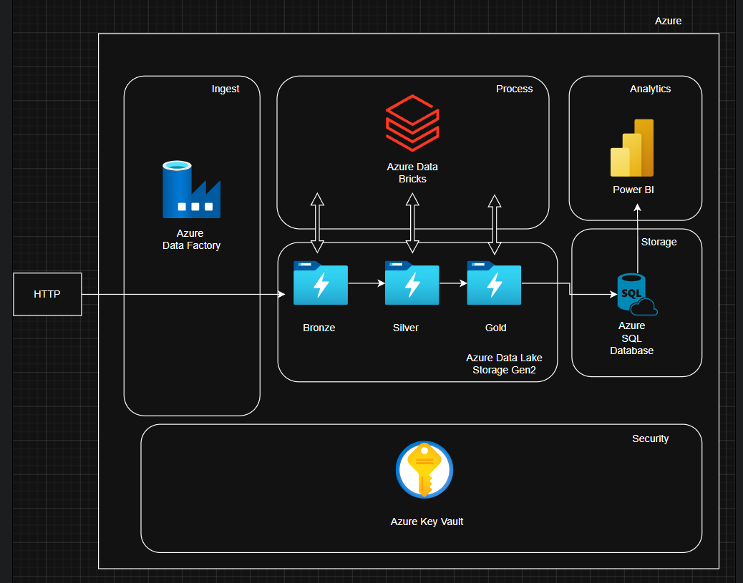

Layer | Description
Bronze | Raw CSV data copied from Kaggle HTTP source via ADF Copy Activity into ADLS Gen2
Silver | Cleaned & typed Parquet data — MinorTransformation Databricks notebook
Gold | 12 aggregated Parquet tables partitioned for analytics — MajorTransformation notebook
Azure SQL | Same 12 tables loaded via JDBC for direct Power BI Import / DirectQuery
Power BI | 6 chart visuals + KPI cards connected to Azure SQL

Setup Steps

- Create ADLS Gen2 storage account adlstoragesiddharth with containers: bronze, silver, gold
- Create Azure SQL Database AzureSQLDB on server sqldbc37.database.windows.net
- Create Databricks workspace and store ADLS key in secret scope DBSecrets under key adls
- Store SQL password in DBSecrets under key azsqldb
- Create Azure Data Factory and configure linked services: HTTP source, ADLS Gen2 sink, Databricks
- Upload MinorTransformation.ipynb and Major_Transformation_SQLandGold.ipynb to Databricks
- Deploy and trigger the HealthDataset_Pipeline in ADF
- Connect Power BI Desktop to Azure SQL and build visuals from the 12 tables

Contributors
- Siddharth Pal — Pipeline Architecture, PySpark Transformations, ADF Orchestration

Folder Structure

Customer_Account_Analysis_Pipeline_TeamName/
├── Documentation/
│ ├── Step_1_ADF_Ingestion.md
│ ├── Step_2_Minor_Transformation.md
│ ├── Step_3_Major_Transformation_Gold.md
│ └── Step_4_PowerBI_Visualisation.md
├── Code/
│ ├── minor_transformation.ipynb
│ ├── major_transformation_sql_and_gold.ipynb
│ └── health_dataset_pipeline.json
├── Screenshots/
│ ├── Step_1_Screenshot_1_ADF_Pipeline_Overview.png
│ ├── Step_1_Screenshot_2_Copy_Activity_Config.png
│ ├── Step_2_Screenshot_1_Silver_Parquet_Output.png
│ ├── Step_3_Screenshot_1_Gold_ADLS_Folders.png
│ ├── Step_3_Screenshot_2_SQL_Tables.png
│ └── Step_4_Screenshot_1_PowerBI_Dashboard.png
└── README.md

Naming Conventions
Artefact Type | Convention | Example
Documentation | Step_X_Description.md | Step_2_Minor_Transformation.md
Code files | snake_case | minor_transformation.ipynb
Screenshots | Step_X_Screenshot_Y_Description | Step_3_Screenshot_1_Gold_ADLS_Folders.png
ADF Pipeline | PascalCase JSON export | health_dataset_pipeline.json
Git repository | PascalCase with underscores | Customer_Account_Analysis_Pipeline_TeamName

Step 1 — ADF Data Ingestion (HTTP → Bronze)

Overview
Azure Data Factory copies the raw healthcare CSV from a Kaggle HTTP endpoint into the Bronze container of ADLS Gen2. This is the first activity in the HealthDataset_Pipeline and acts as the entry point for all downstream processing.

Configuration
Setting | Value
Activity type | Copy Activity
Source type | DelimitedTextSource (HTTP)
Request method | GET
Compression | ZipDeflate
Sink type | DelimitedTextSink (ADLS Gen2)
Copy behaviour | FlattenHierarchy
File extension | .csv
Quote all text | true
Staging enabled | false
Timeout | 12 hours
Retry | 0
Sink container | bronze
Sink folder | Healthcare_Dataset
Input dataset | HealthcareData
Output dataset | HeathCareData

ADF Pipeline JSON — Key Extract

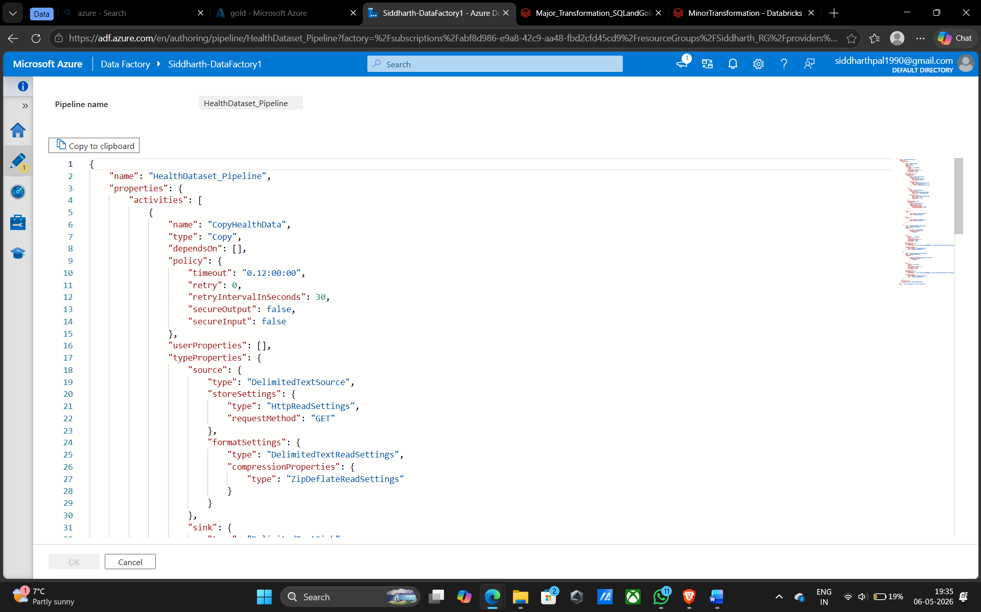

Challenges & Resolutions
Challenge | Resolution
ZIP compression on HTTP source | Added ZipDeflateReadSettings to formatSettings so ADF auto-decompresses on download
Special characters in CSV | Enabled quoteAllText on the sink and set quote/escape chars in the downstream Spark reader
Pipeline dependency ordering | Set CopyHealthData as the predecessor so Databricks notebooks only trigger after copy succeeds

Step 2 — Minor Transformation (Bronze → Silver)

Overview
The MinorTransformation Databricks notebook reads raw CSV from Bronze, applies cleaning and type-casting, filters invalid records, and writes the result as Parquet to the Silver layer. This is the second activity in the pipeline and runs only after the Copy Activity succeeds.

Configuration
Setting | Value
Notebook path | /Users/siddharthpal1990@gmail.com/Transformation_PySpark/MinorTransformation
Linked service | AzureDatabricksLS
Activity type | DatabricksNotebook
Depends on | CopyHealthData — Succeeded
Timeout | 12 hours
Source path | abfss://bronze@adlstoragesiddharth.dfs.core.windows.net/Healthcare_Dataset
Sink path | abfss://silver@adlstoragesiddharth.dfs.core.windows.net/healthcare/patient_data
Output format | Parquet (overwrite mode)
Spark app name | Healthcare_Bronze_to_Silver_Parquet

Transformations Applied
Column | Operation | Detail
Name | initcap + trim | Standardises casing, removes whitespace
Gender | initcap + trim | Standardises casing
Blood Type | upper + trim | Ensures e.g. AB- not ab-
Medical Condition | initcap + trim | Standardises casing
Doctor | initcap + trim | Standardises casing
Insurance Provider | initcap + trim | Standardises casing
Medication | initcap + trim | Standardises casing
Test Results | initcap + trim | Standardises casing
Hospital | regexp_replace + initcap | Strips quotes and commas, then standardises
Age | cast IntegerType | Ensures integer; filtered Age > 0 and < 120
Billing Amount | cast DoubleType | Ensures double; filtered >= 0
Room Number | cast IntegerType | Ensures integer
Date of Admission | to_date | Parses string to DateType
Discharge Date | to_date | Parses string to DateType
processed_at | current_timestamp() | Audit column added at write time

Code 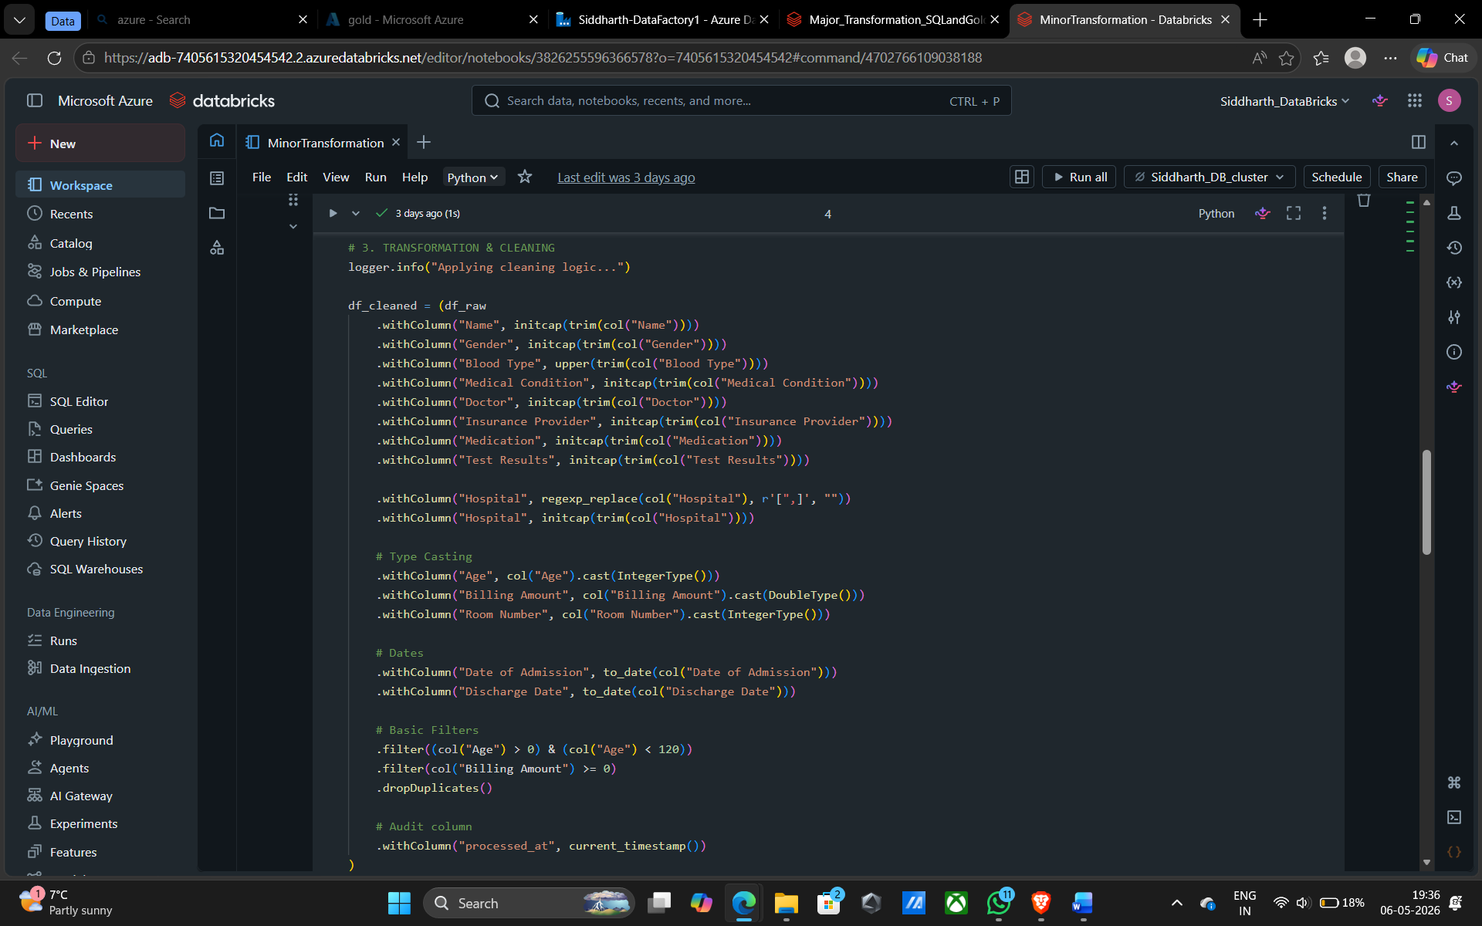

Challenges & Resolutions
Challenge | Resolution
Hospital names with embedded commas | Used regexp_replace to strip quotes and commas before initcap
NameError on df_patient_demographics | Fixed in Major Transformation — each table defined in its own isolated cell so failures are independent
inferSchema slowness on large CSV | Acceptable for one-time or scheduled daily load; can pin schema explicitly if latency becomes an issue

Step 3 — Major Transformation (Silver → Gold + Azure SQL)

Overview
The Major_Transformation_SQLandGold notebook reads cleaned Parquet from Silver, produces 12 aggregated DataFrames, and writes each one to two destinations simultaneously: the Gold layer on ADLS as partitioned Parquet, and Azure SQL Database via JDBC for Power BI consumption.

Configuration
Setting | Value
Notebook path | /Users/siddharthpal1990@gmail.com/Transformation_PySpark/Major_Transformation_SQLandGold
Linked service | AzureDatabricksLS
Activity type | DatabricksNotebook
Depends on | Notebook_DataBricks_MinTransfm — Succeeded
Silver source | abfss://silver@adlstoragesiddharth.dfs.core.windows.net/healthcare/patient_data
Gold base path | abfss://gold@adlstoragesiddharth.dfs.core.windows.net/healthcare
SQL server | sqldbc37.database.windows.net
SQL database | AzureSQLDB
SQL user | siddharthdb
SQL driver | com.microsoft.sqlserver.jdbc.SQLServerDriver
Write mode | overwrite (both destinations)

12 Aggregated Tables
# | SQL / Gold Table | Partition By | Power BI Visual
1 | patient_age_group_summary | — | Hospital Usage by Age Group (bar)
2 | age_group_condition_summary | age_group | Medical Conditions Across Age Groups (stacked)
3 | insurance_avg_billing_summary | — | Average Billing by Insurance Provider (bar)
4 | gender_condition_summary | gender | Medical Condition by Gender (stacked)
5 | blood_type_condition_summary | blood_type | Blood Type vs Medical Condition (stacked)
6 | condition_billing_summary | — | Average Billing by Medical Condition (bar)
7 | patient_demographics | gender | Patient dimension table
8 | medical_conditions_summary | — | Condition-level KPIs
9 | hospital_performance_metrics | — | Hospital-level KPIs
10 | doctor_performance_summary | — | Doctor-level KPIs
11 | admission_type_analysis | admission_type | Admission type KPIs
12 | insurance_provider_analysis | — | Insurer-level KPIs

Gold Layer Path Structure

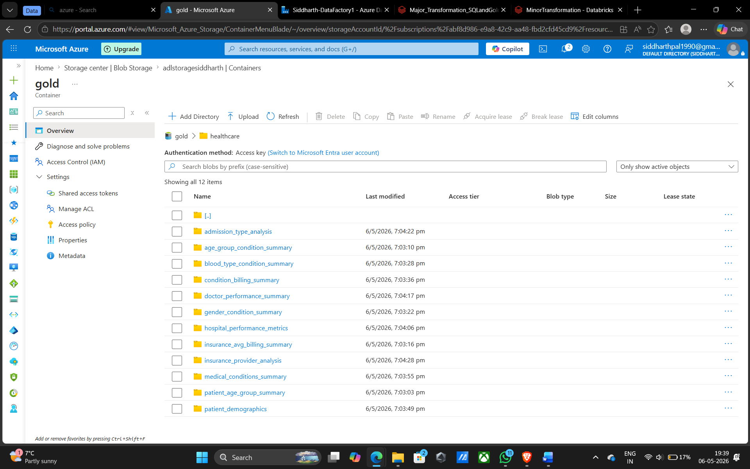

Age Group Derivation Logic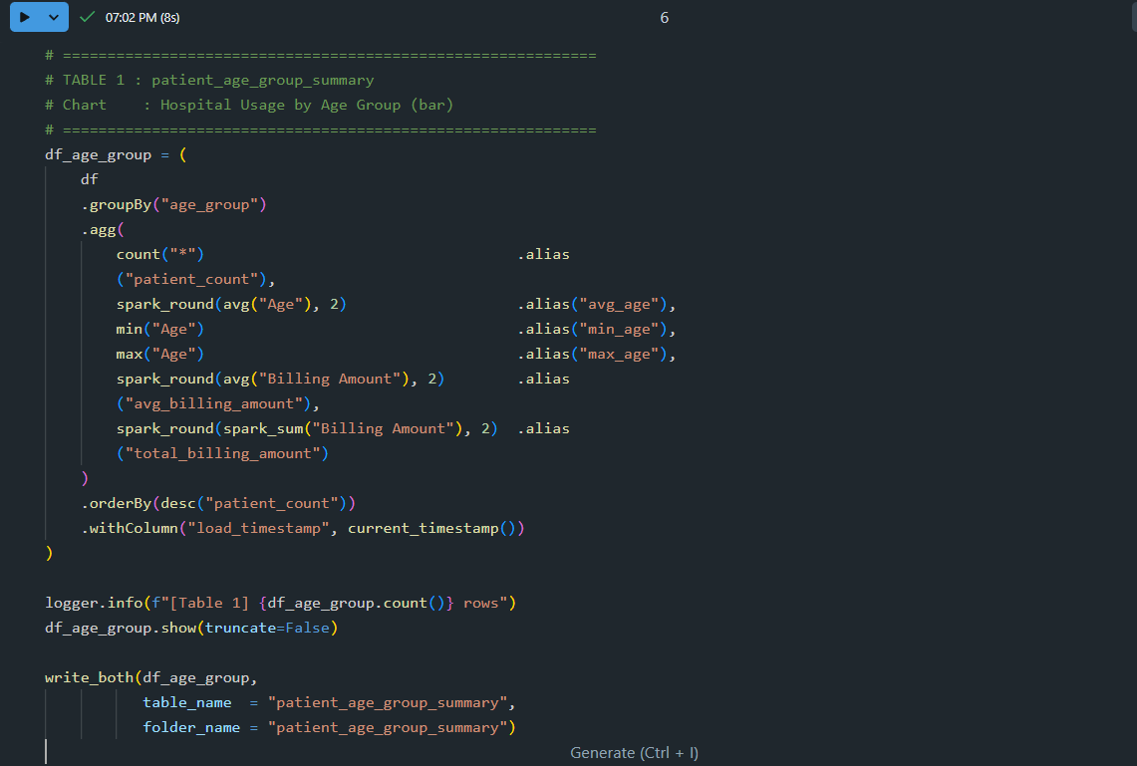

Challenges & Resolutions
Challenge | Resolution
NameError: df_patient_demographics | Moved each table into its own cell — errors are now isolated and the pipeline continues for other tables
SQL JDBC timeout on large writes | Kept write mode as overwrite with no staging; connection timeout set to 30s in the JDBC URL
Gold path conflict with Silver | Used a separate gold container and healthcare/ subfolder, matching the existing abfss://gold@ path convention
Partitioning strategy | Only low-cardinality columns (gender, age_group, blood_type, admission_type) used as partition keys to avoid too many small files

Step 4 — Power BI Visualisation

Overview
Power BI Desktop connects to Azure SQL Database (Import mode) and renders 6 chart visuals and KPI cards. All 12 tables are loaded; slicers applied to any visual automatically cross-filter the entire dashboard via Power BI's relationship model.

Connection Setup
Setting | Value
Data source | Azure SQL Database
Server | sqldbc37.database.windows.net
Database | AzureSQLDB
Authentication | Database — SQL credentials
Connectivity mode | Import
Tables loaded | All 12 (see Step 3 table list)

Chart Mapping
Visual / Chart | Type | SQL Table | Field Mapping
Hospital Usage by Age Group | Clustered Bar | patient_age_group_summary | X: age_group | Y: patient_count
Medical Conditions × Age Group | Stacked Bar | age_group_condition_summary | X: age_group | Y: patient_count | Legend: medical_condition
Avg Billing by Insurance Provider | Clustered Bar | insurance_avg_billing_summary | X: insurance_provider | Y: avg_billing_amount
Medical Condition by Gender | Stacked Bar | gender_condition_summary | X: gender | Y: patient_count | Legend: medical_condition
Blood Type vs Medical Condition | Stacked Bar | blood_type_condition_summary | X: blood_type | Y: patient_count | Legend: medical_condition
Avg Billing by Medical Condition | Clustered Bar | condition_billing_summary | X: medical_condition | Y: avg_billing_amount

- Add KPI cards at top: Insert → Card → patient_count (SUM), avg_billing_amount
- Refresh: after re-running the Databricks pipeline, click Refresh in Power BI — all visuals update

Challenges & Resolutions
Challenge | Resolution
Cross-filter not working on slicers | Go to Model view and verify relationships between patient_demographics and summary tables on shared columns (medical_condition, admission_type)
Bars not sorted as expected | Use Sort axis menu on the visual, not column sort in the data pane
Billing values showing as integers | Change value format to Fixed decimal / $ English (US) in Format pane
All bars same height (avg billing) | Expected — billing is uniformly distributed across insurers and conditions in this dataset

Submission
Github: siddharthpal18/HealthCare-Data-Pipeline-End-to-End-DE
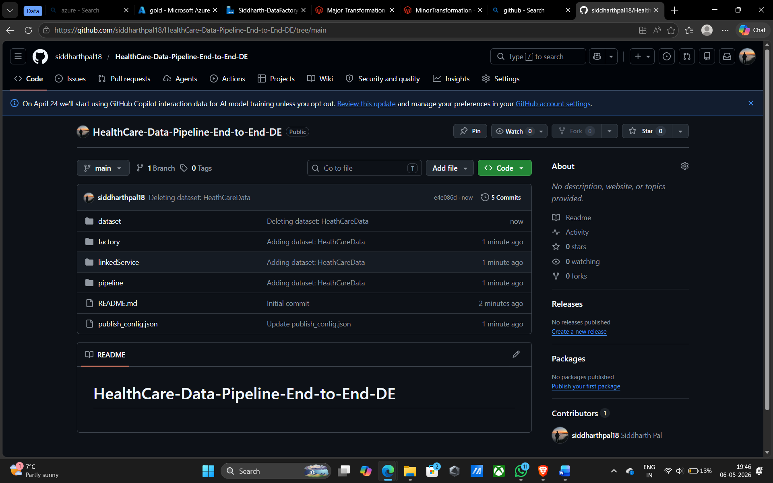

Documentation folder
- Step_1_ADF_Ingestion.md — brief steps, ADF JSON config, Copy Activity settings, challenges
- Step_2_Minor_Transformation.md — transformation table, PySpark snippet, Silver path, challenges
- Step_3_Major_Transformation_Gold.md — 12 tables list, dual-write helper code, Gold path structure, challenges
- Step_4_PowerBI_Visualisation.md — chart mapping table, Power BI connection settings, polish checklist

Code folder
- minor_transformation.ipynb — MinorTransformation notebook (snake_case filename)
- major_transformation_sql_and_gold.ipynb — MajorTransformation notebook
- health_dataset_pipeline.json — ADF pipeline JSON export

Screenshots folder
- Step_1_Screenshot_1_ADF_Pipeline_Overview.png
- Step_1_Screenshot_2_Copy_Activity_Config.png
- Step_2_Screenshot_1_Silver_Parquet_Output.png
- Step_3_Screenshot_1_Gold_ADLS_Folders.png
- Step_3_Screenshot_2_SQL_Tables.png
- Step_4_Screenshot_1_PowerBI_Dashboard.png

Repository
- README.md present at root
- Repository name: Customer_Account_Analysis_Pipeline_TeamName
- No secrets, keys, or passwords committed — all accessed via dbutils.secrets
- All notebooks run top-to-bottom without errors before submission

