**Globetrotter**

For my android project, I plan to implement the same app that I have already implemented on the iOS platform.

The goal is to have an app that a user can keep as a journal for all the places they’ve been, a brief description of a memory along with a picture to remind the users of the amazing experiences that they’ve had.

It is intended for anyone and everyone who likes to travel and see new places.

The mockups are the same as the iOS mockups (mentioned below) except there won’t be a back button on the navigation bar and instead will be as default on android phones. The rest of the UI elements will remain the same.

1. **Homescreen**

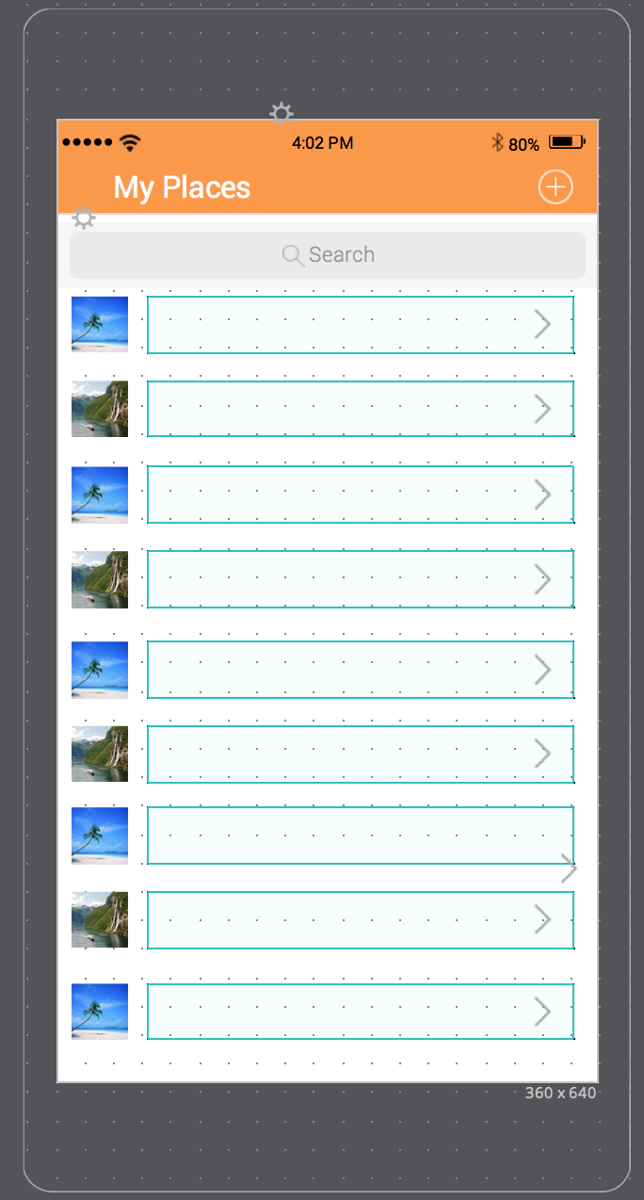

1. **New places**

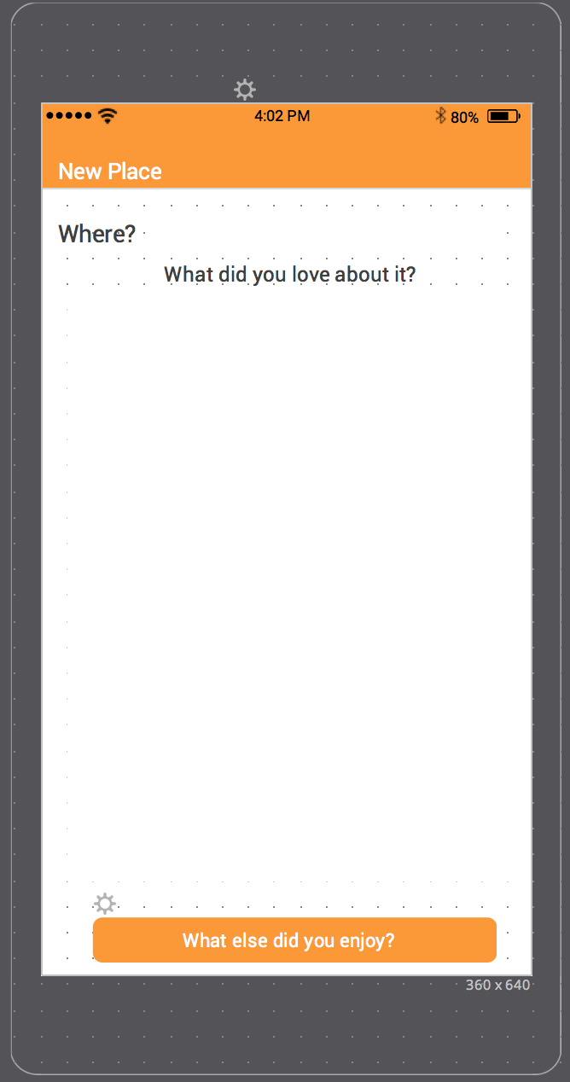

1. **New Place Extra**

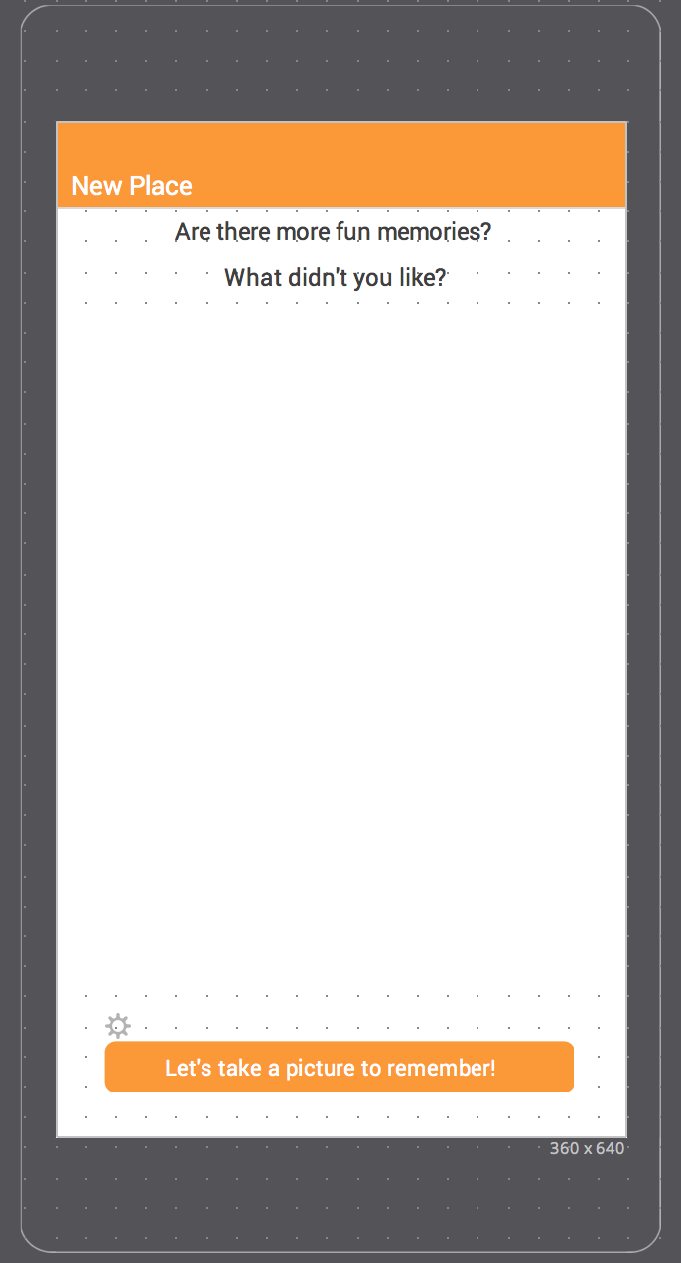

1. **New Place Image**

