**Digital Journal (To be renamed!)**

Instead of having just a photo that could get lost in a huge collection of photos and a vague memory of that photo, users can now have a description which serves as a highlight for each place they’ve visited.

The goal is to have an app that a user can keep as a journal for all the places they’ve been, a brief description of a memory along with a picture to remind the users of the amazing experiences that they’ve had.

It is intended for anyone and everyone who likes to travel and see new places.

All the content of the app will be entered by the user themselves. They can either take a picture from the camera or they can select a previously taken image from their gallery and enter a description or highlight of that memory as explained below

**Challenges:**

* Log in with facebook or gmail? Removes the need of having some backend database to manage this. Is it necessary though?
* Will too many images take up a lot of memory? Or will it be manageable?

**Possible Improvements:**

* If I include log in functionality with facebook, functionality to share it?

**Mockups:**

1. This will be the launch screen for the app

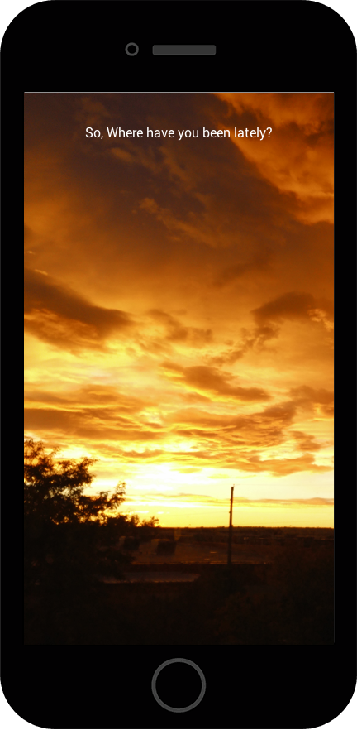

1. This will be a list of the places entered by the user. On the left will be a thumbnail image of each place that the user has chosen. The text will be the name of each place that the user has entered. The top left is a search icon which allows the user to search for a place. The top right is a button which allows the user to add a new place.

PS: Was not able to mockup a tableview, however, the name of the places and the images will be displayed in a table view.

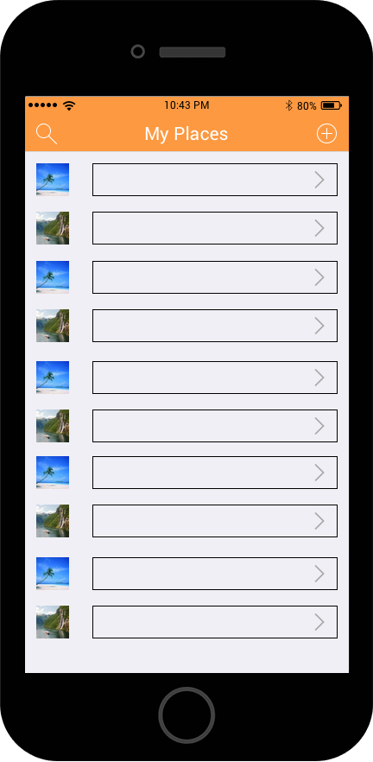

1. When the user taps the add button, they can enter a new place. The enter the name of the place along with a brief description on what they loved about that place. The user can then navigate to select an image of that place. This image will be used as the thumbnail image in screen 2

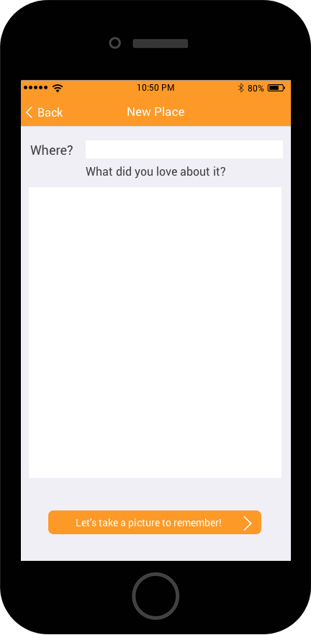

1. This page allows a user to either take a picture by clicking on the camera icon or by selecting a previously taken image from their gallery which will then be displayed to the user in the image view.

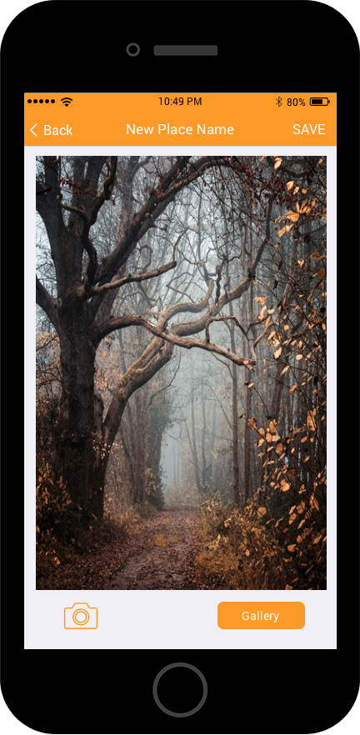

1. If the user taps on a cell instead of the add button, then they are taken to the same screens. Screen 3 will have the input text fields already filled but the user can edit them. Same applies to the image which will already be displayed.

**Suggestions?**