My Results are as follows for the test files:

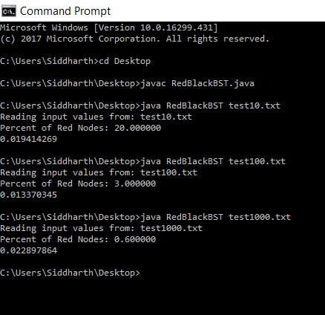

For the general hypothesis my results were:

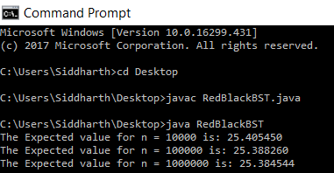

Therefore, the average percentage of Red Nodes will be 25.3927513% in a RedBlack Tree of any size.