AUTODEZIRE
Software Requirements Specification (SRS)
UML & Use Case Architecture Document
System Architecture • Functional Use Cases • Domain Models • Sequence Flows
Version 1.0.0 | September 2026

1. Executive Summary & System Overview
AutoDezire is an advanced automobile decision-support and recommendation platform engineered to assist buyers in selecting optimal vehicles (Cars, Motorcycles, and Electric Scooters) tailored to their exact physical ergonomics, driving environment, passenger obligations, and budget. Unlike generic automotive portals that rank vehicles purely on marketing specs, AutoDezire implements a 12-dimension deterministic suitability engine paired with OpenRouter Google Gemma 4 26B AI conversational guidance.

2. System Actors & Responsibilities
Actor | Type | Functional Scope & Responsibilities
Guest (Unauthenticated) | Human (Primary) | Browses catalog, filters vehicles, views suitability reports, interacts with AI Advisor demo.
Registered User | Human (Primary) | Maintains persistent 30+ parameter lifestyle profile, saves wishlists, receives weighted suitability scores, compares vehicles side-by-side.
Administrator | Human (Secondary) | Manages system inventory (CRUD operations for cars/bikes/scooters), monitors dashboard platform KPIs, audits active listings.
External AI Service (Gemma) | Automated System (Supporting) | Google Gemma 26B via OpenRouter API. Evaluates user lifestyle prompts, produces context-aware natural language vehicular advice.

3. High-Level System Overview Use Case Diagram
The following diagram captures the complete functional boundary of AutoDezire. It maps the interactions between all four primary/secondary actors and the core functional modules: Authentication, Vehicle Discovery, AI Advisor, Saved Wishlists, and the Administrative Control Panel.

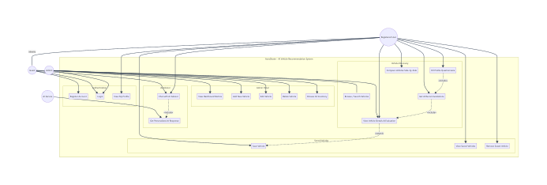
Figure 1: AutoDezire High-Level System Overview Use Case Diagram

4. Detailed Module-Level Use Case Diagrams & Specifications

4.1 Authentication & Identity Subsystem
Manages secure user registration, bcrypt credential encryption, JWT session management, and fallback in-memory store for high-availability operation.

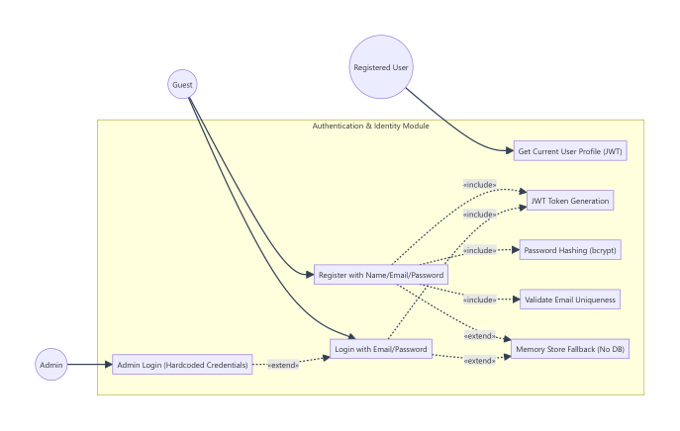
Figure 2: 4.1 Authentication & Identity Subsystem
Use Case | Actor | Priority | «include» | «extend» | Functional Summary
UC-01: User Registration | Guest | High | Validate Email Uniqueness, Hash Password, Generate JWT | Memory Fallback | Allows new users to create accounts with email and password.
UC-02: User Login | Guest / Admin | High | Validate Credentials, Generate JWT | Admin Hardcoded Override | Authenticates registered users or admin credentials and issues Bearer tokens.

4.2 Vehicle Discovery & Recommendation Engine Subsystem
Drives the personalized matching pipeline. Collects 30+ buyer profile data points and executes 12-dimension deterministic scoring across terrain, ergonomics, space, and finances.

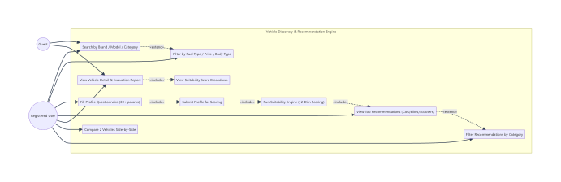
Figure 3: 4.2 Vehicle Discovery & Recommendation Engine Subsystem
Use Case | Actor | Priority | «include» | «extend» | Functional Summary
UC-05: Submit Lifestyle Questionnaire | Registered User | High | Suitability Engine Execution | Category Filter | Saves user constraints (height, daily km, terrain, budget) to profile.
UC-06: Compute Recommendations | Registered User | High | 12-Dimension Scoring Engine | Budget Categorization | Ranks catalog by overall suitability score (0-100) and groups by category.

4.3 AI Conversational Advisor Subsystem
Integrates OpenRouter Google Gemma 4 26B LLM with AutoDezire's internal domain models, injecting buyer profile and suitability scores into prompts.

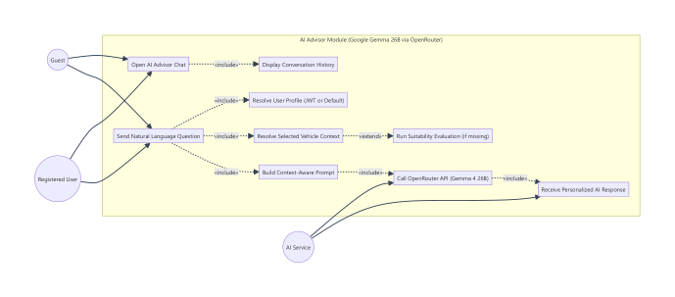
Figure 4: 4.3 AI Conversational Advisor Subsystem
Use Case | Actor | Priority | «include» | «extend» | Functional Summary
UC-09: Chat with AI Advisor | Guest / User | High | Resolve User Context, Build Prompt, OpenRouter API | On-the-fly Suitability Engine | Provides real-time conversational vehicular advice and comparisons.
UC-10: Receive AI Response | AI Service | High | JSON Formatting, Model Attribution | Fallback Graceful Message | Generates personalized advice streaming response.

4.4 Saved Vehicles (Wishlist) Subsystem
Enables users to curate a personal comparison list of preferred models with real-time suitability metrics.

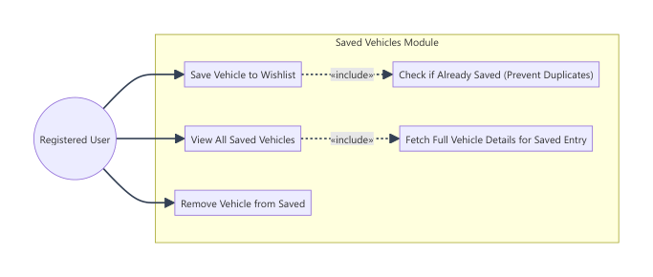
Figure 5: 4.4 Saved Vehicles (Wishlist) Subsystem
Use Case | Actor | Priority | «include» | «extend» | Functional Summary
UC-11: Save Vehicle | Registered User | Medium | Duplicate Check, Store Update | None | Adds vehicle ID and timestamped evaluation score to user wishlist.
UC-12: View Saved Vehicles | Registered User | Medium | Populate Vehicle Details | None | Fetches rich vehicle specs and suitability for all wishlisted items.

4.5 Administrative Inventory & Metrics Subsystem
Restricted administration dashboard for automotive catalog management, inventory audits, and platform metrics.

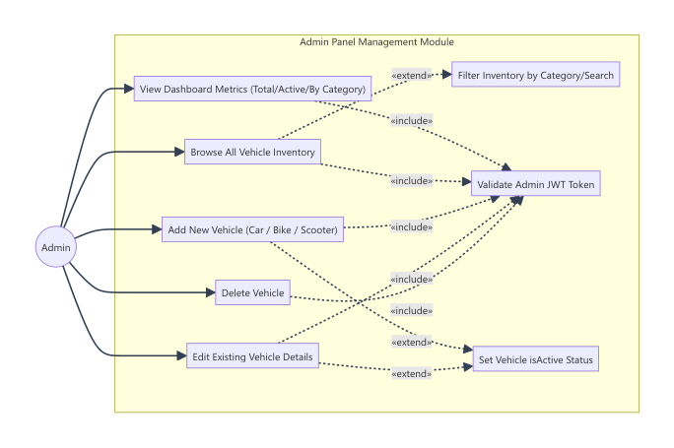
Figure 6: 4.5 Administrative Inventory & Metrics Subsystem
Use Case | Actor | Priority | «include» | «extend» | Functional Summary
UC-14: View Admin Metrics | Admin | High | Verify JWT Admin Role | None | Aggregates inventory counts: total cars, bikes, scooters, active listings.
UC-15: Add New Vehicle | Admin | High | Input Validation, Store Insert | Default Base Scores | Creates new vehicle entry with pricing, powertrain, and ergonomics specs.

5. UML Structural Class Diagram & Domain Entities
AutoDezire utilizes an Object-Document Data Model implemented via Mongoose ODM. The class diagram below visualizes primary entities: User (with embedded Profile), Vehicle (Car model with TrimVariants), Bike (Motorcycles and Scooters with 2-Wheeler ergonomic parameters), SavedVehicle, and the SuitabilityResult computational entity.

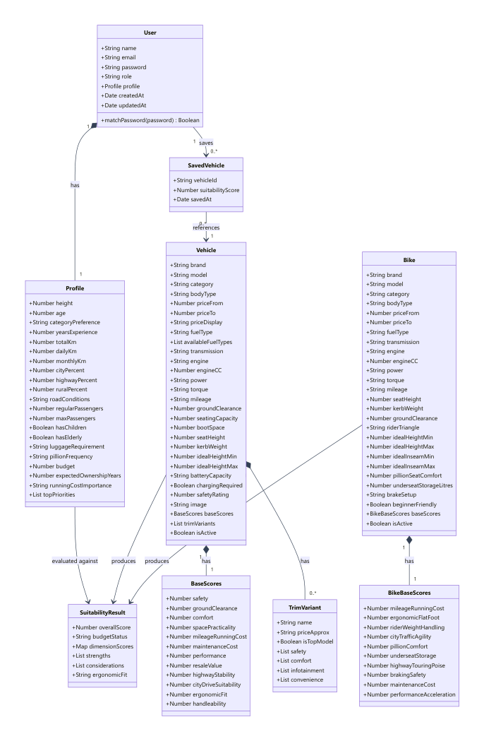
Figure 7: UML Domain Class Diagram

Domain Entity Schema Specifications
Entity | Type | Key Attributes / Fields | Domain Purpose
User | Root Document | name, email, password (hashed), role ('user'|'admin'), profile, createdAt | Identity & authentication root.
Profile | Embedded Document | height (cm), age, budget (Lakhs), dailyKm, highwayPercent, cityPercent, roadConditions, regularPassengers, topPriorities (max 3) | Stores buyer lifestyle parameters for deterministic scoring.
Vehicle | Root Document | brand, model, category ('Car'), bodyType, priceFrom, priceTo, engine, power, mileage, groundClearance, seatingCapacity, baseScores, trimVariants | 4-wheeler catalog with dimensional ergonomics and baseline scores.
Bike | Root Document | brand, model, category ('Motorcycle'|'Scooter'), seatHeight (mm), kerbWeight, riderTriangle, idealInseamMin/Max, pillionSeatComfort, underseatStorageLitres | 2-wheeler catalog with rider triangle ergonomics and inseam fit.
SavedVehicle | Root Document | vehicleId (ref), suitabilityScore, savedAt | Persistent wishlist collection references.
SuitabilityResult | Computed Object | overallScore (0-100), budgetStatus, dimensionScores (12 dimensions), strengths[], considerations[] | Output generated by SuitabilityEngine per vehicle-profile pair.

6. System Architecture & Tier Interaction Models
AutoDezire follows a modern decoupled 4-Tier Architecture: Presentation Tier (Vite React), Application Service Tier (Node.js Express), Persistence Tier (MongoDB Atlas with memory store fallback), and External Intelligence Tier (OpenRouter Gemma 26B).

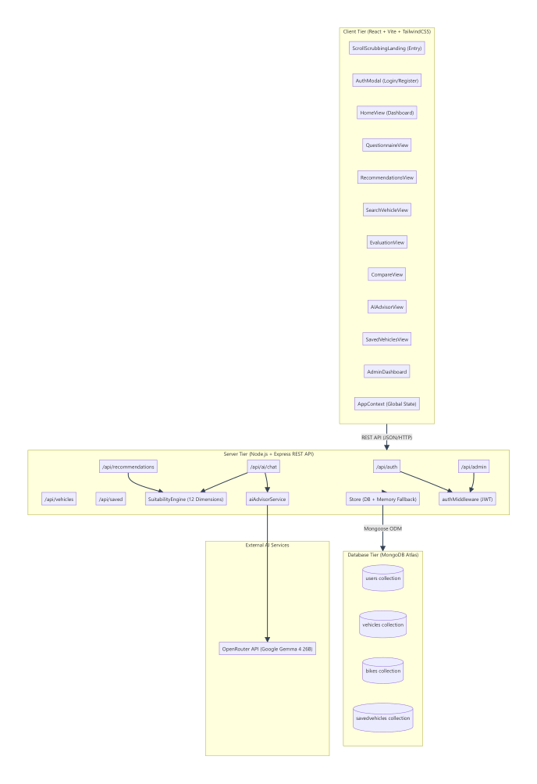
Figure 8: 4-Tier System Architecture & Deployment Diagram

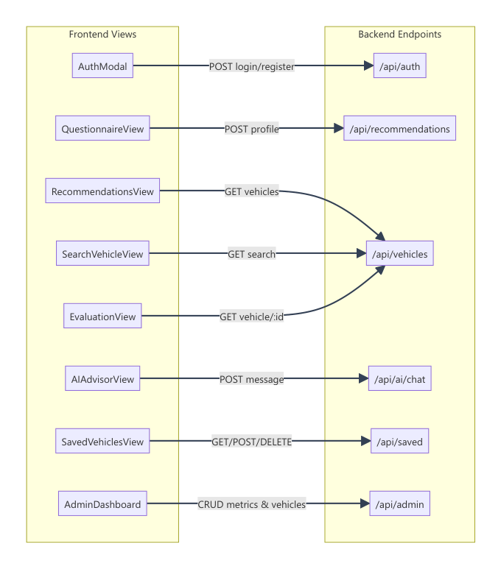
Figure 9: Frontend Views to REST API Endpoints Interaction Map

7. Behavioral UML Sequence Diagrams

7.1 AI Advisor Conversational Query Execution Flow
This sequence traces the end-to-end flow of an automotive advisory query. The server decodes JWT authentication, retrieves candidate vehicle specs, dynamically triggers the suitability engine if uncomputed, constructs an expert persona prompt, and calls OpenRouter Gemma 26B.

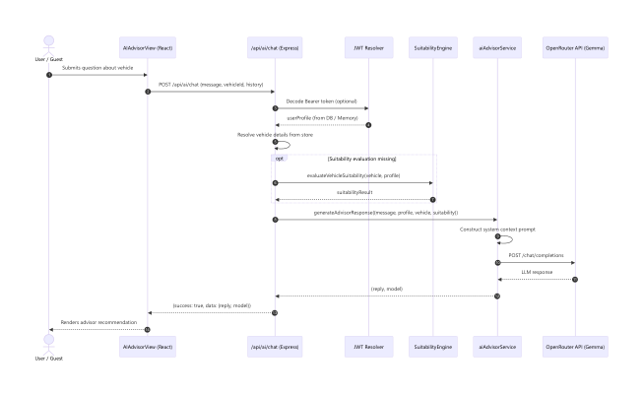
Figure 10: UML Sequence Diagram — AI Advisor Chat Interaction

7.2 Vehicle Recommendation & Scoring Execution Flow
Traces user questionnaire submission, catalog batch loading, and 12-dimensional weighted scoring by the SuitabilityEngine, followed by descending rank sorting and category classification.

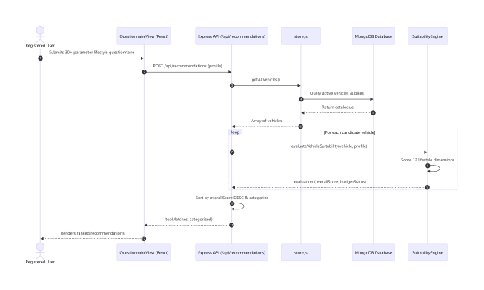
Figure 11: UML Sequence Diagram — Recommendation & Scoring Flow

8. SRS Requirements Traceability Matrix (RTM)
The following matrix maps all 20 functional use cases to the underlying Express REST API endpoints, backend service handlers, and React frontend views.
UC ID | Use Case Title | Primary Actor | REST Endpoint | Frontend Component
UC-01 | Register Account | Guest | POST /api/auth/register | AuthModal.jsx
UC-02 | Login | Guest / Admin | POST /api/auth/login | AuthModal.jsx
UC-03 | View Profile | User | GET /api/auth/me | SettingsView.jsx
UC-04 | Search / Filter Vehicles | Guest / User | GET /api/vehicles | SearchVehicleView.jsx
UC-05 | Submit Questionnaire | User | POST /api/recommendations | QuestionnaireView.jsx
UC-06 | Get AI Recommendations | User | POST /api/recommendations | RecommendationsView.jsx
UC-07 | View Vehicle Evaluation | Guest / User | GET /api/vehicles/:id | EvaluationView.jsx
UC-08 | Compare Vehicles | User | Local State / Store | CompareView.jsx
UC-09 | Chat with AI Advisor | Guest / User | POST /api/ai/chat | AIAdvisorView.jsx
UC-10 | Receive AI Advice | AI Service | OpenRouter Gemma 26B | AIAdvisorView.jsx
UC-11 | Save Vehicle Wishlist | User | POST /api/saved | EvaluationView.jsx / Card
UC-12 | View Saved Vehicles | User | GET /api/saved | SavedVehiclesView.jsx
UC-13 | Remove Saved Vehicle | User | DELETE /api/saved/:id | SavedVehiclesView.jsx
UC-14 | View Admin Metrics | Admin | GET /api/admin/metrics | AdminDashboard.jsx
UC-15 | Browse Inventory | Admin | GET /api/admin/vehicles | AdminDashboard.jsx
UC-16 | Add Vehicle | Admin | POST /api/admin/vehicles | AdminDashboard.jsx
UC-17 | Edit Vehicle | Admin | PUT /api/admin/vehicles/:id | AdminDashboard.jsx
UC-18 | Delete Vehicle | Admin | DELETE /api/admin/vehicles/:id | AdminDashboard.jsx
UC-19 | Deterministic Suitability Engine | System Engine | suitabilityEngine.js | Server Internal
UC-20 | Interactive Video Landing Scrub | Guest | Client State | ScrollScrubbingLanding.jsx

