1 | APPROVAL
FUNCTION |  | NAME | DESIGNATION &  DEPARTMENT | SIGNATURE &  DATE
PREPARED BY |  | PRAJKTA  LOLARE | JUNIOR EXECUTIVE  QUALITY ASSURANCE DEPARTMENT |   22/12/2025
REVIEWED BY |  | RAGHAVENDRA  KATTI | MANAGER  OPERATIONS |   23/12/2025
APPROVED BY |  | Dr. VIKAS  GHATTARGI | MANAGER  QUALITY ASSURANCE DEPARTMENT | 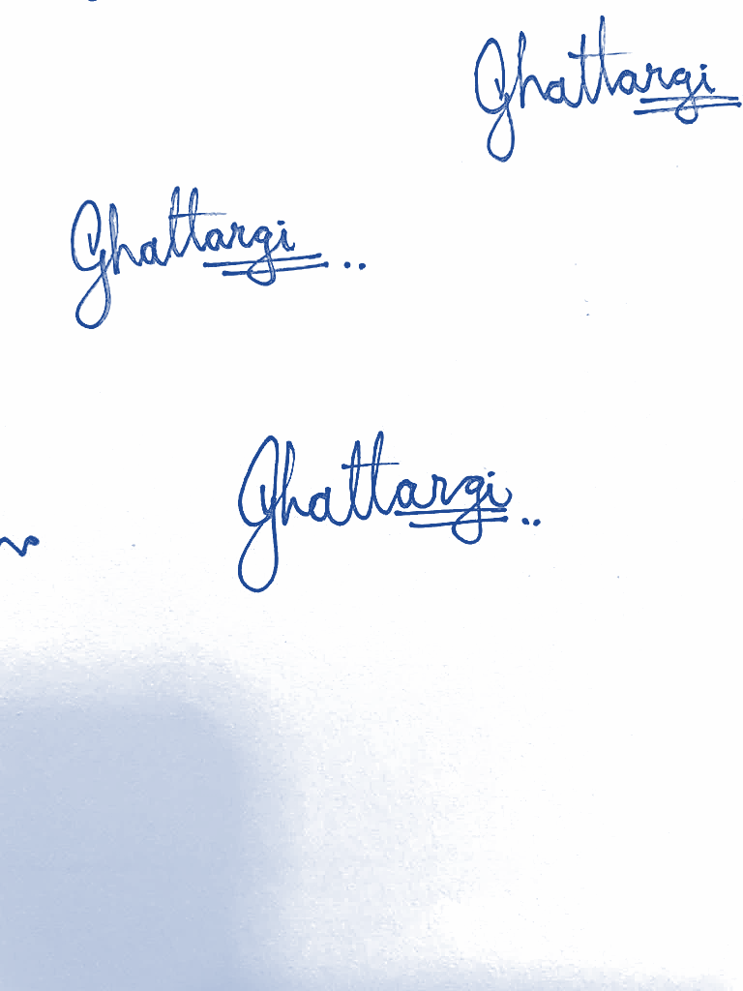  23/12/2025
2 | REVISION HISTORY
REV. NO. |  | DESCRIPTION OF CHANGE
00 |  | New SOP Preparation, Refer CCN/STR/251
01
02
03
04
05

3 | OBJECTIVE
To lay down the procedure for functioning of stores in the Manufacturing facility of Achira Labs Pvt. Ltd.
4 | SCOPE
This SOP is applicable for all raw & packing materials received at the Manufacturing facility of Achira Labs Pvt. Ltd.
5 | RESPONSIBILITY & AUTHORITY
ROLE |  |  | RESPONSIBILITY
Head |  |  | Accountable for effective implementation of the procedure
Security Personnel |  |  | Responsible for informing stores regarding receipt of raw materials and collecting the consignment documents.
Stores Assistant, officers & executive |  |  | Responsible for verification of the documents & physical condition of the material in the vehicle.
6 | REFERENCE AND RELATIONSHIP
S. No. |  | DOCUMENT No. |  | RELATIONSHIP
1 |  | ISO 13485:2016, Clause 7.4.1 |  | Purchasing process
2 |  | ISO 13485:2016, Clause 7.4.3 |  | Verification of purchased product
3 |  | ISO 2859 |  | Sampling plans for attribute features

7 | DEFINITIONS
NA
8 | ABBREVIATIONS
SHORT FORM |  | FULL FORM | SHORT FORM | FULL FORM
SOP |  | Standard Operating Procedure | STR | Stores
PO |  | Purchase Order | QA | Quality assurance
COA |  | Certificate of analysis | PR | Purchase requisition
MFG |  | Manufacturing | QC | Quality control
TMP |  | Template | FMT | Format

9 |  |  | PROCEDURES
  - Health and Safety
    - Ensure proper use and protect the health and safety during handling of biological material.
    - Avoid direct contact, inhalation and ingestion.
    - Use disinfectant on hands and wear hand gloves to avoid direct contact.
    - Wash the hands thoroughly after handling.

  - Material Receipt
    - On arrival of materials at the gate, security officer shall collect the documents received along with the material and handover the documents to Stores department.
    - Then stores In-charge shall verify the consignment against valid PO and related documents of the material received.
    - Check the physical condition & quantity of the material against DC / Invoice / Goods consignment Note / Docket.
    - In case the material does not meet the requirement as per the order placed, immediately the matter should be brought to the notice of the respective Heads.
    - Allow the material to unload on the clean pallet and transfer into the de-dusting area.
    - Detail entry to be done in the Material Inward Register(TMP/STR/001).
    - In case of damage packs, transfer into the new corrugated boxes. Remove the supplier label from the damage boxes and paste on the repacked corrugated box/ plastic crate.
    - Carry out de-dusting and Physical verification of the incoming material (For manufacturing process only) and record the detail in the respective template (TMP/STR/002).
    - Dedusting to be performed first by applying vacuum cleaning on the outer surface of the packages received. If necessary, apply dry cloth mopping of received material.
    - Physical Verification for Biological Raw Material should be 100%.
    - Physical Verification for Packing material as mentioned below as well as referring ISO 2859.

- For Carton / Leaflet / Label/ Aluminium Foil Pouch.
No. of Boxes  received | Physical Verification of Boxes | Physical Verification by counts
2 to 8 boxes | 2 boxes | One pack from each Box
9 to 15 boxes | 3 boxes | One pack from each Box
16 to 25 boxes | 5 boxes | One pack from each Box
26 to 50 boxes | 8 boxes | One pack from each Box
For packs, more than above mentioned to refer in ISO 2859.

(B)For Plastic cassettes/cartridge/ cartridge parts follow above mentioned sample plan for packs and Physical Verification by counts/weight to be done by following formula-
$\frac{Wt of 25 nos X Net Wt of Packet }{25} …$
(C) In case of Shipper physically count the Number of bundles multiply by shipper in each bundle.
(D) In case of PVC roll, physically verify the quantity by weight.
    - In case of abnormal observation while verifying the quantity of received material, then keep it separately and inform to the person in charge.

  - Preparation of GRN
    - Respective entries to be done in template (TMP/STR/003) with respect batch No. to the received material.

  - Labelling
    - Print out the required quantity of Quarantine labels with all detail mentioned on each label.
    - Affix the labels on all containers/boxes/bundles. In case in the roll form then pasted inside the core of the roll.
    - Transfer the materials to the dedicated quarantine area / under testing area.
    - QC will affix “Under Testing” yellow colour label on the quarantine label of all containers(refer .
    - After testing QC, will paste the green colour approved label on all each container.
    - In case the material stands rejected, then QC will paste the red colour rejected label.
    - For all above labeling refer SOP/QAD/012.

 | APPROVED |  | TMP/QAD/019
Material Name: |  | Date:
GRN No.: |  | Prod./Cat. Code:
Batch/Lot No.: |  | Item Code:
Release Qty.: |  | AR No.:
Retest Date: |  | Exp. Date:
Released By (Sign. /Date):
  - Storage of Material
    - Approved material shifted to Approved area.
    - Rejected material to shift in separate isolated area and the information to be given to the QA & Purchase department for necessary action & recommendation.
    - Biological and other critical raw material should be stored accordingly to the storage conditions specified in the COA.
    - Photosensitive material to be stored in amber or black colored packaging.eg. Gold Chloride, Silver Nitrate etc.
    - Material inventory is taken in the Stock register.

  - Dispensing of Material
    - The requisition slip should receive from manufacturing & packing department duly signed by authorized person.
    - FEFO (First Expiry First Out) system to be followed for issuing the raw material.
    - FIFO (First In First Out) system to be followed issuing the packing material.
    - Balance verification to be done as per SOP.
    - After dispensing, loose quantity of the material should be closed tightly and shifts it into the original container. Consumption/ Stock log to be updated – refer (TMP/STR/004).

  - Expired Material
    - Expired raw materials should be informed to QA department for necessary action.
    - Keep track on expiry date of materials.
    - Packing material without Expiry Date to be retested after three years from date of receipt.

  - Indenting of Material
    - Indent (Purchase requisition) is raised by the stores / MFG department as per the manufacturing planning.
    - Material Indent (PR)is prepared by Store In-charge, approved by MFG head and authorized by Plant Head.

  - Interdepartmental transfer note
    - The TMP/STR/011 will control the interdepartmental transfer of materials, including raw materials, packing materials, biomaterials, engineering materials, and capital items.

  - Document Numbering System both D&D AND MFG

S.  No. | Groups | Inward Entry No  (Register) | GRN No
1 | Raw Material,Packing Material,Biomaterial,Engineering material | IN/RM/00N | GR/RM/00N
2 | D&D Material | IN/DD/00N | GR/DD/00N
3 | Capital Goods  (e.g., Refrigerators, Oven, Coating M/c. Computers, Racks, S.S. Furniture’s, Plastic Bins, Weighing balance, Xerox M/c & etc. | IN/CG/00N | GR/CG/00N
4 | Services  (e.g., Pest Control, AHU, Consultancy, Calibration & etc.) | IN/SE/00N | GR/SE/00N
5 | Miscellaneous Material (e.g., Office stationery, housekeeping material, grocery, provisional & etc.) | IN/CC/00N | GR/CC/00N

10 |  |  | RECORDS
RECORD NO. |  |  |  | DESCRIPTION |  | STORAGE & RETENTION PERIOD
TMP/STR/001 |  |  |  | MATERIAL INWARD REGISTER |  | QAD, 3 Years
TMP/STR/002 |  |  |  | DE-DUSTING AND PHYSICAL VERIFICATION |  | QAD, 3 Years
TMP/STR/003 |  |  |  | PREPARATION OF GRN |  | QAD, 3 Years
TMP/STR/004 |  |  |  | CONSUMPTION LOG |  | QAD, 3 Years
TMP/STR/011 |  |  |  | INTERDEPARTMENTAL TRANSFER NOTE |  | QAD, 3 Years
11 | MONITORING & MEASUREMENTS
SOP is to be reviewed at least every two years. This shall be tracked using the Master Document List by entering a date two years from the effective date.
12 | RISK MANAGEMENT
S. No. |  | HAZARD |  |  | CONTROL MEASURES
1 |  | Breakage of material during Pickup or Movement of material. |  |  | Hooks are not used for pickup or movement of the material containers/bags.
2 |  | During Inspection of raw materials, in vehicle if containers/drums/ bags are found to be tampered. |  |  | Personnel verifies the materials as per the checklist

