1 | APPROVAL
FUNCTION |  | NAME | DESIGNATION &  DEPARTMENT | SIGNATURE &  DATE
PREPARED BY |  | PRAJKTA  LOLARE | JUNIOR EXECUTIVE  QUALITY ASSURANCE DEPARTMENT | 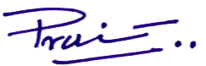  22/12/2025
REVIEWED BY |  | RAGHAVENDRA  KATTI | MANAGER  OPERATIONS |   23/12/2025
APPROVED BY |  | Dr. VIKAS  GHATTARGI | MANAGER  QUALITY ASSURANCE DEPARTMENT | 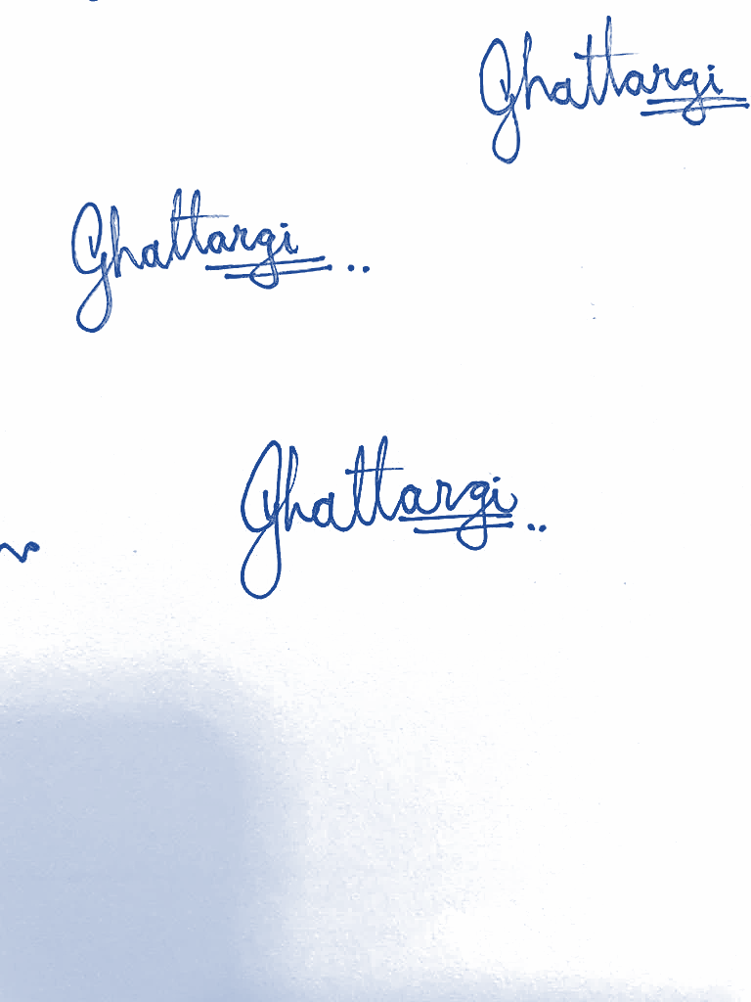  23/12/2025
2 | REVISION HISTORY
REV. NO. |  | DESCRIPTION OF CHANGE
00 |  | New SOP Preparation, Refer CCN/STR/251
01
02
03
04
05

3 | OBJECTIVE
To lay down the procedure for functioning of stores in the Manufacturing facility of Achira Labs Pvt. Ltd.
4 | SCOPE
This SOP is applicable for all raw & packing materials received at the Manufacturing facility of Achira Labs Pvt. Ltd.
5 | RESPONSIBILITY & AUTHORITY
ROLE |  |  | RESPONSIBILITY
Head |  |  | Accountable for effective implementation of the procedure
Security Personnel |  |  | Responsible for informing stores regarding receipt of raw materials and collecting the consignment documents.
Stores Assistant, officers & executive |  |  | Responsible for verification of the documents & physical condition of the material in the vehicle.
6 | REFERENCE AND RELATIONSHIP
S. No. |  | DOCUMENT No. |  | RELATIONSHIP
1 |  | ISO 13485:2016, Clause 7.4.1 |  | Purchasing process
2 |  | ISO 13485:2016, Clause 7.4.3 |  | Verification of purchased product
3 |  | ISO 2859 |  | Sampling plans for attribute features

7 | DEFINITIONS
NA
8 | ABBREVIATIONS
SHORT FORM |  | FULL FORM | SHORT FORM | FULL FORM
SOP |  | Standard Operating Procedure | STR | Stores
PO |  | Purchase Order | QA | Quality assurance
COA |  | Certificate of analysis | PR | Purchase requisition
MFG |  | Manufacturing | QC | Quality control
TMP |  | Template | FMT | Format

9 |  |  | PROCEDURES
  - Health and Safety
    - Ensure proper use and protect the health and safety during handling of biological material.
    - Avoid direct contact, inhalation and ingestion.
    - Use disinfectant on hands and wear hand gloves to avoid direct contact.
    - Wash the hands thoroughly after handling.

  - Material Receipt
    - On arrival of materials at the gate, security officer shall collect the documents received along with the material and handover the documents to Stores department.
    - Then stores In-charge shall verify the consignment against valid PO and related documents of the material received.
    - Check the physical condition & quantity of the material against DC / Invoice / Goods consignment Note / Docket.
    - In case the material does not meet the requirement as per the order placed, immediately the matter should be brought to the notice of the respective Heads.
    - Allow the material to unload on the clean pallet and transfer into the de-dusting area.
    - Detail entry to be done in the Material Inward Register(TMP/STR/001).
    - In case of damage packs, transfer into the new corrugated boxes. Remove the supplier label from the damage boxes and paste on the repacked corrugated box/ plastic crate.
    - Carry out de-dusting and Physical verification of the incoming material (For manufacturing process only) and record the detail in the respective template (TMP/STR/002).
    - Dedusting to be performed first by applying vacuum cleaning on the outer surface of the packages received. If necessary, apply dry cloth mopping of received material.
    - Physical Verification for Biological Raw Material should be 100%.
    - Physical Verification for Packing material as mentioned below as well as referring ISO 2859.

- For Carton / Leaflet / Label/ Aluminium Foil Pouch.
No. of Boxes  received | Physical Verification of Boxes | Physical Verification by counts
2 to 8 boxes | 2 boxes | One pack from each Box
9 to 15 boxes | 3 boxes | One pack from each Box
16 to 25 boxes | 5 boxes | One pack from each Box
26 to 50 boxes | 8 boxes | One pack from each Box
For packs, more than above mentioned to refer in ISO 2859.

(B)For Plastic cassettes/cartridge/ cartridge parts follow above mentioned sample plan for packs and Physical Verification by counts/weight to be done by following formula-
$\frac{Wt of 25 nos X Net Wt of Packet }{25} …$
(C) In case of Shipper physically count the Number of bundles multiply by shipper in each bundle.
(D) In case of PVC roll, physically verify the quantity by weight.
    - In case of abnormal observation while verifying the quantity of received material, then keep it separately and inform to the person in charge.

  - Preparation of GRN / Digital GRN Entry
    - Manual record: Respective entries to be done in template (TMP/STR/003) with respect to Batch No. of the received material. Where the digital Inventory Management System described below is in use, this template is replaced by the “Create GRN” (GRN Entry) screen, which captures the same information -- and more -- directly, and is the current method of preparing the GRN.
    - Digital GRN Entry — overview: GRN Entry is a web-based form (“📋 GRN Entry”, grn-entry.html) reached from the Inventory Management System’s Home screen. It covers everything from optionally linking a Purchase Order through submitting the completed GRN; once submitted, the person named as Requested By is notified to verify and approve it (see “Verify & Approve” below).
[SCREENSHOT PLACEHOLDER -- Figure 1 -- Create GRN initial screen. Capture: grn-entry.html on load, before any data is entered -- showing the “Link to Purchase Order” and “Category” cards.]
    - Opening Create GRN: Open the GRN Entry page from the Home screen. The form is organised into cards in this order: Link to Purchase Order, Category, Receipt Details, GRN Identifiers, Material, and Handling.
    - Link to Purchase Order (optional): “Open PO” -- optional; selecting one auto-fills the vendor, and lists every outstanding item on that PO as a checklist (“Item(s) received in this delivery”). One delivery can cover several PO line items -- check every item actually included in this delivery. Each item shows its own remaining balance (ordered minus everything already received on earlier GRNs against that PO item), and its Quantity field defaults to that remaining balance, not the full original order. A PO line item that will never be fully delivered can be reported as a shortfall (“Report shortfall — no more of this item is coming”, with a reason and the reporting person’s name) once at least some quantity has already arrived against it -- a deliberate human decision, never inferred by the system. “+ Add an extra item not on this PO” additionally allows logging something that arrived alongside the PO items but is not actually one of them (a substitution or free sample); it is saved with a “[Not on PO]” prefix on its description so it stays clearly flagged.
[SCREENSHOT PLACEHOLDER -- Figure 2 -- PO linkage and item checklist. Capture: grn-entry.html with an Open PO selected, showing the outstanding-items checklist and the “+ Add an extra item not on this PO” toggle.]
    - GRN Category / Tab: required. Determines which category sheet this GRN is logged in, and corresponds to the material groups in the Document Numbering table of Section 9.10 below (e.g. D&D Material; Raw Material / Packing Material / Biomaterial / Engineering Material; Capital Goods; Services; Miscellaneous Material).
    - GRN Prefix, Inward Entry No. and GRN No. (numbering): GRN Prefix is a dropdown auto-loaded from the chosen category’s own GRN history (e.g. GR/DD/ for D&D Material, matching the GR/../00N convention in Section 9.10); if that category has no history yet, a plain text field appears so a first prefix can be typed by hand. Inward Entry No. and GRN No. are both generated automatically by the system on submission and are never typed by the user (the fields on screen show “Automatically generated on submission”). Inward Entry No. is ONE running numeric sequence shared across every category (not a separate counter per tab) -- for example, a single-item GRN receives a bare number such as 6458, while a delivery of three items sharing one invoice receives one shared base number split per item as 6459_1, 6459_2 and 6459_3. GRN No. combines the chosen GRN Prefix with the next available number for that specific prefix (e.g. GR/DD/112), and is suffixed the same way for a multi-item delivery (GR/DD/112_1, GR/DD/112_2, GR/DD/112_3). Sl No. is a separate, auto-suggested running serial number for the chosen category and prefix -- normally left as suggested, and can be recomputed with “↻ Re-suggest Sl No.” if needed.
[SCREENSHOT PLACEHOLDER -- Figure 3 -- GRN identifiers and category. Capture: The Category card and the GRN Identifiers card (Sl No., Inward Entry No., GRN Prefix, GRN No.) with a category selected.]
    - Receipt Details — Received Date, Invoice No., Invoice Date, PO No., Requested By: Received Date (required) is the date the goods physically arrived. Invoice No. and Invoice Date are copied from the vendor’s invoice and may differ from Received Date. PO No. is the Purchase Order this delivery is against, if any. Requested By is who originally asked for the material -- this is the person notified afterward to verify the GRN (see “Verify & Approve” below).
    - Name of the Party (vendor): the vendor/supplier who sent the delivery -- auto-filled when a Purchase Order is selected, otherwise typed in.
    - Material Description, Quantity, Catalogue / Lot / Batch No., Expiry Date: for each item checked from a Purchase Order, these come from the PO’s own item (Material Description, and Quantity defaulting to the outstanding balance as above), while Catalogue / Lot / Batch No. and Expiry Date are always entered fresh, per item, since they are specific to this physical delivery. When no PO item is used, Description of Material is entered by hand (required -- copy the wording from the vendor’s invoice) together with Quantity (free text, e.g. “100” or “20L”). Expiry Date accepts either DD/MM/YYYY or MM/YYYY (or may be left blank), and is validated in that format before submission.
[SCREENSHOT PLACEHOLDER -- Figure 4 -- Catalogue/Lot/Batch and Expiry Date. Capture: One item card (PO item or manual item) showing Description, Quantity, Catalogue/Lot/Batch No. and Expiry Date fields filled in.]
    - Basic Amount, Discount, Total Amount (per item): Basic Amount is the item’s own pre-tax cost -- a plain number, pre-filled from the PO’s amount when a PO item is checked, and otherwise typed in. Discount is optional, entered either as a percentage (e.g. “10%”) or a fixed amount (e.g. “100”), and cannot exceed Basic Amount. Total Amount is calculated automatically and cannot be typed directly -- it equals the Taxable Amount (Basic Amount minus Discount) plus this item’s own tax (see Tax below), and updates live as any of these fields change.
[SCREENSHOT PLACEHOLDER -- Figure 5 -- Item financial details. Capture: One item's Basic Amount, Discount and (read-only, calculated) Total Amount fields.]
    - Tax — Tax Application (Per Item or Overall): a GRN-level choice with two options: “Tax per item” (the default) or “Overall tax for this GRN”. This decides whether tax is entered separately on every item, or once for the whole delivery, matching how the vendor’s invoice actually states it.
    - Tax per item: each item card carries its own GST / CGST / SGST / IGST checkboxes, each with its own rate entered as a percentage or a fixed rupee amount. Item-level tax is OPTIONAL -- a valid item may have GST alone, CGST + SGST together, IGST alone, or no tax at all. GST and IGST are mutually exclusive with every other option, including each other; CGST and SGST may be selected together.
[SCREENSHOT PLACEHOLDER -- Figure 6 -- Per-item tax. Capture: One item card with the Tax Type checkboxes expanded, e.g. CGST and SGST both checked with their rate fields.]
    - Overall tax for this GRN: hides every item’s own tax fields (which are then held at zero) and shows one “Overall Tax” section instead, applied once for the whole delivery: the same choice of GST alone, CGST + SGST together, IGST alone, or no tax -- but the rate is resolved against the SUM of every item’s own Basic Amount minus Discount in this GRN, not any single item’s own amount. For example, two items of ₹1,000 and ₹2,000 give a combined taxable amount of ₹3,000; Overall CGST 9% + Overall SGST 9% then resolves to ₹270 + ₹270 = ₹540 total tax for the GRN.
[SCREENSHOT PLACEHOLDER -- Figure 7 -- Overall tax. Capture: The Overall Tax section with, for example, CGST and SGST both checked at 9% each, and its live taxable amount / tax / final amount summary line.]
    - Choosing between the two: use Tax per item when the vendor’s invoice states a tax rate against each line item; use Overall tax when the invoice instead states one combined tax figure for the whole bill (e.g. a single “GST 18%” or “CGST 9% + SGST 9%” line covering everything). Tax must never be double-applied: selecting Overall automatically empties and disables every item’s own tax fields, and the system independently refuses to save a GRN that still carries both an item’s own tax and an Overall tax at the same time.
    - Adding another item / multiple-item GRNs: “+ Add another item (same GRN No., different item)” adds another item card for a hand-typed item; each item on a GRN -- whether pulled from a PO, typed manually, or added as an ad-hoc extra -- has its own Description of Material, Quantity, Catalogue/Lot/Batch No., Expiry Date and financial details (Basic Amount, Discount, Total Amount), and, in Tax per item mode, its own tax. All items added this way are submitted together and recorded under ONE GRN No., exactly as one invoice/challan can legitimately cover several line items; the system only refuses a submission if the exact same GRN No. and exact same item description already exist (guarding against an accidental double-submit of one line, without blocking a genuine multi-item delivery). Only the FIRST item of a multi-item GRN triggers the Slack notification to the Requested By person, so a delivery of several lines does not notify them several times over for what is, to them, one delivery to verify.
[SCREENSHOT PLACEHOLDER -- Figure 8 -- Multiple items. Capture: The Material card with more than one item card visible (e.g. two manual items, or a PO item plus an ad-hoc item).]
    - Invoice Amount and Other Charges: Invoice Amount is ONE field for the whole GRN, taken directly from the vendor’s invoice total (it is not recalculated from the individual items). Other Charges (freight, etc.) likewise applies once for the whole delivery. Both are recorded once per GRN, but -- because every row in the underlying record is an item row, with no separate GRN-level row -- the same value is stored against every item of a multi-item GRN; neither value is folded into any individual item’s own Total Amount.
[SCREENSHOT PLACEHOLDER -- Figure 9 -- Invoice Amount and Other Charges. Capture: The Invoice Amount and Other Charges fields, filled in, in the Material card.]
    - Received By / Issued To: Received By is who at Achira physically received and checked the delivery. Issued To is optional, used only if the material is already earmarked for a specific person at the time of receipt.
    - Final review and submission: before the GRN is saved, the system re-checks every item’s financial fields (and the Overall Tax fields, if that mode is used) and blocks submission with an on-screen message if anything is invalid -- for example a negative rate, a GST value combined with CGST/SGST on the same item, or an Expiry Date not in DD/MM/YYYY or MM/YYYY format. At least one item -- from a PO, typed manually, or added as an ad-hoc extra -- is required before “Submit GRN” can proceed.
[SCREENSHOT PLACEHOLDER -- Figure 10 -- Final review / submission. Capture: The completed form immediately before clicking “Submit GRN” (or a validation error message being shown, if one is deliberately triggered for illustration).]
    - Success confirmation: on submission, the system allocates the Inward Entry No. and GRN No., writes one row per item, and shows a confirmation such as “✅ GRN GR/DD/112 logged in “D&D_GR_All” (Inward Entry No. 6458).” for a single item, or “✅ 3 items logged under GRN GR/DD/112 (GR/DD/112_1–GR/DD/112_3) in “D&D_GR_All” (Inward Entry No. 6459, items 6459_1–6459_3).” for a multi-item delivery. The form then clears itself, ready for the next GRN. The whole submission is all-or-nothing -- if anything fails validation, an error message explains why and nothing from that submission is saved.
[SCREENSHOT PLACEHOLDER -- Figure 11 -- Successful GRN creation. Capture: The green success message shown immediately after a real GRN is submitted.]
    - Verify & Approve: submitting a GRN automatically notifies the Requested By person by Slack -- only once per GRN, on the first item of a multi-item delivery -- with a “Verify & approve” link to a separate Verify GRN screen. There, the requester enters their name and reviews the delivery against what was ordered, approving individual line items selectively; any item left unchecked stays “Pending Verification” rather than being force-approved, so a multi-item delivery can be partly confirmed while one questionable line is held back. Approving an item that is already approved is safe and does not process it a second time.
[SCREENSHOT PLACEHOLDER -- Figure 12 -- Verify & Approve. Capture: The Verify GRN screen (grn-verify.html) opened from a real “Verify & approve” link, showing the GRN's items and the Approve button.]

  - Labelling
    - Print out the required quantity of Quarantine labels with all detail mentioned on each label.
    - Affix the labels on all containers/boxes/bundles. In case in the roll form then pasted inside the core of the roll.
    - Transfer the materials to the dedicated quarantine area / under testing area.
    - QC will affix “Under Testing” yellow colour label on the quarantine label of all containers(refer .
    - After testing QC, will paste the green colour approved label on all each container.
    - In case the material stands rejected, then QC will paste the red colour rejected label.
    - For all above labeling refer SOP/QAD/012.

 | APPROVED |  | TMP/QAD/019
Material Name: |  | Date:
GRN No.: |  | Prod./Cat. Code:
Batch/Lot No.: |  | Item Code:
Release Qty.: |  | AR No.:
Retest Date: |  | Exp. Date:
Released By (Sign. /Date):
  - Storage of Material
    - Approved material shifted to Approved area.
    - Rejected material to shift in separate isolated area and the information to be given to the QA & Purchase department for necessary action & recommendation.
    - Biological and other critical raw material should be stored accordingly to the storage conditions specified in the COA.
    - Photosensitive material to be stored in amber or black colored packaging.eg. Gold Chloride, Silver Nitrate etc.
    - Material inventory is taken in the Stock register.

  - Dispensing of Material
    - The requisition slip should receive from manufacturing & packing department duly signed by authorized person.
    - FEFO (First Expiry First Out) system to be followed for issuing the raw material.
    - FIFO (First In First Out) system to be followed issuing the packing material.
    - Balance verification to be done as per SOP.
    - After dispensing, loose quantity of the material should be closed tightly and shifts it into the original container. Consumption/ Stock log to be updated – refer (TMP/STR/004).

  - Expired Material
    - Expired raw materials should be informed to QA department for necessary action.
    - Keep track on expiry date of materials.
    - Packing material without Expiry Date to be retested after three years from date of receipt.

  - Indenting of Material
    - Indent (Purchase requisition) is raised by the stores / MFG department as per the manufacturing planning.
    - Material Indent (PR)is prepared by Store In-charge, approved by MFG head and authorized by Plant Head.

  - Interdepartmental transfer note
    - The TMP/STR/011 will control the interdepartmental transfer of materials, including raw materials, packing materials, biomaterials, engineering materials, and capital items.

  - Document Numbering System both D&D AND MFG

S.  No. | Groups | Inward Entry No  (Register) | GRN No
1 | Raw Material,Packing Material,Biomaterial,Engineering material | IN/RM/00N | GR/RM/00N
2 | D&D Material | IN/DD/00N | GR/DD/00N
3 | Capital Goods  (e.g., Refrigerators, Oven, Coating M/c. Computers, Racks, S.S. Furniture’s, Plastic Bins, Weighing balance, Xerox M/c & etc. | IN/CG/00N | GR/CG/00N
4 | Services  (e.g., Pest Control, AHU, Consultancy, Calibration & etc.) | IN/SE/00N | GR/SE/00N
5 | Miscellaneous Material (e.g., Office stationery, housekeeping material, grocery, provisional & etc.) | IN/CC/00N | GR/CC/00N
    - Digital system numbering: in the Inventory Management System, the Inward Entry No. shown above (IN/RM/00N, IN/DD/00N, IN/CG/00N, IN/SE/00N, IN/CC/00N) is generated automatically -- the “00N” portion is one continuous running number shared across every category, never typed by hand. A single-item GRN receives a bare number, e.g. 6458; a delivery of several items sharing one invoice receives one shared base number split per item, e.g. 6459_1, 6459_2, 6459_3.
    - GRN No. generation: GRN No. (GR/RM/00N, GR/DD/00N, GR/CG/00N, GR/SE/00N, GR/CC/00N above) is likewise generated automatically, combining the GRN Category / Tab’s own prefix -- chosen on the Create GRN screen (Section 9.3) from that category’s own history -- with the next available number for that specific prefix, and suffixed the same way for a multi-item delivery (e.g. GR/DD/112_1, GR/DD/112_2).
    - Category selection: the GRN Category / Tab chosen on the Create GRN screen (Section 9.3) determines which of the five groups above -- and therefore which Inward Entry No. / GRN No. prefix family -- a delivery is logged under.

10 |  |  | RECORDS
RECORD NO. |  |  |  | DESCRIPTION |  | STORAGE & RETENTION PERIOD
TMP/STR/001 |  |  |  | MATERIAL INWARD REGISTER |  | QAD, 3 Years
TMP/STR/002 |  |  |  | DE-DUSTING AND PHYSICAL VERIFICATION |  | QAD, 3 Years
TMP/STR/003 |  |  |  | PREPARATION OF GRN |  | QAD, 3 Years
TMP/STR/004 |  |  |  | CONSUMPTION LOG |  | QAD, 3 Years
TMP/STR/011 |  |  |  | INTERDEPARTMENTAL TRANSFER NOTE |  | QAD, 3 Years
11 | MONITORING & MEASUREMENTS
SOP is to be reviewed at least every two years. This shall be tracked using the Master Document List by entering a date two years from the effective date.
12 | RISK MANAGEMENT
S. No. |  | HAZARD |  |  | CONTROL MEASURES
1 |  | Breakage of material during Pickup or Movement of material. |  |  | Hooks are not used for pickup or movement of the material containers/bags.
2 |  | During Inspection of raw materials, in vehicle if containers/drums/ bags are found to be tampered. |  |  | Personnel verifies the materials as per the checklist

