XRM
Knowledge Transfer
UI/UX

UI/UX KT Document

Start Date: 7/25/2018
Table of Content
Multi Chrome Theme 2
1.1.1 File Structure 2
1.1.2 Style Guide 3
Typography 3
Color Theme 3
Icon 3
Form Element 3

Multi Chrome Theme
Multi chrome theme developed in bootstrap 3. This this has two stylesheet for different style. Users can switch style according to their interest.

File Structure
CSS
- all-ie-only.css
- bootstrap.min.css
- font-awesome.min.css
- fonts.css
- jquery.bootgrid.css
- jquery-ui.css
- style.css
- style_new.css
- style-multichrome.css
- style-new-theme.css
Fonts
Images
- acro_logo1.jpg
- acrocorplogo.png
- acro-logo.png
- acro-logo1.png
- arrow-sm.png
- bg-image.jpg
- big-graph.jpg
- blg-logo.png
- bx_loader.gif
- call.png
- clogo.png
- controls.png
- fb-logo.png
- graph.jpg
- graph1.jpg
- graph2.jpg
- graph3.jpg
- graph-sm1.jpg
- graph-sm2.jpg
- graph-sm3.jpg
- graph-sm4.jpg
- grey-arrow.png
- icons.png
- icons-2x.png
- ie-bg.jpg
- in-logo.png
- kellogs.jpg
- link-arrow.png
- logo.png
- mail.png
- navigation-shadow.png
- pass-ic.png
- spritesheet.png
- spritesheet2.png
- tab_heading_bg.png
- tw-logo.png
- user-ic.png
- warning-ic.png
- xrm-logo.png
- xrm-wh-logo.png
js
- bootstrap.min.js
- common.js
- db.js
- html5shiv.min.js
- jquery.bootgrid.js
- jquery.bxslider.min.js
- jquery-1.12.4.js
- jquery-ui.js
- npm.js

Style Guide
As the name suggest Multichrome theme is flat based theme with material inspired flat colors. Idea is to provide a new and refreshing look to current running theme. Two different css are being used to change look and feel of layout. Multichrome css will help in achieving new flat look and New theme css will help in getting existing layout.
Multichrome Layout: style-multichrome.css
Existing layout: style-newtheme.css
Path: D:\kapil\dashboard\html\css (My system)
Note: Do not merge it with live css as it contains many classes that are created for future use.
All HTML files are available in D:\kapil
Bootstrap framework has been used to create consistency and reusable css classes. Structure of layout is div based and bootstrap columns class are used to accommodate design decisions.

Typography
Font Family:
Roboto: Bold, Regular, Medium
Font Sizes:
Section Heading: 22px;
Sub heading:16px
Normal text: 14px

Color Theme
Colors have been changed to provide for clarity and modern look to theme.
#3f51b5 #f8bc26 #f97013 #00bcd4 #d3d5dd #666666
Black and White colors are also used as per needed.
Background for header, Grid border, Grid Heading, Sub Heading: #3f51b5
Inner Panels head bar: #f8bc26
Heading Text Color: #f97013
Table heading background color: #3f51b5
Heading background color: #efefef
Border color (Textbox, Select box, Text Area): #cccccc
Border Radius: 4px
Text color: #333
Links color: #3f51b5

Icon
All Font awesome icons have been used to give flat based look.

Form Element
Text box and select box size has been increased and padding between elements has also been increased to give proper breathing space. Labels have been made bold to increase readability. Border of form elements have been made little lighter to reduce extra retina load.
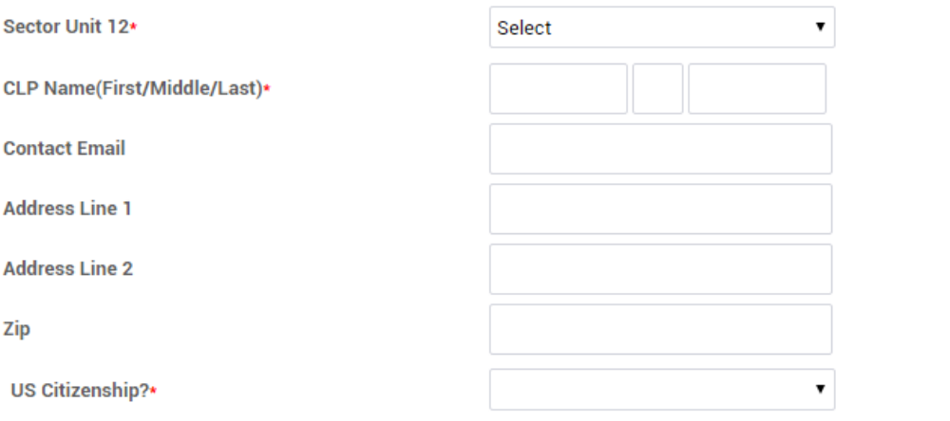

Textbox, Select height: 35px
Textbox, Select width: 100%, Max-width: 375px
Textbox, Select Font-size: 14px

