23CSE202 DATABASE MANAGEMENT SYSTEMS
S3 B.Tech CSE
Department of Computer Science and Engineering
Amrita School of Computing, Amritapuri Campus
3. Database Design Document
Group No :
Team Members :
Roll No | Student Name
AM.SC.U4CSE252509 | BYN.Siddharth Sai
AM.SC.U4CSE25258 | Vurukuti Gowtham Adithya
AM.SC.U4CSE25263 | K.Rama Sri Surya
AM.SC.U4CSE25264 | K.Sai Santhosh

Project Title :
3.1. Detailed description of the project
HostelOS manages a college hostel's operations for four types of users: Admin, Staff, Authority, and Students.

Each Student has a name, major, and emergency contact. Rooms are categorized by a Room Type, which defines a type name and capacity, and each Room belongs to a block, has a room number, and is linked to one room type. A student is placed into a room through an Allocation record, which stores the allocation date and deposit paid — allowing a student's room-assignment history to be tracked over time via separate allocation records rather than overwritten.

Students can raise a Complaint, giving a category, title, status, and urgency. A complaint may initially be unassigned and is later assigned to a Staff member (who has a role type and phone) for resolution.

Admins (with name and email) mark daily Attendance for each student, recording the date and status.

Students can also request a Leave Pass, specifying leave type, expected departure, expected return, and actual return. Each leave pass is reviewed and decided by an Authority (with a designation), who sets its status to approved or rejected — recording a gate pass token if approved, or a rejection reason if rejected.

Core entities: Student, Room Type, Room, Allocation, Admin, Staff, Authority, Complaint, Attendance, Leave Pass — linked exactly as in the relational schema via their respective foreign keys.

3.2. ER Diagram

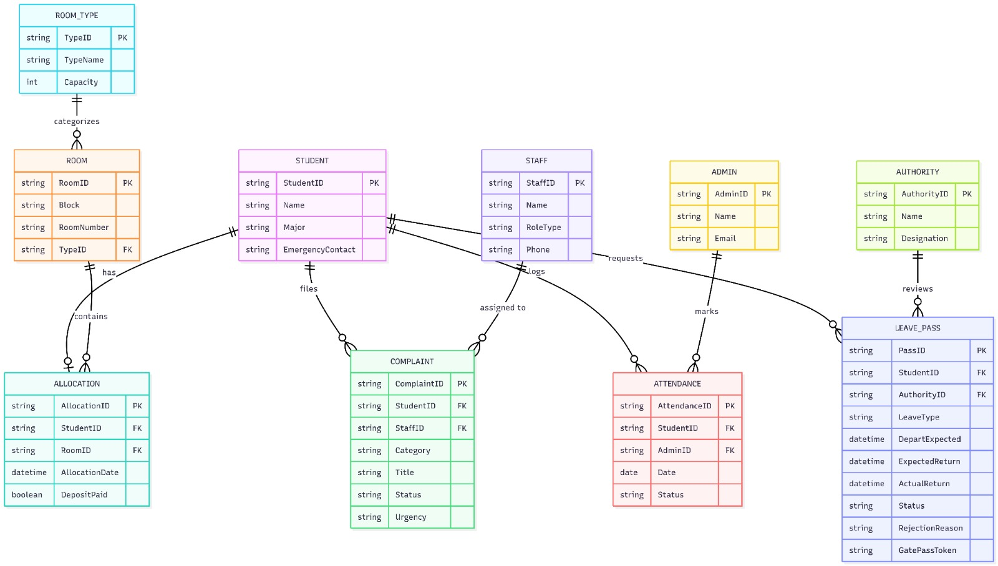
3.3 Relational Schema
STUDENT (StudentID [PK], Name, Major, EmergencyContact)
ROOM_TYPE (TypeID [PK], TypeName, Capacity)
ROOM (RoomID [PK], Block, RoomNumber, TypeID [FK])
ALLOCATION (AllocationID [PK], StudentID [FK], RoomID [FK], AllocationDate, DepositPaid)
ADMIN (AdminID [PK], Name, Email)
STAFF (StaffID [PK], Name, RoleType, Phone)
AUTHORITY (AuthorityID [PK], Name, Designation)
COMPLAINT (ComplaintID [PK], StudentID [FK], StaffID [FK], Category, Title, Status, Urgency)
ATTENDANCE (AttendanceID [PK], StudentID [FK], AdminID [FK], Date, Status)
LEAVE_PASS (PassID [PK], StudentID [FK], AuthorityID [FK], LeaveType, DepartExpected, ExpectedReturn, ActualReturn, Status, RejectionReason, GatePassToken)

3.4 Normalization and Functional dependency analysis
FUNCTIONAL DEPENDENCY:

StudentID → Name, Major, EmergencyContact
TypeID → TypeName, Capacity
RoomID → Block, RoomNumber, TypeID
AllocationID → StudentID, RoomID, AllocationDate, DepositPaid
AdminID → Name, Email
StaffID → Name, RoleType, Phone
AuthorityID → Name, Designation
ComplaintID → StudentID, StaffID, Category, Title, Status, Urgency
AttendanceID → StudentID, AdminID, Date, Status
PassID → StudentID, AuthorityID, LeaveType, DepartExpected, ExpectedReturn, ActualReturn, Status, RejectionReason, GatePassToken

Attribute Closure & Candidate Keys:

To prove our primary keys are valid, we evaluated the attribute closures. For the ROOM table, finding the closure of {RoomID}+ gives us {RoomID, Block, RoomNumber, TypeID}. Since this closure covers every single column in the relation, RoomID is a valid candidate key. While we could have used a composite key of {Block, RoomNumber} to uniquely identify a room, choosing RoomID as a simple primary key makes writing queries and managing foreign keys much easier across the database.

NORMALIZATION:

Normalization Stage | Schema State (Evolution) | Justification / Action Taken
Unnormalized Form (UNF) | STUDENT_DATA (StudentID [PK], Name, {AbsenceDates}) | Original State: The database contains repeating groups (a list of absence dates stuffed into one column per student).
1st Normal Form (1NF) | STUDENT (StudentID [PK], Name)  ATTENDANCE (StudentID [PK], Date [PK]) | Rule applied: Atomic values only, no repeating groups.  Action: Broke the list of dates out into an ATTENDANCE table so every daily record gets its own independent row.
2nd Normal Form (2NF) | INTERMEDIATE_ALLOCATION (StudentID [PK], RoomID [PK], StudentName, RoomCapacity) | Rule applied: No partial dependencies on a composite key.  Action: In this intermediate state, StudentName depends only on StudentID, and RoomCapacity depends only on RoomID (partial dependencies). Splitting this into STUDENT, ROOM, and ALLOCATION (AllocationID [PK], StudentID [FK], RoomID [FK]) resolves the 2NF violation.
3rd Normal Form (3NF) | ROOM (RoomID [PK], TypeID [FK])  ROOM_TYPE (TypeID [PK], Capacity) | Rule applied: No transitive dependencies.  Action: Capacity relied on TypeID, not the RoomID itself (RoomID → TypeID → Capacity). We extracted the type details into the ROOM_TYPE table to prevent update anomalies.
Boyce-Codd Normal Form (BCNF) | (Matches the final 10-table schema listed in Section 3.3) | Rule applied: Every determinant must be a candidate key.  Action: Looking at our functional dependencies, every attribute on the left side (StudentID, RoomID, PassID) is a designated primary key. There are no non-trivial dependencies breaking BCNF rules.

2

