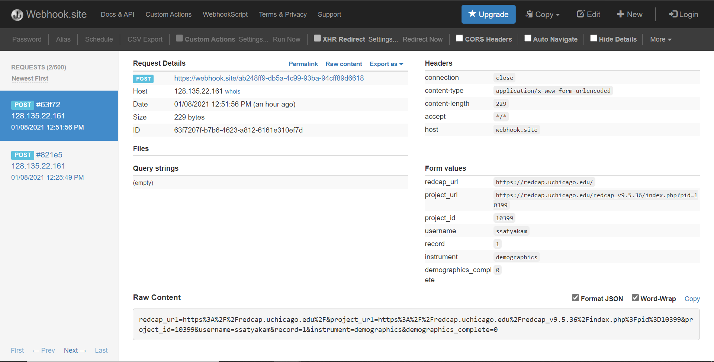

**HHTP POST Request Example:**

redcap_url=https%3A%2F%2Fredcap.uchicago.edu%2F&project_url=https%3A%2F%2Fredcap.uchicago.edu%2Fredcap_v9.5.36%2Findex.php%3Fpid%3D10399&project_id=10399&username=ssatyakam&record=1&instrument=demographics&demographics_complete=0