LAB PROGRAM 1
QUESTION:
Write a C program to simulate the following CPU scheduling algorithm to find turnaround time and waiting time. (Any one) a) FCFS b) SJF c) Priority d) Round Robin (Experiment with different quantum sizes for RR algorithm)

CODE:
a)FCFS:
#include <stdio.h>

int main() {
int n, bt[20], wt[20], tat[20], at[20], ct[20];
int i;
float twt = 0.0, ttat = 0.0, awt, att;

printf("Enter the number of processes: ");
scanf("%d", &n);

// Input Arrival Time and Burst Time
for (i = 0; i < n; i++) {
printf("Enter Arrival Time for Process %d: ", i + 1);
scanf("%d", &at[i]);
printf("Enter Burst Time for Process %d: ", i + 1);
scanf("%d", &bt[i]);
}

// FCFS Scheduling
ct[0] = at[0] + bt[0]; // Completion time of first process
wt[0] = 0; // Waiting time of first process
tat[0] = bt[0]; // Turnaround time

for (i = 1; i < n; i++) {
if (ct[i - 1] < at[i]) {
ct[i] = at[i] + bt[i]; // CPU idle
wt[i] = 0;
} else {
wt[i] = ct[i - 1] - at[i];
ct[i] = ct[i - 1] + bt[i];
}
tat[i] = wt[i] + bt[i];

}

// Calculate averages
for (i = 0; i < n; i++) {
twt += wt[i];
ttat += tat[i];
}

awt = twt / n;
att = ttat / n;

// Output Table
printf("\nPROCESS\tAT\tBT\tCT\tWT\tTAT");
for (i = 0; i < n; i++) {
printf("\nP%d\t%d\t%d\t%d\t%d\t%d",
i + 1, at[i], bt[i], ct[i], wt[i], tat[i]);
}

printf("\n\nAverage Waiting Time = %.2f", awt);
printf("\nAverage Turnaround Time = %.2f\n", att);

return 0;
}
RESULT:
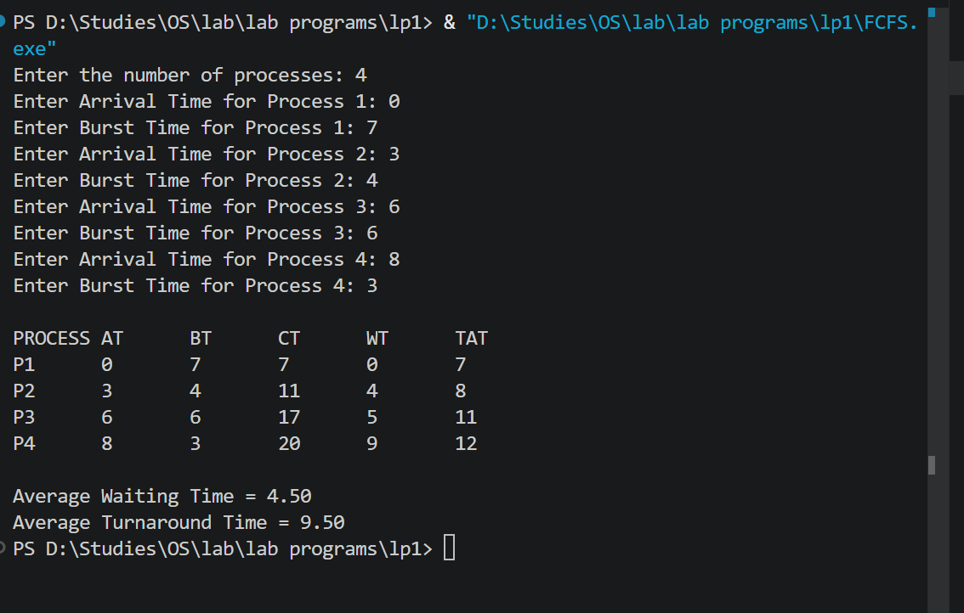

b) 1)SJF:
#include <stdio.h>

int main() {
int n, bt[20], wt[20], tat[20], at[20], ct[20];
int completed[20] = {0};
int i, time = 0, count = 0, min, index;
float twt = 0.0, ttat = 0.0, awt, att;

printf("Enter the number of processes: ");
scanf("%d", &n);

for (i = 0; i < n; i++) {
printf("Enter Arrival Time for Process %d: ", i + 1);
scanf("%d", &at[i]);
printf("Enter Burst Time for Process %d: ", i + 1);
scanf("%d", &bt[i]);
}

while (count < n) {
min = 9999;
index = -1;

for (i = 0; i < n; i++) {
if (at[i] <= time && completed[i] == 0) {
if (bt[i] < min) {
min = bt[i];
index = i;
}
}
}

if (index != -1) {
time += bt[index];
ct[index] = time;
tat[index] = ct[index] - at[index];
wt[index] = tat[index] - bt[index];
completed[index] = 1;
count++;
} else {
time++; // CPU idle
}
}

for (i = 0; i < n; i++) {
twt += wt[i];
ttat += tat[i];
}

awt = twt / n;
att = ttat / n;

printf("\nPROCESS\tAT\tBT\tCT\tWT\tTAT");
for (i = 0; i < n; i++) {
printf("\nP%d\t%d\t%d\t%d\t%d\t%d",
i + 1, at[i], bt[i], ct[i], wt[i], tat[i]);
}

printf("\n\nAverage Waiting Time = %.2f", awt);
printf("\nAverage Turnaround Time = %.2f\n", att);

return 0;
}
RESULT:
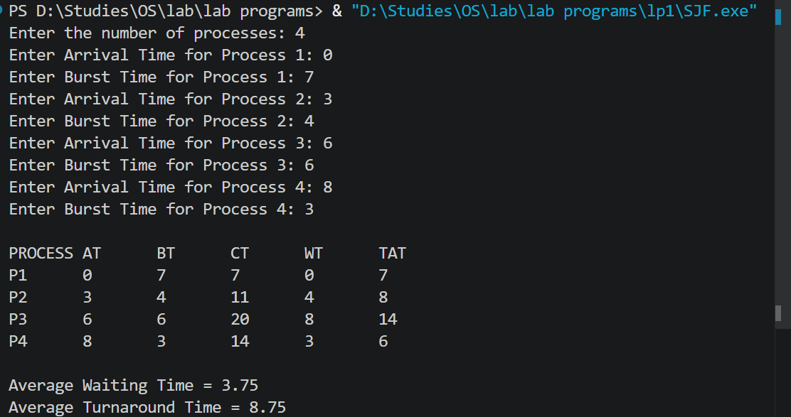

2)SRTF:
#include <stdio.h>

int main() {
int n, bt[20], wt[20], tat[20], at[20], ct[20], rt[20];
int i, time = 0, count = 0, min, index;
float twt = 0.0, ttat = 0.0, awt, att;

printf("Enter the number of processes: ");
scanf("%d", &n);

for (i = 0; i < n; i++) {
printf("Enter Arrival Time for Process %d: ", i + 1);
scanf("%d", &at[i]);
printf("Enter Burst Time for Process %d: ", i + 1);
scanf("%d", &bt[i]);
rt[i] = bt[i]; // Remaining time
}

while (count < n) {
min = 9999;
index = -1;

for (i = 0; i < n; i++) {
if (at[i] <= time && rt[i] > 0) {
if (rt[i] < min) {
min = rt[i];
index = i;
}
}
}

if (index != -1) {
rt[index]--; // Execute for 1 unit
time++;

if (rt[index] == 0) {
ct[index] = time;
tat[index] = ct[index] - at[index];
wt[index] = tat[index] - bt[index];
count++;
}
} else {
time++; // CPU idle
}
}

for (i = 0; i < n; i++) {
twt += wt[i];
ttat += tat[i];
}

awt = twt / n;
att = ttat / n;

printf("\nPROCESS\tAT\tBT\tCT\tWT\tTAT");
for (i = 0; i < n; i++) {
printf("\nP%d\t%d\t%d\t%d\t%d\t%d",
i + 1, at[i], bt[i], ct[i], wt[i], tat[i]);
}

printf("\n\nAverage Waiting Time = %.2f", awt);
printf("\nAverage Turnaround Time = %.2f\n", att);

return 0;
}
RESULT:
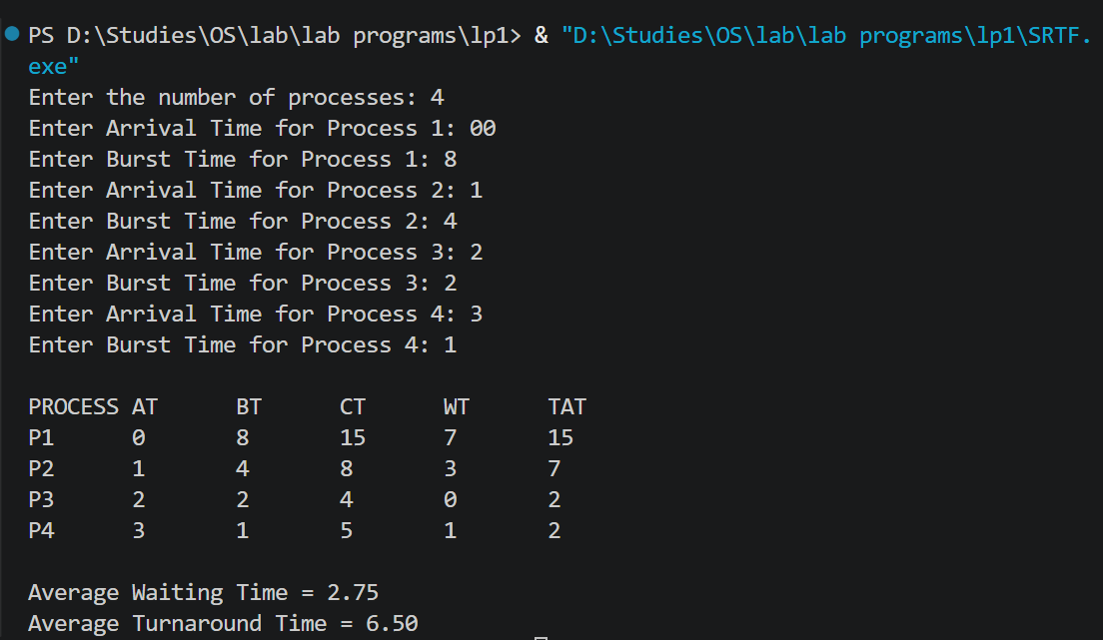

c)PRIORITY:
1)NON PREEMPTIVE:
#include<stdio.h>

struct process{
int pid;
int at;
int bt;
int pr;
int ct;
int tat;
int wt;
int rt;
int done;
};

float average(struct process p[],int n,int choice) {
int sum=0;

for(int i=0;i<n;i++) {
if(choice==1)
sum+=p[i].tat;
else if(choice==2)
sum+=p[i].wt;
}

return (float)sum/n;
}

void calcCT(struct process p[],int n) {

int completed=0;
int time=0;

while(completed<n) {

int idx=-1;
int bestPriority=999;
//running a loop to select the process arrived with highest priority
for(int i=0;i<n;i++) {

if(p[i].at<=time && p[i].done==0) {

if(p[i].pr < bestPriority) {
bestPriority=p[i].pr;
idx=i;
}

}
}

// CPU idle
if(idx==-1) {
time++;
}
//logic for calculating ct for selected highest priority arrived process
else {
time += p[idx].bt;
p[idx].ct = time;
p[idx].done = 1;
completed++;
}
}
}

void calcTAT(struct process p[],int n) {
for(int i=0;i<n;i++) {
p[i].tat = p[i].ct - p[i].at;
}
}

void calcWT(struct process p[],int n) {
for(int i=0;i<n;i++) {
p[i].wt = p[i].tat - p[i].bt;
p[i].rt = p[i].wt;
}
}

int main() {

struct process p[5]={
{1,0,7,3,0,0,0,0,0},
{2,2,4,1,0,0,0,0,0},
{3,3,6,4,0,0,0,0,0},
{4,5,5,2,0,0,0,0,0},
{5,6,2,1,0,0,0,0,0}
};

int n=5;

calcCT(p,n);
calcTAT(p,n);
calcWT(p,n);

printf("PROCESS\tAT\tBT\tPR\tCT\tTAT\tWT\tRT\n\n");

for(int i=0;i<n;i++) {

printf("%d\t%d\t%d\t%d\t%d\t%d\t%d\t%d\n",
p[i].pid,
p[i].at,
p[i].bt,
p[i].pr,
p[i].ct,
p[i].tat,
p[i].wt,
p[i].rt);
}

printf("\nAverage Turnaround Time = %.2f", average(p,n,1));
printf("\nAverage Waiting Time = %.2f\n", average(p,n,2));
}
2)PREEMPTIVE:

#include<stdio.h>

struct process{
int pid;
int at;
int bt;
int pr;
int ct;
int tat;
int wt;
int rt;
};

float average(struct process p[],int n,int choice) {
int sum=0;

for(int i=0;i<n;i++) {
if(choice==1)
sum+=p[i].tat;
else
sum+=p[i].wt;
}

return (float)sum/n;
}

void calcCT(struct process p[],int n) {

int completed=0;
int time=0;

while(completed<n) {

int idx=-1;
int bestPriority=999;

for(int i=0;i<n;i++) {

if(p[i].at<=time && p[i].rt>0) {

if(p[i].pr < bestPriority) {
bestPriority=p[i].pr;
idx=i;
}
}
}

if(idx==-1) {
time++;
}

else {

p[idx].rt--; // run for 1 unit
time++;

if(p[idx].rt==0) {
p[idx].ct=time;
completed++;
}
}
}
}

void calcTAT(struct process p[],int n) {
for(int i=0;i<n;i++) {
p[i].tat=p[i].ct-p[i].at;
}
}

void calcWT(struct process p[],int n) {
for(int i=0;i<n;i++) {
p[i].wt=p[i].tat-p[i].bt;
}
}

int main() {

struct process p[5]={
{1,0,7,3,0,0,0,7},
{2,2,4,1,0,0,0,4},
{3,3,6,4,0,0,0,6},
{4,5,5,2,0,0,0,5},
{5,6,2,1,0,0,0,2}
};

int n=5;

calcCT(p,n);
calcTAT(p,n);
calcWT(p,n);

printf("PROCESS\tAT\tBT\tPR\tCT\tTAT\tWT\n\n");

for(int i=0;i<n;i++) {
printf("%d\t%d\t%d\t%d\t%d\t%d\t%d\n",
p[i].pid,
p[i].at,
p[i].bt,
p[i].pr,
p[i].ct,
p[i].tat,
p[i].wt);
}

printf("\nAverage Turnaround Time = %.2f", average(p,n,1));
printf("\nAverage Waiting Time = %.2f\n", average(p,n,2));

}

RESULT:
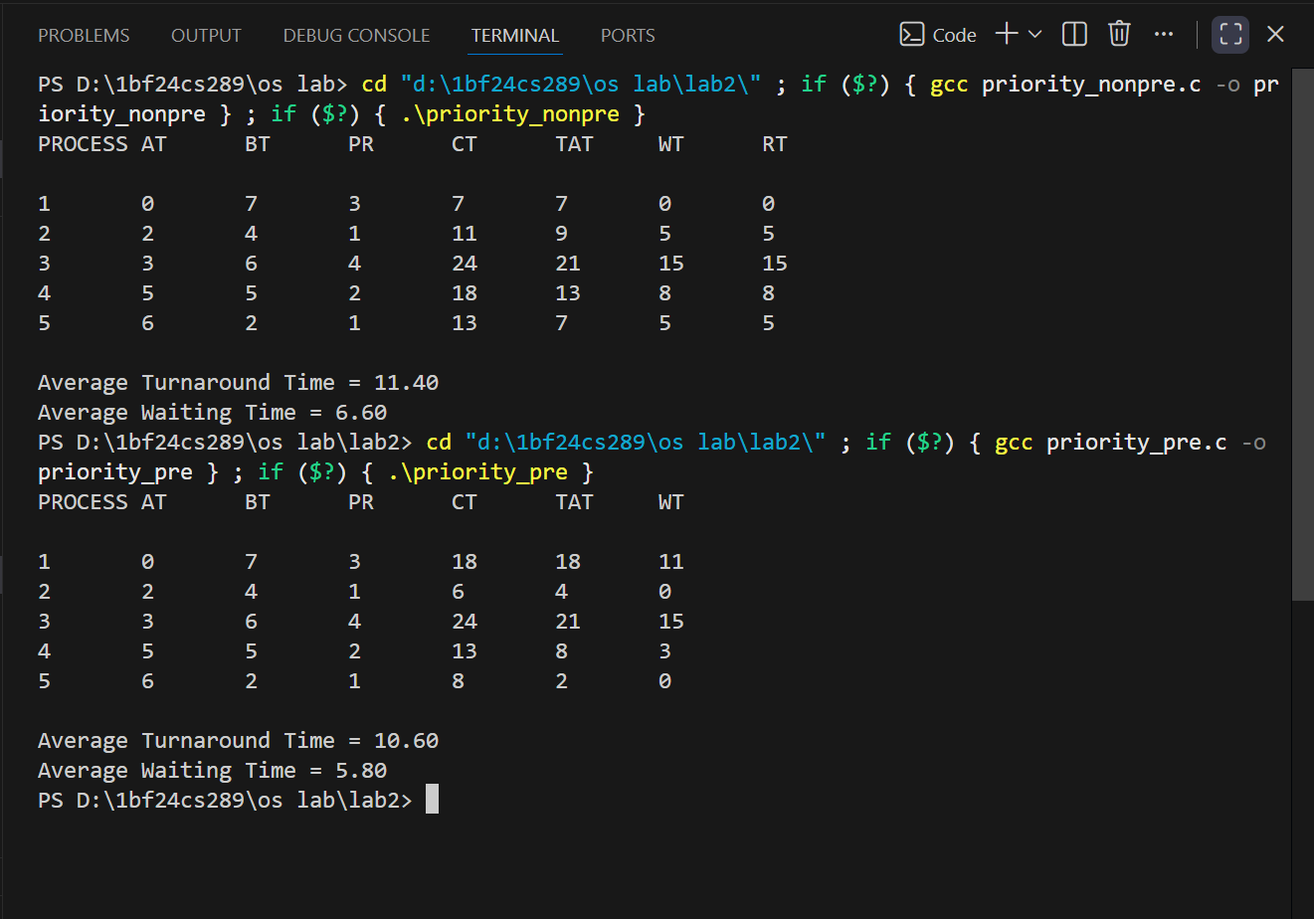
d)ROUND ROBIN:
#include <stdio.h>
#include <stdbool.h>

struct Process {
int pid; // Process ID
int at; // Arrival Time
int bt; // Burst Time
int rbt; // Remaining Burst Time
int ct; // Completion Time
int tat; // Turnaround Time
int wt; // Waiting Time
int rt; // Response Time
bool first_time;// Flag to check if process is getting CPU for the first time
};

int main() {
int n, tq;
float total_tat = 0, total_wt = 0;

printf("Enter the number of processes: ");
scanf("%d", &n);

struct Process p[n];

// 1. Take Inputs
for (int i = 0; i < n; i++) {
printf("Enter PID, Arrival Time, and Burst Time for process %d: ", i + 1);
scanf("%d %d %d", &p[i].pid, &p[i].at, &p[i].bt);
p[i].rbt = p[i].bt;
p[i].first_time = true;
}

printf("Enter Time Quantum: ");
scanf("%d", &tq);

// 2. Sort processes by Arrival Time (Bubble Sort for simplicity)
for (int i = 0; i < n - 1; i++) {
for (int j = 0; j < n - i - 1; j++) {
if (p[j].at > p[j+1].at) {
struct Process temp = p[j];
p[j] = p[j+1];
p[j+1] = temp;
}
}
}

// 3. Initialize Ready Queue
int queue[1000];
int front = 0, rear = 0;

int current_time = 0;
int completed = 0;
int i = 0; // Tracks the next process to arrive

// Fast-forward time to the first process's arrival if CPU is idle at t=0
if (p[0].at > current_time) {
current_time = p[0].at;
}

// Enqueue all processes that have arrived at the starting time
while (i < n && p[i].at <= current_time) {
queue[rear++] = i;
i++;
}

// 4. Execute Round Robin Simulation
while (completed < n) {
// If queue is empty but processes are pending, fast-forward time to next arrival
if (front == rear) {
current_time = p[i].at;
while (i < n && p[i].at <= current_time) {
queue[rear++] = i;
i++;
}
}

// Dequeue process
int idx = queue[front++];

// Calculate Response Time if getting CPU for the first time
if (p[idx].first_time) {
p[idx].rt = current_time - p[idx].at;
p[idx].first_time = false;
}

// Execute process for Time Quantum or Remaining Burst Time, whichever is smaller
int exec_time = (p[idx].rbt < tq) ? p[idx].rbt : tq;
current_time += exec_time;
p[idx].rbt -= exec_time;

// Enqueue newly arrived processes DURING this execution window
while (i < n && p[i].at <= current_time) {
queue[rear++] = i;
i++;
}

// If the current process is not finished, put it back at the end of the queue
if (p[idx].rbt > 0) {
queue[rear++] = idx;
} else {
// Process is finished: Calculate Completion, Turnaround, and Waiting Times
p[idx].ct = current_time;
p[idx].tat = p[idx].ct - p[idx].at;
p[idx].wt = p[idx].tat - p[idx].bt;

total_tat += p[idx].tat;
total_wt += p[idx].wt;
completed++;
}
}

// 5. Sort back by PID to print results neatly in their original order
for (int j = 0; j < n - 1; j++) {
for (int k = 0; k < n - j - 1; k++) {
if (p[k].pid > p[k+1].pid) {
struct Process temp = p[k];
p[k] = p[k+1];
p[k+1] = temp;
}
}
}

// 6. Print the Table
printf("\n-------------------------------------------------------------------------");
printf("\nPID\tAT\tBT\tCT\tTAT\tWT\tRT\n");
printf("-------------------------------------------------------------------------\n");
for (int j = 0; j < n; j++) {
printf("%d\t%d\t%d\t%d\t%d\t%d\t%d\n",
p[j].pid, p[j].at, p[j].bt, p[j].ct, p[j].tat, p[j].wt, p[j].rt);
}
printf("-------------------------------------------------------------------------\n");
printf("Average Turnaround Time: %.2f\n", total_tat / n);
printf("Average Waiting Time: %.2f\n", total_wt / n);

return 0;
}
RESULT:
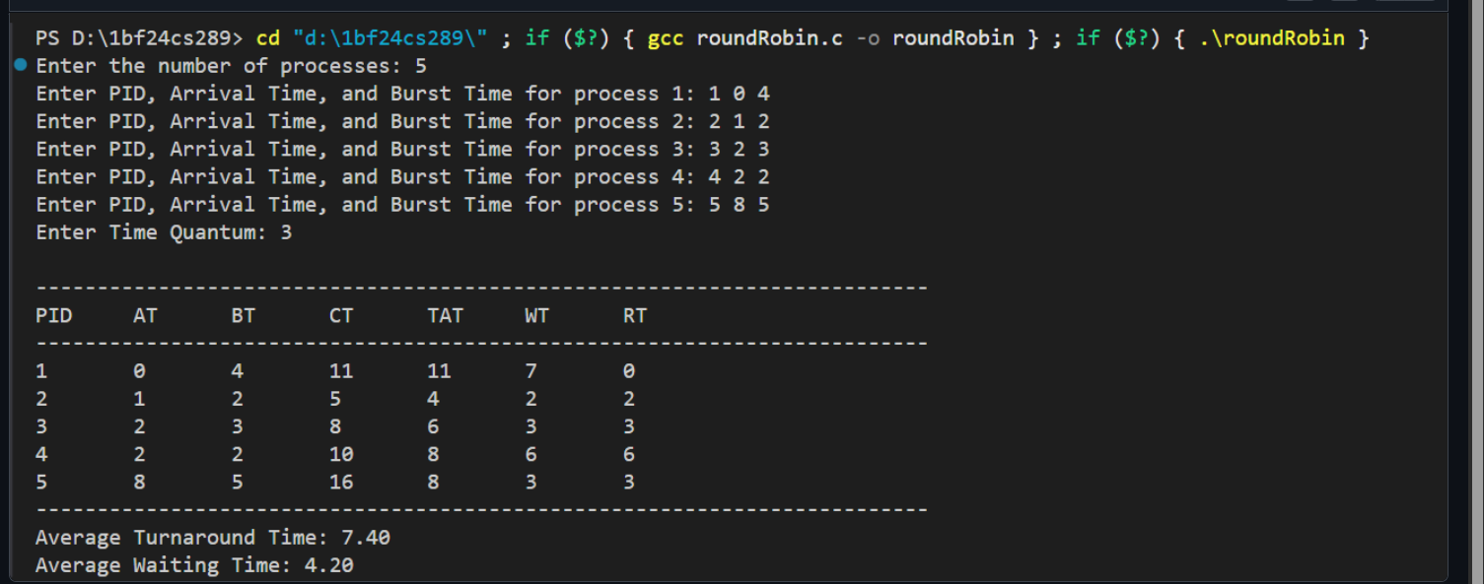
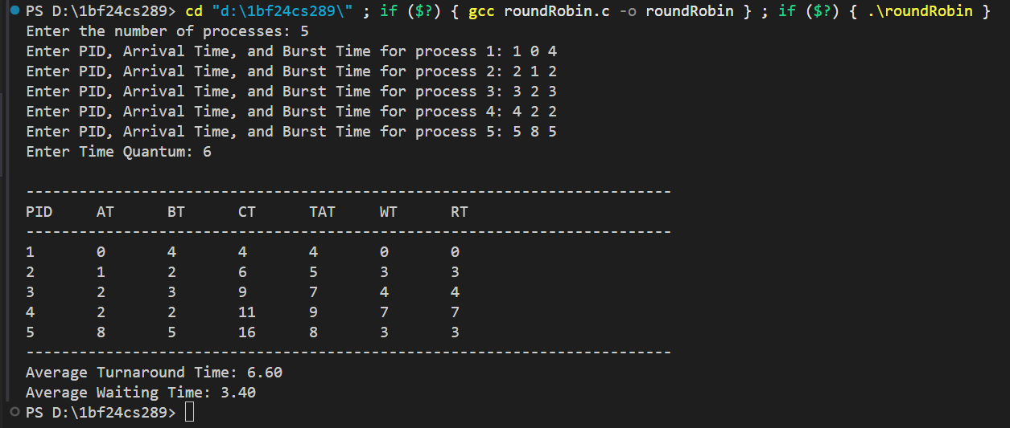

LAB PROGRAM 2
QUESTION:
Write a C program to simulate multi-level queue scheduling algorithm considering the following scenario. All the processes in the system are divided into two categories – system processes and user processes. System processes are to be given higher priority than user processes. Use FCFS scheduling for the processes in each queue.
CODE:
1)MULTI LEVEL NON PREEMPTIVE
//multilevel queue scheduling along with gantt chart
#include <stdio.h>

struct Process {
int pid;
int at; // Arrival Time
int bt; // Burst Time
int ct; // Completion Time
int wt; // Waiting Time
int tat; // Turnaround Time
int type; // 0 = System, 1 = User
int done; // 0 = not done, 1 = completed
};

int main() {
int n, i, time = 0, completed = 0;

printf("Enter total number of processes: ");
scanf("%d", &n);

struct Process p[n];

// Input
for(i = 0; i < n; i++) {
printf("\nProcess %d\n", i+1);
p[i].pid = i + 1;

printf("Enter Arrival Time: ");
scanf("%d", &p[i].at);

printf("Enter Burst Time: ");
scanf("%d", &p[i].bt);

printf("Enter Type (0 = System, 1 = User): ");
scanf("%d", &p[i].type);

p[i].done = 0;
}

// Scheduling
while(completed < n) {
int idx = -1;

// Step 1: Check System processes first
for(i = 0; i < n; i++) {
if(p[i].at <= time && p[i].done == 0 && p[i].type == 0) {
idx = i;
break; // FCFS → first arrived
}
}

// Step 2: If no system process, check user
if(idx == -1) {
for(i = 0; i < n; i++) {
if(p[i].at <= time && p[i].done == 0 && p[i].type == 1) {
idx = i;
break;
}
}
}

// Step 3: If no process available → increment time
if(idx == -1) {
time++;
continue;
}

// Execute process
time += p[idx].bt;
p[idx].ct = time;
p[idx].tat = p[idx].ct - p[idx].at;
p[idx].wt = p[idx].tat - p[idx].bt;
p[idx].done = 1;
completed++;
}

// Output
float avg_wt = 0, avg_tat = 0;

printf("\nPID\tAT\tBT\tType\tCT\tTAT\tWT\n");

for(i = 0; i < n; i++) {
printf("%d\t%d\t%d\t%s\t%d\t%d\t%d\n",
p[i].pid, p[i].at, p[i].bt,
(p[i].type == 0) ? "SYS" : "USR",
p[i].ct, p[i].tat, p[i].wt);

avg_wt += p[i].wt;
avg_tat += p[i].tat;
}

printf("\nAverage WT = %.2f", avg_wt / n);
printf("\nAverage TAT = %.2f\n", avg_tat / n);

//displaying gantt chart
for(i = 0; i < n; i++) {
printf("| P%d ", p[i].pid);
}
printf("|\n");
for(i = 0; i < n; i++) {
printf("%d ", p[i].ct);
}
printf("\n");
return 0;
}
RESULT:
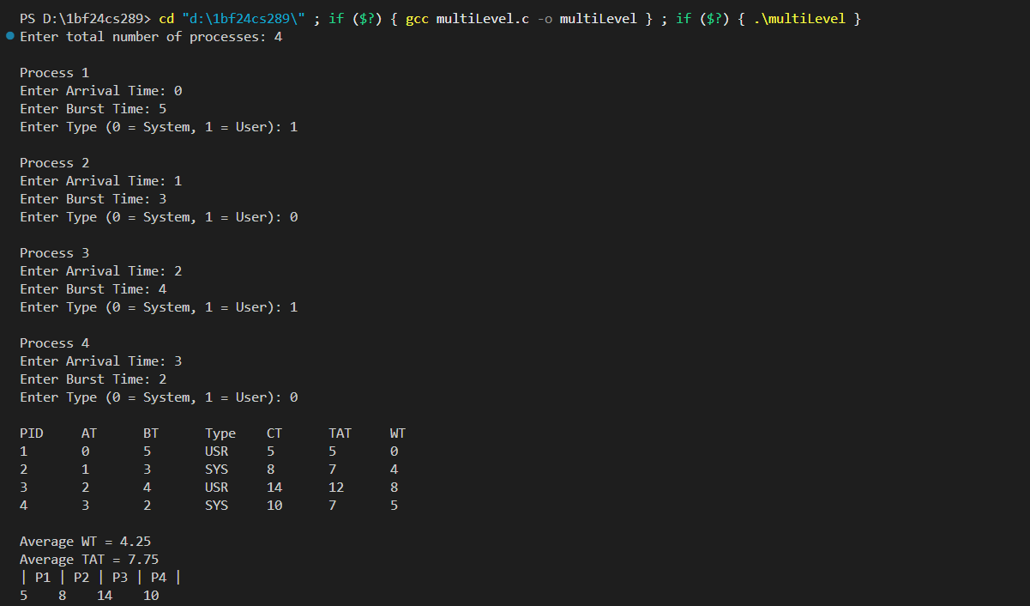
2)MULTI LEVEL PREEMPTIVE
#include <stdio.h>

struct Process {
int pid;
int at; // Arrival Time
int bt; // Burst Time
int rt; // Remaining Time
int ct; // Completion Time
int wt; // Waiting Time
int tat; // Turnaround Time
int type; // 0 = System, 1 = User
int done; // 0 = not done, 1 = completed
};

int main() {
int n, i, time = 0, completed = 0;

printf("Enter total number of processes: ");
scanf("%d", &n);

struct Process p[n];

// Input
for(i = 0; i < n; i++) {
printf("\nProcess %d\n", i+1);
p[i].pid = i + 1;

printf("Enter Arrival Time: ");
scanf("%d", &p[i].at);

printf("Enter Burst Time: ");
scanf("%d", &p[i].bt);

printf("Enter Type (0 = System, 1 = User): ");
scanf("%d", &p[i].type);

p[i].rt = p[i].bt; // initialize remaining time
p[i].done = 0;
}

// Preemptive Scheduling
while(completed < n) {
int idx = -1;
int best_at = 1e9;

// Step 1: System processes (higher priority)
for(i = 0; i < n; i++) {
if(p[i].at <= time && p[i].done == 0 && p[i].type == 0 && p[i].rt > 0) {
if(p[i].at < best_at) {
best_at = p[i].at;
idx = i;
}
}
}

// Step 2: User processes if no system process found
if(idx == -1) {
best_at = 1e9;
for(i = 0; i < n; i++) {
if(p[i].at <= time && p[i].done == 0 && p[i].type == 1 && p[i].rt > 0) {
if(p[i].at < best_at) {
best_at = p[i].at;
idx = i;
}
}
}
}

// Step 3: If no process available
if(idx == -1) {
time++;
continue;
}

// Execute for 1 time unit (PREEMPTIVE)
p[idx].rt--;
time++;

// If process completes
if(p[idx].rt == 0) {
p[idx].ct = time;
p[idx].tat = p[idx].ct - p[idx].at;
p[idx].wt = p[idx].tat - p[idx].bt;
p[idx].done = 1;
completed++;
}
}

// Output
float avg_wt = 0, avg_tat = 0;

printf("\nPID\tAT\tBT\tType\tCT\tTAT\tWT\n");

for(i = 0; i < n; i++) {
printf("%d\t%d\t%d\t%s\t%d\t%d\t%d\n",
p[i].pid, p[i].at, p[i].bt,
(p[i].type == 0) ? "SYS" : "USR",
p[i].ct, p[i].tat, p[i].wt);

avg_wt += p[i].wt;
avg_tat += p[i].tat;
}

printf("\nAverage WT = %.2f", avg_wt / n);
printf("\nAverage TAT = %.2f\n", avg_tat / n);

return 0;
}
RESULT:
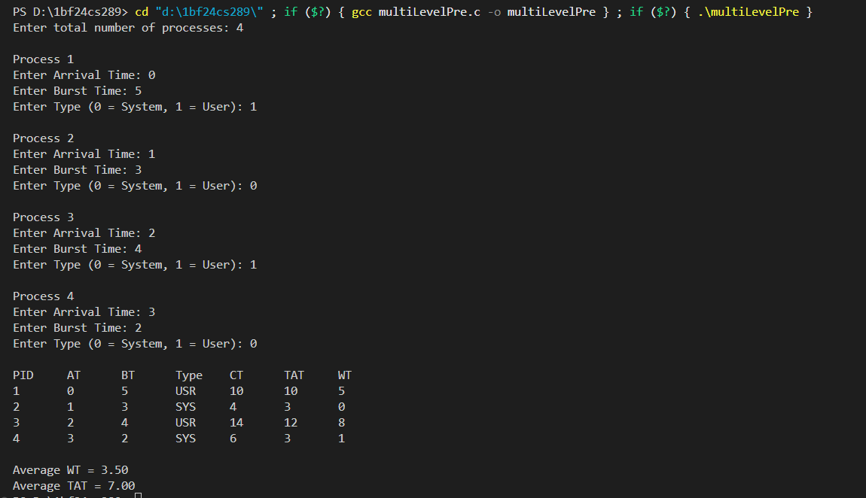

LAB PROGRAM 3
QUESTION:
Write a C program to simulate Real-Time CPU Scheduling
algorithms: (Any one)
a) Rate- Monotonic
b) Earliest-deadline First
c) Proportional scheduling
CODE:
a) RATE- MONOTONIC:
// rate monotonic scheduling
#include<stdio.h>
#include<math.h>

struct tasks {
int pid;
int Ci;
int Ti;
int remaining;
int next_arrival;
};

//gcd function for getting lcm
int gcd(int a, int b) {
while(b != 0) {
int temp = b;
b = a % b;
a = temp;
}
return a;
}

//lcm function for 2 numbers
int lcm(int a,int b) {
return (a*b)/gcd(a,b);
}

//getting lcm of all tasks
int tasks_lcm(struct tasks t[],int n) {
int result=t[0].Ti;

for(int i=1;i<n;i++) {
result=lcm(result,t[i].Ti);
}
return result;
}

int main() {

int n;
printf("enter number of tasks: ");
scanf("%d",&n);

struct tasks t[n];

// input
for(int i=0;i<n;i++) {
printf("Task %d\n", i+1);

printf("enter Ci: ");
scanf("%d", &t[i].Ci);

printf("enter Ti: ");
scanf("%d", &t[i].Ti);

t[i].pid = i+1;

// init for step 5
t[i].remaining = 0;
t[i].next_arrival = 0;
}

// Step 1: CPU utilization
float u=0;
for(int i=0;i<n;i++) {
u += (float)t[i].Ci / t[i].Ti;
}
printf("CPU utilization: %f\n", u);

// Step 2: RMS bound
float bound = n * (pow(2, (float)1/n) - 1);
printf("Bound: %f\n", bound);

// Step 3
if(u <= bound) {
printf("Schedulable using RMS\n");
} else {
printf("Not guaranteed schedulable\n");
}

// Step 4: sort by Ti
for(int i=0;i<n;i++) {
for(int j=i+1;j<n;j++) {
if(t[i].Ti > t[j].Ti) {
struct tasks temp = t[i];
t[i] = t[j];
t[j] = temp;
}
}
}

// Step 5: Scheduling simulation

int LIMIT = tasks_lcm(t,n); // simulate till lcm time

printf("\n--- Scheduling ---\n");

for(int time = 0; time < LIMIT; time++) {

// check arrivals
for(int i=0;i<n;i++) {
if(time == t[i].next_arrival) {
t[i].remaining = t[i].Ci;
t[i].next_arrival += t[i].Ti;
}
}

// pick highest priority task (smallest Ti)
int idx = -1;
for(int i=0;i<n;i++) {
if(t[i].remaining > 0) {
idx = i;
break;
}
}

// execute
if(idx != -1) {
printf("Time %d: Task %d\n", time, t[idx].pid);
t[idx].remaining--;
} else {
printf("Time %d: Idle\n", time);
}
}

return 0;
}

RESULT:
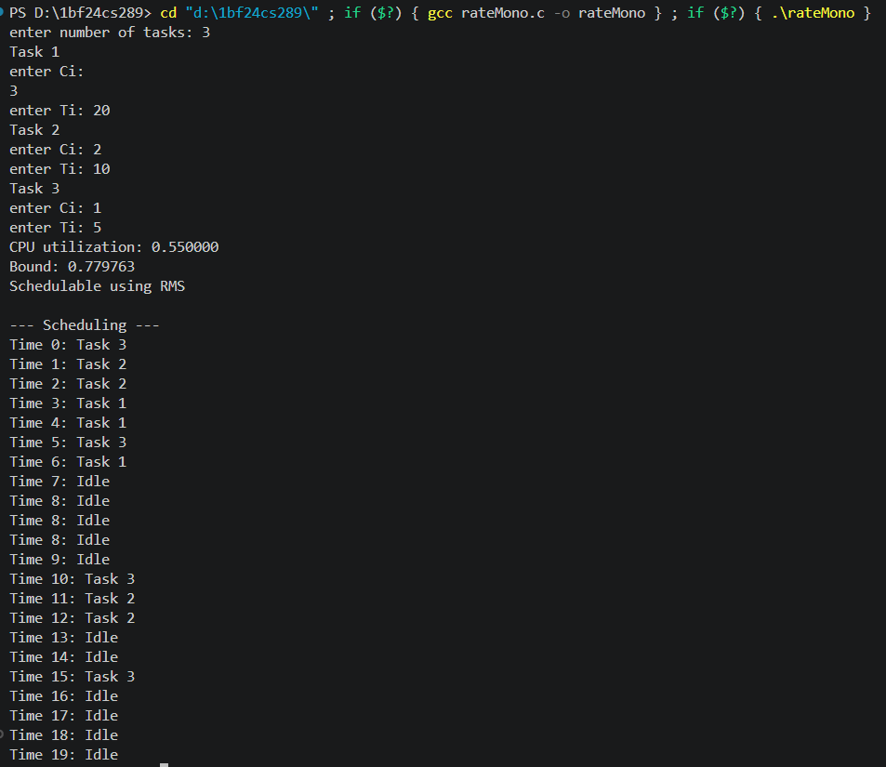

b) EARLIEST-DEADLINE FIRST
#include <stdio.h>

struct process {
int pid;
int Ci;
int Ti;
int Di; // deadline = Ti - 1

int remaining;
int next_arrival;
int absolute_deadline;
};

// GCD
int gcd(int a, int b) {
while(b != 0) {
int temp = b;
b = a % b;
a = temp;
}
return a;
}

// LCM
int lcm(int a, int b) {
return (a * b) / gcd(a, b);
}

// LCM of all Ti
int find_lcm(struct process p[], int n) {
int result = p[0].Ti;
for(int i = 1; i < n; i++) {
result = lcm(result, p[i].Ti);
}
return result;
}

int main() {
int n;
printf("Enter number of processes: ");
scanf("%d", &n);

struct process p[n];

// input
for(int i = 0; i < n; i++) {
printf("Process %d\n", i+1);

printf("Enter Ci: ");
scanf("%d", &p[i].Ci);

printf("Enter Ti: ");
scanf("%d", &p[i].Ti);

p[i].pid = i + 1;

// given condition
p[i].Di = p[i].Ti - 1;

// init
p[i].remaining = 0;
p[i].next_arrival = 0;
p[i].absolute_deadline = p[i].Di;
}

// utilization (EDF uses Di)
float U = 0;
for(int i = 0; i < n; i++) {
U += (float)p[i].Ci / p[i].Di;
}

printf("Utilization: %f\n", U);

if(U <= 1)
printf("Feasible\n");
else
printf("Not guaranteed feasible\n");

int LIMIT = find_lcm(p, n);

printf("\n--- EDF Scheduling (till %d) ---\n", LIMIT);

// scheduling loop
for(int time = 0; time < LIMIT; time++) {

// arrivals
for(int i = 0; i < n; i++) {
if(time == p[i].next_arrival) {
p[i].remaining = p[i].Ci;
p[i].absolute_deadline = time + p[i].Di;
p[i].next_arrival += p[i].Ti;
}
}

// select earliest deadline
int idx = -1;
int min_deadline = 999999;

for(int i = 0; i < n; i++) {
if(p[i].remaining > 0) {
if(p[i].absolute_deadline < min_deadline) {
min_deadline = p[i].absolute_deadline;
idx = i;
}
}
}

// execute
if(idx != -1) {
printf("Time %d: P%d\n", time, p[idx].pid);
p[idx].remaining--;
} else {
printf("Time %d: Idle\n", time);
}
}

return 0;
}
RESULT:
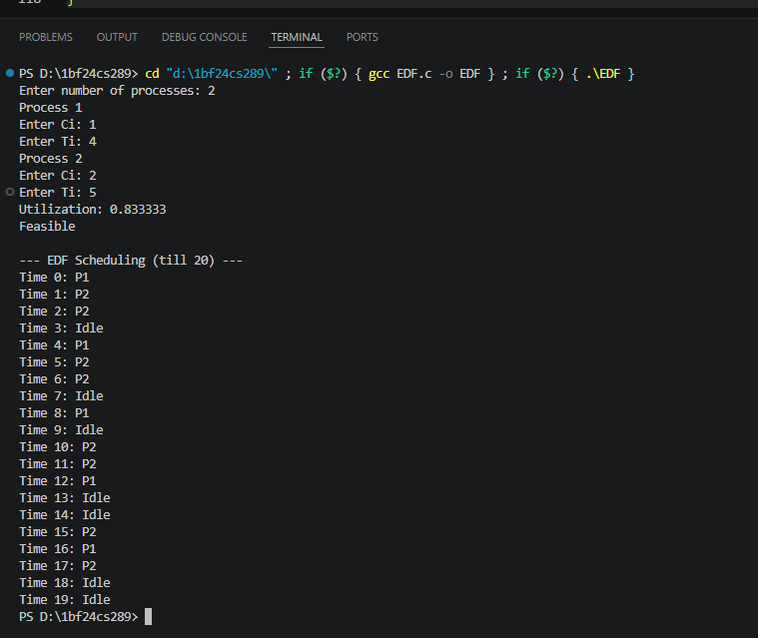

c)PROPORTIONAL SCHEDULING:
#include <stdio.h>

#define TIME_QUANTUM 10 // you can change this

struct process {
int pid;
int Ci; // total execution time
int remaining;
int weight;
int completed;
};

int main() {
int n;
printf("Enter number of processes: ");
scanf("%d", &n);

struct process p[n];

int total_weight = 0;

// input
for(int i = 0; i < n; i++) {
printf("Process %d\n", i+1);

printf("Enter Ci: ");
scanf("%d", &p[i].Ci);

printf("Enter weight: ");
scanf("%d", &p[i].weight);

p[i].pid = i + 1;
p[i].remaining = p[i].Ci;
p[i].completed = 0;

total_weight += p[i].weight;
}

int time = 0;
int completed_count = 0;

printf("\n--- Proportional Share Scheduling ---\n");

// Step 4
while(completed_count < n) {

// Step 5: loop through all processes
for(int i = 0; i < n; i++) {

if(p[i].completed)
continue;

// Step 6: ready check (all ready here)

// Step 8: calculate time slice
int time_slice = (p[i].weight * TIME_QUANTUM) / total_weight;

if(time_slice == 0) time_slice = 1; // avoid 0 slice

// Step 9: run process
printf("Time %d: P%d runs for %d units\n", time, p[i].pid, time_slice);

// Step 10
p[i].remaining -= time_slice;
time += time_slice;

// Step 11–12
if(p[i].remaining <= 0) {
printf("P%d completed at time %d\n", p[i].pid, time);

p[i].completed = 1;
completed_count++;

// Step 13
total_weight -= p[i].weight;
}
}
}

return 0;
}

RESULT:
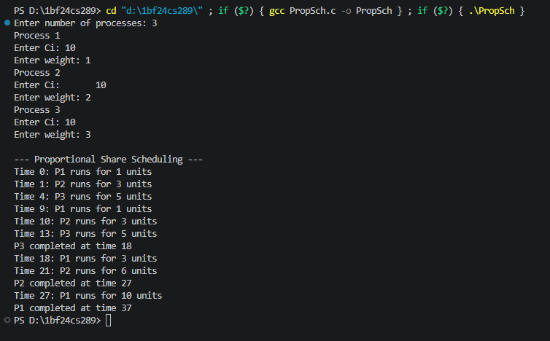

LAB PROGRAM 4
QUESTION:
Write a C program to simulate:
a) Producer-Consumer problem using semaphores.
b) Dining-Philosopher’s problem
CODE:
a) Producer-Consumer problem using semaphores:
#include <stdio.h>
#include <stdlib.h>
#include <pthread.h>
#include <semaphore.h>
#include <unistd.h>

#define BUFFER_SIZE 5

int buffer[BUFFER_SIZE];
int in = 0, out = 0;

sem_t empty, full;
pthread_mutex_t mutex;

// Producer function
void* producer(void* arg) {
int item;

for(int i = 0; i < 10; i++) {
item = rand() % 100;

sem_wait(&empty); // wait if buffer is full
pthread_mutex_lock(&mutex); // enter critical section

buffer[in] = item;
printf("Produced: %d at index %d\n", item, in);
in = (in + 1) % BUFFER_SIZE;

pthread_mutex_unlock(&mutex); // exit critical section
sem_post(&full); // increase filled slots

sleep(1);
}
return NULL;
}

// Consumer function
void* consumer(void* arg) {
int item;

for(int i = 0; i < 10; i++) {
sem_wait(&full); // wait if buffer is empty
pthread_mutex_lock(&mutex);

item = buffer[out];
printf("Consumed: %d from index %d\n", item, out);
out = (out + 1) % BUFFER_SIZE;

pthread_mutex_unlock(&mutex);
sem_post(&empty); // increase empty slots

sleep(2);
}
return NULL;
}

int main() {
pthread_t p, c;

// Initialize semaphores
sem_init(&empty, 0, BUFFER_SIZE); // initially all slots empty
sem_init(&full, 0, 0); // initially no items

pthread_mutex_init(&mutex, NULL);

// Create threads
pthread_create(&p, NULL, producer, NULL);
pthread_create(&c, NULL, consumer, NULL);

// Wait for threads to finish
pthread_join(p, NULL);
pthread_join(c, NULL);

// Cleanup
sem_destroy(&empty);
sem_destroy(&full);
pthread_mutex_destroy(&mutex);

return 0;
}
RESULT:
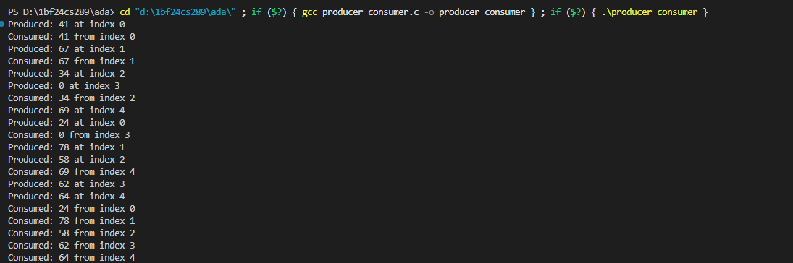

b) Dining-Philosopher’s problem:
#include <stdio.h>
#include <stdlib.h>
#include <pthread.h>
#include <unistd.h>

#define N 5 // Number of philosophers

pthread_mutex_t forks[N];

void* philosopher(void* num) {
int id = *(int*)num;

while (1) {
printf("Philosopher %d is thinking\n", id);
sleep(1);

// Deadlock prevention strategy
if (id % 2 == 0) {
pthread_mutex_lock(&forks[(id + 1) % N]); // right fork
pthread_mutex_lock(&forks[id]); // left fork
} else {
pthread_mutex_lock(&forks[id]); // left fork
pthread_mutex_lock(&forks[(id + 1) % N]); // right fork
}

printf("Philosopher %d is eating\n", id);
sleep(2);

pthread_mutex_unlock(&forks[id]);
pthread_mutex_unlock(&forks[(id + 1) % N]);

printf("Philosopher %d finished eating\n", id);
}
}

int main() {
pthread_t threads[N];
int ids[N];

// Initialize mutexes (forks)
for (int i = 0; i < N; i++) {
pthread_mutex_init(&forks[i], NULL);
}

// Create philosopher threads
for (int i = 0; i < N; i++) {
ids[i] = i;
pthread_create(&threads[i], NULL, philosopher, &ids[i]);
}

// Join threads (never actually ends)
for (int i = 0; i < N; i++) {
pthread_join(threads[i], NULL);
}

return 0;
}
RESULT:
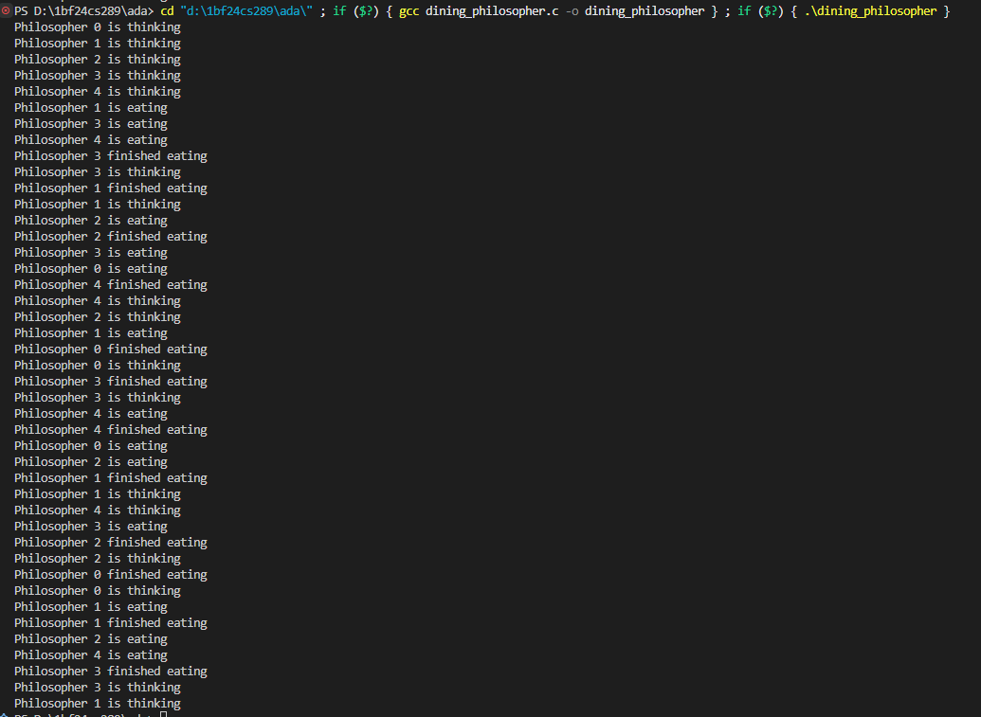

LAB PROGRAM 5
QUESTION:
Write a C program to simulate:
a) Bankers’ algorithm for the purpose of deadlock avoidance.
b) Deadlock Detection
CODE:
a) Bankers’ algorithm for the purpose of deadlock avoidance.
#include <stdio.h>

int main() {
int n, m;

printf("Enter number of processes: ");
scanf("%d", &n);

printf("Enter number of resource types: ");
scanf("%d", &m);

int alloc[n][m], max[n][m], need[n][m];
int avail[m];

// Allocation Matrix
printf("\nEnter Allocation Matrix:\n");
for(int i = 0; i < n; i++) {
for(int j = 0; j < m; j++) {
scanf("%d", &alloc[i][j]);
}
}

// Max Matrix
printf("\nEnter Max Matrix:\n");
for(int i = 0; i < n; i++) {
for(int j = 0; j < m; j++) {
scanf("%d", &max[i][j]);
}
}

// Available Resources
printf("\nEnter Available Resources:\n");
for(int i = 0; i < m; i++) {
scanf("%d", &avail[i]);
}

// Calculate Need Matrix
for(int i = 0; i < n; i++) {
for(int j = 0; j < m; j++) {
need[i][j] = max[i][j] - alloc[i][j];
}
}

printf("\nNeed Matrix:\n");
for(int i = 0; i < n; i++) {
for(int j = 0; j < m; j++) {
printf("%d ", need[i][j]);
}
printf("\n");
}

int finish[n], safeSeq[n];
int work[m];

for(int i = 0; i < n; i++)
finish[i] = 0;

for(int i = 0; i < m; i++)
work[i] = avail[i];

int count = 0;

while(count < n) {
int found = 0;

for(int i = 0; i < n; i++) {

if(finish[i] == 0) {

int possible = 1;

for(int j = 0; j < m; j++) {
if(need[i][j] > work[j]) {
possible = 0;
break;
}
}

if(possible) {

for(int j = 0; j < m; j++) {
work[j] += alloc[i][j];
}

safeSeq[count] = i;
count++;
finish[i] = 1;
found = 1;
}
}
}

if(found == 0) {
break;
}
}

if(count == n) {
printf("\nSystem is in SAFE state\n");
printf("Safe Sequence: ");

for(int i = 0; i < n; i++) {
printf("P%d ", safeSeq[i]);
}

printf("\n");
}
else {
printf("\nSystem is NOT in safe state\n");
}

return 0;
}
RESULT:
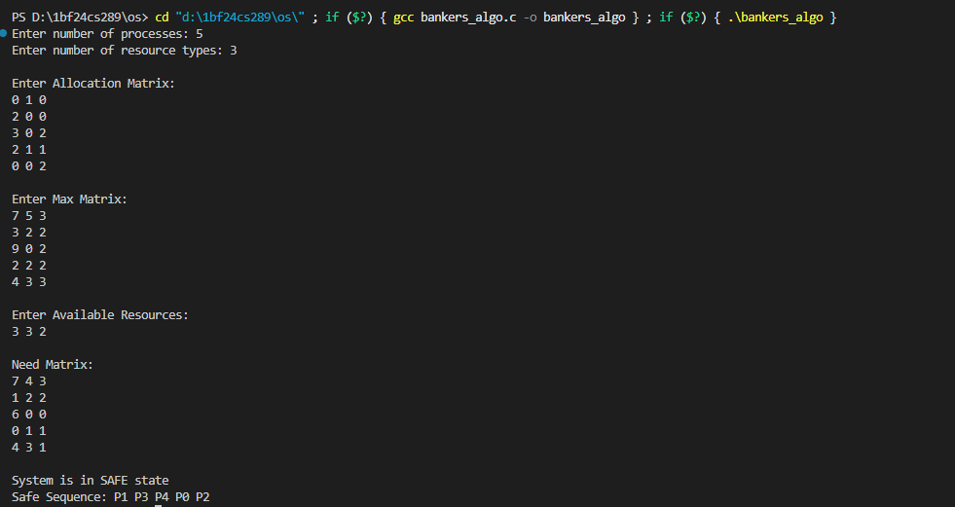

b) Deadlock Detection:
#include <stdio.h>

int main() {

int n, m;

printf("Enter number of processes: ");
scanf("%d", &n);

printf("Enter number of resource types: ");
scanf("%d", &m);

int alloc[n][m], request[n][m];
int avail[m];

// Allocation Matrix
printf("\nEnter Allocation Matrix:\n");
for(int i = 0; i < n; i++) {
for(int j = 0; j < m; j++) {
scanf("%d", &alloc[i][j]);
}
}

// Request Matrix
printf("\nEnter Request Matrix:\n");
for(int i = 0; i < n; i++) {
for(int j = 0; j < m; j++) {
scanf("%d", &request[i][j]);
}
}

// Available Resources
printf("\nEnter Available Resources:\n");
for(int i = 0; i < m; i++) {
scanf("%d", &avail[i]);
}

int finish[n];
int work[m];

// Initialize work = available
for(int i = 0; i < m; i++) {
work[i] = avail[i];
}

// Initialize finish[]
for(int i = 0; i < n; i++) {

int empty = 1;

for(int j = 0; j < m; j++) {
if(alloc[i][j] != 0) {
empty = 0;
break;
}
}

if(empty)
finish[i] = 1;
else
finish[i] = 0;
}

while(1) {

int found = 0;

for(int i = 0; i < n; i++) {

if(finish[i] == 0) {

int possible = 1;

for(int j = 0; j < m; j++) {

if(request[i][j] > work[j]) {
possible = 0;
break;
}
}

if(possible) {

for(int j = 0; j < m; j++) {
work[j] += alloc[i][j];
}

finish[i] = 1;
found = 1;
}
}
}

if(found == 0)
break;
}

int deadlock = 0;

for(int i = 0; i < n; i++) {

if(finish[i] == 0) {
deadlock = 1;
break;
}
}

if(deadlock) {

printf("\nDeadlock detected among processes:\n");

for(int i = 0; i < n; i++) {
if(finish[i] == 0) {
printf("P%d ", i);
}
}

printf("\n");
}
else {
printf("\nNo deadlock detected\n");
}

return 0;
}
RESULT:
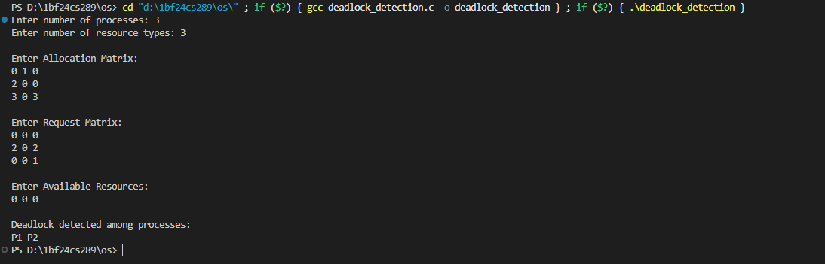

LAB PROGRAM 6
QUESTION:
Write a C program to simulate the following contiguous memory allocation techniques.
a) Worst-fit b) Best-fit c) First-fit
CODE:
#include <stdio.h>

void firstFit(int blockSize[], int blocks, int processSize[], int processes) {
int allocation[10];

for (int i = 0; i < processes; i++)
allocation[i] = -1;

for (int i = 0; i < processes; i++) {
for (int j = 0; j < blocks; j++) {
if (blockSize[j] >= processSize[i]) {
allocation[i] = j;
blockSize[j] -= processSize[i];
break;
}
}
}

printf("\n--- First Fit ---\n");
printf("Process No.\tProcess Size\tBlock No.\n");

for (int i = 0; i < processes; i++) {
printf("%d\t\t%d\t\t", i + 1, processSize[i]);

if (allocation[i] != -1)
printf("%d\n", allocation[i] + 1);
else
printf("Not Allocated\n");
}
}

void bestFit(int blockSize[], int blocks, int processSize[], int processes) {
int allocation[10];

for (int i = 0; i < processes; i++)
allocation[i] = -1;

for (int i = 0; i < processes; i++) {
int bestIdx = -1;

for (int j = 0; j < blocks; j++) {
if (blockSize[j] >= processSize[i]) {
if (bestIdx == -1 || blockSize[j] < blockSize[bestIdx]) {
bestIdx = j;
}
}
}

if (bestIdx != -1) {
allocation[i] = bestIdx;
blockSize[bestIdx] -= processSize[i];
}
}

printf("\n--- Best Fit ---\n");
printf("Process No.\tProcess Size\tBlock No.\n");

for (int i = 0; i < processes; i++) {
printf("%d\t\t%d\t\t", i + 1, processSize[i]);

if (allocation[i] != -1)
printf("%d\n", allocation[i] + 1);
else
printf("Not Allocated\n");
}
}

void worstFit(int blockSize[], int blocks, int processSize[], int processes) {
int allocation[10];

for (int i = 0; i < processes; i++)
allocation[i] = -1;

for (int i = 0; i < processes; i++) {
int worstIdx = -1;

for (int j = 0; j < blocks; j++) {
if (blockSize[j] >= processSize[i]) {
if (worstIdx == -1 || blockSize[j] > blockSize[worstIdx]) {
worstIdx = j;
}
}
}

if (worstIdx != -1) {
allocation[i] = worstIdx;
blockSize[worstIdx] -= processSize[i];
}
}

printf("\n--- Worst Fit ---\n");
printf("Process No.\tProcess Size\tBlock No.\n");

for (int i = 0; i < processes; i++) {
printf("%d\t\t%d\t\t", i + 1, processSize[i]);

if (allocation[i] != -1)
printf("%d\n", allocation[i] + 1);
else
printf("Not Allocated\n");
}
}

int main() {
int blocks, processes;

int blockSize[10], processSize[10];

int block1[10], block2[10], block3[10];

printf("Enter number of memory blocks: ");
scanf("%d", &blocks);

printf("Enter sizes of %d memory blocks:\n", blocks);

for (int i = 0; i < blocks; i++) {
scanf("%d", &blockSize[i]);

block1[i] = blockSize[i];
block2[i] = blockSize[i];
block3[i] = blockSize[i];
}

printf("\nEnter number of processes: ");
scanf("%d", &processes);

printf("Enter sizes of %d processes:\n", processes);

for (int i = 0; i < processes; i++)
scanf("%d", &processSize[i]);

firstFit(block1, blocks, processSize, processes);

bestFit(block2, blocks, processSize, processes);

worstFit(block3, blocks, processSize, processes);

return 0;
}
RESULT:
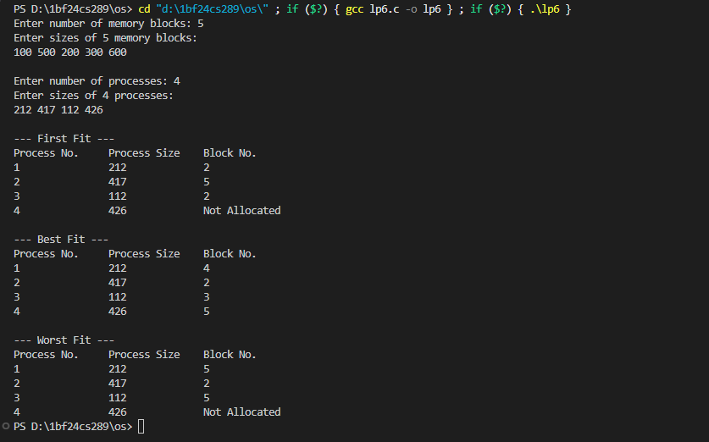

LAB PROGRAM 7
QUESTION:
Write a C program to simulate page replacement algorithms.
a) FIFO b) LRU c) Optimal

CODE:
#include <stdio.h>

#define MAX 50

// Function to print frame contents
void printFrames(int frames[], int f) {
for (int i = 0; i < f; i++) {
if (frames[i] == -1)
printf("- ");
else
printf("%d ", frames[i]);
}
printf("\n");
}

// FIFO Algorithm
void FIFO(int pages[], int n, int f) {
int frames[MAX];
int pageFaults = 0;
int index = 0;

for (int i = 0; i < f; i++)
frames[i] = -1;

printf("FIFO Page Replacement Process:\n");

for (int i = 0; i < n; i++) {
int found = 0;

for (int j = 0; j < f; j++) {
if (frames[j] == pages[i]) {
found = 1;
break;
}
}

if (!found) {
frames[index] = pages[i];
index = (index + 1) % f;

pageFaults++;

printf("PF No. %d: ", pageFaults);
printFrames(frames, f);
}
}

printf("FIFO Page Faults: %d\n", pageFaults);
}

// LRU Algorithm
void LRU(int pages[], int n, int f) {
int frames[MAX], time[MAX];
int pageFaults = 0;
int counter = 0;

for (int i = 0; i < f; i++) {
frames[i] = -1;
time[i] = 0;
}

printf("\nLRU Page Replacement Process:\n");

for (int i = 0; i < n; i++) {
int found = 0;

for (int j = 0; j < f; j++) {
if (frames[j] == pages[i]) {
counter++;
time[j] = counter;
found = 1;
break;
}
}

if (!found) {
int pos = 0;

for (int j = 1; j < f; j++) {
if (time[j] < time[pos])
pos = j;
}

frames[pos] = pages[i];

counter++;
time[pos] = counter;

pageFaults++;

printf("PF No. %d: ", pageFaults);
printFrames(frames, f);
}
}

printf("LRU Page Faults: %d\n", pageFaults);
}

// Function for Optimal Algorithm
int predict(int pages[], int frames[], int n, int index, int f) {
int farthest = index;
int pos = -1;

for (int i = 0; i < f; i++) {
int j;

for (j = index; j < n; j++) {
if (frames[i] == pages[j]) {
if (j > farthest) {
farthest = j;
pos = i;
}
break;
}
}

if (j == n)
return i;
}

if (pos == -1)
return 0;
else
return pos;
}

// Optimal Algorithm
void Optimal(int pages[], int n, int f) {
int frames[MAX];
int pageFaults = 0;

for (int i = 0; i < f; i++)
frames[i] = -1;

printf("\nOptimal Page Replacement Process:\n");

for (int i = 0; i < n; i++) {
int found = 0;

for (int j = 0; j < f; j++) {
if (frames[j] == pages[i]) {
found = 1;
break;
}
}

if (!found) {
int empty = -1;

for (int j = 0; j < f; j++) {
if (frames[j] == -1) {
empty = j;
break;
}
}

if (empty != -1) {
frames[empty] = pages[i];
} else {
int pos = predict(pages, frames, n, i + 1, f);
frames[pos] = pages[i];
}

pageFaults++;

printf("PF No. %d: ", pageFaults);
printFrames(frames, f);
}
}

printf("Optimal Page Faults: %d\n", pageFaults);
}

int main() {
int f, n;
int pages[MAX];

printf("Enter the number of Frames: ");
scanf("%d", &f);

printf("Enter the length of reference string: ");
scanf("%d", &n);

printf("Enter the reference string: ");

for (int i = 0; i < n; i++)
scanf("%d", &pages[i]);

FIFO(pages, n, f);

LRU(pages, n, f);

Optimal(pages, n, f);

return 0;
}
RESULT:
