VISVESVARAYA TECHNOLOGICAL UNIVERSITY
“JnanaSangama”, Belgaum -590014, Karnataka.

LAB REPORT
on
Object Oriented Java Programming (23CS3PCOOJ)
Submitted by
SHRIHARI VISWANATHAN (1BF24CS288)
in partial fulfillment for the award of the degree of
BACHELOR OF ENGINEERING
in

B.M.S. COLLEGE OF ENGINEERING
(Autonomous Institution under VTU)
BENGALURU-560019
Aug-2025 to Jan-2026

B.M.S. College of Engineering,
Bull Temple Road, Bangalore 560019
(Affiliated To Visvesvaraya Technological University, Belgaum)
Department of Computer Science and Engineering

CERTIFICATE
This is to certify that the Lab work entitled “Object Oriented Java Programming (23CS3PCOOJ)” carried out by SHRIHARI VISWANATHAN (1BF24CS288), who is bonafide student of B.M.S. College of Engineering. It is in partial fulfilment for the award of Bachelor of Engineering in Computer Science and Engineering of the Visvesvaraya Technological University, Belgaum. The Lab report has been approved as it satisfies the academic requirements in respect of an Object-Oriented Java Programming (23CS3PCOOJ) work prescribed for the said degree.

Dr. Seema Patil  Associate Professor  Department of CSE, BMSCE | Dr. Kavitha Sooda  Professor & HOD  Department of CSE, BMSCE

Index
Sl.  No. | Date | Experiment Title | Page No.
1 | 23/09/25 | QUADRATIC EQUATION
2 | 13/10/25 | SGPA CALCULATION
3 | 20/10/25 | BOOKS (TO STRING)
4 | 04/11/25 | ABSTRACT CLASS DEMO
5 | 04/11/25 | BANK
6 |  | PACKAGES
7 |  | EXCEPTION
8 |  | MULTITHREADING
9

Github Link:
https://github.com/siddharthshuklacs24/sem-3-java

Program 1
Implement Quadratic Equation

CODE:
/*Develop a Java program that prints all real solutions to the quadratic
equation ax2+bx+c = 0. Read in a, b, c and use the quadratic formula. If
the discriminate b2-4ac is negative, display a message stating that there
are no real solutions.*/

import java.util.Scanner; //SIDDHARTH SHUKLA 1BF24CS289
public class quad
{
public static void main(String args[])
{
Scanner sc=new Scanner(System.in);
System.out.println("enter the coefficient a: ");
double a=sc.nextDouble();
System.out.println("enter the coefficient b: ");
double b=sc.nextDouble();
System.out.println("enter the coefficient c: ");
double c=sc.nextDouble();
double D=(b*b)-(4*a*c);

if(D<0)
{
System.out.println("there are no real solutions");
double real=-b/(2*a);
double complex=Math.pow(-D,(1/2.0))/(2*a);
System.out.println("the complex roots are:"+real+"+i*"+complex+" and "+real+"-i*"+complex);

}
else
{
double rt1=(-b+Math.pow(D,(1/2.0)))/(2*a);
double rt2=(-b-Math.pow(D,(1/2.01
-2
)))/(2*a);
if(D==0)
{
System.out.println("the roots are equal and they are:\n"+rt1);
}
else
{
System.out.println("there are 2 real roots and they are:\n"+rt1+" and "+rt2);
}
}
}

}
OUTPUT:
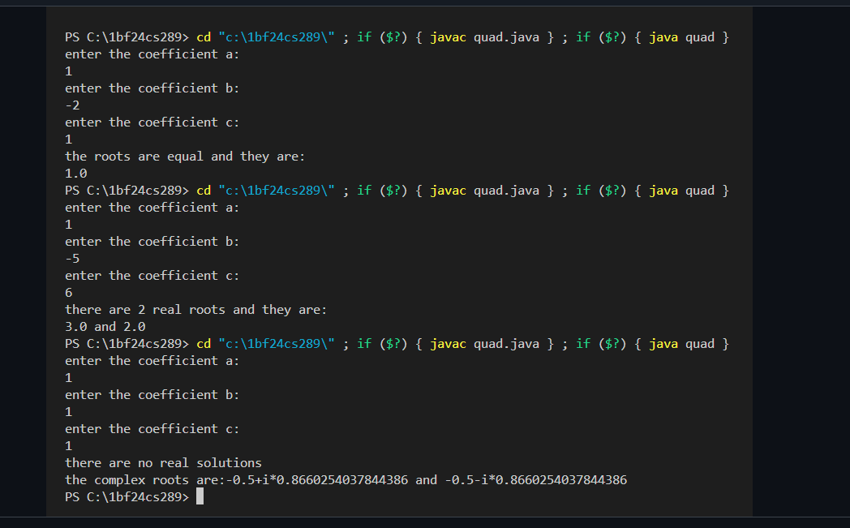

PROGRAM 2:
SGPA CALCULATION
CODE: import java.util.*;
class student {
String usn;
String name;
double creds[];
double marks[];
Scanner sc=new Scanner(System.in);
//method to accept details
void accept()
{

System.out.println("enter usn of student:");
this.usn=sc.nextLine();
System.out.println("enter name of student:");
this.name=sc.nextLine();
}
//method to display details
void display()
{
System.out.println("student's name:"+name);
System.out.println("student's usn:"+usn);
}
void sgpa()
{
System.out.println("enter the number of subjects:");
int num=sc.nextInt();
creds=new double[num];
marks=new double[num];
double grade[]=new double[num];
double numerator=0;
double denom=0;
for(int i=0;i<num;i++)
{

System.out.println("enter marks for subject "+(i+1));
marks[i]=sc.nextDouble();
sc.nextline();
System.out.println("enter credits for subject "+(i+1));
creds[i]=sc.nextDouble();
sc.nextline();

//now,we need to calculate grade array based of range of marks
if(marks[i]>=90 && marks[i]<=100)
{
grade[i]= 10;
}
else if(marks[i]>=80 && marks[i]<90)
{
grade[i]= 9;
}
else if(marks[i]>=70 && marks[i]<80)
{
grade[i]= 8;
}
else if(marks[i]>=60 && marks[i]<70)
{
grade[i]= 7;
}

else if(marks[i]>=50 && marks[i]<60)
{
grade[i]= 6;
}
else if(marks[i]>=40 && marks[i]<50)
{
grade[i]= 5;
}
else if(marks[i]>=0 && marks[i]<40)
{
grade[i]= 0;
}
numerator+=creds[i]*grade[i];
denom+=creds[i];

}
double sgpa=(double)(numerator/denom);
System.out.println("the sgpa of the student is:"+sgpa);

}

}
public class sgpamain {
public static void main(String[] args) {
student s1=new student();
s1.accept();
s1.display();
s1.sgpa();
}

}
OUTPUT:
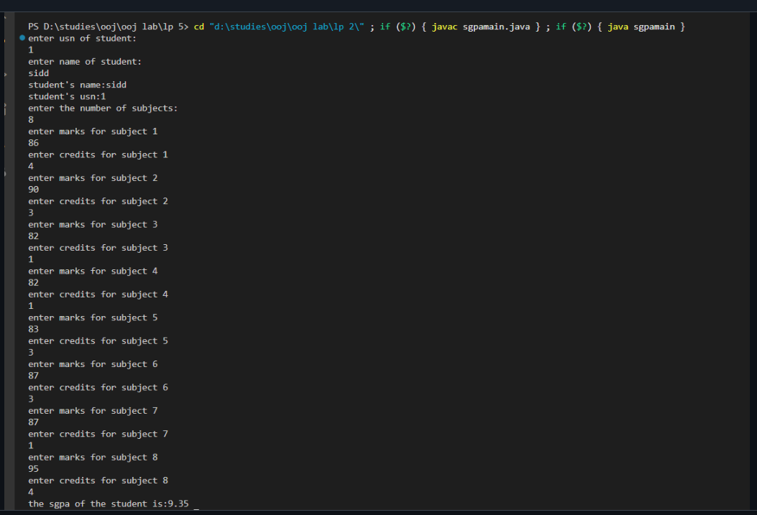

PROGRAM 3:
TO STRING DEMO
CODE: import java.util.*;
class Book {
String name,author;
double price;
int num_pages;
//constructor for setting values of the members
Book(String name,String author,double price,int num_pages)
{
this.name=name;
this.author=author;
this.price=price;
this.num_pages=num_pages;
}
//set methods
void SetName(String name)
{
this.name=name;
}
void SetAuthor(String author)
{
this.author=author;
}
void SetPrice(double price)
{
this.price=price;
}
void SetNum_Pages(int num_pages)
{
this.num_pages=num_pages;
}
//get methods
String GetName()
{
return name;
}
String GetAuthor()
{
return author;
}
double GetPrice()
{
return price;
}
int GetNum_Pages()
{
return num_pages;
}
//tostring method
public String toString() {
return "Name:"+name+"\nAuthor:"+author+"\nPrice:"+price+"\nNumber of pages:"+num_pages;
}
}
public class tostring {
public static void main(String[] args) {
Scanner sc=new Scanner(System.in);
int n;
System.out.println("enter number of books:");
n=sc.nextInt();
sc.nextLine();
Book b[]=new Book[n];
//for loop for setting details of n objects of type Book through constructor
for(int i=0;i<n;i++)
{
System.out.println("enter details for book"+(i+1)+":");
System.out.println("Name:");
String Name=sc.nextLine();
System.out.println("Author:");
String Author=sc.nextLine();
System.out.println("Price:");
double Price=sc.nextDouble();
System.out.println("Number of pages:");
int NumPages=sc.nextInt();
sc.nextLine();
b[i]= new Book(Name,Author,Price,NumPages);
}
//displaying details
System.out.println("------------Book details:------------");
//for loop to display using tostring
for(int i=0;i<n;i++)
{
System.out.println("Book "+(i+1)+":");
System.out.println(b[i].toString());
System.out.println("--------------------------");
}
}
}
OUTPUT:
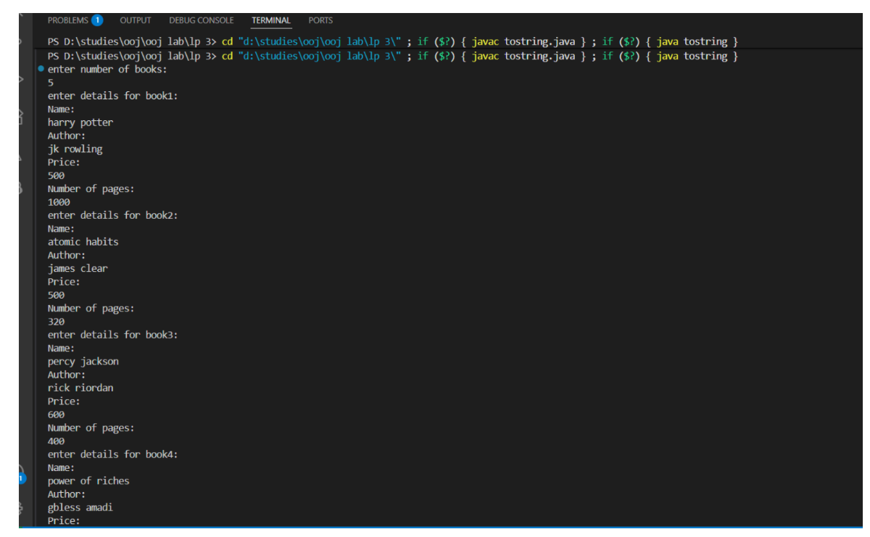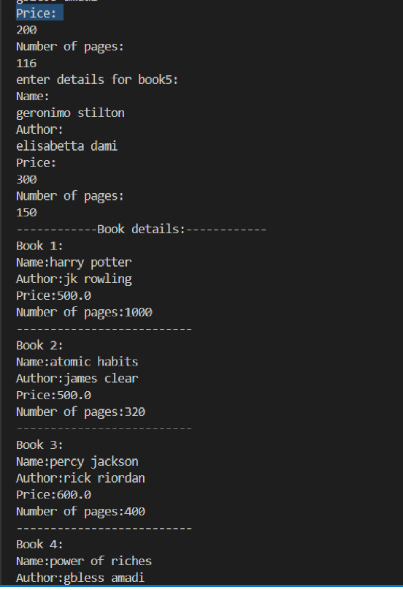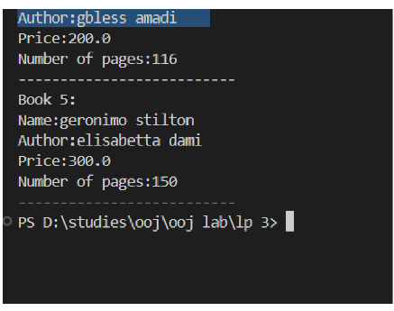

PROGRAM 4:
ABSTRACT CLASS DEMO
CODE: import java.util.*;
abstract class Shape{
int i,j;
Shape(int i,int j)
{
this.i=i;
this.j=j;
}
abstract void printArea();

}
class Rectangle extends Shape {
Rectangle(int length,int breadth)
{
super(length,breadth);
}
void printArea()
{
System.out.println("the area of rectangle is:"+(i*j));
}
}
class Triangle extends Shape {
Triangle(int base,int height)
{
super(base,height);
}
void printArea() {
System.out.println("the area of triangle is:"+((1/2.0)*i*j));
}
}
class Circle extends Shape {
Circle(int radius)
{
super(radius,0);
}
void printArea() {
System.out.println("the area of circle is:"+(3.14*i*i));
}

}
public class abstractdemo {
public static void main(String[] args) {
Scanner sc=new Scanner(System.in);

//inputting length and breadth of rectangle
System.out.println("enter length and breadth of rectangle:");
int l=sc.nextInt();
int b=sc.nextInt();
Rectangle rect=new Rectangle(l,b);

//inputting base and height of triangle
System.out.println("enter base and height of triangle:");
int base=sc.nextInt();
int height=sc.nextInt();
Triangle tri=new Triangle(base,height);

//inputting radius of circle
System.out.println("enter radius of circle:");
int radius=sc.nextInt();
Circle circ=new Circle(radius);

//calling classes for calculating areas
System.out.println("---------------Areas-------------");
rect.printArea();
tri.printArea();
circ.printArea();
}
}
OUTPUT:
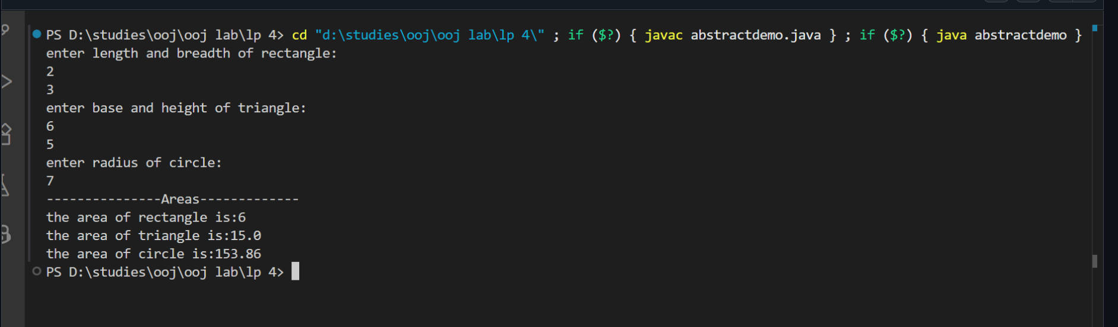

PROGRAM 5:
BANK

CODE: import java.util.*;
class Account {

//initialising instance variables
String cname;
int accNo;
String accType;
double balance;
Scanner sc=new Scanner(System.in);

//constructor
Account(String cname,int accNo,String accType,double balance)
{
this.cname=cname;
this.accNo=accNo;
this.accType=accType;
this.balance=balance;
}

//deposit method
void deposit()
{
double amount;
System.out.println("enter the amount to be deposited:");
amount=sc.nextDouble();
balance+=amount;
System.out.println("deposited succesfully");
}

//display balance method
void disBal()
{
System.out.println("the balance right now is:"+balance);
}

//method for withdrawal(general as we have to modify later for current account)
void withdrawal()
{
double amount;
System.out.println("enter the amount to be withdrawn:");
amount=sc.nextDouble();
if(amount>balance)
{
System.out.println("insufficient funds");
}
else
{
balance-=amount;
System.out.println("withdrawal successful");
}
}
}
class cur_Acct extends Account {
//giving a minimum balance limit and a service charge
double minBal=10000;
double serviceCharge=500;

//constructor involving super
cur_Acct(String name,int accNo,double balance)
{
super(name,accNo,"Current",balance);
}

//method for checking whether current balance is above minimum balance or not
void checkMinBal()
{
if(balance<minBal)
{
balance-=serviceCharge;
System.out.println("balance below minimum balance limit therefore service charge imposed.");
}
}

//withdraw method but modified/overridden with extra check of minimum balance penalty
void withdrawal()
{
double amount;
System.out.println("enter the amount to be withdrawn:");
amount=sc.nextDouble();
if(amount>balance)
{
System.out.println("insufficient funds");
}
else
{
balance-=amount;
System.out.println("withdrawal successful");
checkMinBal();
}
}
}
class sav_Acct extends Account {
//defining the rate of interest
double rate=0.05; //5% per annum

//constructor involving super
sav_Acct(String name,int accNo,double balance)
{
super(name,accNo,"Savings",balance);
}

//calculation and deposit of interest
void intCalcDep()
{
double interest=balance*Math.pow(1+rate/12,12)-balance;
balance+=interest;
System.out.println("yearly compound interest of amount "+interest+" has been added to the balance");
}
}
public class Bank {
public static void main(String[] args) {

//asking input details from the user
Scanner sc=new Scanner(System.in);

String name;
int accNo;
int accType;
double balance;
System.out.println("enter customer name:");
name=sc.nextLine();
System.out.println("enter account number:");
accNo=sc.nextInt();
sc.nextLine();
System.out.println("enter initial balance:");
balance=sc.nextDouble();
System.out.println("enter 1 for current account,2 for savings account");
accType=sc.nextInt();
sc.nextLine();

//prepartion of menu driven program
int choice1;
int choice2;
//1st case-user enters current account
if(accType==1)
{
//keep on asking the user until he stops/exits
cur_Acct ob1=new cur_Acct(name, accNo, balance);
while(true)
{
System.out.println("press 1 for deposit,2 for withdrawal,3 for balance display,4 for exit");
choice1=sc.nextInt();

switch(choice1)
{
case 1:ob1.deposit();
break;
case 2:ob1.withdrawal();
break;
case 3:ob1.disBal();
break;
case 4:System.exit(0);
break;
default:System.err.println("invalid input!");
}
}
}
else if(accType==2)
{
//keep on asking the user until he stops/exits
sav_Acct ob1=new sav_Acct(name, accNo, balance);
while(true)
{
System.out.println("press 1 for deposit,2 for withdrawal,3 for interest check,4 for balance display,5 for exit");
choice1=sc.nextInt();

switch(choice1)
{
case 1:ob1.deposit();
break;
case 2:ob1.withdrawal();
break;
case 3:ob1.intCalcDep();
break;
case 4:ob1.disBal();
break;
case 5:System.exit(0);
break;
default:System.err.println("invalid input!");
}
}
}
}

}
OUTPUT:
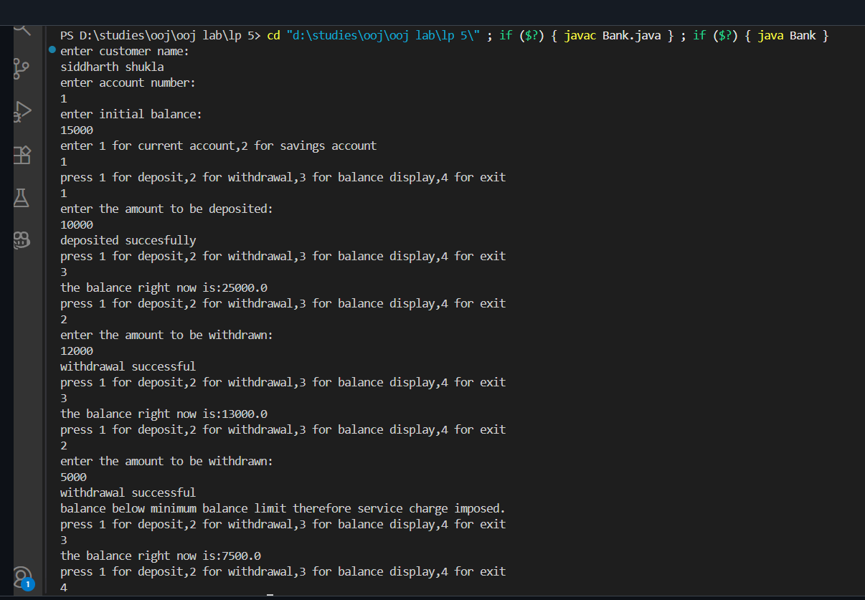
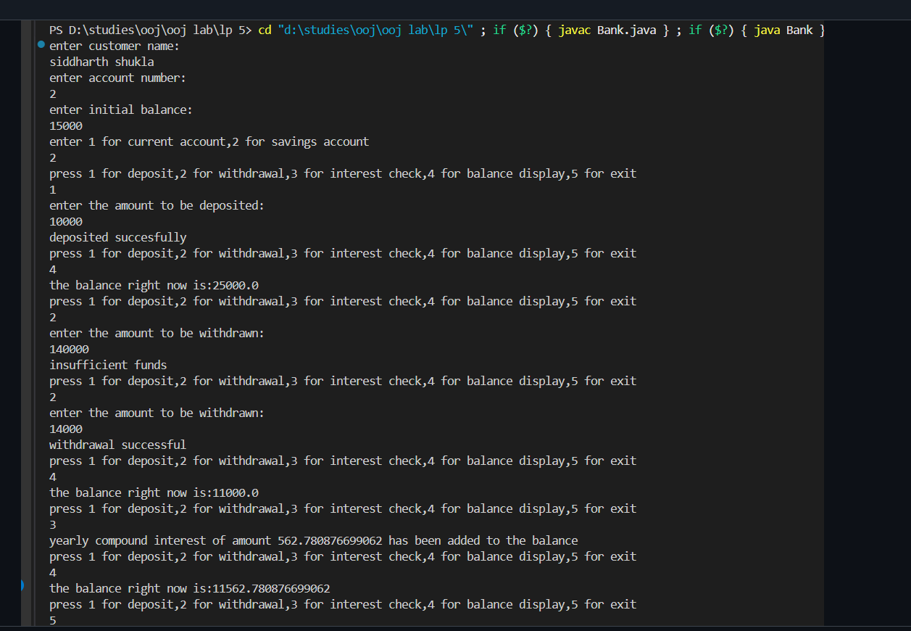

PROGRAM 6:
PACKAGES

CODE:
File 1:internals.java:
package cie;

import java.util.Scanner;
public class internals {

public void setmarks(int marks[]) {
System.out.println("enter marks of student in cie:");

for(int i=0;i<5;i++)
{
Scanner sc=new Scanner(System.in);
System.out.print("subject"+(i+1)+":");
marks[i]=sc.nextInt();
sc.nextLine();
}
}
}
file 2:
Personal.java:
package cie;
import java.util.Scanner;

public class personal {
String usn,name;
int sem;
public personal(String usn,String name,int sem) {
this.usn=usn;
this.name=name;
this.sem=sem;
}
}
file 3:
external.java:
package see;

import java.util.Scanner;

import cie.personal;

public class External extends personal {

public External(String usn,String name,int sem) {
super(usn,name,sem);

}
public void setmarks(int marks1[]) {
System.out.println("enter marks of student in see:");

for(int i=0;i<5;i++)
{
Scanner sc=new Scanner(System.in);
System.out.print("subject"+(i+1)+":");
marks1[i]=sc.nextInt();
sc.nextLine();
}
}
}
file 4:
Main.java:
//coded by 1bf24cs289
import cie.*;
import see.*;
import java.util.Scanner;
public class main {
public static void main(String[] args) {
Scanner sc=new Scanner(System.in);
internals internal=new internals();
External ext=new External("1bf24cs289","sidd",3);
int cie_marks[]=new int[5];
int see_marks[]=new int [5];

System.out.println("enter number of students:");
int num;
num=sc.nextInt();

int nfinalmarks[]=new int[num];
//FOR INPUTTING INFO OF N STUDENTS
for(int i=0;i<num;i++)
{
System.out.println("student"+(i+1)+":");
internal.setmarks(cie_marks);
ext.setmarks(see_marks);
}
//for displaying info of n students
for(int i=0;i<num;i++)
{
nfinalmarks[i]=cie_marks[i]+see_marks[i];
}
System.out.println("---------------------");
System.out.println("final marks are:");
System.out.println();
for(int i=0;i<num;i++)
{

System.out.println("student"+(i+1)+":");
System.out.println();
for(int j=0;j<5;j++)
{
System.out.println("subject"+(j+1)+":"+(cie_marks[j]+see_marks[j]));
}
System.out.println();
}
}
}

OUTPUT:
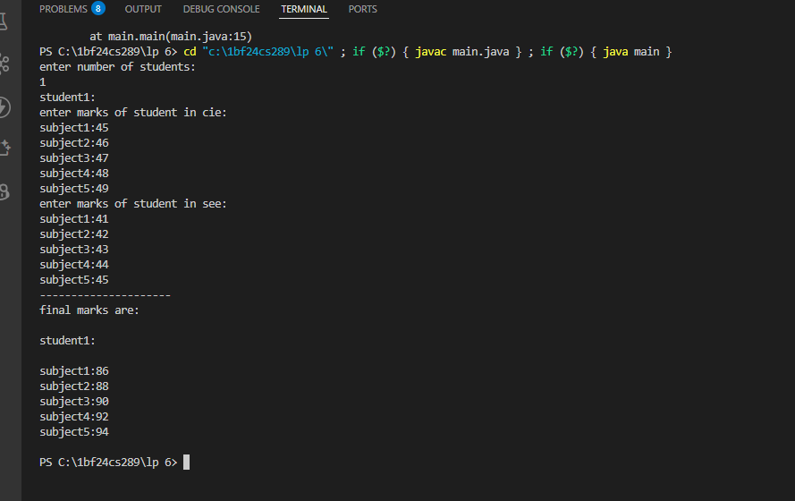

PROGRAM 7:
EXCEPTIONS
CODE:
import java.util.*;
class wrongAgeException extends Exception {
wrongAgeException(String message) {
super(message);
}
}
class wrongSonAgeException extends Exception {
wrongSonAgeException(String message) {
super(message);
}
}
class Father {
int fAge;
Father(int fAge) {

try {
if(fAge<0) {
throw new wrongAgeException("father's age cannot be less than 0");
}
this.fAge=fAge;
}
catch (wrongAgeException e) {
System.out.println("Error:"+e);
}

}
}
class Son extends Father {
int sAge;
Son(int fAge,int sAge) {
super( fAge );

try {
if (sAge>=fAge) {
throw new wrongSonAgeException("Son's age cannot be more than Father's age");
}
this.sAge=sAge;
}
catch (wrongSonAgeException e) {
System.out.println("Error:"+e);
}
}

}

public class exceptions {
public static void main(String[] args) {
Scanner sc=new Scanner(System.in);
System.out.println("enter the father and son age");
int fatherAge=sc.nextInt();
int sonAge=sc.nextInt();
Son s1=new Son(fatherAge,sonAge);
}
}
OUTPUT:
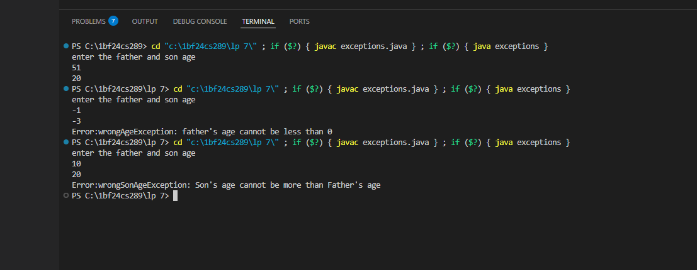

PROGRAM 8:
MULTI-THREADING

CODE:

class MessageThread extends Thread {
private String message;
private int interval; // in milliseconds

public MessageThread(String message, int interval) {
this.message = message;
this.interval = interval;
}

@Override
public void run() {
while (true) {
System.out.println(message);
try {
Thread.sleep(interval);
} catch (InterruptedException e) {
System.out.println("Thread interrupted: " + e.getMessage());
}
}
}
}

public class TwoThreadDemo {
public static void main(String[] args) {
// Thread 1: prints every 10 seconds
MessageThread t1 = new MessageThread("BMS College of Engineering", 10000);

// Thread 2: prints every 2 seconds
MessageThread t2 = new MessageThread("CSE", 2000);

t1.start();
t2.start();
}
}

OUTPUT:
