Low-Level Design Document
Order Management System (OMS)

Version: 1.0
Author: None
Role: Solution Architect
Date: May 12, 2026
Status: Draft

Table of Contents
1. Document Control
2. Introduction
3. System Architecture Overview
4. Data Flow Diagram
5. Request Processing Flow
6. Component Design
7. Database Design
8. API Specification
9. Security Design
10. Error Handling Strategy
11. Non-Functional Requirements
12. Deployment Architecture
13. Appendix

1. Document Control

1.1 Revision History
Version | Date | Author | Description
0.1 | 2026-04-15 | None | Initial draft
0.5 | 2026-04-28 | None | Added data flow diagrams
1.0 | 2026-05-12 | None | Final review & baseline

1.2 Approvals
Role | Name | Date | Signature
Solution Architect | None | 2026-05-12
Tech Lead | TBD
Engineering Manager | TBD

1.3 References
# | Document | Version
1 | High-Level Design (HLD) | 2.0
2 | API Standards Guide | 1.3
3 | Security Policy Document | 4.1

2. Introduction

2.1 Purpose
This Low-Level Design (LLD) document provides a detailed technical blueprint for the Order Management System (OMS). It covers component-level design, data flow, database schema, API contracts, error handling, and security considerations required for development.

2.2 Scope
This document covers the backend microservices architecture including Authentication, User Management, Order Processing, and Notification services. Frontend design is out of scope and covered in a separate document.

2.3 Assumptions & Constraints
- The system will be deployed on AWS (EKS for container orchestration).
- PostgreSQL 15+ is the primary relational database.
- Redis 7+ is used for caching and session management.
- All inter-service communication uses gRPC internally and REST externally.
- The system must support 10,000 concurrent users at peak load.

3. System Architecture Overview
The system follows a microservices architecture pattern with an API Gateway for routing, authentication middleware, and independent services for each business domain.
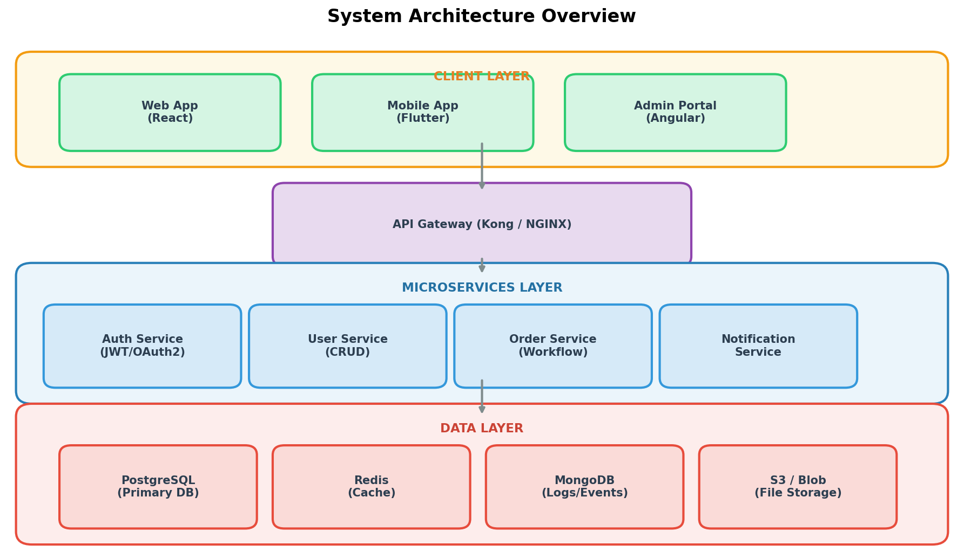
Figure 1: System Architecture Overview

3.1 Technology Stack
Layer | Technology | Version | Purpose
API Gateway | Kong | 3.4 | Routing, rate limiting, auth
Backend Services | Python (FastAPI) | 3.11 / 0.104 | REST & gRPC endpoints
Message Queue | RabbitMQ | 3.12 | Async event processing
Primary DB | PostgreSQL | 15.4 | Transactional data
Cache | Redis | 7.2 | Session & query caching
Search | Elasticsearch | 8.11 | Full-text search
Container Runtime | Docker + EKS | 24.0 / 1.28 | Orchestration
CI/CD | GitHub Actions | - | Build & deploy pipelines

4. Data Flow Diagram
The following Level-1 Data Flow Diagram illustrates how data moves between external entities, internal processes, and data stores within the Order Management System.
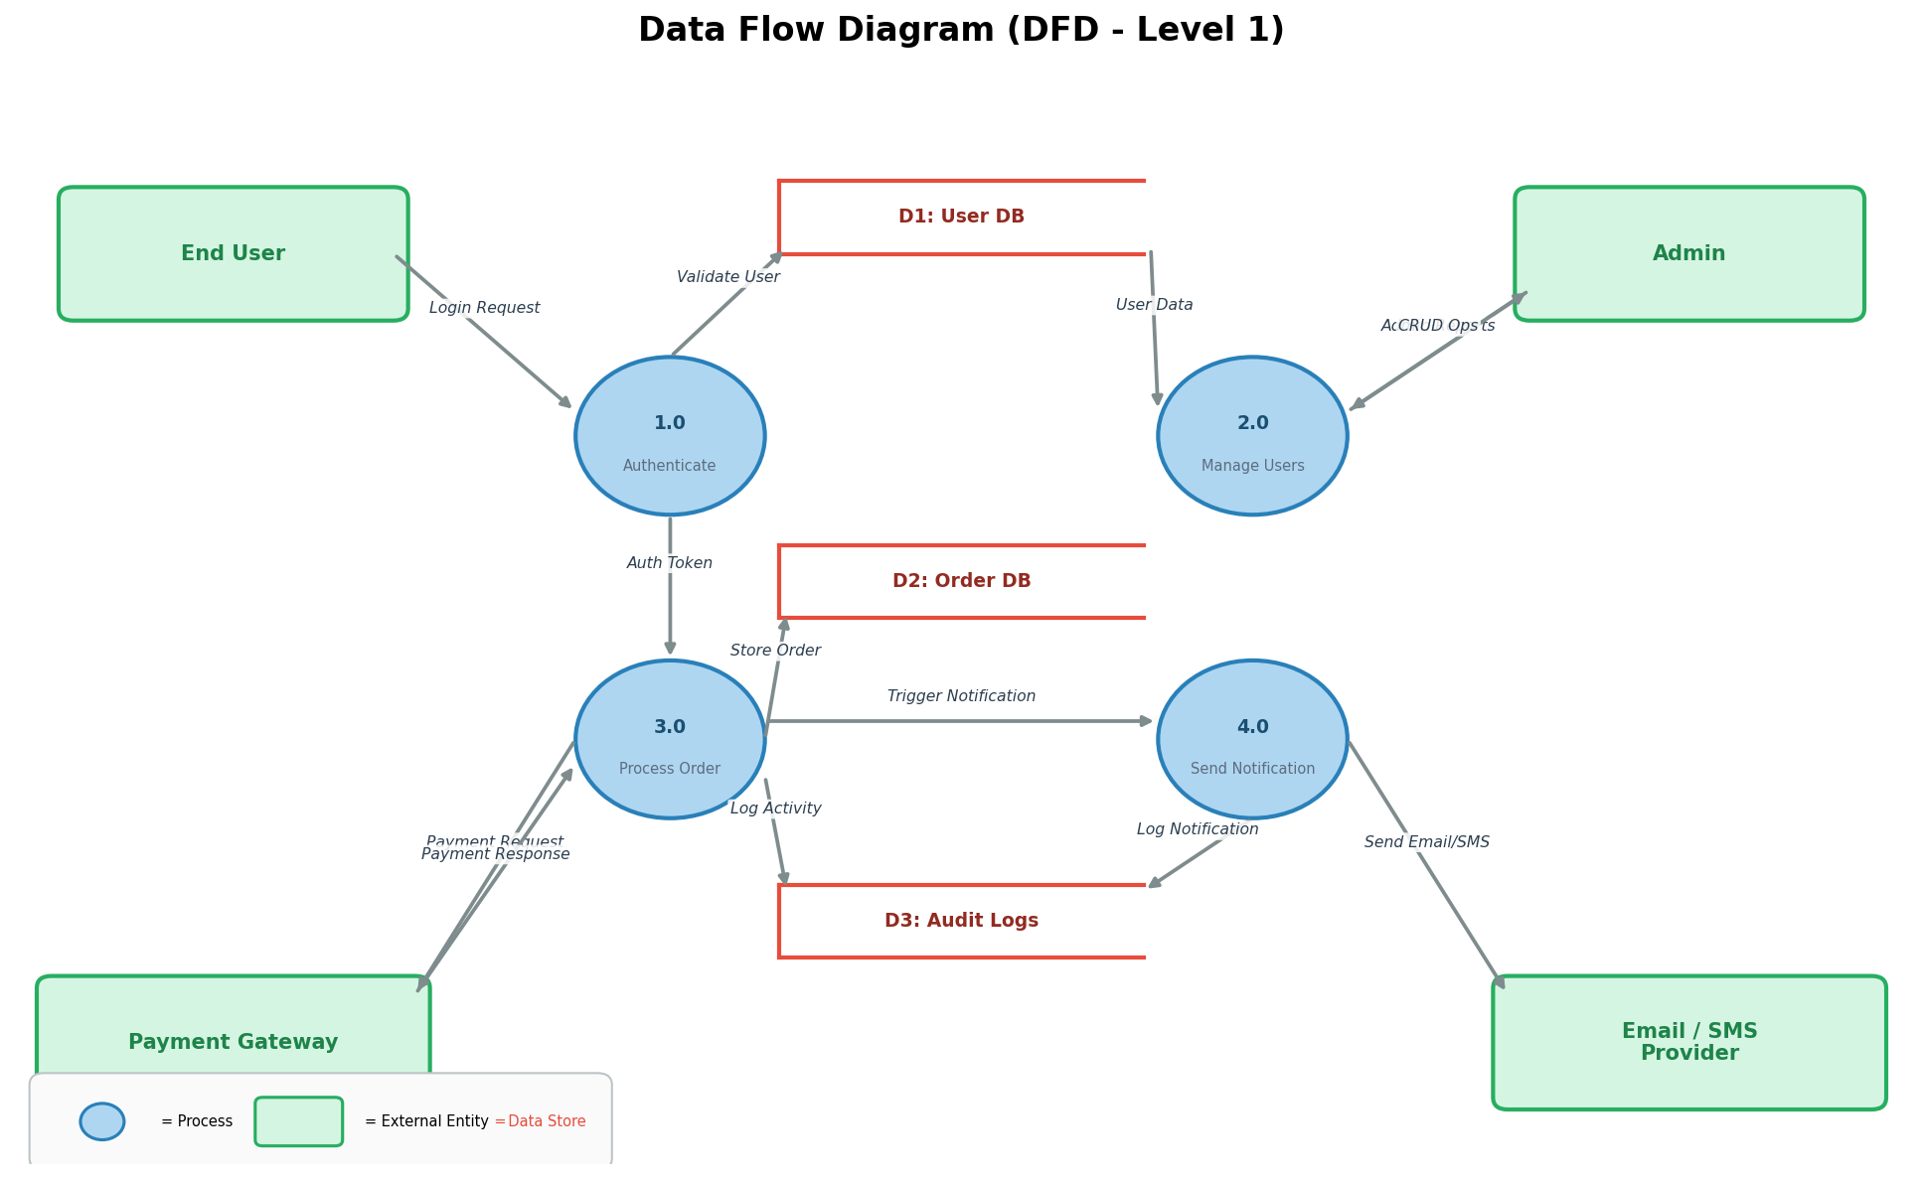
Figure 2: Data Flow Diagram (DFD Level 1)

4.1 Data Flow Description
# | Flow | Source | Destination | Data Description
1 | Login Request | End User | Auth Service | Email + Password credentials
2 | Token Validation | Auth Service | User DB | JWT token verification
3 | Order Submission | End User | Order Service | Cart items, shipping address, payment info
4 | Payment Processing | Order Service | Payment Gateway | Amount, card token, order reference
5 | Order Confirmation | Notification Service | Email/SMS Provider | Order ID, status, user contact
6 | Audit Logging | All Services | Audit Logs DB | Action type, user ID, timestamp, payload

5. Request Processing Flow
Every incoming API request passes through a standardized processing pipeline ensuring security, rate limiting, load distribution, and consistent response formatting.
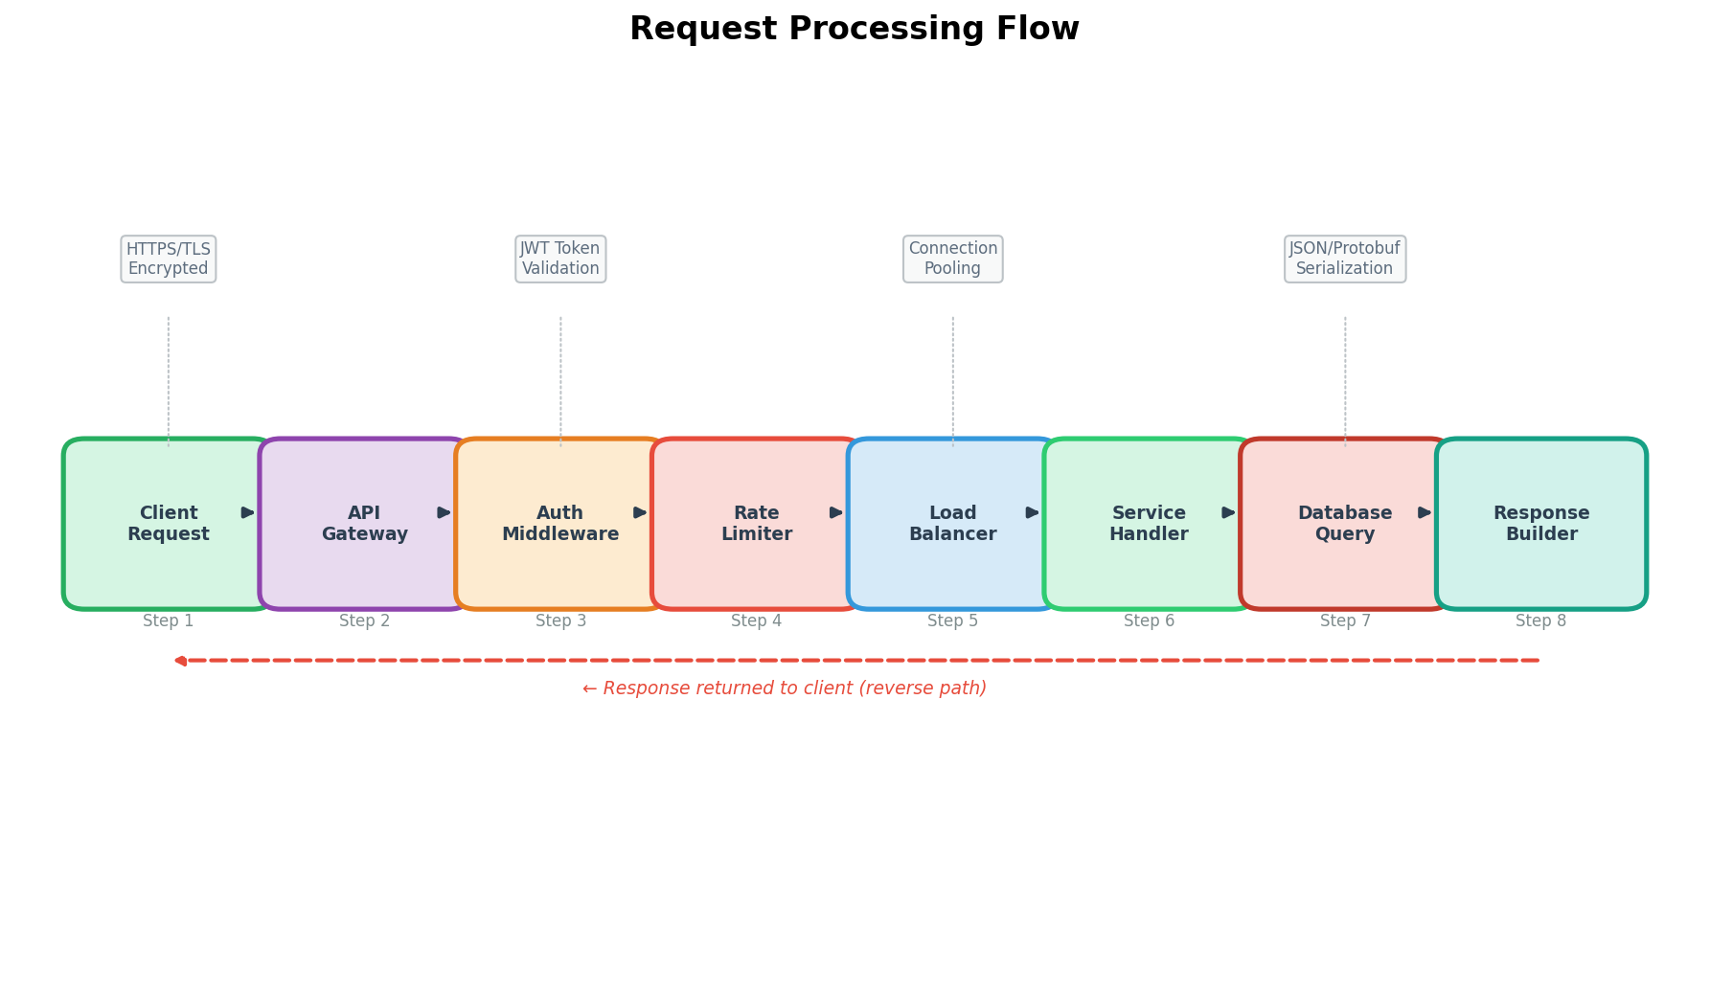
Figure 3: Request Processing Flow

6. Component Design

6.1 Auth Service
Aspect | Details
Responsibility | User authentication, token issuance, token refresh, password reset.
Endpoints | POST /auth/login, POST /auth/register, POST /auth/refresh, POST /auth/reset-password
Dependencies | User DB (PostgreSQL), Redis (session cache)
Design Pattern | Strategy pattern for multiple auth providers (email, OAuth, SSO)

6.2 User Service
Aspect | Details
Responsibility | User CRUD operations, profile management, role-based access control.
Endpoints | GET /users/{id}, PUT /users/{id}, DELETE /users/{id}, GET /users?filters
Dependencies | User DB (PostgreSQL), Auth Service (token validation)
Design Pattern | Repository pattern with Unit of Work

6.3 Order Service
Aspect | Details
Responsibility | Order creation, status management, payment orchestration, order history.
Endpoints | POST /orders, GET /orders/{id}, PATCH /orders/{id}/status, GET /orders?user_id=
Dependencies | Order DB, Payment Gateway, Notification Service (via message queue)
Design Pattern | State machine pattern for order lifecycle, Saga pattern for distributed transactions

6.4 Notification Service
Aspect | Details
Responsibility | Email and SMS delivery, notification templates, delivery tracking.
Endpoints | POST /notifications/send, GET /notifications/{id}/status
Dependencies | Email provider (SendGrid), SMS provider (Twilio), Audit Logs DB
Design Pattern | Observer pattern with async message queue consumers

7. Database Design

7.1 Entity-Relationship Diagram
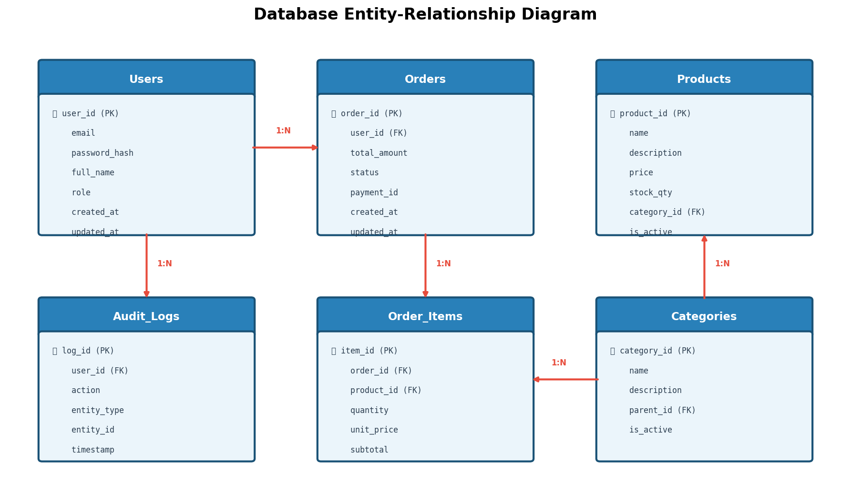
Figure 4: Entity-Relationship Diagram

7.2 Table Definitions

Users Table
Column | Type | Constraints | Description
user_id | UUID | PK, NOT NULL | Unique user identifier
email | VARCHAR(255) | UNIQUE, NOT NULL | User email address
password_hash | VARCHAR(512) | NOT NULL | Bcrypt hashed password
full_name | VARCHAR(200) | NOT NULL | User display name
role | ENUM | NOT NULL, DEFAULT 'user' | user | admin | moderator
created_at | TIMESTAMP | NOT NULL, DEFAULT NOW() | Record creation time
updated_at | TIMESTAMP | NOT NULL | Last modification time

Orders Table
Column | Type | Constraints | Description
order_id | UUID | PK, NOT NULL | Unique order identifier
user_id | UUID | FK → users.user_id, NOT NULL | Ordering user
total_amount | DECIMAL(12,2) | NOT NULL | Order total in base currency
status | ENUM | NOT NULL, DEFAULT 'pending' | pending | confirmed | shipped | delivered | cancelled
payment_id | VARCHAR(100) | NULLABLE | External payment reference
created_at | TIMESTAMP | NOT NULL, DEFAULT NOW() | Order placement time
updated_at | TIMESTAMP | NOT NULL | Last status change time

7.3 Indexing Strategy
Table | Index Name | Columns | Type
users | idx_users_email | email | UNIQUE B-Tree
orders | idx_orders_user_id | user_id | B-Tree
orders | idx_orders_status | status, created_at | Composite B-Tree
order_items | idx_items_order_id | order_id | B-Tree
audit_logs | idx_logs_timestamp | timestamp | B-Tree (DESC)

8. API Specification
All APIs follow RESTful conventions with JSON request/response bodies.

8.1 Authentication APIs
Method | Endpoint | Auth | Request Body | Response | Status Codes
POST | /api/v1/auth/login | None | {"email", "password"} | {"access_token", "refresh_token", "expires_in"} | 200, 401, 429
POST | /api/v1/auth/register | None | {"email", "password", "full_name"} | {"user_id", "message"} | 201, 400, 409
POST | /api/v1/auth/refresh | Bearer Token | {"refresh_token"} | {"access_token", "expires_in"} | 200, 401

8.2 Order APIs
Method | Endpoint | Auth | Request Body | Response | Status Codes
POST | /api/v1/orders | Bearer Token | {"items": [...], "shipping_address": {...}} | {"order_id", "status", "total"} | 201, 400, 401
GET | /api/v1/orders/{id} | Bearer Token | - | {"order_id", "items", "status", ...} | 200, 404, 401
PATCH | /api/v1/orders/{id}/status | Admin Token | {"status": "shipped"} | {"order_id", "status", "updated_at"} | 200, 400, 403

8.3 Error Response Format
All error responses follow a standard structure:
{
"error": {
"code": "VALIDATION_ERROR",
"message": "Human-readable description",
"details": [...],
"request_id": "uuid-for-tracing"
}
}

9. Security Design
Aspect | Implementation
Authentication | JWT (RS256) with 15-min access tokens and 7-day refresh tokens
Authorization | Role-Based Access Control (RBAC) with middleware enforcement
Data Encryption | TLS 1.3 in transit; AES-256 at rest for sensitive fields
Password Storage | Bcrypt with cost factor 12, minimum 8-char passwords
Rate Limiting | 100 req/min per IP (anonymous), 500 req/min per user (authenticated)
Input Validation | Pydantic schemas with strict mode; SQL injection prevention via ORM
CORS | Whitelist-based origin policy; no wildcard in production
Audit Logging | All write operations logged with user ID, IP, timestamp, and payload hash
Secrets Management | AWS Secrets Manager; no secrets in code or environment variables
Dependency Scanning | Automated Snyk/Dependabot scans on every PR

10. Error Handling Strategy
Error Category | HTTP Code | Retry | Action
Validation Error | 400 | No | Return detailed field-level errors
Authentication Failure | 401 | No | Invalidate token, prompt re-login
Authorization Failure | 403 | No | Log attempt, return generic message
Resource Not Found | 404 | No | Return resource type + ID in error
Rate Limit Exceeded | 429 | Yes (with backoff) | Return Retry-After header
Internal Server Error | 500 | Yes (3 attempts) | Log full stack trace, alert ops team
Service Unavailable | 503 | Yes (with backoff) | Circuit breaker opens after 5 failures
Database Timeout | 504 | Yes (1 attempt) | Fallback to read replica if available

11. Non-Functional Requirements
Requirement | Target | Measurement
Response Time (P95) | < 200ms | API Gateway metrics (Prometheus)
Availability | 99.95% uptime | Monthly SLA calculation
Throughput | 10,000 concurrent users | Load testing (k6 / Locust)
Data Retention | 90 days hot, 2 years cold | S3 lifecycle policies
RTO (Recovery Time) | < 15 minutes | Failover drill results
RPO (Recovery Point) | < 5 minutes | WAL shipping frequency
Scalability | Auto-scale 2x within 5 min | HPA metrics (CPU > 70%)

12. Deployment Architecture
The application is containerized using Docker and orchestrated via Amazon EKS. Each microservice runs as an independent Kubernetes Deployment with Horizontal Pod Autoscaler (HPA).
Service | Min Replicas | Max Replicas | CPU Request | Memory Request | Health Check
API Gateway | 2 | 6 | 250m | 512Mi | /health (TCP)
Auth Service | 2 | 8 | 200m | 256Mi | /healthz (HTTP)
User Service | 2 | 6 | 200m | 256Mi | /healthz (HTTP)
Order Service | 3 | 10 | 500m | 512Mi | /healthz (HTTP)
Notification Service | 2 | 4 | 200m | 256Mi | /healthz (HTTP)
PostgreSQL | 1 primary + 2 replicas | - | 1000m | 2Gi | pg_isready
Redis | 3 (cluster) | - | 500m | 1Gi | redis-cli ping

13. Appendix

13.1 Glossary
Term | Definition
LLD | Low-Level Design — detailed technical design document
HLD | High-Level Design — system-level architecture overview
JWT | JSON Web Token — compact token format for authentication
RBAC | Role-Based Access Control
HPA | Horizontal Pod Autoscaler (Kubernetes)
WAL | Write-Ahead Log (PostgreSQL replication)
RTO | Recovery Time Objective
RPO | Recovery Point Objective

13.2 Contact
For queries regarding this document, contact:
Name: None
Role: Solution Architect
Email: vikas.mishra@company.com

