E-Commerce Business Analysis Report

1. Overview
This project analyzes e-commerce transactional data to uncover insights related to customer behavior, product performance, sales trends, and inventory management. The objective is to transform raw business data into actionable recommendations that support data-driven decision-making across marketing, operations, sales, and supply chain functions.
2. Dataset Summary
Dataset Overview:
- Customers Dataset: customer_id, name, and location
- Products Dataset: product_id, name, category, and price.
- Orders Dataset: order_id, order_date, customer_id, and total_amount.
- OrderDetails Dataset: order_id, product_id, quantity, and price_per_unit.
Dataset Size:
- Customers Dataset: (100 x 3)
- Products Dataset: (8 x 4)
- Orders Dataset: (200 x 4)
- OrderDetails Dataset: (200 x 4)

3. Exploratory Data Analysis (Python)
Data Cleaning: All the data are having extra columns and no missing values , so only the extra columns are removed using python(pandas) and then uploaded to MySQL database. Here are the pictures of cleaned and uncleaned data sets
This is customers Raw and Cleaned:-
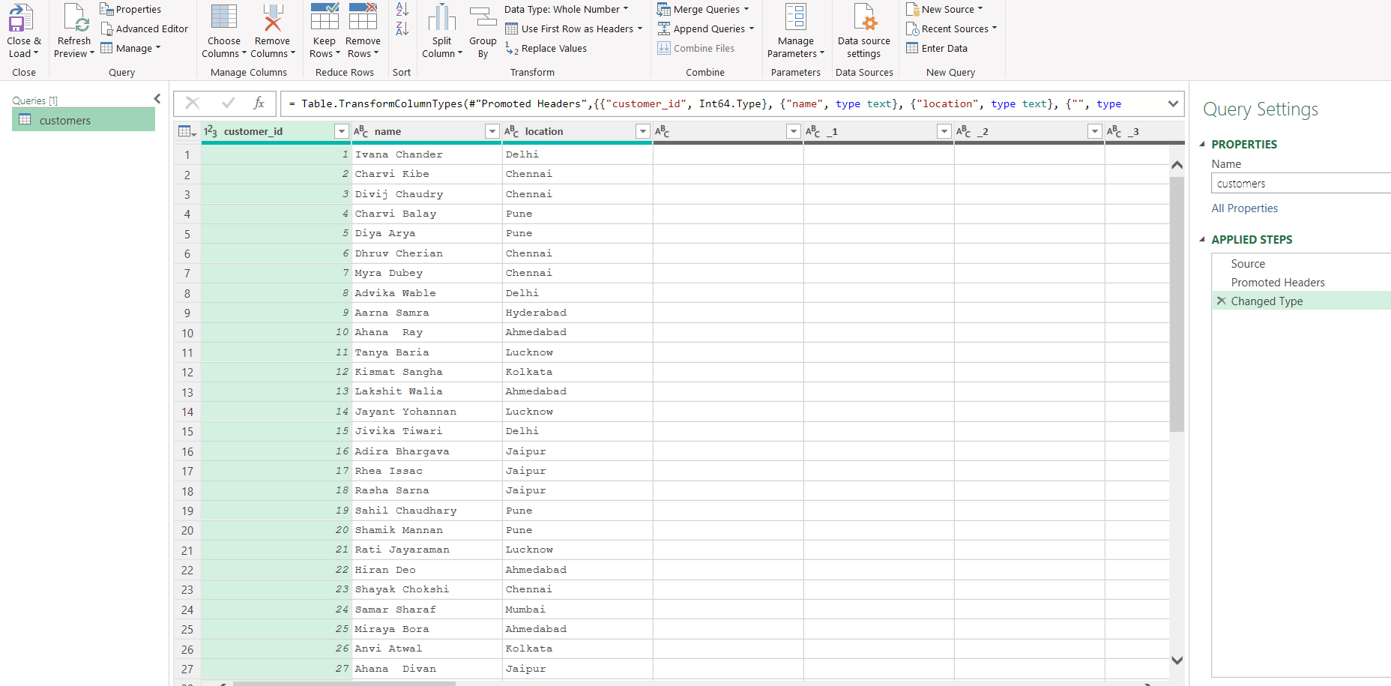
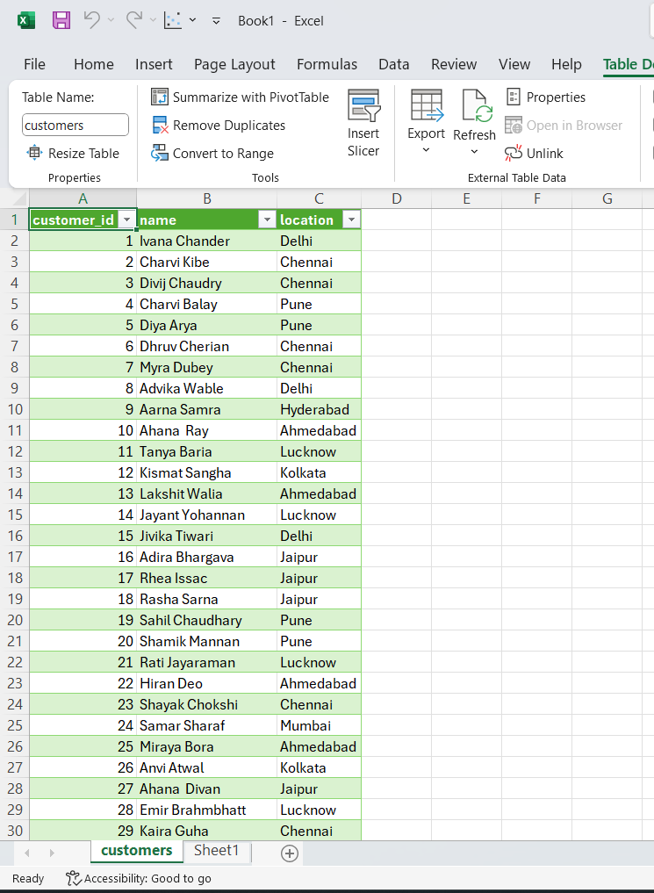
This is the OrdersDetails Raw vs cleaned:-
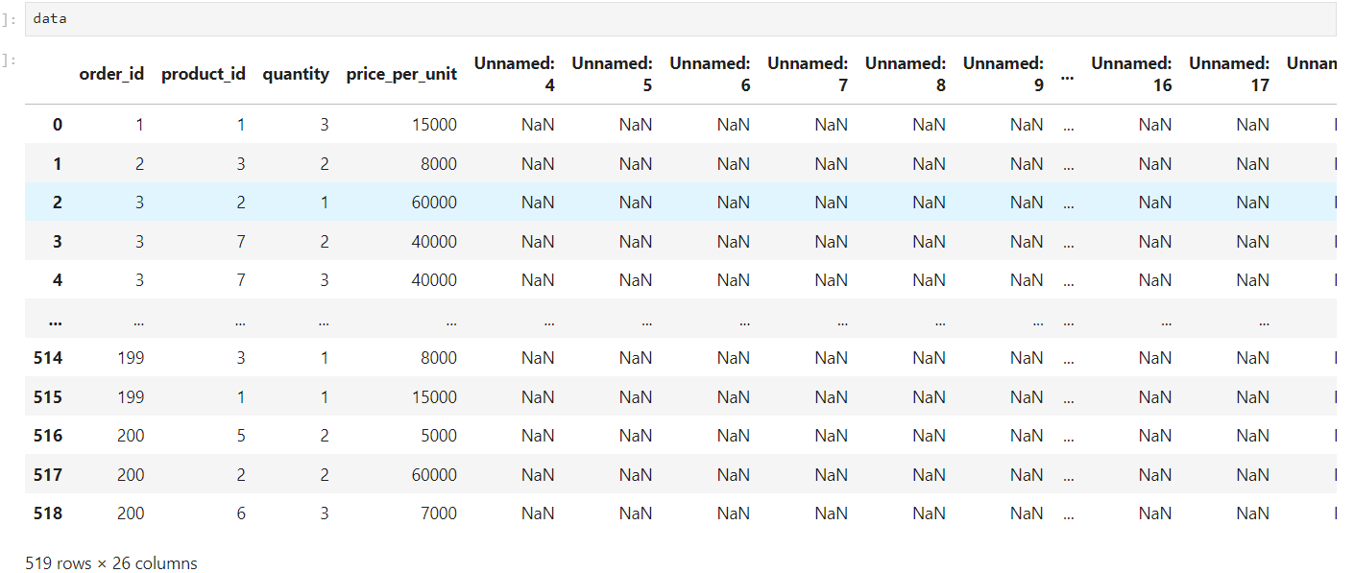
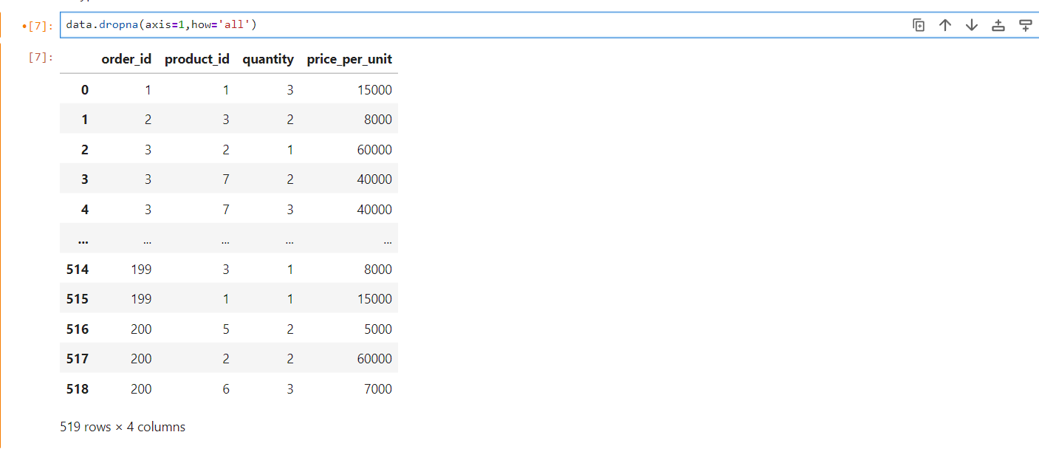

This is the Orders dataset RAW vs Cleaned:-
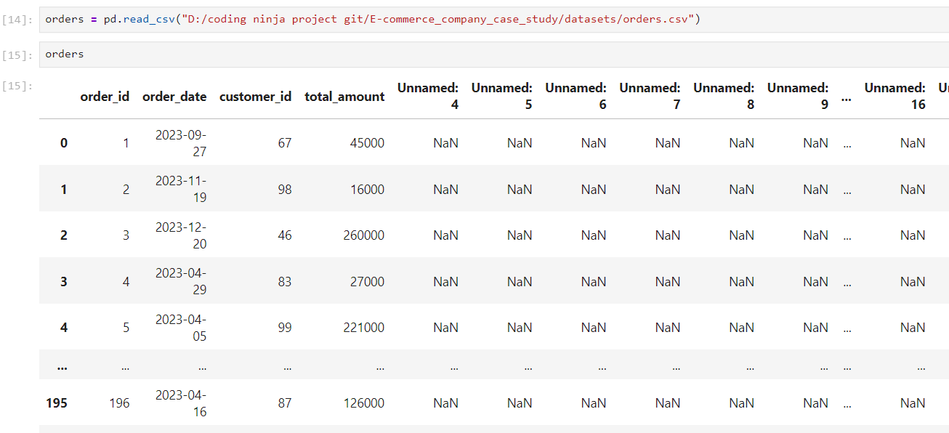
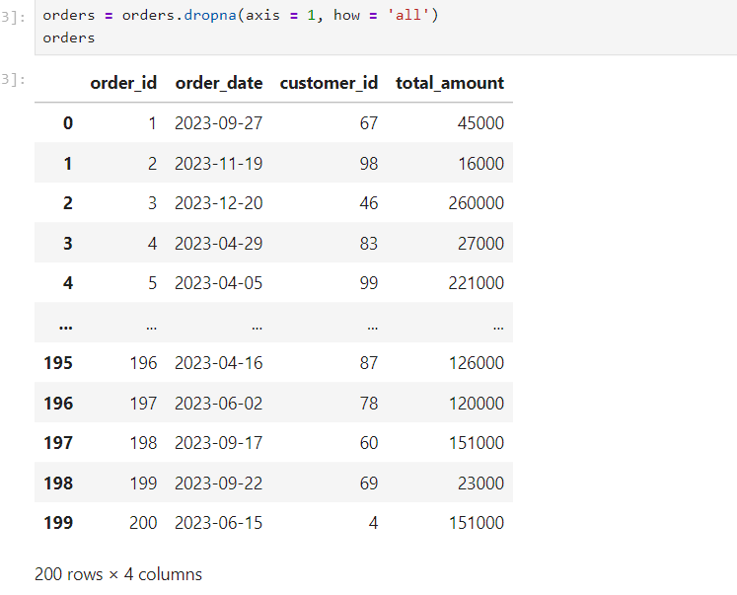
This the Products dataset RAW vs Cleaned: -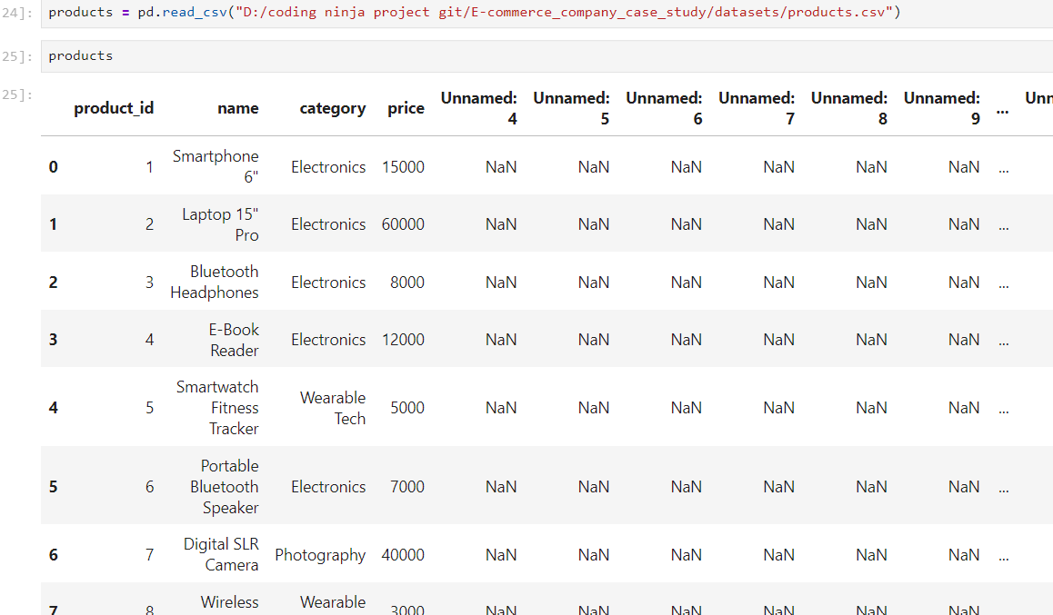
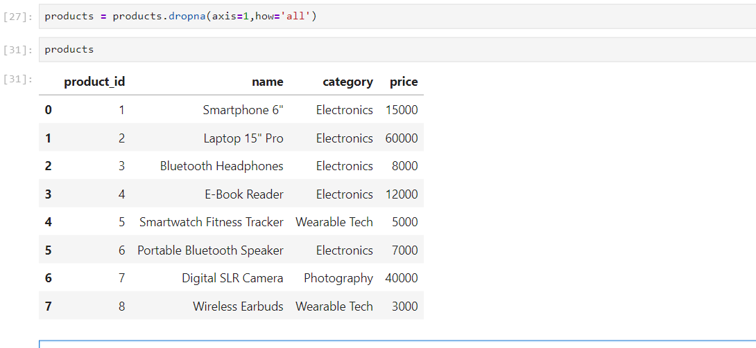
4. SQL Business Analysis & Insights
The core business analysis was conducted using SQL queries to answer practical business questions.
CUSTOMER INSIGHTS
1. Customer Concentration Analysis
Business Question:
- Which cities have the highest concentration of customers for targeted marketing and logistical optimization?
location | number_of_customers
Delhi | 16
Chennai | 15
Jaipur | 11
Pune | 10
Ahmedabad | 10

Business Value:
Identifies regions with the strongest customer base to support localized marketing campaigns and distribution planning.

2. Customer Order Frequency Analysis
Business Question:
- What is the distribution of customer order frequencies across our platform?
NumberOfOrders | CustomerCount
1 | 26
2 | 26
3 | 18
4 | 6
5 | 6
6 | 1
8 | 1

Business Value:
Helps distinguish one-time buyers from loyal customers and supports retention initiatives.

3. New Customer Acquisition Analysis
Business Question:
- How successful are our marketing and market expansion efforts at acquiring entirely new customers month-over-month?
FirstPurchaseMonth | TotalNewCustomers
01-03-2023 | 11
01-04-2023 | 18
01-05-2023 | 11
01-06-2023 | 8
01-07-2023 | 11
01-08-2023 | 9
01-09-2023 | 5
01-10-2023 | 3
01-11-2023 | 1
01-12-2023 | 4
01-01-2024 | 2
01-02-2024 | 1

Business Value:
Measures customer acquisition performance and market growth.

PRODUCT ANALYSIS
4. Revenue Contribution Analysis
Business Question:
- Which products generate the highest revenue?
Product_id | Product_Name | TotalPrice
2 | Laptop 15 Pro" | 7560000
7 | Digital SLR Camera | 6040000
1 | Smartphone 6",1620000  4,E-Book Reader" | 1560000
3 | Bluetooth Headphones | 1080000
6 | Portable Bluetooth Speaker | 938000
5 | Smartwatch Fitness Tracker | 595000
8 | Wireless Earbuds | 390000

Business Value:
Identifies products that contribute most significantly to business performance.

5. Market Basket Analysis
Business Question:
- Which products are commonly purchased together?
Product1 | Product2 | Times_Bought
7 | 8 | 20
3 | 7 | 19
2 | 5 | 17
6 | 7 | 17
1 | 5 | 14
2 | 7 | 14
3 | 4 | 14
4 | 7 | 14
4 | 8 | 14
5 | 6 | 14
5 | 8 | 14
1 | 4 | 13
1 | 8 | 13
2 | 3 | 13
2 | 4 | 13
3 | 6 | 13
1 | 3 | 12
2 | 6 | 12
3 | 5 | 12
1 | 2 | 11
1 | 7 | 11
3 | 8 | 11
4 | 6 | 11
1 | 6 | 10
2 | 8 | 10
4 | 5 | 10
5 | 7 | 9
6 | 8 | 6

Business Value:
Supports cross-selling, product bundling, and recommendation strategies.

6. High-Value Product Pair Analysis
Business Question:
- What are our top-grossing products that customers consistently buy in pairs?
product_id | AvgQuantity | TotalRevenue
1 | 2 | 1620000
8 | 2 | 390000
Here the products which are average quantity is taken as 2 and seen what the total revenue. So, by this we could replicate for 3 and more
Business Value:
Reveals profitable product which are sold with average quantity as 2 for promotional campaigns .This will give targeted focus on products.

7. Product Category Reach Analysis
Business Question:
- Which product categories have the widest appeal across our customer base?
category | unique_customers
Electronics | 79
Wearable Tech | 61
Photography | 45

Business Value:
Identifies categories with broad customer adoption and growth potential.

SALES OPTIMIZATION
8. Sales Growth Analysis
Business Question:
- What does our month-over-month sales growth trajectory look like, and are we picking up momentum?
Month | TotalSales | PercentChange
01-03-2023 | 789000 | 0
01-04-2023 | 1704000 | 115.97
01-05-2023 | 1582000 | -7.16
01-06-2023 | 1040000 | -34.26
01-07-2023 | 2568000 | 146.92
01-08-2023 | 1800000 | -29.91
01-09-2023 | 2927000 | 62.61
01-10-2023 | 1497000 | -48.86
01-11-2023 | 1151000 | -23.11
01-12-2023 | 2774000 | 141.01
01-01-2024 | 1555000 | -43.94
01-02-2024 | 396000 | -74.53

Business Value:
Tracks business growth and identifies expansion opportunities.

9. Average Order Value Analysis
Business Question:
- How is our average order value shifting month-over-month, and what does that tell us about our current pricing momentum?
Month | AvgOrderValue | ChangeInValue
01-12-2023 | 132095.24 | 36179
01-04-2023 | 81142.86 | 20451
01-06-2023 | 104000 | 16111
01-08-2023 | 112500 | 13731
01-11-2023 | 95916.67 | 12750
01-09-2023 | 121958.33 | 9458
01-05-2023 | 87888.89 | 6746
01-01-2024 | 129583.33 | -2512
01-07-2023 | 98769.23 | -5231
01-10-2023 | 83166.67 | -38792
01-02-2024 | 44000 | -85583
01-03-2023 | 60692.31

Business Value:
Measures customer spending behavior and pricing effectiveness.

10. Seasonal Demand Analysis
Business Question:
- When do we hit our absolute busiest shopping seasons, and how can we use that data to prepare our inventory and staffing?

Month | TotalSales
01-03-2023 | 789000
01-04-2023 | 1704000
01-05-2023 | 1582000
01-06-2023 | 1040000
01-07-2023 | 2568000
01-08-2023 | 1800000
01-09-2023 | 2927000
01-10-2023 | 1497000
01-11-2023 | 1151000
01-12-2023 | 2774000
01-01-2024 | 1555000
01-02-2024 | 396000

Business Value:
Supports inventory planning, workforce allocation, and promotional timing.

INVENTORY MANAGEMENT
11. Inventory Turnover Analysis
Business Question:
- Based on sales data, which products have the fastest turnover rates, suggesting high demand and the need for frequent restocking?

product_id | SalesFrequency
7 | 78
3 | 68
4 | 68
2 | 67
8 | 65

Business Value:
Helps prevent stockouts and optimize replenishment schedules.

12. Dead Stock Identification
Business Question:
- Which items in our inventory are at risk of becoming dead stock due to a lack of customer interest?
Product_id | Name | UniqueCustomerCount
1 | Smartphone 6" | 36
8 | Wireless Earbuds | 38

Business Value:
Supports inventory optimization and reduces carrying costs. As well identify that is marketing campaign is working or not.

STRATEGIC INSIGHTS
13. Which products drive 'repeat' purchases?
product_id | repeat_customer_count
1 | 32
2 | 34
3 | 35
4 | 40
5 | 35
6 | 34
7 | 38
8 | 34

Business Value:
We should give discounts to the loyal customers to attract them and we could also market the products which have lower loyalty to loyal customers .

5. Dashboard in Power BI

