Retail Analytics Case Study

Table of content:
1. Summary
2. Dataset Overview
3. Data Cleaning and Preparation
4. Sales Performance Analysis
5. Product Performance Analysis
6. Customer Behavior Analysis
7. Customer Loyalty and Retention Analysis
8. Customer Segmentation
9. Power BI Dashboard
10. Key Business Recommendations
11. Conclusion
Summary:
This project analyzes retail sales transactions, customer profiles, and product inventory data to evaluate business performance, customer purchasing behavior, and product effectiveness. The analysis aims to identify high-performing and underperforming products, understand customer loyalty patterns, create customer segments, and provide actionable recommendations for improving revenue growth and customer retention.
Key Objectives:
• Analyze overall sales performance.
• Identify top and low-performing products.
• Understand customer purchasing behavior.
• Measure customer loyalty and retention.
• Segment customers based on purchasing activity.
• Generate data-driven business recommendations.
2. Dataset Overview
Sales Transaction: ( 5000 X 6 )
• Transaction ID
• Customer ID
• Product ID
• Quantity Purchased
• Transaction Date
• Product Price
Customer Profiles: ( 1000 X 5 )
• Customer ID
• Age
• Gender
• Location
• Join Date
Product Inventory: ( 200 X 5 )
• Product ID
• Product Name
• Category
• Stock Level
• Product Price
3. Data Cleaning and Preparation
Data Cleaning Steps-
• Checked for duplicate records.
Duplicates are found in Sales Transaction table and they are removed using the pandas library drop_duplicates() function.
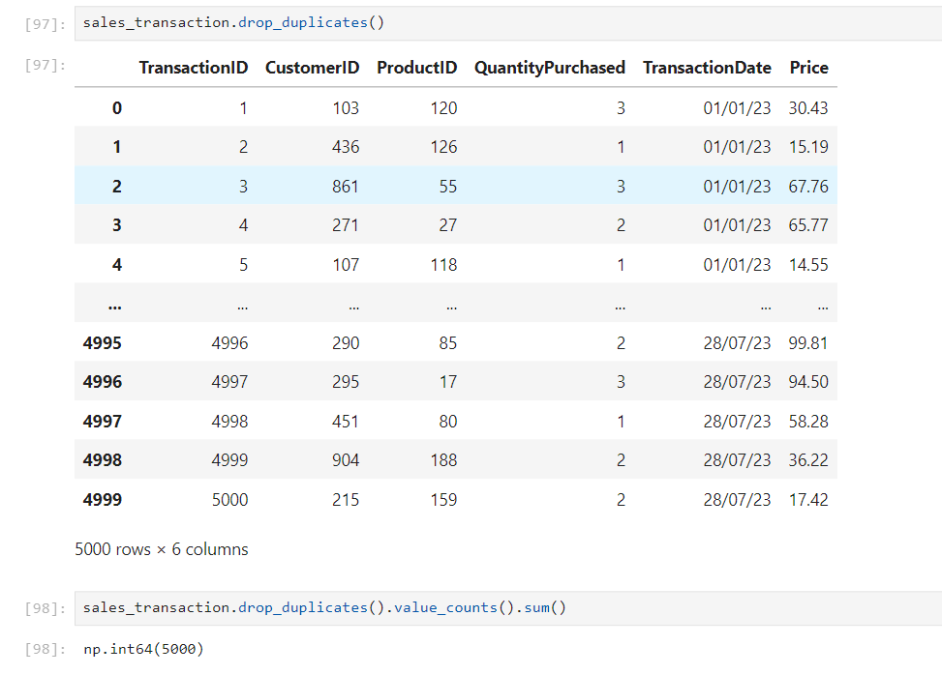
• Checked for mis-match values.
Data set Sales Transaction have mis-match in price column from Price Inventory this was removed from data set using Update statement in SQL
• Standardized date formats.
The Transaction Date column in Sales Transaction was found to be in text and not standard format which as converted to a standard date time by altering the table content.
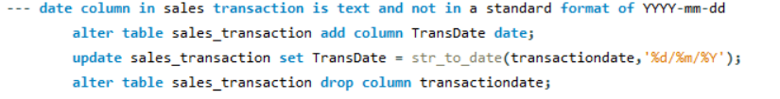
• Checked for null values in the dataset and found that data set Customer Profile contain 13 null
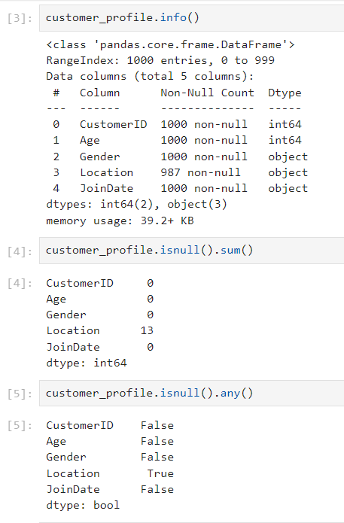

These null values are located at location column and deleting these column would cause a data loss so these columns were replaced with ‘Unknown’
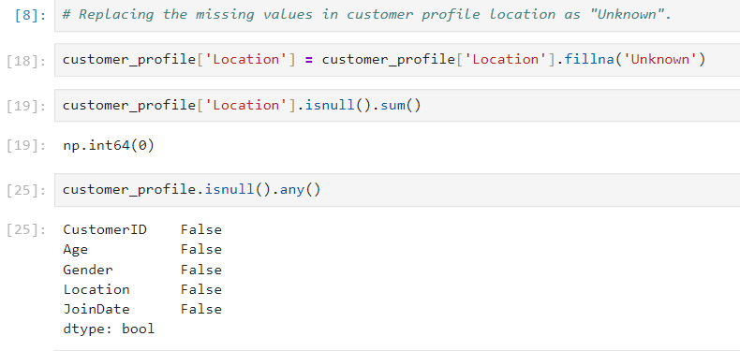
Outcome
The dataset was successfully cleaned and prepared for analysis using pandas and SQL both.
4. Sales Performance Analysis
Q1. Total Revenue, Quantity Sold and Transactions.
Objective:
Evaluate the overall business performance.
total_revenue | totalquantitysold | total_transaction
702003.62 | 12325 | 12502500
Findings:
• Total Revenue: $702003.62
• Total Quantity Sold: 12325
• Total Transactions: 12502500
Business Insight:
The company generated significant revenue through $702003.62 transactions, indicating overall business activity and market demand.
Q2. Month-over-Month Revenue Growth
Months | total_revenue | previous_month_revenue | percentage_change
01-01-2023 | 104289.18 | NULL | NULL
01-02-2023 | 96690.99 | 104289.17999999993 | -7.29
01-03-2023 | 103271.49 | 96690.98999999995 | 6.81
01-04-2023 | 101561.09 | 103271.49 | -1.66
01-05-2023 | 102998.84 | 101561.09000000014 | 1.42
01-06-2023 | 102210.28 | 102998.83999999995 | -0.77
01-07-2023 | 90981.75 | 102210.28 | -10.99

Business Insight:
The company is facing downward trend in revenue collection.

Q3. Highest and Lowest Revenue Months.

Months | Total_Revenue
01-01-2023 | 104289.18
01-07-2023 | 90981.75

Business Insight:
These months needs to be looked into carefully that what is causing this fall in revenue and we should replicate the strategy in the months of high revenue.

5. Product Performance Analysis

Q4. What are the top 10 products by total revenue?
PRODUCTNAME | TOTAL_REVENUE
Product_17 | 9450
Product_87 | 7817.24
Product_179 | 7388.26
Product_96 | 7132.32
Product_54 | 7052.86
Product_187 | 6915.88
Product_156 | 6827.84
Product_57 | 6622.2
Product_200 | 6479.79
Product_127 | 6415.8

Business Insight:

Top-performing products are responsible for a significant share of revenue. These products demonstrate strong customer demand and should be prioritized for inventory availability, promotions, and cross-selling opportunities.

Q5. What are the bottom 10 products by units sold (excluding products with zero sales)?

PRODUCTNAME | TOTAL_QUANTITY
Product_142 | 27
Product_33 | 31
Product_174 | 33
Product_159 | 35
Product_60 | 35
Product_41 | 35
Product_91 | 35
Product_198 | 36
Product_124 | 39
Product_163 | 39

Business Insight:

These products show weak customer demand. Low sales may be caused by poor visibility, pricing issues, limited relevance, or strong competition from substitute products.

Q6. Revenue Contribution by Product Category
PRODUCT_CATEGOY | TOTAL_REVENUE
Home & Kitchen | 217755.94
Electronics | 177548.48
Clothing | 162874.21
Beauty & Health | 143824.99

Business Insight:
Home & Kitchen contributes the highest revenue, indicating strong market demand. Beauty & Health contributes the least and may require targeted marketing or product assortment improvements.
Q7. Which products have high sales volume but low stock levels?

PRODUCT | TOTAL_QUANTITY_SOLD | TOTAL_STOCK
Product_93 | 79 | 0
Product_35 | 57 | 9
Product_85 | 62 | 11
Product_69 | 60 | 13
Product_83 | 62 | 16
Product_119 | 67 | 17
Product_1 | 40 | 22
Product_152 | 47 | 24
Product_47 | 55 | 34
Product_187 | 82 | 35
Product_90 | 74 | 36
Product_136 | 45 | 38
Product_118 | 72 | 44
Product_127 | 68 | 49

Business Insight:

Several fast-moving products have critically low inventory levels, creating a risk of stockouts, lost sales, and reduced customer satisfaction.

6. Customer Behavior Analysis

Q8. How many transactions has each customer made ?
customerID | Number_of_transaction
664 | 14
958 | 12
99 | 12
113 | 12
929 | 12
936 | 12
670 | 12
39 | 12
277 | 11
476 | 11
776 | 11
727 | 11
648 | 11
613 | 11
268 | 11
881 | 11
659 | 11
704 | 11
75 | 11

Business Insight:

A small group of customers purchases frequently, indicating a loyal customer base that can be leveraged through loyalty programs and personalized offers.

Q9. Who are the top 10 customers by total spending?
customerID | Total_Revenue
39 | 2221.29
75 | 1862.73
364 | 1885.4
407 | 1882.26
435 | 2158.98
664 | 2519.04
670 | 2432.15
921 | 1866.29
936 | 2834.47
958 | 2104.71

Business Insight:

High-spending customers contribute disproportionately to revenue and represent a valuable segment for retention and premium marketing campaigns.

Q10. Who are the customers with the lowest purchasing activity?
customerID | Total_Revenue
464 | 10.95
255 | 14.29
219 | 22.24
555 | 22.27
766 | 28.86
444 | 40.95
150 | 43.65
315 | 53.91
487 | 60.92
355 | 61.64
Business Insight:

Customers with minimal spending may be at risk of churn or may not have found products aligned with their needs.

Q11. Average Order Value (AOV)
Formula:
AOV = Total Revenue / Total Transactions
customerid | customer_average_order_value
94 | 360.64
312 | 328.88
174 | 304.17
181 | 298.23
187 | 295.63
471 | 293.66
534 | 282.98
927 | 280.43
85 | 278.33
138 | 272.74
591 | 269.4
362 | 268.66
897 | 267.02
347 | 265.24
979 | 265.16
54 | 264.83
628 | 262.28
238 | 261.95
907 | 261.54

Business Insight:

Customers with high AOV demonstrate willingness to spend more per transaction, creating opportunities for premium bundles and upselling strategies.

7. Customer Loyalty and Retention Analysis
Q12. What percentage of customers are repeat customers?

percentage_of_repeat_customer
95%
Business Insight:

A repeat-customer rate of 95% indicates excellent retention and strong customer satisfaction, reducing customer acquisition dependency.

Q13. What is the duration between the first and last purchase for each customer?

customer_id | customer_segment
103 | long-term-customer
436 | moderately-engaged-customer
861 | moderately-engaged-customer
271 | moderately-engaged-customer
107 | long-term-customer
72 | moderately-engaged-customer
701 | long-term-customer
21 | moderately-engaged-customer
615 | moderately-engaged-customer
122 | long-term-customer
467 | long-term-customer
215 | long-term-customer
331 | moderately-engaged-customer
459 | moderately-engaged-customer
88 | moderately-engaged-customer
373 | moderately-engaged-customer
100 | moderately-engaged-customer
872 | moderately-engaged-customer
664 | long-term-customer
Business Insight:
Long-term customers contribute recurring revenue and provide evidence of sustained engagement with the brand.

Q14 . Customers who are registeded but never bought any product?

customerid | TransactionID | CustomerID.1 | ProductID | QuantityPurchased
52 | NULL | NULL | NULL | NULL
71 | NULL | NULL | NULL | NULL
197 | NULL | NULL | NULL | NULL
299 | NULL | NULL | NULL | NULL
433 | NULL | NULL | NULL | NULL
600 | NULL | NULL | NULL | NULL
671 | NULL | NULL | NULL | NULL
694 | NULL | NULL | NULL | NULL
756 | NULL | NULL | NULL | NULL
765 | NULL | NULL | NULL | NULL
808 | NULL | NULL | NULL | NULL

Business Insight:

These customers represent untapped revenue opportunities because acquisition costs have already been incurred.

8.Customer Segmentation
Q15. Segment customers based on total quantity purchased and count customers in each segment?
| Segment | Quantity Purchased |
|----------|------------------|
| No Orders | 0 |
| Low Value | 1-10 |
| Mid Value | 11-30 |
| High Value | >30 |

customer_segment | total_count
High | 7
No Order | 11
Low | 423
Medium | 559

Business Insight:

Most customers belong to the Medium and Low segments, while only a small number fall into the High-Value category, highlighting opportunities to move customers up the value ladder.
9. Power BI Dashboard

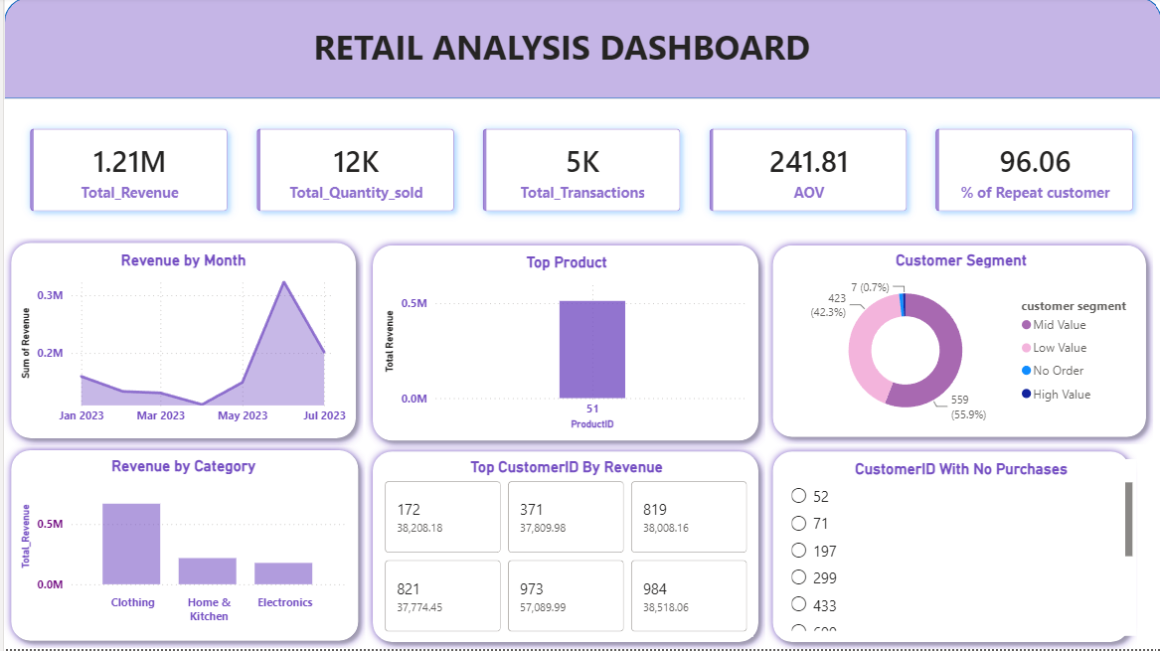

10. Key Business Recommendations

Product & Inventory
- Increase stock levels for high-demand products to avoid stockouts.
- Promote top-performing products through targeted campaigns and bundles.
- Review or discontinue consistently low-performing products.
Customer Growth & Retention
- Launch loyalty programs for high-value customers.
- Re-engage inactive customers through discounts and personalized offers.
- Convert registered non-buyers using welcome offers and first-purchase incentives.
Revenue Enhancement
- Increase Average Order Value through cross-selling, upselling, and product bundles.
- Focus marketing investments on high-revenue categories such as Home & Kitchen and Electronics.
- Monitor monthly revenue trends and replicate successful sales strategies.
Customer Segmentation
- Create targeted campaigns for High-, Medium-, and Low-Value customer segments.
- Provide personalized offers based on customer purchasing behavior.

11. Conclusion

This analysis identified key revenue drivers, customer purchasing patterns, and opportunities for improving customer retention and inventory management. The findings provide actionable insights that can support strategic decision-making and contribute to sustainable business growth.

