SOFTWARE REQUIREMENTS
SPECIFICATION
PortfolioPro
Stock Trading & Portfolio Management System

Document Item | Details
Project Name | PortfolioPro
Document Type | Software Requirements Specification (SRS)
Domain | Finance / Stock Portfolio Management
Project Type | Full-Stack Web Application / REST API
Student | Siddharth Sharma
Class / Section | CSE-28
Roll No. | 2400320101096
Program | B.Tech – Computer Science Engineering
Institution | ABES Engineering College

Academic Project Document

Document Control
Version | Date | Description | Prepared By
1.0 | 30 September 2026 | SRS converted from the PortfolioPro project synopsis | Siddharth Sharma

Table of Contents
- 1. Introduction
- 2. Overall Description
- 3. Functional Requirements
- 4. Non-Functional Requirements
- 5. System Architecture and Data Requirements
- 6. External Interface Requirements
- 7. Testing and Acceptance Criteria
- 8. Future Scope and Constraints

1. Introduction

1.1 Purpose
This Software Requirements Specification defines the requirements for PortfolioPro, a web-based Stock Trading & Portfolio Management System. The system is intended to organize users, portfolios, stocks, holdings and buy/sell transaction records in a relational database and expose the data through REST APIs. The SRS describes the required functionality, interfaces, architecture, data requirements, testing expectations and project constraints.

1.2 Product Scope
PortfolioPro provides a single application for maintaining stock-related information and tracking a user's portfolio. The planned full-stack implementation uses Java and Spring Boot for the backend, Spring Data JPA/Hibernate for persistence, MySQL for data storage and Angular for the frontend. Postman is used for API testing.

1.3 Intended Users
- Application users who want to maintain portfolio, holding and transaction information.
- Project administrators/developers who maintain the application and database.
- Frontend/API clients that consume the REST endpoints.

1.4 Definitions and Acronyms
Term | Meaning
REST | Representational State Transfer; API style used for HTTP communication.
CRUD | Create, Read, Update and Delete operations.
JPA | Java Persistence API used for object-relational persistence.
ORM | Object-Relational Mapping.
PK | Primary Key.
FK | Foreign Key.
API | Application Programming Interface.
SRS | Software Requirements Specification.

2. Overall Description

2.1 Product Perspective
PortfolioPro follows a layered architecture. A client such as Angular or Postman sends an HTTP request to a Spring Boot REST Controller. The controller invokes the Service Layer, which uses the Repository Layer to access MySQL through JPA/Hibernate. The response is returned to the client as structured JSON.
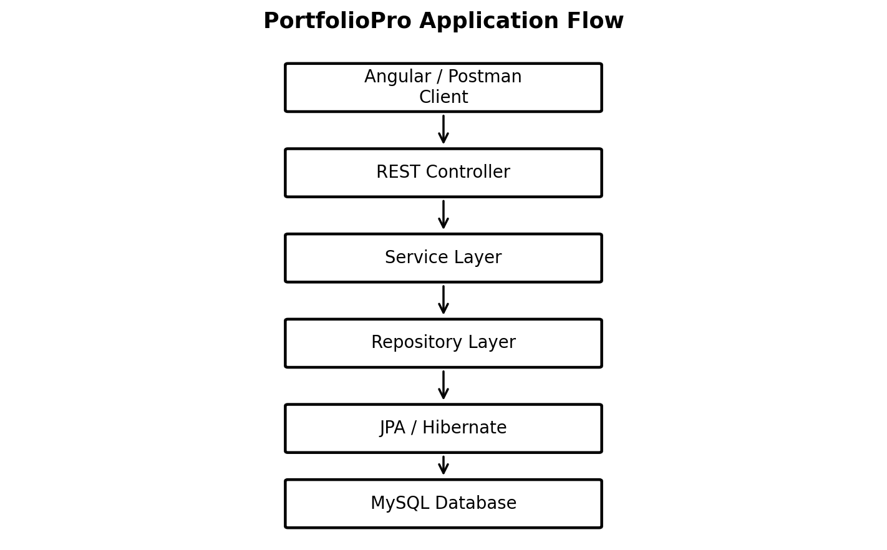
Figure 1. PortfolioPro application flow based on the project architecture.

2.2 Major System Components
Component | Responsibility
Model / Entity Layer | Defines Java entities such as User and maps application objects to database tables using JPA annotations.
Repository Layer | Extends JpaRepository and provides persistence operations such as save(), findAll() and findById().
Service Layer | Contains application logic and coordinates repository operations.
Controller Layer | Receives HTTP requests and exposes REST endpoints.
Database Layer | Stores persistent users, portfolios, stocks, holdings and transactions in MySQL.
API Testing Layer | Uses Postman to send requests and verify HTTP/JSON responses.
Frontend Layer | Angular interface consumes REST APIs and provides user interaction.

2.3 Operating Environment
- Backend: Java with Spring Boot, Spring Web, Spring Data JPA and Hibernate.
- Database: MySQL; database management and inspection through MySQL Workbench.
- Frontend: Angular.
- Build: Maven.
- Development IDE: IntelliJ IDEA.
- API validation: Postman.

3. Functional Requirements
The following requirements translate the features and API design in the project synopsis into testable system requirements.
ID | Requirement | Description
FR-01 | User Management | The system shall allow creation of a user through POST /users and retrieval of all users through GET /users.
FR-02 | User Retrieval | The system shall allow retrieval of a single user using GET /users/{id}.
FR-03 | User Update | The system shall allow an existing user record to be updated through PUT /users.
FR-04 | Portfolio Management | The system shall allow portfolio records to be created and associated with a user.
FR-05 | Stock Management | The system shall store stock symbol, company name and current/reference price information.
FR-06 | Holdings Management | The system shall maintain holdings associated with a portfolio and stock, including quantity and average purchase price.
FR-07 | Transaction Recording | The system shall record buy/sell transactions containing portfolio, stock, type, quantity, price and timestamp.
FR-08 | Transaction Retrieval | The system shall provide access to transaction history through REST APIs.
FR-09 | Persistence | The system shall persist application data in MySQL using Spring Data JPA/Hibernate.
FR-10 | API Communication | The system shall expose REST endpoints that can be consumed by Postman and the Angular frontend.

3.1 User CRUD Flow
For the User module, a POST request sends user data to UserController. The controller calls UserService, and the service calls UserRepository.save(). For retrieval, GET requests use findAll() or findById(). The result is returned to the client as JSON.

3.2 API Requirements
Method | Endpoint | Purpose
POST | /users | Create a new user.
GET | /users | Fetch all users.
GET | /users/{id} | Fetch one user by ID.
PUT | /users | Update an existing user.
POST | /portfolios | Create a portfolio.
GET | /portfolios | Fetch portfolios.
POST | /stocks | Add stock information.
GET | /stocks | Fetch stock information.
POST | /transactions | Record a buy/sell transaction.
GET | /transactions | View transaction history.

4. Non-Functional Requirements
ID | Category | Requirement
NFR-01 | Maintainability | The application shall maintain separate controller, service, repository and entity responsibilities.
NFR-02 | Usability | REST APIs shall return understandable JSON responses that can be inspected through Postman.
NFR-03 | Reliability | The application shall start successfully and establish a connection with the PortfolioPro MySQL database.
NFR-04 | Data Integrity | Database relationships shall use primary and foreign keys to associate users, portfolios, stocks, holdings and transactions.
NFR-05 | Extensibility | The architecture shall allow additional entities and frontend screens to be added without redesigning the complete backend.
NFR-06 | Persistence | Changes made through API operations shall be reflected in the MySQL database.
NFR-07 | Testability | REST endpoints shall be testable independently using Postman.

4.1 Security Considerations
The project synopsis identifies authentication and role-based access as future scope. Therefore, the current SRS does not treat authentication as an implemented core requirement. User data includes a password field in the documented model; production deployment would require appropriate password protection and access controls.

4.2 Performance and Availability
The supplied project synopsis does not define numerical performance targets such as response-time limits, concurrent-user capacity or uptime. Such values can be specified later if deployment requirements are established.

5. System Architecture and Data Requirements

5.1 Technology Stack
Layer | Technology | Purpose
Programming Language | Java | Core backend language.
Backend | Spring Boot | Web application and REST API layer.
REST | Spring Web / REST Controller | Handles HTTP requests such as GET and POST.
Persistence | Spring Data JPA | Repository methods such as save(), findAll() and findById().
ORM | Hibernate | Maps Java entities to relational tables.
Database | MySQL | Stores project data.
Frontend | Angular | User interface and REST API client.
Testing | Postman | API request and response testing.
Build | Maven | Dependency management and project build.
IDE | IntelliJ IDEA | Java/Spring Boot development.

5.2 Database Requirements
Table | Key Fields | Purpose / Relationship
users | id PK, name, email, password | Stores user information; one user can own multiple portfolios.
portfolios | portfolio_id PK, user_id FK, portfolio_name, created_at | Stores portfolio information and belongs to one user.
stocks | stock_id PK, symbol, company_name, price | Stores stock master data used by holdings and transactions.
holdings | holding_id PK, portfolio_id FK, stock_id FK, quantity, avg_price | Stores stocks currently held and links portfolio with stock.
transactions | transaction_id PK, portfolio_id FK, stock_id FK, type, quantity, price, created_at | Stores buy/sell history and links portfolio with stock.

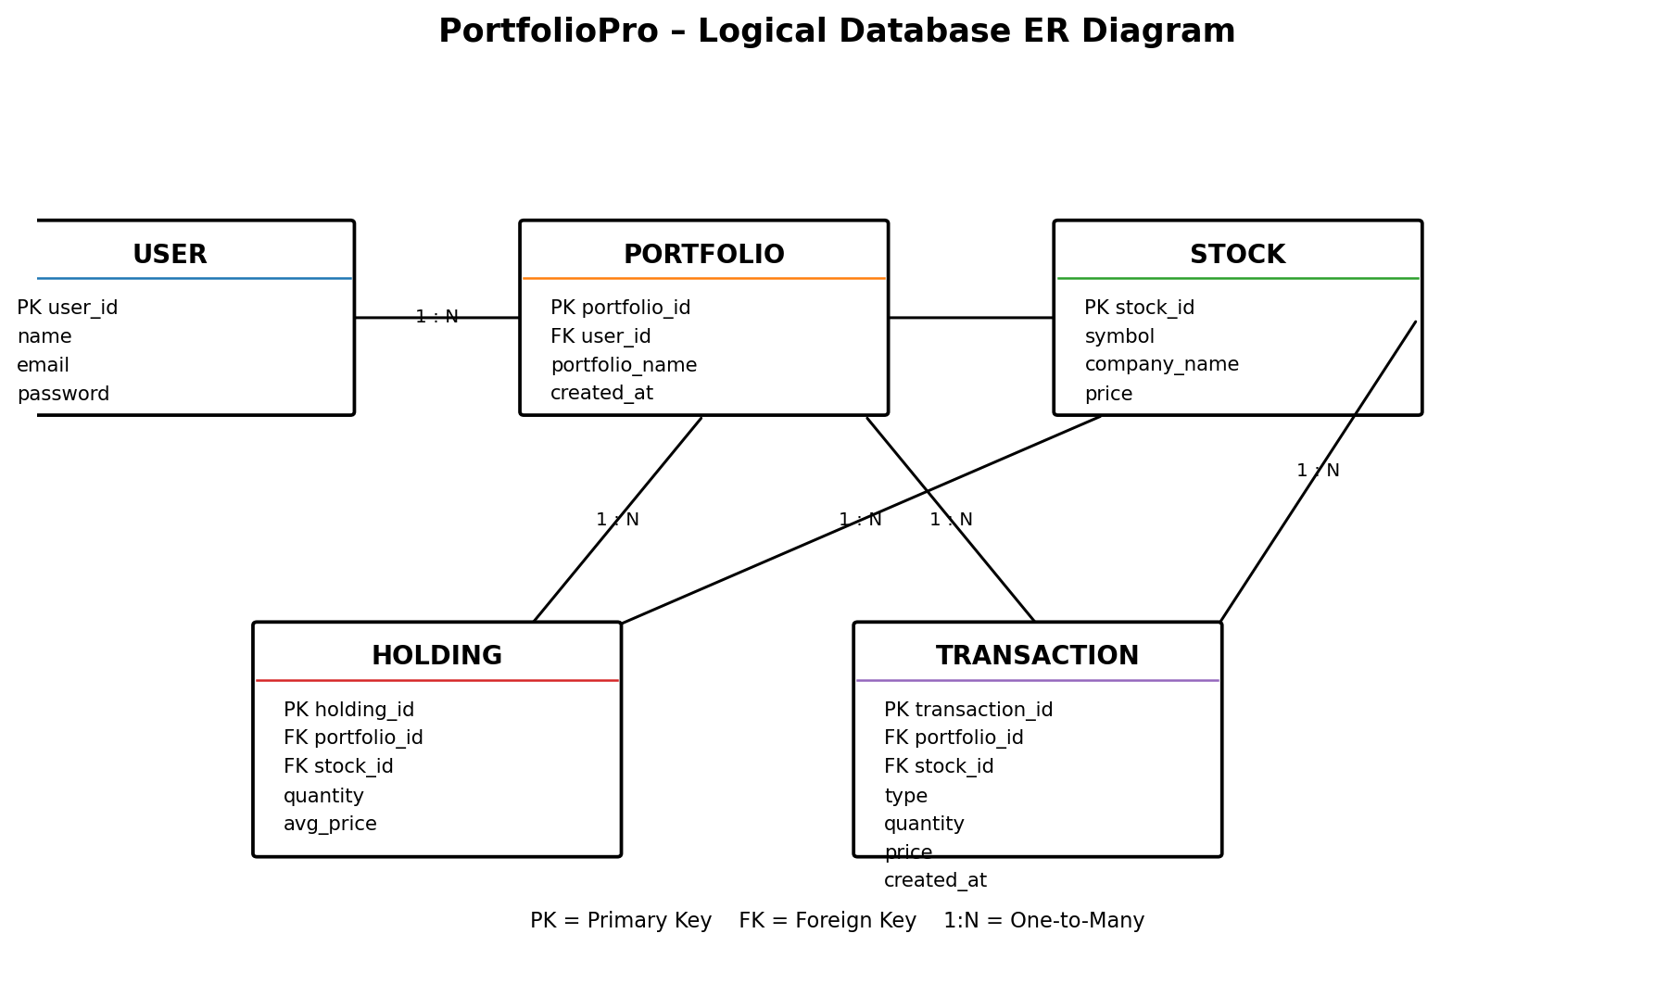
Figure 2. Logical ER diagram recreated from the database design in the project synopsis.

6. External Interface Requirements

6.1 User / Frontend Interface
The planned Angular frontend shall communicate with the Spring Boot REST backend. The frontend is expected to provide screens for managing users, portfolios, stock information, holdings and transaction information. The supplied synopsis does not define final screen layouts, so detailed UI specifications are left for the frontend phase.

6.2 API Interface
The REST API is the communication interface between the frontend/API client and backend. Requests use HTTP methods such as GET, POST and PUT, and responses are represented as JSON.

6.3 Database Interface
Spring Data JPA and Hibernate provide the persistence interface between Java entities and MySQL tables. The repository layer abstracts common database operations.

6.4 Example Request / Response
POST /users
{
"name": "Siddharth",
"email": "siddharth@gmail.com",
"password": "123456"
}
Example JSON response
{
"id": 1,
"name": "Siddharth",
"email": "siddharth@gmail.com",
"password": "123456"
}

7. Testing and Acceptance Criteria
Testing shall verify application startup, database connectivity, REST operations and persistence. The project synopsis specifically identifies Postman and MySQL Workbench as validation tools.
Test ID | Test | Expected Result
T-01 | Application startup | Spring Boot starts without configuration errors.
T-02 | Database connection | Application connects to the PortfolioPro MySQL database.
T-03 | POST /users | A new user is inserted and returned as JSON.
T-04 | GET /users | Stored users are returned as a list.
T-05 | GET /users/{id} | The requested user is returned.
T-06 | PUT /users | An existing user record is updated.
T-07 | Database verification | MySQL Workbench confirms API changes in the relevant table.
T-08 | API response verification | Postman shows expected HTTP status codes and JSON data.

7.1 Acceptance Criteria
- Spring Boot application starts successfully.
- MySQL database connection is established.
- User CRUD workflow works through REST APIs.
- Portfolio, stock, holding and transaction data can be represented in the defined relational structure.
- API requests can be tested through Postman and return JSON responses.
- Database records reflect successful API operations.

8. Future Scope and Constraints

8.1 Future Enhancements
- Complete the Angular frontend and connect all screens to REST APIs.
- Add user authentication and role-based access.
- Add a portfolio dashboard showing total investment and current value.
- Add profit/loss calculations and transaction summaries.
- Add validation and exception handling across APIs.
- Integrate an external market-data source for updated stock prices.
- Add charts for portfolio allocation and performance.
- Deploy the application to a cloud platform after testing.

8.2 Project Constraints / Out of Scope
- Real-money stock trading or direct connection to a real stock exchange.
- Actual brokerage account integration.
- Guaranteed or personalized investment advice.
- Real-time market execution.
- Handling of real financial transactions.

8.3 Conclusion
PortfolioPro is specified as a practical full-stack application for stock portfolio and trading management. Its requirements center on a layered Java/Spring Boot backend, REST APIs, Spring Data JPA/Hibernate persistence and a MySQL relational database, with Angular planned as the frontend. The current project establishes the User entity and basic database/API workflow, while the same architecture can be extended to portfolios, stocks, holdings and transactions.
Source basis: PortfolioPro Project Synopsis supplied for conversion to SRS. The SRS preserves the project's stated scope, architecture, entities, endpoints, testing approach and future scope.

