1. **ADMIN User**
2. ***Employee DB***
3. **Login**

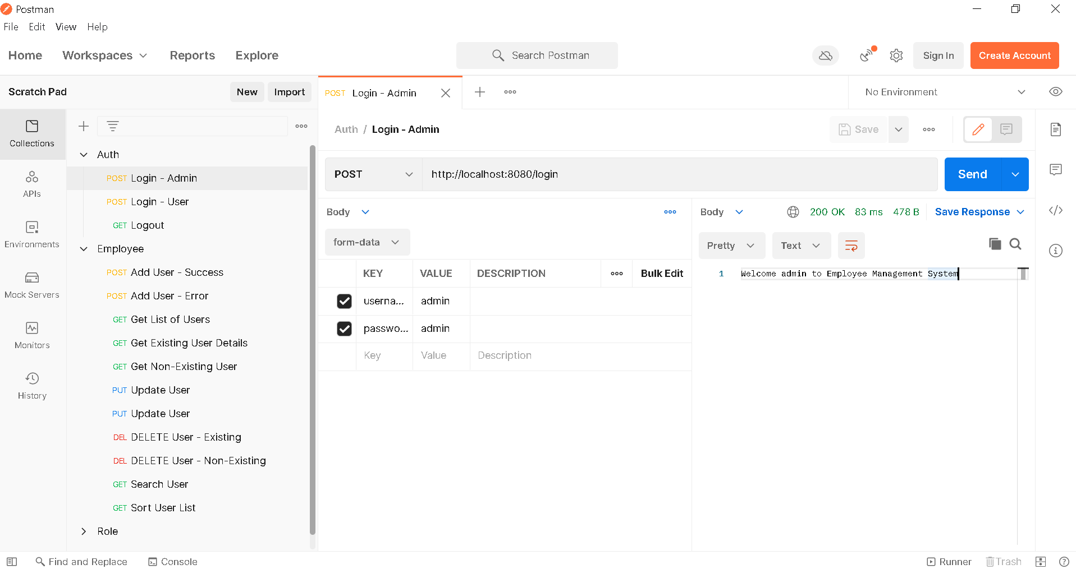

1. **Get Employees List**

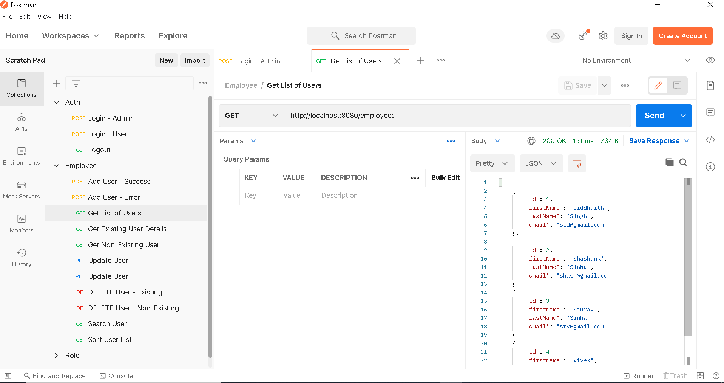

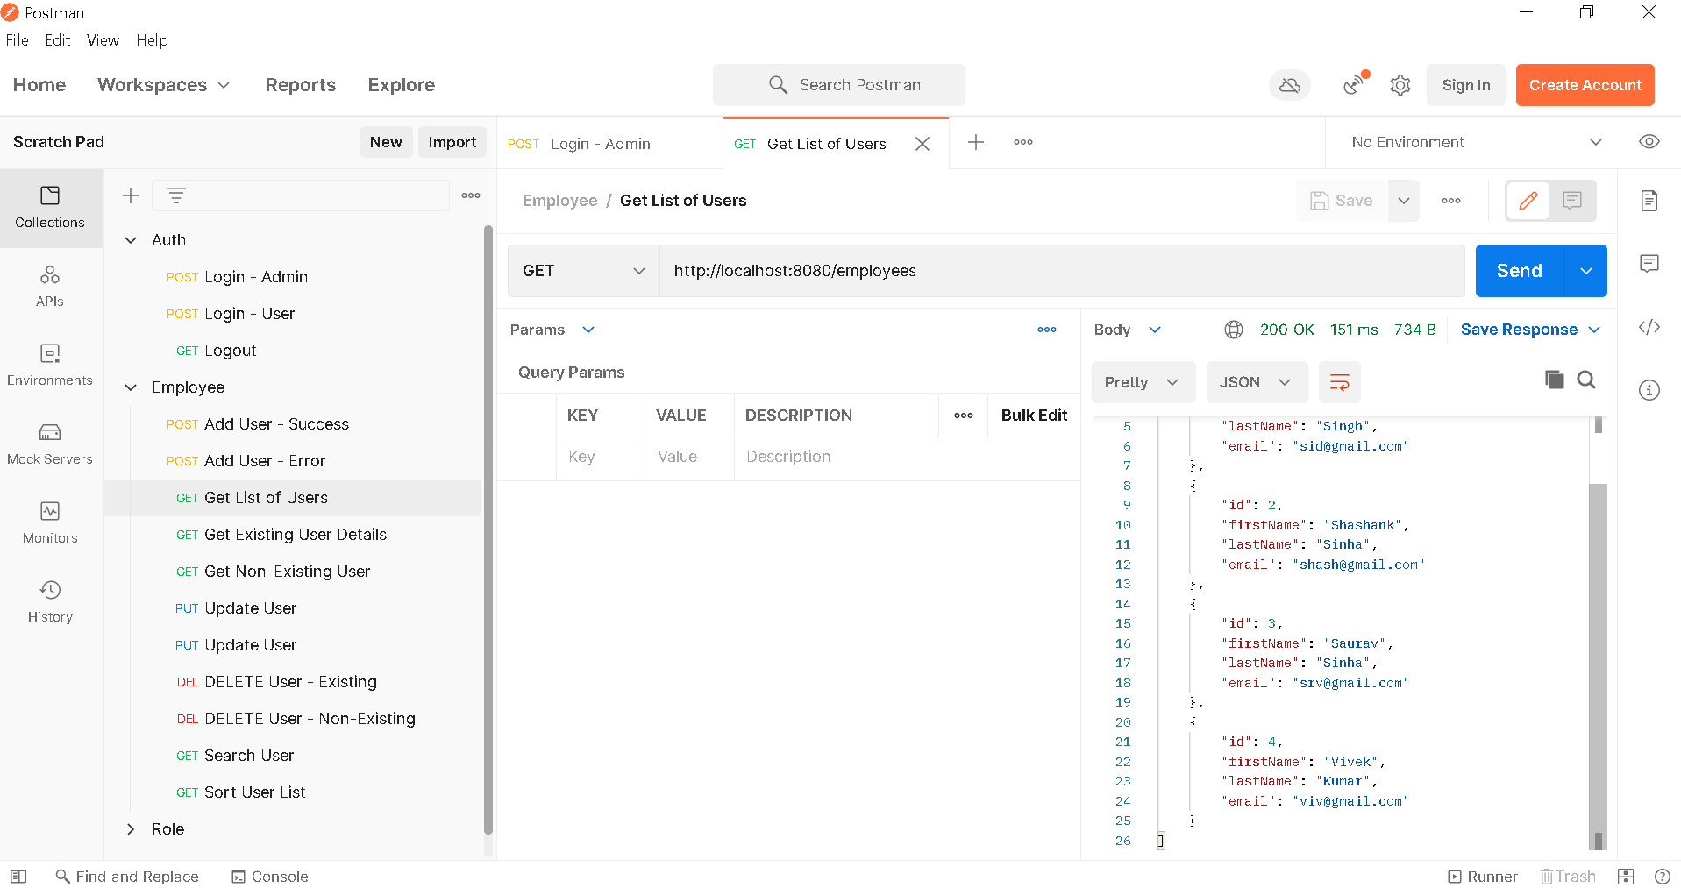

1. **Get Employee – Success**

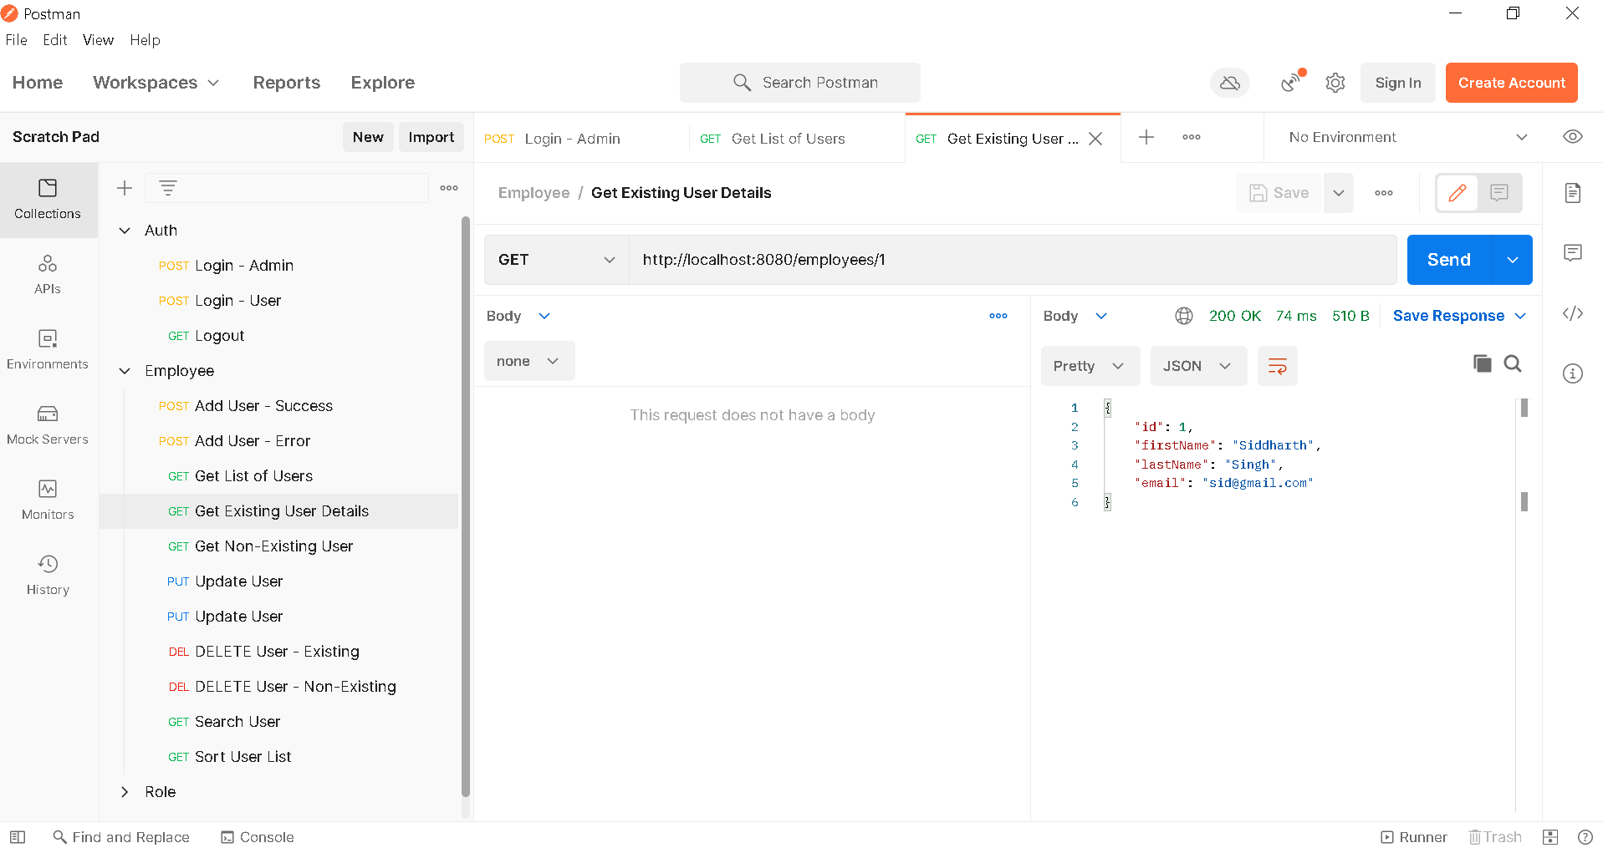

1. **Get Employee – Error**

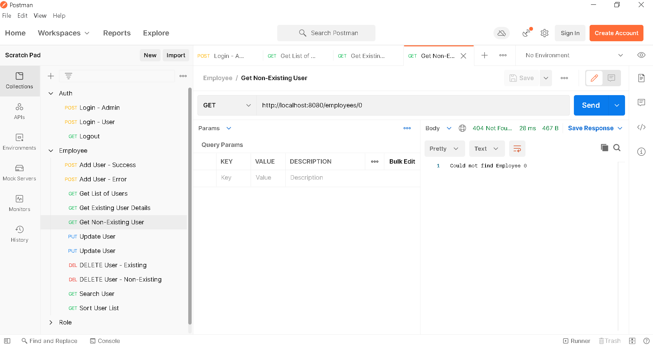

1. **Add Employee – Success**

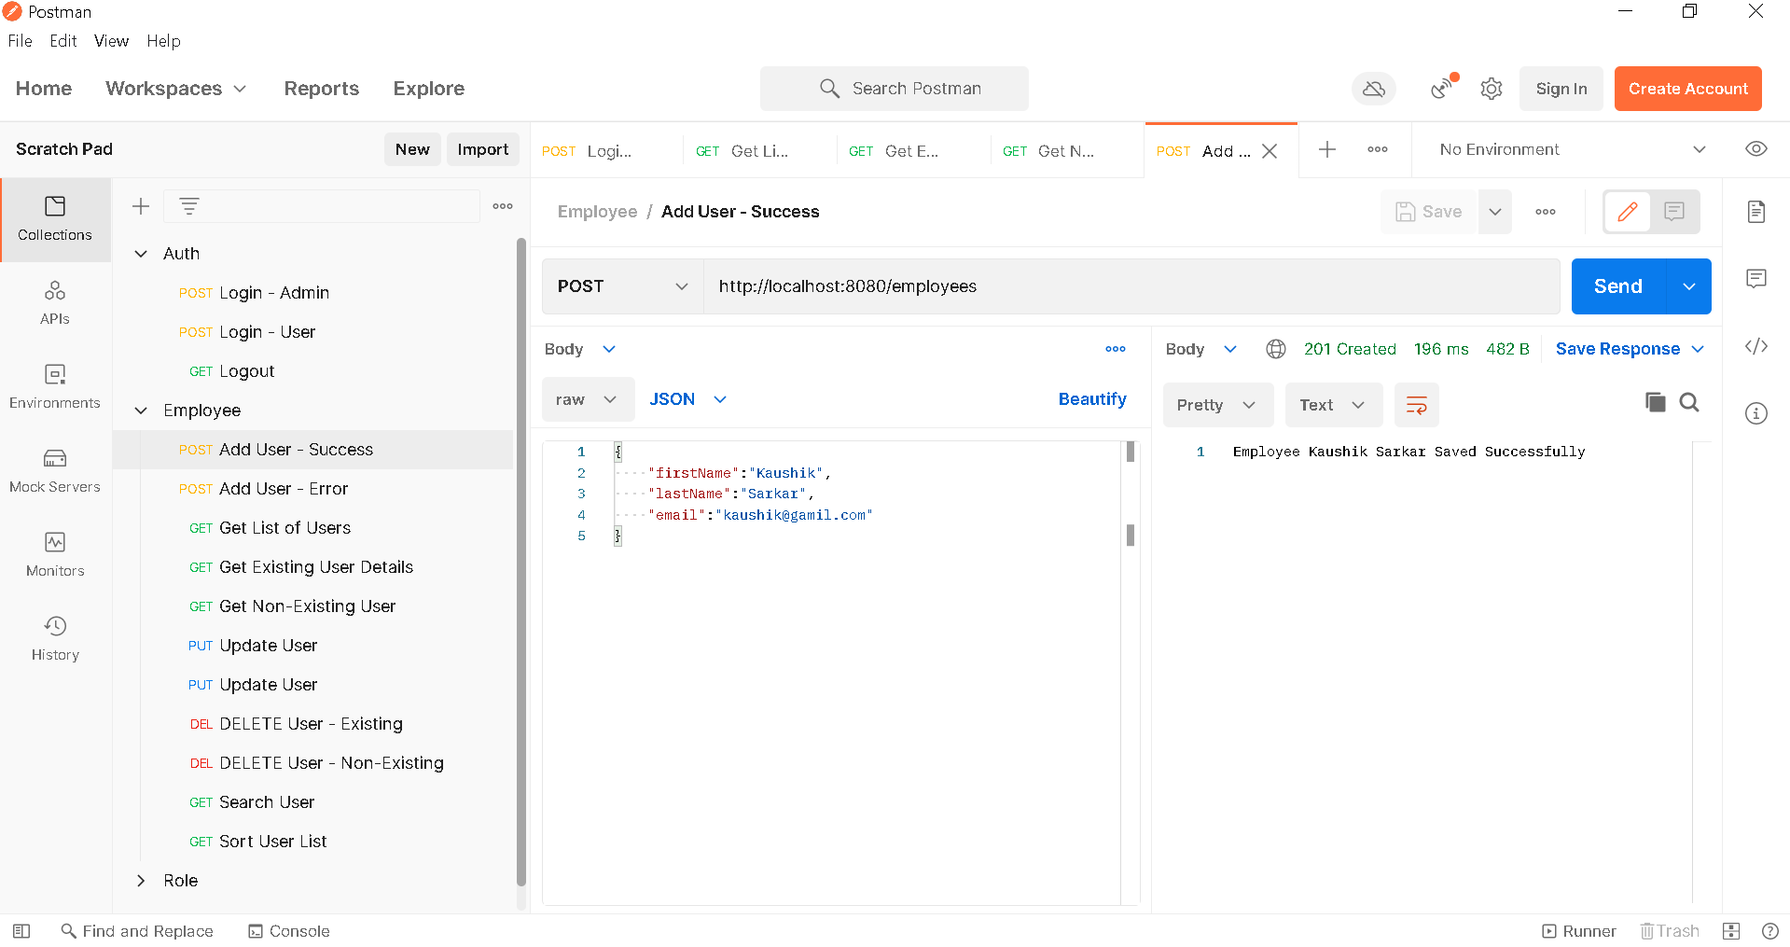

1. **Get List of Employees – After Addition**

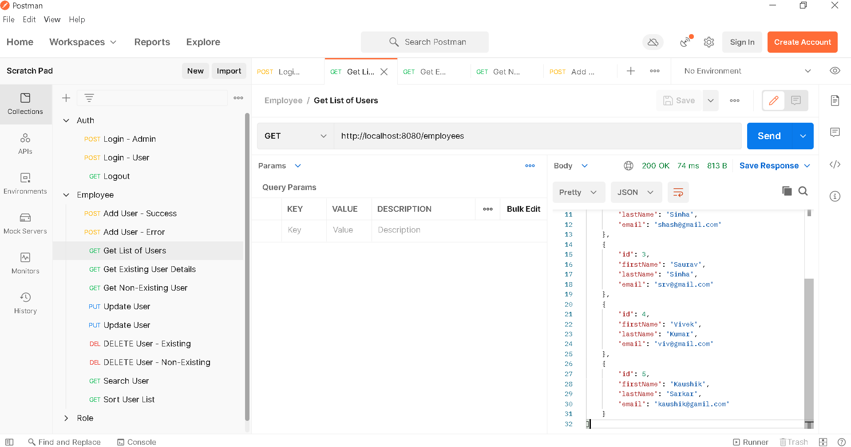

1. **Add Employee – Error – First Name**

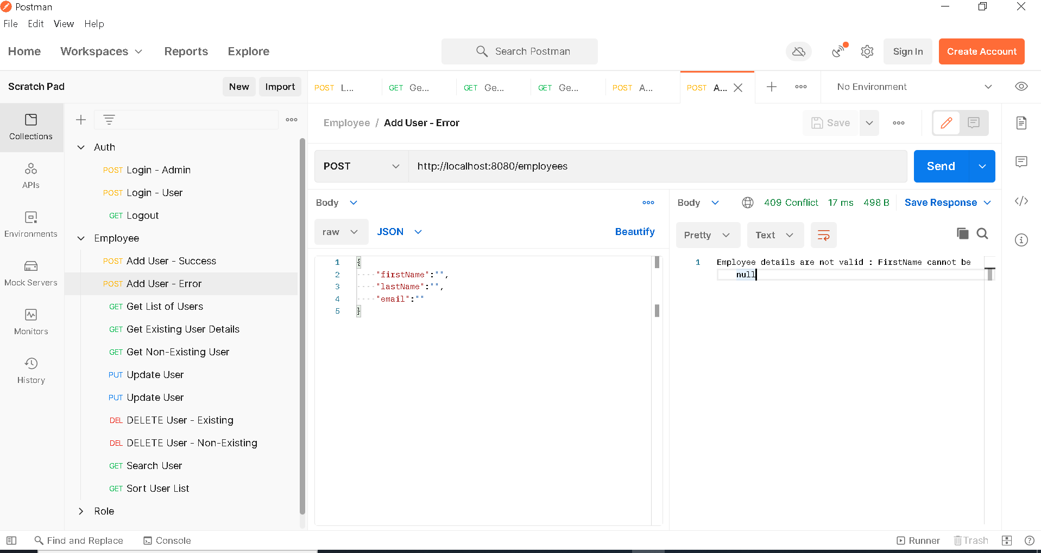

1. **Add Employee – Error – Last Name**

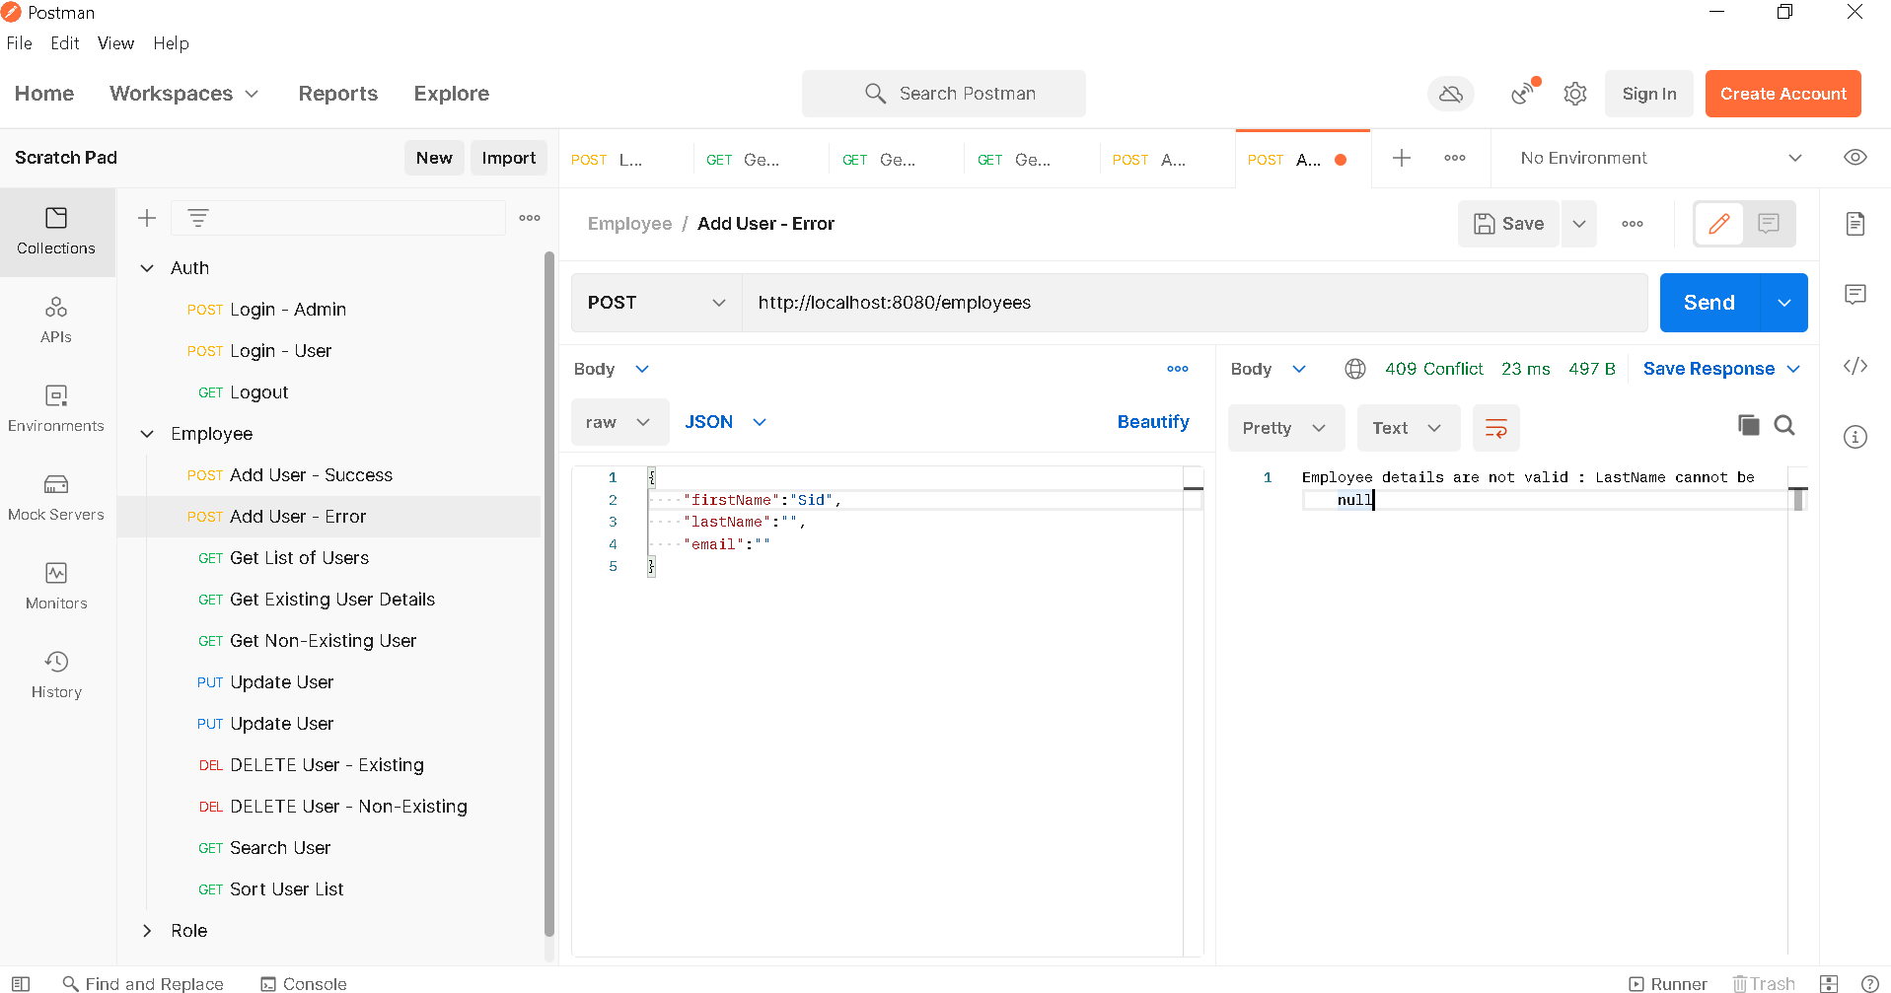

1. **Add Employee – Error – Email**

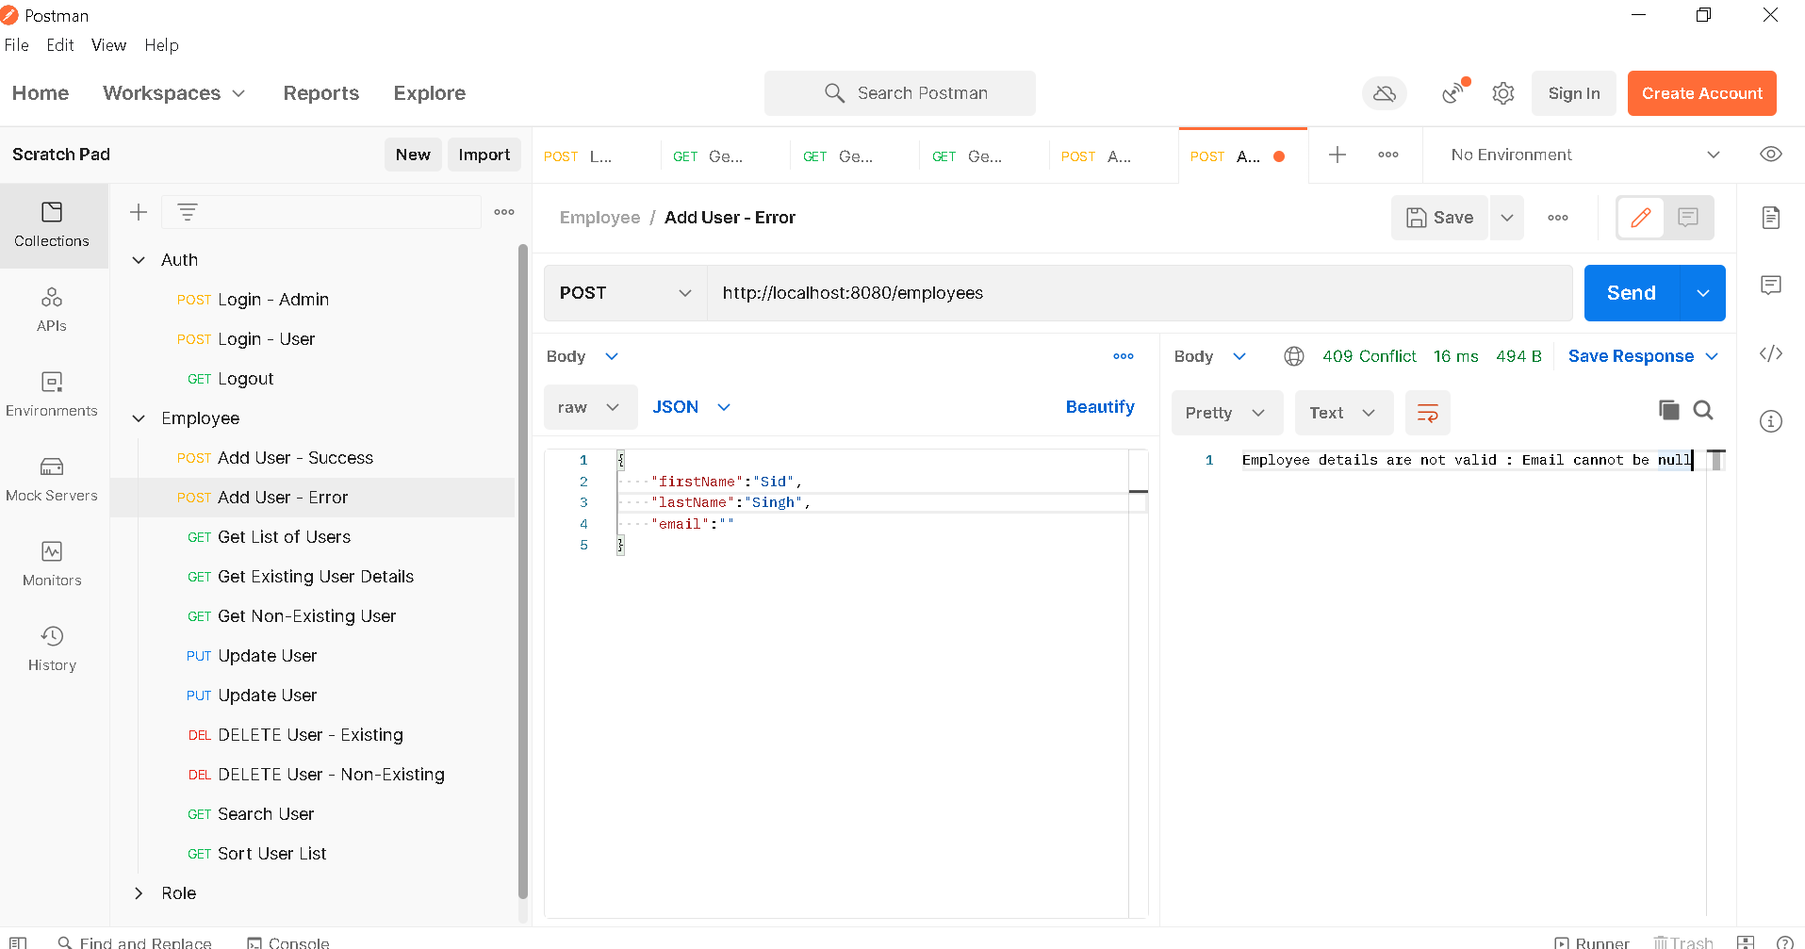

1. **Add Employee – Error – Email Already Exists**

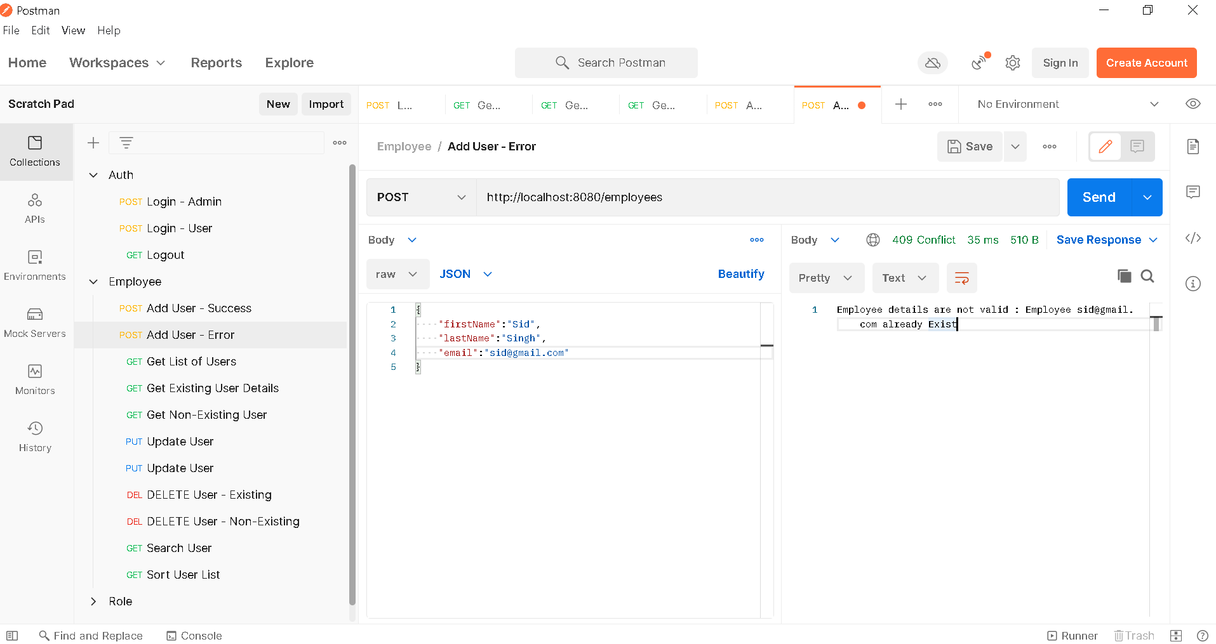

1. **Update Employee – Success**

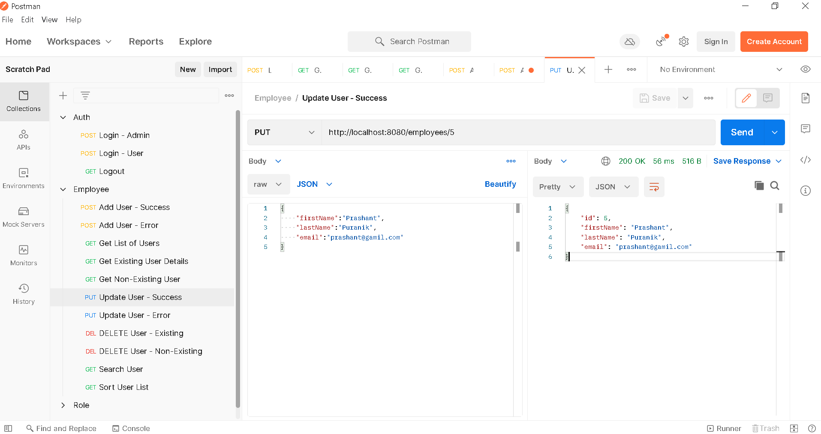

1. **Get List of Employees – After Update**

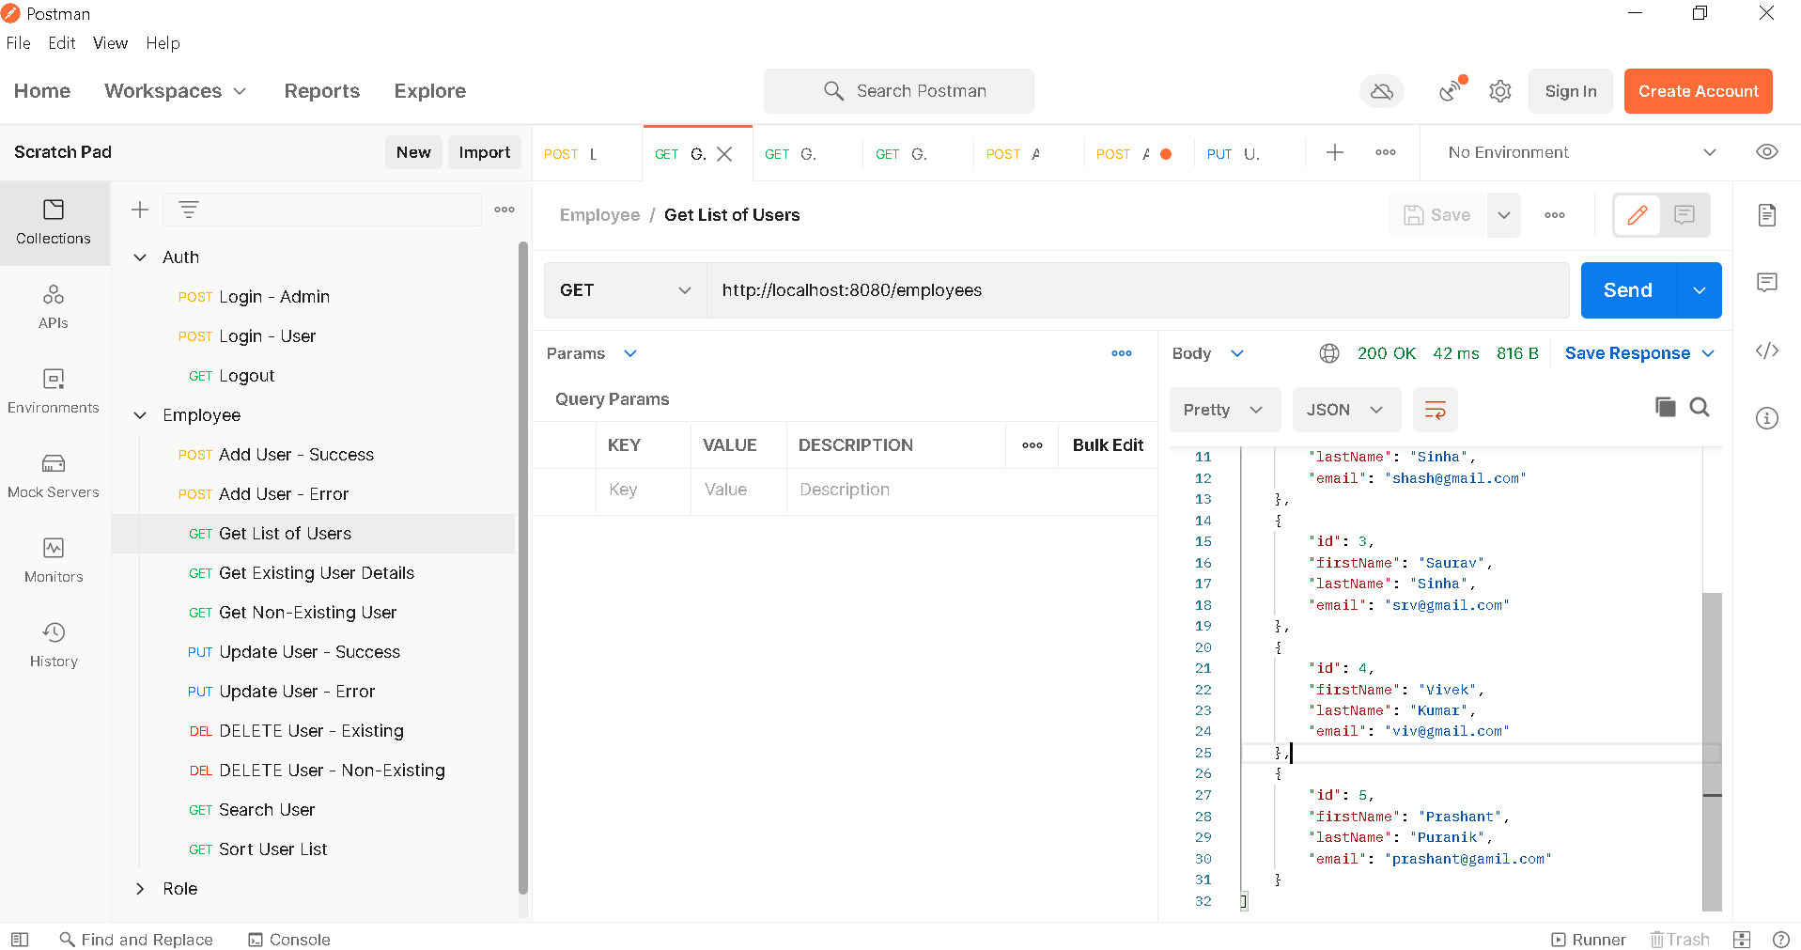

1. **Update Employee – Error**

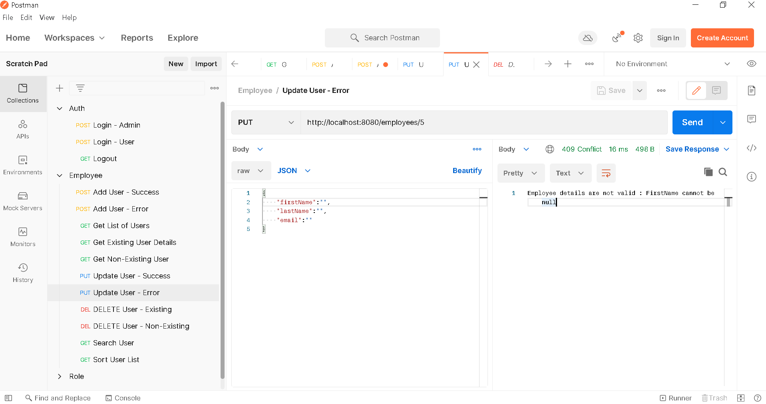

1. **Delete Employee – Success**

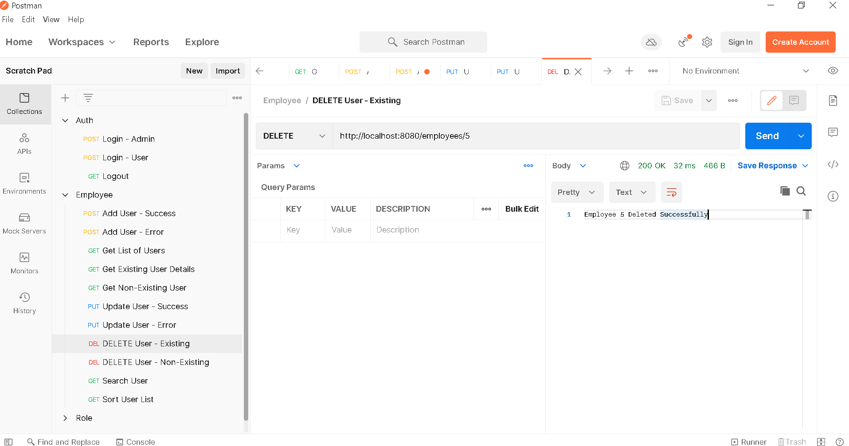

1. **Get List of Employee – After Deletion**

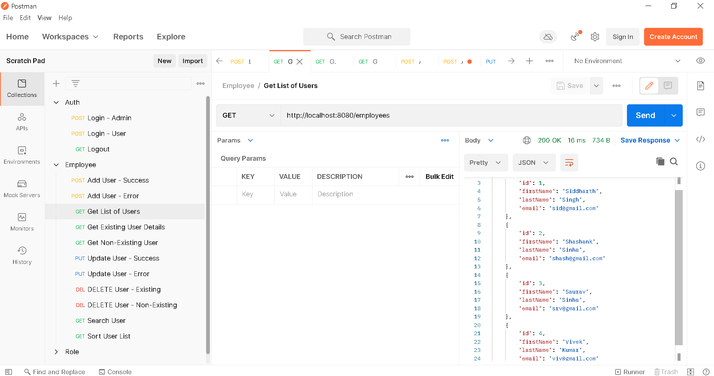

1. **Delete Employee – Error**

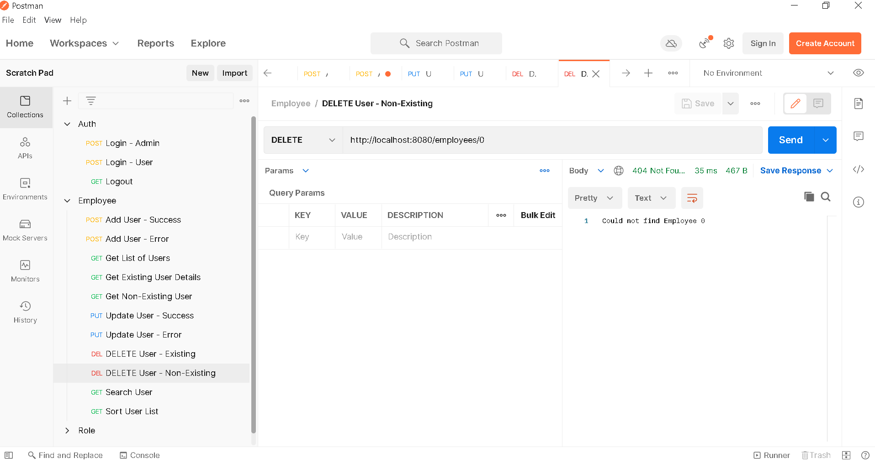

1. **Searc Employee**

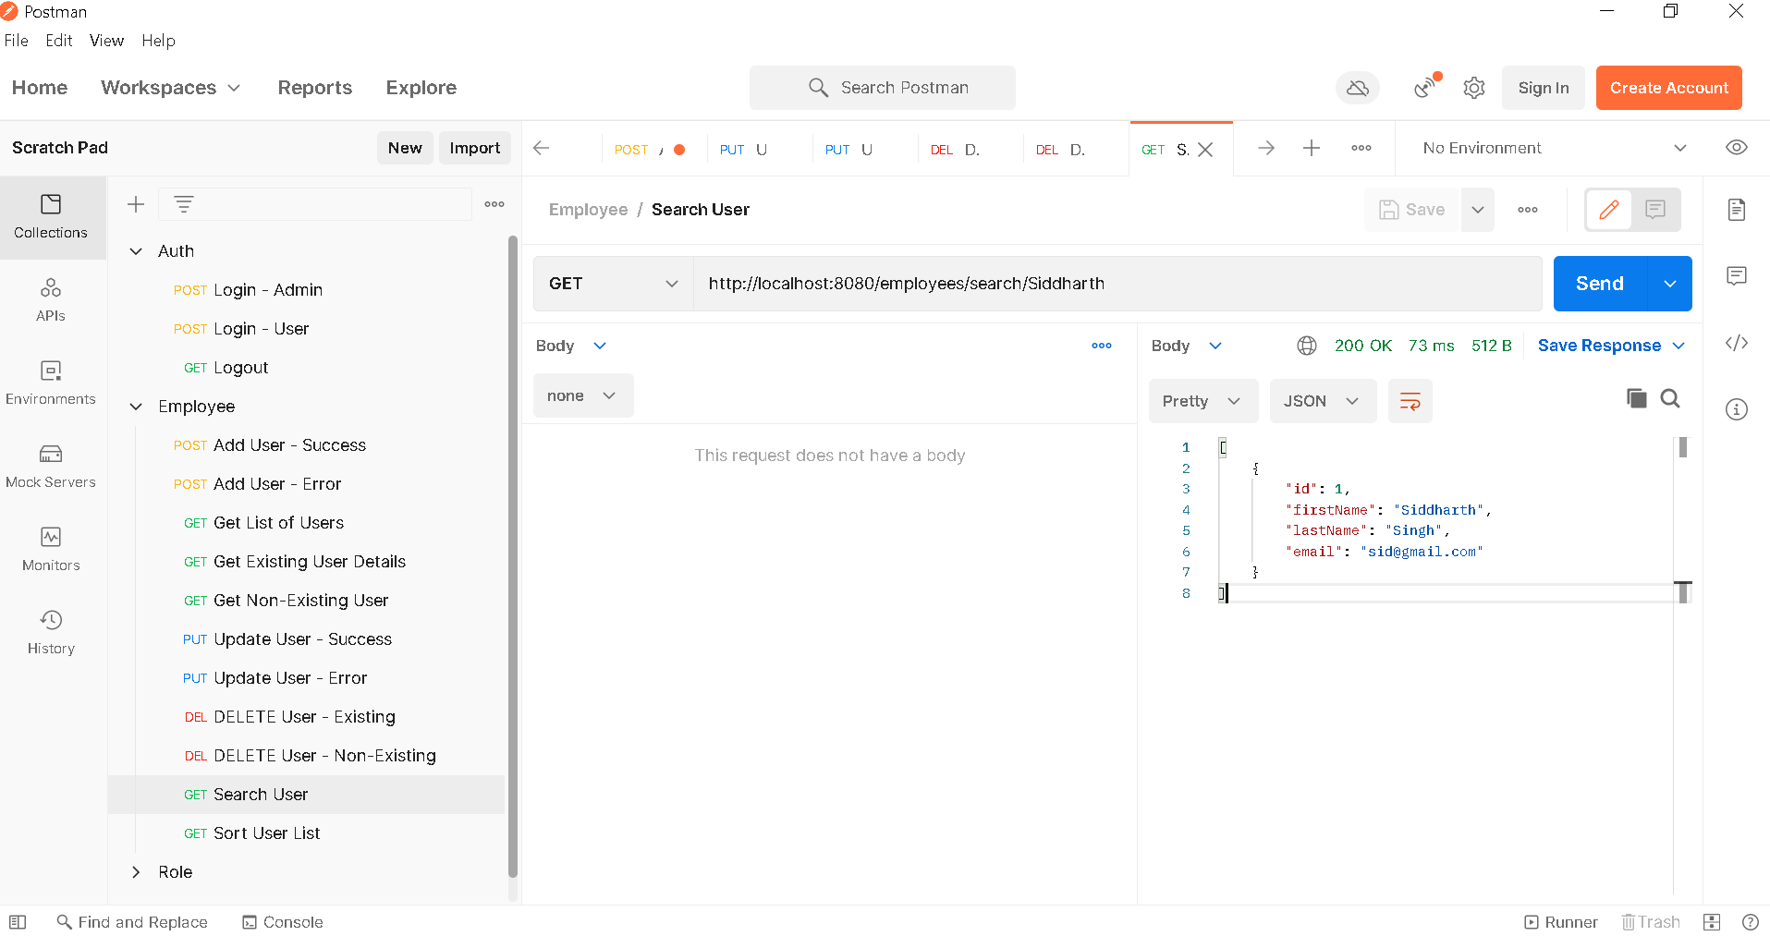

1. **Sort Employees – Ascending**

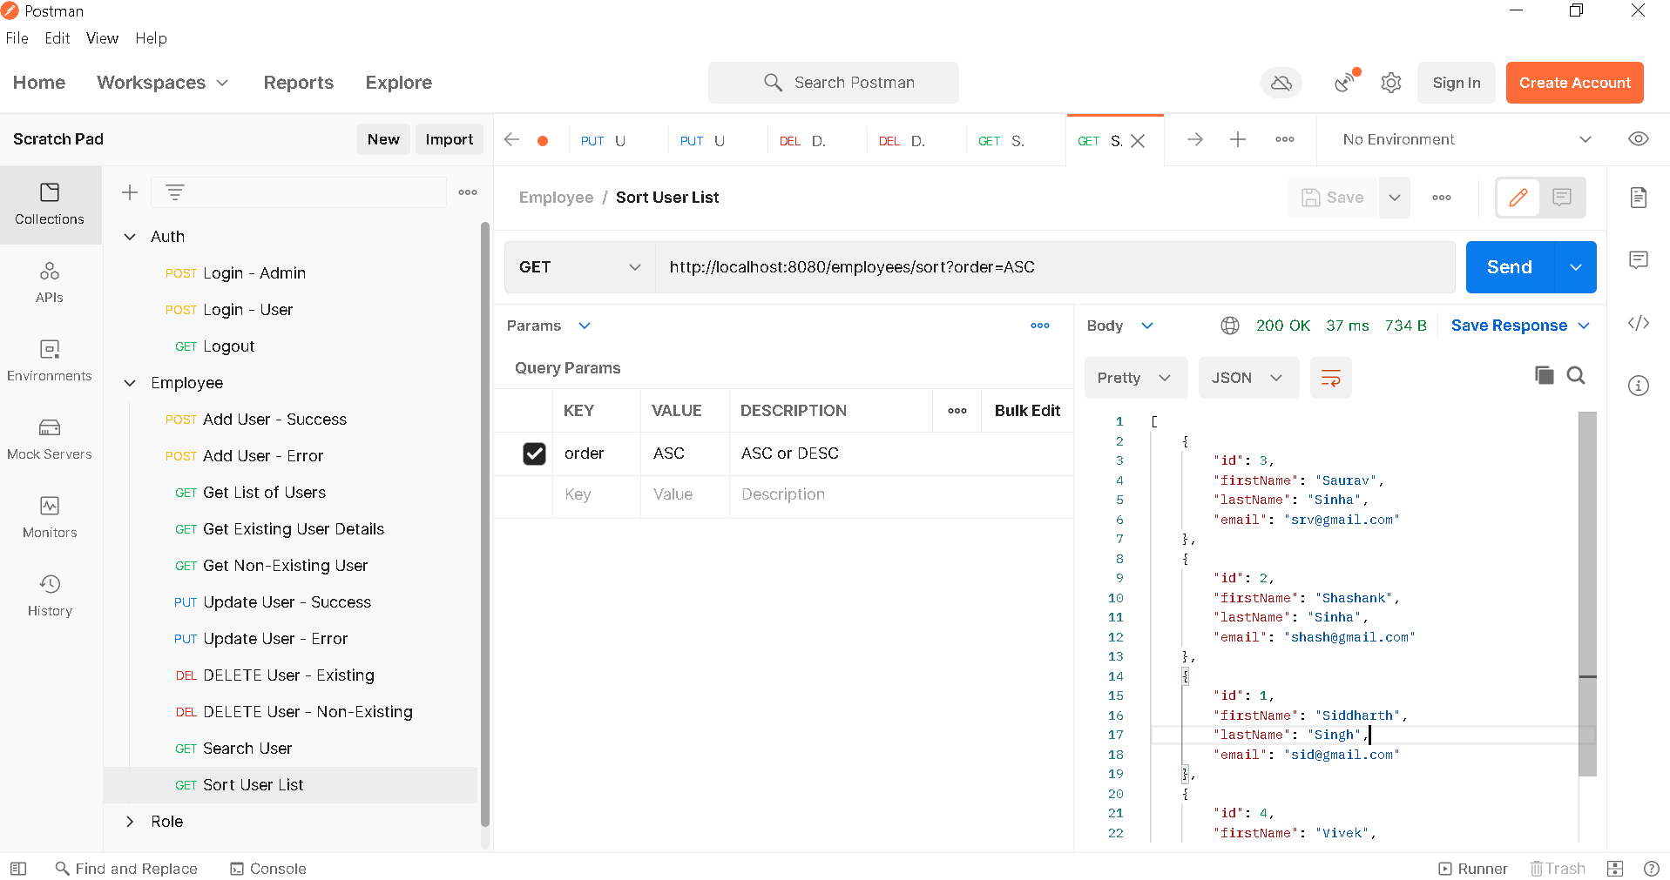

1. **Sort Employees – Descending**

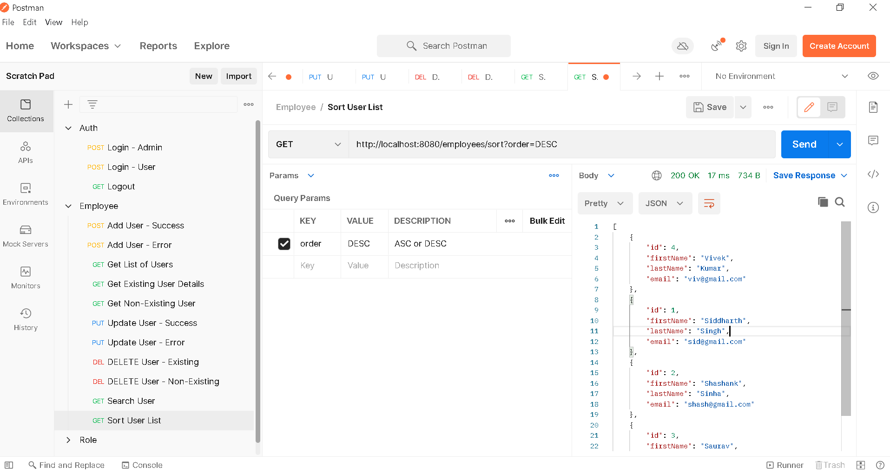

1. ***Roles DB***
2. **Get All Roles**

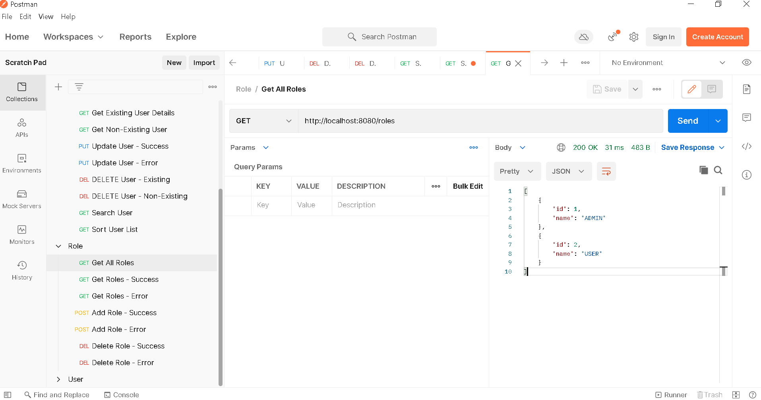

1. **Get Role – Success**

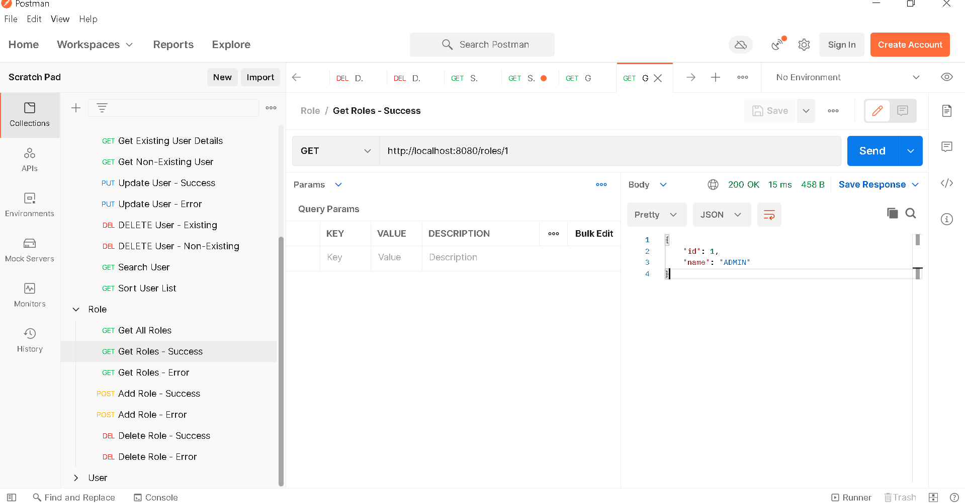

1. **Get Role –Error**

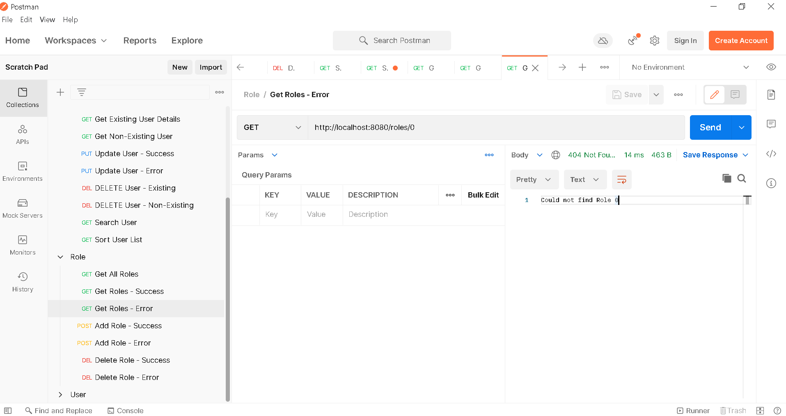

1. **Add Role – Success**

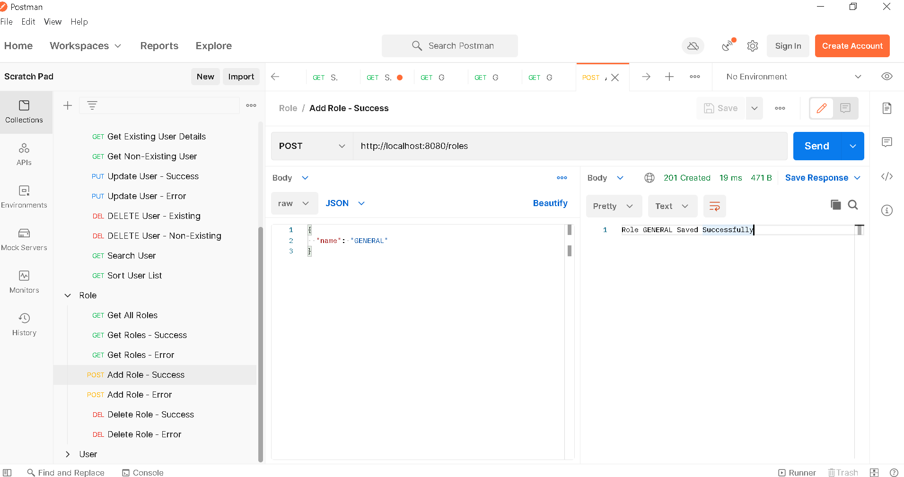

1. **Get All Roles – After Addition**

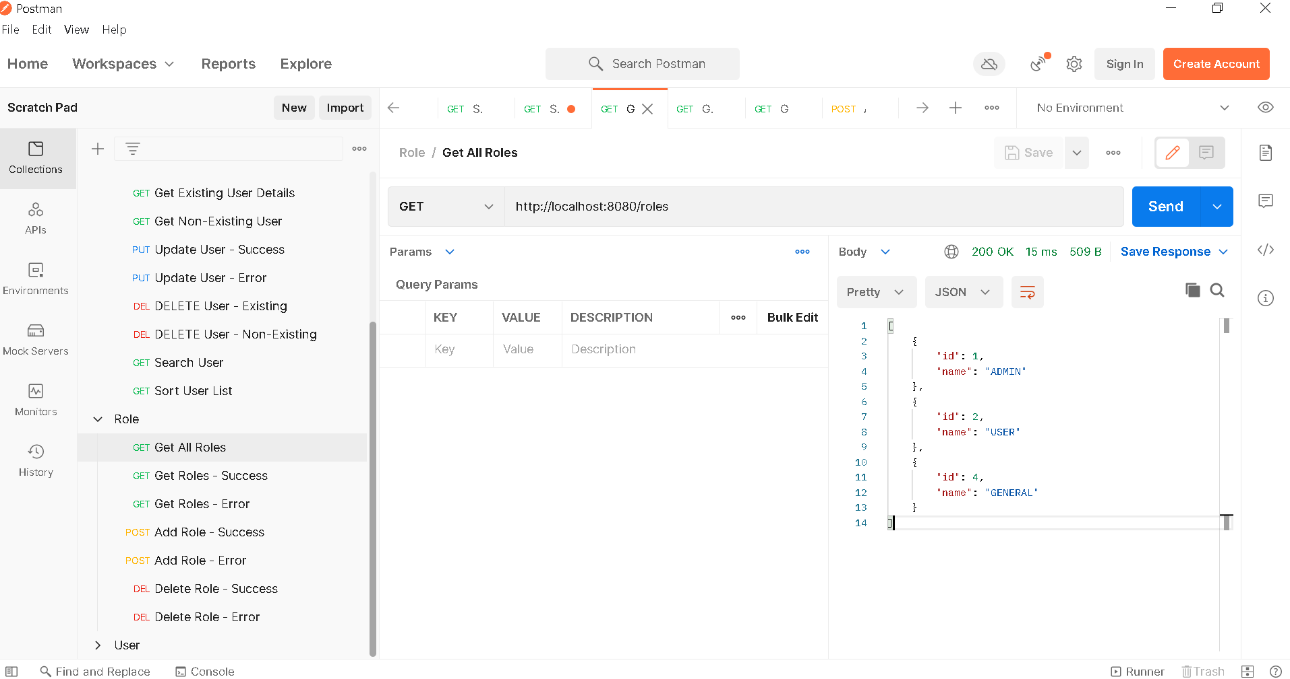

1. **Add Role – Error**

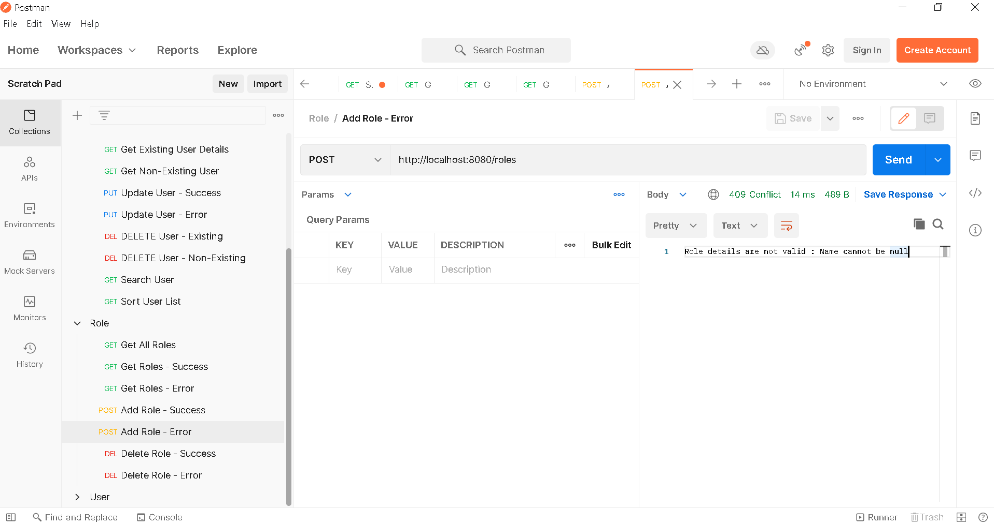

1. **Delete Role – Success**

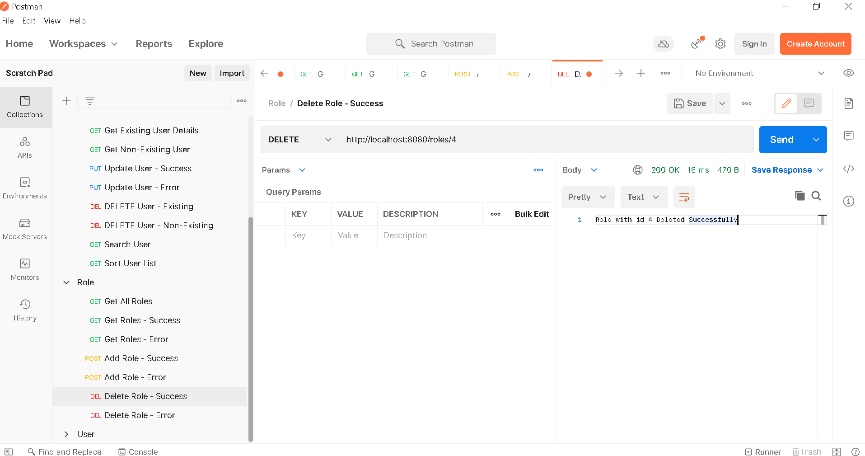

1. **Get All Roles – After Deletion**

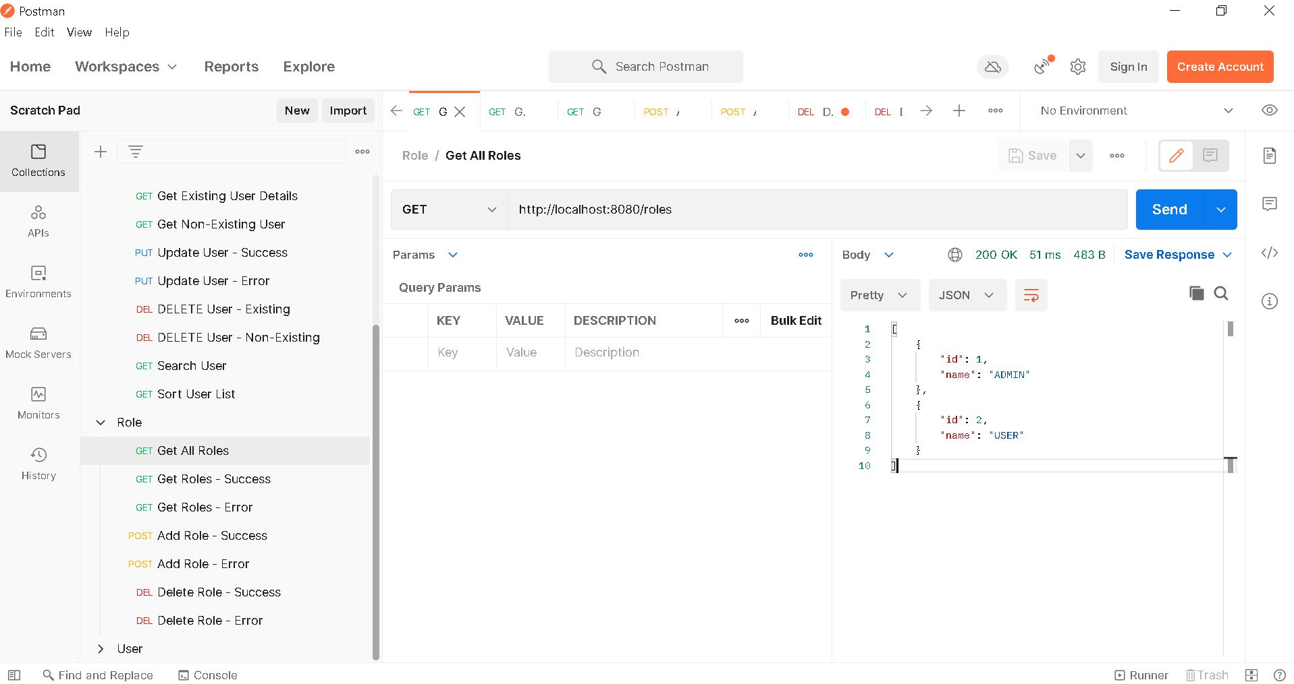

1. **Delete Role – Error**

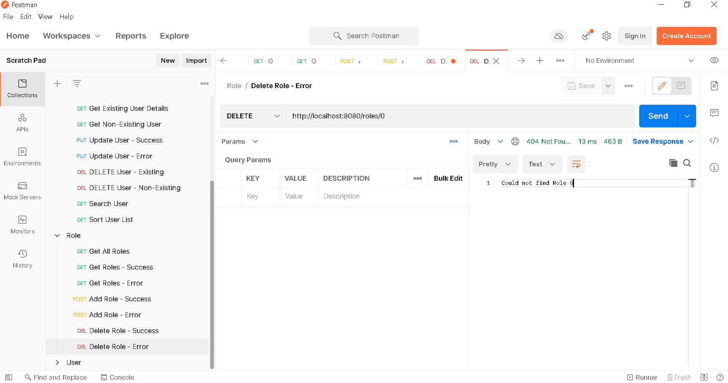

1. ***Users DB***
2. **Get All Users**

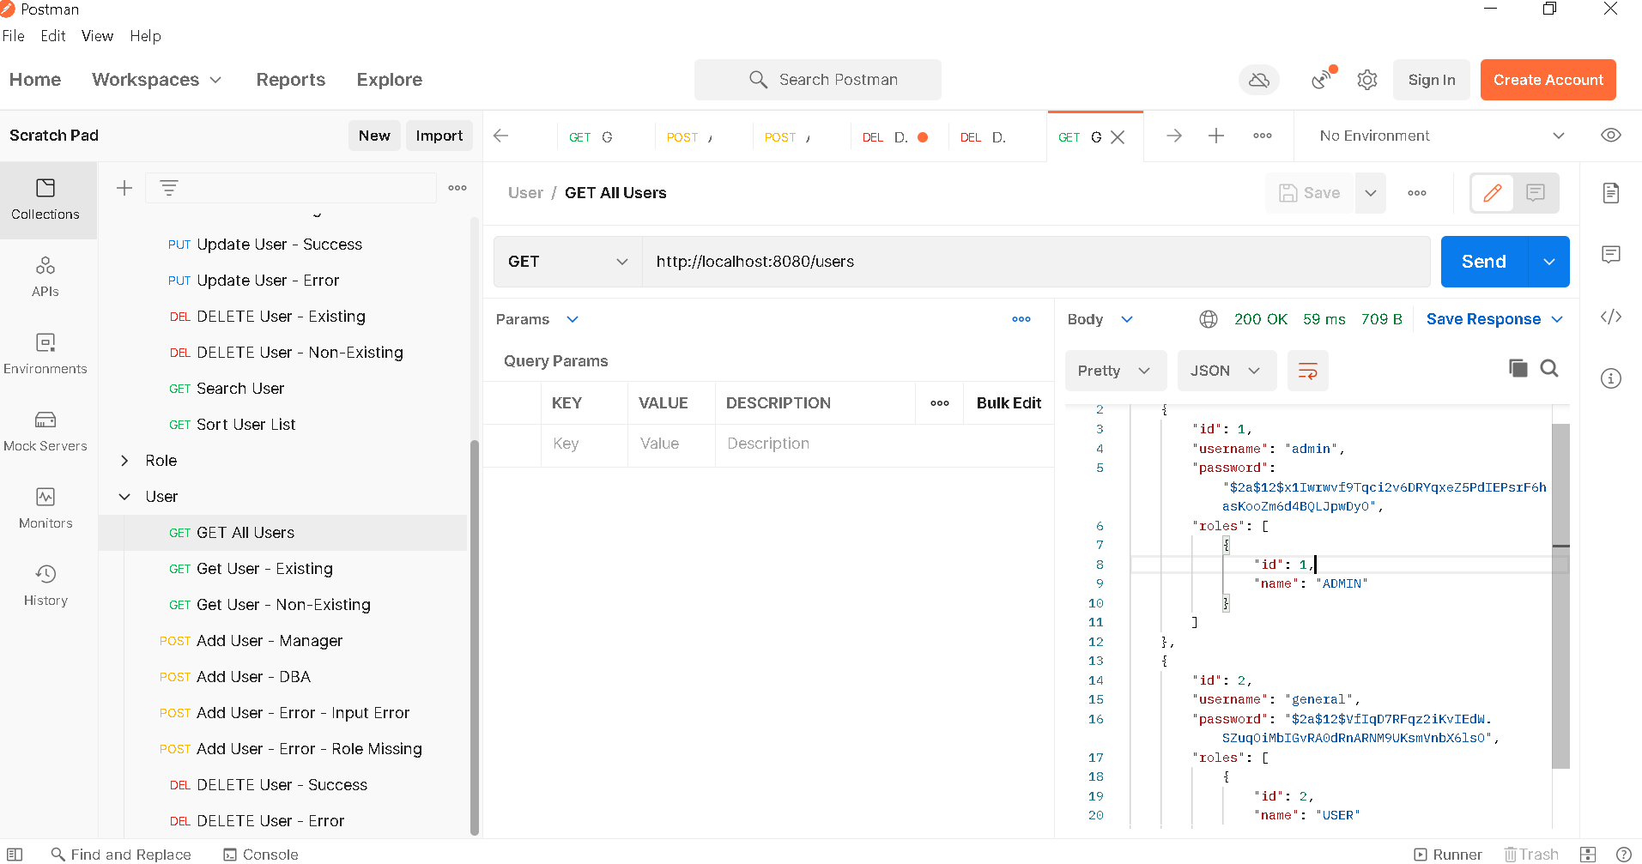

1. **Get User – Success**

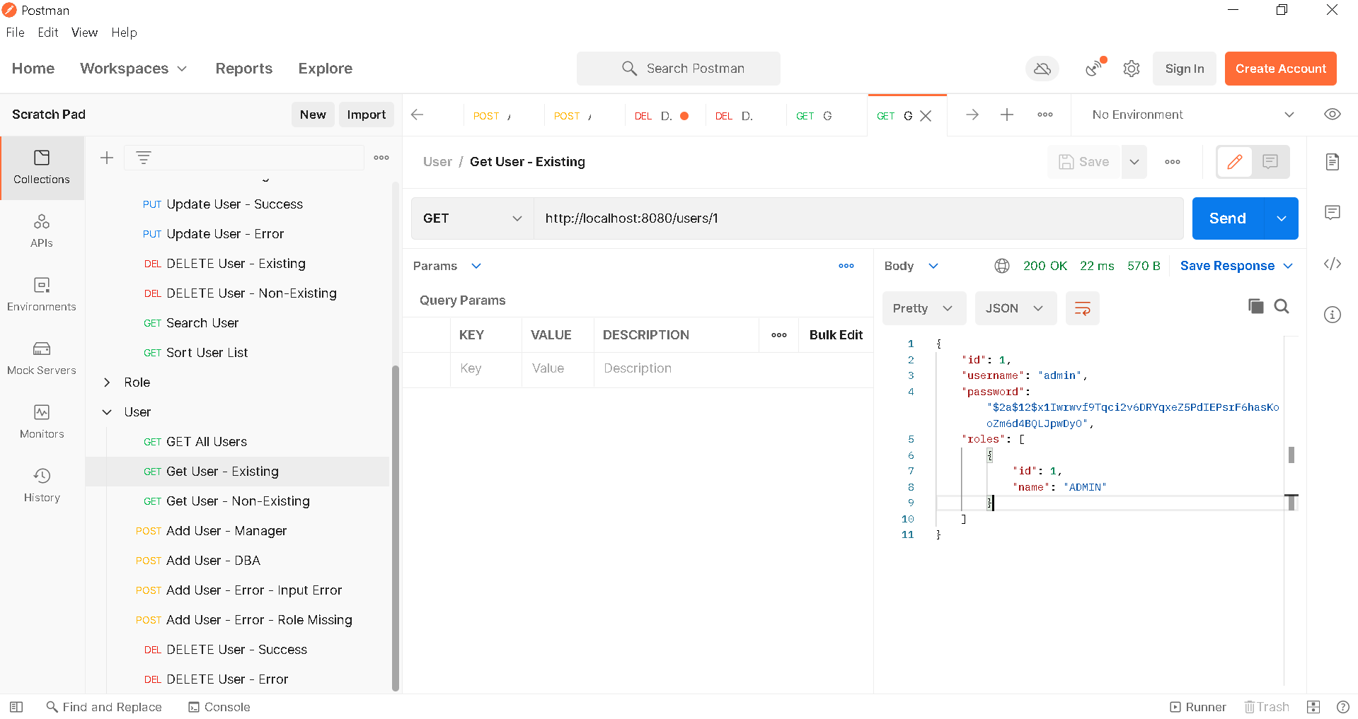

1. **Get User – Error**

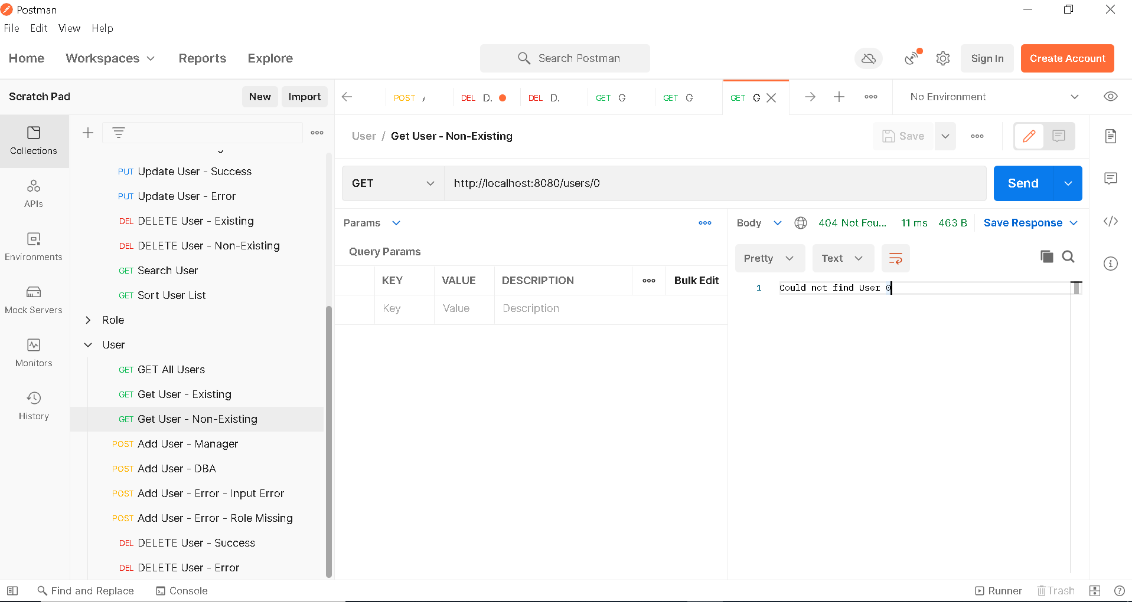

1. **Add User – Admin Role**

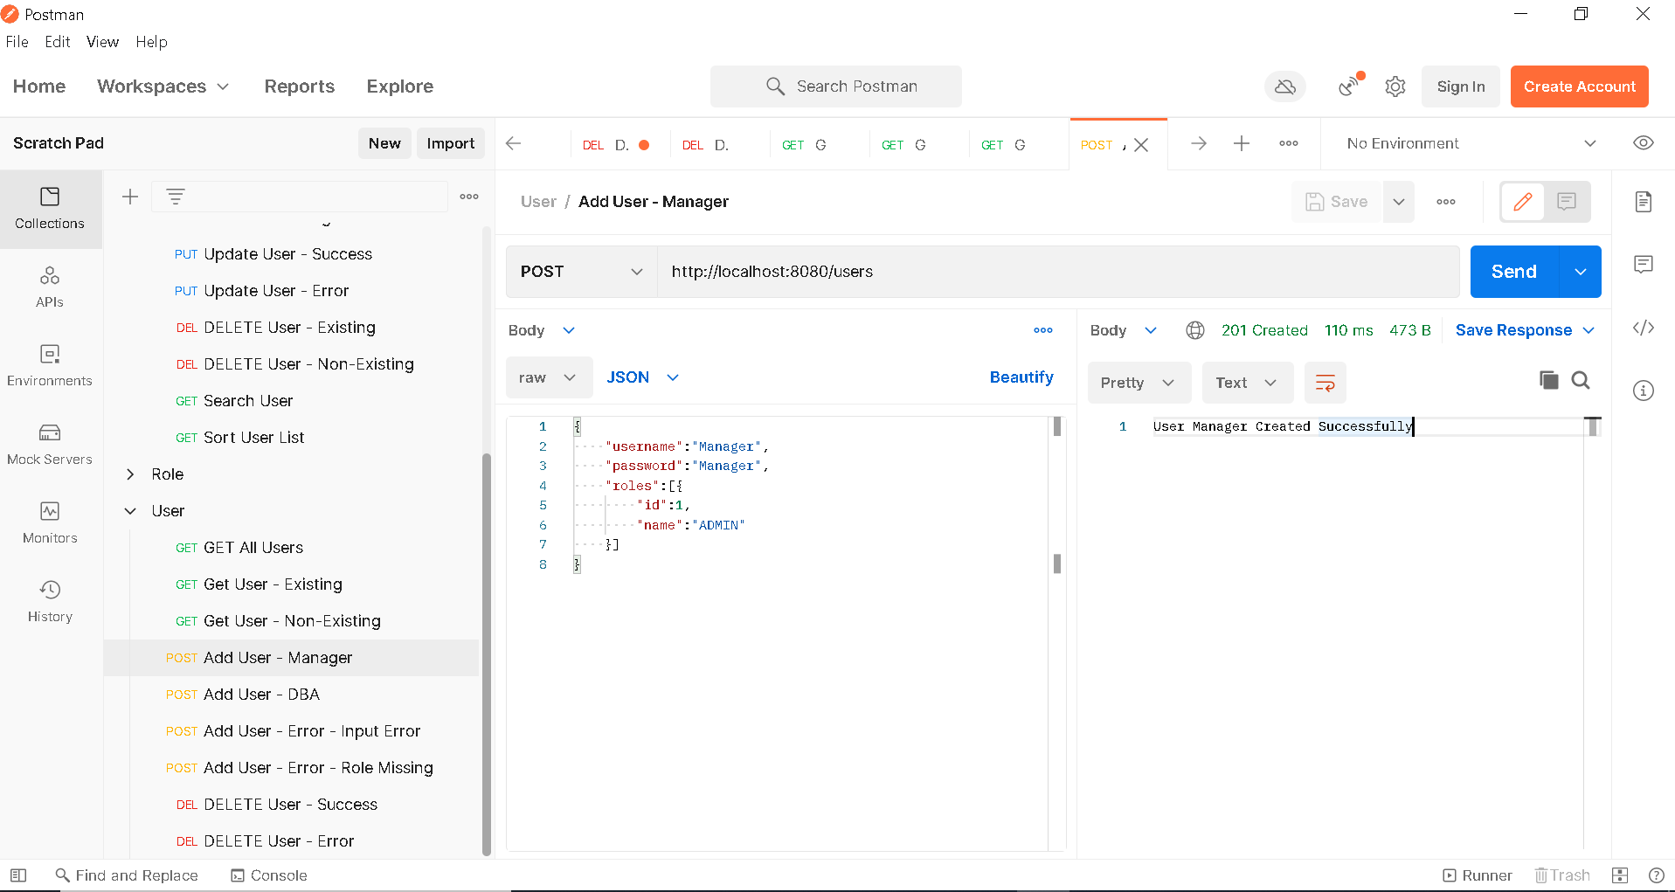

1. **Add User – Admin and User Role**

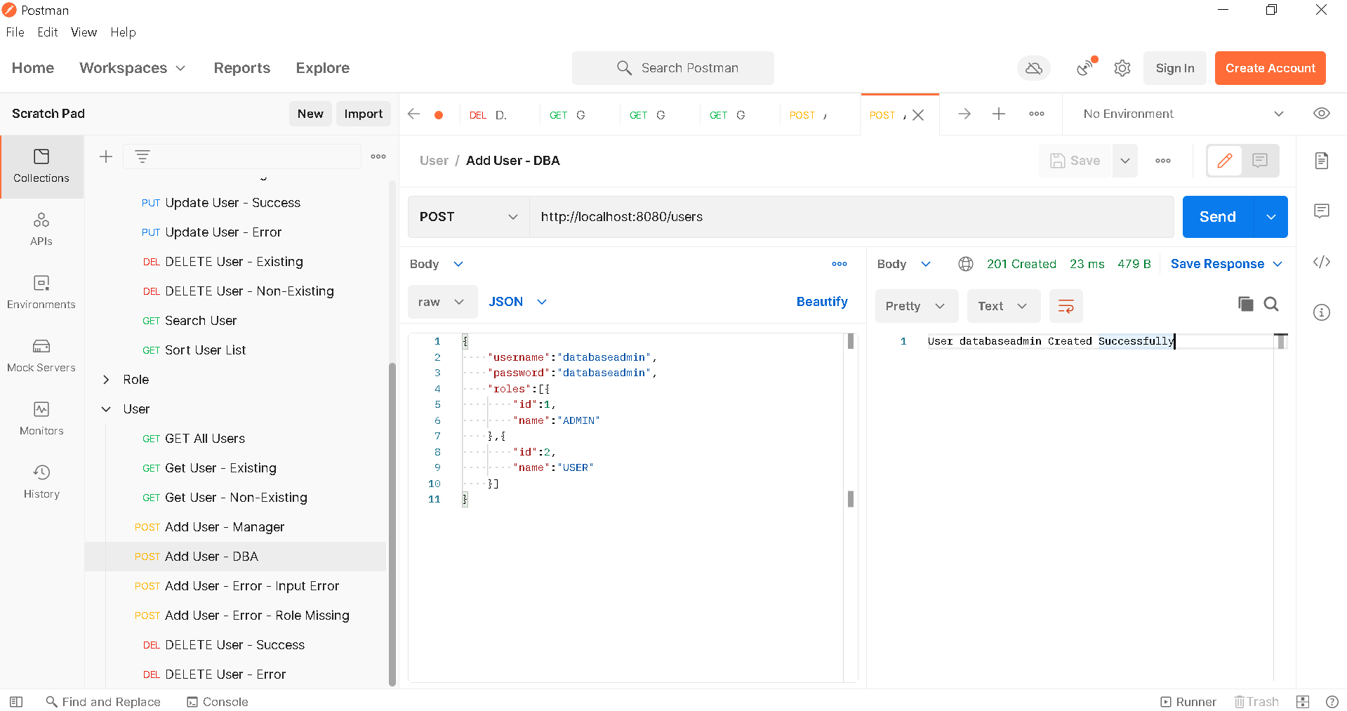

1. **Get All User – After Addition**

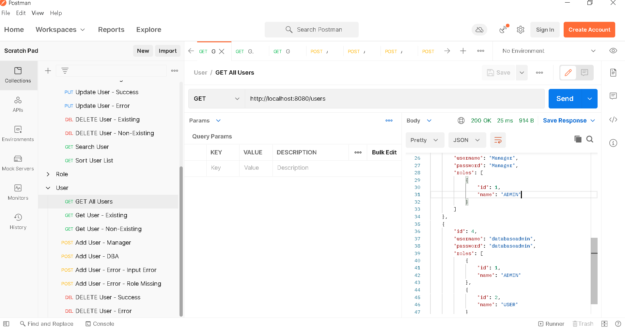

1. **Add User – Error – Input Error**

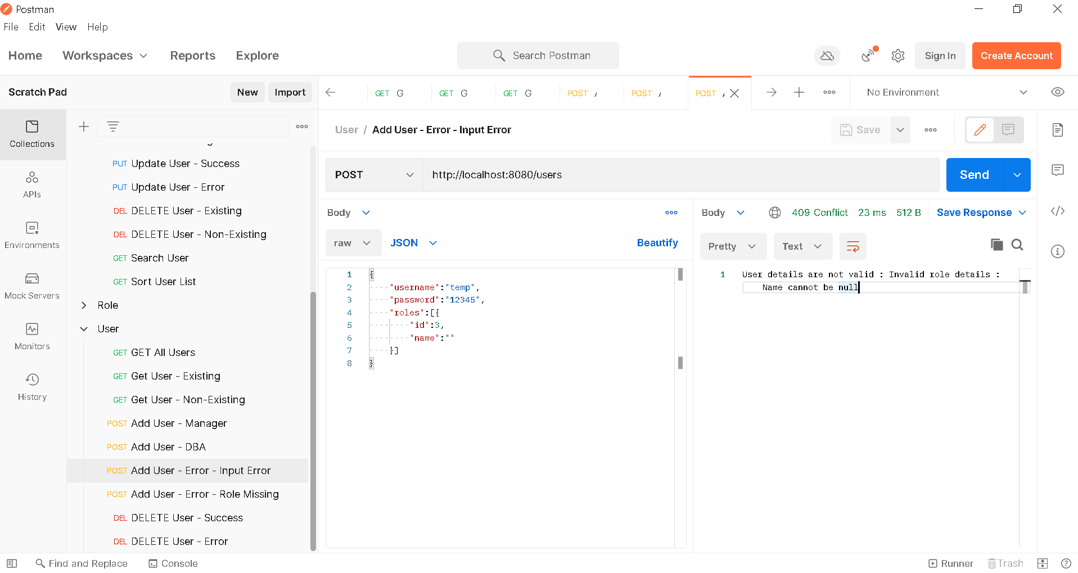

1. **Add User – Error – Role Missing**

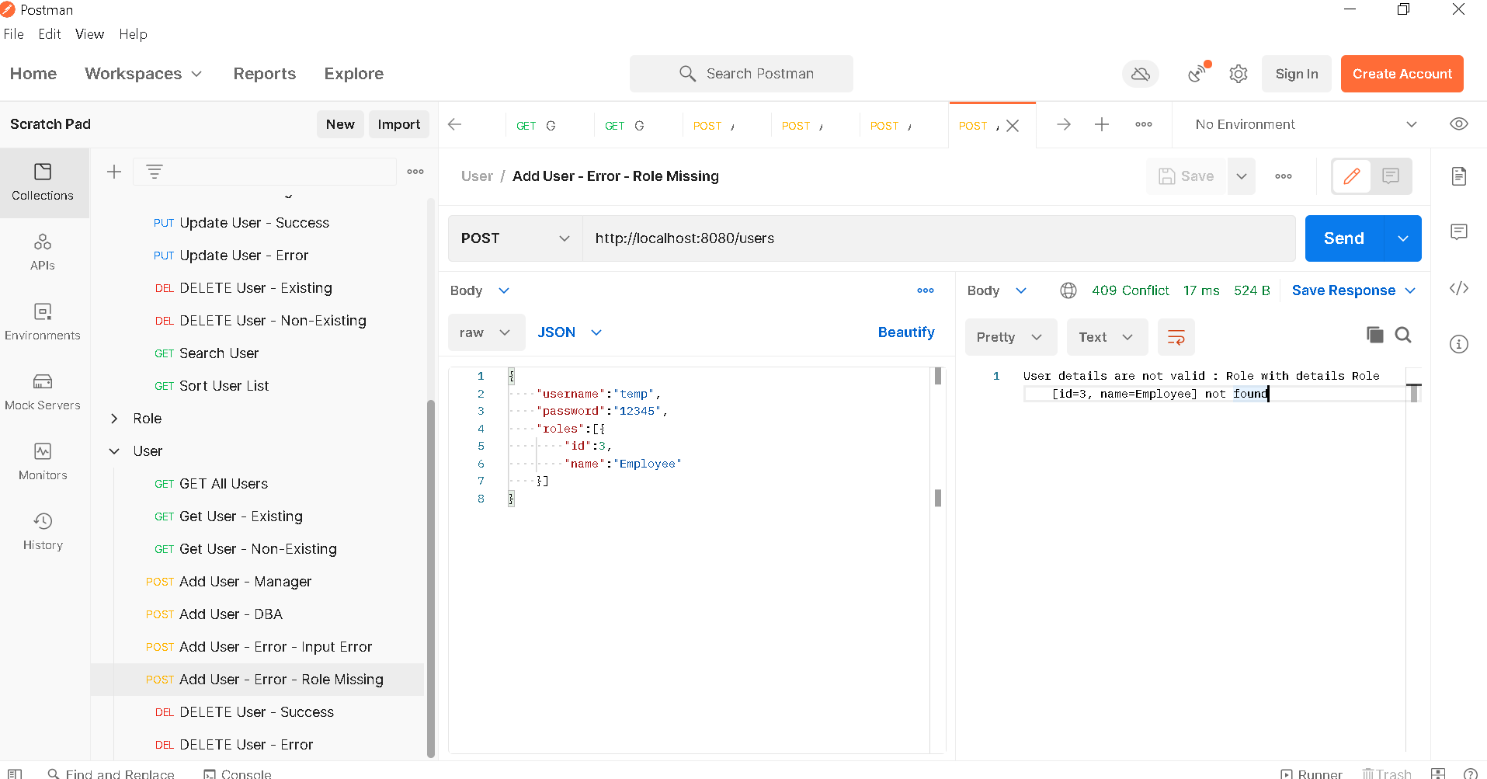

1. **Delete User – Success**

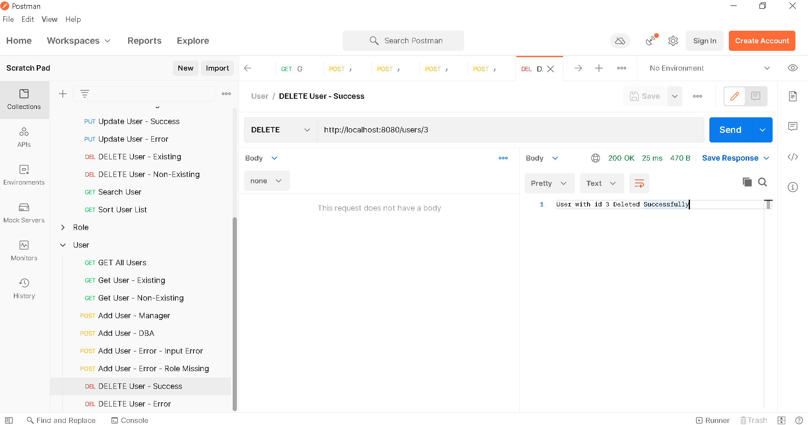

1. **Delete User – Error**

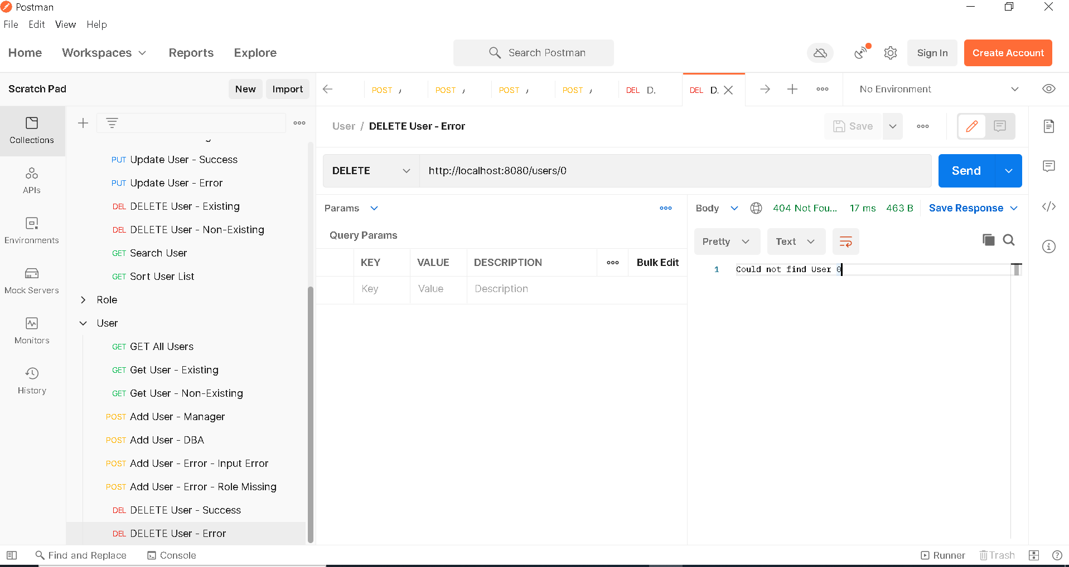

1. **Get All Users – After Deletion**

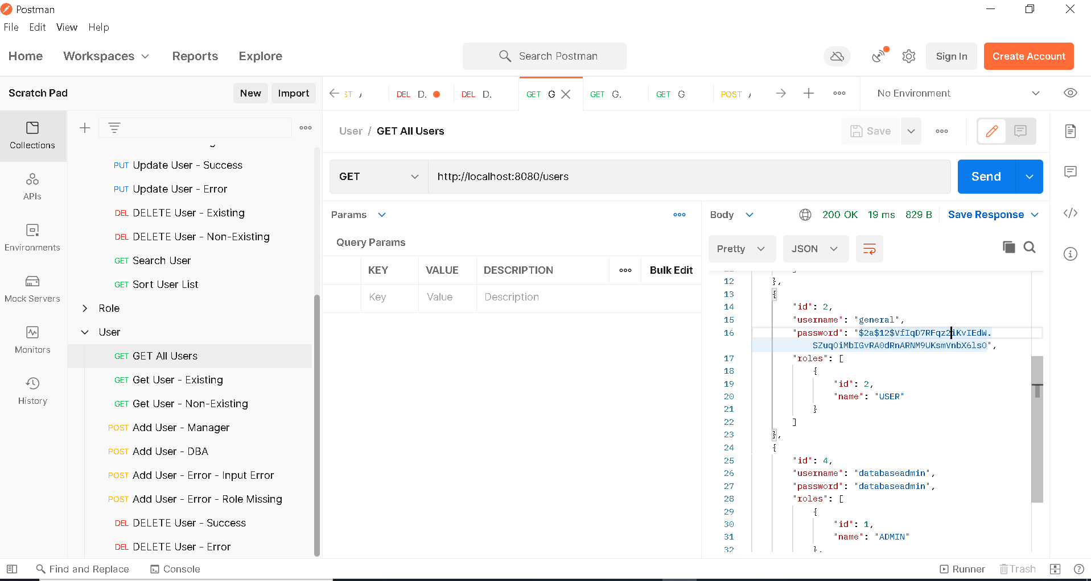

1. **GENERAL User**
2. **Login**

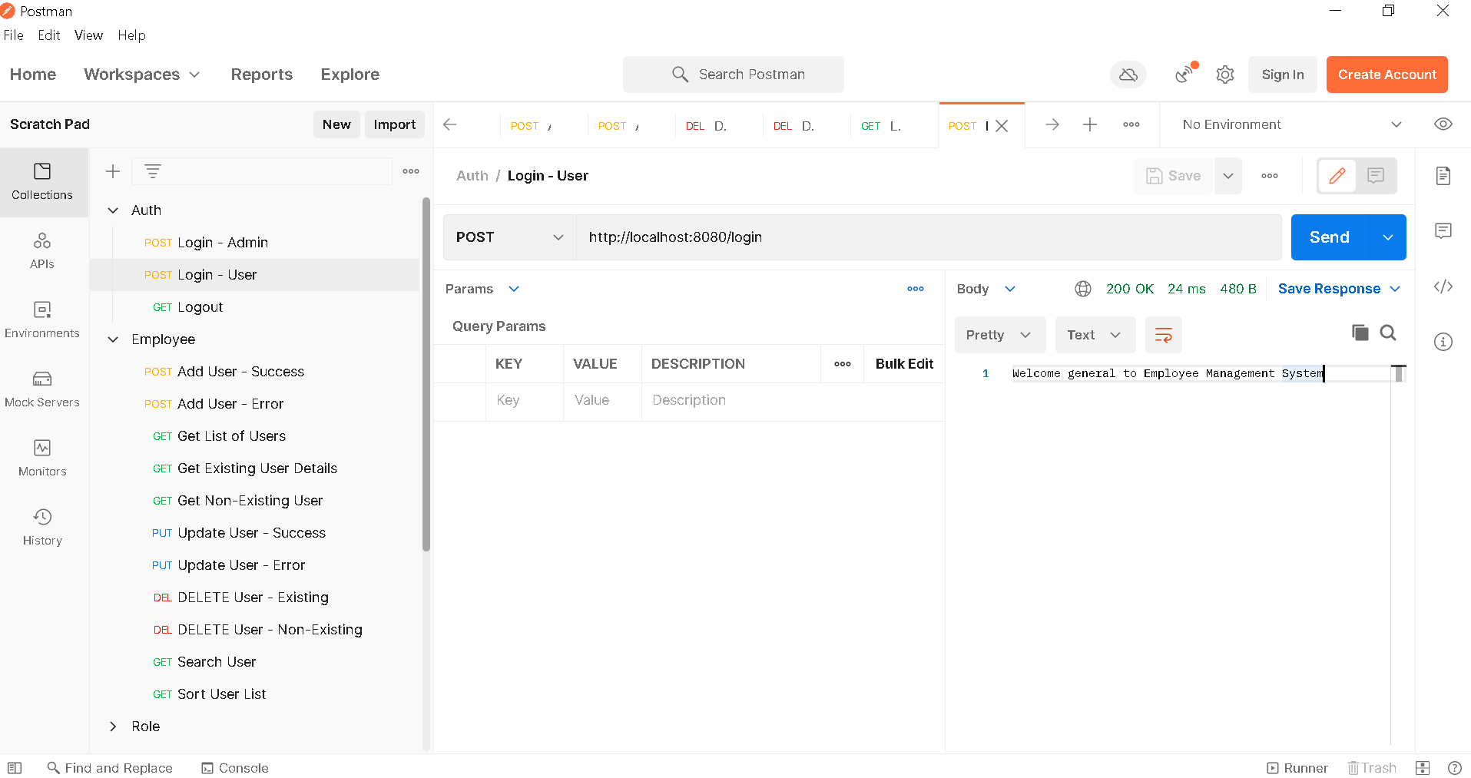

1. **Get List of Users**

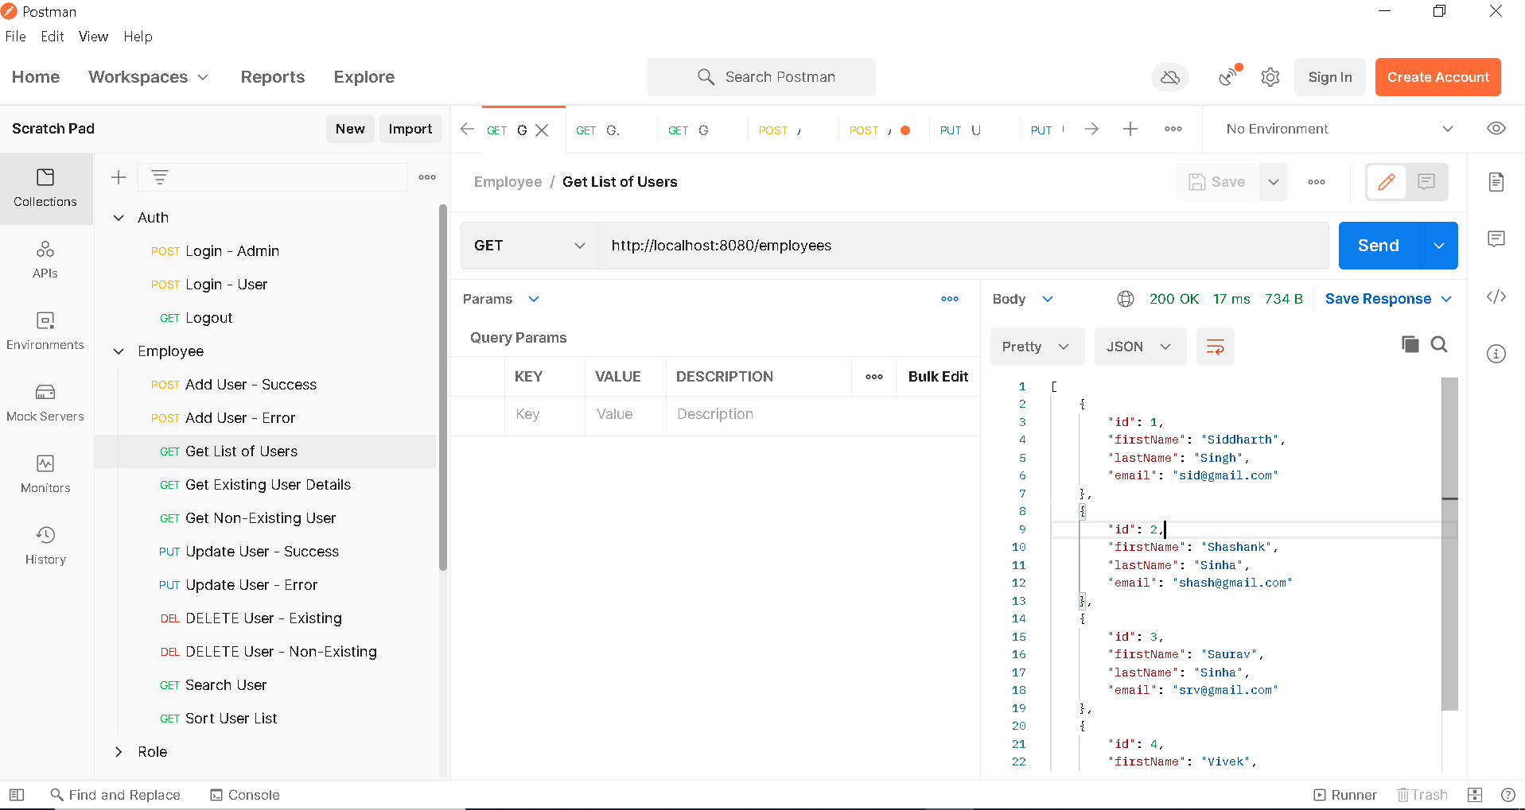

1. **Add Employee – Error**

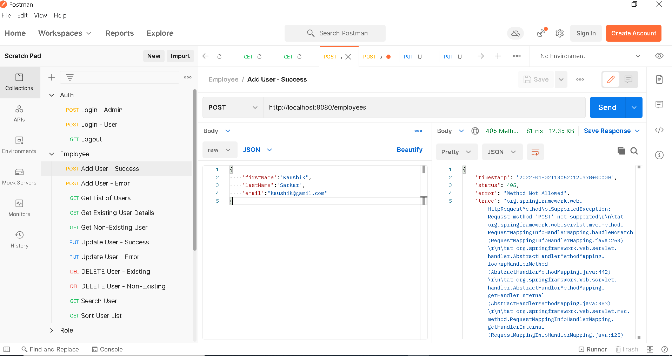

1. **Update Employee – Error**

