Project On

**SKY HIGH INSTITUTE OF MANAGEMENT**

**PROJECT MEMBERS:**

SIDDHARTH M SUJIR -S100030601294

VAISHNAVI S -S110030600223

NIIT, ANNA NAGAR

CHENNAI

**CO-ORDINATOR: Mrs.R.VIJAYALAKSHMI**

**SKY HIGH INSTITUTE OF MANAGEMENT**

Batch Code : B110674

Start Date : June 27, 2011

End Date : July 2011

Name of the Coordinator : Mrs. Vijayalakshmi

Names of the Developer : Siddharth , Vaishnavi

Date of Submission: July , 2011

http://www.niitstudent.com/india/images/niit-logo-png.png

**CERTIFICATE**

This is to certify that this report, titled *Sky High Institute Of Management* embodies the original work done by *Siddharth* in partial fulfilment of her course requirement at NIIT.

Coordinator:

Mrs. Vijayalakshmi

**ACKNOWLEDGEMENT**

For all efforts, behind this successful project, we are highly intended to the following personalities without whom this project would ever be completed.

We heartily express our sincere thanks and gratitude to **Mrs. R. Vijayalakshmi** faculty of NIIT for her constant encouragement, guidance & support and also for offering technical and manual resources for the completion of throughout this project.

We could also like to thank all the teaching and non-teaching staffs in NIIT, Anna Nagar for their cooperation during the course.

We have a great pleasure in thanking all the faculty members of the NIIT, Anna Nagar.

**SYSTEM ANALYSIS**

**System Summary:** The Sky High Institute Of Management is an Enterprise application that facilitates students to login and register for new courses made available to them by the institute.

**USE CASE DIAGRAM**

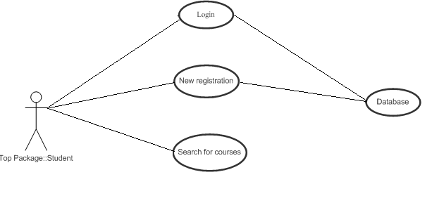

**E-R DIAGRAM**

**Database Name:** new1

* LOGIN:

LOGIN

* REGISTER:

REGISTER

**SCHEMATIC DIAGRAM OF THE DATABASE**

**Database Name: sample**

NewUser_Table:

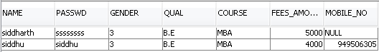

**CONFIGURATION**

**Hardware:** PC compatible with a Intel Pentium-IV processor, 512-MB RAM, and 20GB of Hard disk.

**Operating system:** Windows 7 Professional

**Software:** NetBeans IDE 6.0.1 bundled with GlassFish V2, JDK1.5

**PROJECT FILE DETAILS**

|  |  |  |
| --- | --- | --- |
| **S. No.** | **File Name** | **Remarks** |
| 1. | index.jsp | Displays home page of the application |
| 2. | LoginServlet.java | Allows students to login |
| 3. | RegistrationServlet.java | Allows new students to register |
| 4. | ViewDetails.java | Allows students to search for courses |
| 5. | LoginformServlet.java | Provides access to the login form |
| 6. | RegFormServlet.java | Provides access to the registration form |
| 7. | Payment.java | Provides secure payment form |
| 8. | Djvt.java | Provides information about Djvt course |
| 9. | Java.java | Provides information about Java course |
| 10. | DotNet.java | Provides information about DotNet course |
| 11. | Unix.java | Provides information about Unix course |
| 12. | Php.java | Provides information about Php course |
| 13. | LoginBean.java | Validates user login |
| 14. | RegistrationBean.java | Stores student information into the database |

**Sample Code**

**index.jsp**

<html>

<head>

<meta http-equiv="Content-Type" content="text/html; charset=UTF-8">

<title>JSP Page</title>

</head>

<body bgcolor="9BFDFC">

<center> <img src="Images/sky06.jpg" width="700" height="200"> </center>

<br><br>

<h1><center>SKY HIGH INSTITUTE</center></h1>

<ul>

<a href="LoginFormServlet"><li> LOGIN</li> </a>

<br/>

<a href="RegFormServlet"><li> NEW USER REGISTRATION</li> </a>

</ul>

<br/>

</body>

</html>

**LoginServlet.java**

package ctrl;

import java.io.*;

import java.net.*;

import javax.ejb.EJB;

import javax.servlet.*;

import javax.servlet.http.*;

import mode.LoginRemote;

public class LoginServlet extends HttpServlet {

@EJB

private LoginRemote loginBean;

protected void processRequest(HttpServletRequest request, HttpServletResponse response)

throws ServletException, IOException {

response.setContentType("text/html;charset=UTF-8");

PrintWriter out = response.getWriter();

try {

String u=request.getParameter("t1");

String p=request.getParameter("t2");

out.println("<html>");

out.println("<head>");

out.println("<title>Servlet logincontrol</title>");

out.println("</head>");

out.println("<body bgcolor='9BFDFC'>");

out.println("<h1> Welcome" + " " + " " + u + "!</h1>");

out.println("</body>");

out.println("</html>");

String res= loginBean.Login_Table(u, p);

out.println(res);

if (res.equals("Success"))

{

out.println("<ul>");

out.println("<a href='Payment.html'><li> Payment</li></a>");

out.println("<a href='ViewDetails'><li> Courses</li></a>");

out.println("</ul>");

}

else

{

out.println("invalid user name / password");

}

}

finally {

out.close();

}

}

**RegistrationServlet.java**

package ctrl;

import java.io.*;

import java.net.*;

import javax.ejb.EJB;

import javax.servlet.*;

import javax.servlet.http.*;

import mode.RegistrationRemote;

public class RegisterServlet extends HttpServlet {

@EJB

private RegistrationRemote registrationBean;

protected void processRequest(HttpServletRequest request, HttpServletResponse response)

throws ServletException, IOException {

response.setContentType("text/html;charset=UTF-8");

PrintWriter out = response.getWriter();

try {

String n=request.getParameter("t1");

String p=request.getParameter("t2");

String g=request.getParameter("g1");

String q=request.getParameter("d1");

String c=request.getParameter("d2");

String m=request.getParameter("dd");

//String mb=request.getParameter("de");

int py=0; //Integer.parseInt(mb);

out.println("<html>");

out.println("<head>");

out.println("<title>Servlet newusercontrol</title>");

out.println("</head>");

out.println("<body bgcolor='9BFDFC'>");

out.println("<h1>Congratulations");

out.println("<i>" + n + "</i> ");

out.println("! You have been registered successfully.</h1>");

out.println("</body>");

out.println("</html>");

out.println(registrationBean.RegUser(n,p,g,q,c,py,m));

out.println("<a href='LoginFormServlet'> click here to Login</a>");

} finally {

out.close();

}

}

**ViewDetaila.java**

package ctrl;

import java.io.*;

import java.net.*;

import javax.servlet.*;

import javax.servlet.http.*;

public class ViewDetails extends HttpServlet {

protected void processRequest(HttpServletRequest request, HttpServletResponse response)

throws ServletException, IOException {

response.setContentType("text/html;charset=UTF-8");

PrintWriter out = response.getWriter();

try{

out.println("<html>");

out.println("<head>");

out.println("<title>Servlet searchServlet</title>");

out.println("</head>");

out.println("<body bgcolor='9BFDFC'>");

out.println("<h1>COURSES AVAILABLE</h1>");

out.println("<ul>");

out.println("<a href='Djvt' ><li>Diploma in Java</li></a>");

out.println("<br/>");

out.println("<a href='Java' ><li>Learn Java in 2 Days</li></a>");

out.println("<br/>");

out.println("<a href='DotNet' ><li>Dot Net</li></a>");

out.println("<br/>");

out.println("<a href='Unix' ><li>Unix</li></a>");

out.println("<br/>");

out.println("<a href='Php' ><li>Php</li></a>");

out.println("</ul>");

out.println("<br/>");

out.println("</body>");

out.println("</html>");

}

finally{

out.close();

}

}

**Payment.java**

package ctrl;

import java.io.*;

import java.net.*;

import javax.ejb.EJB;

import javax.servlet.*;

import javax.servlet.http.*;

import mode.LoginRemote;

public class PaymentServlet extends HttpServlet {

@EJB

private LoginRemote loginBean;

protected void processRequest(HttpServletRequest request, HttpServletResponse response)

throws ServletException, IOException {

response.setContentType("text/html;charset=UTF-8");

PrintWriter out = response.getWriter();

try {

String cno=request.getParameter("c_no");

String amt=request.getParameter("amount");

int amt1=Integer.parseInt(amt);

String cvv=request.getParameter("cvv");

String name=request.getParameter("un");

String tdate=request.getParameter("date");

String xyz= loginBean.PaymentBean(name,amt1);

out.println(xyz);

} finally {

out.close();

}

}

**RegistrationBean.java**

package mode;

import java.sql.Connection;

import java.sql.PreparedStatement;

import java.sql.ResultSet;

import javax.annotation.Resource;

import javax.ejb.Stateless;

import javax.sql.DataSource;

@Stateless

public class RegistrationBean implements RegistrationRemote {

@Resource(name = "s")

private DataSource s;

Connection con;

PreparedStatement stmt;

ResultSet rs;

String name,pass,gen,qual,course;

int pay=0,mobno;

String str="Insert into NewUser_Table values(?,?,?,?,?,?,?)";

public String RegUser(String name, String passwd, String gender, String qualification, String course, int pay, String mobno) {

int x=0;

try

{

String sd=Integer.toString(pay);

con=s.getConnection();

stmt=con.prepareStatement(str);

stmt.setString(1,name);

stmt.setString(2,passwd);

stmt.setString(3,gender);

stmt.setString(4,qualification);

stmt.setString(5,course);

stmt.setString(6,sd);

stmt.setString(7,mobno);

x =stmt.executeUpdate();

}

catch(Exception e)

{

}

if(x==1)

return "row inserted";

else

return "Failed";

**SCREEN SHOTS**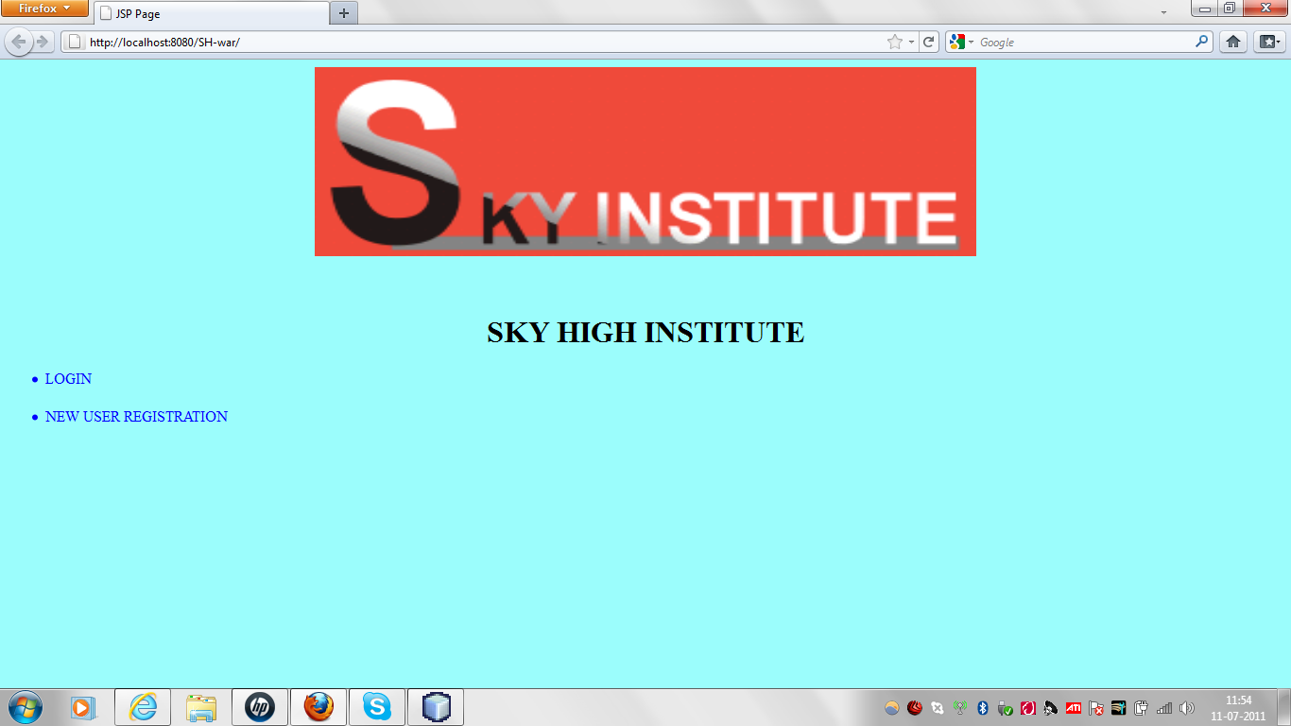

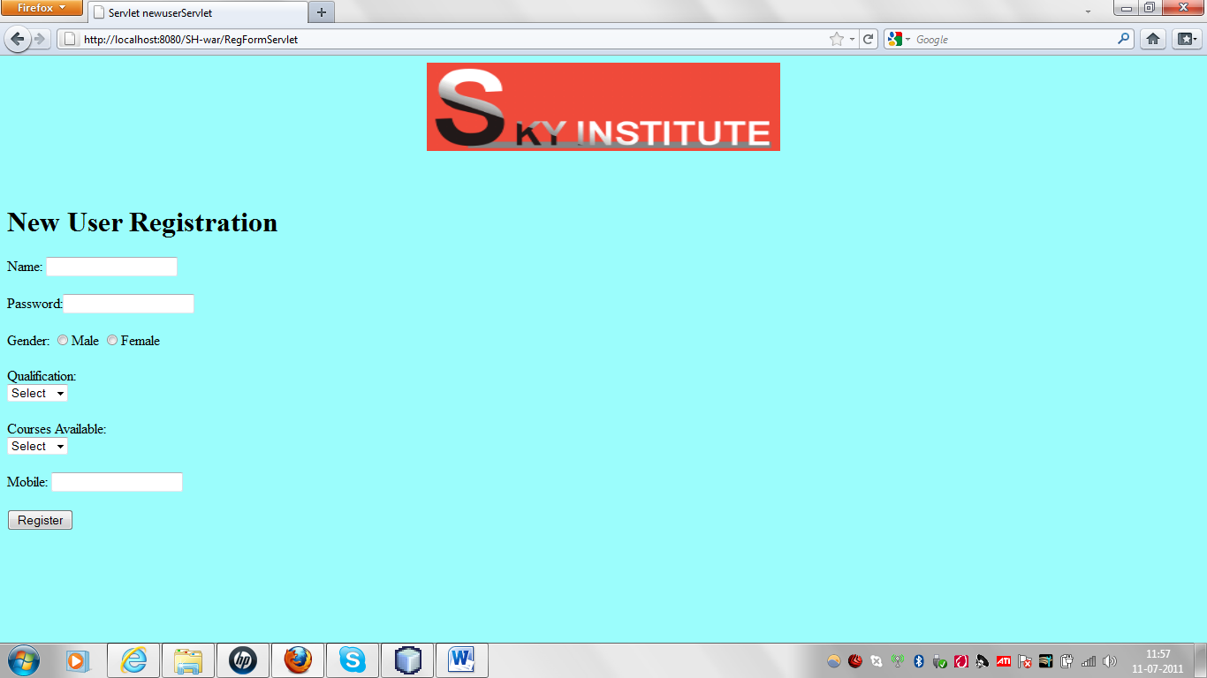

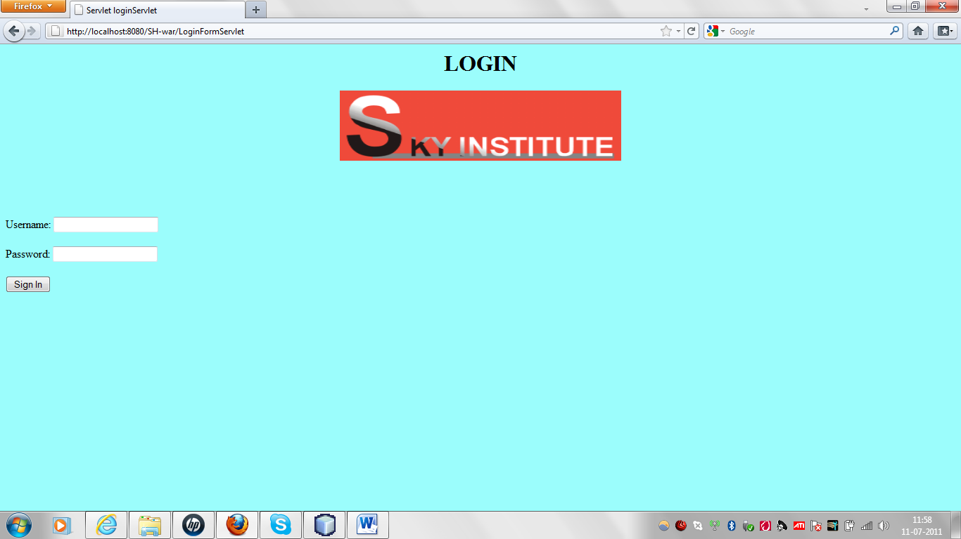

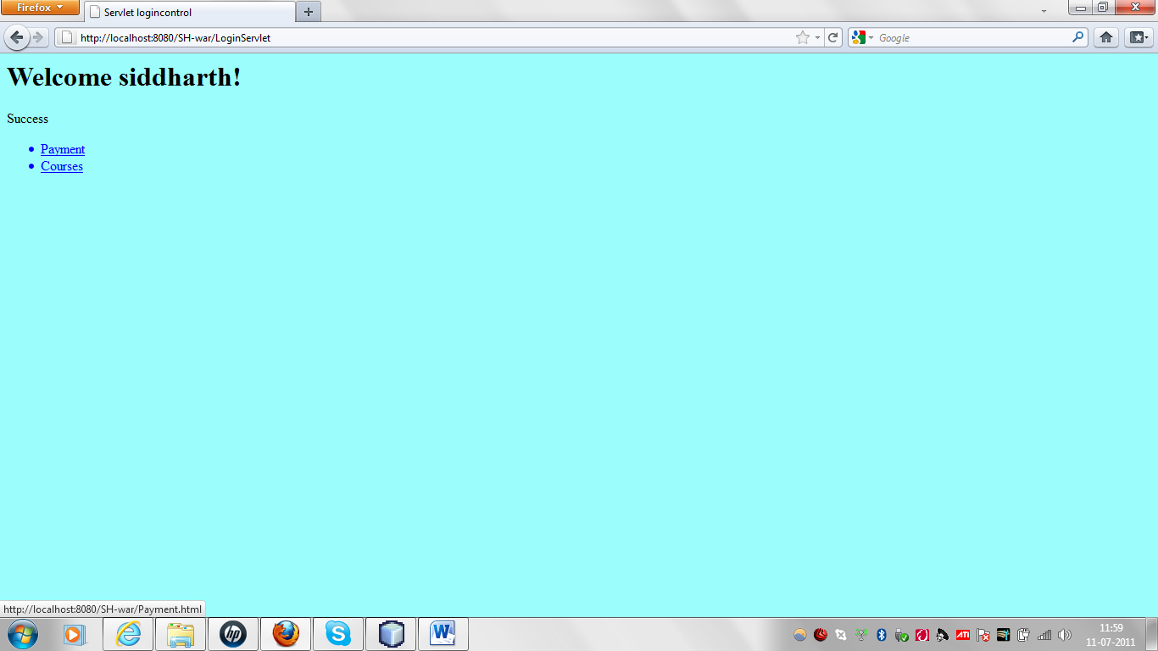

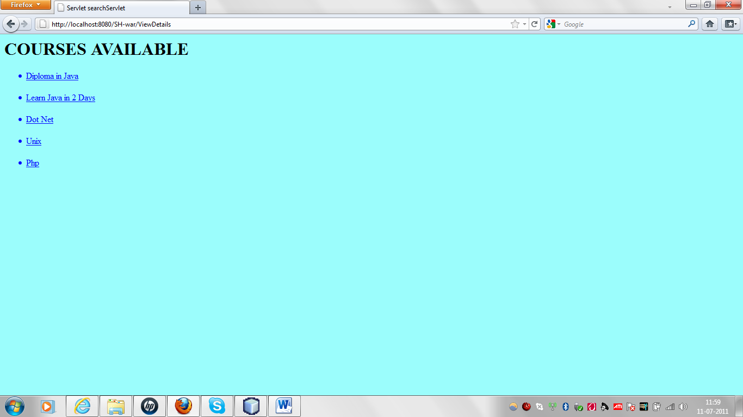

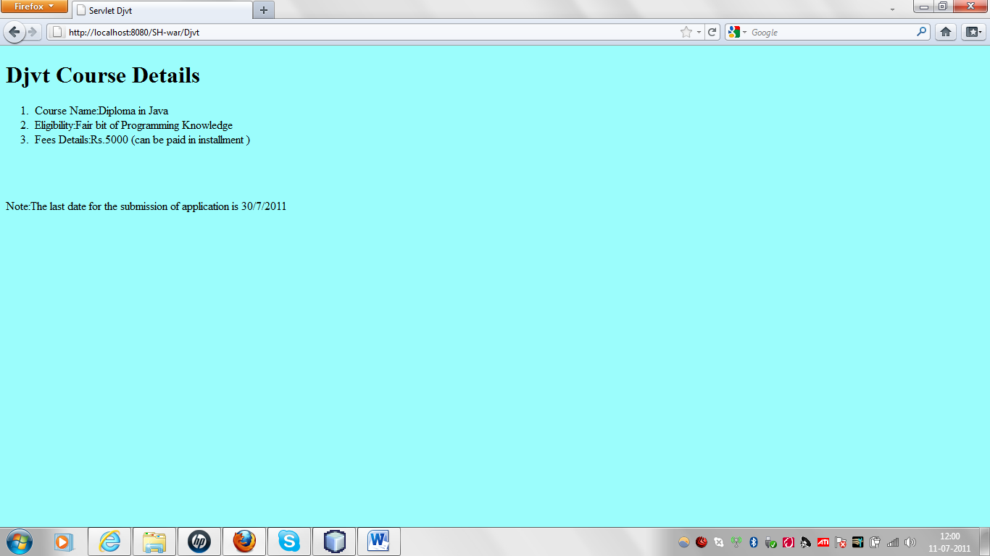

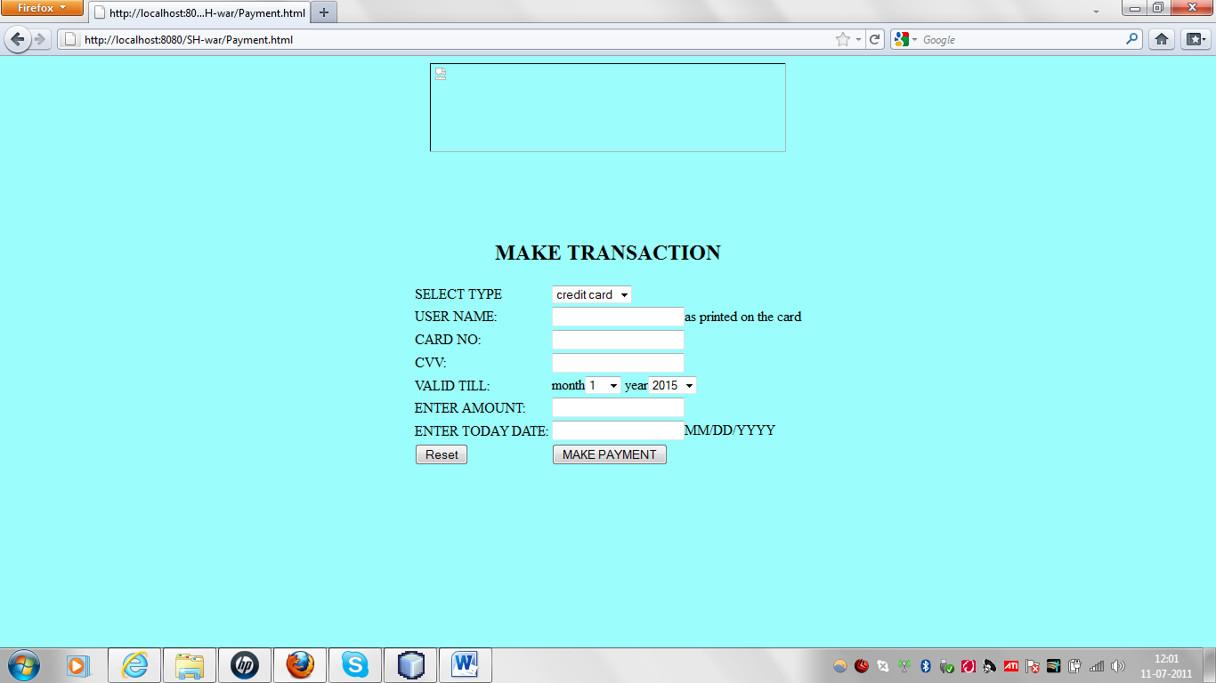

**CONCLUSION**

Thus the Sky High Institute Of Management serves as a centralized database to store the course details and information on new students. The students are given a facility of a mechanism, where they can keep the record of the courses they have been enrolled for.