**IT161: Introduction to Programming and Problem Solving**

**Lab 1/Assignment 1**

**NAME: SHIDDHARTH BHEEMARAI TASHILDAR  
ROLL NUMBER: 202451151**

**PROGRAMS**

**Q.1 Program to find area and circumference of circle. Find area of circle of radius a, where a=1+last digit of your id.**

**Code:**

#include <stdio.h>

int main(){

    int *radius*;

    float *pi* = 3.14;

    float *area*;

    float *circm*;

    printf("\nEnter your Radius: ");

    scanf("%d",&*radius*);

*circm* = 2 * *pi* * *radius*;

*area* = *pi* * *radius* \**radius* ;

    printf("\nThe Crcumference of Circle with radius %d is : %.2f\n",*radius*,*circm*);

    printf("The Area of Circle with radius %d is : %.2f\n",*radius*,*area*);

    return 0;

}

**Output:**

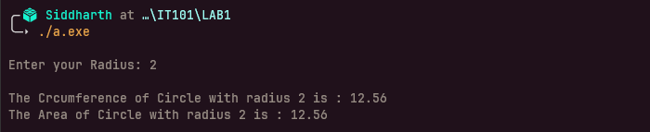

**Q.2 Program to convert temperature from degree centigrade to Fahrenheit.**

**Code:**

#include <stdio.h>

int main()

    float *Fah*;

    float *Cel*;

    printf("\nEnter your Temperature in Celsius: ");

    scanf("%f",&*Cel*);

*Fah* =(*Cel* * 9/5) + 32;

    printf("\nThe Temperature in Fahrenhite for %.2f degree celsius is : %.2f\n",*Cel*,*Fah*);

    return 0;

}

**Output:**

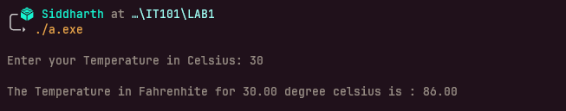

**Q.3 Program to calculate sum of marks of 5 subjects and find percentage.**

**Code:**

#include <stdio.h>

int main(){

    float *temp*;

    float *total_sum*=0;

    float *percentage*;

    for(int *i* =1; *i* <= 5;*i*++) {

        printf("\nEnter your marks out of 100 for subject %d:",*i*);

        scanf("%f",&*temp*);

*total_sum* =*total_sum* + *temp*;

    }

*percentage* = (*total_sum*/500) * 100;

    printf("\nThe total marks the student obtained is %.2f\n",*total_sum*);

    printf("\nThe total Percentage of the student is %.2f\n",*percentage*);

    return 0;

}

**Output:**

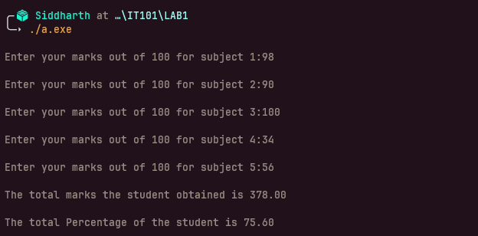

**Q.4 Program to show swap of two no’s without using third variable.**

**Code:**

#include <stdio.h>

int main(){

    int *num1*;

    int *num2*;

    printf("Enter your First Number: ");

    scanf("%d",&*num1*);

    printf("Enter your Second Number: ");

    scanf("%d",&*num2*);

    printf("\nEntered numbers ---> %d %d\n",*num1*,*num2*);

*num2* = *num1* + *num2*;

*num1* = *num2* - *num1*;

*num2* = *num2* - *num1*;

    printf("\nSwaped Numbers ----> %d %d\n",*num1*,*num2*);

    return 0;

}

**Output:**

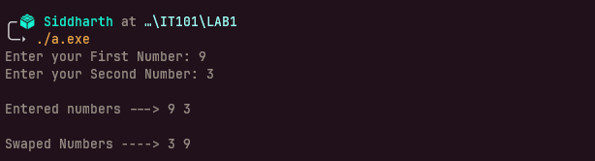

**Q.5 Program to reverse the digits of a given number.**

**Code:**

#include <stdio.h>

int main(){

    int *num*;

    int *reversed* = 0;

    int *temp_digit*;

    printf("Enter your number to reverse: ");

    scanf("%d",&*num*);

    printf("\nEntered Number----> %d\n",*num*);

    while(*num* != 0){

*temp_digit* = *num* % 10;

*num* = *num* / 10;

*reversed* = *reversed* * 10 + *temp_digit*;

    }

    printf("\nReversed Number----> %d\n",*reversed*);

    return 0;

}

**Output:**

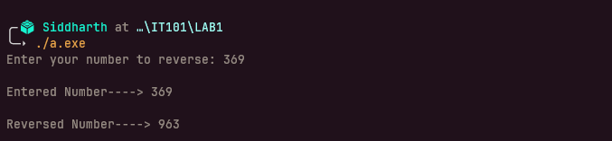

**Q.6 Program to find the greatest (and least) of 3 numbers.**

**Code:**

#include <stdio.h>

int main(){

    int *n1*;

    int *n2*;

    int *n3*;

    int *greatest*;

    printf("\nenter your first number: ");

    scanf("%d",&*n1*);

    printf("\nenter your second number: ");

    scanf("%d",&*n2*);

    printf("\nenter your second number: ");

    scanf("%d",&*n3*);

    if(*n1*>*n2* && *n1*>*n3*){

        printf("\nThe Greatest number is ---> %d\n",*n1*);

    }

    else if(*n2*>*n1* && *n2*>*n3*){

        printf("\nThe Greatest number is ---> %d\n",*n2*);

    }

    else if(*n3*>*n2* && *n3*>*n1*){

        printf("\nThe Greatest number is ---> %d\n",*n3*);

    }

    return 0;

}

**Output:**

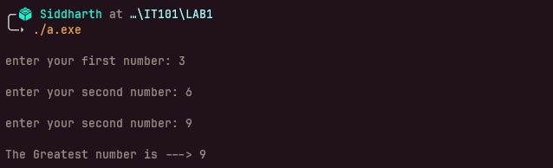

**Q.7 Program to print a multiplication table of any number.**

**Code:**

#include <stdio.h>

int main(){

    int *num*;

    printf("\nEnter your number: ");

    scanf("%d",&*num*);

    printf("\nHeres your table for %d ---> \n",*num*);

    for(int *i*=1; *i* <= 10; *i*++){

    printf("%d X %d = %d\n", *num* , *i* , *num*\**i*);

    }

    return 0;

}

**Output:**

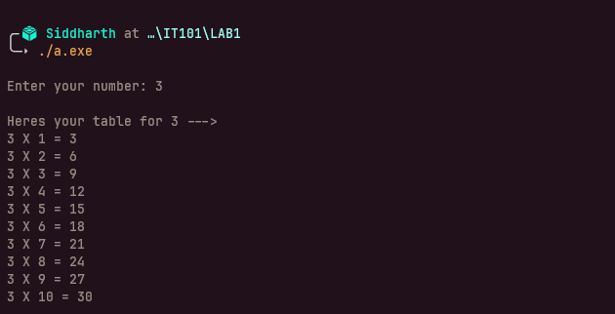

**Q.8 Prime testing algorithm**

**Code:**

#include <stdio.h>

int main(){

    int *num*;

    int *temp* = 0;

    printf("\nEnter your number: ");

    scanf("%d",&*num*);

    for(int *i* = 2; *i* < *num*;*i*++){

        if(*num* % *i* == 0){

*temp* += 1;

        }

    }

    if(*temp* == 0){

    printf("\n%d is a prime number!\n",*num*);

    }

    else{

    printf("\n%d is not a prime number!\n",*num*);

    }

    return 0;

}

**Output:**

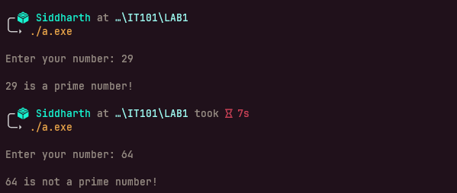

**Q.9 Sum: input: n, output: 1+½+⅓+...1/n.**

**Code:**

#include <stdio.h>

int main(){

    int *n*;

    float *ans*=0;

    float *temp*;

    printf("Enter your number: ");

    scanf("%d",&*n*);

    for(int *i* = 1; *i* <= *n*; *i*++){

*temp* = 1/(float)*i*;

*ans* = *temp* + *ans*;

    }

    printf("\nHeres your answer---> %f\n",*ans*);

    return 0;

}

**Output:**

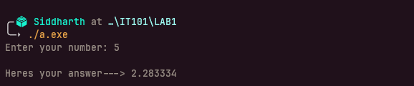

**Q.10 Print Fibonacci sequence of given length and ratio of two consecutive Fibonacci numbers.**

**Code:**

#include <stdio.h>

int main(){

    int *n*;

    int *num1*=0;

    int *num2*=1;

    int *next_number*;

    float *ratio*;

    printf("\nEnter your number: ");

    scanf("%d",&*n*);

    printf("\nHeres your series---> \n");

    printf("\nHeres the first number---> 0\n");

    for(int *i* = 1; *i* <= *n*; *i*++){

*next_number* = *num2* + *num1* ;

    printf("\nHeres next number---> %d",*next_number*);

    if(*num1* != 0){

*ratio* = (float)*num2*/(float)*num1*;

    printf("\nRatio for %d and %d is : %.2f\n",*num2*,*num1*,*ratio*);

    }

    else if(*num1* == 0){

    printf("\nFirst ratio is infinite as we are dividing by Zero!\n");

    }

*num1* = *num2*;

*num2* = *next_number*;

    }

    return 0;

}

**Output:**

