**IT161: Introduction to Programming and Problem Solving**

**Lab 2/Assignment 2**

**NAME: SHIDDHARTH BHEEMARAI TASHILDAR  
ROLL NUMBER: 202451151**

**PROGRAMS**

1. **Printing special characters**

**Code:**

#include <stdio.h>

int main(){

    printf("Special Characters 1 -->  ");

    for(int *i* = 32; *i* <= 47;*i*++){

        printf("  %c",*i*);

    }

    printf("\n");

    printf("Special Characters 2 -->  ");

    for(int *i* = 58; *i* <= 64;*i*++){

        printf("  %c",*i*);

    }

    printf("\n");

    printf("Special Characters 3 -->  ");

    for(int *i* = 91; *i* <= 96;*i*++){

        printf("  %c",*i*);

    }

    printf("\n");

    printf("Special Characters 4 -->  ");

    for(int *i* = 123; *i* <= 126;*i*++){

        printf("  %c",*i*);

    }

    printf("\n");

        return 0;}

**Output:**

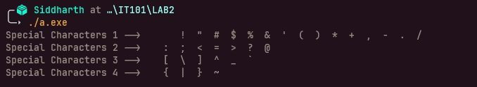

1. **C Program to Check Leap Year**

**Code:**

#include <stdio.h>

int main(){

    int *year*;

    printf("\nEnter your to check: ");

    scanf("%d",&*year*);

    if(*year*%4 == 0){

        printf("\n%d is a leap year!\n",*year*);

    }

    else if(*year*% 100 == 0 && *year* % 400 == 0){

        printf("\n%d is a leap year!\n",*year*);

    }

    else {

        printf("\n%d is not a leap year!\n",*year*);

    }

    return 0;

}

**Output:**

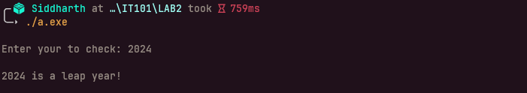

1. **C Program to Find the Factorial**

**Code:**

#include <stdio.h>

int main(){

    int *n*;

    int *fact* = 1;

    printf("\nEnter your Number: ");

    scanf("%d",&*n*);

    for(int *i* = 1; *i* <= *n*;*i*++){

*fact* = *fact* * *i*;}

    printf("\nThe factorial of %d is %d\n",*n*,*fact*);

    return 0;}

**Output:**

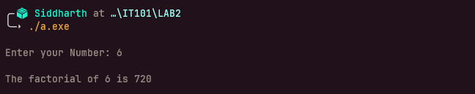

1. **C Program to Make a Simple Calculator**

**Code:**

#include <stdio.h>

#include <stdlib.h>

int main(){

    int *operation*;

    int *a*;

    int *b*;

    printf("\nEnter number 1: ");

    scanf("%d",&*a*);

    printf("\nEnter number 2: ");

    scanf("%d",&*b*);

    printf("\nSelect Operator: \n");

    printf("1.Add\n");

    printf("2.Subtract\n");

    printf("3.Multiply\n");

    printf("4.Divide\n");

    printf("\nWhat operations do you want to perform on %d and %d (1/2/3/4): ",*a*,*b*);

    scanf("%d",&*operation*);

    if(*operation* == 1){

        printf("\nThe sum of %d and %d is : %d\n",*a*,*b*,*a*+*b*);

    }

    else if(*operation* == 2){

        printf("\nThe diff of %d and %d is : %d\n",*a*,*b*,abs(*a*-*b*));

    }

    else if(*operation* == 3){

        printf("\nThe product of %d and %d is : %d\n",*a*,*b*,*a*\**b*);

    }

    else if(*operation* == 4){

        printf("\nThe Division of %d and %d is : %.2f\n",*a*,*b*,(float)*a*/(float)*b*);

    }

    return 0;

}

**Output:**

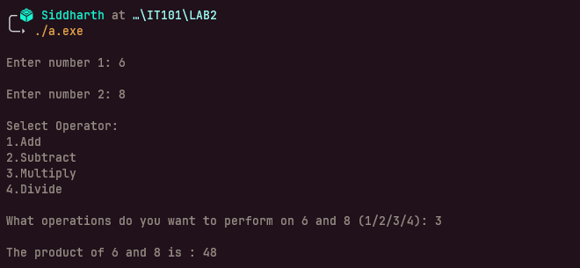

1. **C Program to Print Pyramid Pattern**

**Code:**

#include <stdio.h>

int main(){

    int *n*;

    printf("\nEnter No of rows: ");

    scanf("%d",&*n*);

    for(int *i*=1; *i*<=*n* ; *i*++){

        for(int *j* = 1; *j* <= *i*;*j*++){

            printf("*");

        }

        printf("\n");

    }

    return 0;

}

**Output:**

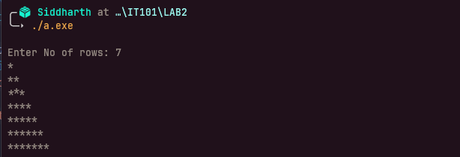

1. **C Program to Display Factors of a Number**

**Code:**

#include <stdio.h>

int main(){

    int *n*;

    printf("\nEnter the Number to check factors: ");

    scanf("%d",&*n*);

    printf("\nFactors ---> ");

    for(int *i* = 1 ; *i* <= *n* ; *i*++){

        if(*n*%*i*==0){

        printf(" %d",*i*);

        }

    }

    printf("\n");

    return 0;

}

**Output:**

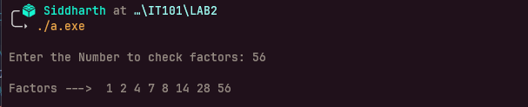

1. **Store integers in an array**

**Code:**

#include <stdio.h>

int main(){

    int *n*;

    printf("\n how many numbers do you want to enter: ");

    scanf("%d",&*n*);

    int *array*[*n*];

    for(int *i*; *i* < *n* ; *i*++)

        printf("\nEnter the %dth Number:  ",*i*+1);

        scanf("%d",&*array*[*i*]);

    }

    printf("\nhere is your Final Array --> \n")

    for(int *j*; *j*<*n* ; *j*++){

    printf(" %d",*array*[*j*]);

    }

    printf("\n");

    return 0;

}

**Output:**

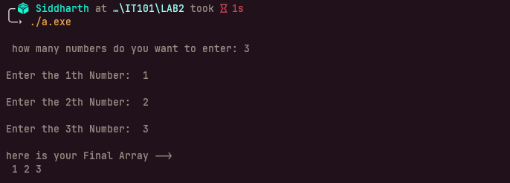

1. **Finding min, max from integer array**

**Code:**

#include <stdio.h>

int main(){

    int *array*[] = {2,6,4,9,10,99,0};

    int *great* = *array*[0];

    int *least* = *array*[0];

    int *len* = sizeof(*array*)/sizeof(*array*[0]);

    for(int *i* = 1; *i*<= *len* ; *i*++){

        if (*array*[*i*] > *great*){

*great* = *array*[*i*];

        }

    }

    for(int *i* =0 ; *i*< *len* ; *i*++){

        if (*array*[*i*] < *least*){

*least* = *array*[*i*];

        }

    }

    printf("\ngreatest no --->%d\n",*great*);

    printf("\nsmallest no --->%d\n",*least*);

    return 0;

}

**Output:**

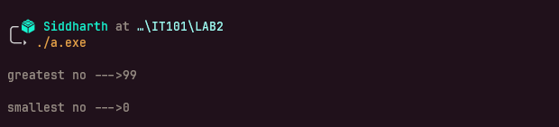

1. **Checking whether an array is in ascending or descending**

**Code:**

#include <stdio.h>

int main()

    int *array*[] = {10,9,7,4,2,1,0};

    int *is_asc* = 0;

    int *is_dsc* = 0;

    int *len* = sizeof(*array*)/sizeof(*array*[0]);

    for(int *i* = 0; *i*< *len* ; *i*++){

        if (*array*[*i*] < *array*[*i*+1]){

*is_asc* += 1;

        }

        else if (*array*[*i*] > *array*[*i*+1]){

*is_dsc* += 1;

        }  }

    if(*is_asc* == *len*-1){

        printf("\nThe Array is in ascending order!\n");

    }

    else if(*is_dsc* == *len*-1){

        printf("\nThe Array is in desecnding order!\n");

    }

    else{

        printf("\nArray Not sorted!\n");

        }

    return 0; }

**Output:**

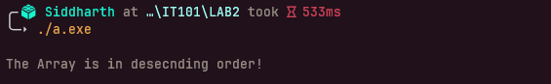

1. **Reverse the entries of an integer array**

**Code:**

#include <stdio.h>

int main(){

    int *array*[] = {3,6,4,9,10,98,54,77,22};

    int *len* = sizeof(*array*)/sizeof(*array*[0]);

    int *reversed*[*len*];

    for(int *i* = 0; *i* < *len*; *i*++){

*reversed*[*i*] = *array*[*len*-1-*i*];

    }

    int *len_reversed* = sizeof(*reversed*)/sizeof(*reversed*[0]);

    printf("\nhere is your Reversed Array --> \n");

    for(int *j* = 0; *j* < *len_reversed*; *j*++){

        printf(" %d",*reversed*[*j*]);

    }

    printf("\n");

    return 0;

}

**Output:**

