**IT161: Introduction to Programming and Problem Solving**

**Lab 5/Assignment 5**

**NAME: SHIDDHARTH BHEEMARAI TASHILDAR  
ROLL NUMBER: 202451151**

**PROGRAMS**

**1.Factorial of number n using recursion:**

**Code:**

#include <stdio.h>

int factorial(int *n*);

int main(){

    int *n*;

    int *fac*;

    printf("\nEnter number: ");

    scanf("%d",&*n*);

*fac* = factorial(*n*);

    printf("\n The factorial of %d is: %d\n",*n*,*fac*);

    return 0;

}

int factorial(int *n*){

    if (*n* == 1) {return *n*;}

    else{

        return *n* * factorial(*n*-1);

    }

}

**OutPut:**

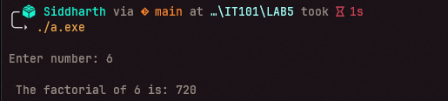

**2. Hanoi Tower using Recursion:**

**Code:**

#include <stdio.h>

void moveDisc(int *n*, char *A*, char *B*, char *C*);

int main(){

    int *n*;

    printf("\nEnter the number of Discs: ");

    scanf("%d",&*n*);

    moveDisc(*n*,'A','B','C');

    return 0;

}

void moveDisc(int *n*, char *A*, char *B*, char *C*){

    if(*n* == 1){

        printf("\nMoved Disc %d from %c to %c\n",*n*,*A*,*C*);

        return;

    }

    else{

        moveDisc(*n*-1,*A*,*C*,*B*);

        printf("\nMoved DIsc %d from %c to %c\n",*n*,*A*,*C*);

        moveDisc(*n*-1,*B*,*A*,*C*);

    }

}

**Output:**

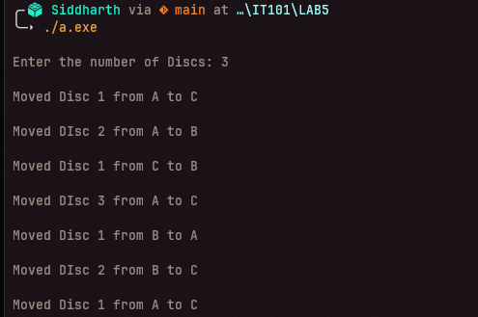

**3.Printing Array using pointer:**

**Code:**

#include <stdio.h>

int main(){

    int *n*;

    printf("\n Enter N: ");

    scanf("%d",&*n*);

    int *Arr*[*n*];

    printf("\nEnter Elements: ");

    for(int *i* = 0; *i*<*n*;*i*++){

        scanf("%d",&*Arr*[*i*]);

    }

    int \**pArr* = *Arr*;

    for(int *i* = 0; *i*<*n*;*i*++){

        printf("%d ",*(*pArr*+*i*));

    }

    printf("\n");

    return 0;

}

**Output:  
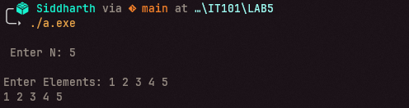**

**4.Checking prime number using a efficient way:**

**Code:**

#include <stdio.h>

int main(){

    int *n*;

    printf("\n Enter N: ");

    scanf("%d",&*n*);

    int *count* = 0;

    int *temp* = 5;

    if(*n* % 2 == 0 || *n* % 3 == 0){

*count* += 1;

    }

    if (*n* % 6 == 0){

*count* += 1;

    }

    while(*temp* < *n*){

        if(*n*%*temp* == 0){

*count* += 1;

        }

*temp* += 5;

    }

    if(*count* == 0){

        printf("\nPRIME!\n");

    }

    else{

        printf("\nNOT PRIME!\n");

    }

    return 0;

}

**Output:**

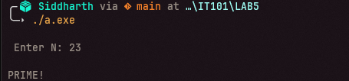

**5.Solving Quadratic equations and printing values using pointers:**

**Code:**

#include <stdio.h>

#include <math.h>

void quad(double ,double ,double , double * , double *);

int main(){

    double *a*,*b*,*c*;

    double *r1*,*r2*;

*//double *pr1 = &r1;*

*//double *pr2 = &r2;*

    printf("\nEnter a: ");

    scanf("%lf",&*a*);

    printf("\nEnter b: ");

    scanf("%lf",&*b*);

    printf("\nEnter c: ");

    scanf("%lf",&*c*);

    quad(*a*,*b*,*c*,&*r1*,&*r2*);

    printf("\nthe roots of quadratic equations are: %lf %lf \n",*r1*,*r2*);

    return 0;

}

void quad(double *a*,double *b*,double *c* , double \**r1* , double \**r2*){

    double *d*;

    double *x* = (*b*\**b*)-(4\**a*\**c*);

*d* = sqrt(*x*);

    \**r1* = ((-*b*) + *d*) / (2\**a*);

    \**r2* = ((-*b*) - *d*) / (2\**a*);

}

**Output:**

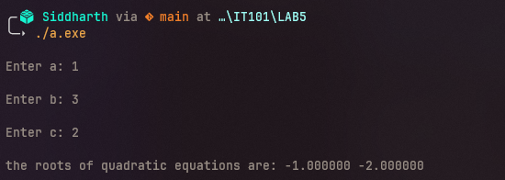

**6.Printing Three names from array using pointers:**

**Code:**

#include <stdio.h>

int main(){

    char \**Arr*[] = {"Joseph","Vissarionovich","Stalin"};

    printf("\n");

    for(int *i* = 0; *i*<3;*i*++){

        printf("%s ",*Arr*[*i*]);

    }

    printf("\n");

    return 0;

}

**Output:**

