**IT161: Introduction to Programming and Problem Solving**

**Lab 6/Assignment 6**

**NAME: SHIDDHARTH BHEEMARAI TASHILDAR  
ROLL NUMBER: 202451151**

**PROGRAMS**

1. **C function to reverse an array using pointers**

**Code:**

#include <stdio.h>

void swap(int \**a* , int \**b*);

int main(){

    int *n*;

    printf("\nEnter Your Array Lenght: ");

    scanf("%d",&*n*);

    int *array*[*n*];

    printf("Enter the Elements: ");

    for(int *i* = 0;*i*<*n*;*i*++){

        scanf("%d",&*array*[*i*]);

    }

    for(int *i* = 0; *i* < *n*/2 ; *i*++){

        int \**a* = &*array*[*i*];

        int \**b* = &*array*[*n*-1-*i*];

        swap(*a*,*b*);

    }

    printf("\nYour Reversed array --> ");

    for(int *i* = 0;*i*<*n*;*i*++){

        printf(" %d",*array*[*i*]);

    }

    printf("\n");

}

void swap(int \**a*, int \**b*){

    int *temp* = \**a*;

    \**a* = \**b*;

    \**b* = *temp*;

}

**Output:**

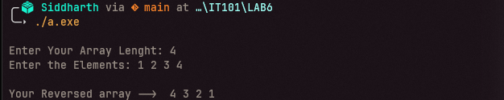

1. **c program to find numbers in an array whose digit sum is/are even.**

**Code:**

#include <stdio.h>

#include <stdbool.h>

int sum(int *a*);

bool isEven(int *a*);

int main(){

    int *n*;

    printf("\nEnter Your Array Lenght: ");

    scanf("%d",&*n*);

    int *array*[*n*];

    printf("Enter the Elements: ");

    for(int *i* = 0;*i*<*n*;*i*++){

        scanf("%d",&*array*[*i*]);

    }

    printf("\n");

    for(int *i* = 0; *i* < *n* ; *i*++){

        if(isEven(sum(*array*[*i*])) == true){

            printf("%dth element which is %d has even sum. \n",(*i*+1),*array*[*i*]);

            printf("\n");

        }

    }

}

int sum(int *a*){

    int *temp* = 0;

    int *x* = 0;

    while(*a* != 0){

*temp* = *a* % 10;

*x* = *x* + *temp*;

*a* = *a*/10;

    }

    return *x*;

}

bool isEven(int *a*){

    if(*a* % 2 == 0){

        return true;

    }

    else{

        return false;

    }

}

**Output:**

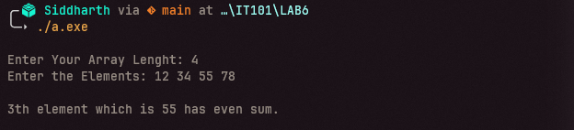

1. **C function to remove duplicates from an array using pointers.**

**Code:**

#include <stdio.h>

void swap(int \**a* , int \**b*);

void sort(int *n* , int \**arr*);

int removeDup(int *a* , int \**arr*);

int main(){

    int *n*,*new_len*;

    printf("\nEnter Your Array Lenght: ");

    scanf("%d",&*n*);

    int *array*[*n*];

    printf("Enter the Elements: ");

    for(int *i* = 0;*i*<*n*;*i*++){

        scanf("%d",&*array*[*i*]);

    }

    sort(*n*,*array*);

    printf("\nYour Sorted Array--> ");

    for(int *i* = 0;*i*<*n*;*i*++){

        printf(" %d",*array*[*i*]);

    }

*new_len* = removeDup(*n*,*array*);

    printf("\nYour New Array with len %d--> ",*new_len*);

    for(int *i* = 0;*i*<*new_len*;*i*++){

        printf(" %d",*array*[*i*]);

    }

    printf("\n");

}

void swap(int \**a*, int \**b*){

    int *temp* = \**a*;

    \**a* = \**b*;

    \**b* = *temp*;

}

void sort(int *n* , int \**arr*){

    for(int *i* = 0 ; *i* < *n* ; *i*++){

        for(int *j* = *i*+1;*j*<*n*;*j*++){

            if(*(*arr*+*j*) < *(*arr*+*i*)){

                swap(*arr*+*j*,*arr*+*i*);

            }

        }

    }

}

*/*int removeDup(int a, int *arr){*

*for(int i = 0 ; i < a ; i++){*

*for(int j = i+1;j<a;j++){*

*if(*(arr+i) == *(arr+j)){*

*\*(arr+i) = *(arr+j);*

*a--;*

*}*

*}*

*}*

*return a;*

*}*/*

int removeDup(int *a*, int \**arr*){

    int *i* = 0;

    for(int *j* = 1;*j*<*a*;*j*++){

        if(*(*arr*+*i*) != *(*arr*+*j*)){

*i*++;

            *(*arr*+*i*) = *(*arr*+*j*);

        }

    }

    return *i* + 1;

}

**Output:**

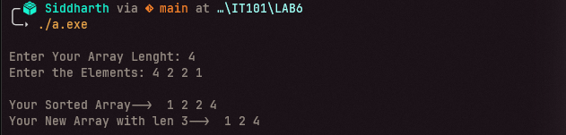

1. **C program to swap two values using call by reference.**

**Code:**

#include <stdio.h>

void swap(int \**a* , int \**b*);

int main(){

    int *x*,*y*;

    printf("\nEnter Your Numbers: ");

    scanf("%d %d",&*x*,&*y*);

    swap(&*x*,&*y*);

    printf("\nSwapped--> %d %d \n",*x*,*y*);

}

void swap(int \**a*, int \**b*){

    int *temp* = \**a*;

    \**a* = \**b*;

    \**b* = *temp*;

}

**Output:**

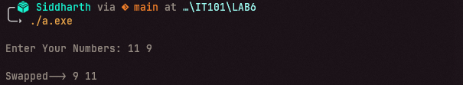

1. **A 5-digit positive integer is entered through the keyboard, write a function to calculate sum of digits of the 5-digit number:**
2. **Without Recursion**

**Code:**

#include <stdio.h>

int sum(int *a*);

int main(){

    int *n*, *totalSum*;

    printf("\nEnter Your Number: ");

    scanf("%d",&*n*);

*totalSum* = sum(*n*);

    printf("\nThe sum of digits in %d without recursion is --> %d\n",*n*,*totalSum*);

}

int sum(int *a*){

    int *temp* = 0;

    int *x* = 0;

    while(*a* != 0){

*temp* = *a* % 10;

*x* = *x* + *temp*;

*a* = *a*/10;

    }

    return *x*;

}

**Output:**

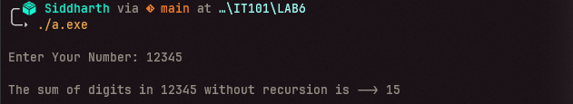

1. **With Recursion**

**Code:**

#include <stdio.h>

int sum(int *a*);

int main(){

    int *n*, *totalSum*;

    printf("\nEnter Your Number: ");

    scanf("%d",&*n*);

*totalSum* = sum(*n*);

    printf("\nThe sum of digits in %d using recursion is --> %d\n",*n*,*totalSum*);

}

int sum(int *a*){

    if(*a* == 0){return 0;}

    else{

        return ((*a*%10) + sum(*a*/10));

    }

}

**Output:**

