Screenshots of the console output

Tested with given input:

b)

PLACE 0,0,NORTH

MOVE

REPORT

Output: 0,1,NORTH

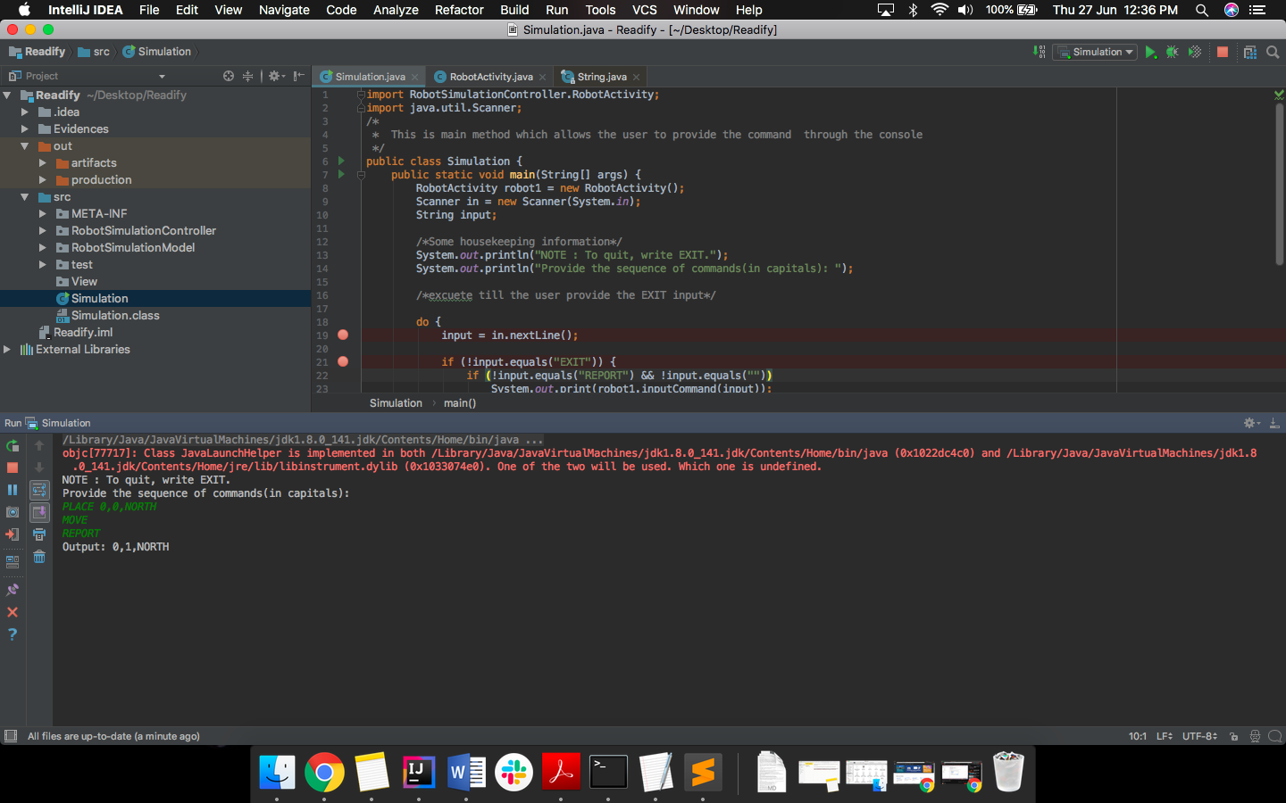

b)

PLACE 0,0,NORTH

LEFT

REPORT

Output: 0,0,WEST

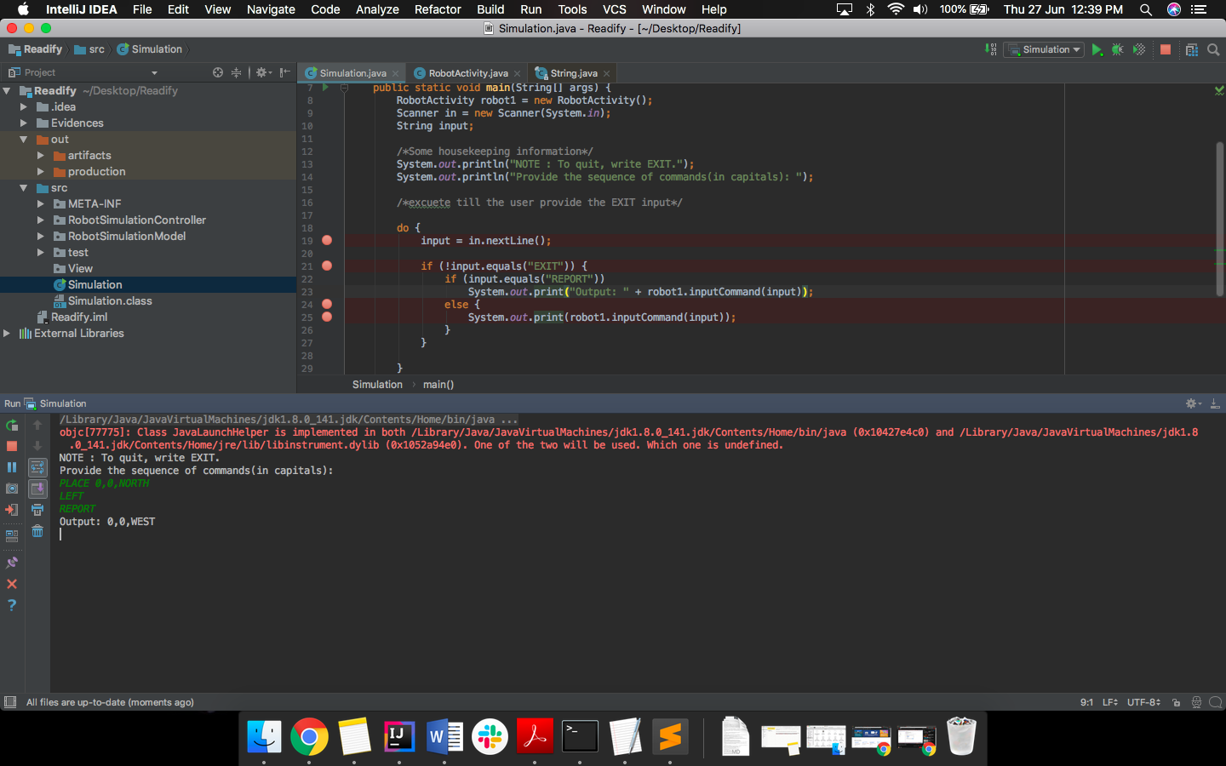

c)

PLACE 1,2,EAST

MOVE

MOVE

LEFT

MOVE

REPORT

Output: 3,3,NORTH

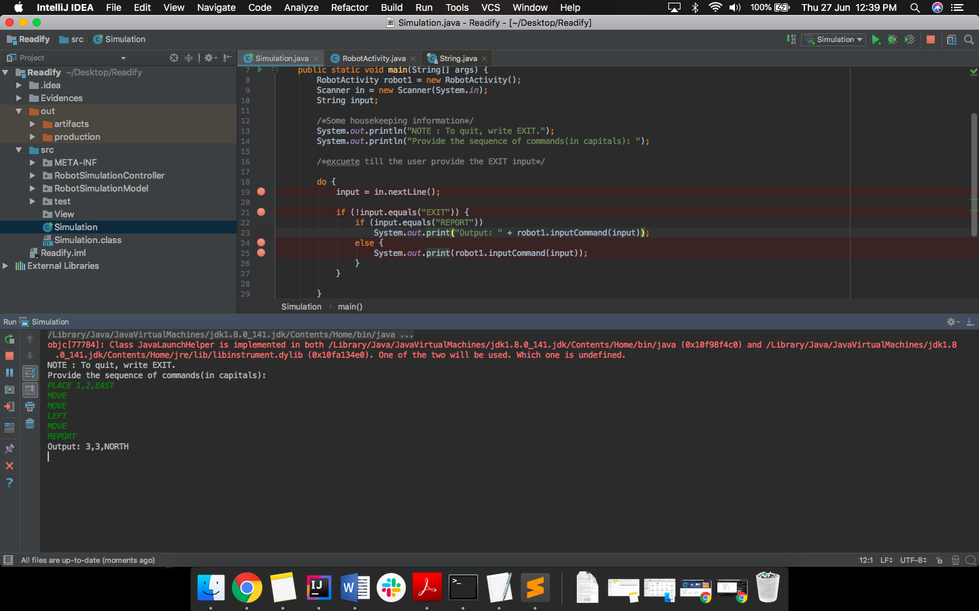

e)

Invalid Commands

