Design Document

LLM Evaluation Harness (evalharness)
Version: 1.0 Companion docs: docs/SRS.md (requirements), docs/HLD.md (architecture), docs/LLD.md (module detail).
This document explains *why* the harness is shaped the way it is: the goals, the principles that follow from them, the hard trade-offs, and how the pieces move at runtime.

1. The core problem, restated
Software testing rests on determinism: f(x) returns the same y every time, so assert f(x) == y is a stable signal. LLMs break that assumption twice over:
- Non-determinism — the same prompt yields different-but-often-valid outputs.
- Graded correctness — "right" is frequently a matter of degree (a summary can be 80% good), not equality.
So you cannot gate a release on output == expected. But you *can* gate on aggregate quality against a fixed golden set, compared to a known-good baseline. That reframing — from unit assertion to statistical regression test — is the whole idea. evalharness is "pytest for probabilistic systems": the same discipline (fixtures, assertions, CI gates), adapted to outputs that must be *scored* rather than *compared*.

2. Design goals
- G1 — Honest gating. The gate must fail when quality actually drops and stay green otherwise. False greens erode trust in the whole idea; false reds get the check disabled.
- G2 — Reproducibility. The same inputs must yield the same gate decision, despite model non-determinism.
- G3 — Cheap to run. Evals that cost real money and minutes every push won't survive contact with a busy team.
- G4 — Reusable, not bespoke. A framework with clean extension points — not a notebook copy-pasted per project.
- G5 — Works offline in CI. The core must be testable and partially runnable with no API key.

3. Principles that follow
Principle | Consequence in the design
Determinism where you can, judgment where you must | Deterministic scorers (exact/regex/contains) and a local embedding scorer handle most checks; the LLM-judge is reserved for genuinely open-ended quality.
Cache everything model-generated | A content-addressed response cache makes re-runs free and — crucially — makes the *gate decision* reproducible even though the underlying model is not.
Pin the world | Model IDs come from config, never "latest". A model swap is an explicit, reviewable change.
Separate policy from mechanism | Thresholds/tolerances live in config; the regression algorithm is fixed and simple.
Small interfaces, many implementations | Provider and Scorer are one-method protocols; adding a backend or metric never touches the runner.
Secrets stay out | Keys come from the environment/SDK auth and are never written to reports or baselines.

4. Key trade-offs and decisions

4.1 LLM-as-judge flakiness
An LLM judge is the only scorer that can grade open-ended quality — but it is itself a non-deterministic LLM, which threatens G1/G2. Mitigations, layered:
- Structured verdicts. The judge returns a schema-validated {score, pass, reasoning} via messages.parse(), not free text we regex. This removes parsing flakiness entirely.
- Caching. Judge calls are keyed and cached like any other model call, so a given (judge_model, rubric, output) grades identically on every re-run.
- Low effort, clear rubric. The judge runs at low effort with adaptive thinking and a strict, calibrated rubric prompt — cheaper and more consistent than an open-ended "is this good?".
- Thresholds, not point values. Gating compares *aggregate* judge means against a baseline with a tolerance, so single-point judge noise doesn't flip the gate.

4.2 Embedding scorer runs locally
Anthropic has no first-party embeddings endpoint. Rather than pull in a second cloud provider (extra key, cost, network, non-determinism), the embedding scorer uses a local sentence-transformers model. This keeps semantic similarity offline, free, and deterministic — a strict win for G2, G3, and G5.

4.3 Response cache vs. "true" sampling
A cache means re-runs don't re-sample the model — arguably hiding variance. That is the intended trade: for gating, stability beats fresh sampling. When you *want* fresh numbers (e.g. after changing the prompt), the cache key changes automatically (the prompt is part of the key), or you pass --no-cache. So the cache never masks a real change; it only suppresses re-sampling noise for *unchanged* inputs.

4.4 Anthropic-first, pluggable
Building one real provider (Anthropic) proves the interface end-to-end; a stub OpenAI adapter proves it's backend-agnostic. This delivers a working demo now without over-investing in providers that aren't the focus. A "model swap regression" — the headline use case — is just a one-line config change to target_model.

4.5 Multiple scorers, explicit aggregation
Different questions need different scorers (does it contain the required fact? is it semantically close? is it *good*?). Rather than pick one, a suite composes several, and each case's pass/fail is an explicit combination (all required scorers pass). This keeps each scorer simple and honest about what it measures.

5. Sequence walkthrough: one evalharness gate
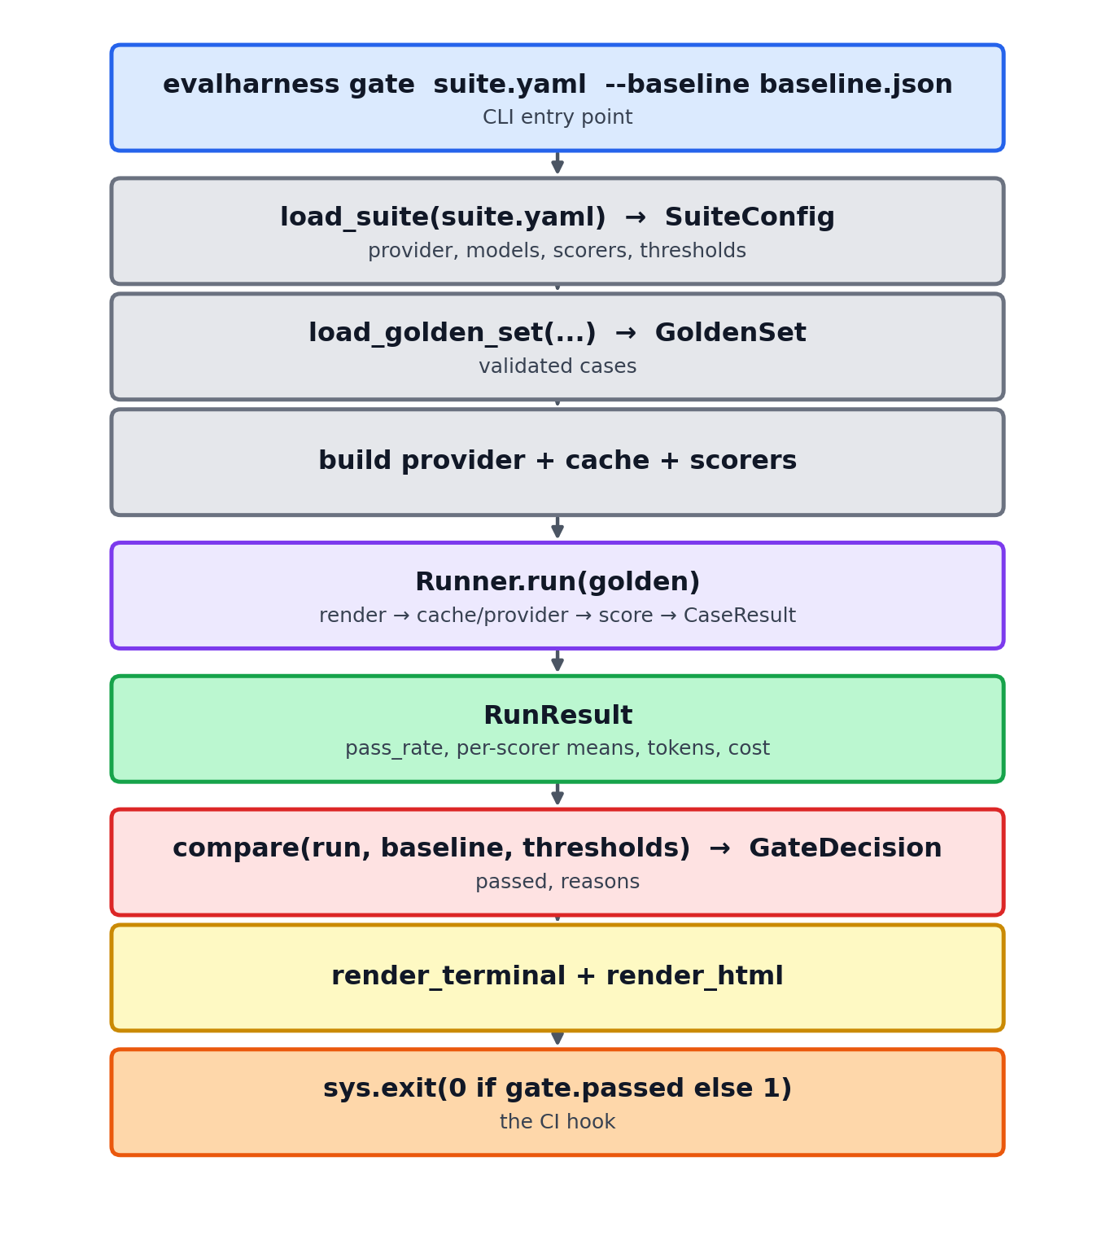
Figure: Sequence of one evalharness gate

6. Testing strategy
- Unit tests (offline, no key): scorers (each with crafted inputs), dataset loading (valid + malformed), config validation, cache round-trip, and the regression algorithm (constructed RunResult/Baseline fixtures). A MockProvider supplies deterministic outputs so the *runner* is testable end-to-end offline — satisfying G5.
- Live smoke (opt-in): running the bundled example suite against Anthropic when a key is present.
- Regression demo: degrade the example prompt, confirm gate exits non-zero and names the regressed cases — the acceptance test for G1.

7. Security & cost posture
- Keys are read via the SDK's own env/profile resolution; the harness never accepts a key as an argument, logs it, or serializes it.
- Every run reports token usage and an estimated dollar cost from a small per-model price table; cached responses contribute zero cost, making the savings visible.

8. Roadmap (post-v1)
- Judge calibration against a set of human-labeled cases (agreement %, per-rubric drift).
- Statistical significance on aggregate deltas (bootstrap CIs) so gates account for sample size.
- More providers (OpenAI, local/Ollama) fleshed out beyond the stub.
- Latency/cost budgets as first-class gated metrics, not just reported.
- Dataset versioning & tag-scoped runs (e.g. gate only on tags: [critical]).

9. Why this stands out
Most LLM "evaluation" in the wild is a one-off script that prints a few outputs for a human to eyeball. This design is the opposite: a *reusable* framework with a pinned, cached, reproducible pipeline; composable scorers including a structured LLM judge; an explicit regression algorithm; and a CI gate that actually fails the build. It treats LLM quality as what it is — test infrastructure with a probabilistic twist — which is exactly the signal that separates people who have shipped LLM systems from people who have watched tutorials.

